**Mata Kuliah : PBO – TI – S1**

**Pertemuan : 3**

**NIM : A11.2022.14667**

**Nama : Nila Farihah**

**Hasil Program :**

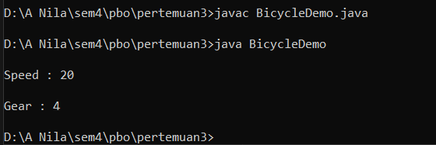

**Kode Program :**

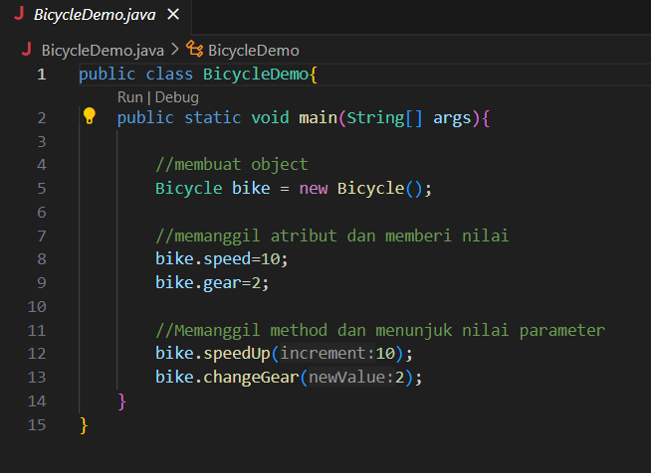

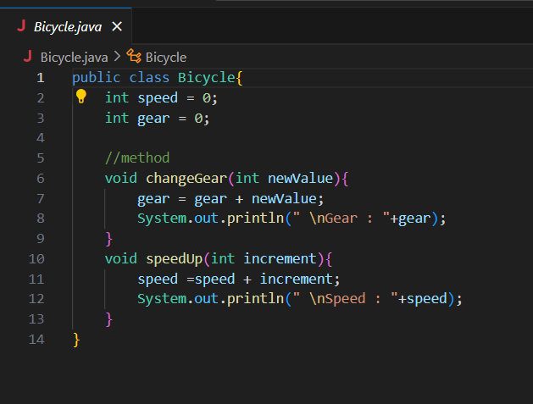

**Hasil Program :**

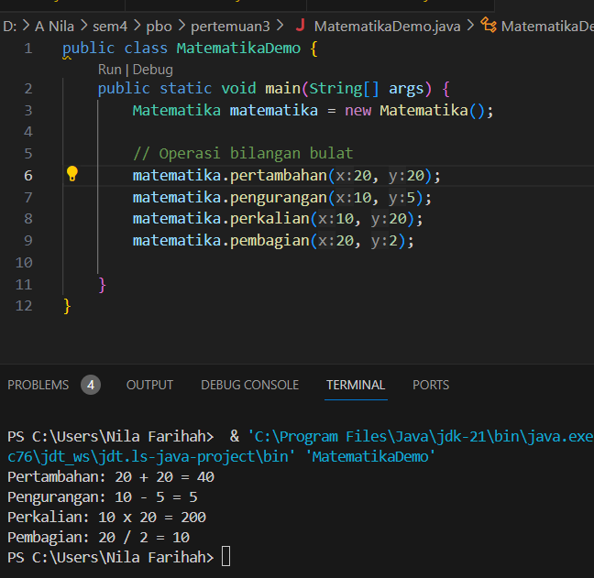

**Kode Program :**

**File “Matematika.java”**

public class Matematika {

    public void pertambahan(int x, int y) {

        System.out.println("Pertambahan: " + x + " + " + y + " = " + (x + y));

    }

    public void pengurangan(int x, int y) {

        System.out.println("Pengurangan: " + x + " - " + y + " = " + (x - y));

    }

    public void perkalian(int x, int y) {

        System.out.println("Perkalian: " + x + " x " + y + " = " + (x * y));

    }

    public void pembagian(int x, int y) {

        if (y != 0) {

            System.out.println("Pembagian: " + x + " / " + y + " = " + (x / y));

        } else {

            System.out.println("Error: Pembagian dengan nol tidak diperbolehkan");

        }

    }

}

**File “MatematikaDemo.java”**

public class MatematikaDemo {

    public static void main(String[] args) {

        Matematika matematika = new Matematika();

        // Operasi bilangan bulat

        matematika.pertambahan(20, 20);

        matematika.pengurangan(10, 5);

        matematika.perkalian(10, 20);

        matematika.pembagian(20, 2);

    }

}

**Hasil Program :**

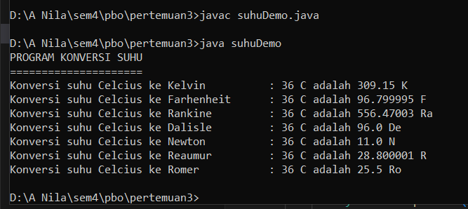

**Kode Program :**

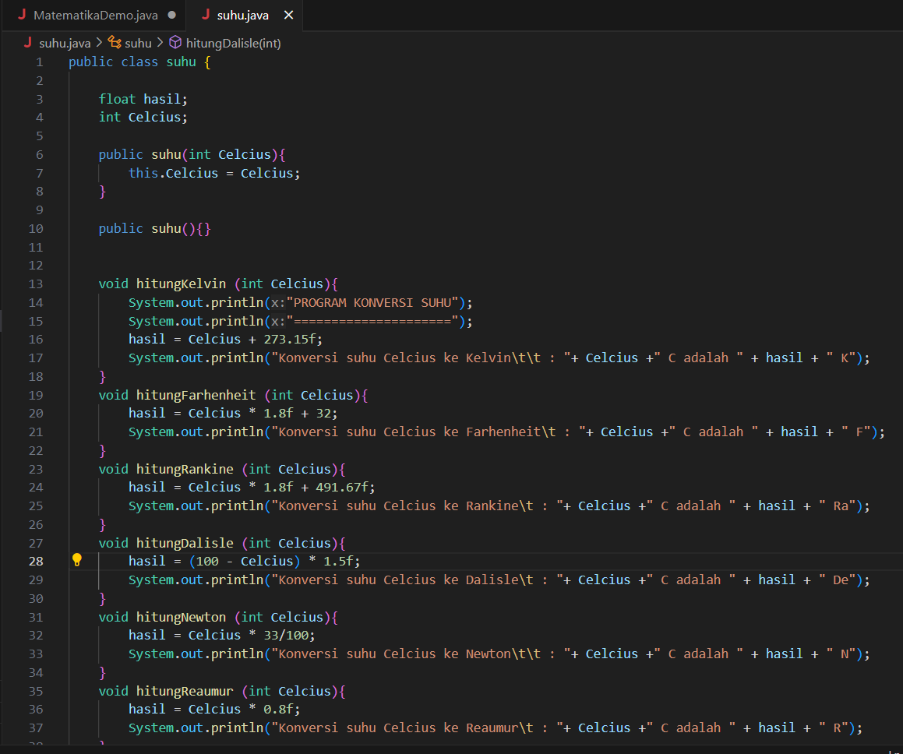

**File “suhu.java”**

public class suhu {

    float hasil;

    int Celcius;

    public suhu(int Celcius){

        this.Celcius = Celcius;

    }

    public suhu(){}

    void hitungKelvin (int Celcius){

        System.out.println("PROGRAM KONVERSI SUHU");

        System.out.println("=====================");

        hasil = Celcius + 273.15f;

        System.out.println("Konversi suhu Celcius ke Kelvin\t\t : "+ Celcius +" C adalah " + hasil + " K");

    }

    void hitungFarhenheit (int Celcius){

        hasil = Celcius * 1.8f + 32;

        System.out.println("Konversi suhu Celcius ke Farhenheit\t : "+ Celcius +" C adalah " + hasil + " F");

    }

    void hitungRankine (int Celcius){

        hasil = Celcius * 1.8f + 491.67f;

        System.out.println("Konversi suhu Celcius ke Rankine\t : "+ Celcius +" C adalah " + hasil + " Ra");

    }

    void hitungDalisle (int Celcius){

        hasil = (100 - Celcius) * 1.5f;

        System.out.println("Konversi suhu Celcius ke Dalisle\t : "+ Celcius +" C adalah " + hasil + " De");

    }

    void hitungNewton (int Celcius){

        hasil = Celcius * 33/100;

        System.out.println("Konversi suhu Celcius ke Newton\t\t : "+ Celcius +" C adalah " + hasil + " N");

    }

    void hitungReaumur (int Celcius){

        hasil = Celcius * 0.8f;

        System.out.println("Konversi suhu Celcius ke Reaumur\t : "+ Celcius +" C adalah " + hasil + " R");

    }

    void hitungRomer(int Celcius){

        hasil = Celcius * 21/40 + 7.5f;

        System.out.println("Konversi suhu Celcius ke Romer\t\t : "+ Celcius +" C adalah " + hasil + " Ro");

    }

}

**File “suhuDemo.java”**

public class suhuDemo {

    public static void main(String[] args) {

        suhu Suhu = new suhu(36);

        Suhu.hitungKelvin(Suhu.Celcius);

        Suhu.hitungFarhenheit(Suhu.Celcius);

        Suhu.hitungRankine(Suhu.Celcius);

        Suhu.hitungDalisle(Suhu.Celcius);

        Suhu.hitungNewton(Suhu.Celcius);

        Suhu.hitungReaumur(Suhu.Celcius);

        Suhu.hitungRomer(Suhu.Celcius);

    }

}

**Hasil Program :**

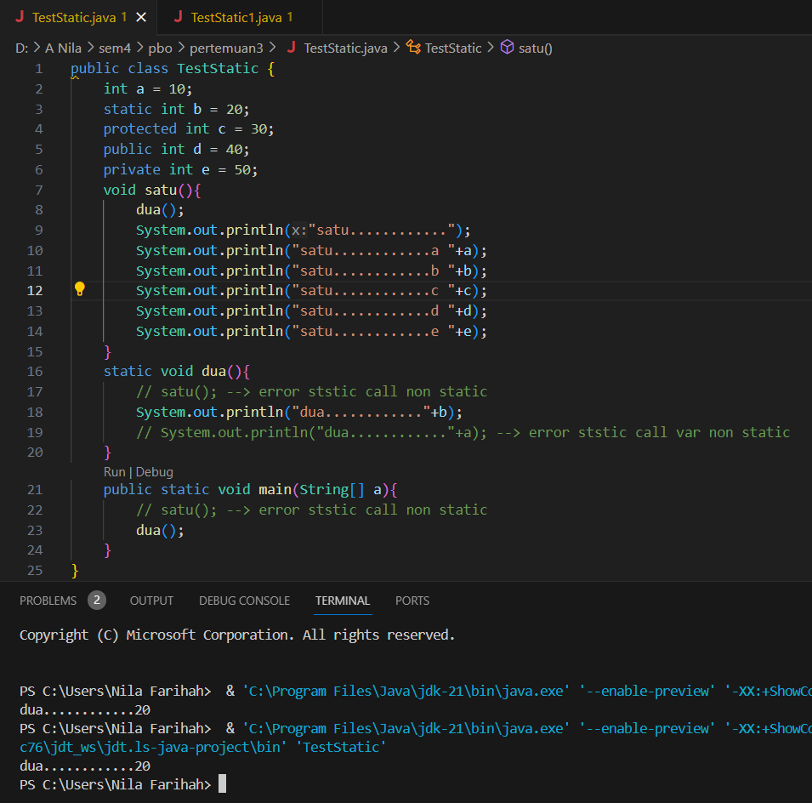

**Kode Program :**

**File “TestStatic.java”**

public class TestStatic {

    int a = 10;

    static int b = 20;

    protected int c = 30;

    public int d = 40;

    private int e = 50;

    void satu(){

        dua();

        System.out.println("satu............");

        System.out.println("satu............a "+a);

        System.out.println("satu............b "+b);

        System.out.println("satu............c "+c);

        System.out.println("satu............d "+d);

        System.out.println("satu............e "+e);

    }

    static void dua(){

        // satu(); --> error ststic call non static

        System.out.println("dua............"+b);

        // System.out.println("dua............"+a); --> error ststic call var non static

    }

    public static void main(String[] a){

        // satu(); --> error ststic call non static

        dua();

    }

}

**Hasil Program :**

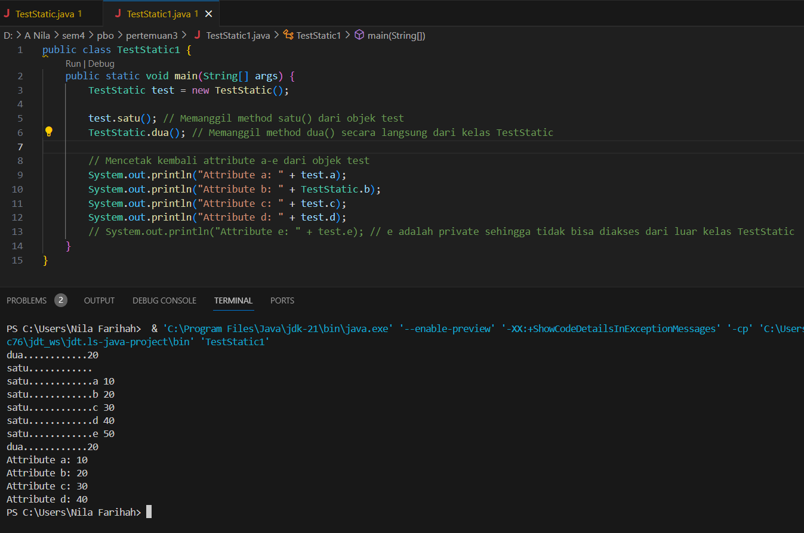

**Kode Program :**

**File “TestStatic1.java”**

public class TestStatic1 {

    public static void main(String[] args) {

        TestStatic test = new TestStatic();

        test.satu(); // Memanggil method satu() dari objek test

        TestStatic.dua(); // Memanggil method dua() secara langsung dari kelas TestStatic

        // Mencetak kembali attribute a-e dari objek test

        System.out.println("Attribute a: " + test.a);

        System.out.println("Attribute b: " + TestStatic.b);

        System.out.println("Attribute c: " + test.c);

        System.out.println("Attribute d: " + test.d);

        // System.out.println("Attribute e: " + test.e); // e adalah private sehingga tidak bisa diakses dari luar kelas TestStatic

    }

}