**Mata Kuliah : PBO – TI – S1**

**Pertemuan : 4**

**NIM : A11.2022.14667**

**Nama : Nila Farihah**

**Hasil Program Faktorial:**

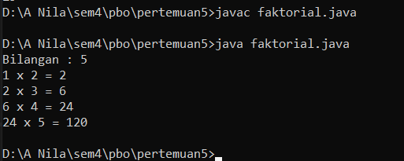

**Kode Program :**

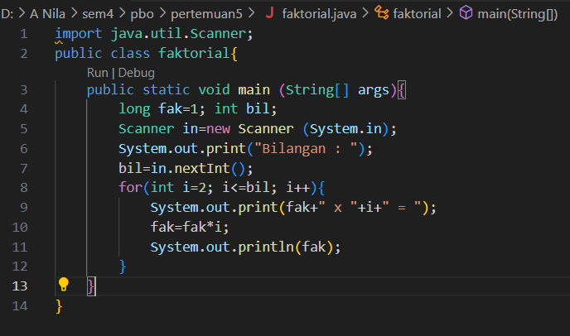

**File “faktorial.java”**

import java.util.Scanner;

public class faktorial{

    public static void main (String[] args){

        long fak=1; int bil;

        Scanner in=new Scanner (System.in);

        System.out.print("Bilangan : ");

        bil=in.nextInt();

        for(int i=2; i<=bil; i++){

            System.out.print(fak+" x "+i+" = ");

            fak=fak*i;

            System.out.println(fak);

        }

    }

}

**Hasil Program pecah :**

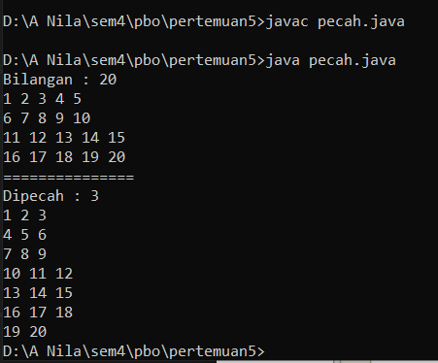

**Kode Program :**

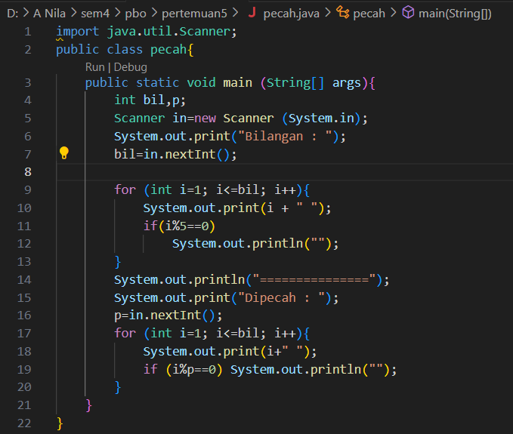

**File “pecah.java”**

import java.util.Scanner;

public class pecah{

    public static void main (String[] args){

        int bil,p;

        Scanner in=new Scanner (System.in);

        System.out.print("Bilangan : ");

        bil=in.nextInt();

        for (int i=1; i<=bil; i++){

            System.out.print(i + " ");

            if(i%5==0)

                System.out.println("");

        }

        System.out.println("===============");

        System.out.print("Dipecah : ");

        p=in.nextInt();

        for (int i=1; i<=bil; i++){

            System.out.print(i+" ");

            if (i%p==0) System.out.println("");

        }

    }

}

**Hasil Program SinggleArray :**

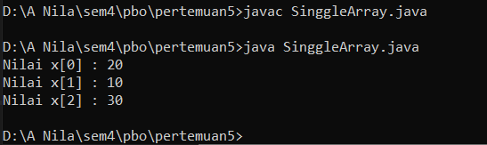

**Kode Program :**

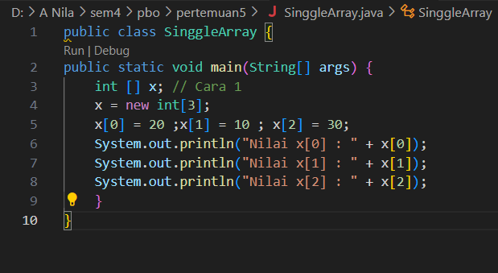

**File “SinggelArray.java”**

public class SinggleArray {

public static void main(String[] args) {

    int [] x; // Cara 1

    x = new int[3];

    x[0] = 20 ;x[1] = 10 ; x[2] = 30;

    System.out.println("Nilai x[0] : " + x[0]);

    System.out.println("Nilai x[1] : " + x[1]);

    System.out.println("Nilai x[2] : " + x[2]);

    }

}

**Hasil Program MatrixExample :**

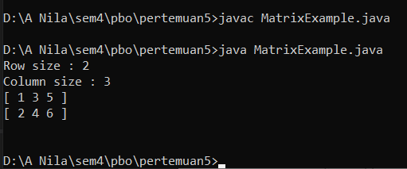

**Kode Program :**

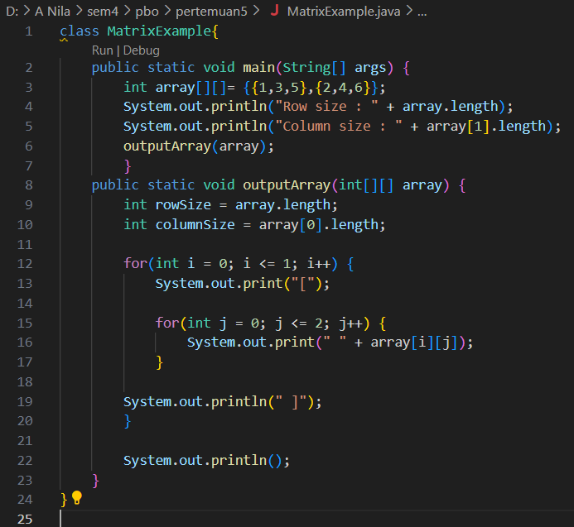

**Latihan 1**

**Hasil Program Array1 :**

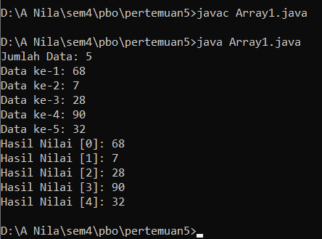

**Kode Program :**

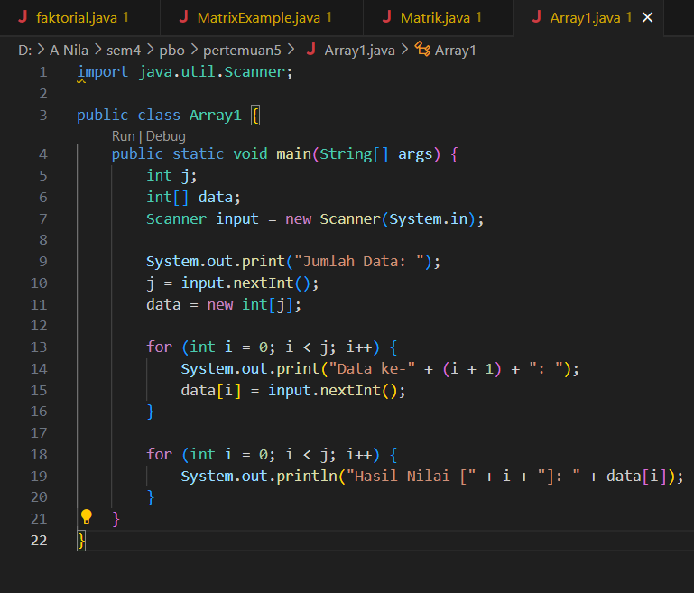

**File “Array1.java”**

import java.util.Scanner;

public class Array1 {

    public static void main(String[] args) {

        int j;

        int[] data;

        Scanner input = new Scanner(System.in);

        System.out.print("Jumlah Data: ");

        j = input.nextInt();

        data = new int[j];

        for (int i = 0; i < j; i++) {

            System.out.print("Data ke-" + (i + 1) + ": ");

            data[i] = input.nextInt();

        }

        for (int i = 0; i < j; i++) {

            System.out.println("Hasil Nilai [" + i + "]: " + data[i]);

        }

    }

}