**Mata Kuliah : PBO – TI – S1**

**Pertemuan : 9**

**NIM : A11.2022.14667**

**Nama : Nila Farihah**

**Latihan 1**

**Hasil Program :**

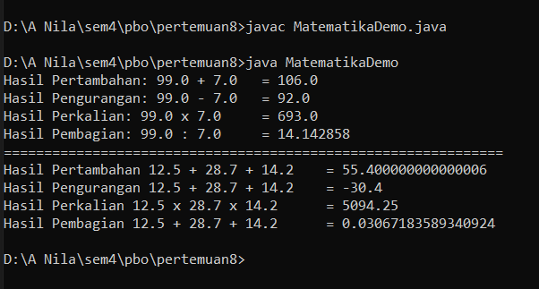

**Kode Program :**

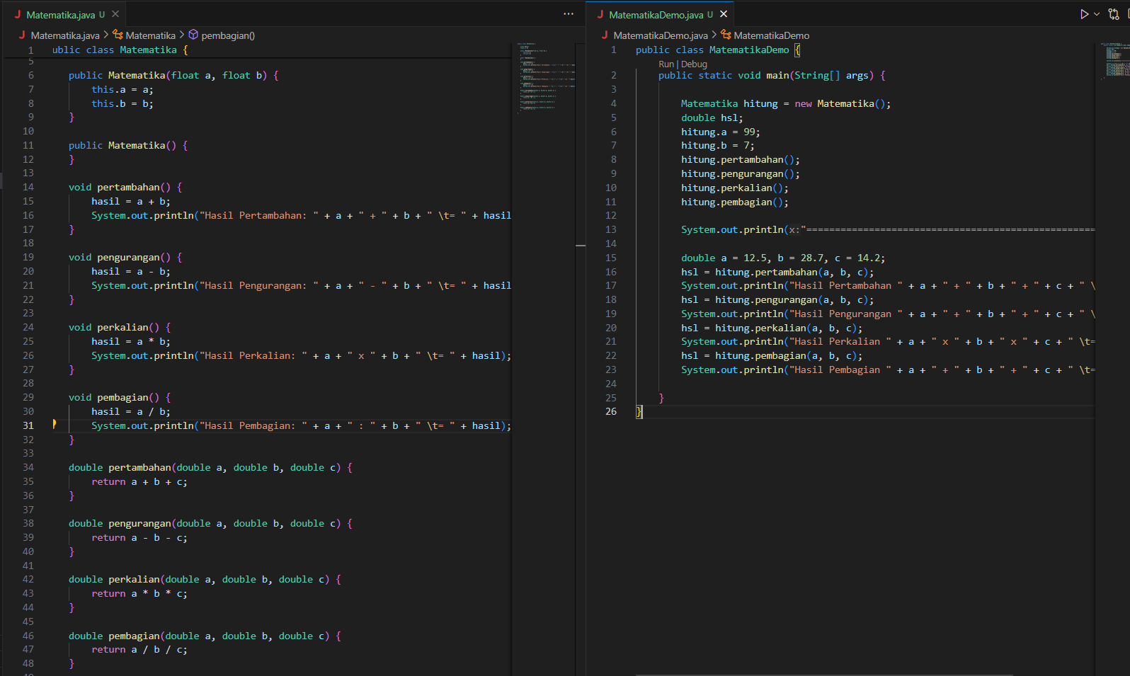

**File coding “Matematika.java”**

public class Matematika {

    float hasil;

**File coding “Matematika.java”**

public class Matematika {

    float hasil;

**File coding “Matematika.java”**

public class Matematika {

    float hasil;