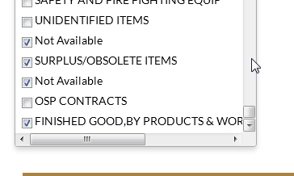
Other/MSME


Remove

For category of item



ISO Yes/No

Other Add

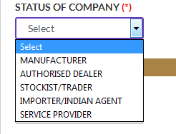
All heading are same

