Chapter 1 Introduction

Introduction
The Smart Online Exam Monitoring System is a web-based application developed to conduct online examinations in a secure, fair, and controlled environment. The main purpose of this system is to reduce cheating and ensure discipline during online exams. The system continuously monitors students using a webcam and tracks browser activities such as tab switching and window minimizing. By doing this, it helps maintain honesty and reliability in online examinations.
With the rapid growth of online education, especially after the adoption of remote learning, online examinations have become very common. Although online exams are convenient and flexible, they face many challenges related to supervision and security. Traditional online exam systems do not provide proper monitoring, which makes it easier for students to cheat. This project is designed to overcome these challenges by providing an automated monitoring system that works in real time.
This chapter provides an overview of the project and explains the background of the study, aim and objectives, scope, problem statement, relevance, importance, and key terms related to the project.

Background of the Study
In recent years, online education has increased significantly due to advancements in technology and the need for remote learning. Educational institutions such as schools, colleges, universities, and training centers are now using online platforms to conduct classes and examinations. While online exams save time and resources, they also introduce serious issues related to exam security and fairness.
In traditional classroom exams, invigilators can physically monitor students to prevent cheating. However, in online exams, such supervision is not possible. Students can misuse this situation by looking away from the screen, opening other browser tabs to search for answers, using mobile phones, or even allowing another person to take the exam on their behalf. These practices reduce the trustworthiness of online exams and affect the quality of education.

Many existing online exam systems focus only on delivering questions and collecting answers. They do not monitor student behavior effectively. Some systems use human proctors, but this method is expensive, time-consuming, and not scalable. To solve these issues, the Smart Online Exam Monitoring System was developed. This project focuses on monitoring students in real time using a webcam and browser activity tracking to ensure that exams are conducted in a fair and honest manner.

Aim and Objectives of the Project
Aim
The main aim of this project is to design and develop a secure, automated, and reliable online examination system that monitors students in real time and helps prevent cheating during online examinations.
Objectives

- The specific objectives of this project are:
- To verify the identity of the student using face detection before the exam begins
- To monitor students continuously using a webcam throughout the examination
- To detect face absence, head movement, and other suspicious actions during the exam
- To track browser activities such as tab switching and window minimizing
- To generate automatic warnings when the student violates exam rules
- To automatically submit or terminate the exam after repeated violations
- To reduce dependency on human invigilators and manual supervision
- These objectives together help in maintaining discipline and fairness during online exams.

Scope of the Study
The scope of this project is limited to conducting and monitoring online examinations through a web-based platform. The system focuses on monitoring student behavior using webcam input and browser activity tracking. It includes features such as face detection, head movement detection, tab switching detection, and automatic warning generation.
The system is designed for use in educational institutions such as schools, colleges, universities, and training institutes that conduct online exams. It is suitable for remote examinations where physical supervision is not possible.
This project does not include offline examinations, physical examination centers, or manual invigilation. It also does not cover advanced biometric verification or mobile-based examination systems.

Statement of the Problem
One of the major challenges in online examinations is the lack of proper monitoring and supervision. Without physical invigilators, it becomes difficult to ensure that students follow exam rules. Students may cheat by looking away from the screen, switching tabs to search for answers, using unauthorized devices, or receiving help from others.
There is also no reliable way to confirm whether the student attempting the exam is the same person who registered for it. These problems reduce the credibility and reliability of online examination systems. Educational institutions face difficulty in trusting online exam results.
This project addresses these issues by providing an automated monitoring system that uses webcam-based face detection and browser activity tracking to monitor students continuously during the exam.

Relevance and Importance of the Project
The Smart Online Exam Monitoring System is highly relevant in the current educational environment, where online learning and remote assessments are widely used. This project helps maintain fairness, honesty, and discipline in online examinations.
By automating the monitoring process, the system reduces the need for human invigilators, which helps save time and cost. It also reduces human errors and ensures consistent monitoring throughout the exam. The system improves the reliability and credibility of online exam results.
This project can be used by educational institutions to conduct secure online exams and build trust in online assessment methods. It also supports the digital transformation of education.

Key Terms and Abbreviations
- Online Exam – An examination conducted using the internet
- Webcam Monitoring – Using a webcam to observe student behavior during an exam
- Face Detection – Identifying whether the student’s face is present in front of the camera
- Head Movement Detection – Monitoring head direction to detect suspicious behavior
- Tab Switching – Changing browser tabs or minimizing the exam window during an exam
- Flask – A Python-based web framework used to develop the backend of the system
- SQLite – A lightweight database used to store exam data, logs, and results
- MediaPipe – A library used for face detection and head movement tracking

Chapter 2 System Analysis

System Analysis

Requirement Gathering
The requirements for the Smart Online Exam Monitoring System were gathered by studying current online examination methods like google form, zoom etc and identifying their limitations. Discussions were also held regarding common problems faced during online exams, such as cheating, lack of monitoring, and difficulty in managing exams.

The requirements were collected by focusing on two main users of the system: students and admin.

Student Requirements
- Students should be able to register and log in securely.
- Students should be verified using a webcam before starting the exam.
- Students should be monitored continuously during the exam.
- The system should detect activities like face absence, looking away, and tab switching etc.
- Students should receive warnings when rules are violated.
- The exam should be automatically submitted if violations exceed the allowed limit

Admin Requirements
- Admin should be able to upload exam questions using Excel files
- Admin should be able to create, schedule, and manage exams
- Admin should be able to view student activity logs and violations
- Admin should be able to view and export exam results

System Requirements
- Real-time webcam access and monitoring
- Browser activity tracking during the exam
- Secure storage of exam data and student information
- These requirements formed the foundation for designing and developing the system.

Feasibility Study
    - Technical Feasibility
The project is technically feasible because it uses technologies that are already available and widely used. The backend is developed using Python Flask, which is suitable for web applications. The frontend uses HTML, CSS, and JavaScript for user interaction. Webcam monitoring is implemented using MediaPipe, which supports real-time face and head movement detection.

The database used is SQLite, which is lightweight and easy to manage. All tools and libraries used in the project are open-source, making development technically possible without any difficulty.

    - Financial Feasibility
The project is financially feasible because it does not require expensive hardware or licensed software. The system can run on a standard computer with a webcam and internet connection. Since open-source tools and frameworks are used, there is no additional software cost involved.

This makes the system affordable for educational institutions and suitable for academic implementation.

    - Operational Feasibility
The system is operationally feasible as it is easy to use for both students and admin. Students only need basic computer knowledge to attend exams. Admin can manage exams through a simple dashboard without technical expertise.

The system works automatically once the exam starts, reducing manual supervision and making it suitable for real-world use.

Proposed System Overview
The proposed system is a Smart Online Exam Monitoring System designed to conduct and monitor online exams securely. The system starts with student registration and login. Before the exam begins, face dictation is performed using the webcam to confirm the student’s identity.

During the exam, the webcam continuously monitors the student, and browser activities such as tab switching are tracked. If the system detects any suspicious activity like face absence, head movement, or tab switching, it generates warnings. After 3 warnings, the exam is automatically submitted or terminated.

The admin manages the system by uploading questions through Excel files, scheduling exams, and monitoring student activity logs and results. The system fulfills all gathered requirements by providing automation, security, and ease of use.

Functional and Non-Functional Requirements
    - Functional Requirements

The functional requirements of the Smart Online Exam Monitoring System are:
      - Student registration and login
      - Admin login and dashboard access
      - Face dictation after starting the exam
      - Real-time webcam monitoring during the exam
      - Detection of face absence and head movement
      - Detection of tab switching and window minimizing
      - Automatic warning generation
      - Automatic exam submission or termination
      - Uploading and managing questions by admin
      - Viewing exam results and student activity logs

    - Non-Functional Requirements

The non-functional requirements of the system are:
      - The system should respond in real time without delay
      - The system should run continuously during the exam without crashing
      - The system should be easy to understand and use
      - Student and exam data should be stored securely
      - The system should support multiple users at the same time
      - The system should work on commonly used web browsers

Chapter 3 Specific Requirements

Specific Requirements

System Architecture Diagram:
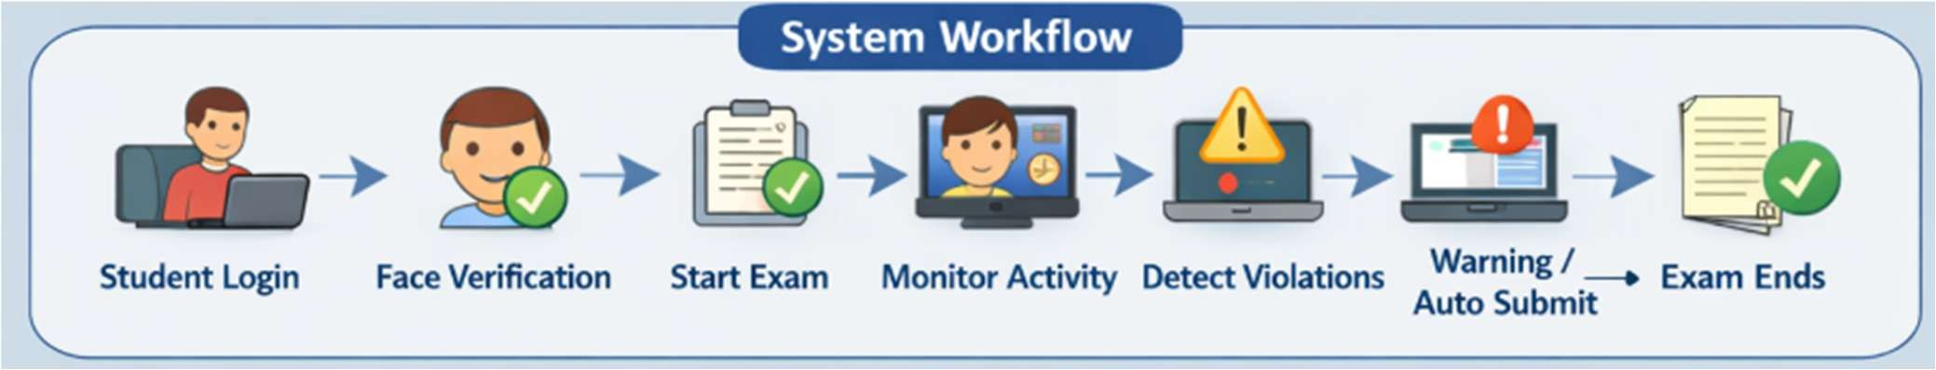
Figure:3.1 System Architecture Diagram

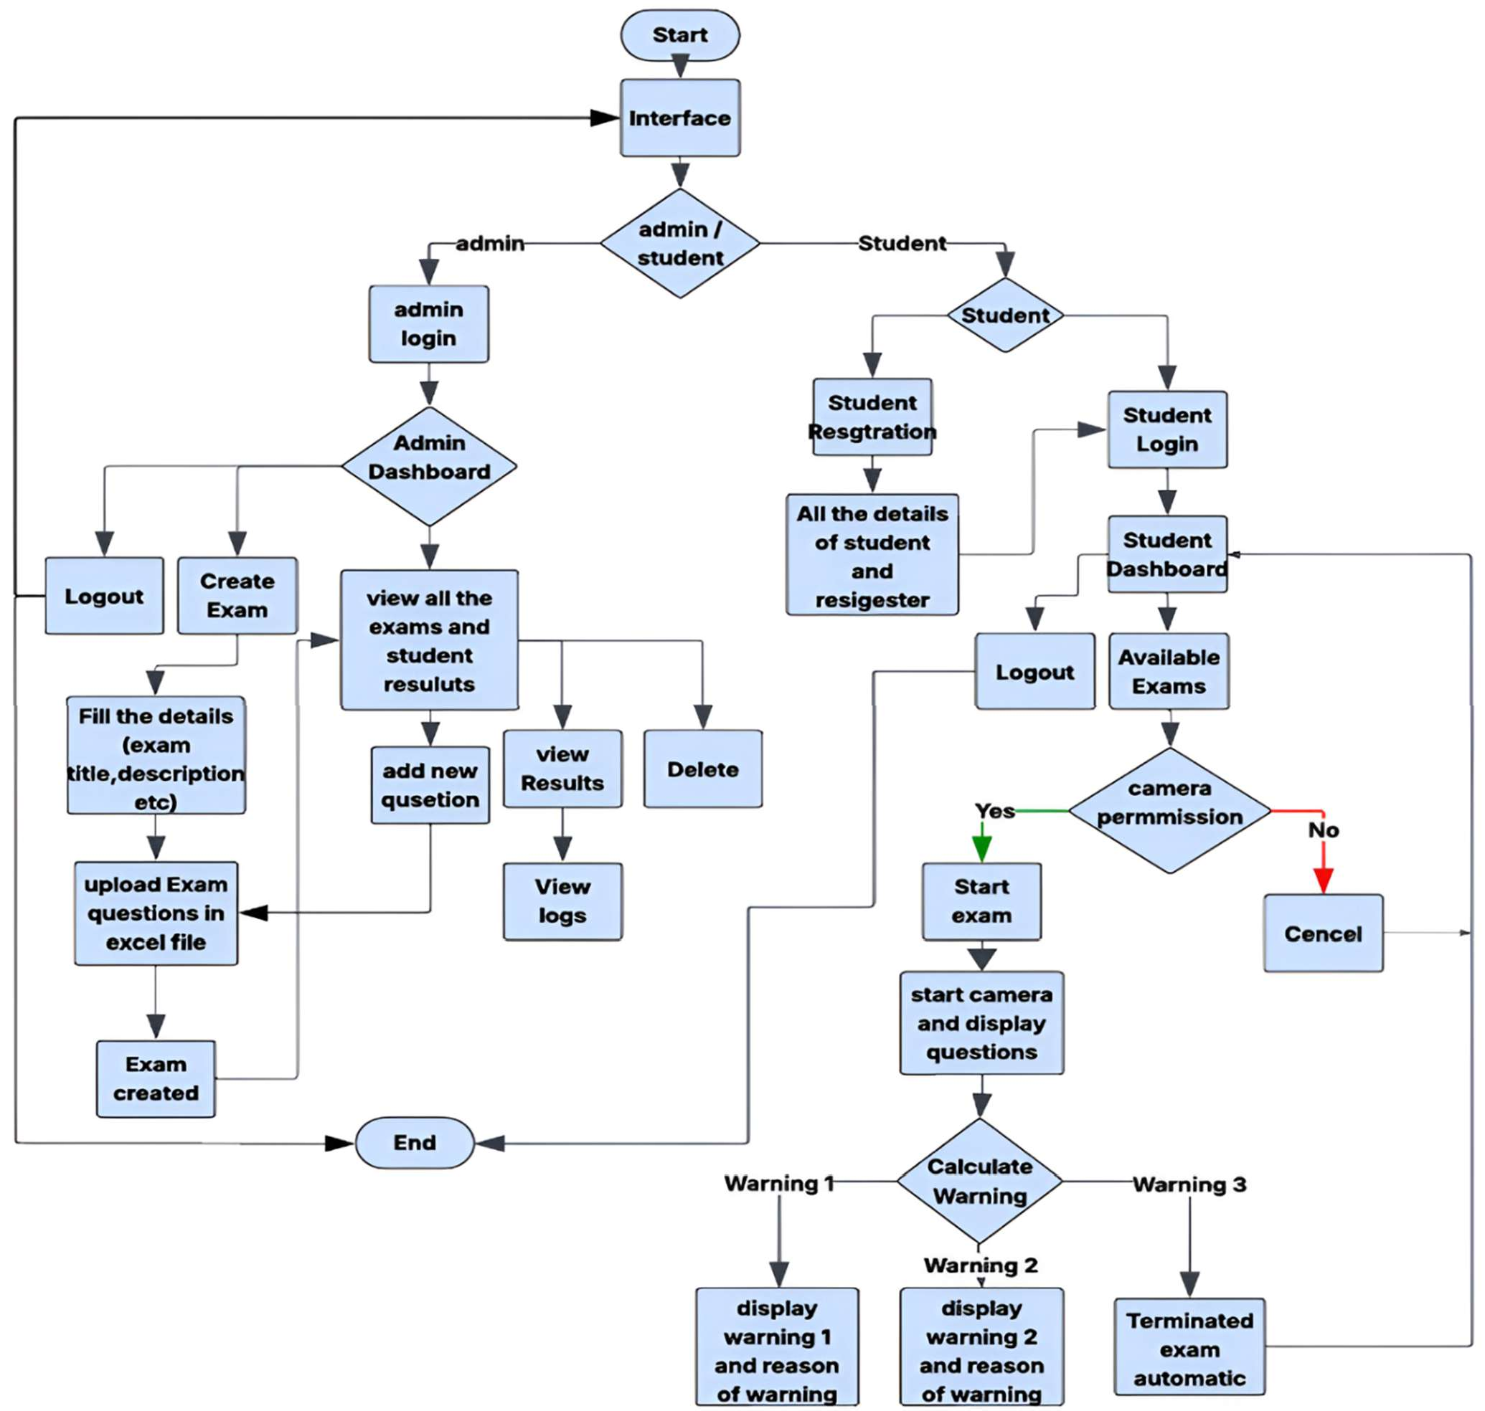
Flow Chart
Figure:3.1.1 Flow Chart

    - ER Diagram
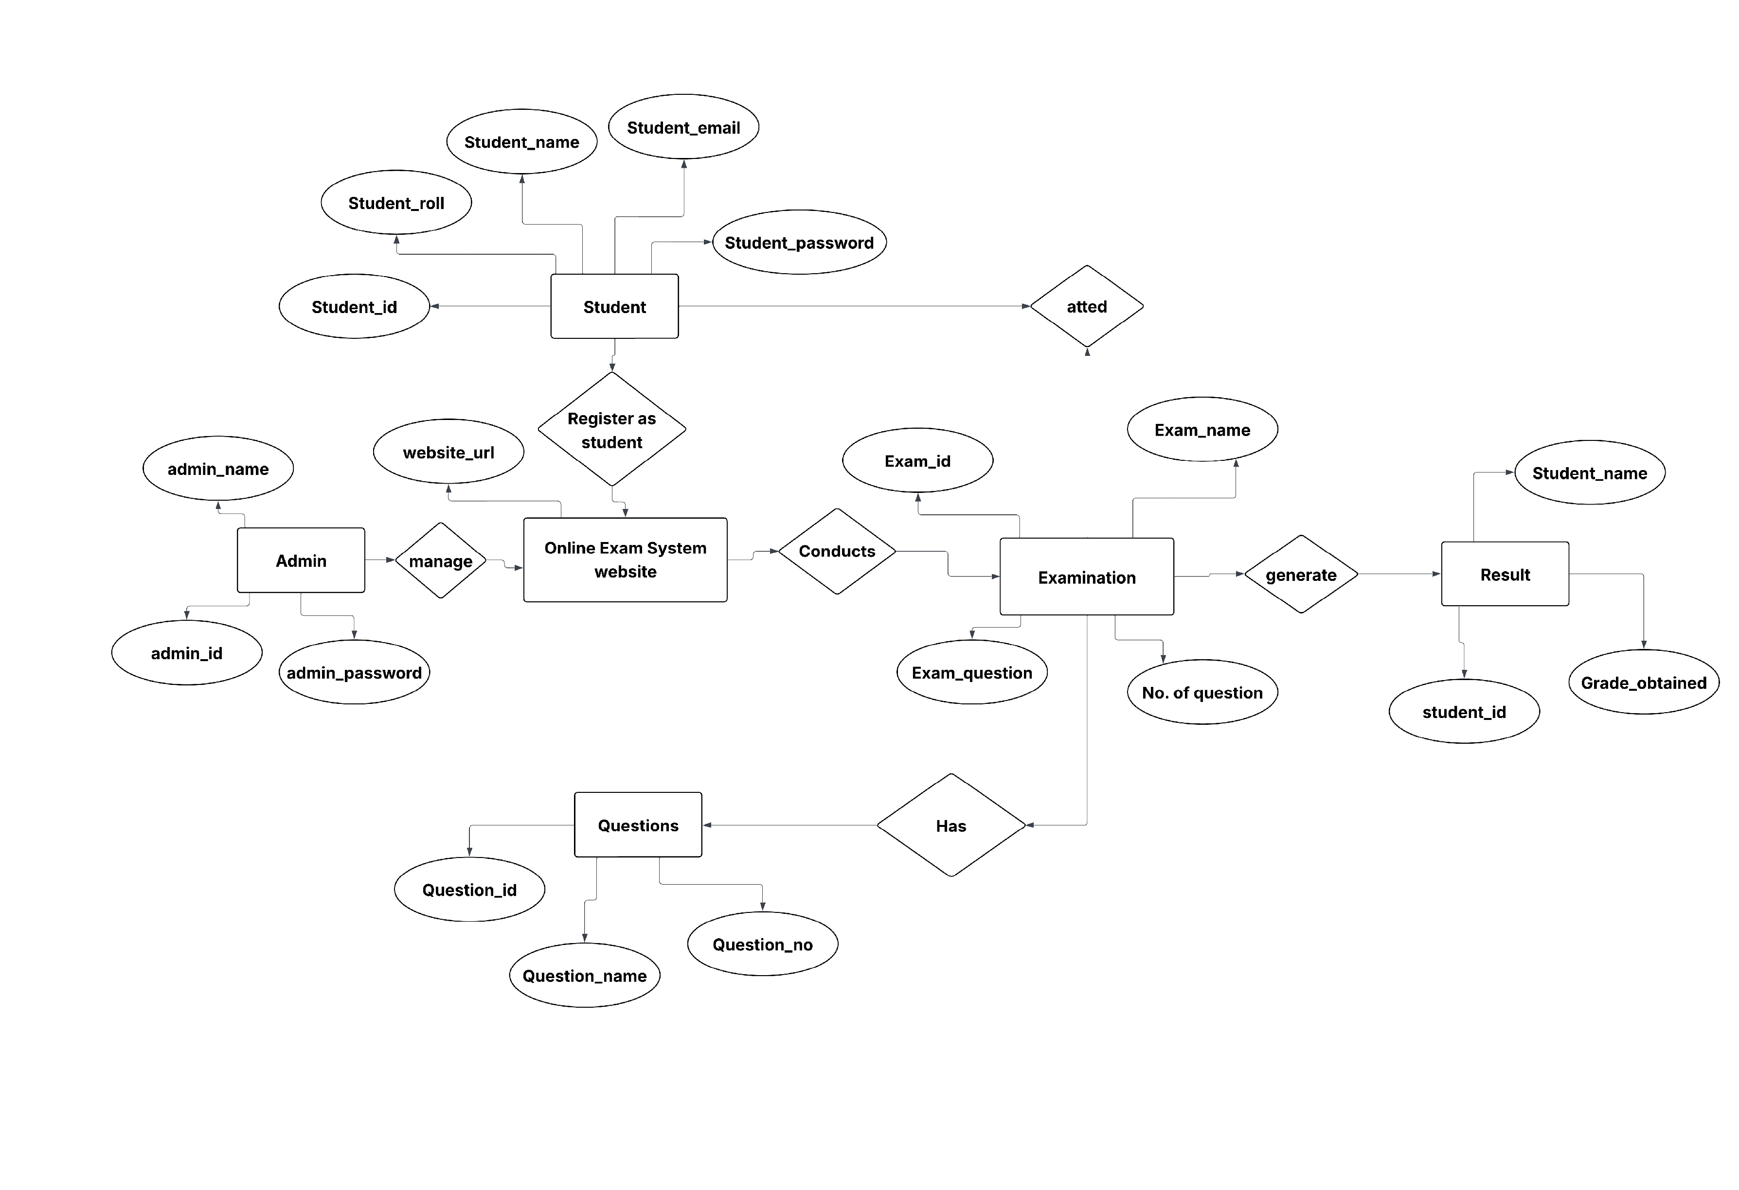
Figure:3.1.2 ER Diagram
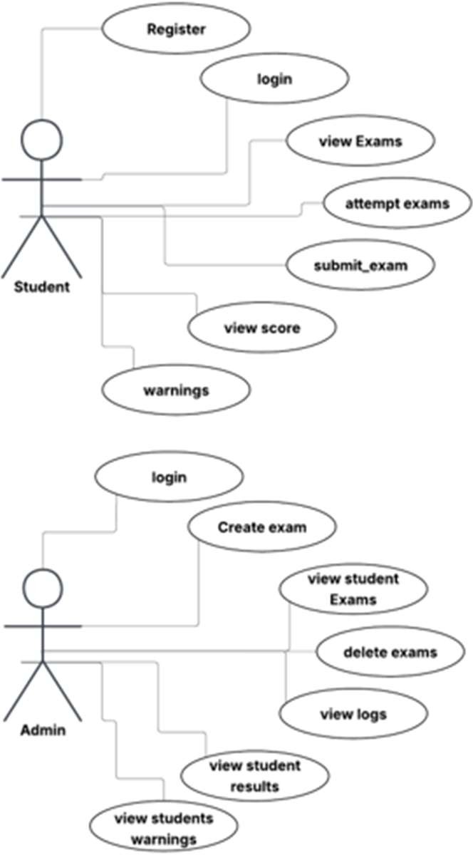
    - Use-Case

Figure 3.1.3 Use-Case

3.1.5 DFD Diagram
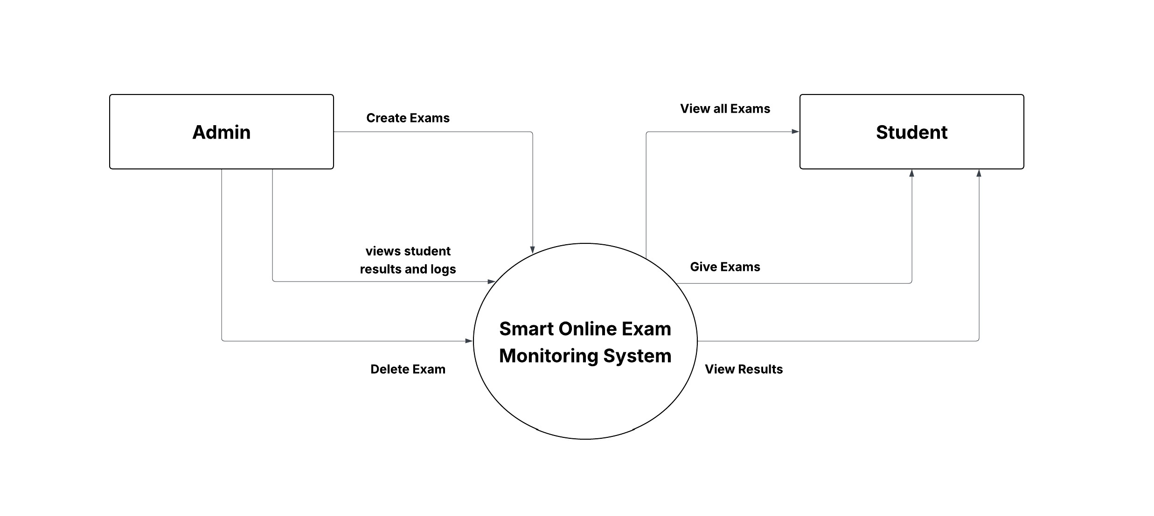
Figure 3.1.5 DFD Diagram

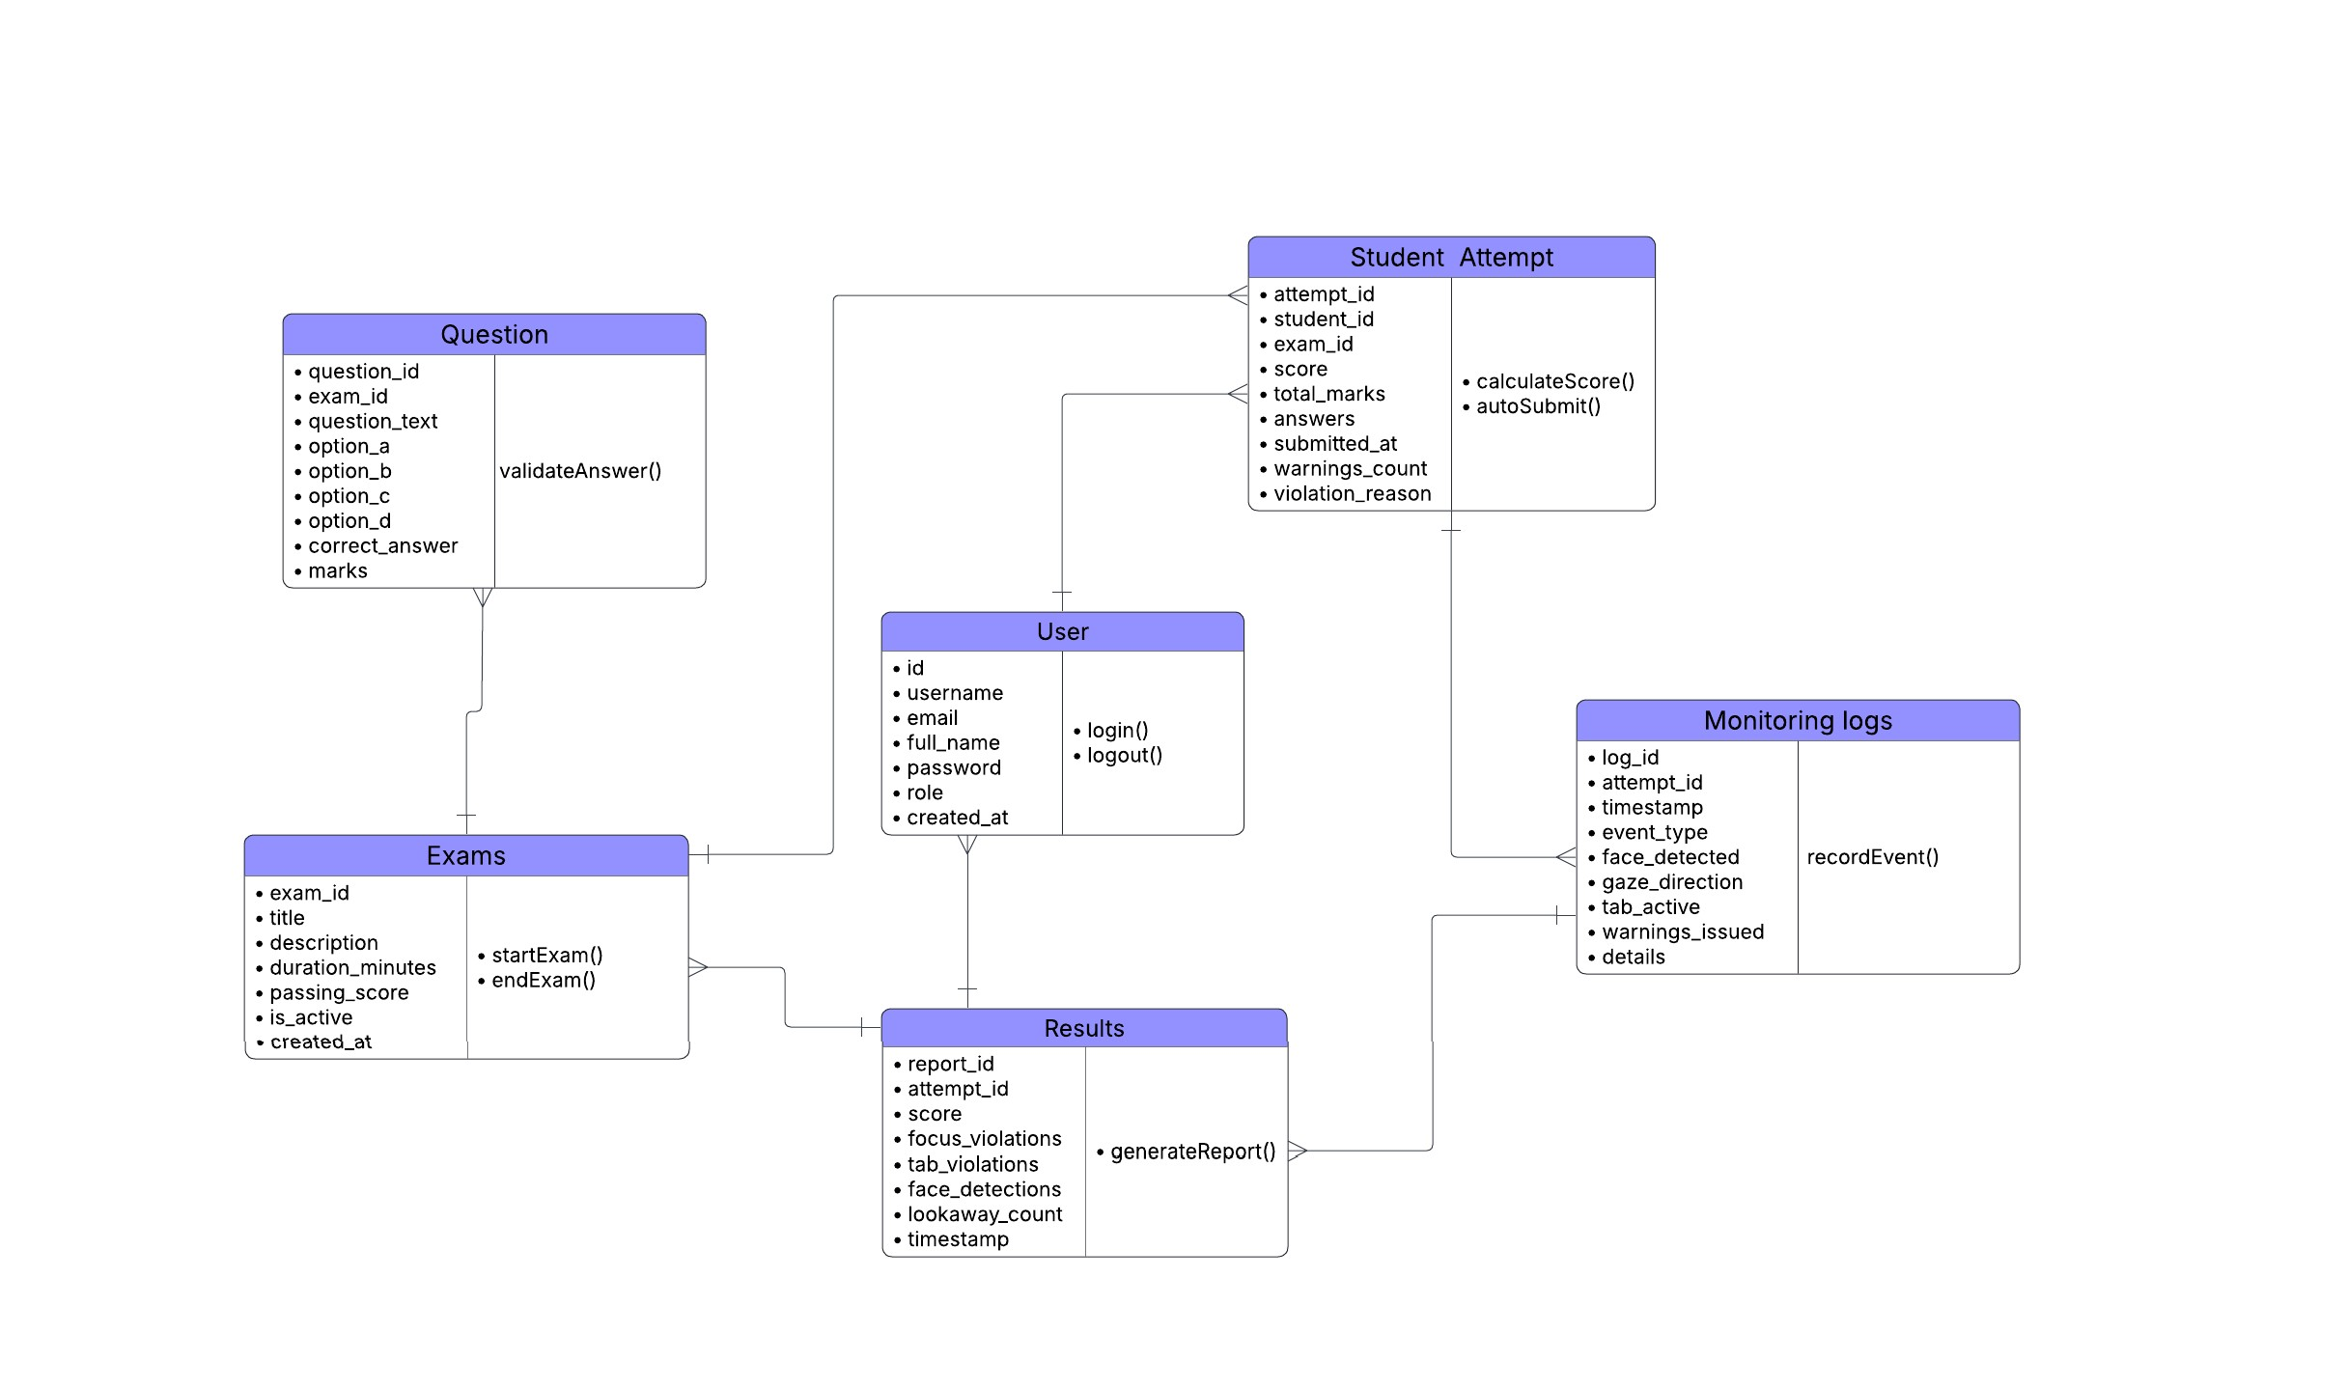
    - Class diagram

Figure 3.1.6 Class diagram

    - Activity Diagram
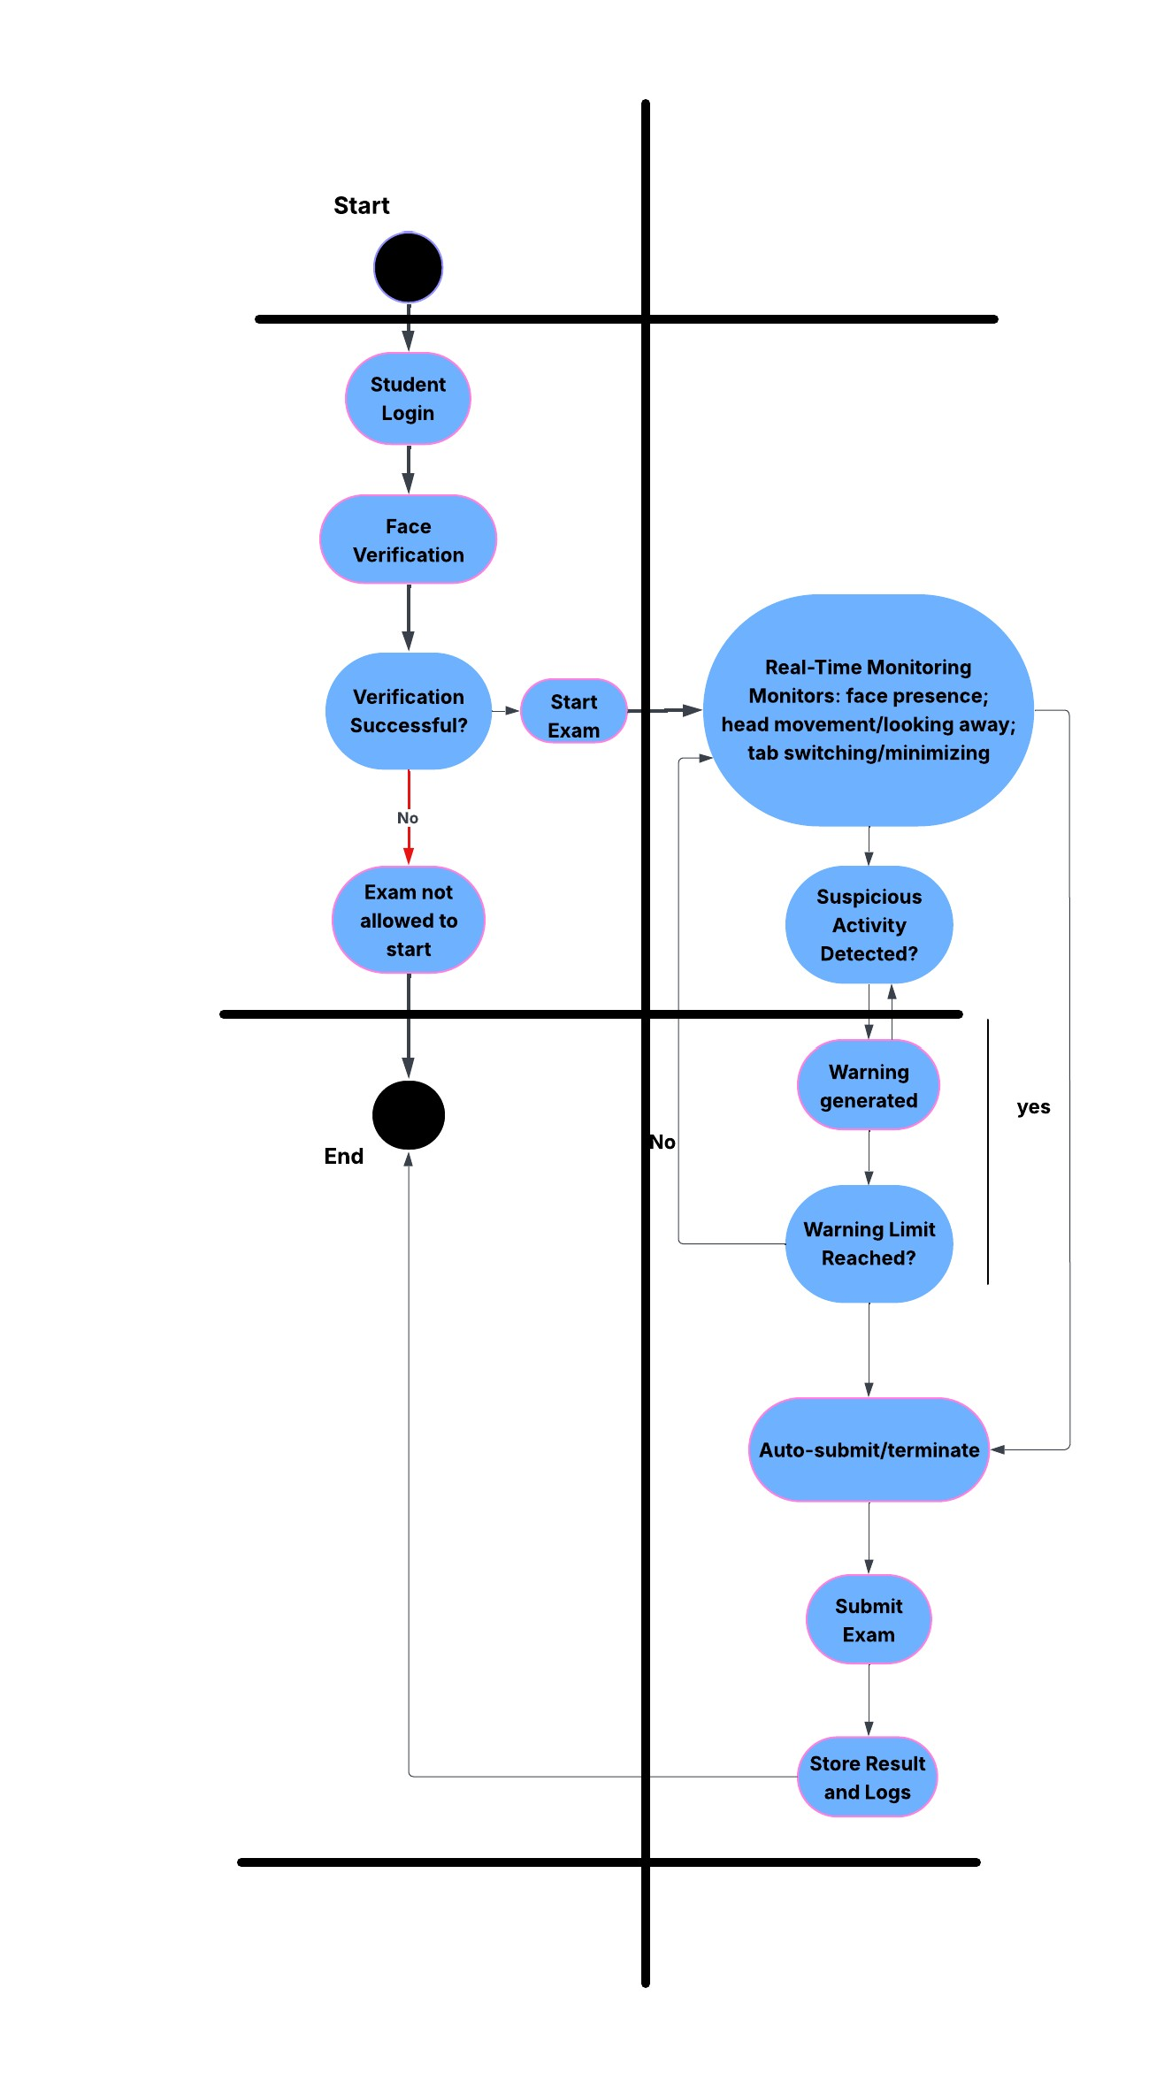

Figure 3.1.7 Activity Diagram

  - Hardware Design and Components Used
This System does not require complex hardware. The required hardware components are:

- Computer or Laptop
- Webcam (built-in or external)
- Internet connection
The webcam is used to capture live video of the student during the exam. No additional sensors or controllers are required, making the system simple and cost-effective.

Software Design and Modules
The software is divided into different modules, each responsible for specific tasks.
Student Module
- Registration and login
- Face verification
- Exam interface
- Real-time monitoring
- Auto submission

Admin Module
- Login and dashboard
- Upload questions via Excel
- Create and schedule exams
- View logs and results

Monitoring Module
- Webcam access
- Face detection
- Head movement detection
- Tab switching detection

Database Module
- Store users, exams, questions
- Store logs and results
- All modules work together to ensure smooth and secure exam execution.

Database Design
The system uses an SQLite database to store information. The database includes tables such as:
- Student
- Admin
- Exam
- Questions
- Exam Logs
- Results
Each table is connected using unique IDs to maintain relationships. This design ensures proper data storage and retrieval.

Flowcharts and Algorithms
- User login
- Face dictation
- Monitoring loop
- Warning count handling
- Auto submission of exam

Chapter 4 Implementation

Implementation

Programming Languages and Development Tools
The Smart Online Exam Monitoring System is developed using modern web technologies that are easy to use, reliable, and suitable for real-time applications.

Programming Languages Used
Python: Python is used for backend development. It handles user authentication, exam logic, monitoring control, and database operations.

HTML: HTML is used to design the structure of web pages such as login page, exam page, and admin dashboard.

CSS: CSS is used to style the web pages and make the interface user-friendly.

JavaScript: JavaScript is used for frontend logic, webcam access, real-time monitoring, and detecting tab switching.

Development Tools and Libraries
- Flask – Used as the backend web framework
- SQLite – Used as the database
- MediaPipe – Used for face and head movement detection
- openpyxl – Used to read and upload questions from Excel files
- VS Code – Used as the development environment
- Web Browser – Used to test and run the application

Hardware and Software Integration
The system integrates hardware and software components to work together smoothly.
The webcam acts as the main hardware component. It captures live video of the student during the exam. This video data is accessed using JavaScript on the frontend and processed using MediaPipe for face and head movement detection.

The browser sends monitoring data such as tab switching events and webcam status to the backend server. The Flask backend processes this data and applies rules such as warning generation and auto submission.

The SQLite database stores all important information including users, exams, answers, monitoring logs, and results. This integration ensures real-time monitoring and secure data storage.

Key Code Snippets and Explanations
User Login (Flask Backend) @app.route('/login', methods=['POST']) def login():
username = request.form['username'] password = request.form['password']
user = User.query.filter_by(username=username).first()

if user and check_password_hash(user.password, password): session['user_id'] = user.id
session['role'] = user.role return redirect('/dashboard')

else:
return "Invalid Login"
Explanation:
This code verifies user login credentials. If the username and password are correct, the user is redirected to the dashboard based on their role.

Webcam Face Detection (JavaScript + MediaPipe) if (results.multiFaceLandmarks.length === 0) { warningCount++;
sendWarning("Face Not Detected");
}
Explanation:
This code checks whether a face is detected using the webcam. If no face is found, a warning is generated and sent to the backend.

Tab Switching Detection document.addEventListener("visibilitychange", function () { if (document.hidden) {
sendWarning("Tab Switch Detected");}
});
Explanation:
This code detects when the student switches tabs or minimizes the browser window during the exam.
Automatic Exam Submission
if warnings_count >= MAX_WARNINGS: submit_exam(attempt_id)
Explanation:
If the student exceeds the allowed number of warnings, the system automatically submits or terminates the exam.

    - Challenges Encountered and Solutions:

Table 1.1: Challenges Encountered and Solutions:
Problem Faced | How I Solved It
Face not detected properly during the exam | Improved camera positioning and lighting conditions
Tab switching not detected properly | Improved JavaScript event handling and tested on different browsers
Automatic warning count increased even after exam submission | Fixed logic to stop monitoring once the exam is submitted
Webcam permission issues | Helped by Chirag Visani sir
Performance issues during real-time monitoring | Optimized code to reduce processing load

Chapter 5 Results and Discussion

Results and Discussion

Overview of Results
After successful implementation, the Smart Online Exam Monitoring System worked as expected. The system was able to conduct online exams securely while monitoring students in real time. Students were able to log in, verify their identity using a webcam, attend exams, and submit answers successfully.
The monitoring module detected activities such as face absence, head movement, and tab switching. Automatic warnings were generated whenever exam rules were violated. When the warning limit was exceeded, the system automatically submitted or terminated the exam. Admin users were able to upload questions, schedule exams, view student activity logs, and check exam results.

Comparison with Expected Outcomes
The initial objective of the project was to develop a secure and automated online exam system with real-time monitoring. The actual results closely matched the expected outcomes

Table 1.2: Complarision with Expected Outcomes:
Feature | Description | Status
User Registration & Login | Secure login for admin and students | Completed
Admin Exam Creation | Create and schedule exams | Completed
Question Upload | Upload Excel files | Completed
MCQ Extraction | Automatic question extraction | Completed
Student Exam Interface | Exam page with timer | Completed
Face detection | Face check before exam | Completed
Webcam Monitoring | Face presence & head movement detection | Completed
Tab Switch Detection | Detect browser tab switching | Completed
Warning System | Auto warnings for violations | Completed
Auto Exam Submission | Auto-submit after violations | Completed

Performance Analysis
The performance of the system was analyzed based on speed, accuracy, and stability.
Speed:The system responded quickly during login, exam loading, and submission. Monitoring actions were processed in near real time.
Accuracy:Face detection and tab switching detection worked accurately in most cases. Head movement detection was effective, although minor movements sometimes triggered warnings.
SystemStability:The system remained stable throughout the exam duration without crashes. Data was stored correctly in the database.

Limitations of the Project
- The system depends heavily on webcam quality and lighting conditions
- Minor head movements may cause false warnings
- Internet connectivity issues can affect real-time monitoring
- The system is designed mainly for desktop or laptop browsers
- Advanced AI-based behavior analysis is not included
- These limitations can be improved in future versions of the system.

Discussion on Findings
The results of the project show that automated online exam monitoring is possible using simple and lightweight technologies. Webcam-based monitoring and browser activity tracking proved effective in reducing cheating.
Face detection and tab switching detection worked well and helped maintain exam discipline. Automatic warnings and exam termination reduced the need for human supervision. However, sensitivity tuning is required to avoid false warnings due to small movements.
The project successfully demonstrated that a cost-effective and automated system can improve the reliability of online examinations. With further improvements, the system can be made more accurate and scalable for real-world use.
Outputs:
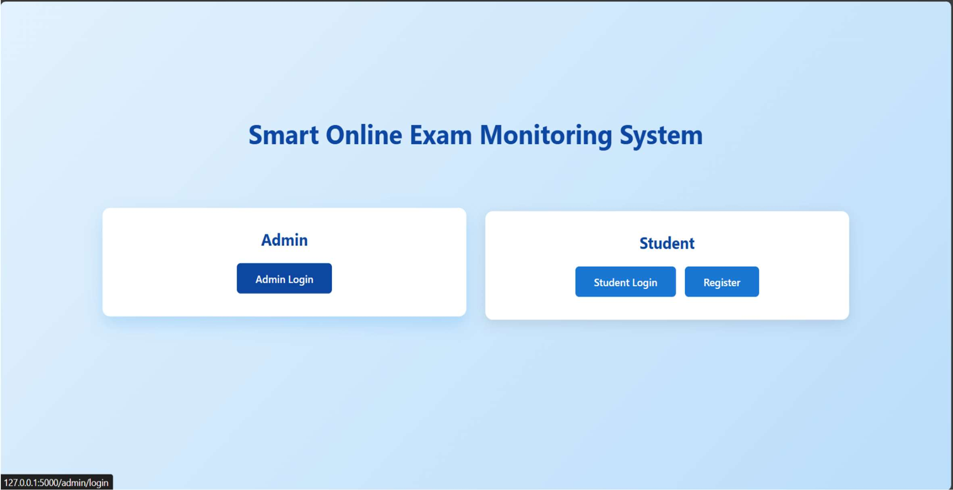
Figure 3.1.8 Main Screen

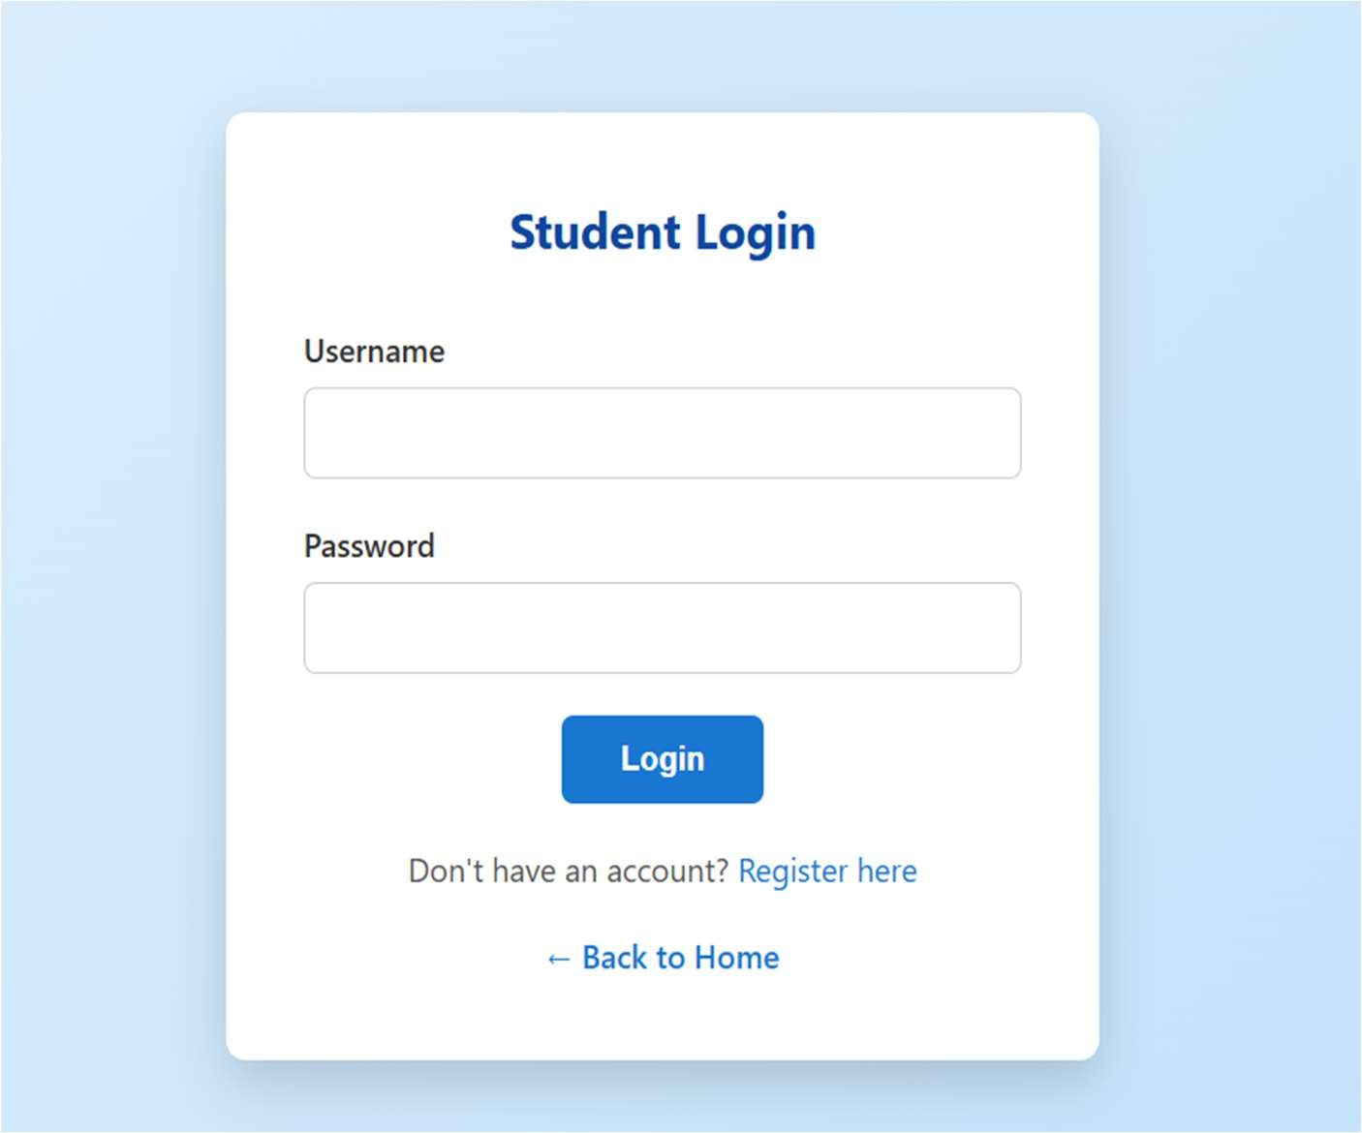

Figure 3.1.9 Student Login
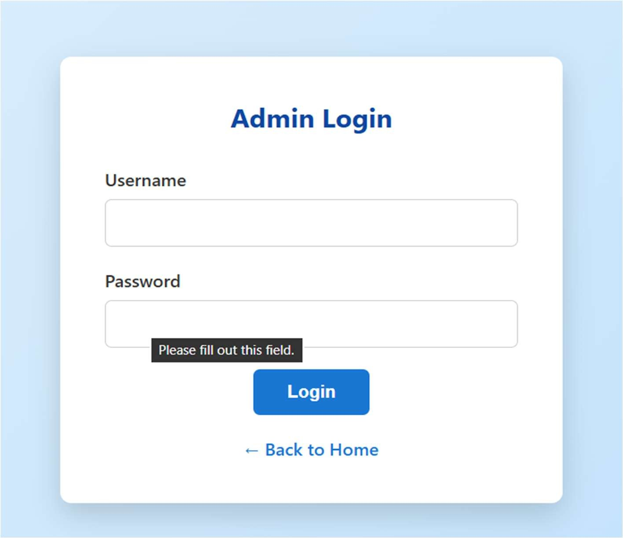
Figure 3.2 Admin Login

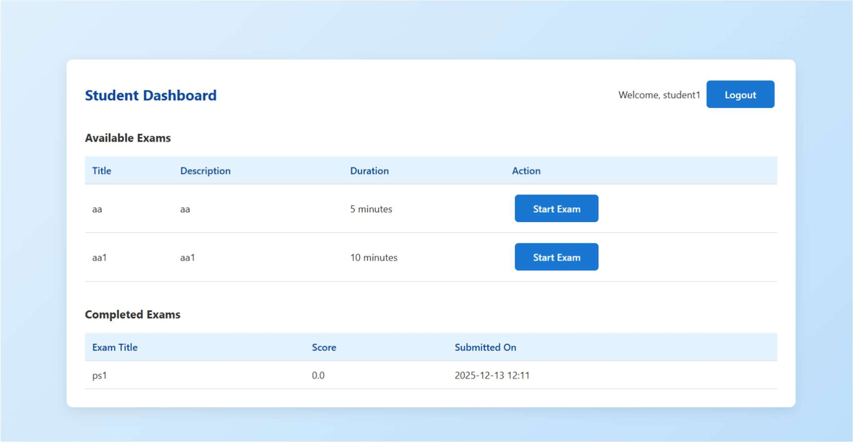
Figure 3.2.1 Student Dashboard

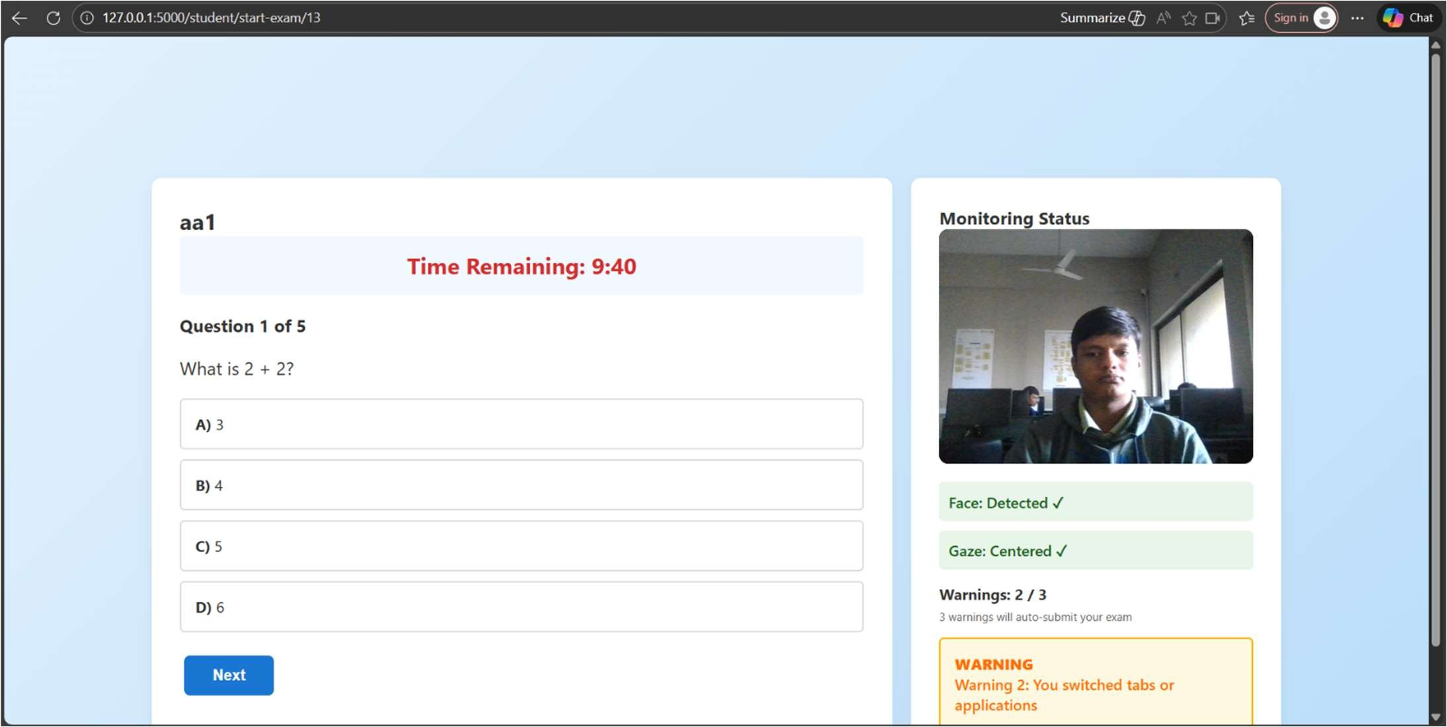
Figure 3.2.2 Live exam view

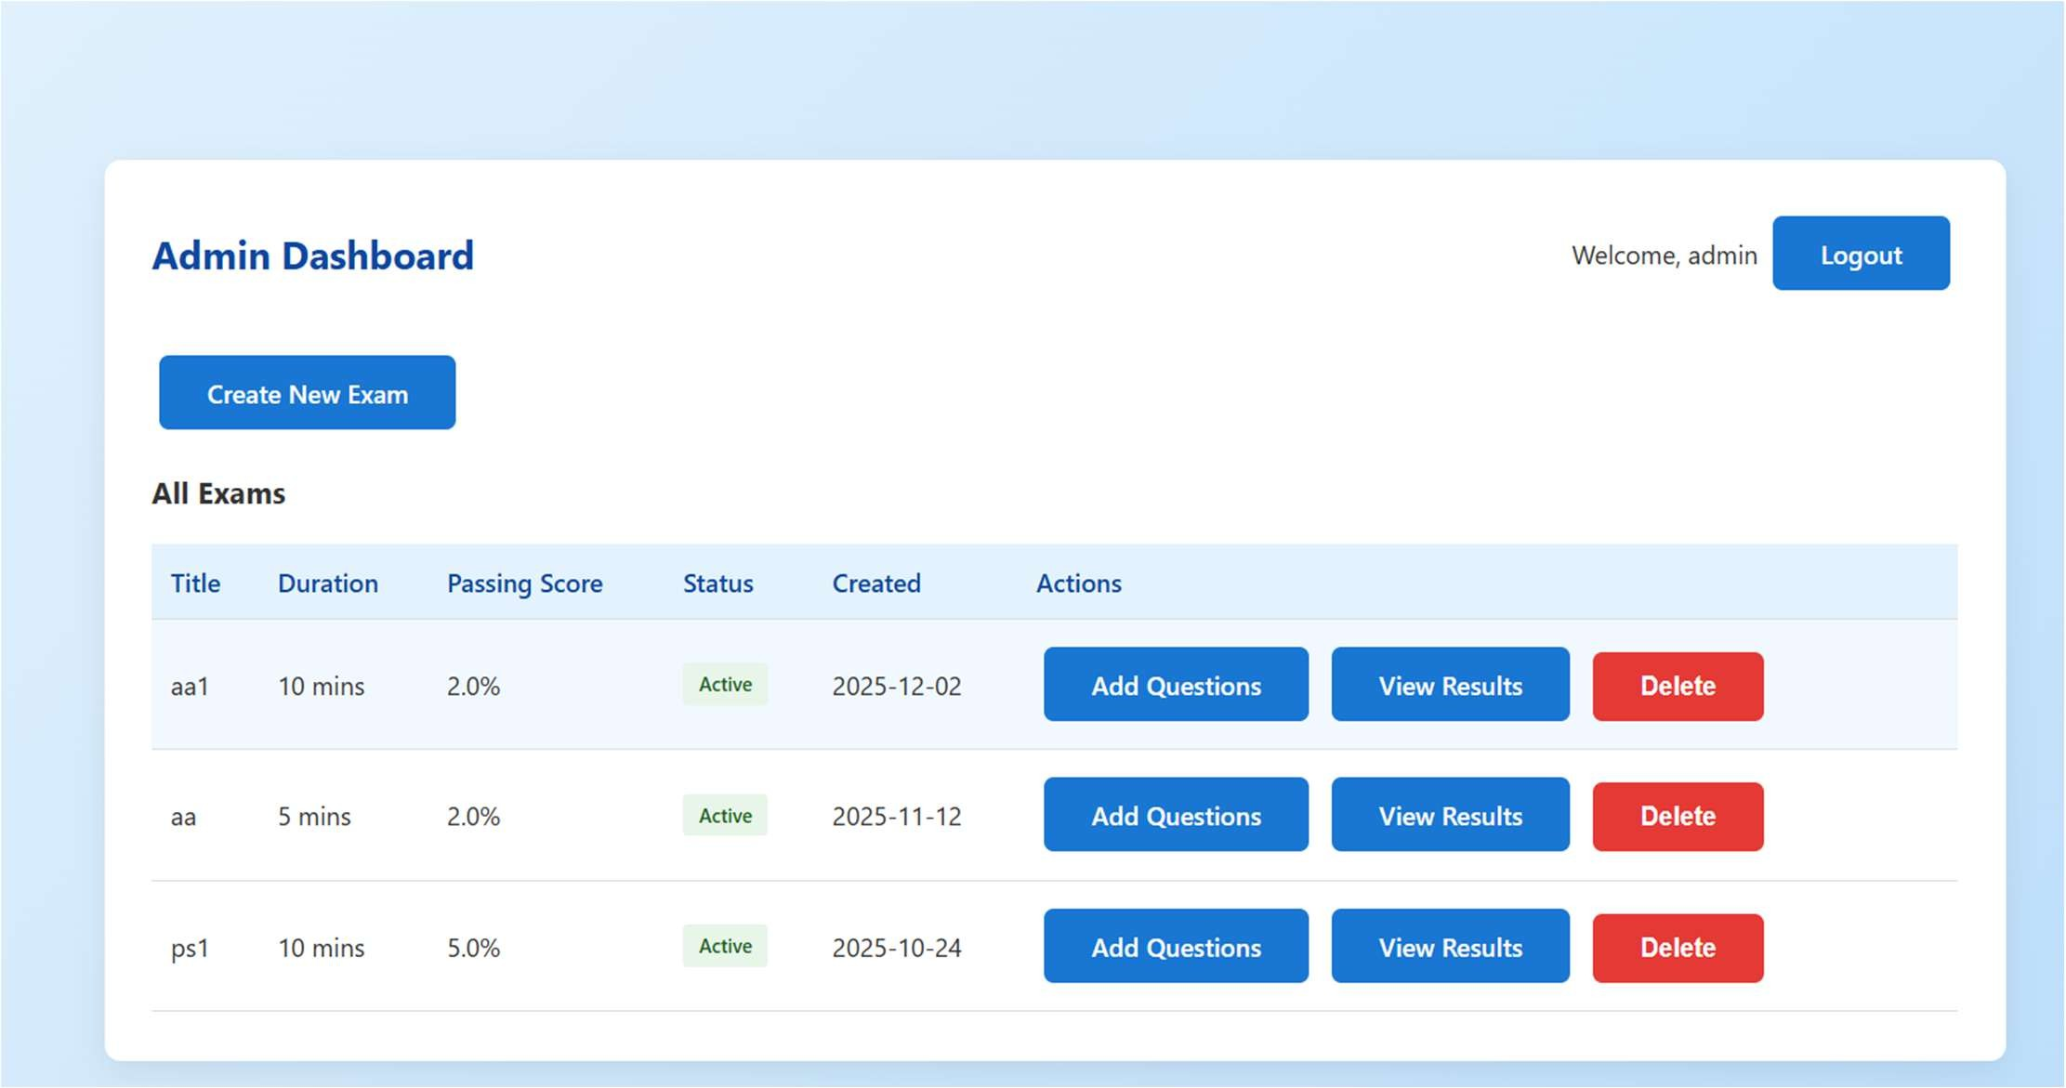
Figure 3.2.3 Admin Dashboard

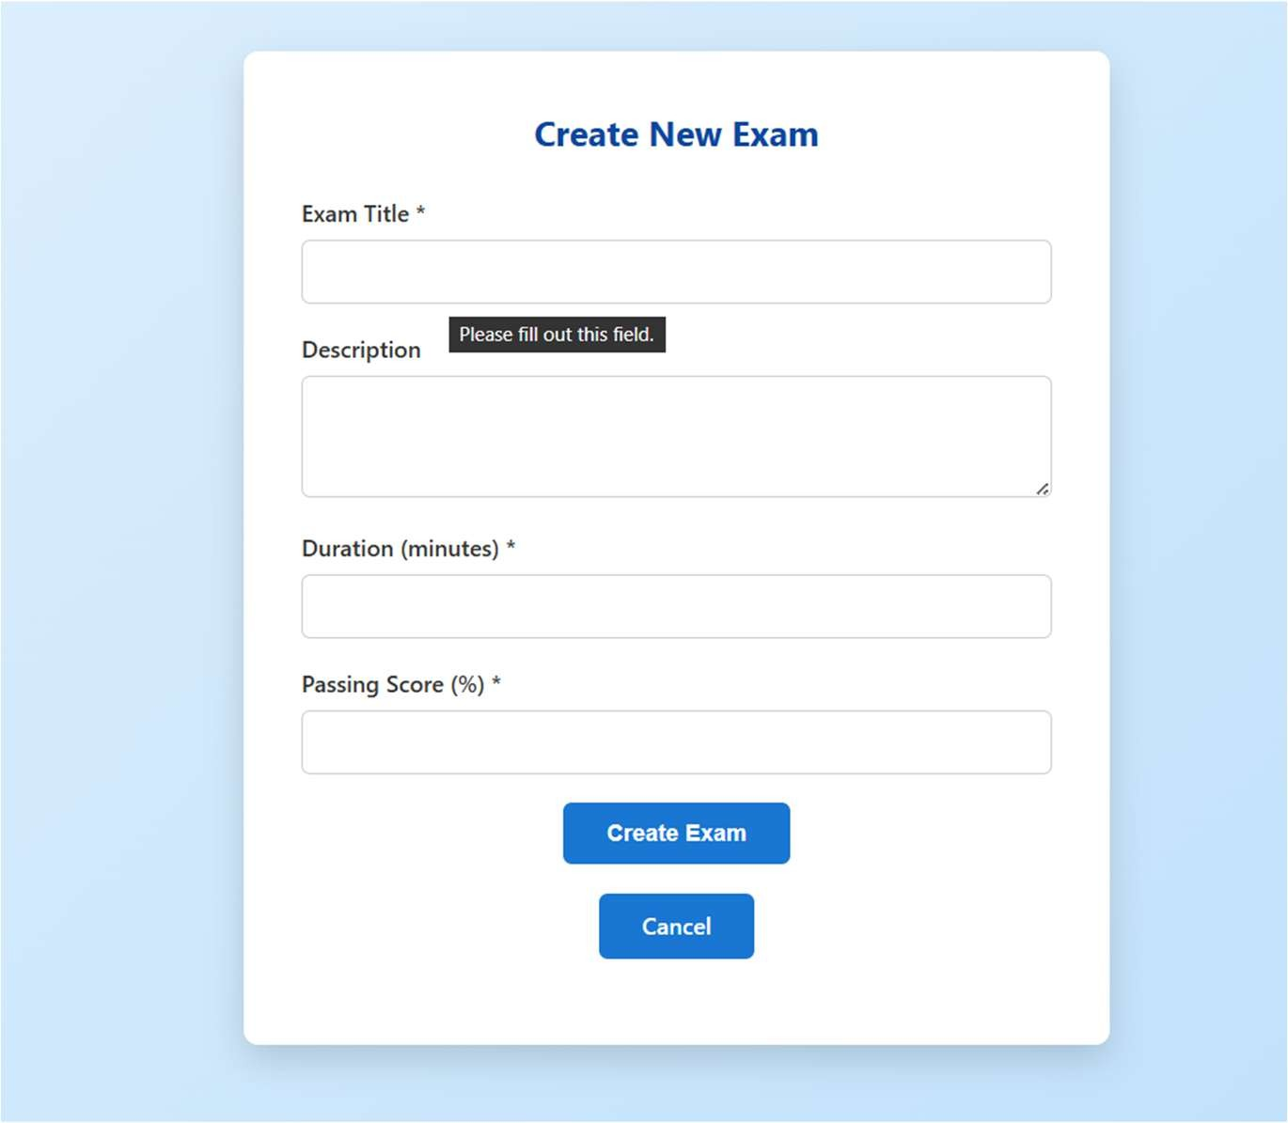
Figure 3.2.4 Create new exam page

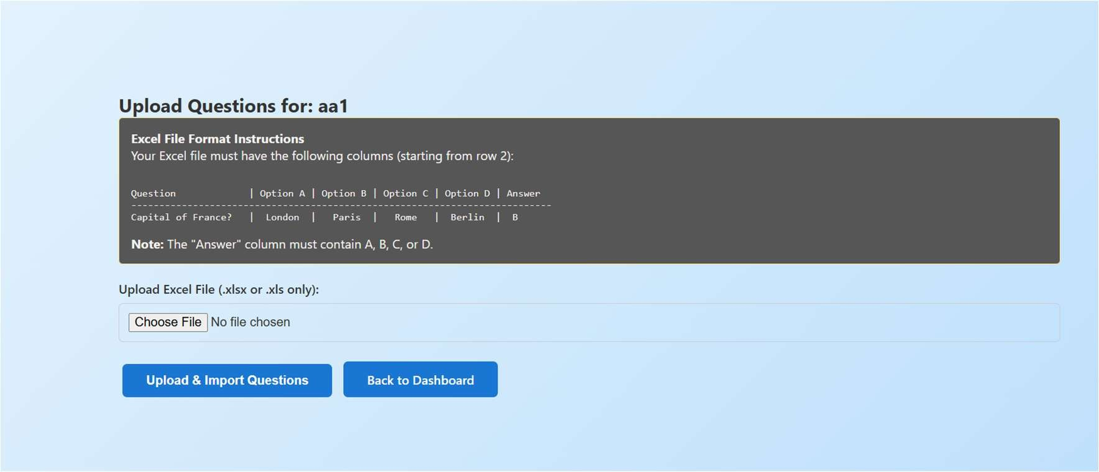
Figure 3.2.5 Question upload page

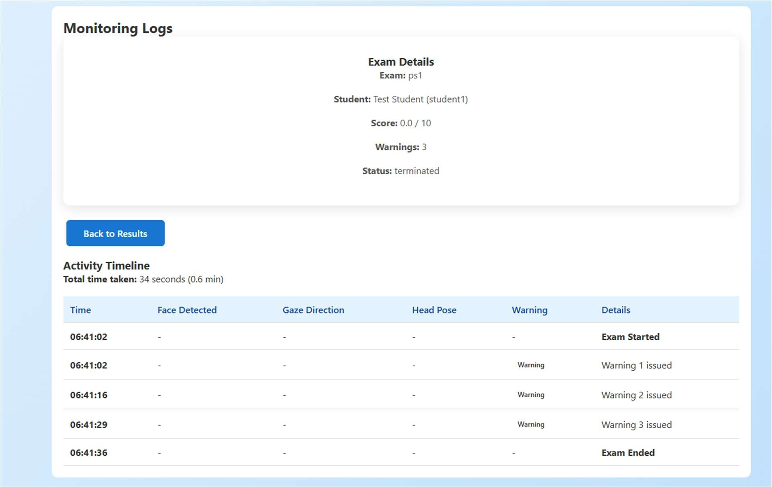

Figure 3.2.6 Student logs

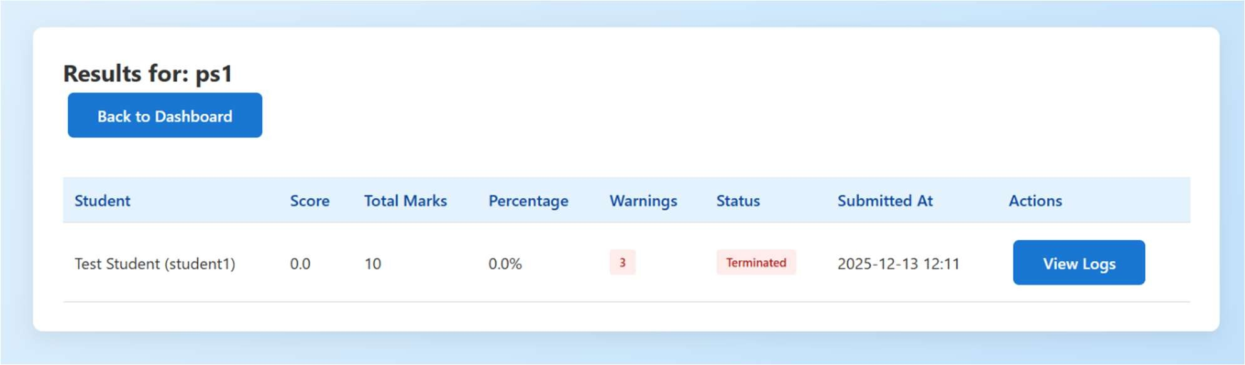
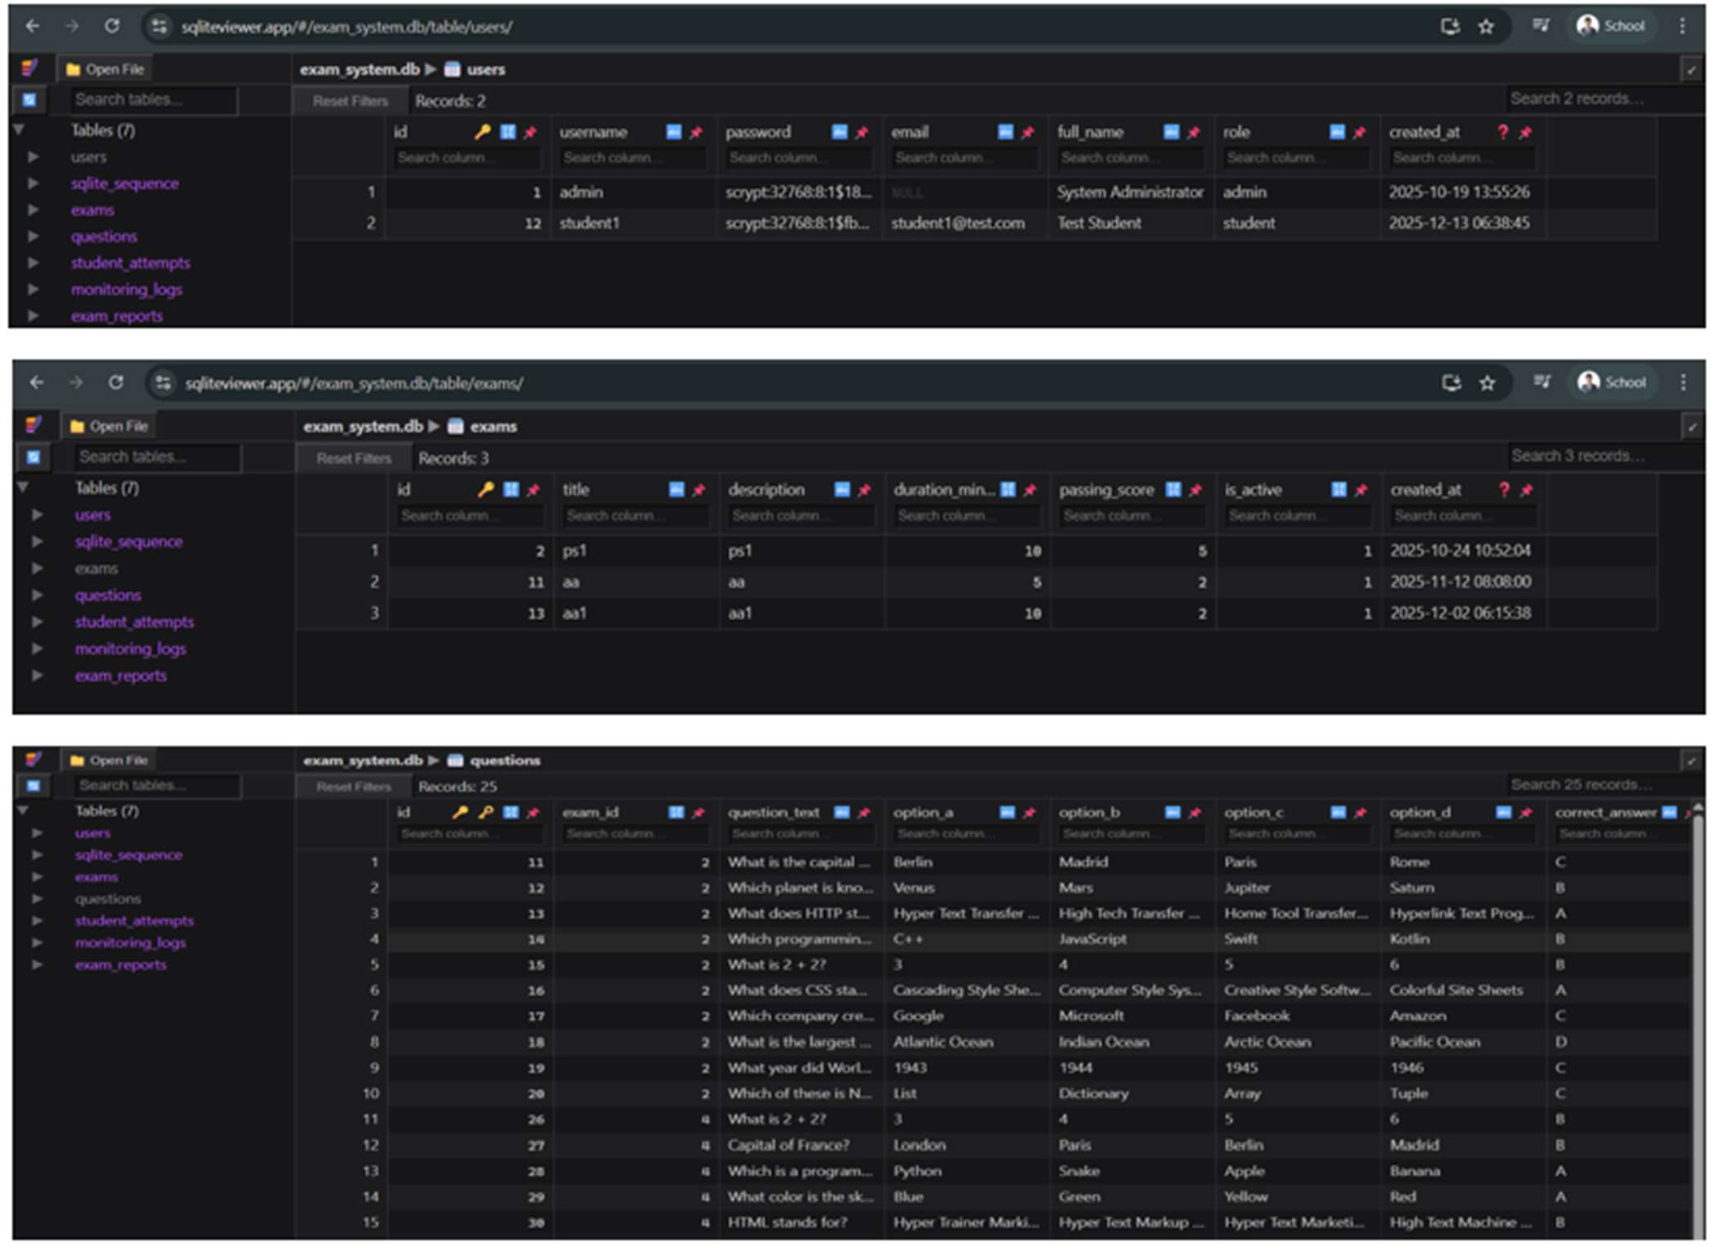
Figure 3.2.7 Student marks view

Figure 3.2.8 Databases view

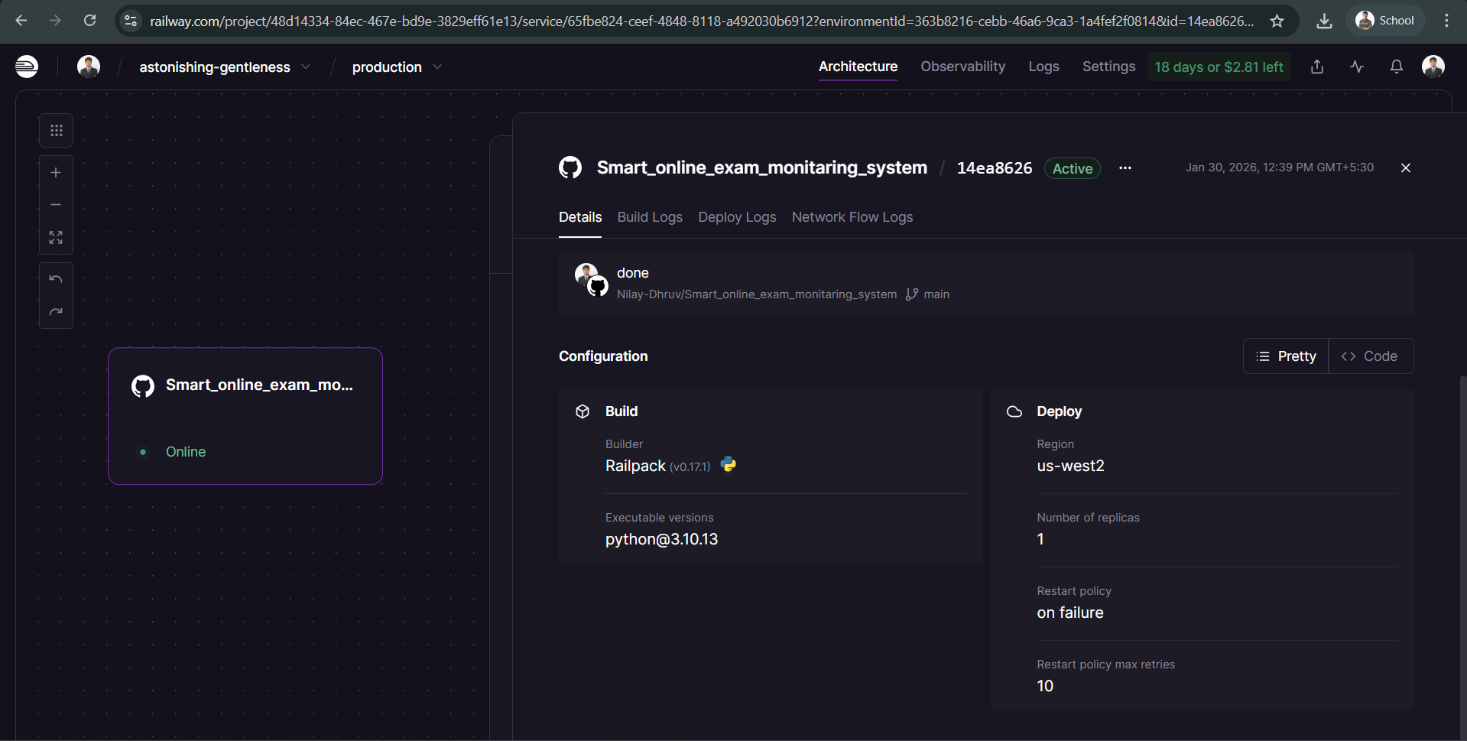

Figure 3.2.9 Deployment view

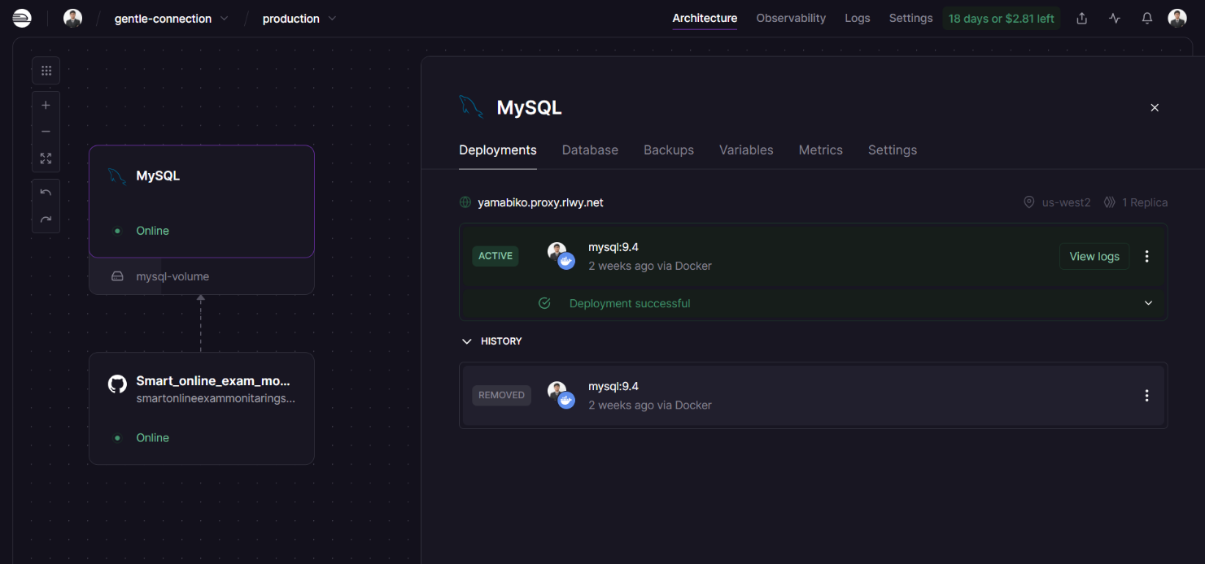

Figure 3.3.0 Deployment view

Chapter 6 Conclusion and Future Work

Conclusion and Future Work

Conclusion
The Smart Online Exam Monitoring System was successfully designed and implemented to conduct online examinations in a secure and controlled manner. The system addressed major problems found in traditional online exams, such as lack of supervision and increased chances of cheating. By using webcam monitoring and browser activity tracking, the system ensured better discipline and fairness during examinations.
The project achieved its main objectives, including face verification before the exam, real-time monitoring during the exam, detection of suspicious activities like looking away and tab switching, and automatic warning generation. The admin module allowed easy exam management, including question upload, exam scheduling, and result analysis.
Overall, the system proved to be reliable, cost-effective, and easy to use. It reduced the need for human invigilators and improved the credibility of online exam results. The project successfully demonstrated that automated monitoring can enhance the integrity of online examinations.

Future Work
Although the system works effectively, there is scope for further improvement. In future, the following enhancements can be added:
- Improve face and head movement detection accuracy using advanced AI models
- Add voice detection to identify external help during exams
- Support mobile devices and tablets
- Include live admin monitoring during exams
- Improve handling of poor internet connectivity
- Add cloud database support for large-scale deployment
- Integrate identity verification using ID cards or biometric methods

Chapter 7 References

7. References
- Flask Documentation – Official Flask Web Framework Documentation
source : https://flask.palletsprojects.com/
- MediaPipe Documentation – Google MediaPipe Framework
source : https://developers.google.com/mediapipe
- SQLite Documentation – SQLite Database Engine
source : https://www.sqlite.org/docs.html
- Python Official Documentation
source : https://docs.python.org/3/
- JavaScript MDN Web Docs – Mozilla Developer Network
source : https://developer.mozilla.org/en-US/docs/Web/JavaScript
- HTML and CSS Documentation – MDN Web Docs
source : https://developer.mozilla.org/en-US/docs/Web/HTML
source : https://developer.mozilla.org/en-US/docs/Web/CSS
- openpyxl Documentation – Python Excel File Handling
source :https://openpyxl.readthedocs.io/
- OpenCV Documentation – Computer Vision Library
source : https://docs.opencv.org/
- Google AI Blog – Face Detection and Computer Vision Concepts
source : https://ai.googleblog.com/
- W3Schools – Web Development Tutorials (HTML, CSS, JavaScript)
source : https://www.w3schools.com/
- Flask Mega-Tutorial by Miguel Grinberg
source : https://blog.miguelgrinberg.com/post/the-flask-mega-tutorial-part-i-hello-world
- GeeksforGeeks – Python, Flask, and Web Development Tutorials
source : https://www.geeksforgeeks.org/
- GitHub Open Source Projects related to Online Examination and Proctoring Systems
source : https://github.com/

