Software Requirements Specification

AgriCare Management System
CSPIT – CE
Date: 02-05-2026

Table of Contents
- Introduction
1.1 Purpose
1.2 Document Conventions
1.3 Intended Audience and Reading Suggestions
1.4 Project Scope
1.5 References
- Overall Description
2.1 Product Perspective
2.2 Product Features
2.3 User Classes and Characteristics
2.4 Operating Environment
2.5 Design and Implementation Constraints
2.6 User Documentation
2.7 Assumptions and Dependencies
- System Features
3.1 AI Disease Detection & Pest Detection
3.2 Mandi Price Intelligence
3.3 Government Subsidy System
3.4 Local Shop Locator
- External Interface Requirements
4.1 User Interfaces
4.2 Hardware Interfaces
4.3 Software Interfaces
4.4 Communications Interfaces
- Other Nonfunctional Requirements
5.1 Performance Requirements
5.2 Safety Requirements
5.3 Security Requirements
5.4 Software Quality Attributes
- Other Requirements
Appendix A: Glossary
Appendix B: Analysis Models
Appendix C: Issues List

1. Introduction

1.1 Purpose
AgriCare is a web-based agriculture management system designed to empower farmers using modern technologies such as Artificial Intelligence, real-time market data, and government resources to improve decision-making and productivity.

1.2 Document Conventions
This document is structured using numbered sections and clear headings. Technical terms are defined in the glossary.

1.3 Intended Audience and Reading Suggestions
- Project Developers & Maintainers
- Faculty Evaluators
- Farmers (End Users)
- System Administrators

1.4 Project Scope
The AgriCare system provides:
- AI-based crop disease detection using trained Model
- Live mandi prices using Agmarknet API
- Crop calendar for seasonal farming guidance
- Government subsidy information portal
- Local agricultural shop locator using GPS
- Multilingual support (English, Gujarati, Hindi)

1.5 References
- Rajib Mall – Fundamentals of Software Engineering
- OpenWeatherMap API
- Agmarknet API
- Supabase Documentation

2. Overall Description

2.1 Product Perspective
AgriCare is a standalone web application that integrates:
- AI-based disease detection
- Real-time market price APIs
- Government scheme data
- Location-based services

2.2 Product Features
- User Registration and Login
- Farmer Dashboard
- Admin Panel
- AI Crop Disease Detection
- Live Market Prices
- Crop Calendar
- Government Subsidy Information
- Language Translation

2.3 User Classes and Characteristics

Farmer
- Upload crop images
- View disease results and suggestions
- Access crop calendar and subsidies
- Find nearby shops

Admin
- Manage users
- Update subsidy and pesticide data
- Monitor system data

2.4 Operating Environment
- Client: Web browser (Chrome, Edge, Firefox)
- Server: PHP 8.x environment
- Platform: Windows/Linux
- Cloud Database: Supabase

2.5 Design and Implementation Constraints
- Internet connection required
- API dependency for live data
- AI accuracy depends on image quality
- Browser compatibility required
2.6 User Documentation
The AgriCare system provides user-friendly documentation to help users understand and effectively use the platform. The documentation includes:
- About Section: Provides an overview of the system, its purpose, and features.
- User Dashboard Guide: Explains how farmers can navigate the dashboard, use AI detection, view mandi prices, and access subsidies.
- Image Upload Instructions: Step-by-step guidance for uploading crop images for disease detection.
- Crop Calendar Guide: Instructions for understanding seasonal crop planning.
- Shop Locator Help: Guidance on how to find nearby agricultural shops using location services.
- Multilingual Support Guide: Instructions for switching between English, Gujarati, and Hindi.
The system is designed with a simple and intuitive interface so that even users with basic technical knowledge can operate it easily.
2.7 Assumptions and Dependencies

Assumptions
- Users (farmers) have basic knowledge of smartphones or computers.
- Users have access to the internet.
- Farmers can capture and upload clear images of crops.
- Users understand basic agricultural terms.
Dependencies
- The system depends on external APIs such as:
  - Agmarknet API (for mandi prices)
  - Weather API (for climate data)
- System performance depends on internet connectivity.
- AI accuracy depends on image quality and model performance.
- Database availability (Supabase/PostgreSQL) is required for storing user and system data.
3. System Features

3.1 AI Disease & Pest Detection
Description:
Farmers upload crop images, and the system uses Gemini AI to detect diseases and suggest treatments.
Functional Requirements:
- Upload images (JPG, PNG)
- Detect disease using AI
- Display disease name and confidence
- Suggest treatment and pesticides

3.2 Mandi Price Intelligence
Description:
Provides real-time crop prices using Agmarknet API.
Functional Requirements:
- Filter by commodity, district, and market
- Display latest prices
- Auto-sync data

3.3 Government Subsidy System
Description:
Displays government schemes for farmers.
Functional Requirements:
- Search subsidy schemes
- Filter by category
- View details

3.4 Local Shop Locator
Description:
Helps farmers find nearby agricultural shops using GPS.
Functional Requirements:
- Show nearby shops
- Provide map and directions
- Display shop details

4. External Interface Requirements

4.1 User Interfaces
The AgriCare system provides a user-friendly and responsive interface designed for ease of use by farmers and administrators.
- Responsive Design: Built using Tailwind CSS for compatibility across mobile and desktop devices.
- Dashboard Layout: Sidebar-based navigation with sections like AI Detection, Mandi Prices, Crop Calendar, and Subsidies.
- Simple Navigation: Easy-to-use menus and buttons for quick access to features.
- Multilingual Interface: Supports English, Gujarati, and Hindi for better accessibility.
- Clean UI: Minimal design with clear fonts and icons for better readability.

4.2 Hardware Interfaces
The system interacts with basic hardware devices required for its functionality:
- Smartphone or Computer: Used to access the web application.
- Camera: Required for capturing crop images for AI disease detection.
- Internet Connectivity Device: Necessary for accessing APIs and online features.
No special or advanced hardware is required.

4.3 Software Interfaces
The system interacts with various software components and external services:
Software / Service | Description
Operating System | Windows, Linux, macOS
Frontend | HTML, CSS, JavaScript, Tailwind CSS
Backend | PHP
Database | PostgreSQL (Supabase)
AI Engine | Trained AI Model, Gemini & Groq (Chat-Bot)
APIs | Agmarknet API (mandi prices), Weather API
Browser | Chrome, Edge, Firefox
These interfaces enable communication between the system and external services.

4.4 Communications Interfaces
The communication interfaces define how data is exchanged between the system and external services:
- HTTP/HTTPS Protocol: Used for secure communication between client and server.
- REST APIs: Used to fetch data such as mandi prices, weather updates, and AI responses.
- Internet-Based Communication: All system functionalities depend on internet connectivity.
- JSON Format: Data exchange between APIs and system is handled in JSON format.

5. Other Requirements

5. Other Nonfunctional Requirements

5.1 Performance Requirements
The system should provide efficient and fast performance to ensure a smooth user experience:
- AI disease detection results should be generated within 5 seconds.
- Web pages should load quickly (within 2–3 seconds under normal conditions).
- Real-time mandi data should be updated regularly from APIs.
- The system should support multiple users simultaneously without performance degradation.
5.2 Safety Requirements
The system must ensure safe usage and prevent misuse:
- Uploaded images and user data must be stored securely.
- Proper validation should be applied to all user inputs.
- The system should prevent uploading harmful or invalid files.
- No misleading or harmful agricultural suggestions should be provided.

5.3 Security Requirements
The system must ensure data protection and secure access:
- Passwords must be stored using hashing techniques.
- Role-based access control (Farmer/Admin) must be implemented.
- Protection against SQL Injection using prepared statements.
- Secure API communication using HTTPS.
- Proper session management to prevent unauthorized access.

5.4 Software Quality Attributes
The system should maintain high quality in terms of usability and reliability:
- Availability: System should be accessible 24/7.
- Reliability: Accurate AI results and correct data handling.
- Usability: Simple and user-friendly interface for farmers.
- Maintainability: Easy to update and modify code.
- Scalability: Ability to add new features and users in the future.
6. Other Requirements
The AgriCare system includes additional requirements that support future improvements and overall system functionality:
- The system must securely store user data, including farmer details, crop data, and system records in the database.
- The system should support multilingual functionality (English, Gujarati, Hindi) for better accessibility.
- The platform should be designed to allow future enhancements, such as:
  - Online payment integration
  - SMS or notification system
  - Advanced analytics and reports
- The system should be scalable to handle increasing users and agricultural data.
- Backup and recovery mechanisms should be considered to prevent data loss.
- The system should maintain compatibility with modern web browsers and devices.

Appendix A: Glossary
Term | Meaning
SRS | Software Requirements Specification
API | Application Programming Interface
AI | Artificial Intelligence
Agmarknet | Government agriculture market data system
Gemini AI | Google’s AI model

Appendix B: Analysis Models
The following analysis models are used to represent the system design and workflow of the AgriCare system:
- Use Case Diagram:
Shows the interaction between users (Farmer, Admin) and system functionalities such as AI detection, mandi prices, subsidy access, and shop locator.
- Entity-Relationship (ER) Diagram:
Represents the database structure including entities like Users, Crops, Market Prices, Subsidies, and Shops along with their relationships.
- Data Flow Diagram (DFD):
Illustrates the flow of data between users, system processes, and external APIs such as Agmarknet and Gemini AI.
- System Architecture Diagram (optional but recommended):
Shows the overall architecture including frontend (UI), backend (PHP), database (Supabase), and external APIs.

Appendix C: Issues List
The following issues and future improvements have been identified:
- SMS/notification system is pending.
- Accuracy of AI disease detection may vary depending on image quality.
- Dependency on external APIs (Agmarknet, Weather API) may affect system performance if APIs fail.
- Multilingual support may require further improvement for better translation accuracy.
- Advanced analytics and reporting features are not yet implemented.

ER Diagram :
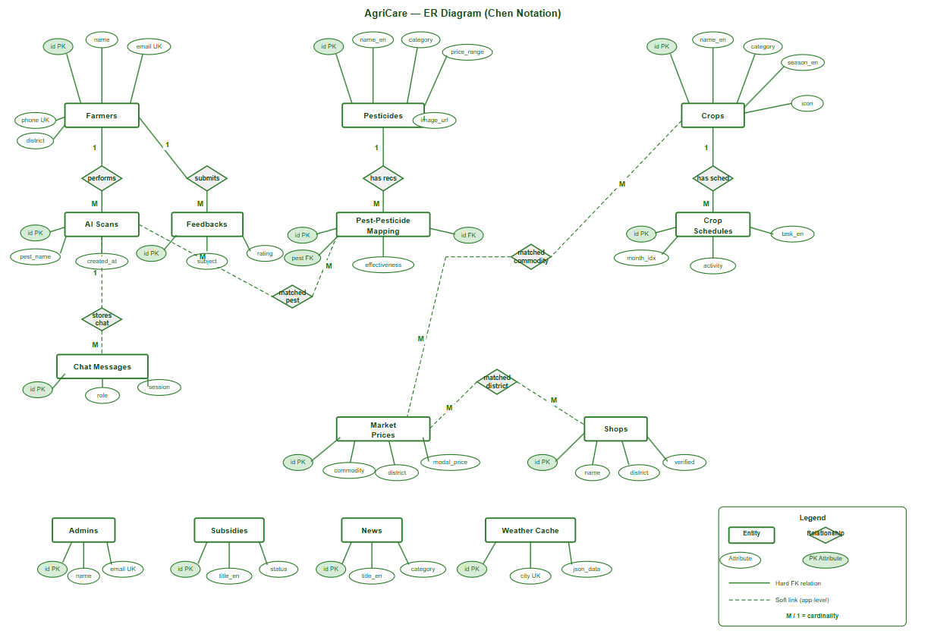

Usecase Diagram :
