User Manual CS416: Blog Post

Nilay Bhatt, Lukasz Brodowski, Donald Moretz

**Instructions**

**Special note: jdbc/HW3DB instead of jdbc/FinalProjectDB.**

**PUN: Project3PU (we’re afraid of everything breaking so we didn’t change it)**

1. When clicking on New Blog Post user should not be allowed to enter the page. One must first register.
2. **To register:** press the register button on the top of the screen, then enter name, email, and password. Password must be longer than 6 character and can contain special characters. Email must be of valid format (custom validation)
3. After registering user must **log in:** Press the log-in text on the top of the page. Then enter the email and password to your account.
4. **To edit account info:** Once logged in, on the top of the screen to the right side “Welcome ‘User name!’ “ will be displayed. Press the text, this will bring up the edit screen. A user can change their name and/ or password then press Update button. (showing update)
5. **Searching blog post:** Press the “Search” text on the top of the screen. The search view will come up and enter the word you wish to search for. The search will search the title and body for the keyword you are looking for, using Ajax to dynamically show matches against the database under the search box. (ajax)
6. **Create new blog post:** Click on the “New Blog Post” text on the top of the screen. Enter the title and the body of the post then press submit. (creating an entity)
7. **Home page:** Pressing the “Home” text on the top of the screen will bring the user back to the home page. On the home page the newest blog post by all users will be visible for the user to read. (viewing all entities) If you created the blog post, you can also hit the delete button to remove the post. (deleting entity)
8. **Logging out:** The user can press the “Logout” text at the top of the screen.

**Screenshots**

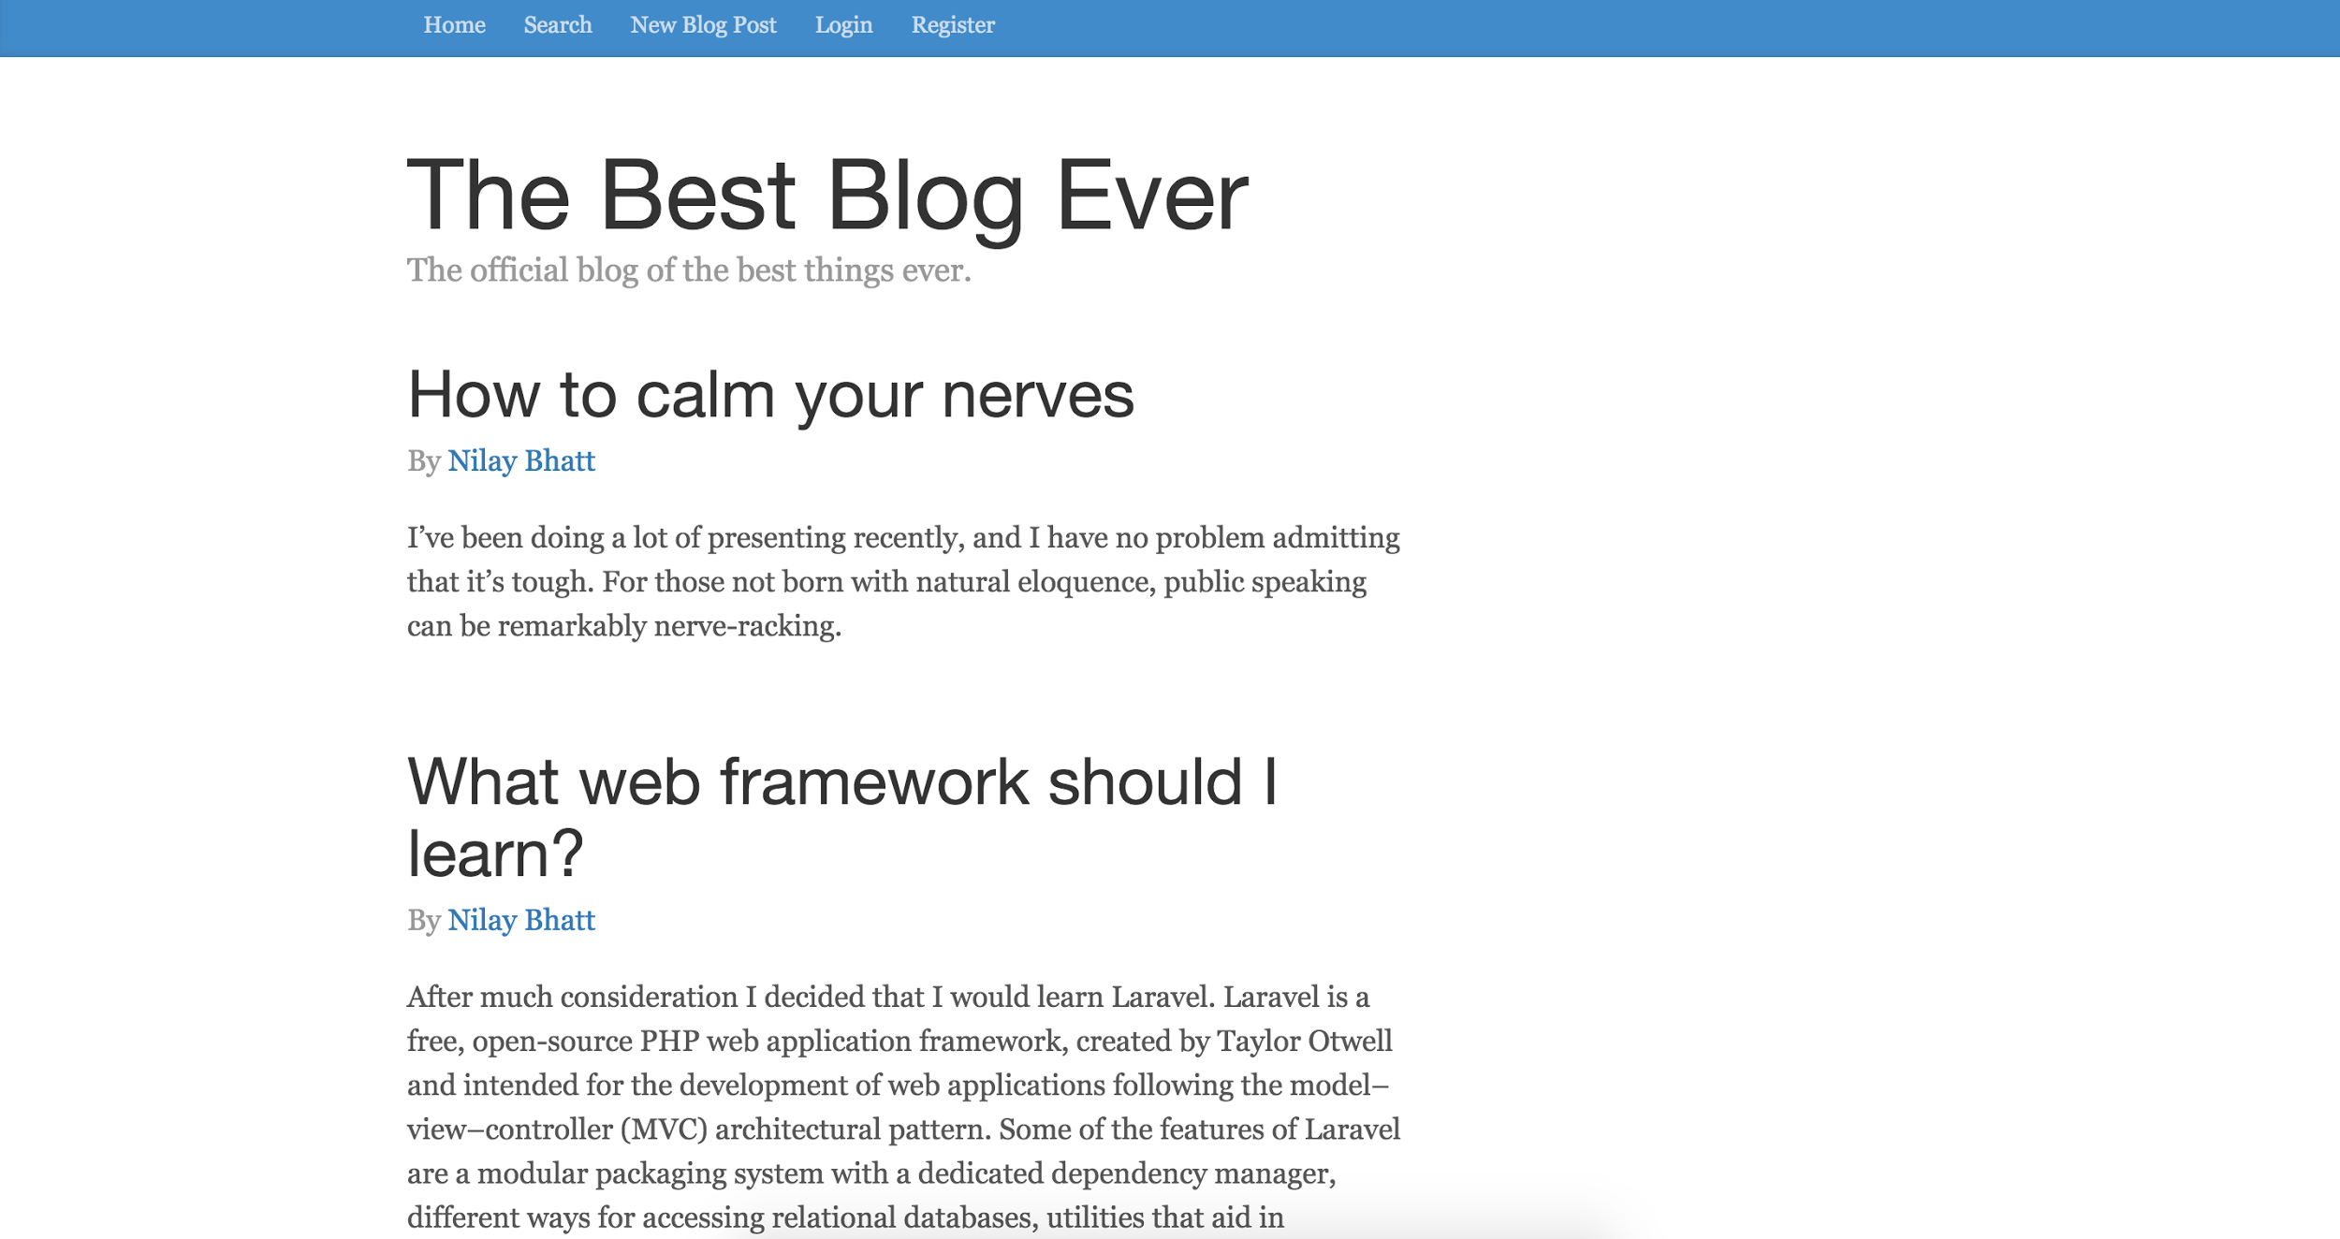

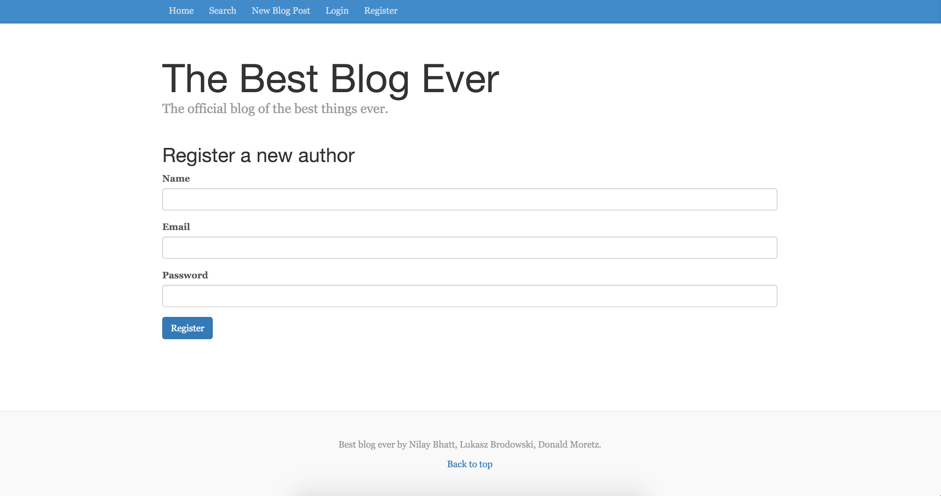

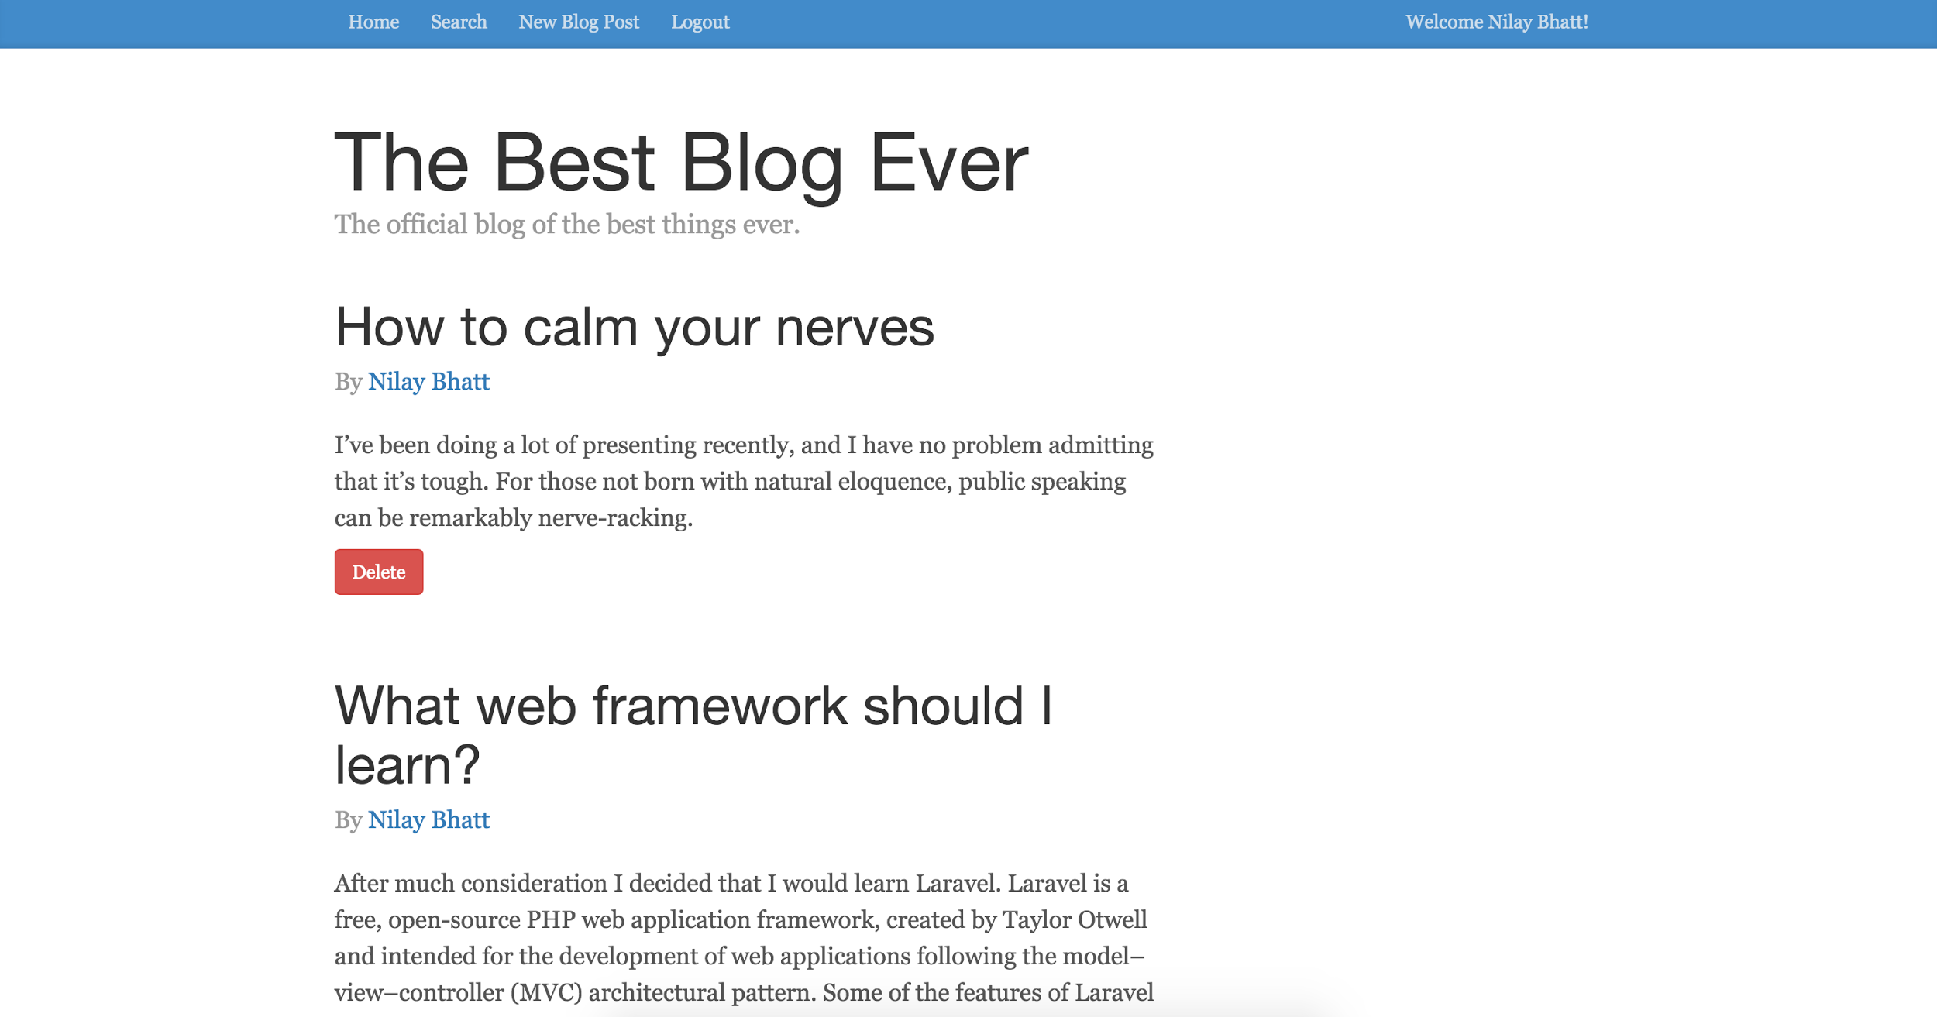

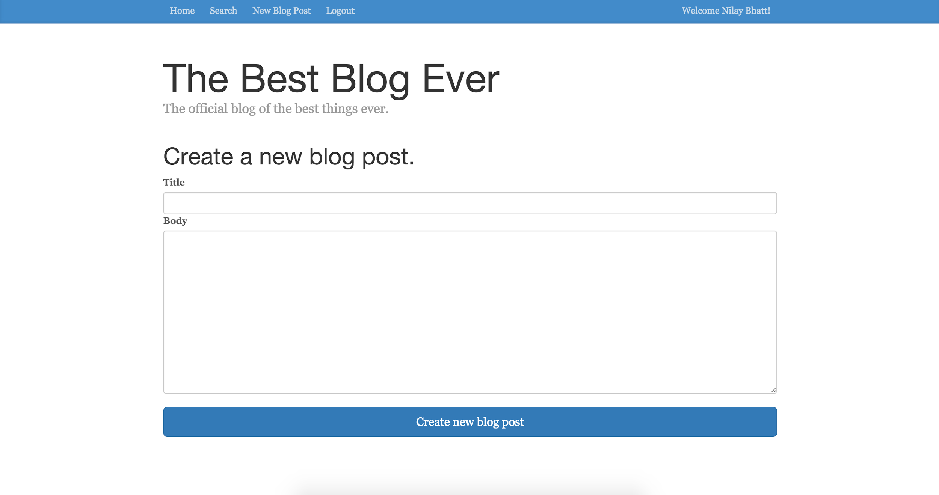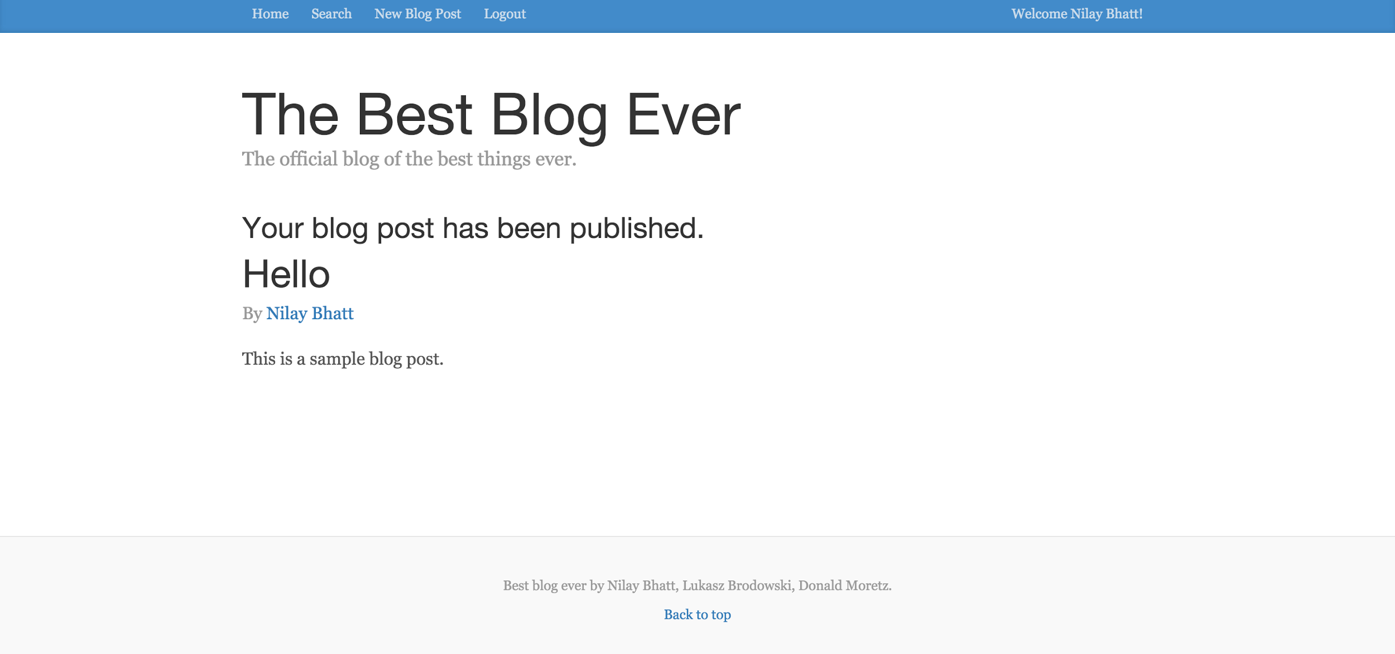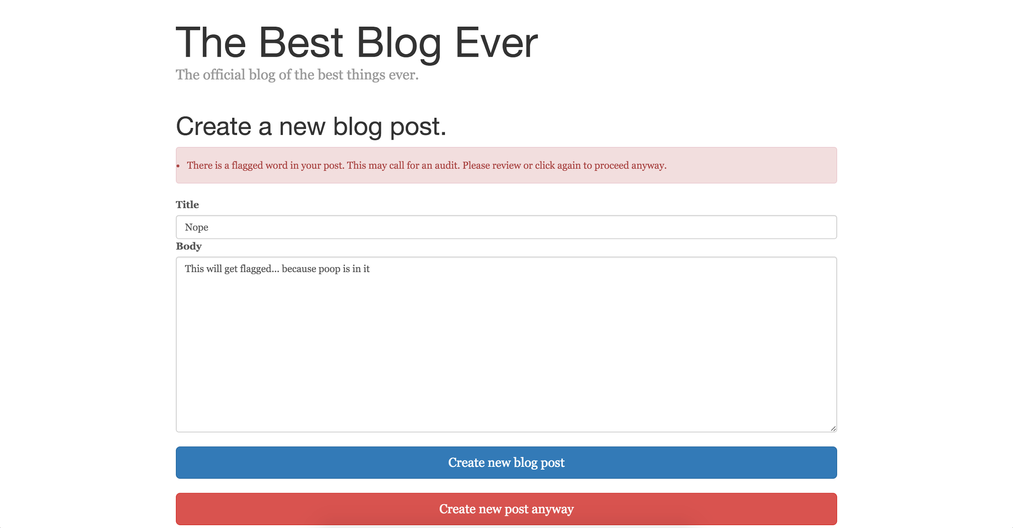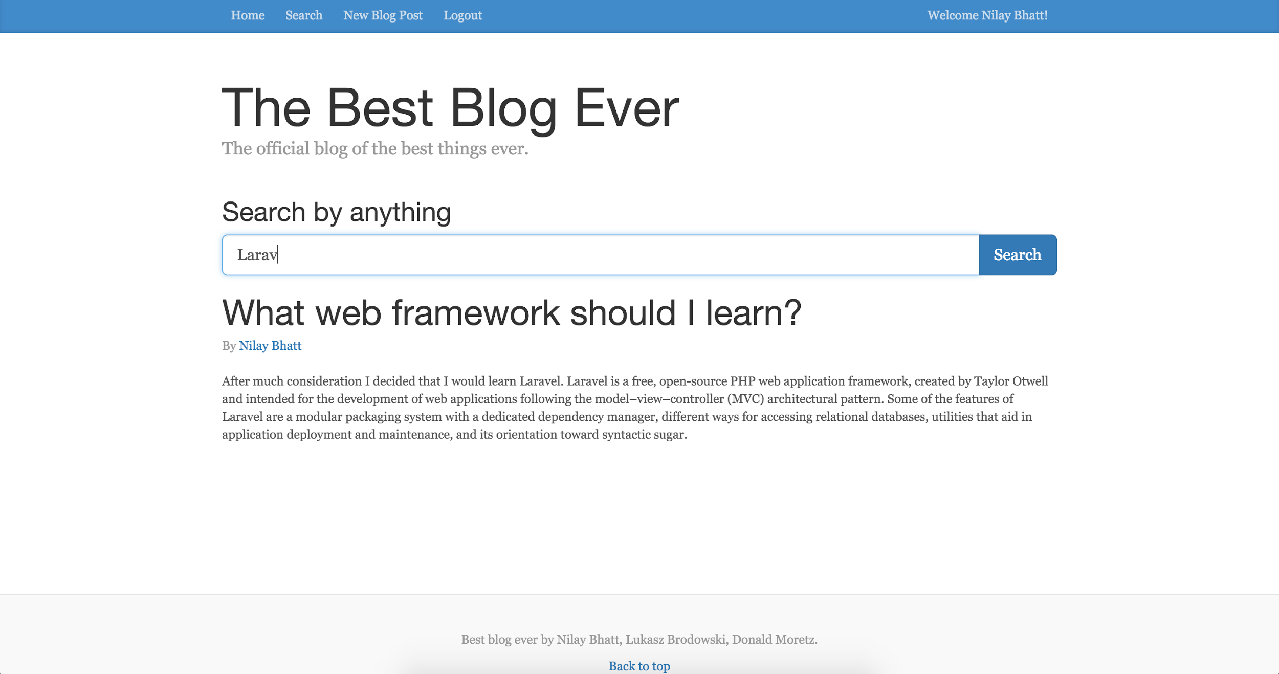

Logout brings you back to login: