Instructions:

First a user can act as a directory server, only one is needed, and IP address must be known. (keeps unwanted people off the network)

To start the directory server press



on the left top of the GUI.

Sharing Files

First all files that wish to be shared must be in the SharedFolder in the project directory.

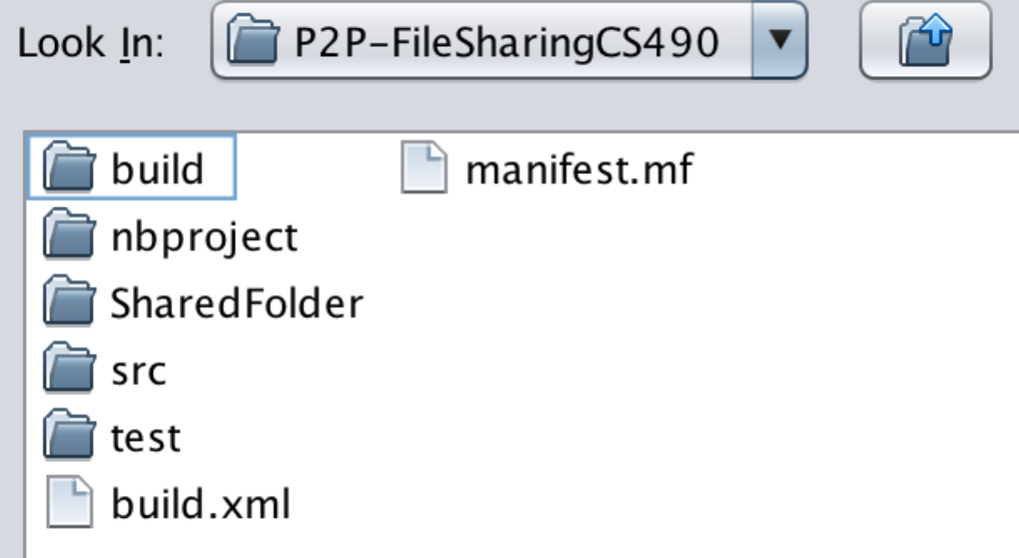

Next press the Files button



From here a user can select/ highlight all files that they wish to share on the server from the folder. Not all files in the folder need to be shared, only the ones that the user wishes to.

Enter the port number you wish to upload from, the IP address of the directory server.

Press the Sync Files button – this will update the server with your files.

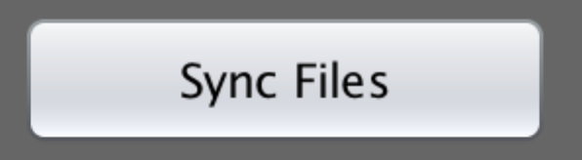

Now all your files will be listed on the directory server for sharing.

Viewing the files on the directory server:

A port to listen on is entered if new files are added on this client.

Enter the IP address of the server in which you wish to check for files and press connect.

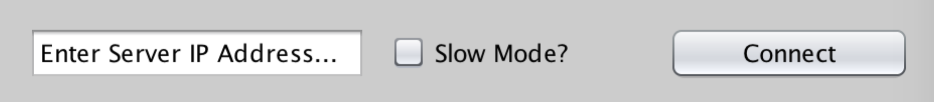

Slow mode here is for if you want to slow mode for the download.

The files will list in the table bellow, listing the file name, File size, Host Address, and port they are listening on.

Highlight/ Select the file you wish to download by clicking on the specified row for the file. Then press the Download Selected File

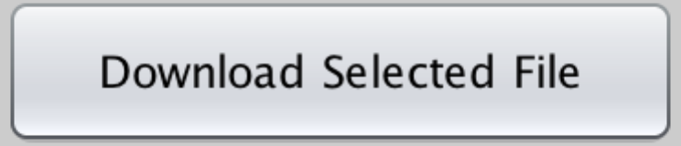

The file will be downloaded to your SharedFolder. If you wish to share the file also, you will need to upload the file.