GET
FILE='C:\Users\user\Documents\NILAY\Mayis2020\7_SPEA2.sav'.
DATASET NAME DataSet1 WINDOW=FRONT.
GLM HV EP GD IGD IGDplus SPREAD BY Crossover MaxEvaluations PopulationSize
/METHOD=SSTYPE(3)
/INTERCEPT=INCLUDE
/POSTHOC=Crossover MaxEvaluations PopulationSize(BONFERRONI)
/PLOT=PROFILE(Crossover MaxEvaluations PopulationSize)
/CRITERIA=ALPHA(.05)
/DESIGN=Crossover MaxEvaluations PopulationSize.

General Linear Model

Notes
Output Created |  | 26-MAY-2020 19:33:08
Comments
Input | Data | C:\Users\user\Documents\NILAY\Mayis2020\7_SPEA2.sav
Input | Active Dataset | DataSet1
Input | Filter | <none>
Input | Weight | <none>
Input | Split File | <none>
Input | N of Rows in Working Data File | 837
Missing Value Handling | Definition of Missing | User-defined missing values are treated as missing.
Missing Value Handling | Cases Used | Statistics are based on all cases with valid data for all variables in the model.
Syntax |  | GLM HV EP GD IGD IGDplus SPREAD BY Crossover MaxEvaluations PopulationSize  /METHOD=SSTYPE(3)  /INTERCEPT=INCLUDE  /POSTHOC=Crossover MaxEvaluations PopulationSize(BONFERRONI)  /PLOT=PROFILE(Crossover MaxEvaluations PopulationSize)  /CRITERIA=ALPHA(.05)  /DESIGN=Crossover MaxEvaluations PopulationSize.
Resources | Processor Time | 00:00:06.23
Resources | Elapsed Time | 00:00:06.31

[DataSet1] C:\Users\user\Documents\NILAY\Mayis2020\7_SPEA2.sav

Between-Subjects Factors
 |  | Value Label | N
Crossover | 1 | 0.7 | 279
Crossover | 2 | 0.8 | 279
Crossover | 3 | 0.9 | 279
MaxEvaluations | 1 | 15000 | 279
MaxEvaluations | 2 | 20000 | 279
MaxEvaluations | 3 | 25000 | 279
PopulationSize | 1 | 100 | 279
PopulationSize | 2 | 50 | 279
PopulationSize | 3 | 200 | 279

Multivariate Testsª
Effect |  | Value | F | Hypothesis df | Error df
Intercept | Pillai's Trace | 1.000 | 9478638.478^{b} | 5.000 | 826.000
Intercept | Wilks' Lambda | .000 | 9478638.478^{b} | 5.000 | 826.000
Intercept | Hotelling's Trace | 57376.746 | 9478638.478^{b} | 5.000 | 826.000
Intercept | Roy's Largest Root | 57376.746 | 9478638.478^{b} | 5.000 | 826.000
Crossover | Pillai's Trace | .015 | 1.218 | 10.000 | 1654.000
Crossover | Wilks' Lambda | .985 | 1.218^{b} | 10.000 | 1652.000
Crossover | Hotelling's Trace | .015 | 1.218 | 10.000 | 1650.000
Crossover | Roy's Largest Root | .012 | 1.960^{c} | 5.000 | 827.000
MaxEvaluations | Pillai's Trace | .020 | 1.676 | 10.000 | 1654.000
MaxEvaluations | Wilks' Lambda | .980 | 1.675^{b} | 10.000 | 1652.000
MaxEvaluations | Hotelling's Trace | .020 | 1.674 | 10.000 | 1650.000
MaxEvaluations | Roy's Largest Root | .013 | 2.176^{c} | 5.000 | 827.000
PopulationSize | Pillai's Trace | .387 | 39.675 | 10.000 | 1654.000
PopulationSize | Wilks' Lambda | .619 | 44.758^{b} | 10.000 | 1652.000
PopulationSize | Hotelling's Trace | .606 | 49.957 | 10.000 | 1650.000
PopulationSize | Roy's Largest Root | .589 | 97.424^{c} | 5.000 | 827.000

Multivariate Testsª
Effect |  | Sig.
Intercept | Pillai's Trace | .000
Intercept | Wilks' Lambda | .000
Intercept | Hotelling's Trace | .000
Intercept | Roy's Largest Root | .000
Crossover | Pillai's Trace | .274
Crossover | Wilks' Lambda | .274
Crossover | Hotelling's Trace | .274
Crossover | Roy's Largest Root | .082
MaxEvaluations | Pillai's Trace | .081
MaxEvaluations | Wilks' Lambda | .081
MaxEvaluations | Hotelling's Trace | .081
MaxEvaluations | Roy's Largest Root | .055
PopulationSize | Pillai's Trace | .000
PopulationSize | Wilks' Lambda | .000
PopulationSize | Hotelling's Trace | .000
PopulationSize | Roy's Largest Root | .000

a. Design: Intercept + Crossover + MaxEvaluations + PopulationSize
b. Exact statistic
c. The statistic is an upper bound on F that yields a lower bound on the significance level.

Tests of Between-Subjects Effects
Source | Dependent Variable | Type III Sum of Squares | df | Mean Square | F
Corrected Model | HV | .335ª | 6 | .056 | 8.992
Corrected Model | EP | .335^{b} | 6 | .056 | 8.992
Corrected Model | GD | .370^{c} | 6 | .062 | 47.229
Corrected Model | IGD | .221^{d} | 6 | .037 | 1.765
Corrected Model | IGDplus | .172e | 6 | .029 | 8.369
Corrected Model | SPREAD | .802^{f} | 6 | .134 | 4.097
Intercept | HV | 768.926 | 1 | 768.926 | 123940.578
Intercept | EP | 1.443 | 1 | 1.443 | 232.664
Intercept | GD | 6.104 | 1 | 6.104 | 4676.690
Intercept | IGD | 297.210 | 1 | 297.210 | 14262.265
Intercept | IGDplus | .557 | 1 | .557 | 163.165
Intercept | SPREAD | 1357.942 | 1 | 1357.942 | 41616.903
Crossover | HV | .022 | 2 | .011 | 1.734
Crossover | EP | .022 | 2 | .011 | 1.734
Crossover | GD | .008 | 2 | .004 | 2.983
Crossover | IGD | .107 | 2 | .054 | 2.567
Crossover | IGDplus | .011 | 2 | .006 | 1.649
Crossover | SPREAD | .095 | 2 | .048 | 1.458
MaxEvaluations | HV | .023 | 2 | .012 | 1.870
MaxEvaluations | EP | .023 | 2 | .012 | 1.870
MaxEvaluations | GD | .002 | 2 | .001 | .634
MaxEvaluations | IGD | .051 | 2 | .026 | 1.233
MaxEvaluations | IGDplus | .012 | 2 | .006 | 1.752
MaxEvaluations | SPREAD | .143 | 2 | .071 | 2.189
PopulationSize | HV | .290 | 2 | .145 | 23.371
PopulationSize | EP | .290 | 2 | .145 | 23.371
PopulationSize | GD | .360 | 2 | .180 | 138.070
PopulationSize | IGD | .062 | 2 | .031 | 1.493
PopulationSize | IGDplus | .148 | 2 | .074 | 21.706
PopulationSize | SPREAD | .564 | 2 | .282 | 8.646
Error | HV | 5.149 | 830 | .006
Error | EP | 5.149 | 830 | .006
Error | GD | 1.083 | 830 | .001
Error | IGD | 17.296 | 830 | .021
Error | IGDplus | 2.835 | 830 | .003

Tests of Between-Subjects Effects
Source | Dependent Variable | Sig.
Corrected Model | HV | .000ª
Corrected Model | EP | .000^{b}
Corrected Model | GD | .000^{c}
Corrected Model | IGD | .103^{d}
Corrected Model | IGDplus | .000e
Corrected Model | SPREAD | .000^{f}
Intercept | HV | .000
Intercept | EP | .000
Intercept | GD | .000
Intercept | IGD | .000
Intercept | IGDplus | .000
Intercept | SPREAD | .000
Crossover | HV | .177
Crossover | EP | .177
Crossover | GD | .051
Crossover | IGD | .077
Crossover | IGDplus | .193
Crossover | SPREAD | .233
MaxEvaluations | HV | .155
MaxEvaluations | EP | .155
MaxEvaluations | GD | .531
MaxEvaluations | IGD | .292
MaxEvaluations | IGDplus | .174
MaxEvaluations | SPREAD | .113
PopulationSize | HV | .000
PopulationSize | EP | .000
PopulationSize | GD | .000
PopulationSize | IGD | .225
PopulationSize | IGDplus | .000
PopulationSize | SPREAD | .000
Error | HV
Error | EP
Error | GD
Error | IGD
Error | IGDplus

Tests of Between-Subjects Effects
Source | Dependent Variable | Type III Sum of Squares | df | Mean Square | F
Error | SPREAD | 27.083ª | 830 | .033
Total | HV | 774.410^{b} | 837
Total | EP | 6.927^{c} | 837
Total | GD | 7.557^{d} | 837
Total | IGD | 314.727e | 837
Total | IGDplus | 3.564^{f} | 837
Total | SPREAD | 1385.827 | 837
Corrected Total | HV | 5.484 | 836
Corrected Total | EP | 5.484 | 836
Corrected Total | GD | 1.453 | 836
Corrected Total | IGD | 17.517 | 836
Corrected Total | IGDplus | 3.006 | 836
Corrected Total | SPREAD | 27.885 | 836

Tests of Between-Subjects Effects
Source | Dependent Variable | Sig.
Error | SPREAD
Total | HV
Total | EP
Total | GD
Total | IGD
Total | IGDplus
Total | SPREAD
Corrected Total | HV
Corrected Total | EP
Corrected Total | GD
Corrected Total | IGD
Corrected Total | IGDplus
Corrected Total | SPREAD

a. R Squared = .061 (Adjusted R Squared = .054)
b. R Squared = .061 (Adjusted R Squared = .054)
c. R Squared = .255 (Adjusted R Squared = .249)
d. R Squared = .013 (Adjusted R Squared = .005)
e. R Squared = .057 (Adjusted R Squared = .050)
f. R Squared = .029 (Adjusted R Squared = .022)

Post Hoc Tests

Crossover

Multiple Comparisons
Bonferroni
Dependent Variable | (I) Crossover | (J) Crossover | Mean Difference (I-J) | Std. Error | Sig.
HV | 0.7 | 0.8 | -.0040 | .00667 | 1.000
HV | 0.7 | 0.9 | .0082 | .00667 | .654
HV | 0.8 | 0.7 | .0040 | .00667 | 1.000
HV | 0.8 | 0.9 | .0122 | .00667 | .205
HV | 0.9 | 0.7 | -.0082 | .00667 | .654
HV | 0.9 | 0.8 | -.0122 | .00667 | .205
EP | 0.7 | 0.8 | .0040 | .00667 | 1.000
EP | 0.7 | 0.9 | -.0082 | .00667 | .654
EP | 0.8 | 0.7 | -.0040 | .00667 | 1.000
EP | 0.8 | 0.9 | -.0122 | .00667 | .205
EP | 0.9 | 0.7 | .0082 | .00667 | .654
EP | 0.9 | 0.8 | .0122 | .00667 | .205
GD | 0.7 | 0.8 | .0055 | .00306 | .223
GD | 0.7 | 0.9 | -.0017 | .00306 | 1.000
GD | 0.8 | 0.7 | -.0055 | .00306 | .223
GD | 0.8 | 0.9 | -.0071 | .00306 | .059
GD | 0.9 | 0.7 | .0017 | .00306 | 1.000
GD | 0.9 | 0.8 | .0071 | .00306 | .059
IGD | 0.7 | 0.8 | .0221 | .01222 | .214
IGD | 0.7 | 0.9 | -.0035 | .01222 | 1.000
IGD | 0.8 | 0.7 | -.0221 | .01222 | .214
IGD | 0.8 | 0.9 | -.0255 | .01222 | .111
IGD | 0.9 | 0.7 | .0035 | .01222 | 1.000
IGD | 0.9 | 0.8 | .0255 | .01222 | .111
IGDplus | 0.7 | 0.8 | .0024 | .00495 | 1.000
IGDplus | 0.7 | 0.9 | -.0063 | .00495 | .614
IGDplus | 0.8 | 0.7 | -.0024 | .00495 | 1.000
IGDplus | 0.8 | 0.9 | -.0087 | .00495 | .237
IGDplus | 0.9 | 0.7 | .0063 | .00495 | .614
IGDplus | 0.9 | 0.8 | .0087 | .00495 | .237
SPREAD | 0.7 | 0.8 | -.0166 | .01529 | .830
SPREAD | 0.7 | 0.9 | .0091 | .01529 | 1.000
SPREAD | 0.8 | 0.7 | .0166 | .01529 | .830

Multiple Comparisons
Bonferroni
Dependent Variable | (I) Crossover | (J) Crossover | 95% Confidence Interval
Dependent Variable | (I) Crossover | (J) Crossover | Lower Bound | Upper Bound
HV | 0.7 | 0.8 | -.0200 | .0120
HV | 0.7 | 0.9 | -.0078 | .0242
HV | 0.8 | 0.7 | -.0120 | .0200
HV | 0.8 | 0.9 | -.0038 | .0282
HV | 0.9 | 0.7 | -.0242 | .0078
HV | 0.9 | 0.8 | -.0282 | .0038
EP | 0.7 | 0.8 | -.0120 | .0200
EP | 0.7 | 0.9 | -.0242 | .0078
EP | 0.8 | 0.7 | -.0200 | .0120
EP | 0.8 | 0.9 | -.0282 | .0038
EP | 0.9 | 0.7 | -.0078 | .0242
EP | 0.9 | 0.8 | -.0038 | .0282
GD | 0.7 | 0.8 | -.0019 | .0128
GD | 0.7 | 0.9 | -.0090 | .0057
GD | 0.8 | 0.7 | -.0128 | .0019
GD | 0.8 | 0.9 | -.0145 | .0002
GD | 0.9 | 0.7 | -.0057 | .0090
GD | 0.9 | 0.8 | -.0002 | .0145
IGD | 0.7 | 0.8 | -.0073 | .0514
IGD | 0.7 | 0.9 | -.0328 | .0258
IGD | 0.8 | 0.7 | -.0514 | .0073
IGD | 0.8 | 0.9 | -.0549 | .0038
IGD | 0.9 | 0.7 | -.0258 | .0328
IGD | 0.9 | 0.8 | -.0038 | .0549
IGDplus | 0.7 | 0.8 | -.0094 | .0143
IGDplus | 0.7 | 0.9 | -.0181 | .0056
IGDplus | 0.8 | 0.7 | -.0143 | .0094
IGDplus | 0.8 | 0.9 | -.0206 | .0032
IGDplus | 0.9 | 0.7 | -.0056 | .0181
IGDplus | 0.9 | 0.8 | -.0032 | .0206
SPREAD | 0.7 | 0.8 | -.0533 | .0200
SPREAD | 0.7 | 0.9 | -.0276 | .0458
SPREAD | 0.8 | 0.7 | -.0200 | .0533

Multiple Comparisons
Bonferroni
Dependent Variable | (I) Crossover | (J) Crossover | Mean Difference (I-J) | Std. Error | Sig.
SPREAD | 0.8 | 0.9 | .0257 | .01529 | .278
SPREAD | 0.9 | 0.7 | -.0091 | .01529 | 1.000
SPREAD | 0.9 | 0.8 | -.0257 | .01529 | .278

Multiple Comparisons
Bonferroni
Dependent Variable | (I) Crossover | (J) Crossover | 95% Confidence Interval
Dependent Variable | (I) Crossover | (J) Crossover | Lower Bound | Upper Bound
SPREAD | 0.8 | 0.9 | -.0109 | .0624
SPREAD | 0.9 | 0.7 | -.0458 | .0276
SPREAD | 0.9 | 0.8 | -.0624 | .0109

Based on observed means.
The error term is Mean Square(Error) = .033.

Homogeneous Subsets

MaxEvaluations

Multiple Comparisons
Bonferroni
Dependent Variable | (I) MaxEvaluations | (J) MaxEvaluations | Mean Difference (I-J) | Std. Error | Sig.
HV | 15000 | 20000 | .0055 | .00667 | 1.000
HV | 15000 | 25000 | -.0074 | .00667 | .811
HV | 20000 | 15000 | -.0055 | .00667 | 1.000
HV | 20000 | 25000 | -.0129 | .00667 | .163
HV | 25000 | 15000 | .0074 | .00667 | .811
HV | 25000 | 20000 | .0129 | .00667 | .163
EP | 15000 | 20000 | -.0055 | .00667 | 1.000
EP | 15000 | 25000 | .0074 | .00667 | .811
EP | 20000 | 15000 | .0055 | .00667 | 1.000
EP | 20000 | 25000 | .0129 | .00667 | .163
EP | 25000 | 15000 | -.0074 | .00667 | .811
EP | 25000 | 20000 | -.0129 | .00667 | .163
GD | 15000 | 20000 | -.0010 | .00306 | 1.000
GD | 15000 | 25000 | -.0033 | .00306 | .825
GD | 20000 | 15000 | .0010 | .00306 | 1.000
GD | 20000 | 25000 | -.0024 | .00306 | 1.000
GD | 25000 | 15000 | .0033 | .00306 | .825
GD | 25000 | 20000 | .0024 | .00306 | 1.000
IGD | 15000 | 20000 | -.0076 | .01222 | 1.000
IGD | 15000 | 25000 | .0115 | .01222 | 1.000
IGD | 20000 | 15000 | .0076 | .01222 | 1.000
IGD | 20000 | 25000 | .0191 | .01222 | .358
IGD | 25000 | 15000 | -.0115 | .01222 | 1.000
IGD | 25000 | 20000 | -.0191 | .01222 | .358
IGDplus | 15000 | 20000 | -.0046 | .00495 | 1.000
IGDplus | 15000 | 25000 | .0047 | .00495 | 1.000
IGDplus | 20000 | 15000 | .0046 | .00495 | 1.000
IGDplus | 20000 | 25000 | .0093 | .00495 | .185
IGDplus | 25000 | 15000 | -.0047 | .00495 | 1.000
IGDplus | 25000 | 20000 | -.0093 | .00495 | .185
SPREAD | 15000 | 20000 | .0125 | .01529 | 1.000
SPREAD | 15000 | 25000 | -.0192 | .01529 | .626
SPREAD | 20000 | 15000 | -.0125 | .01529 | 1.000

Multiple Comparisons
Bonferroni
Dependent Variable | (I) MaxEvaluations | (J) MaxEvaluations | 95% Confidence Interval
Dependent Variable | (I) MaxEvaluations | (J) MaxEvaluations | Lower Bound | Upper Bound
HV | 15000 | 20000 | -.0105 | .0215
HV | 15000 | 25000 | -.0234 | .0086
HV | 20000 | 15000 | -.0215 | .0105
HV | 20000 | 25000 | -.0289 | .0031
HV | 25000 | 15000 | -.0086 | .0234
HV | 25000 | 20000 | -.0031 | .0289
EP | 15000 | 20000 | -.0215 | .0105
EP | 15000 | 25000 | -.0086 | .0234
EP | 20000 | 15000 | -.0105 | .0215
EP | 20000 | 25000 | -.0031 | .0289
EP | 25000 | 15000 | -.0234 | .0086
EP | 25000 | 20000 | -.0289 | .0031
GD | 15000 | 20000 | -.0083 | .0064
GD | 15000 | 25000 | -.0107 | .0040
GD | 20000 | 15000 | -.0064 | .0083
GD | 20000 | 25000 | -.0097 | .0049
GD | 25000 | 15000 | -.0040 | .0107
GD | 25000 | 20000 | -.0049 | .0097
IGD | 15000 | 20000 | -.0369 | .0218
IGD | 15000 | 25000 | -.0178 | .0408
IGD | 20000 | 15000 | -.0218 | .0369
IGD | 20000 | 25000 | -.0103 | .0484
IGD | 25000 | 15000 | -.0408 | .0178
IGD | 25000 | 20000 | -.0484 | .0103
IGDplus | 15000 | 20000 | -.0165 | .0073
IGDplus | 15000 | 25000 | -.0072 | .0165
IGDplus | 20000 | 15000 | -.0073 | .0165
IGDplus | 20000 | 25000 | -.0026 | .0211
IGDplus | 25000 | 15000 | -.0165 | .0072
IGDplus | 25000 | 20000 | -.0211 | .0026
SPREAD | 15000 | 20000 | -.0242 | .0492
SPREAD | 15000 | 25000 | -.0559 | .0175
SPREAD | 20000 | 15000 | -.0492 | .0242

Multiple Comparisons
Bonferroni
Dependent Variable | (I) MaxEvaluations | (J) MaxEvaluations | Mean Difference (I-J) | Std. Error | Sig.
SPREAD | 20000 | 25000 | -.0318 | .01529 | .114
SPREAD | 25000 | 15000 | .0192 | .01529 | .626
SPREAD | 25000 | 20000 | .0318 | .01529 | .114

Multiple Comparisons
Bonferroni
Dependent Variable | (I) MaxEvaluations | (J) MaxEvaluations | 95% Confidence Interval
Dependent Variable | (I) MaxEvaluations | (J) MaxEvaluations | Lower Bound | Upper Bound
SPREAD | 20000 | 25000 | -.0685 | .0049
SPREAD | 25000 | 15000 | -.0175 | .0559
SPREAD | 25000 | 20000 | -.0049 | .0685

Based on observed means.
The error term is Mean Square(Error) = .033.

Homogeneous Subsets

PopulationSize

Multiple Comparisons
Bonferroni
Dependent Variable | (I) PopulationSize | (J) PopulationSize | Mean Difference (I-J) | Std. Error | Sig.
HV | 100 | 50 | .0261* | .00667 | .000
HV | 100 | 200 | -.0193* | .00667 | .012
HV | 50 | 100 | -.0261* | .00667 | .000
HV | 50 | 200 | -.0454* | .00667 | .000
HV | 200 | 100 | .0193* | .00667 | .012
HV | 200 | 50 | .0454* | .00667 | .000
EP | 100 | 50 | -.0261* | .00667 | .000
EP | 100 | 200 | .0193* | .00667 | .012
EP | 50 | 100 | .0261* | .00667 | .000
EP | 50 | 200 | .0454* | .00667 | .000
EP | 200 | 100 | -.0193* | .00667 | .012
EP | 200 | 50 | -.0454* | .00667 | .000
GD | 100 | 50 | -.0262* | .00306 | .000
GD | 100 | 200 | .0247* | .00306 | .000
GD | 50 | 100 | .0262* | .00306 | .000
GD | 50 | 200 | .0508* | .00306 | .000
GD | 200 | 100 | -.0247* | .00306 | .000
GD | 200 | 50 | -.0508* | .00306 | .000
IGD | 100 | 50 | -.0015 | .01222 | 1.000
IGD | 100 | 200 | .0175 | .01222 | .456
IGD | 50 | 100 | .0015 | .01222 | 1.000
IGD | 50 | 200 | .0190 | .01222 | .363
IGD | 200 | 100 | -.0175 | .01222 | .456
IGD | 200 | 50 | -.0190 | .01222 | .363
IGDplus | 100 | 50 | -.0196* | .00495 | .000
IGDplus | 100 | 200 | .0127* | .00495 | .031
IGDplus | 50 | 100 | .0196* | .00495 | .000
IGDplus | 50 | 200 | .0324* | .00495 | .000
IGDplus | 200 | 100 | -.0127* | .00495 | .031
IGDplus | 200 | 50 | -.0324* | .00495 | .000
SPREAD | 100 | 50 | .0322 | .01529 | .107
SPREAD | 100 | 200 | -.0314 | .01529 | .121
SPREAD | 50 | 100 | -.0322 | .01529 | .107

Multiple Comparisons
Bonferroni
Dependent Variable | (I) PopulationSize | (J) PopulationSize | 95% Confidence Interval
Dependent Variable | (I) PopulationSize | (J) PopulationSize | Lower Bound | Upper Bound
HV | 100 | 50 | .0101* | .0421
HV | 100 | 200 | -.0353* | -.0033
HV | 50 | 100 | -.0421* | -.0101
HV | 50 | 200 | -.0614* | -.0294
HV | 200 | 100 | .0033* | .0353
HV | 200 | 50 | .0294* | .0614
EP | 100 | 50 | -.0421* | -.0101
EP | 100 | 200 | .0033* | .0353
EP | 50 | 100 | .0101* | .0421
EP | 50 | 200 | .0294* | .0614
EP | 200 | 100 | -.0353* | -.0033
EP | 200 | 50 | -.0614* | -.0294
GD | 100 | 50 | -.0335* | -.0188
GD | 100 | 200 | .0173* | .0320
GD | 50 | 100 | .0188* | .0335
GD | 50 | 200 | .0435* | .0582
GD | 200 | 100 | -.0320* | -.0173
GD | 200 | 50 | -.0582* | -.0435
IGD | 100 | 50 | -.0308 | .0279
IGD | 100 | 200 | -.0118 | .0468
IGD | 50 | 100 | -.0279 | .0308
IGD | 50 | 200 | -.0103 | .0483
IGD | 200 | 100 | -.0468 | .0118
IGD | 200 | 50 | -.0483 | .0103
IGDplus | 100 | 50 | -.0315* | -.0077
IGDplus | 100 | 200 | .0009* | .0246
IGDplus | 50 | 100 | .0077* | .0315
IGDplus | 50 | 200 | .0205* | .0442
IGDplus | 200 | 100 | -.0246* | -.0009
IGDplus | 200 | 50 | -.0442* | -.0205
SPREAD | 100 | 50 | -.0045 | .0689
SPREAD | 100 | 200 | -.0681 | .0053
SPREAD | 50 | 100 | -.0689 | .0045

Multiple Comparisons
Bonferroni
Dependent Variable | (I) PopulationSize | (J) PopulationSize | Mean Difference (I-J) | Std. Error | Sig.
SPREAD | 50 | 200 | -.0636* | .01529 | .000
SPREAD | 200 | 100 | .0314* | .01529 | .121
SPREAD | 200 | 50 | .0636* | .01529 | .000

Multiple Comparisons
Bonferroni
Dependent Variable | (I) PopulationSize | (J) PopulationSize | 95% Confidence Interval
Dependent Variable | (I) PopulationSize | (J) PopulationSize | Lower Bound | Upper Bound
SPREAD | 50 | 200 | -.1003* | -.0269
SPREAD | 200 | 100 | -.0053* | .0681
SPREAD | 200 | 50 | .0269* | .1003

Based on observed means.
The error term is Mean Square(Error) = .033.
*. The mean difference is significant at the .05 level.

Profile Plots

HV

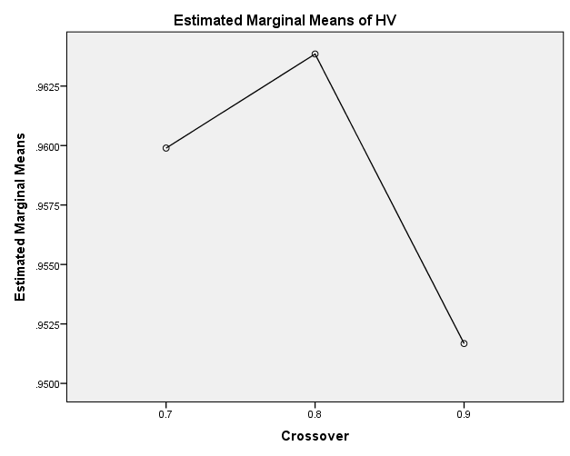

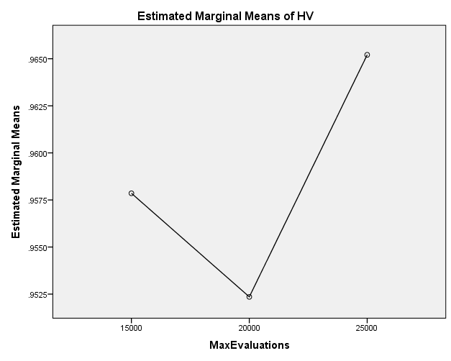

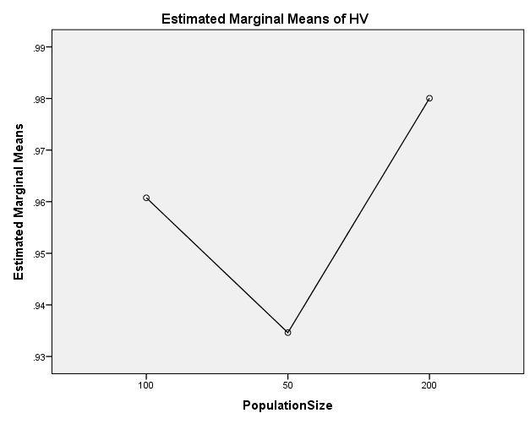

EP

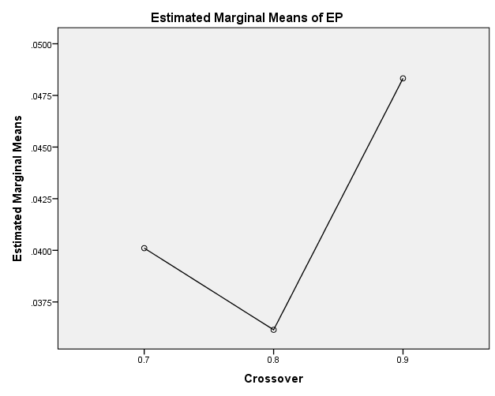

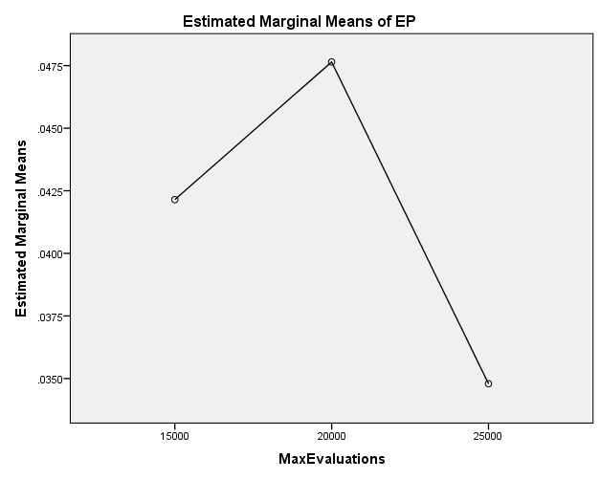

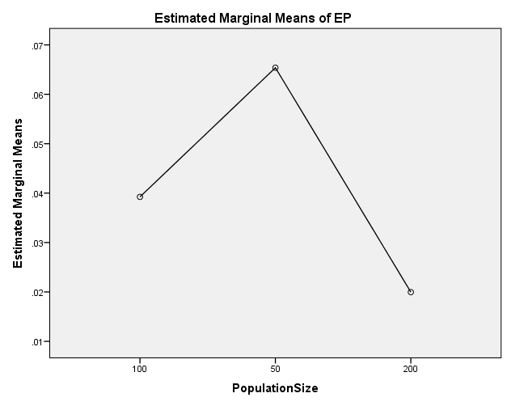

GD

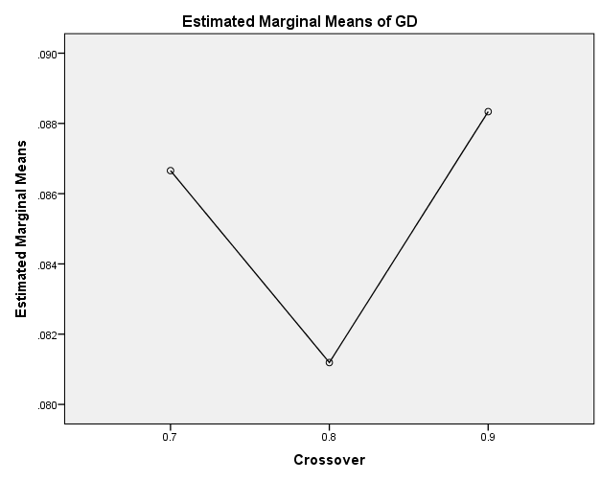

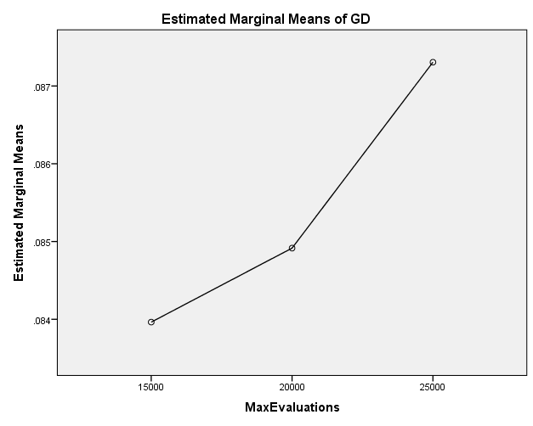

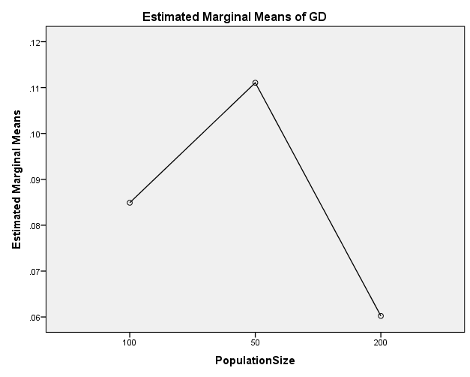

IGD

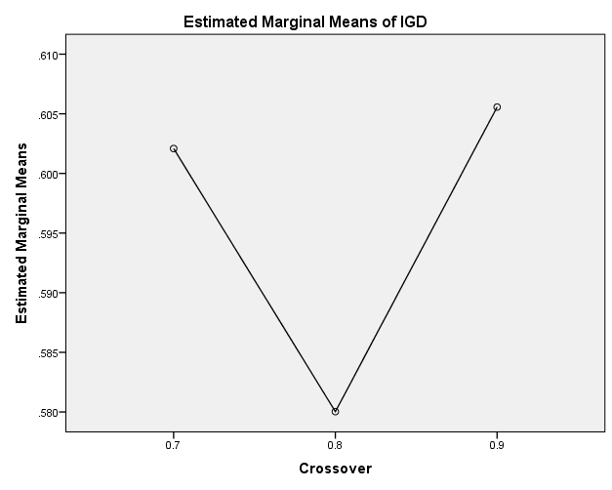

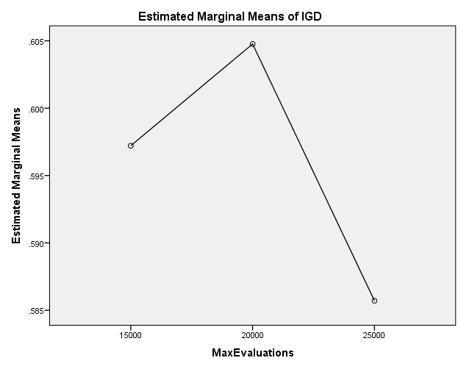

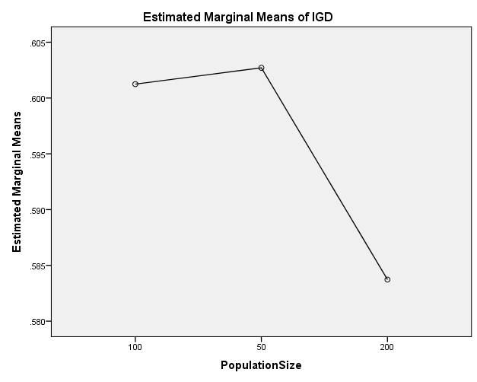

IGDplus

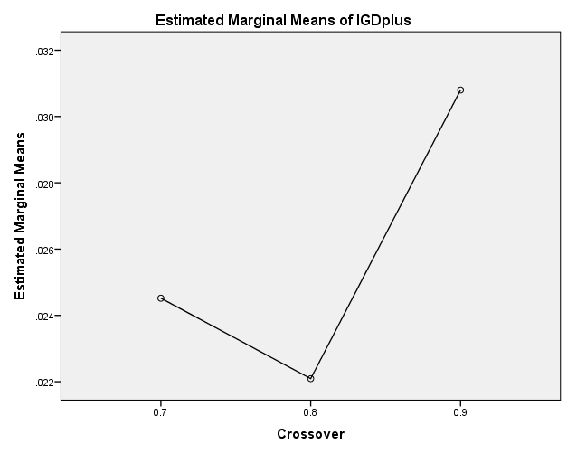

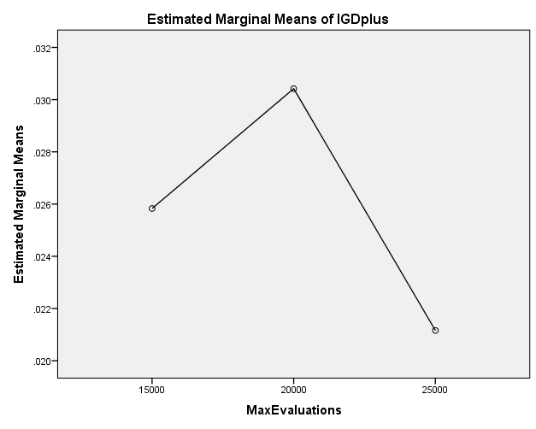

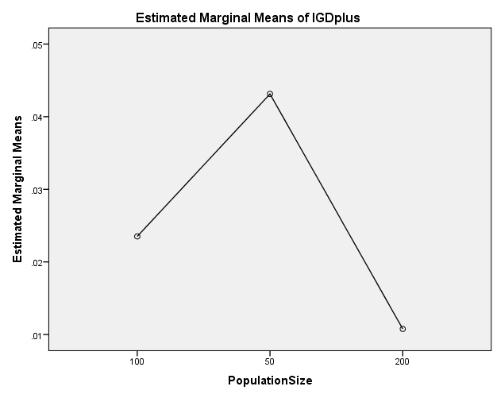

SPREAD

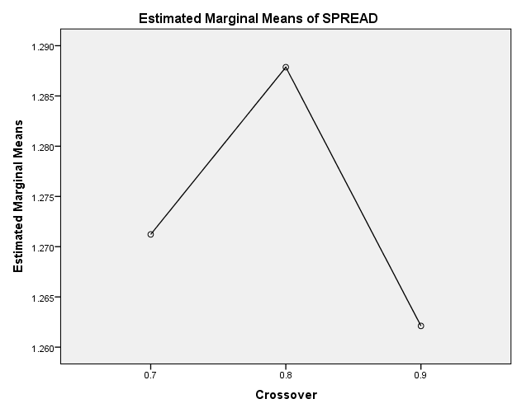

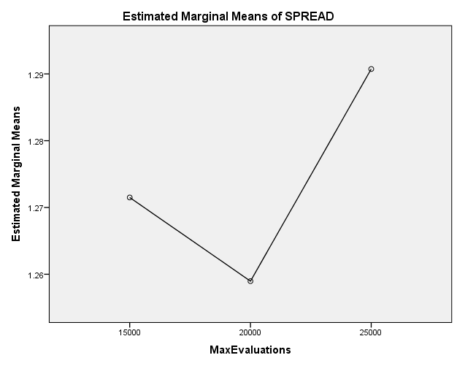

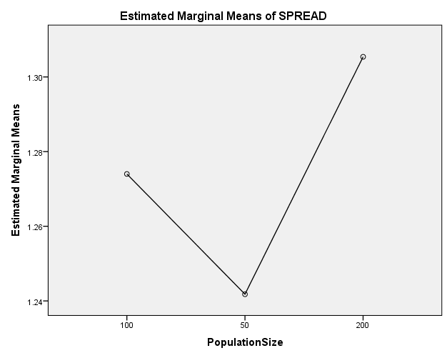

EXAMINE VARIABLES=HV EP GD IGD IGDplus SPREAD BY Crossover MaxEvaluations PopulationSize
/PLOT BOXPLOT
/COMPARE VARIABLES
/STATISTICS NONE
/CINTERVAL 95
/MISSING LISTWISE
/NOTOTAL.

Explore

Notes
Output Created |  | 26-MAY-2020 19:34:28
Comments
Input | Data | C:\Users\user\Documents\NILAY\Mayis2020\7_SPEA2.sav
Input | Active Dataset | DataSet1
Input | Filter | <none>
Input | Weight | <none>
Input | Split File | <none>
Input | N of Rows in Working Data File | 837
Missing Value Handling | Definition of Missing | User-defined missing values for dependent variables are treated as missing.
Missing Value Handling | Cases Used | Statistics are based on cases with no missing values for any dependent variable or factor used.
Syntax |  | EXAMINE VARIABLES=HV EP GD IGD IGDplus SPREAD BY Crossover MaxEvaluations PopulationSize  /PLOT BOXPLOT  /COMPARE VARIABLES  /STATISTICS NONE  /CINTERVAL 95  /MISSING LISTWISE  /NOTOTAL.
Resources | Processor Time | 00:00:01.70
Resources | Elapsed Time | 00:00:01.73

[DataSet1] C:\Users\user\Documents\NILAY\Mayis2020\7_SPEA2.sav

Crossover

Case Processing Summary
 | Crossover | Cases
 | Crossover | Valid |  | Missing |  | Total
 | Crossover | N | Percent | N | Percent | N | Percent
HV | 0.7 | 279 | 100.0% | 0 | 0.0% | 279 | 100.0%
HV | 0.8 | 279 | 100.0% | 0 | 0.0% | 279 | 100.0%
HV | 0.9 | 279 | 100.0% | 0 | 0.0% | 279 | 100.0%
EP | 0.7 | 279 | 100.0% | 0 | 0.0% | 279 | 100.0%
EP | 0.8 | 279 | 100.0% | 0 | 0.0% | 279 | 100.0%
EP | 0.9 | 279 | 100.0% | 0 | 0.0% | 279 | 100.0%
GD | 0.7 | 279 | 100.0% | 0 | 0.0% | 279 | 100.0%
GD | 0.8 | 279 | 100.0% | 0 | 0.0% | 279 | 100.0%
GD | 0.9 | 279 | 100.0% | 0 | 0.0% | 279 | 100.0%
IGD | 0.7 | 279 | 100.0% | 0 | 0.0% | 279 | 100.0%
IGD | 0.8 | 279 | 100.0% | 0 | 0.0% | 279 | 100.0%
IGD | 0.9 | 279 | 100.0% | 0 | 0.0% | 279 | 100.0%
IGDplus | 0.7 | 279 | 100.0% | 0 | 0.0% | 279 | 100.0%
IGDplus | 0.8 | 279 | 100.0% | 0 | 0.0% | 279 | 100.0%
IGDplus | 0.9 | 279 | 100.0% | 0 | 0.0% | 279 | 100.0%
SPREAD | 0.7 | 279 | 100.0% | 0 | 0.0% | 279 | 100.0%
SPREAD | 0.8 | 279 | 100.0% | 0 | 0.0% | 279 | 100.0%
SPREAD | 0.9 | 279 | 100.0% | 0 | 0.0% | 279 | 100.0%

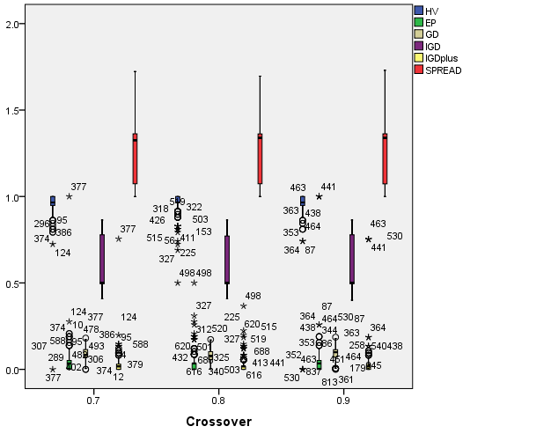

MaxEvaluations

Case Processing Summary
 | MaxEvaluations | Cases
 | MaxEvaluations | Valid |  | Missing |  | Total
 | MaxEvaluations | N | Percent | N | Percent | N | Percent
HV | 15000 | 279 | 100.0% | 0 | 0.0% | 279 | 100.0%
HV | 20000 | 279 | 100.0% | 0 | 0.0% | 279 | 100.0%
HV | 25000 | 279 | 100.0% | 0 | 0.0% | 279 | 100.0%
EP | 15000 | 279 | 100.0% | 0 | 0.0% | 279 | 100.0%
EP | 20000 | 279 | 100.0% | 0 | 0.0% | 279 | 100.0%
EP | 25000 | 279 | 100.0% | 0 | 0.0% | 279 | 100.0%
GD | 15000 | 279 | 100.0% | 0 | 0.0% | 279 | 100.0%
GD | 20000 | 279 | 100.0% | 0 | 0.0% | 279 | 100.0%
GD | 25000 | 279 | 100.0% | 0 | 0.0% | 279 | 100.0%
IGD | 15000 | 279 | 100.0% | 0 | 0.0% | 279 | 100.0%
IGD | 20000 | 279 | 100.0% | 0 | 0.0% | 279 | 100.0%
IGD | 25000 | 279 | 100.0% | 0 | 0.0% | 279 | 100.0%
IGDplus | 15000 | 279 | 100.0% | 0 | 0.0% | 279 | 100.0%
IGDplus | 20000 | 279 | 100.0% | 0 | 0.0% | 279 | 100.0%
IGDplus | 25000 | 279 | 100.0% | 0 | 0.0% | 279 | 100.0%
SPREAD | 15000 | 279 | 100.0% | 0 | 0.0% | 279 | 100.0%
SPREAD | 20000 | 279 | 100.0% | 0 | 0.0% | 279 | 100.0%
SPREAD | 25000 | 279 | 100.0% | 0 | 0.0% | 279 | 100.0%

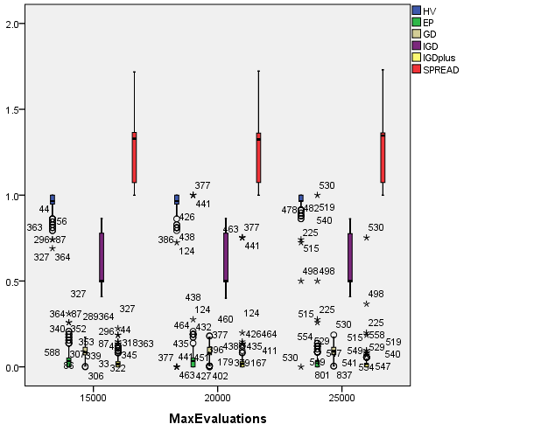

PopulationSize

Case Processing Summary
 | PopulationSize | Cases
 | PopulationSize | Valid |  | Missing |  | Total
 | PopulationSize | N | Percent | N | Percent | N | Percent
HV | 100 | 279 | 100.0% | 0 | 0.0% | 279 | 100.0%
HV | 50 | 279 | 100.0% | 0 | 0.0% | 279 | 100.0%
HV | 200 | 279 | 100.0% | 0 | 0.0% | 279 | 100.0%
EP | 100 | 279 | 100.0% | 0 | 0.0% | 279 | 100.0%
EP | 50 | 279 | 100.0% | 0 | 0.0% | 279 | 100.0%
EP | 200 | 279 | 100.0% | 0 | 0.0% | 279 | 100.0%
GD | 100 | 279 | 100.0% | 0 | 0.0% | 279 | 100.0%
GD | 50 | 279 | 100.0% | 0 | 0.0% | 279 | 100.0%
GD | 200 | 279 | 100.0% | 0 | 0.0% | 279 | 100.0%
IGD | 100 | 279 | 100.0% | 0 | 0.0% | 279 | 100.0%
IGD | 50 | 279 | 100.0% | 0 | 0.0% | 279 | 100.0%
IGD | 200 | 279 | 100.0% | 0 | 0.0% | 279 | 100.0%
IGDplus | 100 | 279 | 100.0% | 0 | 0.0% | 279 | 100.0%
IGDplus | 50 | 279 | 100.0% | 0 | 0.0% | 279 | 100.0%
IGDplus | 200 | 279 | 100.0% | 0 | 0.0% | 279 | 100.0%
SPREAD | 100 | 279 | 100.0% | 0 | 0.0% | 279 | 100.0%
SPREAD | 50 | 279 | 100.0% | 0 | 0.0% | 279 | 100.0%
SPREAD | 200 | 279 | 100.0% | 0 | 0.0% | 279 | 100.0%

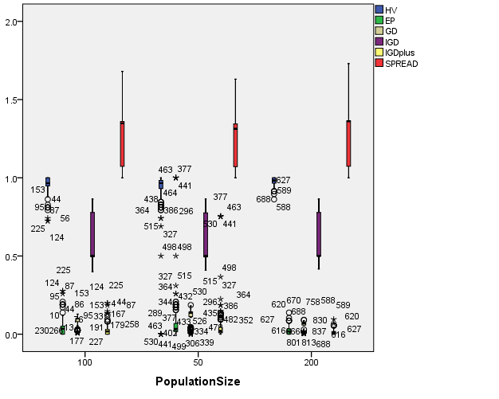

EXAMINE VARIABLES=HV EP GD IGD IGDplus SPREAD BY Crossover MaxEvaluations PopulationSize
/PLOT BOXPLOT
/COMPARE GROUPS
/STATISTICS NONE
/CINTERVAL 95
/MISSING LISTWISE
/NOTOTAL.

Explore

Notes
Output Created |  | 26-MAY-2020 19:36:30
Comments
Input | Data | C:\Users\user\Documents\NILAY\Mayis2020\7_SPEA2.sav
Input | Active Dataset | DataSet1
Input | Filter | <none>
Input | Weight | <none>
Input | Split File | <none>
Input | N of Rows in Working Data File | 837
Missing Value Handling | Definition of Missing | User-defined missing values for dependent variables are treated as missing.
Missing Value Handling | Cases Used | Statistics are based on cases with no missing values for any dependent variable or factor used.
Syntax |  | EXAMINE VARIABLES=HV EP GD IGD IGDplus SPREAD BY Crossover MaxEvaluations PopulationSize  /PLOT BOXPLOT  /COMPARE GROUPS  /STATISTICS NONE  /CINTERVAL 95  /MISSING LISTWISE  /NOTOTAL.
Resources | Processor Time | 00:00:04.13
Resources | Elapsed Time | 00:00:04.11

[DataSet1] C:\Users\user\Documents\NILAY\Mayis2020\7_SPEA2.sav

Crossover

Case Processing Summary
 | Crossover | Cases
 | Crossover | Valid |  | Missing |  | Total
 | Crossover | N | Percent | N | Percent | N | Percent
HV | 0.7 | 279 | 100.0% | 0 | 0.0% | 279 | 100.0%
HV | 0.8 | 279 | 100.0% | 0 | 0.0% | 279 | 100.0%
HV | 0.9 | 279 | 100.0% | 0 | 0.0% | 279 | 100.0%
EP | 0.7 | 279 | 100.0% | 0 | 0.0% | 279 | 100.0%
EP | 0.8 | 279 | 100.0% | 0 | 0.0% | 279 | 100.0%
EP | 0.9 | 279 | 100.0% | 0 | 0.0% | 279 | 100.0%
GD | 0.7 | 279 | 100.0% | 0 | 0.0% | 279 | 100.0%
GD | 0.8 | 279 | 100.0% | 0 | 0.0% | 279 | 100.0%
GD | 0.9 | 279 | 100.0% | 0 | 0.0% | 279 | 100.0%
IGD | 0.7 | 279 | 100.0% | 0 | 0.0% | 279 | 100.0%
IGD | 0.8 | 279 | 100.0% | 0 | 0.0% | 279 | 100.0%
IGD | 0.9 | 279 | 100.0% | 0 | 0.0% | 279 | 100.0%
IGDplus | 0.7 | 279 | 100.0% | 0 | 0.0% | 279 | 100.0%
IGDplus | 0.8 | 279 | 100.0% | 0 | 0.0% | 279 | 100.0%
IGDplus | 0.9 | 279 | 100.0% | 0 | 0.0% | 279 | 100.0%
SPREAD | 0.7 | 279 | 100.0% | 0 | 0.0% | 279 | 100.0%
SPREAD | 0.8 | 279 | 100.0% | 0 | 0.0% | 279 | 100.0%
SPREAD | 0.9 | 279 | 100.0% | 0 | 0.0% | 279 | 100.0%

HV

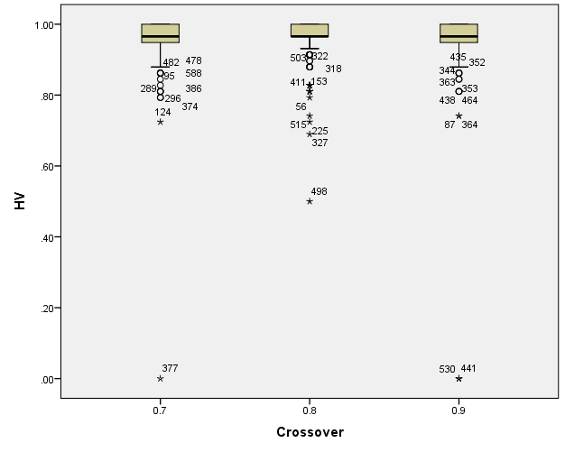

EP

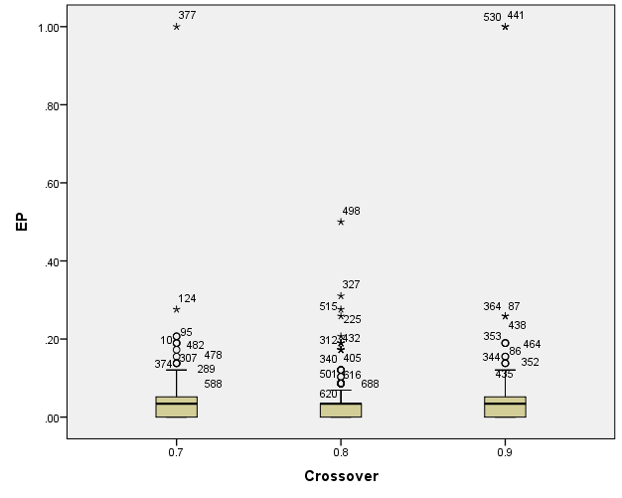

GD

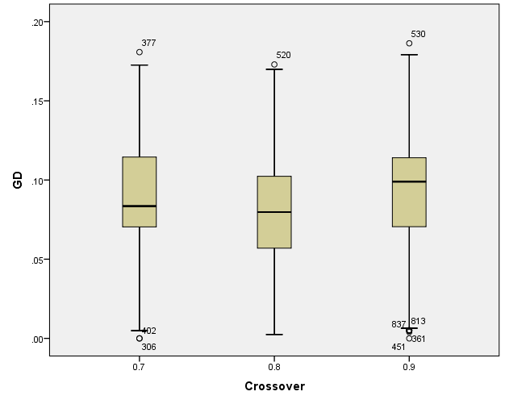

IGD

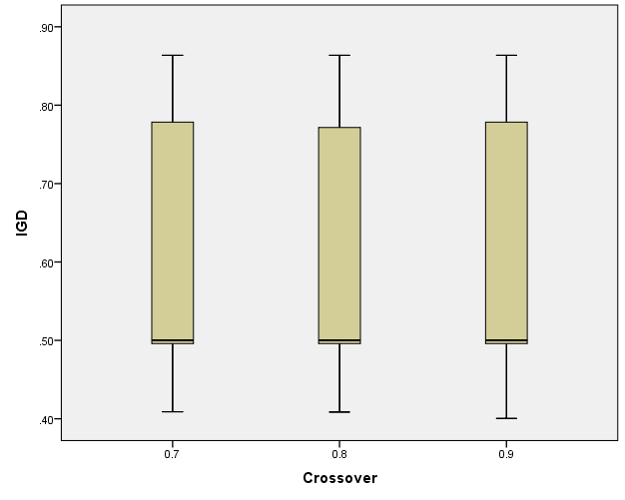

IGDplus

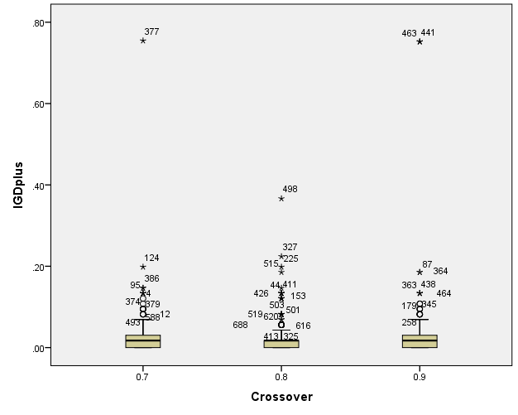

SPREAD

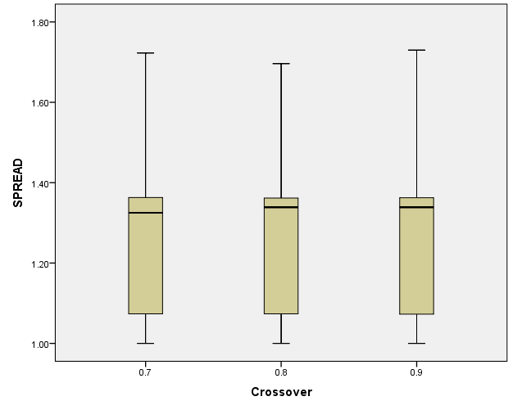

MaxEvaluations

Case Processing Summary
 | MaxEvaluations | Cases
 | MaxEvaluations | Valid |  | Missing |  | Total
 | MaxEvaluations | N | Percent | N | Percent | N | Percent
HV | 15000 | 279 | 100.0% | 0 | 0.0% | 279 | 100.0%
HV | 20000 | 279 | 100.0% | 0 | 0.0% | 279 | 100.0%
HV | 25000 | 279 | 100.0% | 0 | 0.0% | 279 | 100.0%
EP | 15000 | 279 | 100.0% | 0 | 0.0% | 279 | 100.0%
EP | 20000 | 279 | 100.0% | 0 | 0.0% | 279 | 100.0%
EP | 25000 | 279 | 100.0% | 0 | 0.0% | 279 | 100.0%
GD | 15000 | 279 | 100.0% | 0 | 0.0% | 279 | 100.0%
GD | 20000 | 279 | 100.0% | 0 | 0.0% | 279 | 100.0%
GD | 25000 | 279 | 100.0% | 0 | 0.0% | 279 | 100.0%
IGD | 15000 | 279 | 100.0% | 0 | 0.0% | 279 | 100.0%
IGD | 20000 | 279 | 100.0% | 0 | 0.0% | 279 | 100.0%
IGD | 25000 | 279 | 100.0% | 0 | 0.0% | 279 | 100.0%
IGDplus | 15000 | 279 | 100.0% | 0 | 0.0% | 279 | 100.0%
IGDplus | 20000 | 279 | 100.0% | 0 | 0.0% | 279 | 100.0%
IGDplus | 25000 | 279 | 100.0% | 0 | 0.0% | 279 | 100.0%
SPREAD | 15000 | 279 | 100.0% | 0 | 0.0% | 279 | 100.0%
SPREAD | 20000 | 279 | 100.0% | 0 | 0.0% | 279 | 100.0%
SPREAD | 25000 | 279 | 100.0% | 0 | 0.0% | 279 | 100.0%

HV

Boxplots

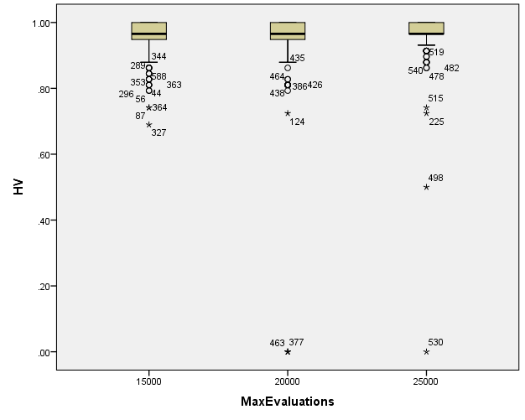

EP

Boxplots

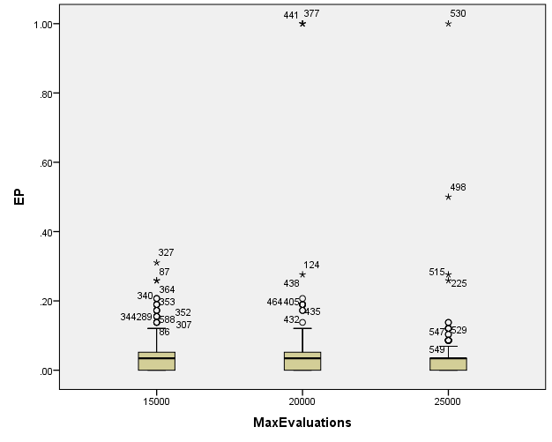

GD

Boxplots

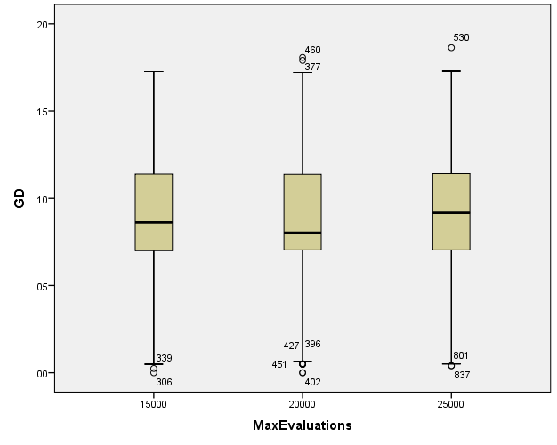

IGD

Boxplots

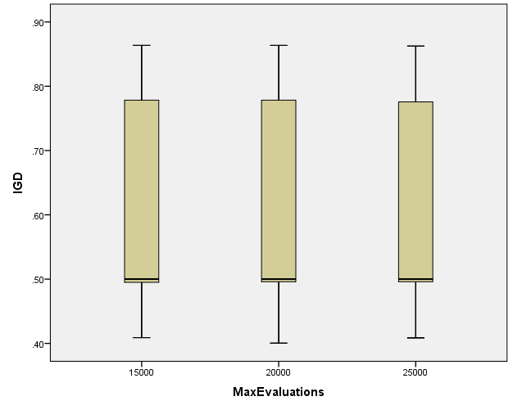

IGDplus

Boxplots

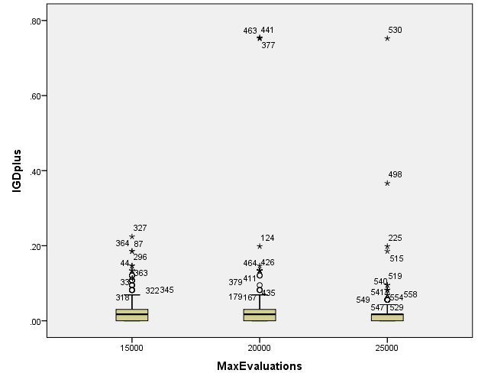

SPREAD

Boxplots

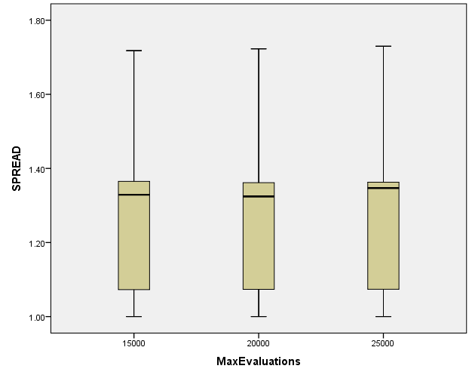

PopulationSize

Case Processing Summary
 | PopulationSize | Cases
 | PopulationSize | Valid |  | Missing |  | Total
 | PopulationSize | N | Percent | N | Percent | N | Percent
HV | 100 | 279 | 100.0% | 0 | 0.0% | 279 | 100.0%
HV | 50 | 279 | 100.0% | 0 | 0.0% | 279 | 100.0%
HV | 200 | 279 | 100.0% | 0 | 0.0% | 279 | 100.0%
EP | 100 | 279 | 100.0% | 0 | 0.0% | 279 | 100.0%
EP | 50 | 279 | 100.0% | 0 | 0.0% | 279 | 100.0%
EP | 200 | 279 | 100.0% | 0 | 0.0% | 279 | 100.0%
GD | 100 | 279 | 100.0% | 0 | 0.0% | 279 | 100.0%
GD | 50 | 279 | 100.0% | 0 | 0.0% | 279 | 100.0%
GD | 200 | 279 | 100.0% | 0 | 0.0% | 279 | 100.0%
IGD | 100 | 279 | 100.0% | 0 | 0.0% | 279 | 100.0%
IGD | 50 | 279 | 100.0% | 0 | 0.0% | 279 | 100.0%
IGD | 200 | 279 | 100.0% | 0 | 0.0% | 279 | 100.0%
IGDplus | 100 | 279 | 100.0% | 0 | 0.0% | 279 | 100.0%
IGDplus | 50 | 279 | 100.0% | 0 | 0.0% | 279 | 100.0%
IGDplus | 200 | 279 | 100.0% | 0 | 0.0% | 279 | 100.0%
SPREAD | 100 | 279 | 100.0% | 0 | 0.0% | 279 | 100.0%
SPREAD | 50 | 279 | 100.0% | 0 | 0.0% | 279 | 100.0%
SPREAD | 200 | 279 | 100.0% | 0 | 0.0% | 279 | 100.0%

HV

Boxplots

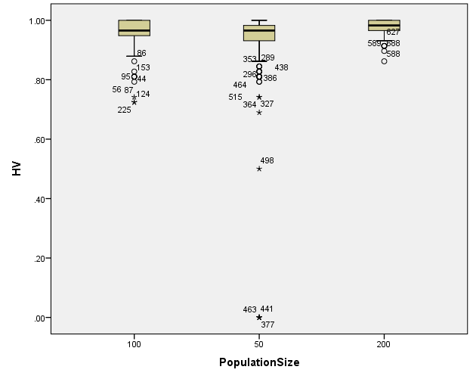

EP

Boxplots

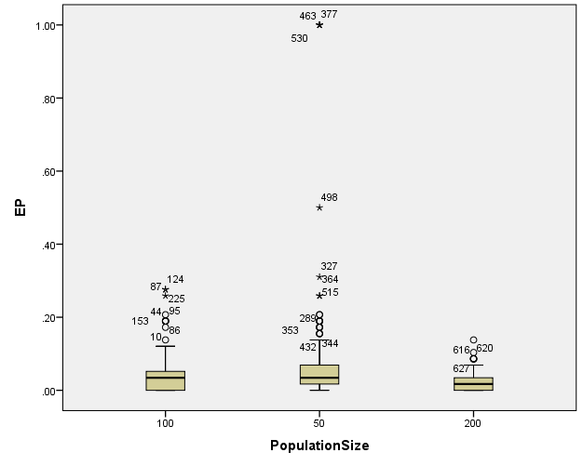

GD

Boxplots

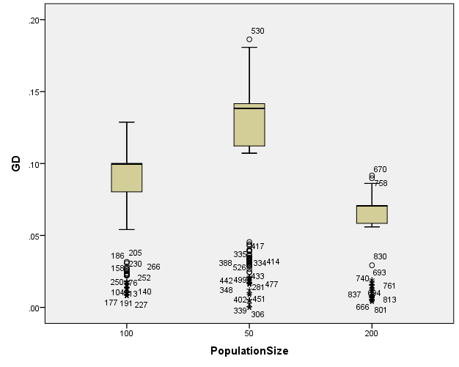

IGD

Boxplots

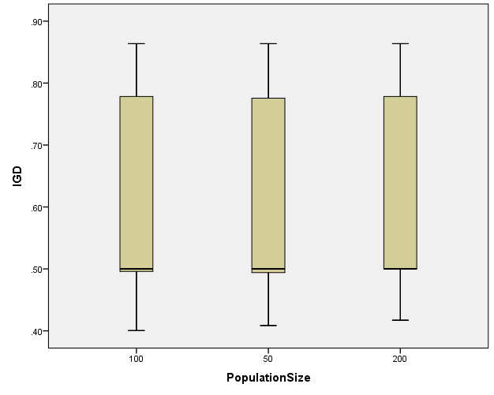

IGDplus

Boxplots

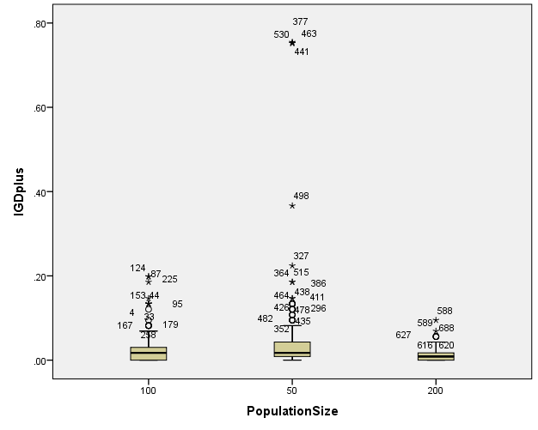

SPREAD

Boxplots

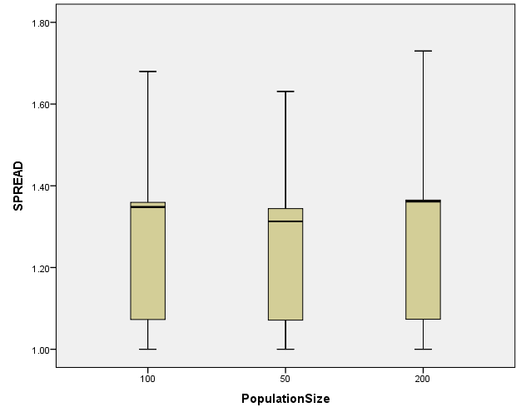

*Nonparametric Tests: Independent Samples.
NPTESTS
/INDEPENDENT TEST (HV EP GD IGD IGDplus SPREAD) GROUP (Crossover) MEDIAN(TESTVALUE=SAMPLE COMPARE=PAIRWISE)
/MISSING SCOPE=ANALYSIS USERMISSING=EXCLUDE
/CRITERIA ALPHA=0.05 CILEVEL=95.

Nonparametric Tests

Notes
Output Created |  | 26-MAY-2020 19:38:04
Comments
Input | Data | C:\Users\user\Documents\NILAY\Mayis2020\7_SPEA2.sav
Input | Active Dataset | DataSet1
Input | Filter | <none>
Input | Weight | <none>
Input | Split File | <none>
Input | N of Rows in Working Data File | 837
Syntax |  | NPTESTS  /INDEPENDENT TEST (HV EP GD IGD IGDplus SPREAD) GROUP (Crossover) MEDIAN(TESTVALUE=SAMPLE COMPARE=PAIRWISE)  /MISSING SCOPE=ANALYSIS USERMISSING=EXCLUDE  /CRITERIA ALPHA=0.05 CILEVEL=95.
Resources | Processor Time | 00:00:00.33
Resources | Elapsed Time | 00:00:00.80

[DataSet1] C:\Users\user\Documents\NILAY\Mayis2020\7_SPEA2.sav

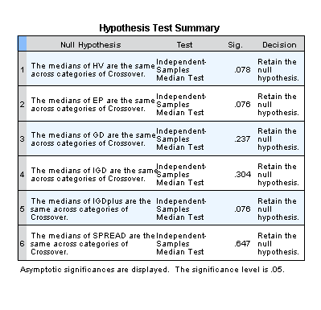

*Nonparametric Tests: Independent Samples.
NPTESTS
/INDEPENDENT TEST (HV EP GD IGD IGDplus SPREAD) GROUP (MaxEvaluations) MEDIAN(TESTVALUE=SAMPLE COMPARE=PAIRWISE)
/MISSING SCOPE=ANALYSIS USERMISSING=EXCLUDE
/CRITERIA ALPHA=0.05 CILEVEL=95.

Nonparametric Tests

Notes
Output Created |  | 26-MAY-2020 19:38:23
Comments
Input | Data | C:\Users\user\Documents\NILAY\Mayis2020\7_SPEA2.sav
Input | Active Dataset | DataSet1
Input | Filter | <none>
Input | Weight | <none>
Input | Split File | <none>
Input | N of Rows in Working Data File | 837
Syntax |  | NPTESTS  /INDEPENDENT TEST (HV EP GD IGD IGDplus SPREAD) GROUP (MaxEvaluations) MEDIAN(TESTVALUE=SAMPLE COMPARE=PAIRWISE)  /MISSING SCOPE=ANALYSIS USERMISSING=EXCLUDE  /CRITERIA ALPHA=0.05 CILEVEL=95.
Resources | Processor Time | 00:00:00.19
Resources | Elapsed Time | 00:00:00.14

[DataSet1] C:\Users\user\Documents\NILAY\Mayis2020\7_SPEA2.sav

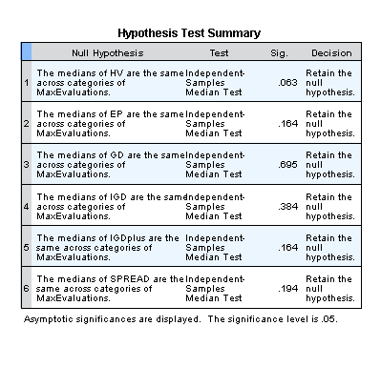

*Nonparametric Tests: Independent Samples.
NPTESTS
/INDEPENDENT TEST (HV EP GD IGD IGDplus SPREAD) GROUP (PopulationSize) MEDIAN(TESTVALUE=SAMPLE COMPARE=PAIRWISE)
/MISSING SCOPE=ANALYSIS USERMISSING=EXCLUDE
/CRITERIA ALPHA=0.05 CILEVEL=95.

Nonparametric Tests

Notes
Output Created |  | 26-MAY-2020 19:38:41
Comments
Input | Data | C:\Users\user\Documents\NILAY\Mayis2020\7_SPEA2.sav
Input | Active Dataset | DataSet1
Input | Filter | <none>
Input | Weight | <none>
Input | Split File | <none>
Input | N of Rows in Working Data File | 837
Syntax |  | NPTESTS  /INDEPENDENT TEST (HV EP GD IGD IGDplus SPREAD) GROUP (PopulationSize) MEDIAN(TESTVALUE=SAMPLE COMPARE=PAIRWISE)  /MISSING SCOPE=ANALYSIS USERMISSING=EXCLUDE  /CRITERIA ALPHA=0.05 CILEVEL=95.
Resources | Processor Time | 00:00:00.22
Resources | Elapsed Time | 00:00:00.17

[DataSet1] C:\Users\user\Documents\NILAY\Mayis2020\7_SPEA2.sav

