SAVE OUTFILE='C:\Users\user\Documents\NILAY\Mayis2020\medium_NSGAII.sav'
/COMPRESSED.
GLM HV EP GD IGD IGDplus SPREAD BY Crossover MaxEvaluations PopulationSize
/METHOD=SSTYPE(3)
/INTERCEPT=INCLUDE
/POSTHOC=Crossover MaxEvaluations PopulationSize(BONFERRONI)
/PLOT=PROFILE(Crossover MaxEvaluations PopulationSize)
/CRITERIA=ALPHA(.05)
/DESIGN=Crossover MaxEvaluations PopulationSize.

General Linear Model

Notes
Output Created |  | 26-MAY-2020 20:14:13
Comments
Input | Data | C:\Users\user\Documents\NILAY\Mayis2020\medium_NSGAII.sav
Input | Active Dataset | DataSet1
Input | Filter | <none>
Input | Weight | <none>
Input | Split File | <none>
Input | N of Rows in Working Data File | 837
Missing Value Handling | Definition of Missing | User-defined missing values are treated as missing.
Missing Value Handling | Cases Used | Statistics are based on all cases with valid data for all variables in the model.
Syntax |  | GLM HV EP GD IGD IGDplus SPREAD BY Crossover MaxEvaluations PopulationSize  /METHOD=SSTYPE(3)  /INTERCEPT=INCLUDE  /POSTHOC=Crossover MaxEvaluations PopulationSize(BONFERRONI)  /PLOT=PROFILE(Crossover MaxEvaluations PopulationSize)  /CRITERIA=ALPHA(.05)  /DESIGN=Crossover MaxEvaluations PopulationSize.
Resources | Processor Time | 00:00:03.30
Resources | Elapsed Time | 00:00:03.20

[DataSet1] C:\Users\user\Documents\NILAY\Mayis2020\medium_NSGAII.sav

Between-Subjects Factors
 |  | Value Label | N
Crossover | 1 | 0.7 | 279
Crossover | 2 | 0.8 | 279
Crossover | 3 | 0.9 | 279
MaxEvaluations | 1 | 15000 | 279
MaxEvaluations | 2 | 20000 | 279
MaxEvaluations | 3 | 25000 | 279
PopulationSize | 1 | 100 | 279
PopulationSize | 2 | 50 | 279
PopulationSize | 3 | 200 | 279

Multivariate Testsª
Effect |  | Value | F | Hypothesis df | Error df
Intercept | Pillai's Trace | 1.000 | 684849.521^{b} | 6.000 | 825.000
Intercept | Wilks' Lambda | .000 | 684849.521^{b} | 6.000 | 825.000
Intercept | Hotelling's Trace | 4980.724 | 684849.521^{b} | 6.000 | 825.000
Intercept | Roy's Largest Root | 4980.724 | 684849.521^{b} | 6.000 | 825.000
Crossover | Pillai's Trace | .043 | 2.992 | 12.000 | 1652.000
Crossover | Wilks' Lambda | .958 | 3.008^{b} | 12.000 | 1650.000
Crossover | Hotelling's Trace | .044 | 3.023 | 12.000 | 1648.000
Crossover | Roy's Largest Root | .039 | 5.365^{c} | 6.000 | 826.000
MaxEvaluations | Pillai's Trace | .144 | 10.705 | 12.000 | 1652.000
MaxEvaluations | Wilks' Lambda | .857 | 11.011^{b} | 12.000 | 1650.000
MaxEvaluations | Hotelling's Trace | .165 | 11.317 | 12.000 | 1648.000
MaxEvaluations | Roy's Largest Root | .153 | 21.106^{c} | 6.000 | 826.000
PopulationSize | Pillai's Trace | .488 | 44.454 | 12.000 | 1652.000
PopulationSize | Wilks' Lambda | .521 | 52.920^{b} | 12.000 | 1650.000
PopulationSize | Hotelling's Trace | .899 | 61.763 | 12.000 | 1648.000
PopulationSize | Roy's Largest Root | .879 | 120.941^{c} | 6.000 | 826.000

Multivariate Testsª
Effect |  | Sig.
Intercept | Pillai's Trace | .000
Intercept | Wilks' Lambda | .000
Intercept | Hotelling's Trace | .000
Intercept | Roy's Largest Root | .000
Crossover | Pillai's Trace | .000
Crossover | Wilks' Lambda | .000
Crossover | Hotelling's Trace | .000
Crossover | Roy's Largest Root | .000
MaxEvaluations | Pillai's Trace | .000
MaxEvaluations | Wilks' Lambda | .000
MaxEvaluations | Hotelling's Trace | .000
MaxEvaluations | Roy's Largest Root | .000
PopulationSize | Pillai's Trace | .000
PopulationSize | Wilks' Lambda | .000
PopulationSize | Hotelling's Trace | .000
PopulationSize | Roy's Largest Root | .000

a. Design: Intercept + Crossover + MaxEvaluations + PopulationSize
b. Exact statistic
c. The statistic is an upper bound on F that yields a lower bound on the significance level.

Tests of Between-Subjects Effects
Source | Dependent Variable | Type III Sum of Squares | df | Mean Square | F
Corrected Model | HV | 2.115ª | 6 | .352 | 58.875
Corrected Model | EP | 1.402^{b} | 6 | .234 | 59.228
Corrected Model | GD | 2.206^{c} | 6 | .368 | 77.426
Corrected Model | IGD | .144^{d} | 6 | .024 | 13.971
Corrected Model | IGDplus | .906e | 6 | .151 | 61.809
Corrected Model | SPREAD | .572^{f} | 6 | .095 | 15.901
Intercept | HV | 474.423 | 1 | 474.423 | 79246.389
Intercept | EP | 23.822 | 1 | 23.822 | 6037.819
Intercept | GD | 5.905 | 1 | 5.905 | 1243.620
Intercept | IGD | 154.232 | 1 | 154.232 | 89645.621
Intercept | IGDplus | 12.857 | 1 | 12.857 | 5265.178
Intercept | SPREAD | 875.402 | 1 | 875.402 | 146097.696
Crossover | HV | .018 | 2 | .009 | 1.522
Crossover | EP | .014 | 2 | .007 | 1.798
Crossover | GD | .017 | 2 | .008 | 1.755
Crossover | IGD | .023 | 2 | .012 | 6.750
Crossover | IGDplus | .009 | 2 | .004 | 1.796
Crossover | SPREAD | .021 | 2 | .011 | 1.775
MaxEvaluations | HV | .522 | 2 | .261 | 43.606
MaxEvaluations | EP | .350 | 2 | .175 | 44.386
MaxEvaluations | GD | .197 | 2 | .099 | 20.766
MaxEvaluations | IGD | .012 | 2 | .006 | 3.470
MaxEvaluations | IGDplus | .236 | 2 | .118 | 48.387
MaxEvaluations | SPREAD | .229 | 2 | .114 | 19.093
PopulationSize | HV | 1.574 | 2 | .787 | 131.496
PopulationSize | EP | 1.038 | 2 | .519 | 131.502
PopulationSize | GD | 1.992 | 2 | .996 | 209.756
PopulationSize | IGD | .109 | 2 | .055 | 31.693
PopulationSize | IGDplus | .660 | 2 | .330 | 135.243
PopulationSize | SPREAD | .322 | 2 | .161 | 26.835
Error | HV | 4.969 | 830 | .006
Error | EP | 3.275 | 830 | .004
Error | GD | 3.941 | 830 | .005
Error | IGD | 1.428 | 830 | .002
Error | IGDplus | 2.027 | 830 | .002

Tests of Between-Subjects Effects
Source | Dependent Variable | Sig.
Corrected Model | HV | .000ª
Corrected Model | EP | .000^{b}
Corrected Model | GD | .000^{c}
Corrected Model | IGD | .000^{d}
Corrected Model | IGDplus | .000e
Corrected Model | SPREAD | .000^{f}
Intercept | HV | .000
Intercept | EP | .000
Intercept | GD | .000
Intercept | IGD | .000
Intercept | IGDplus | .000
Intercept | SPREAD | .000
Crossover | HV | .219
Crossover | EP | .166
Crossover | GD | .174
Crossover | IGD | .001
Crossover | IGDplus | .167
Crossover | SPREAD | .170
MaxEvaluations | HV | .000
MaxEvaluations | EP | .000
MaxEvaluations | GD | .000
MaxEvaluations | IGD | .032
MaxEvaluations | IGDplus | .000
MaxEvaluations | SPREAD | .000
PopulationSize | HV | .000
PopulationSize | EP | .000
PopulationSize | GD | .000
PopulationSize | IGD | .000
PopulationSize | IGDplus | .000
PopulationSize | SPREAD | .000
Error | HV
Error | EP
Error | GD
Error | IGD
Error | IGDplus

Tests of Between-Subjects Effects
Source | Dependent Variable | Type III Sum of Squares | df | Mean Square | F
Error | SPREAD | 4.973ª | 830 | .006
Total | HV | 481.507^{b} | 837
Total | EP | 28.499^{c} | 837
Total | GD | 12.051^{d} | 837
Total | IGD | 155.805e | 837
Total | IGDplus | 15.789^{f} | 837
Total | SPREAD | 880.947 | 837
Corrected Total | HV | 7.084 | 836
Corrected Total | EP | 4.677 | 836
Corrected Total | GD | 6.146 | 836
Corrected Total | IGD | 1.572 | 836
Corrected Total | IGDplus | 2.932 | 836
Corrected Total | SPREAD | 5.545 | 836

Tests of Between-Subjects Effects
Source | Dependent Variable | Sig.
Error | SPREAD
Total | HV
Total | EP
Total | GD
Total | IGD
Total | IGDplus
Total | SPREAD
Corrected Total | HV
Corrected Total | EP
Corrected Total | GD
Corrected Total | IGD
Corrected Total | IGDplus
Corrected Total | SPREAD

a. R Squared = .299 (Adjusted R Squared = .293)
b. R Squared = .300 (Adjusted R Squared = .295)
c. R Squared = .359 (Adjusted R Squared = .354)
d. R Squared = .092 (Adjusted R Squared = .085)
e. R Squared = .309 (Adjusted R Squared = .304)
f. R Squared = .103 (Adjusted R Squared = .097)

Post Hoc Tests

Crossover

Multiple Comparisons
Bonferroni
Dependent Variable | (I) Crossover | (J) Crossover | Mean Difference (I-J) | Std. Error | Sig.
HV | 0.7 | 0.8 | .0112 | .00655 | .267
HV | 0.7 | 0.9 | .0034 | .00655 | 1.000
HV | 0.8 | 0.7 | -.0112 | .00655 | .267
HV | 0.8 | 0.9 | -.0078 | .00655 | .711
HV | 0.9 | 0.7 | -.0034 | .00655 | 1.000
HV | 0.9 | 0.8 | .0078 | .00655 | .711
EP | 0.7 | 0.8 | -.0101 | .00532 | .177
EP | 0.7 | 0.9 | -.0056 | .00532 | .871
EP | 0.8 | 0.7 | .0101 | .00532 | .177
EP | 0.8 | 0.9 | .0044 | .00532 | 1.000
EP | 0.9 | 0.7 | .0056 | .00532 | .871
EP | 0.9 | 0.8 | -.0044 | .00532 | 1.000
GD | 0.7 | 0.8 | -.0028 | .00583 | 1.000
GD | 0.7 | 0.9 | -.0105 | .00583 | .213
GD | 0.8 | 0.7 | .0028 | .00583 | 1.000
GD | 0.8 | 0.9 | -.0078 | .00583 | .550
GD | 0.9 | 0.7 | .0105 | .00583 | .213
GD | 0.9 | 0.8 | .0078 | .00583 | .550
IGD | 0.7 | 0.8 | .0008 | .00351 | 1.000
IGD | 0.7 | 0.9 | .0115* | .00351 | .003
IGD | 0.8 | 0.7 | -.0008 | .00351 | 1.000
IGD | 0.8 | 0.9 | .0108* | .00351 | .007
IGD | 0.9 | 0.7 | -.0115* | .00351 | .003
IGD | 0.9 | 0.8 | -.0108* | .00351 | .007
IGDplus | 0.7 | 0.8 | -.0079 | .00418 | .177
IGDplus | 0.7 | 0.9 | -.0035 | .00418 | 1.000
IGDplus | 0.8 | 0.7 | .0079 | .00418 | .177
IGDplus | 0.8 | 0.9 | .0044 | .00418 | .869
IGDplus | 0.9 | 0.7 | .0035 | .00418 | 1.000
IGDplus | 0.9 | 0.8 | -.0044 | .00418 | .869
SPREAD | 0.7 | 0.8 | .0041 | .00655 | 1.000
SPREAD | 0.7 | 0.9 | .0121 | .00655 | .193
SPREAD | 0.8 | 0.7 | -.0041 | .00655 | 1.000

Multiple Comparisons
Bonferroni
Dependent Variable | (I) Crossover | (J) Crossover | 95% Confidence Interval
Dependent Variable | (I) Crossover | (J) Crossover | Lower Bound | Upper Bound
HV | 0.7 | 0.8 | -.0046 | .0269
HV | 0.7 | 0.9 | -.0123 | .0191
HV | 0.8 | 0.7 | -.0269 | .0046
HV | 0.8 | 0.9 | -.0235 | .0080
HV | 0.9 | 0.7 | -.0191 | .0123
HV | 0.9 | 0.8 | -.0080 | .0235
EP | 0.7 | 0.8 | -.0228 | .0027
EP | 0.7 | 0.9 | -.0184 | .0071
EP | 0.8 | 0.7 | -.0027 | .0228
EP | 0.8 | 0.9 | -.0083 | .0172
EP | 0.9 | 0.7 | -.0071 | .0184
EP | 0.9 | 0.8 | -.0172 | .0083
GD | 0.7 | 0.8 | -.0168 | .0112
GD | 0.7 | 0.9 | -.0245 | .0035
GD | 0.8 | 0.7 | -.0112 | .0168
GD | 0.8 | 0.9 | -.0218 | .0062
GD | 0.9 | 0.7 | -.0035 | .0245
GD | 0.9 | 0.8 | -.0062 | .0218
IGD | 0.7 | 0.8 | -.0076 | .0092
IGD | 0.7 | 0.9 | .0031* | .0200
IGD | 0.8 | 0.7 | -.0092 | .0076
IGD | 0.8 | 0.9 | .0023* | .0192
IGD | 0.9 | 0.7 | -.0200* | -.0031
IGD | 0.9 | 0.8 | -.0192* | -.0023
IGDplus | 0.7 | 0.8 | -.0179 | .0021
IGDplus | 0.7 | 0.9 | -.0135 | .0066
IGDplus | 0.8 | 0.7 | -.0021 | .0179
IGDplus | 0.8 | 0.9 | -.0056 | .0145
IGDplus | 0.9 | 0.7 | -.0066 | .0135
IGDplus | 0.9 | 0.8 | -.0145 | .0056
SPREAD | 0.7 | 0.8 | -.0117 | .0198
SPREAD | 0.7 | 0.9 | -.0036 | .0279
SPREAD | 0.8 | 0.7 | -.0198 | .0117

Multiple Comparisons
Bonferroni
Dependent Variable | (I) Crossover | (J) Crossover | Mean Difference (I-J) | Std. Error | Sig.
SPREAD | 0.8 | 0.9 | .0081 | .00655 | .657
SPREAD | 0.9 | 0.7 | -.0121 | .00655 | .193
SPREAD | 0.9 | 0.8 | -.0081 | .00655 | .657

Multiple Comparisons
Bonferroni
Dependent Variable | (I) Crossover | (J) Crossover | 95% Confidence Interval
Dependent Variable | (I) Crossover | (J) Crossover | Lower Bound | Upper Bound
SPREAD | 0.8 | 0.9 | -.0077 | .0238
SPREAD | 0.9 | 0.7 | -.0279 | .0036
SPREAD | 0.9 | 0.8 | -.0238 | .0077

Based on observed means.
The error term is Mean Square(Error) = .006.
*. The mean difference is significant at the .05 level.

Homogeneous Subsets

MaxEvaluations

Multiple Comparisons
Bonferroni
Dependent Variable | (I) MaxEvaluations | (J) MaxEvaluations | Mean Difference (I-J) | Std. Error | Sig.
HV | 15000 | 20000 | -.0374* | .00655 | .000
HV | 15000 | 25000 | -.0606* | .00655 | .000
HV | 20000 | 15000 | .0374* | .00655 | .000
HV | 20000 | 25000 | -.0233* | .00655 | .001
HV | 25000 | 15000 | .0606* | .00655 | .000
HV | 25000 | 20000 | .0233* | .00655 | .001
EP | 15000 | 20000 | .0319* | .00532 | .000
EP | 15000 | 25000 | .0494* | .00532 | .000
EP | 20000 | 15000 | -.0319* | .00532 | .000
EP | 20000 | 25000 | .0175* | .00532 | .003
EP | 25000 | 15000 | -.0494* | .00532 | .000
EP | 25000 | 20000 | -.0175* | .00532 | .003
GD | 15000 | 20000 | .0185* | .00583 | .005
GD | 15000 | 25000 | .0376* | .00583 | .000
GD | 20000 | 15000 | -.0185* | .00583 | .005
GD | 20000 | 25000 | .0191* | .00583 | .003
GD | 25000 | 15000 | -.0376* | .00583 | .000
GD | 25000 | 20000 | -.0191* | .00583 | .003
IGD | 15000 | 20000 | -.0085* | .00351 | .049
IGD | 15000 | 25000 | -.0075 | .00351 | .101
IGD | 20000 | 15000 | .0085* | .00351 | .049
IGD | 20000 | 25000 | .0010 | .00351 | 1.000
IGD | 25000 | 15000 | .0075 | .00351 | .101
IGD | 25000 | 20000 | -.0010 | .00351 | 1.000
IGDplus | 15000 | 20000 | .0263* | .00418 | .000
IGDplus | 15000 | 25000 | .0406* | .00418 | .000
IGDplus | 20000 | 15000 | -.0263* | .00418 | .000
IGDplus | 20000 | 25000 | .0142* | .00418 | .002
IGDplus | 25000 | 15000 | -.0406* | .00418 | .000
IGDplus | 25000 | 20000 | -.0142* | .00418 | .002
SPREAD | 15000 | 20000 | -.0150 | .00655 | .068
SPREAD | 15000 | 25000 | -.0401* | .00655 | .000
SPREAD | 20000 | 15000 | .0150 | .00655 | .068

Multiple Comparisons
Bonferroni
Dependent Variable | (I) MaxEvaluations | (J) MaxEvaluations | 95% Confidence Interval
Dependent Variable | (I) MaxEvaluations | (J) MaxEvaluations | Lower Bound | Upper Bound
HV | 15000 | 20000 | -.0531* | -.0217
HV | 15000 | 25000 | -.0763* | -.0449
HV | 20000 | 15000 | .0217* | .0531
HV | 20000 | 25000 | -.0390* | -.0075
HV | 25000 | 15000 | .0449* | .0763
HV | 25000 | 20000 | .0075* | .0390
EP | 15000 | 20000 | .0191* | .0446
EP | 15000 | 25000 | .0367* | .0622
EP | 20000 | 15000 | -.0446* | -.0191
EP | 20000 | 25000 | .0048* | .0303
EP | 25000 | 15000 | -.0622* | -.0367
EP | 25000 | 20000 | -.0303* | -.0048
GD | 15000 | 20000 | .0045* | .0325
GD | 15000 | 25000 | .0236* | .0516
GD | 20000 | 15000 | -.0325* | -.0045
GD | 20000 | 25000 | .0051* | .0331
GD | 25000 | 15000 | -.0516* | -.0236
GD | 25000 | 20000 | -.0331* | -.0051
IGD | 15000 | 20000 | -.0169* | .0000
IGD | 15000 | 25000 | -.0159 | .0010
IGD | 20000 | 15000 | .0000* | .0169
IGD | 20000 | 25000 | -.0074 | .0094
IGD | 25000 | 15000 | -.0010 | .0159
IGD | 25000 | 20000 | -.0094 | .0074
IGDplus | 15000 | 20000 | .0163* | .0364
IGDplus | 15000 | 25000 | .0305* | .0506
IGDplus | 20000 | 15000 | -.0364* | -.0163
IGDplus | 20000 | 25000 | .0042* | .0242
IGDplus | 25000 | 15000 | -.0506* | -.0305
IGDplus | 25000 | 20000 | -.0242* | -.0042
SPREAD | 15000 | 20000 | -.0307 | .0008
SPREAD | 15000 | 25000 | -.0558* | -.0244
SPREAD | 20000 | 15000 | -.0008 | .0307

Multiple Comparisons
Bonferroni
Dependent Variable | (I) MaxEvaluations | (J) MaxEvaluations | Mean Difference (I-J) | Std. Error | Sig.
SPREAD | 20000 | 25000 | -.0251* | .00655 | .000
SPREAD | 25000 | 15000 | .0401* | .00655 | .000
SPREAD | 25000 | 20000 | .0251* | .00655 | .000

Multiple Comparisons
Bonferroni
Dependent Variable | (I) MaxEvaluations | (J) MaxEvaluations | 95% Confidence Interval
Dependent Variable | (I) MaxEvaluations | (J) MaxEvaluations | Lower Bound | Upper Bound
SPREAD | 20000 | 25000 | -.0408* | -.0094
SPREAD | 25000 | 15000 | .0244* | .0558
SPREAD | 25000 | 20000 | .0094* | .0408

Based on observed means.
The error term is Mean Square(Error) = .006.
*. The mean difference is significant at the .05 level.

Homogeneous Subsets

PopulationSize

Multiple Comparisons
Bonferroni
Dependent Variable | (I) PopulationSize | (J) PopulationSize | Mean Difference (I-J) | Std. Error | Sig.
HV | 100 | 50 | .0027 | .00655 | 1.000
HV | 100 | 200 | .0933* | .00655 | .000
HV | 50 | 100 | -.0027 | .00655 | 1.000
HV | 50 | 200 | .0906* | .00655 | .000
HV | 200 | 100 | -.0933* | .00655 | .000
HV | 200 | 50 | -.0906* | .00655 | .000
EP | 100 | 50 | -.0028 | .00532 | 1.000
EP | 100 | 200 | -.0760* | .00532 | .000
EP | 50 | 100 | .0028 | .00532 | 1.000
EP | 50 | 200 | -.0733* | .00532 | .000
EP | 200 | 100 | .0760* | .00532 | .000
EP | 200 | 50 | .0733* | .00532 | .000
GD | 100 | 50 | -.0108 | .00583 | .192
GD | 100 | 200 | -.1085* | .00583 | .000
GD | 50 | 100 | .0108 | .00583 | .192
GD | 50 | 200 | -.0977* | .00583 | .000
GD | 200 | 100 | .1085* | .00583 | .000
GD | 200 | 50 | .0977* | .00583 | .000
IGD | 100 | 50 | -.0009 | .00351 | 1.000
IGD | 100 | 200 | .0237* | .00351 | .000
IGD | 50 | 100 | .0009 | .00351 | 1.000
IGD | 50 | 200 | .0247* | .00351 | .000
IGD | 200 | 100 | -.0237* | .00351 | .000
IGD | 200 | 50 | -.0247* | .00351 | .000
IGDplus | 100 | 50 | -.0015 | .00418 | 1.000
IGDplus | 100 | 200 | -.0603* | .00418 | .000
IGDplus | 50 | 100 | .0015 | .00418 | 1.000
IGDplus | 50 | 200 | -.0588* | .00418 | .000
IGDplus | 200 | 100 | .0603* | .00418 | .000
IGDplus | 200 | 50 | .0588* | .00418 | .000
SPREAD | 100 | 50 | .0271* | .00655 | .000
SPREAD | 100 | 200 | .0479* | .00655 | .000
SPREAD | 50 | 100 | -.0271* | .00655 | .000

Multiple Comparisons
Bonferroni
Dependent Variable | (I) PopulationSize | (J) PopulationSize | 95% Confidence Interval
Dependent Variable | (I) PopulationSize | (J) PopulationSize | Lower Bound | Upper Bound
HV | 100 | 50 | -.0131 | .0184
HV | 100 | 200 | .0776* | .1090
HV | 50 | 100 | -.0184 | .0131
HV | 50 | 200 | .0749* | .1064
HV | 200 | 100 | -.1090* | -.0776
HV | 200 | 50 | -.1064* | -.0749
EP | 100 | 50 | -.0155 | .0100
EP | 100 | 200 | -.0888* | -.0633
EP | 50 | 100 | -.0100 | .0155
EP | 50 | 200 | -.0860* | -.0605
EP | 200 | 100 | .0633* | .0888
EP | 200 | 50 | .0605* | .0860
GD | 100 | 50 | -.0248 | .0032
GD | 100 | 200 | -.1225* | -.0945
GD | 50 | 100 | -.0032 | .0248
GD | 50 | 200 | -.1116* | -.0837
GD | 200 | 100 | .0945* | .1225
GD | 200 | 50 | .0837* | .1116
IGD | 100 | 50 | -.0093 | .0075
IGD | 100 | 200 | .0153* | .0322
IGD | 50 | 100 | -.0075 | .0093
IGD | 50 | 200 | .0162* | .0331
IGD | 200 | 100 | -.0322* | -.0153
IGD | 200 | 50 | -.0331* | -.0162
IGDplus | 100 | 50 | -.0115 | .0086
IGDplus | 100 | 200 | -.0704* | -.0503
IGDplus | 50 | 100 | -.0086 | .0115
IGDplus | 50 | 200 | -.0689* | -.0488
IGDplus | 200 | 100 | .0503* | .0704
IGDplus | 200 | 50 | .0488* | .0689
SPREAD | 100 | 50 | .0114* | .0429
SPREAD | 100 | 200 | .0321* | .0636
SPREAD | 50 | 100 | -.0429* | -.0114

Multiple Comparisons
Bonferroni
Dependent Variable | (I) PopulationSize | (J) PopulationSize | Mean Difference (I-J) | Std. Error | Sig.
SPREAD | 50 | 200 | .0207 | .00655 | .005
SPREAD | 200 | 100 | -.0479* | .00655 | .000
SPREAD | 200 | 50 | -.0207 | .00655 | .005

Multiple Comparisons
Bonferroni
Dependent Variable | (I) PopulationSize | (J) PopulationSize | 95% Confidence Interval
Dependent Variable | (I) PopulationSize | (J) PopulationSize | Lower Bound | Upper Bound
SPREAD | 50 | 200 | .0050 | .0364
SPREAD | 200 | 100 | -.0636* | -.0321
SPREAD | 200 | 50 | -.0364 | -.0050

Based on observed means.
The error term is Mean Square(Error) = .006.
*. The mean difference is significant at the .05 level.

Profile Plots

HV

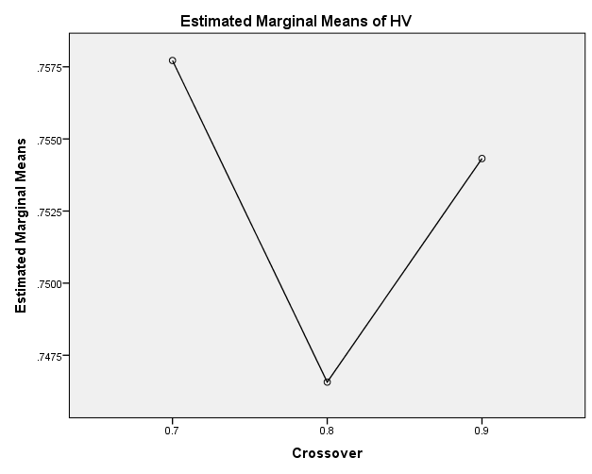

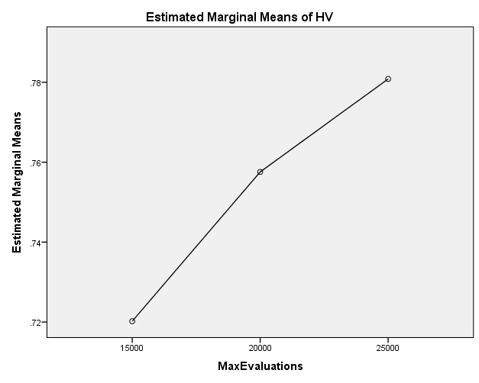

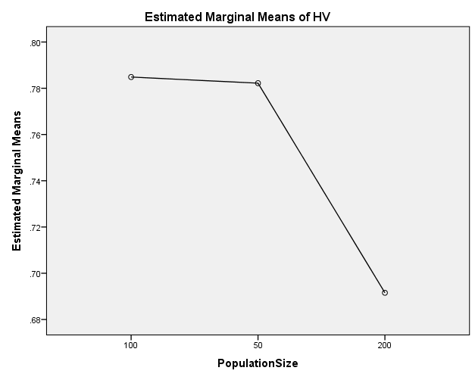

EP

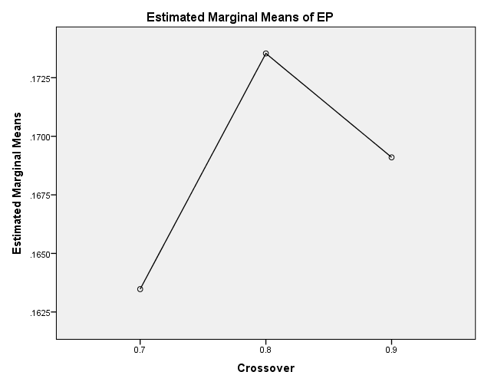

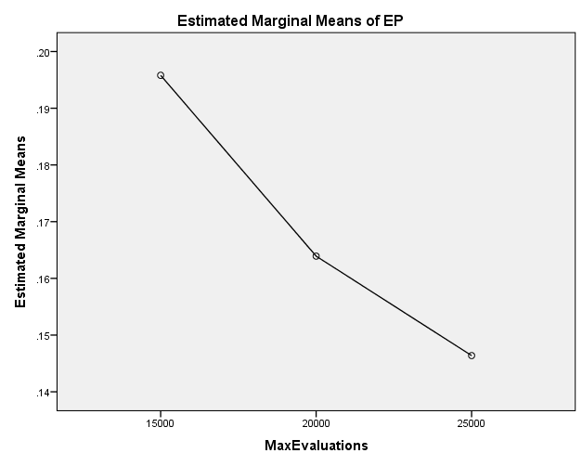

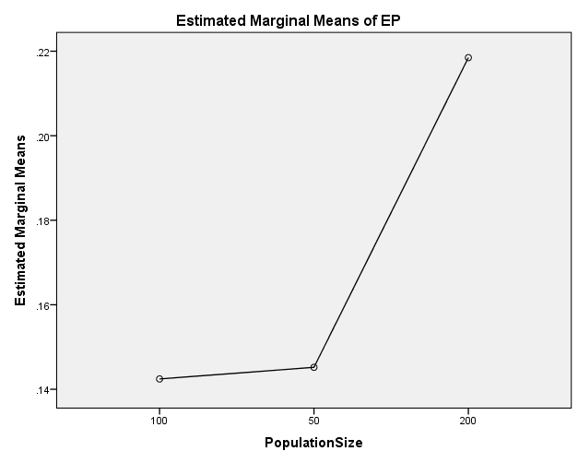

GD

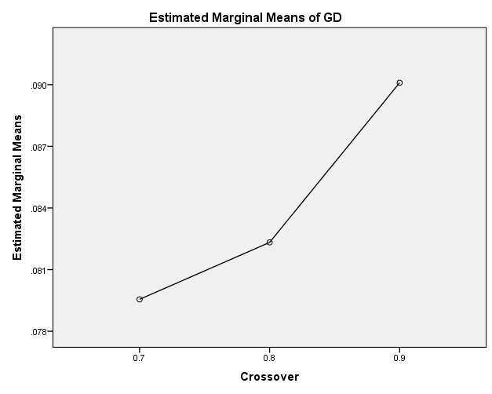

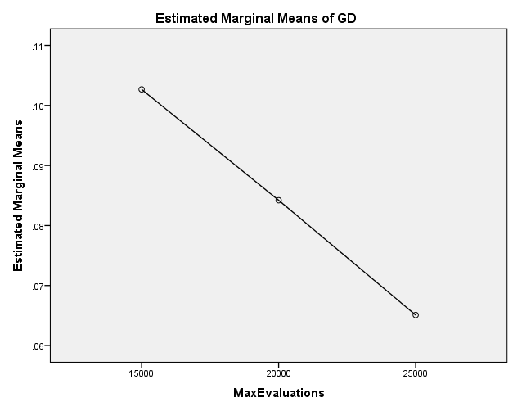

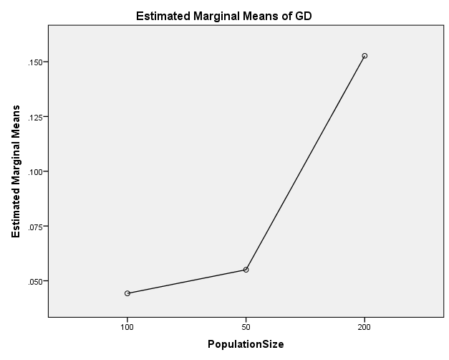

IGD

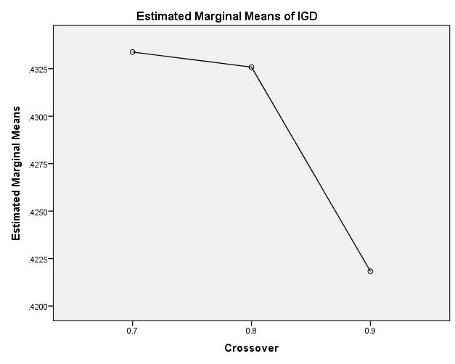

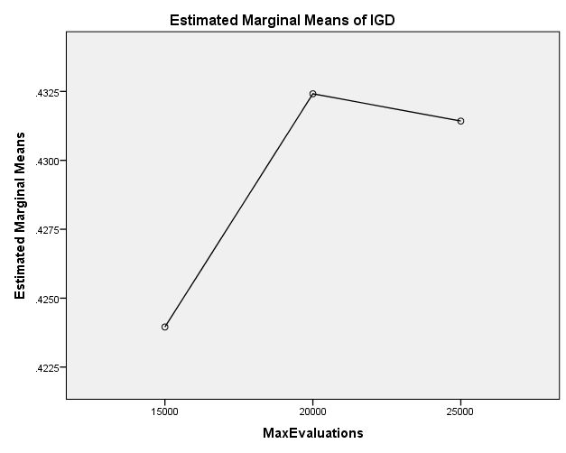

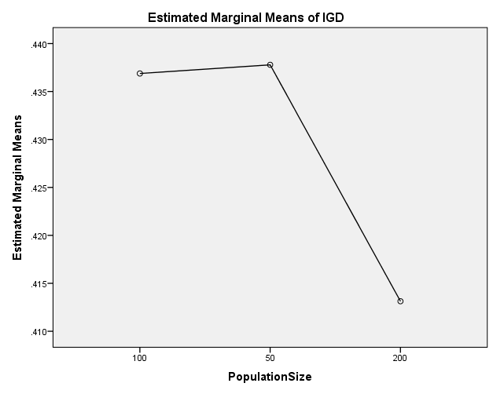

IGDplus

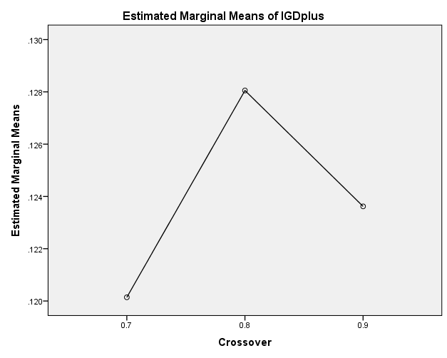

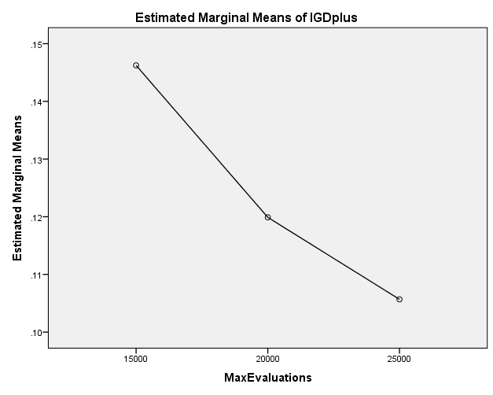

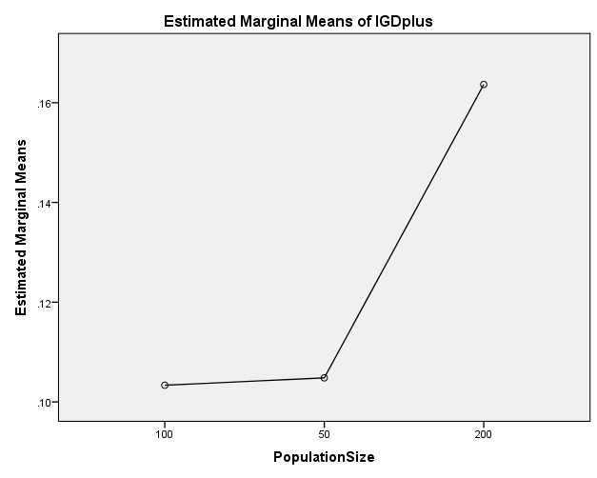

SPREAD

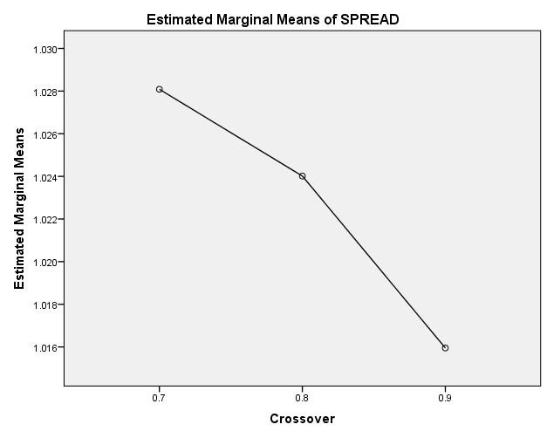

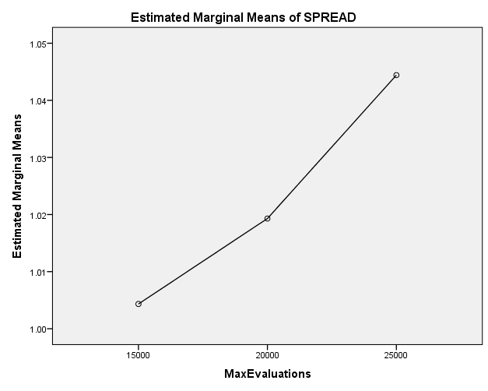

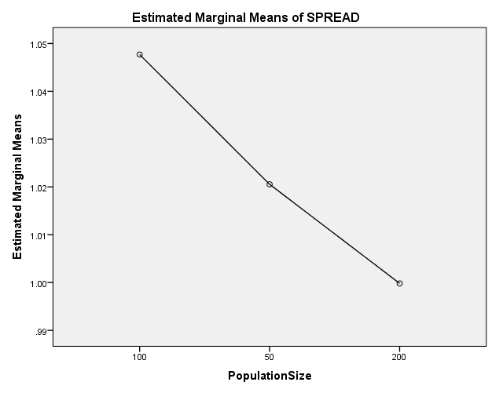

EXAMINE VARIABLES=HV EP GD IGD IGDplus SPREAD BY Crossover MaxEvaluations PopulationSize
/PLOT BOXPLOT
/COMPARE VARIABLES
/STATISTICS NONE
/CINTERVAL 95
/MISSING LISTWISE
/NOTOTAL.

Explore

Notes
Output Created |  | 26-MAY-2020 20:15:07
Comments
Input | Data | C:\Users\user\Documents\NILAY\Mayis2020\medium_NSGAII.sav
Input | Active Dataset | DataSet1
Input | Filter | <none>
Input | Weight | <none>
Input | Split File | <none>
Input | N of Rows in Working Data File | 837
Missing Value Handling | Definition of Missing | User-defined missing values for dependent variables are treated as missing.
Missing Value Handling | Cases Used | Statistics are based on cases with no missing values for any dependent variable or factor used.
Syntax |  | EXAMINE VARIABLES=HV EP GD IGD IGDplus SPREAD BY Crossover MaxEvaluations PopulationSize  /PLOT BOXPLOT  /COMPARE VARIABLES  /STATISTICS NONE  /CINTERVAL 95  /MISSING LISTWISE  /NOTOTAL.
Resources | Processor Time | 00:00:01.78
Resources | Elapsed Time | 00:00:01.81

[DataSet1] C:\Users\user\Documents\NILAY\Mayis2020\medium_NSGAII.sav

Crossover

Case Processing Summary
 | Crossover | Cases
 | Crossover | Valid |  | Missing |  | Total
 | Crossover | N | Percent | N | Percent | N | Percent
HV | 0.7 | 279 | 100.0% | 0 | 0.0% | 279 | 100.0%
HV | 0.8 | 279 | 100.0% | 0 | 0.0% | 279 | 100.0%
HV | 0.9 | 279 | 100.0% | 0 | 0.0% | 279 | 100.0%
EP | 0.7 | 279 | 100.0% | 0 | 0.0% | 279 | 100.0%
EP | 0.8 | 279 | 100.0% | 0 | 0.0% | 279 | 100.0%
EP | 0.9 | 279 | 100.0% | 0 | 0.0% | 279 | 100.0%
GD | 0.7 | 279 | 100.0% | 0 | 0.0% | 279 | 100.0%
GD | 0.8 | 279 | 100.0% | 0 | 0.0% | 279 | 100.0%
GD | 0.9 | 279 | 100.0% | 0 | 0.0% | 279 | 100.0%
IGD | 0.7 | 279 | 100.0% | 0 | 0.0% | 279 | 100.0%
IGD | 0.8 | 279 | 100.0% | 0 | 0.0% | 279 | 100.0%
IGD | 0.9 | 279 | 100.0% | 0 | 0.0% | 279 | 100.0%
IGDplus | 0.7 | 279 | 100.0% | 0 | 0.0% | 279 | 100.0%
IGDplus | 0.8 | 279 | 100.0% | 0 | 0.0% | 279 | 100.0%
IGDplus | 0.9 | 279 | 100.0% | 0 | 0.0% | 279 | 100.0%
SPREAD | 0.7 | 279 | 100.0% | 0 | 0.0% | 279 | 100.0%
SPREAD | 0.8 | 279 | 100.0% | 0 | 0.0% | 279 | 100.0%
SPREAD | 0.9 | 279 | 100.0% | 0 | 0.0% | 279 | 100.0%

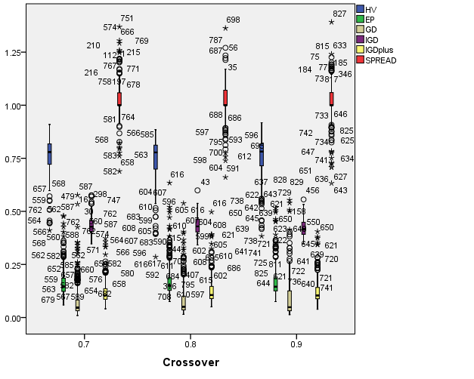

MaxEvaluations

Case Processing Summary
 | MaxEvaluations | Cases
 | MaxEvaluations | Valid |  | Missing |  | Total
 | MaxEvaluations | N | Percent | N | Percent | N | Percent
HV | 15000 | 279 | 100.0% | 0 | 0.0% | 279 | 100.0%
HV | 20000 | 279 | 100.0% | 0 | 0.0% | 279 | 100.0%
HV | 25000 | 279 | 100.0% | 0 | 0.0% | 279 | 100.0%
EP | 15000 | 279 | 100.0% | 0 | 0.0% | 279 | 100.0%
EP | 20000 | 279 | 100.0% | 0 | 0.0% | 279 | 100.0%
EP | 25000 | 279 | 100.0% | 0 | 0.0% | 279 | 100.0%
GD | 15000 | 279 | 100.0% | 0 | 0.0% | 279 | 100.0%
GD | 20000 | 279 | 100.0% | 0 | 0.0% | 279 | 100.0%
GD | 25000 | 279 | 100.0% | 0 | 0.0% | 279 | 100.0%
IGD | 15000 | 279 | 100.0% | 0 | 0.0% | 279 | 100.0%
IGD | 20000 | 279 | 100.0% | 0 | 0.0% | 279 | 100.0%
IGD | 25000 | 279 | 100.0% | 0 | 0.0% | 279 | 100.0%
IGDplus | 15000 | 279 | 100.0% | 0 | 0.0% | 279 | 100.0%
IGDplus | 20000 | 279 | 100.0% | 0 | 0.0% | 279 | 100.0%
IGDplus | 25000 | 279 | 100.0% | 0 | 0.0% | 279 | 100.0%
SPREAD | 15000 | 279 | 100.0% | 0 | 0.0% | 279 | 100.0%
SPREAD | 20000 | 279 | 100.0% | 0 | 0.0% | 279 | 100.0%
SPREAD | 25000 | 279 | 100.0% | 0 | 0.0% | 279 | 100.0%

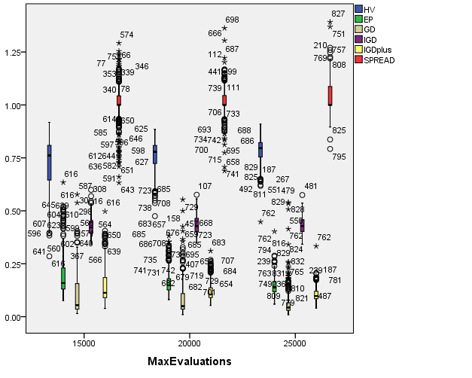

PopulationSize

Case Processing Summary
 | PopulationSize | Cases
 | PopulationSize | Valid |  | Missing |  | Total
 | PopulationSize | N | Percent | N | Percent | N | Percent
HV | 100 | 279 | 100.0% | 0 | 0.0% | 279 | 100.0%
HV | 50 | 279 | 100.0% | 0 | 0.0% | 279 | 100.0%
HV | 200 | 279 | 100.0% | 0 | 0.0% | 279 | 100.0%
EP | 100 | 279 | 100.0% | 0 | 0.0% | 279 | 100.0%
EP | 50 | 279 | 100.0% | 0 | 0.0% | 279 | 100.0%
EP | 200 | 279 | 100.0% | 0 | 0.0% | 279 | 100.0%
GD | 100 | 279 | 100.0% | 0 | 0.0% | 279 | 100.0%
GD | 50 | 279 | 100.0% | 0 | 0.0% | 279 | 100.0%
GD | 200 | 279 | 100.0% | 0 | 0.0% | 279 | 100.0%
IGD | 100 | 279 | 100.0% | 0 | 0.0% | 279 | 100.0%
IGD | 50 | 279 | 100.0% | 0 | 0.0% | 279 | 100.0%
IGD | 200 | 279 | 100.0% | 0 | 0.0% | 279 | 100.0%
IGDplus | 100 | 279 | 100.0% | 0 | 0.0% | 279 | 100.0%
IGDplus | 50 | 279 | 100.0% | 0 | 0.0% | 279 | 100.0%
IGDplus | 200 | 279 | 100.0% | 0 | 0.0% | 279 | 100.0%
SPREAD | 100 | 279 | 100.0% | 0 | 0.0% | 279 | 100.0%
SPREAD | 50 | 279 | 100.0% | 0 | 0.0% | 279 | 100.0%
SPREAD | 200 | 279 | 100.0% | 0 | 0.0% | 279 | 100.0%

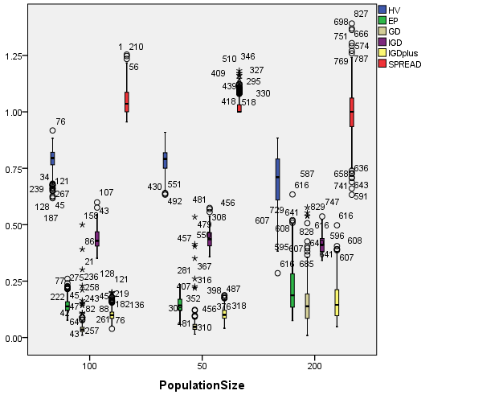

EXAMINE VARIABLES=HV EP GD IGD IGDplus SPREAD BY Crossover MaxEvaluations PopulationSize
/PLOT BOXPLOT
/COMPARE GROUPS
/STATISTICS NONE
/CINTERVAL 95
/MISSING LISTWISE
/NOTOTAL.

Explore

Notes
Output Created |  | 26-MAY-2020 20:15:31
Comments
Input | Data | C:\Users\user\Documents\NILAY\Mayis2020\medium_NSGAII.sav
Input | Active Dataset | DataSet1
Input | Filter | <none>
Input | Weight | <none>
Input | Split File | <none>
Input | N of Rows in Working Data File | 837
Missing Value Handling | Definition of Missing | User-defined missing values for dependent variables are treated as missing.
Missing Value Handling | Cases Used | Statistics are based on cases with no missing values for any dependent variable or factor used.
Syntax |  | EXAMINE VARIABLES=HV EP GD IGD IGDplus SPREAD BY Crossover MaxEvaluations PopulationSize  /PLOT BOXPLOT  /COMPARE GROUPS  /STATISTICS NONE  /CINTERVAL 95  /MISSING LISTWISE  /NOTOTAL.
Resources | Processor Time | 00:00:04.14
Resources | Elapsed Time | 00:00:04.11

[DataSet1] C:\Users\user\Documents\NILAY\Mayis2020\medium_NSGAII.sav

Crossover

Case Processing Summary
 | Crossover | Cases
 | Crossover | Valid |  | Missing |  | Total
 | Crossover | N | Percent | N | Percent | N | Percent
HV | 0.7 | 279 | 100.0% | 0 | 0.0% | 279 | 100.0%
HV | 0.8 | 279 | 100.0% | 0 | 0.0% | 279 | 100.0%
HV | 0.9 | 279 | 100.0% | 0 | 0.0% | 279 | 100.0%
EP | 0.7 | 279 | 100.0% | 0 | 0.0% | 279 | 100.0%
EP | 0.8 | 279 | 100.0% | 0 | 0.0% | 279 | 100.0%
EP | 0.9 | 279 | 100.0% | 0 | 0.0% | 279 | 100.0%
GD | 0.7 | 279 | 100.0% | 0 | 0.0% | 279 | 100.0%
GD | 0.8 | 279 | 100.0% | 0 | 0.0% | 279 | 100.0%
GD | 0.9 | 279 | 100.0% | 0 | 0.0% | 279 | 100.0%
IGD | 0.7 | 279 | 100.0% | 0 | 0.0% | 279 | 100.0%
IGD | 0.8 | 279 | 100.0% | 0 | 0.0% | 279 | 100.0%
IGD | 0.9 | 279 | 100.0% | 0 | 0.0% | 279 | 100.0%
IGDplus | 0.7 | 279 | 100.0% | 0 | 0.0% | 279 | 100.0%
IGDplus | 0.8 | 279 | 100.0% | 0 | 0.0% | 279 | 100.0%
IGDplus | 0.9 | 279 | 100.0% | 0 | 0.0% | 279 | 100.0%
SPREAD | 0.7 | 279 | 100.0% | 0 | 0.0% | 279 | 100.0%
SPREAD | 0.8 | 279 | 100.0% | 0 | 0.0% | 279 | 100.0%
SPREAD | 0.9 | 279 | 100.0% | 0 | 0.0% | 279 | 100.0%

HV

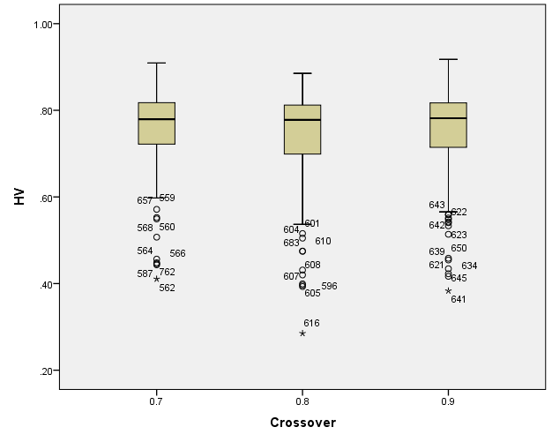

EP

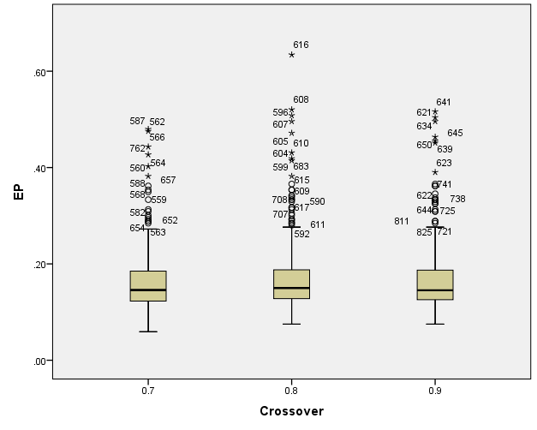

GD

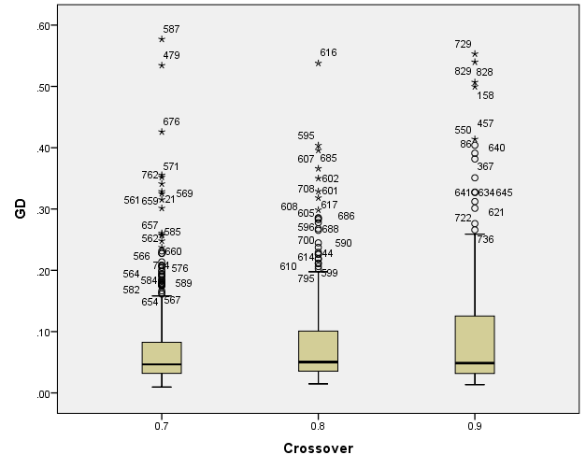

IGD

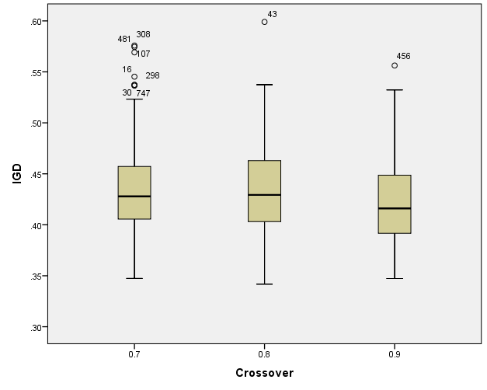

IGDplus

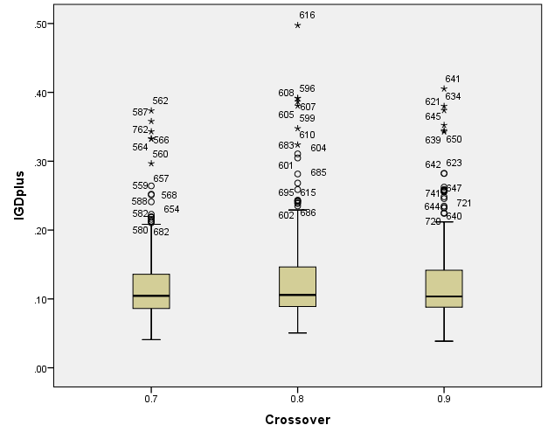

SPREAD

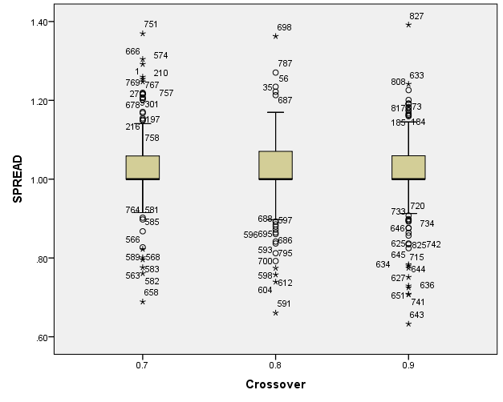

MaxEvaluations

Case Processing Summary
 | MaxEvaluations | Cases
 | MaxEvaluations | Valid |  | Missing |  | Total
 | MaxEvaluations | N | Percent | N | Percent | N | Percent
HV | 15000 | 279 | 100.0% | 0 | 0.0% | 279 | 100.0%
HV | 20000 | 279 | 100.0% | 0 | 0.0% | 279 | 100.0%
HV | 25000 | 279 | 100.0% | 0 | 0.0% | 279 | 100.0%
EP | 15000 | 279 | 100.0% | 0 | 0.0% | 279 | 100.0%
EP | 20000 | 279 | 100.0% | 0 | 0.0% | 279 | 100.0%
EP | 25000 | 279 | 100.0% | 0 | 0.0% | 279 | 100.0%
GD | 15000 | 279 | 100.0% | 0 | 0.0% | 279 | 100.0%
GD | 20000 | 279 | 100.0% | 0 | 0.0% | 279 | 100.0%
GD | 25000 | 279 | 100.0% | 0 | 0.0% | 279 | 100.0%
IGD | 15000 | 279 | 100.0% | 0 | 0.0% | 279 | 100.0%
IGD | 20000 | 279 | 100.0% | 0 | 0.0% | 279 | 100.0%
IGD | 25000 | 279 | 100.0% | 0 | 0.0% | 279 | 100.0%
IGDplus | 15000 | 279 | 100.0% | 0 | 0.0% | 279 | 100.0%
IGDplus | 20000 | 279 | 100.0% | 0 | 0.0% | 279 | 100.0%
IGDplus | 25000 | 279 | 100.0% | 0 | 0.0% | 279 | 100.0%
SPREAD | 15000 | 279 | 100.0% | 0 | 0.0% | 279 | 100.0%
SPREAD | 20000 | 279 | 100.0% | 0 | 0.0% | 279 | 100.0%
SPREAD | 25000 | 279 | 100.0% | 0 | 0.0% | 279 | 100.0%

HV

Boxplots

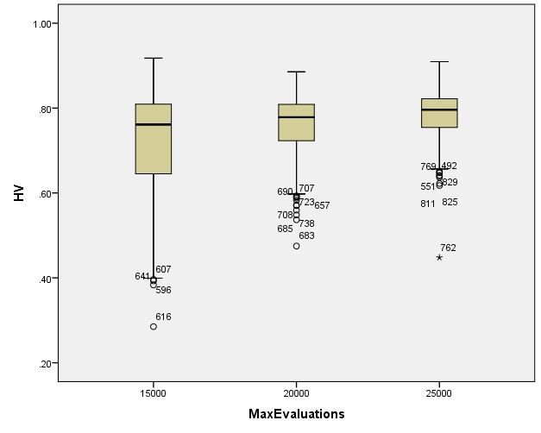

EP

Boxplots

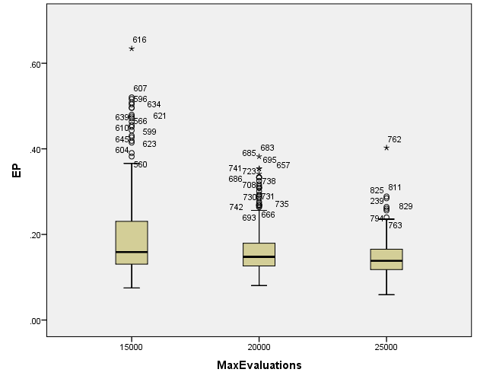

GD

Boxplots

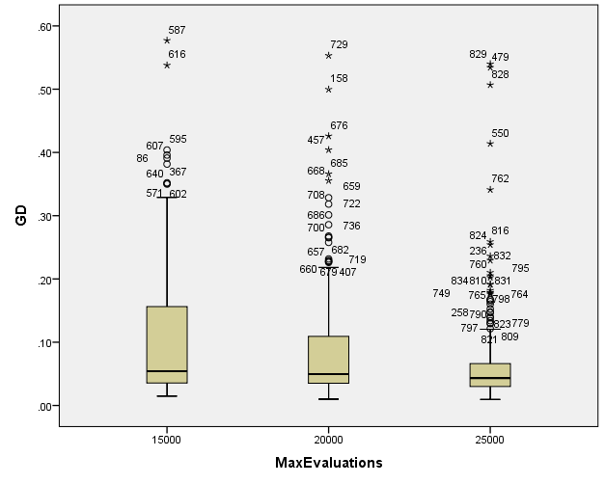

IGD

Boxplots

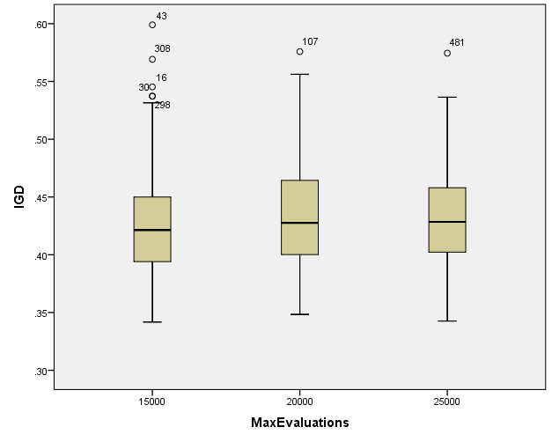

IGDplus

Boxplots

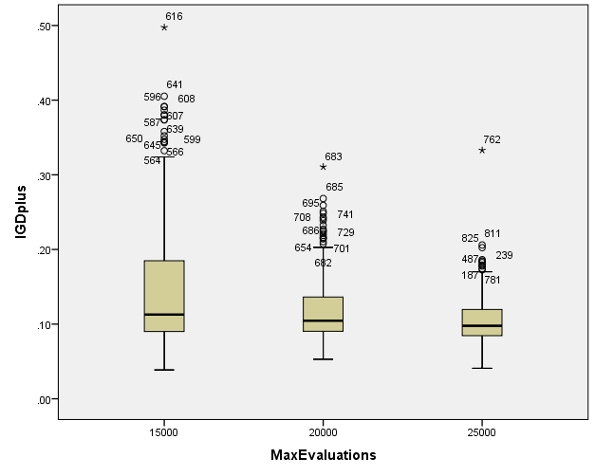

SPREAD

Boxplots

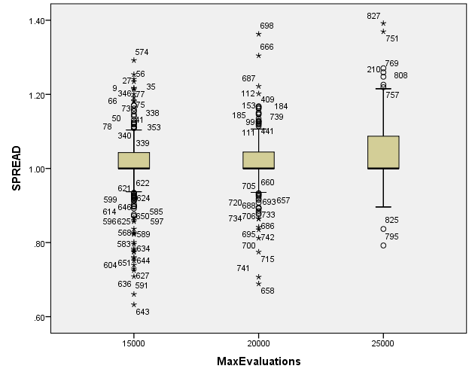

PopulationSize

Case Processing Summary
 | PopulationSize | Cases
 | PopulationSize | Valid |  | Missing |  | Total
 | PopulationSize | N | Percent | N | Percent | N | Percent
HV | 100 | 279 | 100.0% | 0 | 0.0% | 279 | 100.0%
HV | 50 | 279 | 100.0% | 0 | 0.0% | 279 | 100.0%
HV | 200 | 279 | 100.0% | 0 | 0.0% | 279 | 100.0%
EP | 100 | 279 | 100.0% | 0 | 0.0% | 279 | 100.0%
EP | 50 | 279 | 100.0% | 0 | 0.0% | 279 | 100.0%
EP | 200 | 279 | 100.0% | 0 | 0.0% | 279 | 100.0%
GD | 100 | 279 | 100.0% | 0 | 0.0% | 279 | 100.0%
GD | 50 | 279 | 100.0% | 0 | 0.0% | 279 | 100.0%
GD | 200 | 279 | 100.0% | 0 | 0.0% | 279 | 100.0%
IGD | 100 | 279 | 100.0% | 0 | 0.0% | 279 | 100.0%
IGD | 50 | 279 | 100.0% | 0 | 0.0% | 279 | 100.0%
IGD | 200 | 279 | 100.0% | 0 | 0.0% | 279 | 100.0%
IGDplus | 100 | 279 | 100.0% | 0 | 0.0% | 279 | 100.0%
IGDplus | 50 | 279 | 100.0% | 0 | 0.0% | 279 | 100.0%
IGDplus | 200 | 279 | 100.0% | 0 | 0.0% | 279 | 100.0%
SPREAD | 100 | 279 | 100.0% | 0 | 0.0% | 279 | 100.0%
SPREAD | 50 | 279 | 100.0% | 0 | 0.0% | 279 | 100.0%
SPREAD | 200 | 279 | 100.0% | 0 | 0.0% | 279 | 100.0%

HV

Boxplots

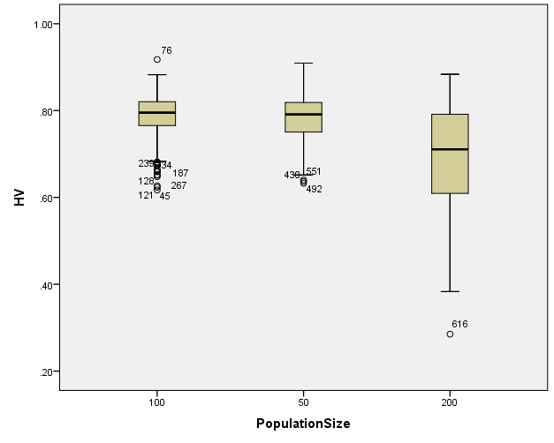

EP

Boxplots

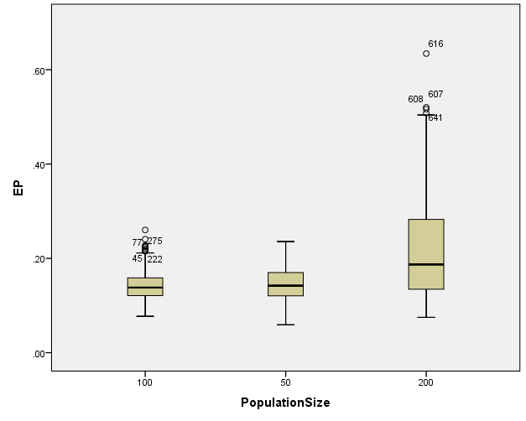

GD

Boxplots

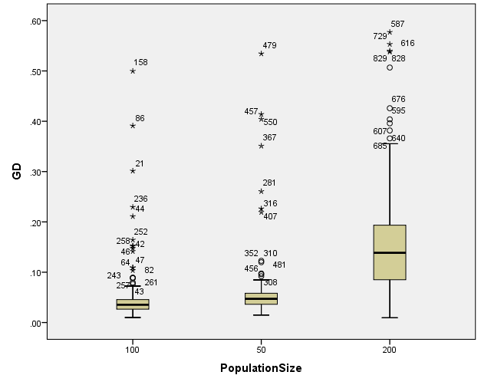

IGD

Boxplots

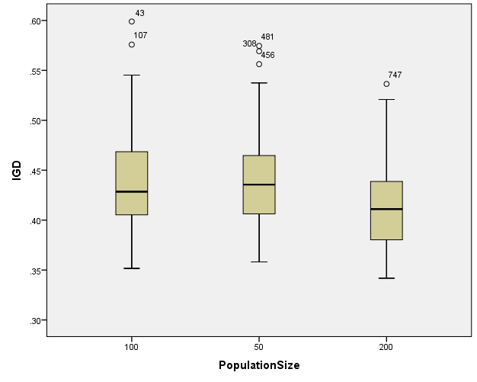

IGDplus

Boxplots

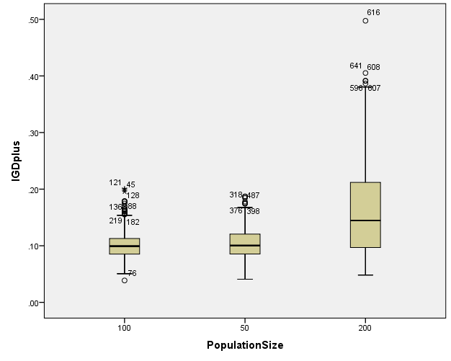

SPREAD

Boxplots

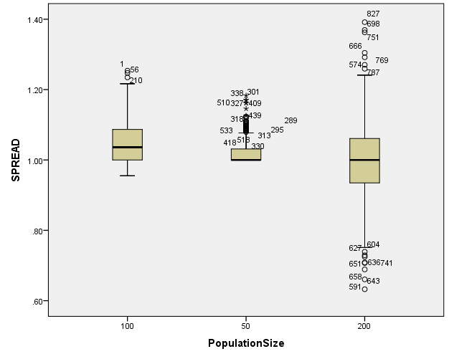

*Nonparametric Tests: Independent Samples.
NPTESTS
/INDEPENDENT TEST (HV EP GD IGD IGDplus SPREAD) GROUP (Crossover) MEDIAN(TESTVALUE=SAMPLE COMPARE=PAIRWISE)
/MISSING SCOPE=ANALYSIS USERMISSING=EXCLUDE
/CRITERIA ALPHA=0.05 CILEVEL=95.

Nonparametric Tests

Notes
Output Created |  | 26-MAY-2020 20:15:56
Comments
Input | Data | C:\Users\user\Documents\NILAY\Mayis2020\medium_NSGAII.sav
Input | Active Dataset | DataSet1
Input | Filter | <none>
Input | Weight | <none>
Input | Split File | <none>
Input | N of Rows in Working Data File | 837
Syntax |  | NPTESTS  /INDEPENDENT TEST (HV EP GD IGD IGDplus SPREAD) GROUP (Crossover) MEDIAN(TESTVALUE=SAMPLE COMPARE=PAIRWISE)  /MISSING SCOPE=ANALYSIS USERMISSING=EXCLUDE  /CRITERIA ALPHA=0.05 CILEVEL=95.
Resources | Processor Time | 00:00:00.17
Resources | Elapsed Time | 00:00:00.27

[DataSet1] C:\Users\user\Documents\NILAY\Mayis2020\medium_NSGAII.sav

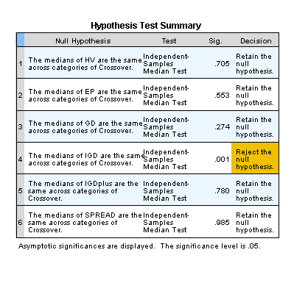

*Nonparametric Tests: Independent Samples.
NPTESTS
/INDEPENDENT TEST (HV EP GD IGD IGDplus SPREAD) GROUP (MaxEvaluations) MEDIAN(TESTVALUE=SAMPLE COMPARE=PAIRWISE)
/MISSING SCOPE=ANALYSIS USERMISSING=EXCLUDE
/CRITERIA ALPHA=0.05 CILEVEL=95.

Nonparametric Tests

Notes
Output Created |  | 26-MAY-2020 20:16:09
Comments
Input | Data | C:\Users\user\Documents\NILAY\Mayis2020\medium_NSGAII.sav
Input | Active Dataset | DataSet1
Input | Filter | <none>
Input | Weight | <none>
Input | Split File | <none>
Input | N of Rows in Working Data File | 837
Syntax |  | NPTESTS  /INDEPENDENT TEST (HV EP GD IGD IGDplus SPREAD) GROUP (MaxEvaluations) MEDIAN(TESTVALUE=SAMPLE COMPARE=PAIRWISE)  /MISSING SCOPE=ANALYSIS USERMISSING=EXCLUDE  /CRITERIA ALPHA=0.05 CILEVEL=95.
Resources | Processor Time | 00:00:00.16
Resources | Elapsed Time | 00:00:00.16

[DataSet1] C:\Users\user\Documents\NILAY\Mayis2020\medium_NSGAII.sav

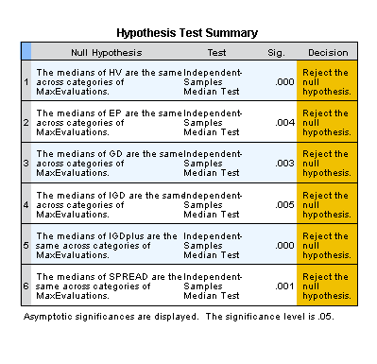

*Nonparametric Tests: Independent Samples.
NPTESTS
/INDEPENDENT TEST (HV EP GD IGD IGDplus SPREAD) GROUP (PopulationSize) MEDIAN(TESTVALUE=SAMPLE COMPARE=PAIRWISE)
/MISSING SCOPE=ANALYSIS USERMISSING=EXCLUDE
/CRITERIA ALPHA=0.05 CILEVEL=95.

Nonparametric Tests

Notes
Output Created |  | 26-MAY-2020 20:16:30
Comments
Input | Data | C:\Users\user\Documents\NILAY\Mayis2020\medium_NSGAII.sav
Input | Active Dataset | DataSet1
Input | Filter | <none>
Input | Weight | <none>
Input | Split File | <none>
Input | N of Rows in Working Data File | 837
Syntax |  | NPTESTS  /INDEPENDENT TEST (HV EP GD IGD IGDplus SPREAD) GROUP (PopulationSize) MEDIAN(TESTVALUE=SAMPLE COMPARE=PAIRWISE)  /MISSING SCOPE=ANALYSIS USERMISSING=EXCLUDE  /CRITERIA ALPHA=0.05 CILEVEL=95.
Resources | Processor Time | 00:00:00.14
Resources | Elapsed Time | 00:00:00.16

[DataSet1] C:\Users\user\Documents\NILAY\Mayis2020\medium_NSGAII.sav

