GET
FILE='C:\Users\user\Documents\NILAY\Mayis2020\medium_SPEA2.sav'.
DATASET NAME DataSet1 WINDOW=FRONT.
GLM HV EP GD IGD IGDplus SPREAD BY Crossover MaxEvaluations PopulationSize
/METHOD=SSTYPE(3)
/INTERCEPT=INCLUDE
/POSTHOC=Crossover MaxEvaluations PopulationSize(BONFERRONI)
/PLOT=PROFILE(Crossover MaxEvaluations PopulationSize)
/CRITERIA=ALPHA(.05)
/DESIGN=Crossover MaxEvaluations PopulationSize.

General Linear Model

Notes
Output Created |  | 26-MAY-2020 20:30:52
Comments
Input | Data | C:\Users\user\Documents\NILAY\Mayis2020\medium_SPEA2.sav
Input | Active Dataset | DataSet1
Input | Filter | <none>
Input | Weight | <none>
Input | Split File | <none>
Input | N of Rows in Working Data File | 837
Missing Value Handling | Definition of Missing | User-defined missing values are treated as missing.
Missing Value Handling | Cases Used | Statistics are based on all cases with valid data for all variables in the model.
Syntax |  | GLM HV EP GD IGD IGDplus SPREAD BY Crossover MaxEvaluations PopulationSize  /METHOD=SSTYPE(3)  /INTERCEPT=INCLUDE  /POSTHOC=Crossover MaxEvaluations PopulationSize(BONFERRONI)  /PLOT=PROFILE(Crossover MaxEvaluations PopulationSize)  /CRITERIA=ALPHA(.05)  /DESIGN=Crossover MaxEvaluations PopulationSize.
Resources | Processor Time | 00:00:06.76
Resources | Elapsed Time | 00:00:04.78

[DataSet1] C:\Users\user\Documents\NILAY\Mayis2020\medium_SPEA2.sav

Between-Subjects Factors
 |  | Value Label | N
Crossover | 1 | 0.7 | 279
Crossover | 2 | 0.8 | 279
Crossover | 3 | 0.9 | 279
MaxEvaluations | 1 | 15000 | 279
MaxEvaluations | 2 | 20000 | 279
MaxEvaluations | 3 | 25000 | 279
PopulationSize | 1 | 100 | 279
PopulationSize | 2 | 50 | 279
PopulationSize | 3 | 200 | 279

Multivariate Testsª
Effect |  | Value | F | Hypothesis df | Error df
Intercept | Pillai's Trace | 1.000 | 479544.148^{b} | 6.000 | 825.000
Intercept | Wilks' Lambda | .000 | 479544.148^{b} | 6.000 | 825.000
Intercept | Hotelling's Trace | 3487.594 | 479544.148^{b} | 6.000 | 825.000
Intercept | Roy's Largest Root | 3487.594 | 479544.148^{b} | 6.000 | 825.000
Crossover | Pillai's Trace | .140 | 10.327 | 12.000 | 1652.000
Crossover | Wilks' Lambda | .862 | 10.605^{b} | 12.000 | 1650.000
Crossover | Hotelling's Trace | .158 | 10.883 | 12.000 | 1648.000
Crossover | Roy's Largest Root | .147 | 20.213^{c} | 6.000 | 826.000
MaxEvaluations | Pillai's Trace | .220 | 17.035 | 12.000 | 1652.000
MaxEvaluations | Wilks' Lambda | .792 | 17.052^{b} | 12.000 | 1650.000
MaxEvaluations | Hotelling's Trace | .249 | 17.069 | 12.000 | 1648.000
MaxEvaluations | Roy's Largest Root | .149 | 20.521^{c} | 6.000 | 826.000
PopulationSize | Pillai's Trace | 1.014 | 141.706 | 12.000 | 1652.000
PopulationSize | Wilks' Lambda | .194 | 174.919^{b} | 12.000 | 1650.000
PopulationSize | Hotelling's Trace | 3.088 | 212.041 | 12.000 | 1648.000
PopulationSize | Roy's Largest Root | 2.688 | 370.078^{c} | 6.000 | 826.000

Multivariate Testsª
Effect |  | Sig.
Intercept | Pillai's Trace | .000
Intercept | Wilks' Lambda | .000
Intercept | Hotelling's Trace | .000
Intercept | Roy's Largest Root | .000
Crossover | Pillai's Trace | .000
Crossover | Wilks' Lambda | .000
Crossover | Hotelling's Trace | .000
Crossover | Roy's Largest Root | .000
MaxEvaluations | Pillai's Trace | .000
MaxEvaluations | Wilks' Lambda | .000
MaxEvaluations | Hotelling's Trace | .000
MaxEvaluations | Roy's Largest Root | .000
PopulationSize | Pillai's Trace | .000
PopulationSize | Wilks' Lambda | .000
PopulationSize | Hotelling's Trace | .000
PopulationSize | Roy's Largest Root | .000

a. Design: Intercept + Crossover + MaxEvaluations + PopulationSize
b. Exact statistic
c. The statistic is an upper bound on F that yields a lower bound on the significance level.

Tests of Between-Subjects Effects
Source | Dependent Variable | Type III Sum of Squares | df | Mean Square | F
Corrected Model | HV | 4.341ª | 6 | .724 | 110.558
Corrected Model | EP | 6.588^{b} | 6 | 1.098 | 39.335
Corrected Model | GD | .053^{c} | 6 | .009 | 54.508
Corrected Model | IGD | .444^{d} | 6 | .074 | 41.644
Corrected Model | IGDplus | 1.893e | 6 | .315 | 112.980
Corrected Model | SPREAD | 12.402^{f} | 6 | 2.067 | 150.972
Intercept | HV | 445.629 | 1 | 445.629 | 68093.972
Intercept | EP | 40.555 | 1 | 40.555 | 1452.712
Intercept | GD | 1.393 | 1 | 1.393 | 8523.125
Intercept | IGD | 147.743 | 1 | 147.743 | 83204.196
Intercept | IGDplus | 16.179 | 1 | 16.179 | 5795.200
Intercept | SPREAD | 1149.580 | 1 | 1149.580 | 83965.891
Crossover | HV | .050 | 2 | .025 | 3.815
Crossover | EP | 2.079 | 2 | 1.040 | 37.237
Crossover | GD | 1.193E-005 | 2 | 5.967E-006 | .037
Crossover | IGD | .002 | 2 | .001 | .465
Crossover | IGDplus | .017 | 2 | .008 | 3.003
Crossover | SPREAD | .288 | 2 | .144 | 10.506
MaxEvaluations | HV | .472 | 2 | .236 | 36.092
MaxEvaluations | EP | 2.222 | 2 | 1.111 | 39.800
MaxEvaluations | GD | .000 | 2 | .000 | 1.299
MaxEvaluations | IGD | .025 | 2 | .013 | 7.176
MaxEvaluations | IGDplus | .244 | 2 | .122 | 43.708
MaxEvaluations | SPREAD | .086 | 2 | .043 | 3.133
PopulationSize | HV | 3.819 | 2 | 1.909 | 291.767
PopulationSize | EP | 2.287 | 2 | 1.144 | 40.967
PopulationSize | GD | .053 | 2 | .027 | 162.189
PopulationSize | IGD | .417 | 2 | .208 | 117.290
PopulationSize | IGDplus | 1.632 | 2 | .816 | 292.230
PopulationSize | SPREAD | 12.028 | 2 | 6.014 | 439.277
Error | HV | 5.432 | 830 | .007
Error | EP | 23.171 | 830 | .028
Error | GD | .136 | 830 | .000
Error | IGD | 1.474 | 830 | .002
Error | IGDplus | 2.317 | 830 | .003

Tests of Between-Subjects Effects
Source | Dependent Variable | Sig.
Corrected Model | HV | .000ª
Corrected Model | EP | .000^{b}
Corrected Model | GD | .000^{c}
Corrected Model | IGD | .000^{d}
Corrected Model | IGDplus | .000e
Corrected Model | SPREAD | .000^{f}
Intercept | HV | .000
Intercept | EP | .000
Intercept | GD | .000
Intercept | IGD | .000
Intercept | IGDplus | .000
Intercept | SPREAD | .000
Crossover | HV | .022
Crossover | EP | .000
Crossover | GD | .964
Crossover | IGD | .629
Crossover | IGDplus | .050
Crossover | SPREAD | .000
MaxEvaluations | HV | .000
MaxEvaluations | EP | .000
MaxEvaluations | GD | .273
MaxEvaluations | IGD | .001
MaxEvaluations | IGDplus | .000
MaxEvaluations | SPREAD | .044
PopulationSize | HV | .000
PopulationSize | EP | .000
PopulationSize | GD | .000
PopulationSize | IGD | .000
PopulationSize | IGDplus | .000
PopulationSize | SPREAD | .000
Error | HV
Error | EP
Error | GD
Error | IGD
Error | IGDplus

Tests of Between-Subjects Effects
Source | Dependent Variable | Type III Sum of Squares | df | Mean Square | F
Error | SPREAD | 11.364ª | 830 | .014
Total | HV | 455.401^{b} | 837
Total | EP | 70.314^{c} | 837
Total | GD | 1.582^{d} | 837
Total | IGD | 149.660e | 837
Total | IGDplus | 20.389^{f} | 837
Total | SPREAD | 1173.345 | 837
Corrected Total | HV | 9.773 | 836
Corrected Total | EP | 29.759 | 836
Corrected Total | GD | .189 | 836
Corrected Total | IGD | 1.917 | 836
Corrected Total | IGDplus | 4.210 | 836
Corrected Total | SPREAD | 23.765 | 836

Tests of Between-Subjects Effects
Source | Dependent Variable | Sig.
Error | SPREAD
Total | HV
Total | EP
Total | GD
Total | IGD
Total | IGDplus
Total | SPREAD
Corrected Total | HV
Corrected Total | EP
Corrected Total | GD
Corrected Total | IGD
Corrected Total | IGDplus
Corrected Total | SPREAD

a. R Squared = .444 (Adjusted R Squared = .440)
b. R Squared = .221 (Adjusted R Squared = .216)
c. R Squared = .283 (Adjusted R Squared = .277)
d. R Squared = .231 (Adjusted R Squared = .226)
e. R Squared = .450 (Adjusted R Squared = .446)
f. R Squared = .522 (Adjusted R Squared = .518)

Post Hoc Tests

Crossover

Multiple Comparisons
Bonferroni
Dependent Variable | (I) Crossover | (J) Crossover | Mean Difference (I-J) | Std. Error | Sig.
HV | 0.7 | 0.8 | -.0188* | .00685 | .019
HV | 0.7 | 0.9 | -.0075 | .00685 | .827
HV | 0.8 | 0.7 | .0188* | .00685 | .019
HV | 0.8 | 0.9 | .0113 | .00685 | .296
HV | 0.9 | 0.7 | .0075 | .00685 | .827
HV | 0.9 | 0.8 | -.0113 | .00685 | .296
EP | 0.7 | 0.8 | .0104 | .01415 | 1.000
EP | 0.7 | 0.9 | -.1001* | .01415 | .000
EP | 0.8 | 0.7 | -.0104 | .01415 | 1.000
EP | 0.8 | 0.9 | -.1105* | .01415 | .000
EP | 0.9 | 0.7 | .1001* | .01415 | .000
EP | 0.9 | 0.8 | .1105* | .01415 | .000
GD | 0.7 | 0.8 | .0001 | .00108 | 1.000
GD | 0.7 | 0.9 | -.0002 | .00108 | 1.000
GD | 0.8 | 0.7 | -.0001 | .00108 | 1.000
GD | 0.8 | 0.9 | -.0003 | .00108 | 1.000
GD | 0.9 | 0.7 | .0002 | .00108 | 1.000
GD | 0.9 | 0.8 | .0003 | .00108 | 1.000
IGD | 0.7 | 0.8 | -.0008 | .00357 | 1.000
IGD | 0.7 | 0.9 | .0025 | .00357 | 1.000
IGD | 0.8 | 0.7 | .0008 | .00357 | 1.000
IGD | 0.8 | 0.9 | .0033 | .00357 | 1.000
IGD | 0.9 | 0.7 | -.0025 | .00357 | 1.000
IGD | 0.9 | 0.8 | -.0033 | .00357 | 1.000
IGDplus | 0.7 | 0.8 | .0109* | .00447 | .046
IGDplus | 0.7 | 0.9 | .0042 | .00447 | 1.000
IGDplus | 0.8 | 0.7 | -.0109* | .00447 | .046
IGDplus | 0.8 | 0.9 | -.0066 | .00447 | .416
IGDplus | 0.9 | 0.7 | -.0042 | .00447 | 1.000
IGDplus | 0.9 | 0.8 | .0066 | .00447 | .416
SPREAD | 0.7 | 0.8 | .0049 | .00991 | 1.000
SPREAD | 0.7 | 0.9 | .0416* | .00991 | .000
SPREAD | 0.8 | 0.7 | -.0049 | .00991 | 1.000

Multiple Comparisons
Bonferroni
Dependent Variable | (I) Crossover | (J) Crossover | 95% Confidence Interval
Dependent Variable | (I) Crossover | (J) Crossover | Lower Bound | Upper Bound
HV | 0.7 | 0.8 | -.0352* | -.0024
HV | 0.7 | 0.9 | -.0239 | .0090
HV | 0.8 | 0.7 | .0024* | .0352
HV | 0.8 | 0.9 | -.0051 | .0277
HV | 0.9 | 0.7 | -.0090 | .0239
HV | 0.9 | 0.8 | -.0277 | .0051
EP | 0.7 | 0.8 | -.0235 | .0443
EP | 0.7 | 0.9 | -.1341* | -.0662
EP | 0.8 | 0.7 | -.0443 | .0235
EP | 0.8 | 0.9 | -.1445* | -.0766
EP | 0.9 | 0.7 | .0662* | .1341
EP | 0.9 | 0.8 | .0766* | .1445
GD | 0.7 | 0.8 | -.0025 | .0027
GD | 0.7 | 0.9 | -.0028 | .0024
GD | 0.8 | 0.7 | -.0027 | .0025
GD | 0.8 | 0.9 | -.0029 | .0023
GD | 0.9 | 0.7 | -.0024 | .0028
GD | 0.9 | 0.8 | -.0023 | .0029
IGD | 0.7 | 0.8 | -.0094 | .0078
IGD | 0.7 | 0.9 | -.0061 | .0111
IGD | 0.8 | 0.7 | -.0078 | .0094
IGD | 0.8 | 0.9 | -.0053 | .0119
IGD | 0.9 | 0.7 | -.0111 | .0061
IGD | 0.9 | 0.8 | -.0119 | .0053
IGDplus | 0.7 | 0.8 | .0001* | .0216
IGDplus | 0.7 | 0.9 | -.0065 | .0150
IGDplus | 0.8 | 0.7 | -.0216* | -.0001
IGDplus | 0.8 | 0.9 | -.0174 | .0041
IGDplus | 0.9 | 0.7 | -.0150 | .0065
IGDplus | 0.9 | 0.8 | -.0041 | .0174
SPREAD | 0.7 | 0.8 | -.0188 | .0287
SPREAD | 0.7 | 0.9 | .0178* | .0653
SPREAD | 0.8 | 0.7 | -.0287 | .0188

Multiple Comparisons
Bonferroni
Dependent Variable | (I) Crossover | (J) Crossover | Mean Difference (I-J) | Std. Error | Sig.
SPREAD | 0.8 | 0.9 | .0366* | .00991 | .001
SPREAD | 0.9 | 0.7 | -.0416 | .00991 | .000
SPREAD | 0.9 | 0.8 | -.0366* | .00991 | .001

Multiple Comparisons
Bonferroni
Dependent Variable | (I) Crossover | (J) Crossover | 95% Confidence Interval
Dependent Variable | (I) Crossover | (J) Crossover | Lower Bound | Upper Bound
SPREAD | 0.8 | 0.9 | .0129* | .0604
SPREAD | 0.9 | 0.7 | -.0653 | -.0178
SPREAD | 0.9 | 0.8 | -.0604* | -.0129

Based on observed means.
The error term is Mean Square(Error) = .014.
*. The mean difference is significant at the .05 level.

Homogeneous Subsets

MaxEvaluations

Multiple Comparisons
Bonferroni
Dependent Variable | (I) MaxEvaluations | (J) MaxEvaluations | Mean Difference (I-J) | Std. Error | Sig.
HV | 15000 | 20000 | -.0353* | .00685 | .000
HV | 15000 | 25000 | -.0577* | .00685 | .000
HV | 20000 | 15000 | .0353* | .00685 | .000
HV | 20000 | 25000 | -.0224* | .00685 | .003
HV | 25000 | 15000 | .0577* | .00685 | .000
HV | 25000 | 20000 | .0224* | .00685 | .003
EP | 15000 | 20000 | -.0756* | .01415 | .000
EP | 15000 | 25000 | .0498* | .01415 | .001
EP | 20000 | 15000 | .0756* | .01415 | .000
EP | 20000 | 25000 | .1253* | .01415 | .000
EP | 25000 | 15000 | -.0498* | .01415 | .001
EP | 25000 | 20000 | -.1253* | .01415 | .000
GD | 15000 | 20000 | .0017 | .00108 | .345
GD | 15000 | 25000 | .0012 | .00108 | .850
GD | 20000 | 15000 | -.0017 | .00108 | .345
GD | 20000 | 25000 | -.0005 | .00108 | 1.000
GD | 25000 | 15000 | -.0012 | .00108 | .850
GD | 25000 | 20000 | .0005 | .00108 | 1.000
IGD | 15000 | 20000 | -.0067 | .00357 | .178
IGD | 15000 | 25000 | -.0135* | .00357 | .000
IGD | 20000 | 15000 | .0067 | .00357 | .178
IGD | 20000 | 25000 | -.0068 | .00357 | .173
IGD | 25000 | 15000 | .0135* | .00357 | .000
IGD | 25000 | 20000 | .0068 | .00357 | .173
IGDplus | 15000 | 20000 | .0246* | .00447 | .000
IGDplus | 15000 | 25000 | .0416* | .00447 | .000
IGDplus | 20000 | 15000 | -.0246* | .00447 | .000
IGDplus | 20000 | 25000 | .0170* | .00447 | .000
IGDplus | 25000 | 15000 | -.0416* | .00447 | .000
IGDplus | 25000 | 20000 | -.0170* | .00447 | .000
SPREAD | 15000 | 20000 | -.0202 | .00991 | .125
SPREAD | 15000 | 25000 | -.0225 | .00991 | .069
SPREAD | 20000 | 15000 | .0202 | .00991 | .125

Multiple Comparisons
Bonferroni
Dependent Variable | (I) MaxEvaluations | (J) MaxEvaluations | 95% Confidence Interval
Dependent Variable | (I) MaxEvaluations | (J) MaxEvaluations | Lower Bound | Upper Bound
HV | 15000 | 20000 | -.0517* | -.0189
HV | 15000 | 25000 | -.0741* | -.0413
HV | 20000 | 15000 | .0189* | .0517
HV | 20000 | 25000 | -.0389* | -.0060
HV | 25000 | 15000 | .0413* | .0741
HV | 25000 | 20000 | .0060* | .0389
EP | 15000 | 20000 | -.1095* | -.0416
EP | 15000 | 25000 | .0158* | .0837
EP | 20000 | 15000 | .0416* | .1095
EP | 20000 | 25000 | .0914* | .1593
EP | 25000 | 15000 | -.0837* | -.0158
EP | 25000 | 20000 | -.1593* | -.0914
GD | 15000 | 20000 | -.0009 | .0043
GD | 15000 | 25000 | -.0014 | .0038
GD | 20000 | 15000 | -.0043 | .0009
GD | 20000 | 25000 | -.0031 | .0021
GD | 25000 | 15000 | -.0038 | .0014
GD | 25000 | 20000 | -.0021 | .0031
IGD | 15000 | 20000 | -.0153 | .0018
IGD | 15000 | 25000 | -.0221* | -.0050
IGD | 20000 | 15000 | -.0018 | .0153
IGD | 20000 | 25000 | -.0153 | .0018
IGD | 25000 | 15000 | .0050* | .0221
IGD | 25000 | 20000 | -.0018 | .0153
IGDplus | 15000 | 20000 | .0139* | .0354
IGDplus | 15000 | 25000 | .0309* | .0523
IGDplus | 20000 | 15000 | -.0354* | -.0139
IGDplus | 20000 | 25000 | .0062* | .0277
IGDplus | 25000 | 15000 | -.0523* | -.0309
IGDplus | 25000 | 20000 | -.0277* | -.0062
SPREAD | 15000 | 20000 | -.0440 | .0035
SPREAD | 15000 | 25000 | -.0463 | .0012
SPREAD | 20000 | 15000 | -.0035 | .0440

Multiple Comparisons
Bonferroni
Dependent Variable | (I) MaxEvaluations | (J) MaxEvaluations | Mean Difference (I-J) | Std. Error | Sig.
SPREAD | 20000 | 25000 | -.0023* | .00991 | 1.000
SPREAD | 25000 | 15000 | .0225* | .00991 | .069
SPREAD | 25000 | 20000 | .0023* | .00991 | 1.000

Multiple Comparisons
Bonferroni
Dependent Variable | (I) MaxEvaluations | (J) MaxEvaluations | 95% Confidence Interval
Dependent Variable | (I) MaxEvaluations | (J) MaxEvaluations | Lower Bound | Upper Bound
SPREAD | 20000 | 25000 | -.0261* | .0214
SPREAD | 25000 | 15000 | -.0012* | .0463
SPREAD | 25000 | 20000 | -.0214* | .0261

Based on observed means.
The error term is Mean Square(Error) = .014.
*. The mean difference is significant at the .05 level.

Homogeneous Subsets

PopulationSize

Multiple Comparisons
Bonferroni
Dependent Variable | (I) PopulationSize | (J) PopulationSize | Mean Difference (I-J) | Std. Error | Sig.
HV | 100 | 50 | .0062 | .00685 | 1.000
HV | 100 | 200 | .1463* | .00685 | .000
HV | 50 | 100 | -.0062 | .00685 | 1.000
HV | 50 | 200 | .1401* | .00685 | .000
HV | 200 | 100 | -.1463* | .00685 | .000
HV | 200 | 50 | -.1401* | .00685 | .000
EP | 100 | 50 | -.1061* | .01415 | .000
EP | 100 | 200 | -.1152* | .01415 | .000
EP | 50 | 100 | .1061* | .01415 | .000
EP | 50 | 200 | -.0091 | .01415 | 1.000
EP | 200 | 100 | .1152* | .01415 | .000
EP | 200 | 50 | .0091 | .01415 | 1.000
GD | 100 | 50 | -.0131* | .00108 | .000
GD | 100 | 200 | .0059* | .00108 | .000
GD | 50 | 100 | .0131* | .00108 | .000
GD | 50 | 200 | .0190* | .00108 | .000
GD | 200 | 100 | -.0059* | .00108 | .000
GD | 200 | 50 | -.0190* | .00108 | .000
IGD | 100 | 50 | -.0024 | .00357 | 1.000
IGD | 100 | 200 | .0461* | .00357 | .000
IGD | 50 | 100 | .0024 | .00357 | 1.000
IGD | 50 | 200 | .0485* | .00357 | .000
IGD | 200 | 100 | -.0461* | .00357 | .000
IGD | 200 | 50 | -.0485* | .00357 | .000
IGDplus | 100 | 50 | -.0035 | .00447 | 1.000
IGDplus | 100 | 200 | -.0954* | .00447 | .000
IGDplus | 50 | 100 | .0035 | .00447 | 1.000
IGDplus | 50 | 200 | -.0919* | .00447 | .000
IGDplus | 200 | 100 | .0954* | .00447 | .000
IGDplus | 200 | 50 | .0919* | .00447 | .000
SPREAD | 100 | 50 | .0543* | .00991 | .000
SPREAD | 100 | 200 | -.2228* | .00991 | .000
SPREAD | 50 | 100 | -.0543* | .00991 | .000

Multiple Comparisons
Bonferroni
Dependent Variable | (I) PopulationSize | (J) PopulationSize | 95% Confidence Interval
Dependent Variable | (I) PopulationSize | (J) PopulationSize | Lower Bound | Upper Bound
HV | 100 | 50 | -.0103 | .0226
HV | 100 | 200 | .1298* | .1627
HV | 50 | 100 | -.0226 | .0103
HV | 50 | 200 | .1237* | .1565
HV | 200 | 100 | -.1627* | -.1298
HV | 200 | 50 | -.1565* | -.1237
EP | 100 | 50 | -.1400* | -.0721
EP | 100 | 200 | -.1491* | -.0812
EP | 50 | 100 | .0721* | .1400
EP | 50 | 200 | -.0431 | .0248
EP | 200 | 100 | .0812* | .1491
EP | 200 | 50 | -.0248 | .0431
GD | 100 | 50 | -.0157* | -.0105
GD | 100 | 200 | .0033* | .0085
GD | 50 | 100 | .0105* | .0157
GD | 50 | 200 | .0165* | .0216
GD | 200 | 100 | -.0085* | -.0033
GD | 200 | 50 | -.0216* | -.0165
IGD | 100 | 50 | -.0110 | .0061
IGD | 100 | 200 | .0375* | .0546
IGD | 50 | 100 | -.0061 | .0110
IGD | 50 | 200 | .0399* | .0570
IGD | 200 | 100 | -.0546* | -.0375
IGD | 200 | 50 | -.0570* | -.0399
IGDplus | 100 | 50 | -.0142 | .0072
IGDplus | 100 | 200 | -.1061* | -.0846
IGDplus | 50 | 100 | -.0072 | .0142
IGDplus | 50 | 200 | -.1026* | -.0811
IGDplus | 200 | 100 | .0846* | .1061
IGDplus | 200 | 50 | .0811* | .1026
SPREAD | 100 | 50 | .0305* | .0780
SPREAD | 100 | 200 | -.2466* | -.1990
SPREAD | 50 | 100 | -.0780* | -.0305

Multiple Comparisons
Bonferroni
Dependent Variable | (I) PopulationSize | (J) PopulationSize | Mean Difference (I-J) | Std. Error | Sig.
SPREAD | 50 | 200 | -.2771 | .00991 | .000
SPREAD | 200 | 100 | .2228* | .00991 | .000
SPREAD | 200 | 50 | .2771 | .00991 | .000

Multiple Comparisons
Bonferroni
Dependent Variable | (I) PopulationSize | (J) PopulationSize | 95% Confidence Interval
Dependent Variable | (I) PopulationSize | (J) PopulationSize | Lower Bound | Upper Bound
SPREAD | 50 | 200 | -.3008 | -.2533
SPREAD | 200 | 100 | .1990* | .2466
SPREAD | 200 | 50 | .2533 | .3008

Based on observed means.
The error term is Mean Square(Error) = .014.
*. The mean difference is significant at the .05 level.

Profile Plots

HV

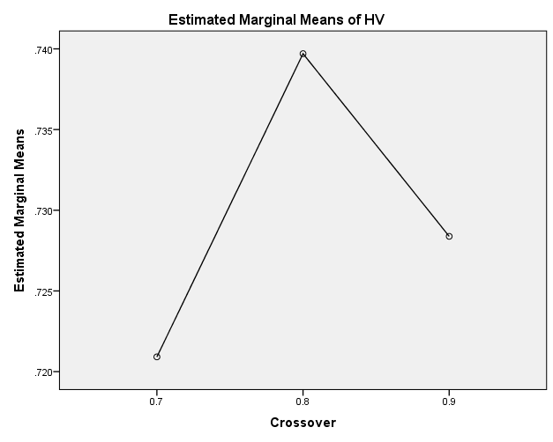

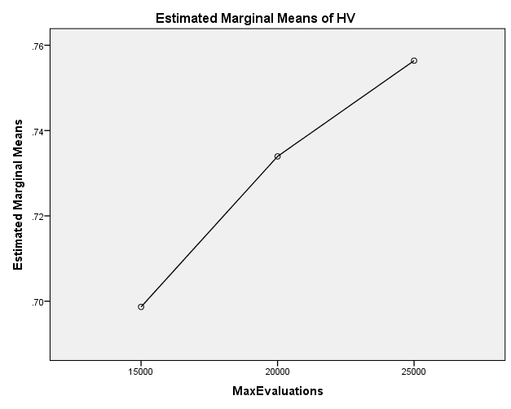

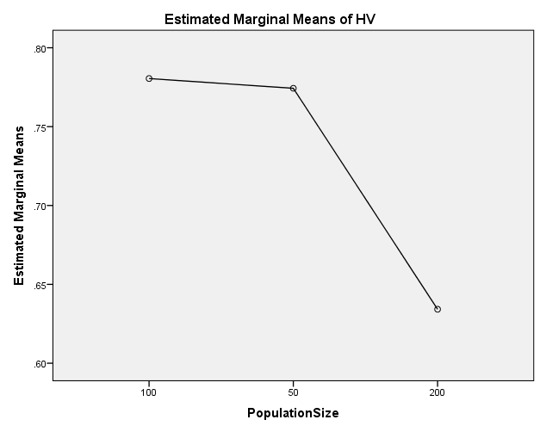

EP

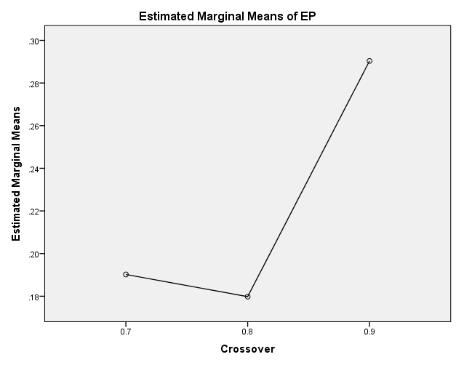

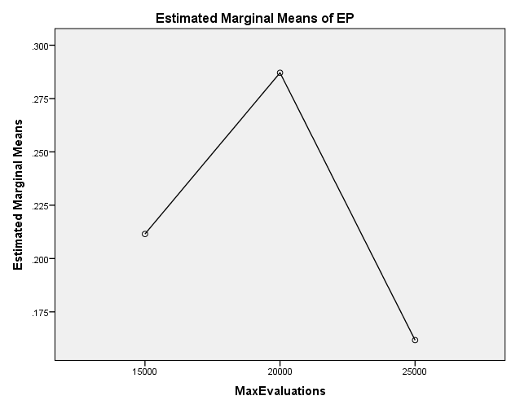

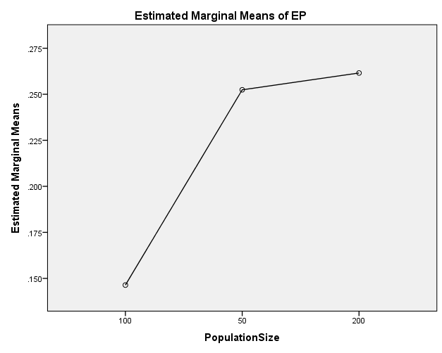

GD

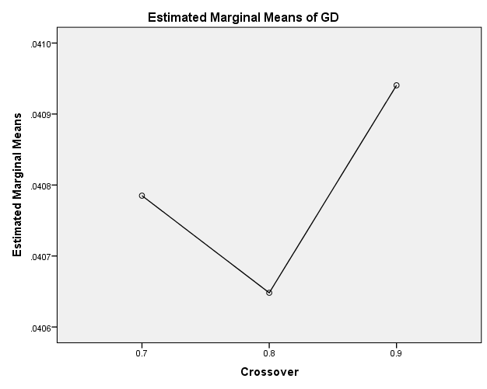

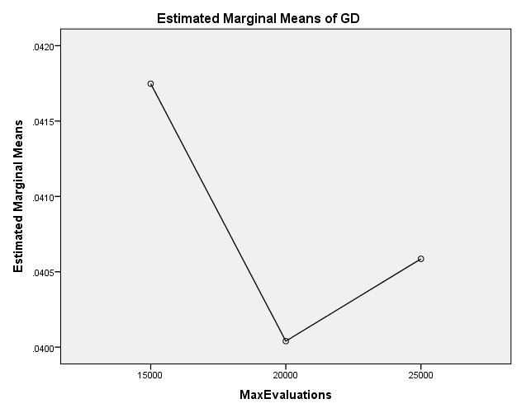

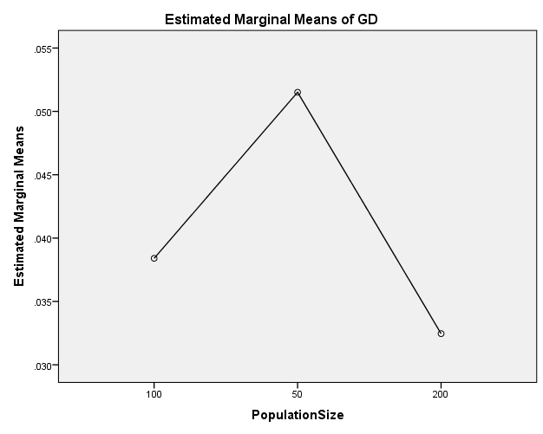

IGD

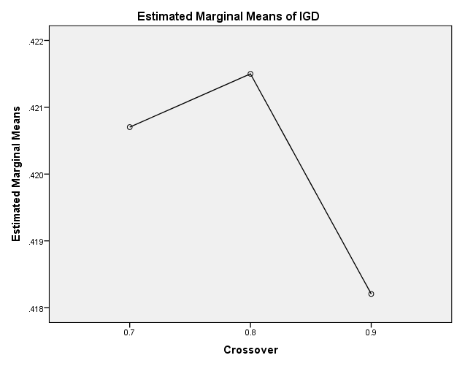

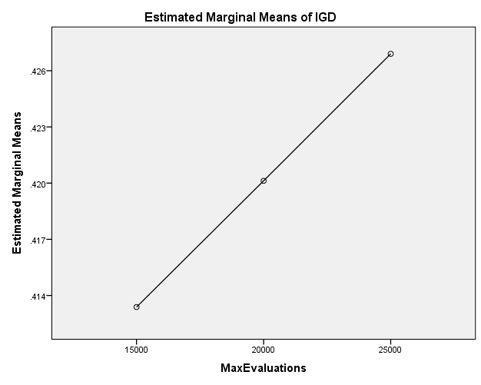

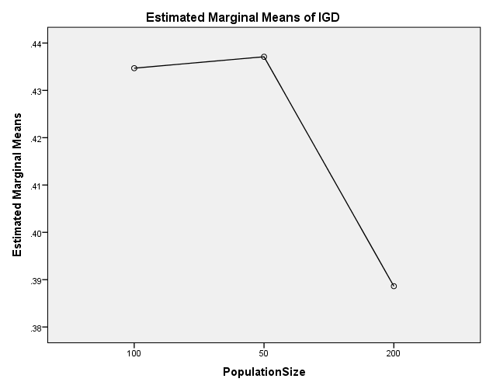

IGDplus

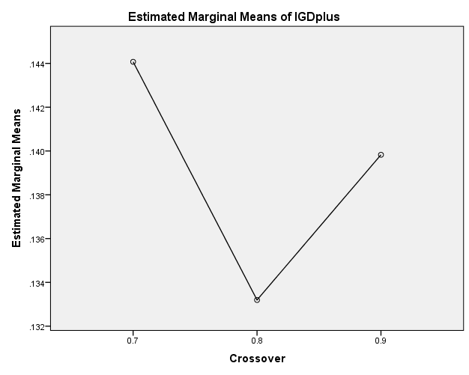

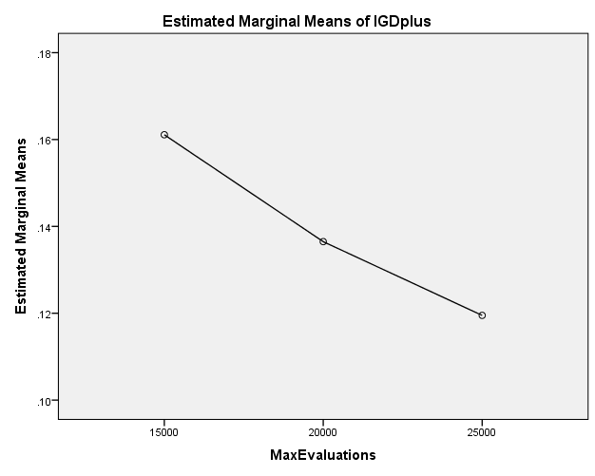

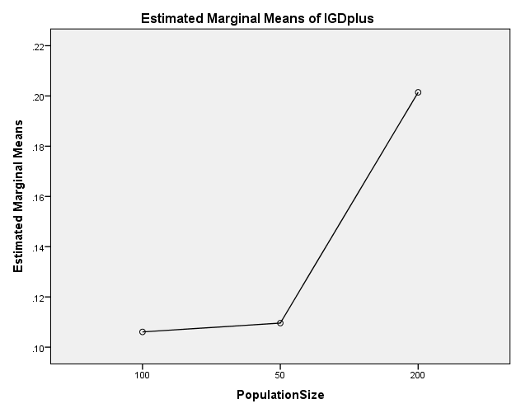

SPREAD

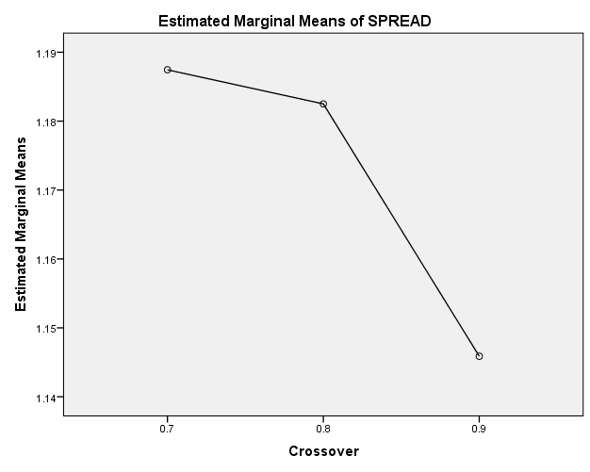

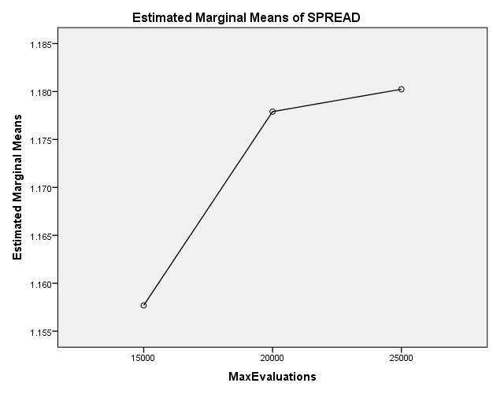

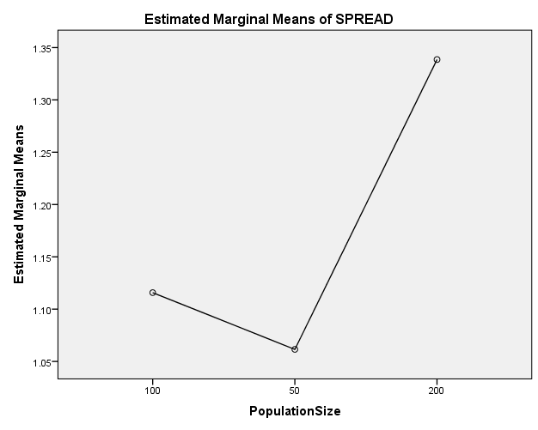

EXAMINE VARIABLES=HV EP GD IGD IGDplus SPREAD BY Crossover MaxEvaluations PopulationSize
/PLOT BOXPLOT
/COMPARE VARIABLES
/STATISTICS NONE
/CINTERVAL 95
/MISSING LISTWISE
/NOTOTAL.

Explore

Notes
Output Created |  | 26-MAY-2020 20:32:31
Comments
Input | Data | C:\Users\user\Documents\NILAY\Mayis2020\medium_SPEA2.sav
Input | Active Dataset | DataSet1
Input | Filter | <none>
Input | Weight | <none>
Input | Split File | <none>
Input | N of Rows in Working Data File | 837
Missing Value Handling | Definition of Missing | User-defined missing values for dependent variables are treated as missing.
Missing Value Handling | Cases Used | Statistics are based on cases with no missing values for any dependent variable or factor used.
Syntax |  | EXAMINE VARIABLES=HV EP GD IGD IGDplus SPREAD BY Crossover MaxEvaluations PopulationSize  /PLOT BOXPLOT  /COMPARE VARIABLES  /STATISTICS NONE  /CINTERVAL 95  /MISSING LISTWISE  /NOTOTAL.
Resources | Processor Time | 00:00:01.72
Resources | Elapsed Time | 00:00:01.74

[DataSet1] C:\Users\user\Documents\NILAY\Mayis2020\medium_SPEA2.sav

Crossover

Case Processing Summary
 | Crossover | Cases
 | Crossover | Valid |  | Missing |  | Total
 | Crossover | N | Percent | N | Percent | N | Percent
HV | 0.7 | 279 | 100.0% | 0 | 0.0% | 279 | 100.0%
HV | 0.8 | 279 | 100.0% | 0 | 0.0% | 279 | 100.0%
HV | 0.9 | 279 | 100.0% | 0 | 0.0% | 279 | 100.0%
EP | 0.7 | 279 | 100.0% | 0 | 0.0% | 279 | 100.0%
EP | 0.8 | 279 | 100.0% | 0 | 0.0% | 279 | 100.0%
EP | 0.9 | 279 | 100.0% | 0 | 0.0% | 279 | 100.0%
GD | 0.7 | 279 | 100.0% | 0 | 0.0% | 279 | 100.0%
GD | 0.8 | 279 | 100.0% | 0 | 0.0% | 279 | 100.0%
GD | 0.9 | 279 | 100.0% | 0 | 0.0% | 279 | 100.0%
IGD | 0.7 | 279 | 100.0% | 0 | 0.0% | 279 | 100.0%
IGD | 0.8 | 279 | 100.0% | 0 | 0.0% | 279 | 100.0%
IGD | 0.9 | 279 | 100.0% | 0 | 0.0% | 279 | 100.0%
IGDplus | 0.7 | 279 | 100.0% | 0 | 0.0% | 279 | 100.0%
IGDplus | 0.8 | 279 | 100.0% | 0 | 0.0% | 279 | 100.0%
IGDplus | 0.9 | 279 | 100.0% | 0 | 0.0% | 279 | 100.0%
SPREAD | 0.7 | 279 | 100.0% | 0 | 0.0% | 279 | 100.0%
SPREAD | 0.8 | 279 | 100.0% | 0 | 0.0% | 279 | 100.0%
SPREAD | 0.9 | 279 | 100.0% | 0 | 0.0% | 279 | 100.0%

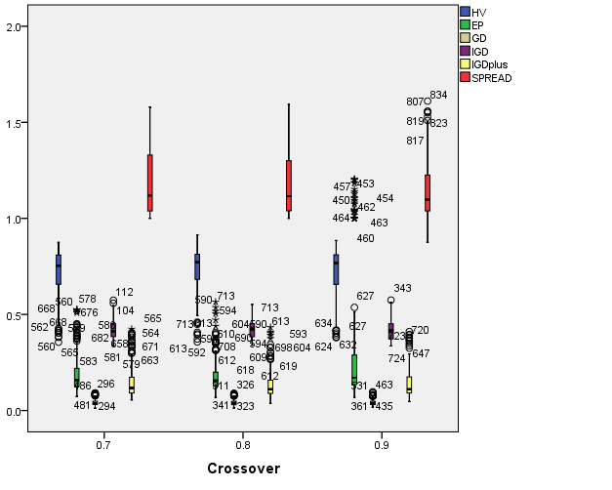

MaxEvaluations

Case Processing Summary
 | MaxEvaluations | Cases
 | MaxEvaluations | Valid |  | Missing |  | Total
 | MaxEvaluations | N | Percent | N | Percent | N | Percent
HV | 15000 | 279 | 100.0% | 0 | 0.0% | 279 | 100.0%
HV | 20000 | 279 | 100.0% | 0 | 0.0% | 279 | 100.0%
HV | 25000 | 279 | 100.0% | 0 | 0.0% | 279 | 100.0%
EP | 15000 | 279 | 100.0% | 0 | 0.0% | 279 | 100.0%
EP | 20000 | 279 | 100.0% | 0 | 0.0% | 279 | 100.0%
EP | 25000 | 279 | 100.0% | 0 | 0.0% | 279 | 100.0%
GD | 15000 | 279 | 100.0% | 0 | 0.0% | 279 | 100.0%
GD | 20000 | 279 | 100.0% | 0 | 0.0% | 279 | 100.0%
GD | 25000 | 279 | 100.0% | 0 | 0.0% | 279 | 100.0%
IGD | 15000 | 279 | 100.0% | 0 | 0.0% | 279 | 100.0%
IGD | 20000 | 279 | 100.0% | 0 | 0.0% | 279 | 100.0%
IGD | 25000 | 279 | 100.0% | 0 | 0.0% | 279 | 100.0%
IGDplus | 15000 | 279 | 100.0% | 0 | 0.0% | 279 | 100.0%
IGDplus | 20000 | 279 | 100.0% | 0 | 0.0% | 279 | 100.0%
IGDplus | 25000 | 279 | 100.0% | 0 | 0.0% | 279 | 100.0%
SPREAD | 15000 | 279 | 100.0% | 0 | 0.0% | 279 | 100.0%
SPREAD | 20000 | 279 | 100.0% | 0 | 0.0% | 279 | 100.0%
SPREAD | 25000 | 279 | 100.0% | 0 | 0.0% | 279 | 100.0%

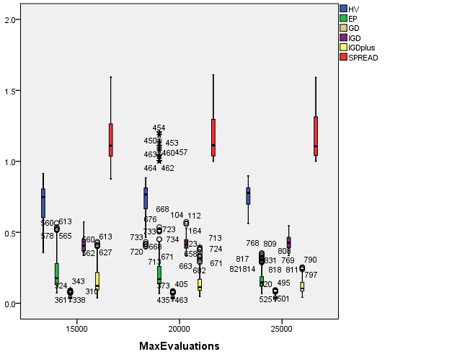

PopulationSize

Case Processing Summary
 | PopulationSize | Cases
 | PopulationSize | Valid |  | Missing |  | Total
 | PopulationSize | N | Percent | N | Percent | N | Percent
HV | 100 | 279 | 100.0% | 0 | 0.0% | 279 | 100.0%
HV | 50 | 279 | 100.0% | 0 | 0.0% | 279 | 100.0%
HV | 200 | 279 | 100.0% | 0 | 0.0% | 279 | 100.0%
EP | 100 | 279 | 100.0% | 0 | 0.0% | 279 | 100.0%
EP | 50 | 279 | 100.0% | 0 | 0.0% | 279 | 100.0%
EP | 200 | 279 | 100.0% | 0 | 0.0% | 279 | 100.0%
GD | 100 | 279 | 100.0% | 0 | 0.0% | 279 | 100.0%
GD | 50 | 279 | 100.0% | 0 | 0.0% | 279 | 100.0%
GD | 200 | 279 | 100.0% | 0 | 0.0% | 279 | 100.0%
IGD | 100 | 279 | 100.0% | 0 | 0.0% | 279 | 100.0%
IGD | 50 | 279 | 100.0% | 0 | 0.0% | 279 | 100.0%
IGD | 200 | 279 | 100.0% | 0 | 0.0% | 279 | 100.0%
IGDplus | 100 | 279 | 100.0% | 0 | 0.0% | 279 | 100.0%
IGDplus | 50 | 279 | 100.0% | 0 | 0.0% | 279 | 100.0%
IGDplus | 200 | 279 | 100.0% | 0 | 0.0% | 279 | 100.0%
SPREAD | 100 | 279 | 100.0% | 0 | 0.0% | 279 | 100.0%
SPREAD | 50 | 279 | 100.0% | 0 | 0.0% | 279 | 100.0%
SPREAD | 200 | 279 | 100.0% | 0 | 0.0% | 279 | 100.0%

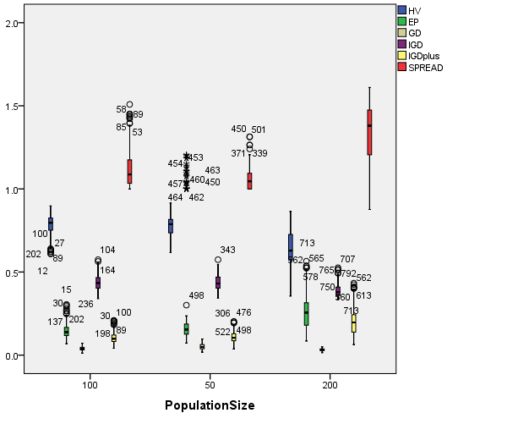

EXAMINE VARIABLES=HV EP GD IGD IGDplus SPREAD BY Crossover MaxEvaluations PopulationSize
/PLOT BOXPLOT
/COMPARE GROUPS
/STATISTICS NONE
/CINTERVAL 95
/MISSING LISTWISE
/NOTOTAL.

Explore

Notes
Output Created |  | 26-MAY-2020 20:32:59
Comments
Input | Data | C:\Users\user\Documents\NILAY\Mayis2020\medium_SPEA2.sav
Input | Active Dataset | DataSet1
Input | Filter | <none>
Input | Weight | <none>
Input | Split File | <none>
Input | N of Rows in Working Data File | 837
Missing Value Handling | Definition of Missing | User-defined missing values for dependent variables are treated as missing.
Missing Value Handling | Cases Used | Statistics are based on cases with no missing values for any dependent variable or factor used.
Syntax |  | EXAMINE VARIABLES=HV EP GD IGD IGDplus SPREAD BY Crossover MaxEvaluations PopulationSize  /PLOT BOXPLOT  /COMPARE GROUPS  /STATISTICS NONE  /CINTERVAL 95  /MISSING LISTWISE  /NOTOTAL.
Resources | Processor Time | 00:00:04.01
Resources | Elapsed Time | 00:00:03.98

[DataSet1] C:\Users\user\Documents\NILAY\Mayis2020\medium_SPEA2.sav

Crossover

Case Processing Summary
 | Crossover | Cases
 | Crossover | Valid |  | Missing |  | Total
 | Crossover | N | Percent | N | Percent | N | Percent
HV | 0.7 | 279 | 100.0% | 0 | 0.0% | 279 | 100.0%
HV | 0.8 | 279 | 100.0% | 0 | 0.0% | 279 | 100.0%
HV | 0.9 | 279 | 100.0% | 0 | 0.0% | 279 | 100.0%
EP | 0.7 | 279 | 100.0% | 0 | 0.0% | 279 | 100.0%
EP | 0.8 | 279 | 100.0% | 0 | 0.0% | 279 | 100.0%
EP | 0.9 | 279 | 100.0% | 0 | 0.0% | 279 | 100.0%
GD | 0.7 | 279 | 100.0% | 0 | 0.0% | 279 | 100.0%
GD | 0.8 | 279 | 100.0% | 0 | 0.0% | 279 | 100.0%
GD | 0.9 | 279 | 100.0% | 0 | 0.0% | 279 | 100.0%
IGD | 0.7 | 279 | 100.0% | 0 | 0.0% | 279 | 100.0%
IGD | 0.8 | 279 | 100.0% | 0 | 0.0% | 279 | 100.0%
IGD | 0.9 | 279 | 100.0% | 0 | 0.0% | 279 | 100.0%
IGDplus | 0.7 | 279 | 100.0% | 0 | 0.0% | 279 | 100.0%
IGDplus | 0.8 | 279 | 100.0% | 0 | 0.0% | 279 | 100.0%
IGDplus | 0.9 | 279 | 100.0% | 0 | 0.0% | 279 | 100.0%
SPREAD | 0.7 | 279 | 100.0% | 0 | 0.0% | 279 | 100.0%
SPREAD | 0.8 | 279 | 100.0% | 0 | 0.0% | 279 | 100.0%
SPREAD | 0.9 | 279 | 100.0% | 0 | 0.0% | 279 | 100.0%

HV

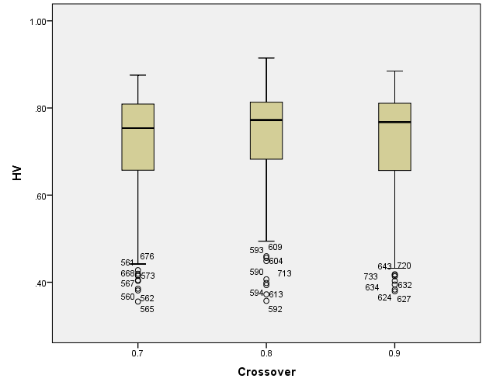

EP

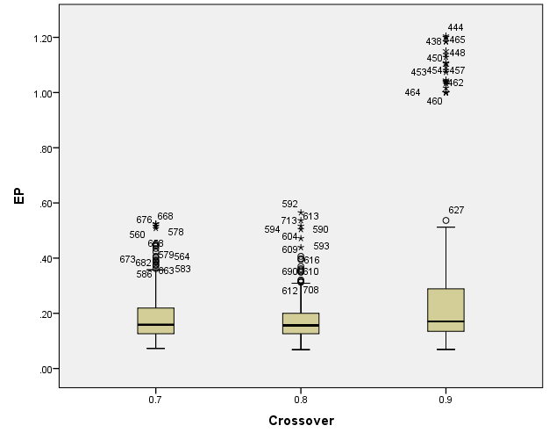

GD

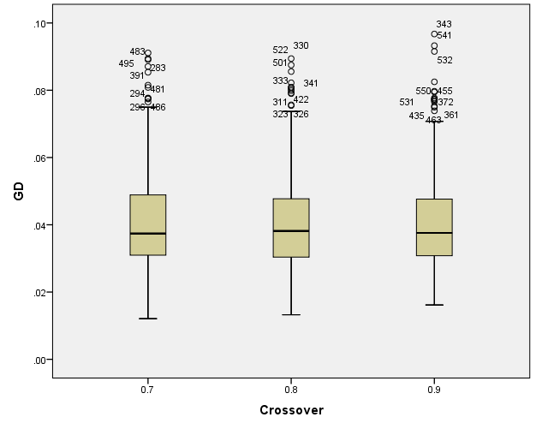

IGD

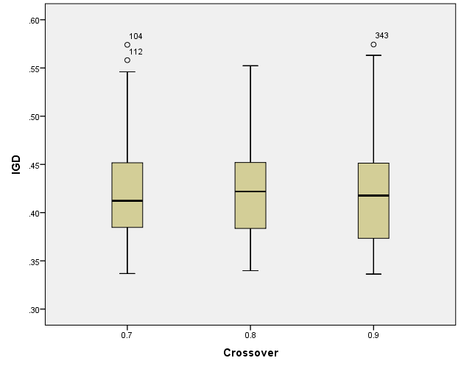

IGDplus

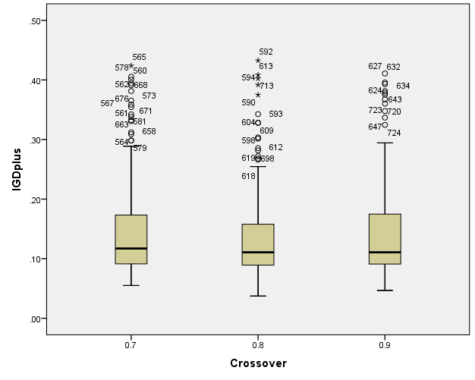

SPREAD

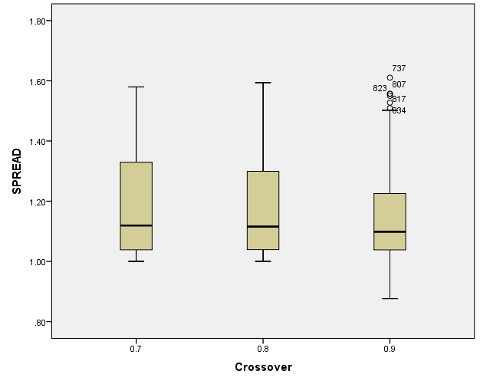

MaxEvaluations

Case Processing Summary
 | MaxEvaluations | Cases
 | MaxEvaluations | Valid |  | Missing |  | Total
 | MaxEvaluations | N | Percent | N | Percent | N | Percent
HV | 15000 | 279 | 100.0% | 0 | 0.0% | 279 | 100.0%
HV | 20000 | 279 | 100.0% | 0 | 0.0% | 279 | 100.0%
HV | 25000 | 279 | 100.0% | 0 | 0.0% | 279 | 100.0%
EP | 15000 | 279 | 100.0% | 0 | 0.0% | 279 | 100.0%
EP | 20000 | 279 | 100.0% | 0 | 0.0% | 279 | 100.0%
EP | 25000 | 279 | 100.0% | 0 | 0.0% | 279 | 100.0%
GD | 15000 | 279 | 100.0% | 0 | 0.0% | 279 | 100.0%
GD | 20000 | 279 | 100.0% | 0 | 0.0% | 279 | 100.0%
GD | 25000 | 279 | 100.0% | 0 | 0.0% | 279 | 100.0%
IGD | 15000 | 279 | 100.0% | 0 | 0.0% | 279 | 100.0%
IGD | 20000 | 279 | 100.0% | 0 | 0.0% | 279 | 100.0%
IGD | 25000 | 279 | 100.0% | 0 | 0.0% | 279 | 100.0%
IGDplus | 15000 | 279 | 100.0% | 0 | 0.0% | 279 | 100.0%
IGDplus | 20000 | 279 | 100.0% | 0 | 0.0% | 279 | 100.0%
IGDplus | 25000 | 279 | 100.0% | 0 | 0.0% | 279 | 100.0%
SPREAD | 15000 | 279 | 100.0% | 0 | 0.0% | 279 | 100.0%
SPREAD | 20000 | 279 | 100.0% | 0 | 0.0% | 279 | 100.0%
SPREAD | 25000 | 279 | 100.0% | 0 | 0.0% | 279 | 100.0%

HV

Boxplots

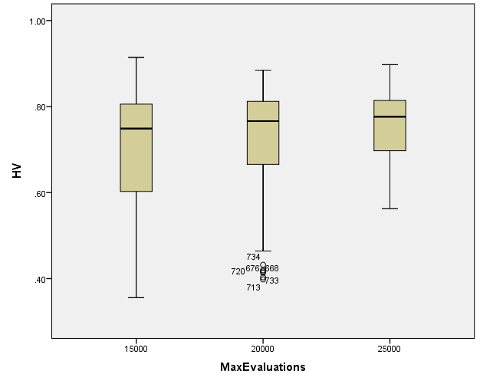

EP

Boxplots

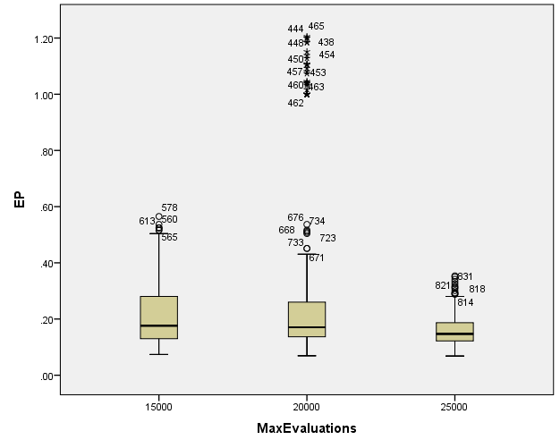

GD

Boxplots

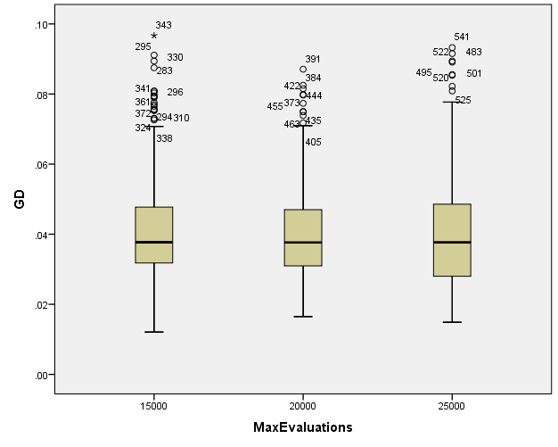

IGD

Boxplots

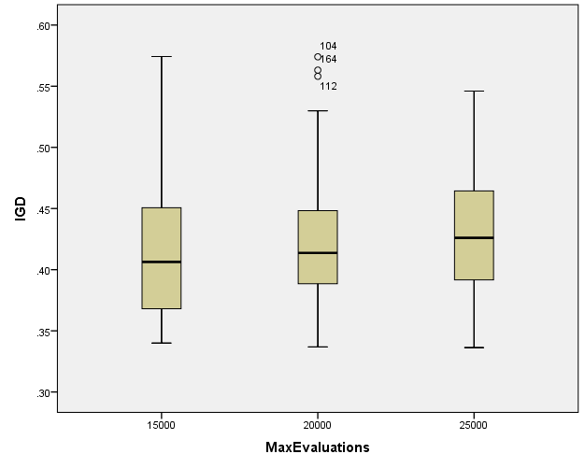

IGDplus

Boxplots

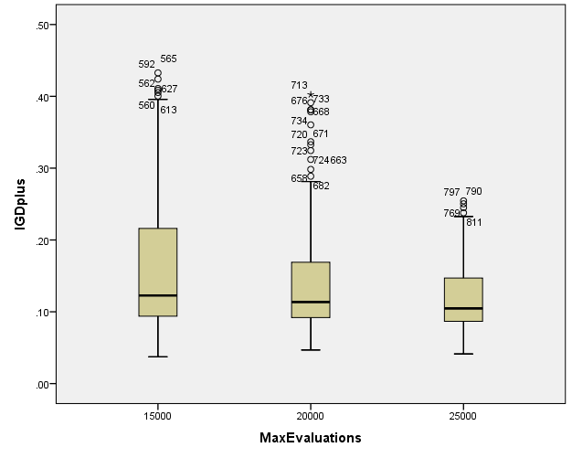

SPREAD

Boxplots

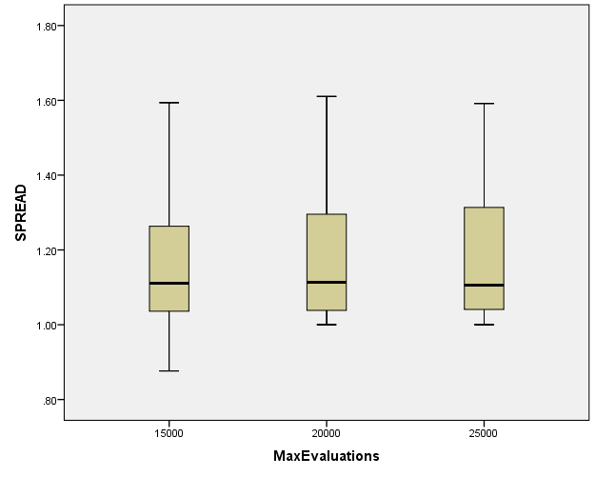

PopulationSize

Case Processing Summary
 | PopulationSize | Cases
 | PopulationSize | Valid |  | Missing |  | Total
 | PopulationSize | N | Percent | N | Percent | N | Percent
HV | 100 | 279 | 100.0% | 0 | 0.0% | 279 | 100.0%
HV | 50 | 279 | 100.0% | 0 | 0.0% | 279 | 100.0%
HV | 200 | 279 | 100.0% | 0 | 0.0% | 279 | 100.0%
EP | 100 | 279 | 100.0% | 0 | 0.0% | 279 | 100.0%
EP | 50 | 279 | 100.0% | 0 | 0.0% | 279 | 100.0%
EP | 200 | 279 | 100.0% | 0 | 0.0% | 279 | 100.0%
GD | 100 | 279 | 100.0% | 0 | 0.0% | 279 | 100.0%
GD | 50 | 279 | 100.0% | 0 | 0.0% | 279 | 100.0%
GD | 200 | 279 | 100.0% | 0 | 0.0% | 279 | 100.0%
IGD | 100 | 279 | 100.0% | 0 | 0.0% | 279 | 100.0%
IGD | 50 | 279 | 100.0% | 0 | 0.0% | 279 | 100.0%
IGD | 200 | 279 | 100.0% | 0 | 0.0% | 279 | 100.0%
IGDplus | 100 | 279 | 100.0% | 0 | 0.0% | 279 | 100.0%
IGDplus | 50 | 279 | 100.0% | 0 | 0.0% | 279 | 100.0%
IGDplus | 200 | 279 | 100.0% | 0 | 0.0% | 279 | 100.0%
SPREAD | 100 | 279 | 100.0% | 0 | 0.0% | 279 | 100.0%
SPREAD | 50 | 279 | 100.0% | 0 | 0.0% | 279 | 100.0%
SPREAD | 200 | 279 | 100.0% | 0 | 0.0% | 279 | 100.0%

HV

Boxplots

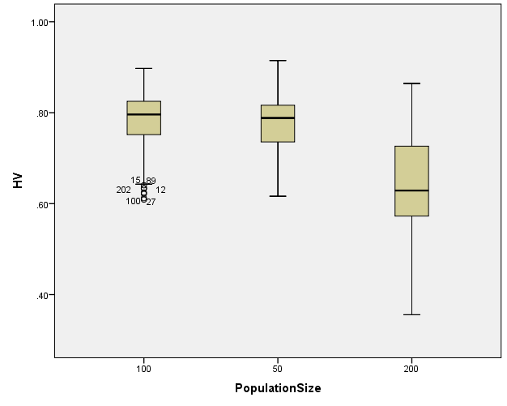

EP

Boxplots

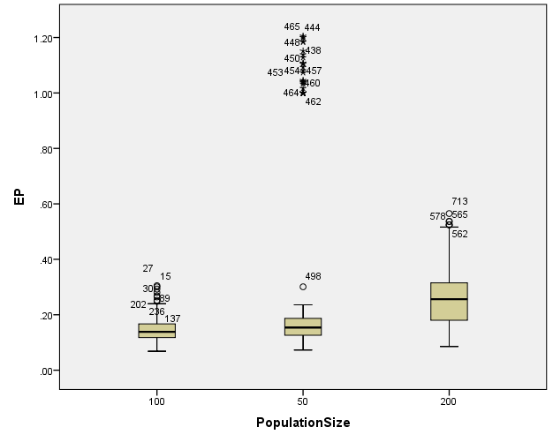

GD

Boxplots

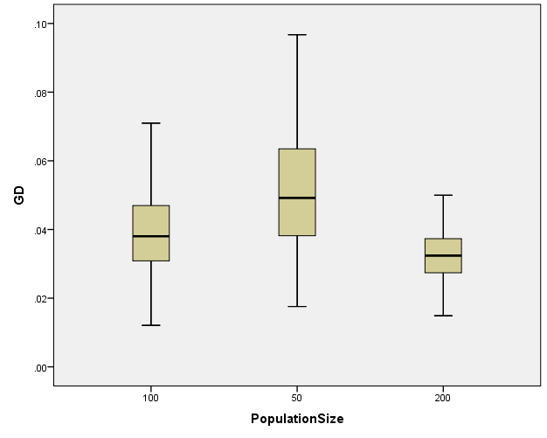

IGD

Boxplots

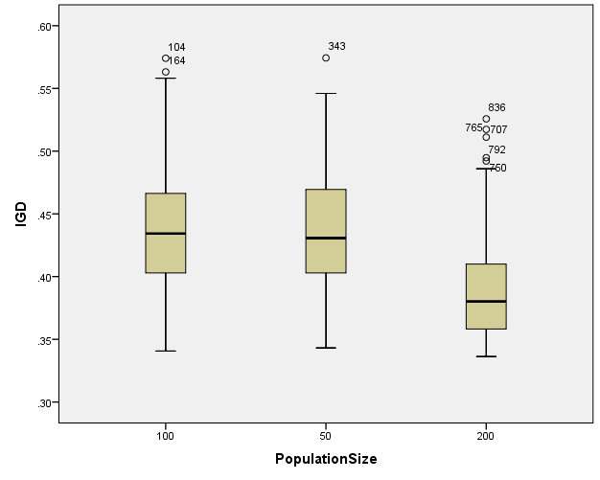

IGDplus

Boxplots

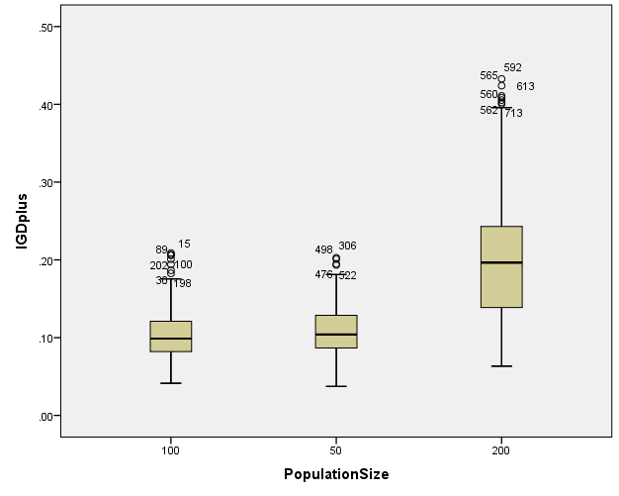

SPREAD

Boxplots

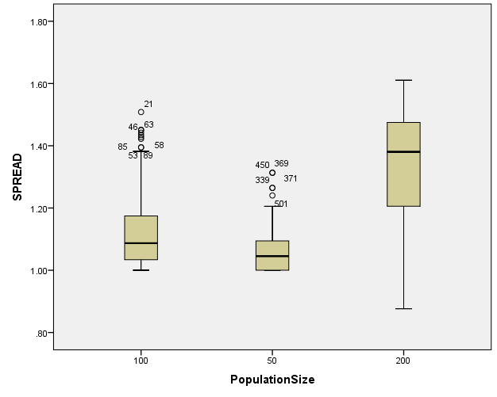

*Nonparametric Tests: Independent Samples.
NPTESTS
/INDEPENDENT TEST (HV EP GD IGD IGDplus SPREAD) GROUP (Crossover) MEDIAN(TESTVALUE=SAMPLE COMPARE=PAIRWISE)
/MISSING SCOPE=ANALYSIS USERMISSING=EXCLUDE
/CRITERIA ALPHA=0.05 CILEVEL=95.

Nonparametric Tests

Notes
Output Created |  | 26-MAY-2020 20:34:07
Comments
Input | Data | C:\Users\user\Documents\NILAY\Mayis2020\medium_SPEA2.sav
Input | Active Dataset | DataSet1
Input | Filter | <none>
Input | Weight | <none>
Input | Split File | <none>
Input | N of Rows in Working Data File | 837
Syntax |  | NPTESTS  /INDEPENDENT TEST (HV EP GD IGD IGDplus SPREAD) GROUP (Crossover) MEDIAN(TESTVALUE=SAMPLE COMPARE=PAIRWISE)  /MISSING SCOPE=ANALYSIS USERMISSING=EXCLUDE  /CRITERIA ALPHA=0.05 CILEVEL=95.
Resources | Processor Time | 00:00:00.42
Resources | Elapsed Time | 00:00:00.51

[DataSet1] C:\Users\user\Documents\NILAY\Mayis2020\medium_SPEA2.sav

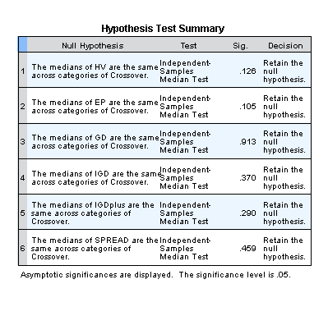

*Nonparametric Tests: Independent Samples.
NPTESTS
/INDEPENDENT TEST (HV EP GD IGD IGDplus SPREAD) GROUP (MaxEvaluations) MEDIAN(TESTVALUE=SAMPLE COMPARE=PAIRWISE)
/MISSING SCOPE=ANALYSIS USERMISSING=EXCLUDE
/CRITERIA ALPHA=0.05 CILEVEL=95.

Nonparametric Tests

Notes
Output Created |  | 26-MAY-2020 20:34:26
Comments
Input | Data | C:\Users\user\Documents\NILAY\Mayis2020\medium_SPEA2.sav
Input | Active Dataset | DataSet1
Input | Filter | <none>
Input | Weight | <none>
Input | Split File | <none>
Input | N of Rows in Working Data File | 837
Syntax |  | NPTESTS  /INDEPENDENT TEST (HV EP GD IGD IGDplus SPREAD) GROUP (MaxEvaluations) MEDIAN(TESTVALUE=SAMPLE COMPARE=PAIRWISE)  /MISSING SCOPE=ANALYSIS USERMISSING=EXCLUDE  /CRITERIA ALPHA=0.05 CILEVEL=95.
Resources | Processor Time | 00:00:00.23
Resources | Elapsed Time | 00:00:00.20

[DataSet1] C:\Users\user\Documents\NILAY\Mayis2020\medium_SPEA2.sav

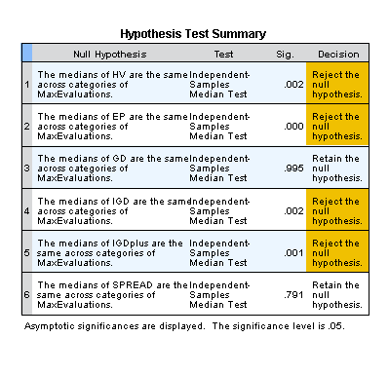

*Nonparametric Tests: Independent Samples.
NPTESTS
/INDEPENDENT TEST (HV EP GD IGD IGDplus SPREAD) GROUP (PopulationSize) MEDIAN(TESTVALUE=SAMPLE COMPARE=PAIRWISE)
/MISSING SCOPE=ANALYSIS USERMISSING=EXCLUDE
/CRITERIA ALPHA=0.05 CILEVEL=95.

Nonparametric Tests

Notes
Output Created |  | 26-MAY-2020 20:34:37
Comments
Input | Data | C:\Users\user\Documents\NILAY\Mayis2020\medium_SPEA2.sav
Input | Active Dataset | DataSet1
Input | Filter | <none>
Input | Weight | <none>
Input | Split File | <none>
Input | N of Rows in Working Data File | 837
Syntax |  | NPTESTS  /INDEPENDENT TEST (HV EP GD IGD IGDplus SPREAD) GROUP (PopulationSize) MEDIAN(TESTVALUE=SAMPLE COMPARE=PAIRWISE)  /MISSING SCOPE=ANALYSIS USERMISSING=EXCLUDE  /CRITERIA ALPHA=0.05 CILEVEL=95.
Resources | Processor Time | 00:00:00.17
Resources | Elapsed Time | 00:00:00.22

[DataSet1] C:\Users\user\Documents\NILAY\Mayis2020\medium_SPEA2.sav

