GET

FILE='C:\Users\user\Documents\NILAY\Mayis2020\7_NSGAII.sav'.

DATASET NAME DataSet2 WINDOW=FRONT.

DATASET CLOSE DataSet1.

GLM HV EP GD IGD IGDplus SPREAD BY Crossover MaxEvaluations PopulationSize

/METHOD=SSTYPE(3)

/INTERCEPT=INCLUDE

/POSTHOC=Crossover MaxEvaluations PopulationSize(BONFERRONI)

/PLOT=PROFILE(Crossover MaxEvaluations PopulationSize)

/CRITERIA=ALPHA(.05)

/DESIGN=Crossover MaxEvaluations PopulationSize.

**General Linear Model**

|  |  |  |
| --- | --- | --- |
| **Notes** | | |
| Output Created | | 26-MAY-2020 20:19:05 |
| Comments | |  |
| Input | Data | C:\Users\user\Documents\NILAY\Mayis2020\7_NSGAII.sav |
| Active Dataset | DataSet2 |
| Filter | <none> |
| Weight | <none> |
| Split File | <none> |
| N of Rows in Working Data File | 837 |
| Missing Value Handling | Definition of Missing | User-defined missing values are treated as missing. |
| Cases Used | Statistics are based on all cases with valid data for all variables in the model. |
| Syntax | | GLM HV EP GD IGD IGDplus SPREAD BY Crossover MaxEvaluations PopulationSize  /METHOD=SSTYPE(3)  /INTERCEPT=INCLUDE  /POSTHOC=Crossover MaxEvaluations PopulationSize(BONFERRONI)  /PLOT=PROFILE(Crossover MaxEvaluations PopulationSize)  /CRITERIA=ALPHA(.05)  /DESIGN=Crossover MaxEvaluations PopulationSize. |
| Resources | Processor Time | 00:00:03.17 |
| Elapsed Time | 00:00:03.13 |

[DataSet2] C:\Users\user\Documents\NILAY\Mayis2020\7_NSGAII.sav

|  |  |  |  |
| --- | --- | --- | --- |
| **Between-Subjects Factors** | | | |
|  | | Value Label | N |
| Crossover | 1 | 0.7 | 279 |
| 2 | 0.8 | 279 |
| 3 | 0.9 | 279 |
| MaxEvaluations | 1 | 15000 | 279 |
| 2 | 20000 | 279 |
| 3 | 25000 | 279 |
| PopulationSize | 1 | 100 | 279 |
| 2 | 50 | 279 |
| 3 | 200 | 279 |

|  |  |  |  |  |  |
| --- | --- | --- | --- | --- | --- |
| **Multivariate Testsa** | | | | | |
| Effect | | Value | F | Hypothesis df | Error df |
| Intercept | Pillai's Trace | 1.000 | 10235110.680b | 5.000 | 826.000 |
| Wilks' Lambda | .000 | 10235110.680b | 5.000 | 826.000 |
| Hotelling's Trace | 61955.876 | 10235110.680b | 5.000 | 826.000 |
| Roy's Largest Root | 61955.876 | 10235110.680b | 5.000 | 826.000 |
| Crossover | Pillai's Trace | .019 | 1.579 | 10.000 | 1654.000 |
| Wilks' Lambda | .981 | 1.578b | 10.000 | 1652.000 |
| Hotelling's Trace | .019 | 1.577 | 10.000 | 1650.000 |
| Roy's Largest Root | .013 | 2.121c | 5.000 | 827.000 |
| MaxEvaluations | Pillai's Trace | .016 | 1.344 | 10.000 | 1654.000 |
| Wilks' Lambda | .984 | 1.344b | 10.000 | 1652.000 |
| Hotelling's Trace | .016 | 1.343 | 10.000 | 1650.000 |
| Roy's Largest Root | .012 | 1.976c | 5.000 | 827.000 |
| PopulationSize | Pillai's Trace | .538 | 60.813 | 10.000 | 1654.000 |
| Wilks' Lambda | .468 | 76.361b | 10.000 | 1652.000 |
| Hotelling's Trace | 1.127 | 92.950 | 10.000 | 1650.000 |
| Roy's Largest Root | 1.116 | 184.652c | 5.000 | 827.000 |

|  |  |  |
| --- | --- | --- |
| **Multivariate Testsa** | | |
| Effect | | Sig. |
| Intercept | Pillai's Trace | .000 |
| Wilks' Lambda | .000 |
| Hotelling's Trace | .000 |
| Roy's Largest Root | .000 |
| Crossover | Pillai's Trace | .107 |
| Wilks' Lambda | .107 |
| Hotelling's Trace | .108 |
| Roy's Largest Root | .061 |
| MaxEvaluations | Pillai's Trace | .201 |
| Wilks' Lambda | .201 |
| Hotelling's Trace | .202 |
| Roy's Largest Root | .080 |
| PopulationSize | Pillai's Trace | .000 |
| Wilks' Lambda | .000 |
| Hotelling's Trace | .000 |
| Roy's Largest Root | .000 |

|  |
| --- |
| a. Design: Intercept + Crossover + MaxEvaluations + PopulationSize |
| b. Exact statistic |
| c. The statistic is an upper bound on F that yields a lower bound on the significance level. |

|  |  |  |  |  |  |
| --- | --- | --- | --- | --- | --- |
| **Tests of Between-Subjects Effects** | | | | | |
| Source | Dependent Variable | Type III Sum of Squares | df | Mean Square | F |
| Corrected Model | HV | .760a | 6 | .127 | 15.503 |
| EP | .760b | 6 | .127 | 15.503 |
| GD | .403c | 6 | .067 | 53.619 |
| IGD | .368d | 6 | .061 | 2.503 |
| IGDplus | .390e | 6 | .065 | 14.134 |
| SPREAD | 1.368f | 6 | .228 | 6.288 |
| Intercept | HV | 741.771 | 1 | 741.771 | 90753.901 |
| EP | 2.875 | 1 | 2.875 | 351.705 |
| GD | 5.191 | 1 | 5.191 | 4147.258 |
| IGD | 326.522 | 1 | 326.522 | 13340.602 |
| IGDplus | 1.183 | 1 | 1.183 | 257.551 |
| SPREAD | 1244.731 | 1 | 1244.731 | 34338.780 |
| Crossover | HV | .017 | 2 | .008 | 1.039 |
| EP | .017 | 2 | .008 | 1.039 |
| GD | .008 | 2 | .004 | 3.035 |
| IGD | .184 | 2 | .092 | 3.754 |
| IGDplus | .008 | 2 | .004 | .885 |
| SPREAD | .274 | 2 | .137 | 3.786 |
| MaxEvaluations | HV | .032 | 2 | .016 | 1.957 |
| EP | .032 | 2 | .016 | 1.957 |
| GD | .002 | 2 | .001 | .805 |
| IGD | .001 | 2 | .001 | .021 |
| IGDplus | .017 | 2 | .009 | 1.893 |
| SPREAD | .007 | 2 | .003 | .093 |
| PopulationSize | HV | .711 | 2 | .356 | 43.511 |
| EP | .711 | 2 | .356 | 43.511 |
| GD | .393 | 2 | .197 | 157.017 |
| IGD | .183 | 2 | .091 | 3.734 |
| IGDplus | .364 | 2 | .182 | 39.624 |
| SPREAD | 1.086 | 2 | .543 | 14.986 |
| Error | HV | 6.784 | 830 | .008 |  |
| EP | 6.784 | 830 | .008 |  |
| GD | 1.039 | 830 | .001 |  |
| IGD | 20.315 | 830 | .024 |  |
| IGDplus | 3.814 | 830 | .005 |  |

|  |  |  |
| --- | --- | --- |
| **Tests of Between-Subjects Effects** | | |
| Source | Dependent Variable | Sig. |
| Corrected Model | HV | .000a |
| EP | .000b |
| GD | .000c |
| IGD | .021d |
| IGDplus | .000e |
| SPREAD | .000f |
| Intercept | HV | .000 |
| EP | .000 |
| GD | .000 |
| IGD | .000 |
| IGDplus | .000 |
| SPREAD | .000 |
| Crossover | HV | .354 |
| EP | .354 |
| GD | .049 |
| IGD | .024 |
| IGDplus | .413 |
| SPREAD | .023 |
| MaxEvaluations | HV | .142 |
| EP | .142 |
| GD | .447 |
| IGD | .980 |
| IGDplus | .151 |
| SPREAD | .912 |
| PopulationSize | HV | .000 |
| EP | .000 |
| GD | .000 |
| IGD | .024 |
| IGDplus | .000 |
| SPREAD | .000 |
| Error | HV |  |
| EP |  |
| GD |  |
| IGD |  |
| IGDplus |  |

|  |  |  |  |  |  |
| --- | --- | --- | --- | --- | --- |
| **Tests of Between-Subjects Effects** | | | | | |
| Source | Dependent Variable | Type III Sum of Squares | df | Mean Square | F |
| Error | SPREAD | 30.086a | 830 | .036 |  |
| Total | HV | 749.315b | 837 |  |  |
| EP | 10.419c | 837 |  |  |
| GD | 6.632d | 837 |  |  |
| IGD | 347.205e | 837 |  |  |
| IGDplus | 5.387f | 837 |  |  |
| SPREAD | 1276.185 | 837 |  |  |
| Corrected Total | HV | 7.544 | 836 |  |  |
| EP | 7.544 | 836 |  |  |
| GD | 1.441 | 836 |  |  |
| IGD | 20.682 | 836 |  |  |
| IGDplus | 4.203 | 836 |  |  |
| SPREAD | 31.454 | 836 |  |  |

|  |  |  |
| --- | --- | --- |
| **Tests of Between-Subjects Effects** | | |
| Source | Dependent Variable | Sig. |
| Error | SPREAD |  |
| Total | HV |  |
| EP |  |
| GD |  |
| IGD |  |
| IGDplus |  |
| SPREAD |  |
| Corrected Total | HV |  |
| EP |  |
| GD |  |
| IGD |  |
| IGDplus |  |
| SPREAD |  |

|  |
| --- |
| a. R Squared = .101 (Adjusted R Squared = .094) |
| b. R Squared = .101 (Adjusted R Squared = .094) |
| c. R Squared = .279 (Adjusted R Squared = .274) |
| d. R Squared = .018 (Adjusted R Squared = .011) |
| e. R Squared = .093 (Adjusted R Squared = .086) |
| f. R Squared = .043 (Adjusted R Squared = .037) |

**Post Hoc Tests**

**Crossover**

|  |  |  |  |  |  |
| --- | --- | --- | --- | --- | --- |
| **Multiple Comparisons** | | | | | |
| Bonferroni | | | | | |
| Dependent Variable | (I) Crossover | (J) Crossover | Mean Difference (I-J) | Std. Error | Sig. |
|
| HV | 0.7 | 0.8 | -.0042 | .00765 | 1.000 |
| 0.9 | -.0109 | .00765 | .460 |
| 0.8 | 0.7 | .0042 | .00765 | 1.000 |
| 0.9 | -.0067 | .00765 | 1.000 |
| 0.9 | 0.7 | .0109 | .00765 | .460 |
| 0.8 | .0067 | .00765 | 1.000 |
| EP | 0.7 | 0.8 | .0042 | .00765 | 1.000 |
| 0.9 | .0109 | .00765 | .460 |
| 0.8 | 0.7 | -.0042 | .00765 | 1.000 |
| 0.9 | .0067 | .00765 | 1.000 |
| 0.9 | 0.7 | -.0109 | .00765 | .460 |
| 0.8 | -.0067 | .00765 | 1.000 |
| GD | 0.7 | 0.8 | .0071 | .00300 | .053 |
| 0.9 | .0053 | .00300 | .239 |
| 0.8 | 0.7 | -.0071 | .00300 | .053 |
| 0.9 | -.0019 | .00300 | 1.000 |
| 0.9 | 0.7 | -.0053 | .00300 | .239 |
| 0.8 | .0019 | .00300 | 1.000 |
| IGD | 0.7 | 0.8 | .0209 | .01325 | .346 |
| 0.9 | .0362* | .01325 | .019 |
| 0.8 | 0.7 | -.0209 | .01325 | .346 |
| 0.9 | .0153 | .01325 | .748 |
| 0.9 | 0.7 | -.0362* | .01325 | .019 |
| 0.8 | -.0153 | .01325 | .748 |
| IGDplus | 0.7 | 0.8 | .0029 | .00574 | 1.000 |
| 0.9 | .0076 | .00574 | .564 |
| 0.8 | 0.7 | -.0029 | .00574 | 1.000 |
| 0.9 | .0047 | .00574 | 1.000 |
| 0.9 | 0.7 | -.0076 | .00574 | .564 |
| 0.8 | -.0047 | .00574 | 1.000 |
| SPREAD | 0.7 | 0.8 | -.0065 | .01612 | 1.000 |
| 0.9 | -.0412* | .01612 | .032 |
| 0.8 | 0.7 | .0065 | .01612 | 1.000 |

|  |  |  |  |  |
| --- | --- | --- | --- | --- |
| **Multiple Comparisons** | | | | |
| Bonferroni | | | | |
| Dependent Variable | (I) Crossover | (J) Crossover | 95% Confidence Interval | |
| Lower Bound | Upper Bound |
| HV | 0.7 | 0.8 | -.0226 | .0142 |
| 0.9 | -.0293 | .0074 |
| 0.8 | 0.7 | -.0142 | .0226 |
| 0.9 | -.0251 | .0116 |
| 0.9 | 0.7 | -.0074 | .0293 |
| 0.8 | -.0116 | .0251 |
| EP | 0.7 | 0.8 | -.0142 | .0226 |
| 0.9 | -.0074 | .0293 |
| 0.8 | 0.7 | -.0226 | .0142 |
| 0.9 | -.0116 | .0251 |
| 0.9 | 0.7 | -.0293 | .0074 |
| 0.8 | -.0251 | .0116 |
| GD | 0.7 | 0.8 | -.0001 | .0143 |
| 0.9 | -.0019 | .0124 |
| 0.8 | 0.7 | -.0143 | .0001 |
| 0.9 | -.0090 | .0053 |
| 0.9 | 0.7 | -.0124 | .0019 |
| 0.8 | -.0053 | .0090 |
| IGD | 0.7 | 0.8 | -.0109 | .0527 |
| 0.9 | .0044* | .0679 |
| 0.8 | 0.7 | -.0527 | .0109 |
| 0.9 | -.0165 | .0470 |
| 0.9 | 0.7 | -.0679* | -.0044 |
| 0.8 | -.0470 | .0165 |
| IGDplus | 0.7 | 0.8 | -.0109 | .0166 |
| 0.9 | -.0062 | .0213 |
| 0.8 | 0.7 | -.0166 | .0109 |
| 0.9 | -.0091 | .0185 |
| 0.9 | 0.7 | -.0213 | .0062 |
| 0.8 | -.0185 | .0091 |
| SPREAD | 0.7 | 0.8 | -.0452 | .0322 |
| 0.9 | -.0799* | -.0026 |
| 0.8 | 0.7 | -.0322 | .0452 |

|  |  |  |  |  |  |
| --- | --- | --- | --- | --- | --- |
| **Multiple Comparisons** | | | | | |
| Bonferroni | | | | | |
| Dependent Variable | (I) Crossover | (J) Crossover | Mean Difference (I-J) | Std. Error | Sig. |
|
| SPREAD | 0.8 | 0.9 | -.0347 | .01612 | .094 |
| 0.9 | 0.7 | .0412 | .01612 | .032 |
| 0.8 | .0347 | .01612 | .094 |

|  |  |  |  |  |
| --- | --- | --- | --- | --- |
| **Multiple Comparisons** | | | | |
| Bonferroni | | | | |
| Dependent Variable | (I) Crossover | (J) Crossover | 95% Confidence Interval | |
| Lower Bound | Upper Bound |
| SPREAD | 0.8 | 0.9 | -.0734 | .0039 |
| 0.9 | 0.7 | .0026 | .0799 |
| 0.8 | -.0039 | .0734 |

|  |
| --- |
| Based on observed means.  The error term is Mean Square(Error) = .036. |
| *. The mean difference is significant at the .05 level. |

**Homogeneous Subsets**

**MaxEvaluations**

|  |  |  |  |  |  |
| --- | --- | --- | --- | --- | --- |
| **Multiple Comparisons** | | | | | |
| Bonferroni | | | | | |
| Dependent Variable | (I) MaxEvaluations | (J) MaxEvaluations | Mean Difference (I-J) | Std. Error | Sig. |
|
| HV | 15000 | 20000 | -.0092 | .00765 | .688 |
| 25000 | -.0150 | .00765 | .150 |
| 20000 | 15000 | .0092 | .00765 | .688 |
| 25000 | -.0058 | .00765 | 1.000 |
| 25000 | 15000 | .0150 | .00765 | .150 |
| 20000 | .0058 | .00765 | 1.000 |
| EP | 15000 | 20000 | .0092 | .00765 | .688 |
| 25000 | .0150 | .00765 | .150 |
| 20000 | 15000 | -.0092 | .00765 | .688 |
| 25000 | .0058 | .00765 | 1.000 |
| 25000 | 15000 | -.0150 | .00765 | .150 |
| 20000 | -.0058 | .00765 | 1.000 |
| GD | 15000 | 20000 | .0006 | .00300 | 1.000 |
| 25000 | -.0029 | .00300 | .979 |
| 20000 | 15000 | -.0006 | .00300 | 1.000 |
| 25000 | -.0036 | .00300 | .707 |
| 25000 | 15000 | .0029 | .00300 | .979 |
| 20000 | .0036 | .00300 | .707 |
| IGD | 15000 | 20000 | -.0026 | .01325 | 1.000 |
| 25000 | -.0019 | .01325 | 1.000 |
| 20000 | 15000 | .0026 | .01325 | 1.000 |
| 25000 | .0007 | .01325 | 1.000 |
| 25000 | 15000 | .0019 | .01325 | 1.000 |
| 20000 | -.0007 | .01325 | 1.000 |
| IGDplus | 15000 | 20000 | .0072 | .00574 | .622 |
| 25000 | .0110 | .00574 | .168 |
| 20000 | 15000 | -.0072 | .00574 | .622 |
| 25000 | .0037 | .00574 | 1.000 |
| 25000 | 15000 | -.0110 | .00574 | .168 |
| 20000 | -.0037 | .00574 | 1.000 |
| SPREAD | 15000 | 20000 | -.0020 | .01612 | 1.000 |
| 25000 | -.0067 | .01612 | 1.000 |
| 20000 | 15000 | .0020 | .01612 | 1.000 |

|  |  |  |  |  |
| --- | --- | --- | --- | --- |
| **Multiple Comparisons** | | | | |
| Bonferroni | | | | |
| Dependent Variable | (I) MaxEvaluations | (J) MaxEvaluations | 95% Confidence Interval | |
| Lower Bound | Upper Bound |
| HV | 15000 | 20000 | -.0276 | .0092 |
| 25000 | -.0334 | .0033 |
| 20000 | 15000 | -.0092 | .0276 |
| 25000 | -.0242 | .0126 |
| 25000 | 15000 | -.0033 | .0334 |
| 20000 | -.0126 | .0242 |
| EP | 15000 | 20000 | -.0092 | .0276 |
| 25000 | -.0033 | .0334 |
| 20000 | 15000 | -.0276 | .0092 |
| 25000 | -.0126 | .0242 |
| 25000 | 15000 | -.0334 | .0033 |
| 20000 | -.0242 | .0126 |
| GD | 15000 | 20000 | -.0066 | .0078 |
| 25000 | -.0101 | .0042 |
| 20000 | 15000 | -.0078 | .0066 |
| 25000 | -.0107 | .0036 |
| 25000 | 15000 | -.0042 | .0101 |
| 20000 | -.0036 | .0107 |
| IGD | 15000 | 20000 | -.0344 | .0292 |
| 25000 | -.0337 | .0299 |
| 20000 | 15000 | -.0292 | .0344 |
| 25000 | -.0310 | .0325 |
| 25000 | 15000 | -.0299 | .0337 |
| 20000 | -.0325 | .0310 |
| IGDplus | 15000 | 20000 | -.0065 | .0210 |
| 25000 | -.0028 | .0248 |
| 20000 | 15000 | -.0210 | .0065 |
| 25000 | -.0100 | .0175 |
| 25000 | 15000 | -.0248 | .0028 |
| 20000 | -.0175 | .0100 |
| SPREAD | 15000 | 20000 | -.0406 | .0367 |
| 25000 | -.0454 | .0319 |
| 20000 | 15000 | -.0367 | .0406 |

|  |  |  |  |  |  |
| --- | --- | --- | --- | --- | --- |
| **Multiple Comparisons** | | | | | |
| Bonferroni | | | | | |
| Dependent Variable | (I) MaxEvaluations | (J) MaxEvaluations | Mean Difference (I-J) | Std. Error | Sig. |
|
| SPREAD | 20000 | 25000 | -.0048 | .01612 | 1.000 |
| 25000 | 15000 | .0067 | .01612 | 1.000 |
| 20000 | .0048 | .01612 | 1.000 |

|  |  |  |  |  |
| --- | --- | --- | --- | --- |
| **Multiple Comparisons** | | | | |
| Bonferroni | | | | |
| Dependent Variable | (I) MaxEvaluations | (J) MaxEvaluations | 95% Confidence Interval | |
| Lower Bound | Upper Bound |
| SPREAD | 20000 | 25000 | -.0434 | .0339 |
| 25000 | 15000 | -.0319 | .0454 |
| 20000 | -.0339 | .0434 |

|  |
| --- |
| Based on observed means.  The error term is Mean Square(Error) = .036. |

**Homogeneous Subsets**

**PopulationSize**

|  |  |  |  |  |  |
| --- | --- | --- | --- | --- | --- |
| **Multiple Comparisons** | | | | | |
| Bonferroni | | | | | |
| Dependent Variable | (I) PopulationSize | (J) PopulationSize | Mean Difference (I-J) | Std. Error | Sig. |
|
| HV | 100 | 50 | .0478* | .00765 | .000 |
| 200 | -.0220* | .00765 | .012 |
| 50 | 100 | -.0478* | .00765 | .000 |
| 200 | -.0698* | .00765 | .000 |
| 200 | 100 | .0220* | .00765 | .012 |
| 50 | .0698* | .00765 | .000 |
| EP | 100 | 50 | -.0478* | .00765 | .000 |
| 200 | .0220* | .00765 | .012 |
| 50 | 100 | .0478* | .00765 | .000 |
| 200 | .0698* | .00765 | .000 |
| 200 | 100 | -.0220* | .00765 | .012 |
| 50 | -.0698* | .00765 | .000 |
| GD | 100 | 50 | -.0293* | .00300 | .000 |
| 200 | .0237* | .00300 | .000 |
| 50 | 100 | .0293* | .00300 | .000 |
| 200 | .0530* | .00300 | .000 |
| 200 | 100 | -.0237* | .00300 | .000 |
| 50 | -.0530* | .00300 | .000 |
| IGD | 100 | 50 | -.0165 | .01325 | .642 |
| 200 | .0197 | .01325 | .414 |
| 50 | 100 | .0165 | .01325 | .642 |
| 200 | .0361* | .01325 | .019 |
| 200 | 100 | -.0197 | .01325 | .414 |
| 50 | -.0361* | .01325 | .019 |
| IGDplus | 100 | 50 | -.0347* | .00574 | .000 |
| 200 | .0151* | .00574 | .026 |
| 50 | 100 | .0347* | .00574 | .000 |
| 200 | .0498* | .00574 | .000 |
| 200 | 100 | -.0151* | .00574 | .026 |
| 50 | -.0498* | .00574 | .000 |
| SPREAD | 100 | 50 | .0625* | .01612 | .000 |
| 200 | -.0228 | .01612 | .475 |
| 50 | 100 | -.0625* | .01612 | .000 |

|  |  |  |  |  |
| --- | --- | --- | --- | --- |
| **Multiple Comparisons** | | | | |
| Bonferroni | | | | |
| Dependent Variable | (I) PopulationSize | (J) PopulationSize | 95% Confidence Interval | |
| Lower Bound | Upper Bound |
| HV | 100 | 50 | .0295* | .0662 |
| 200 | -.0404* | -.0036 |
| 50 | 100 | -.0662* | -.0295 |
| 200 | -.0882* | -.0515 |
| 200 | 100 | .0036* | .0404 |
| 50 | .0515* | .0882 |
| EP | 100 | 50 | -.0662* | -.0295 |
| 200 | .0036* | .0404 |
| 50 | 100 | .0295* | .0662 |
| 200 | .0515* | .0882 |
| 200 | 100 | -.0404* | -.0036 |
| 50 | -.0882* | -.0515 |
| GD | 100 | 50 | -.0364* | -.0221 |
| 200 | .0165* | .0309 |
| 50 | 100 | .0221* | .0364 |
| 200 | .0458* | .0602 |
| 200 | 100 | -.0309* | -.0165 |
| 50 | -.0602* | -.0458 |
| IGD | 100 | 50 | -.0483 | .0153 |
| 200 | -.0121 | .0514 |
| 50 | 100 | -.0153 | .0483 |
| 200 | .0044* | .0679 |
| 200 | 100 | -.0514 | .0121 |
| 50 | -.0679* | -.0044 |
| IGDplus | 100 | 50 | -.0485* | -.0210 |
| 200 | .0013* | .0288 |
| 50 | 100 | .0210* | .0485 |
| 200 | .0360* | .0636 |
| 200 | 100 | -.0288* | -.0013 |
| 50 | -.0636* | -.0360 |
| SPREAD | 100 | 50 | .0238* | .1011 |
| 200 | -.0614 | .0159 |
| 50 | 100 | -.1011* | -.0238 |

|  |  |  |  |  |  |
| --- | --- | --- | --- | --- | --- |
| **Multiple Comparisons** | | | | | |
| Bonferroni | | | | | |
| Dependent Variable | (I) PopulationSize | (J) PopulationSize | Mean Difference (I-J) | Std. Error | Sig. |
|
| SPREAD | 50 | 200 | -.0852* | .01612 | .000 |
| 200 | 100 | .0228* | .01612 | .475 |
| 50 | .0852* | .01612 | .000 |

|  |  |  |  |  |
| --- | --- | --- | --- | --- |
| **Multiple Comparisons** | | | | |
| Bonferroni | | | | |
| Dependent Variable | (I) PopulationSize | (J) PopulationSize | 95% Confidence Interval | |
| Lower Bound | Upper Bound |
| SPREAD | 50 | 200 | -.1239* | -.0466 |
| 200 | 100 | -.0159* | .0614 |
| 50 | .0466* | .1239 |

|  |
| --- |
| Based on observed means.  The error term is Mean Square(Error) = .036. |
| *. The mean difference is significant at the .05 level. |

**Profile Plots**

**HV**

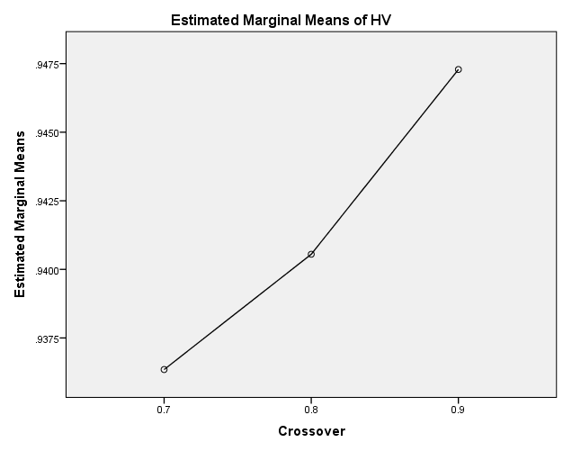

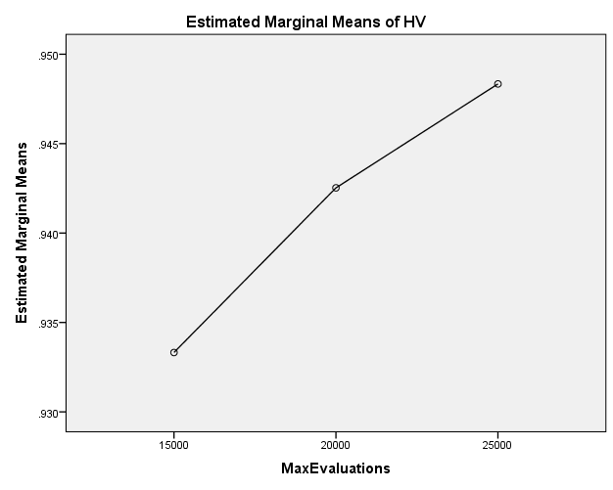

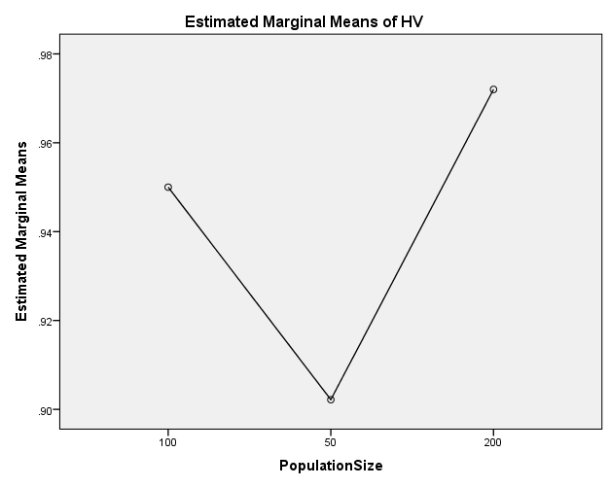

**EP**

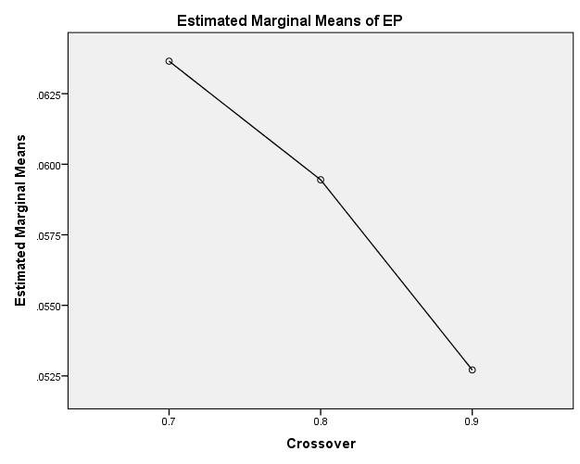

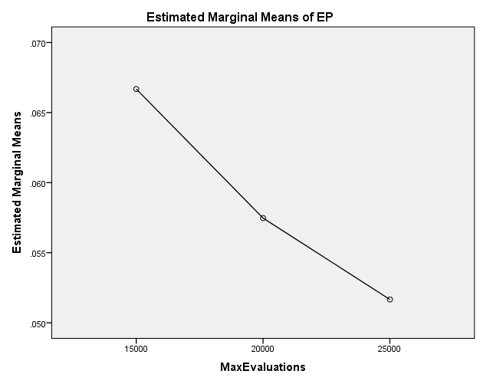

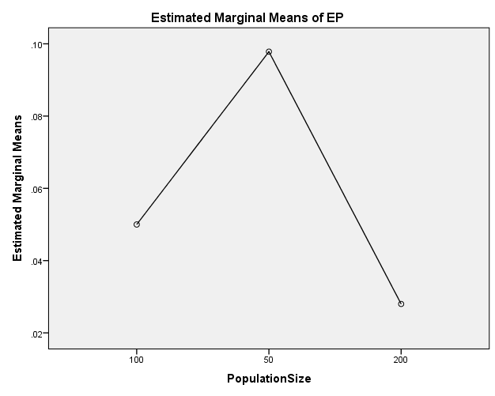

**GD**

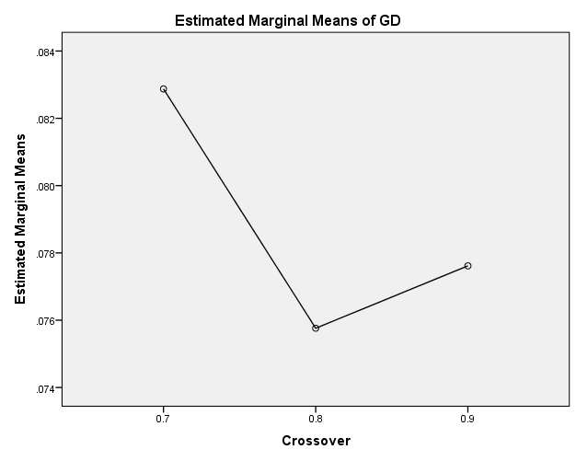

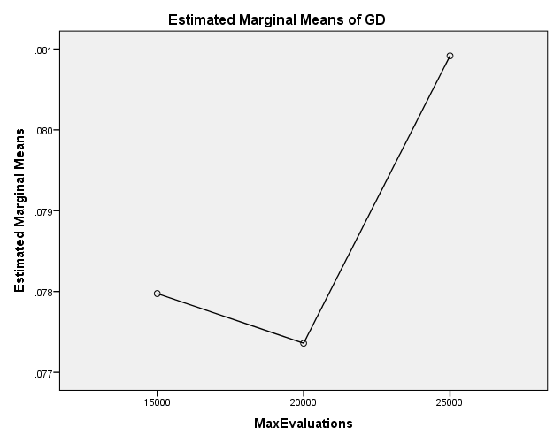

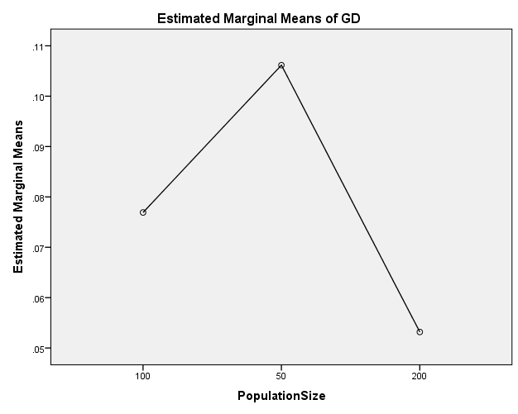

**IGD**

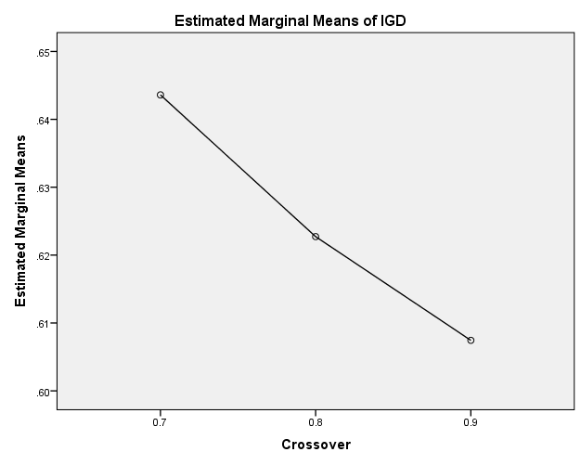

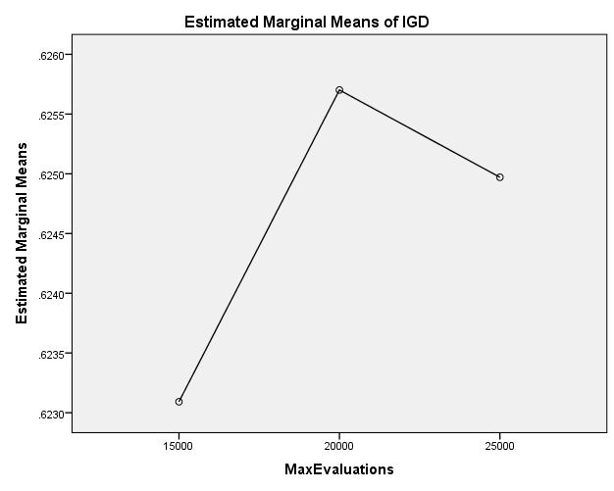

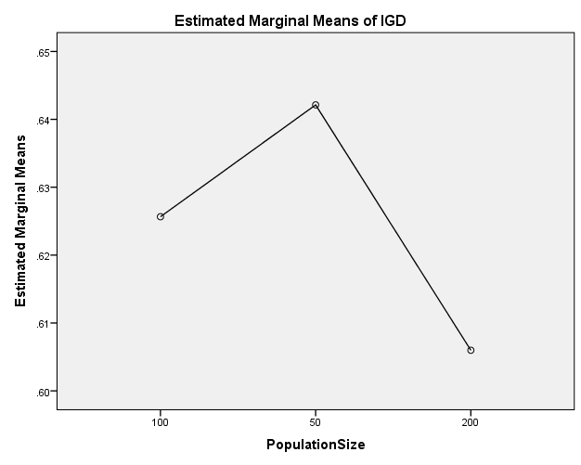

**IGDplus**

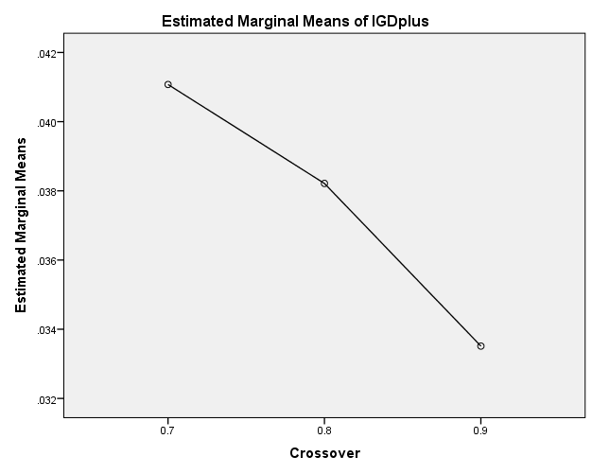

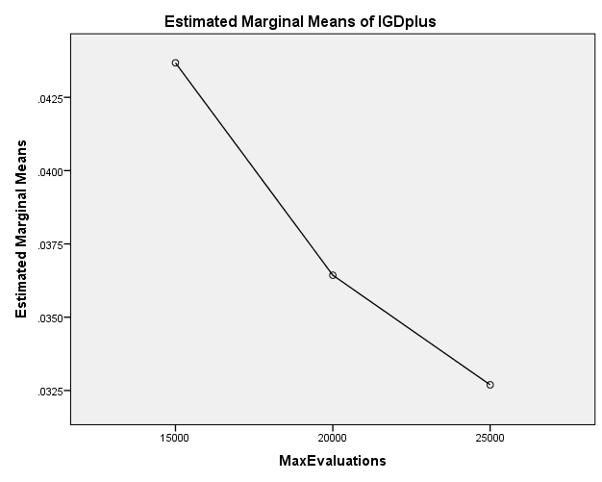

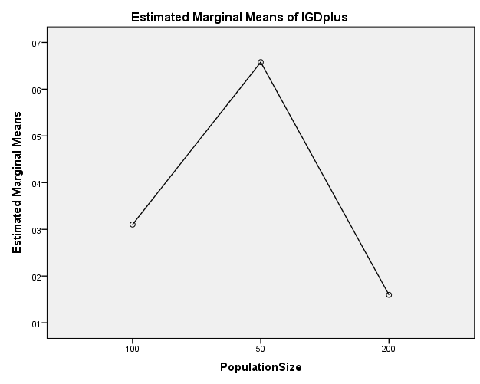

**SPREAD**

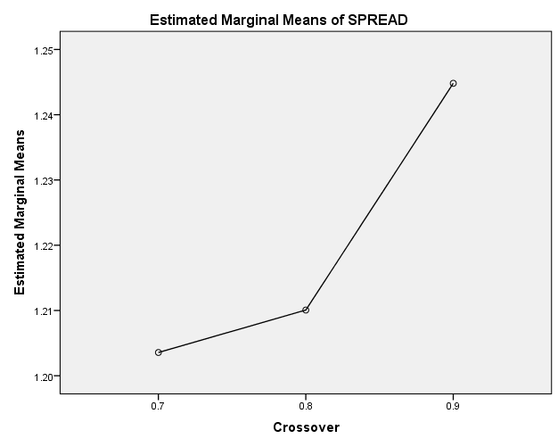

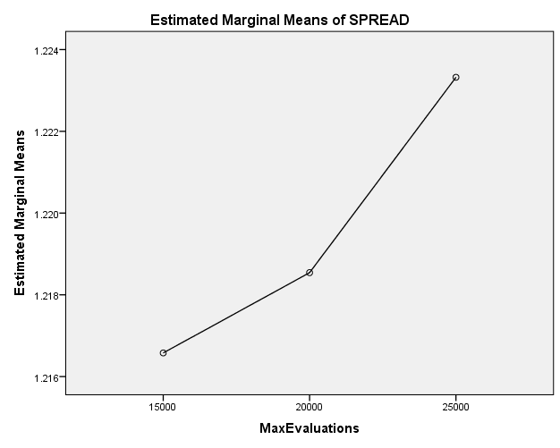

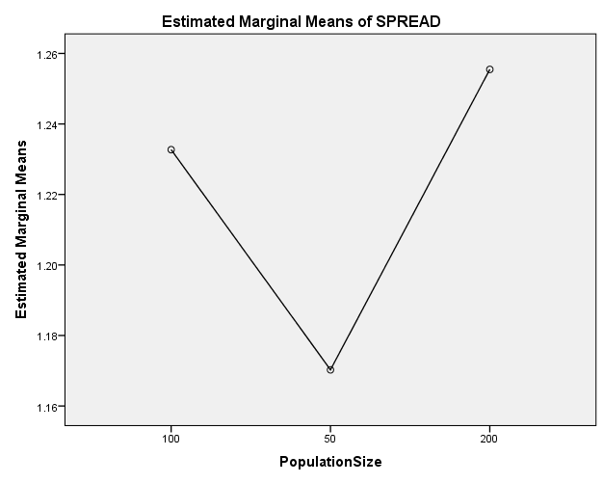

EXAMINE VARIABLES=HV EP GD IGD IGDplus SPREAD BY Crossover MaxEvaluations PopulationSize

/PLOT BOXPLOT

/COMPARE VARIABLES

/STATISTICS NONE

/CINTERVAL 95

/MISSING LISTWISE

/NOTOTAL.

**Explore**

|  |  |  |
| --- | --- | --- |
| **Notes** | | |
| Output Created | | 26-MAY-2020 20:20:15 |
| Comments | |  |
| Input | Data | C:\Users\user\Documents\NILAY\Mayis2020\7_NSGAII.sav |
| Active Dataset | DataSet2 |
| Filter | <none> |
| Weight | <none> |
| Split File | <none> |
| N of Rows in Working Data File | 837 |
| Missing Value Handling | Definition of Missing | User-defined missing values for dependent variables are treated as missing. |
| Cases Used | Statistics are based on cases with no missing values for any dependent variable or factor used. |
| Syntax | | EXAMINE VARIABLES=HV EP GD IGD IGDplus SPREAD BY Crossover MaxEvaluations PopulationSize  /PLOT BOXPLOT  /COMPARE VARIABLES  /STATISTICS NONE  /CINTERVAL 95  /MISSING LISTWISE  /NOTOTAL. |
| Resources | Processor Time | 00:00:01.66 |
| Elapsed Time | 00:00:01.66 |

[DataSet2] C:\Users\user\Documents\NILAY\Mayis2020\7_NSGAII.sav

**Crossover**

|  |  |  |  |  |  |  |  |
| --- | --- | --- | --- | --- | --- | --- | --- |
| **Case Processing Summary** | | | | | | | |
|  | Crossover | Cases | | | | | |
| Valid | | Missing | | Total | |
| N | Percent | N | Percent | N | Percent |
| HV | 0.7 | 279 | 100.0% | 0 | 0.0% | 279 | 100.0% |
| 0.8 | 279 | 100.0% | 0 | 0.0% | 279 | 100.0% |
| 0.9 | 279 | 100.0% | 0 | 0.0% | 279 | 100.0% |
| EP | 0.7 | 279 | 100.0% | 0 | 0.0% | 279 | 100.0% |
| 0.8 | 279 | 100.0% | 0 | 0.0% | 279 | 100.0% |
| 0.9 | 279 | 100.0% | 0 | 0.0% | 279 | 100.0% |
| GD | 0.7 | 279 | 100.0% | 0 | 0.0% | 279 | 100.0% |
| 0.8 | 279 | 100.0% | 0 | 0.0% | 279 | 100.0% |
| 0.9 | 279 | 100.0% | 0 | 0.0% | 279 | 100.0% |
| IGD | 0.7 | 279 | 100.0% | 0 | 0.0% | 279 | 100.0% |
| 0.8 | 279 | 100.0% | 0 | 0.0% | 279 | 100.0% |
| 0.9 | 279 | 100.0% | 0 | 0.0% | 279 | 100.0% |
| IGDplus | 0.7 | 279 | 100.0% | 0 | 0.0% | 279 | 100.0% |
| 0.8 | 279 | 100.0% | 0 | 0.0% | 279 | 100.0% |
| 0.9 | 279 | 100.0% | 0 | 0.0% | 279 | 100.0% |
| SPREAD | 0.7 | 279 | 100.0% | 0 | 0.0% | 279 | 100.0% |
| 0.8 | 279 | 100.0% | 0 | 0.0% | 279 | 100.0% |
| 0.9 | 279 | 100.0% | 0 | 0.0% | 279 | 100.0% |

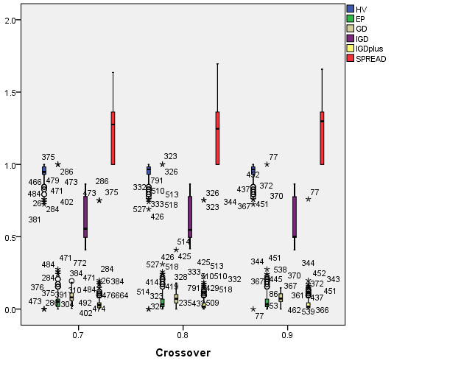

**MaxEvaluations**

|  |  |  |  |  |  |  |  |
| --- | --- | --- | --- | --- | --- | --- | --- |
| **Case Processing Summary** | | | | | | | |
|  | MaxEvaluations | Cases | | | | | |
| Valid | | Missing | | Total | |
| N | Percent | N | Percent | N | Percent |
| HV | 15000 | 279 | 100.0% | 0 | 0.0% | 279 | 100.0% |
| 20000 | 279 | 100.0% | 0 | 0.0% | 279 | 100.0% |
| 25000 | 279 | 100.0% | 0 | 0.0% | 279 | 100.0% |
| EP | 15000 | 279 | 100.0% | 0 | 0.0% | 279 | 100.0% |
| 20000 | 279 | 100.0% | 0 | 0.0% | 279 | 100.0% |
| 25000 | 279 | 100.0% | 0 | 0.0% | 279 | 100.0% |
| GD | 15000 | 279 | 100.0% | 0 | 0.0% | 279 | 100.0% |
| 20000 | 279 | 100.0% | 0 | 0.0% | 279 | 100.0% |
| 25000 | 279 | 100.0% | 0 | 0.0% | 279 | 100.0% |
| IGD | 15000 | 279 | 100.0% | 0 | 0.0% | 279 | 100.0% |
| 20000 | 279 | 100.0% | 0 | 0.0% | 279 | 100.0% |
| 25000 | 279 | 100.0% | 0 | 0.0% | 279 | 100.0% |
| IGDplus | 15000 | 279 | 100.0% | 0 | 0.0% | 279 | 100.0% |
| 20000 | 279 | 100.0% | 0 | 0.0% | 279 | 100.0% |
| 25000 | 279 | 100.0% | 0 | 0.0% | 279 | 100.0% |
| SPREAD | 15000 | 279 | 100.0% | 0 | 0.0% | 279 | 100.0% |
| 20000 | 279 | 100.0% | 0 | 0.0% | 279 | 100.0% |
| 25000 | 279 | 100.0% | 0 | 0.0% | 279 | 100.0% |

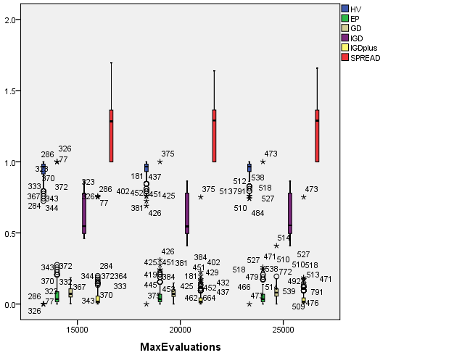

**PopulationSize**

|  |  |  |  |  |  |  |  |
| --- | --- | --- | --- | --- | --- | --- | --- |
| **Case Processing Summary** | | | | | | | |
|  | PopulationSize | Cases | | | | | |
| Valid | | Missing | | Total | |
| N | Percent | N | Percent | N | Percent |
| HV | 100 | 279 | 100.0% | 0 | 0.0% | 279 | 100.0% |
| 50 | 279 | 100.0% | 0 | 0.0% | 279 | 100.0% |
| 200 | 279 | 100.0% | 0 | 0.0% | 279 | 100.0% |
| EP | 100 | 279 | 100.0% | 0 | 0.0% | 279 | 100.0% |
| 50 | 279 | 100.0% | 0 | 0.0% | 279 | 100.0% |
| 200 | 279 | 100.0% | 0 | 0.0% | 279 | 100.0% |
| GD | 100 | 279 | 100.0% | 0 | 0.0% | 279 | 100.0% |
| 50 | 279 | 100.0% | 0 | 0.0% | 279 | 100.0% |
| 200 | 279 | 100.0% | 0 | 0.0% | 279 | 100.0% |
| IGD | 100 | 279 | 100.0% | 0 | 0.0% | 279 | 100.0% |
| 50 | 279 | 100.0% | 0 | 0.0% | 279 | 100.0% |
| 200 | 279 | 100.0% | 0 | 0.0% | 279 | 100.0% |
| IGDplus | 100 | 279 | 100.0% | 0 | 0.0% | 279 | 100.0% |
| 50 | 279 | 100.0% | 0 | 0.0% | 279 | 100.0% |
| 200 | 279 | 100.0% | 0 | 0.0% | 279 | 100.0% |
| SPREAD | 100 | 279 | 100.0% | 0 | 0.0% | 279 | 100.0% |
| 50 | 279 | 100.0% | 0 | 0.0% | 279 | 100.0% |
| 200 | 279 | 100.0% | 0 | 0.0% | 279 | 100.0% |

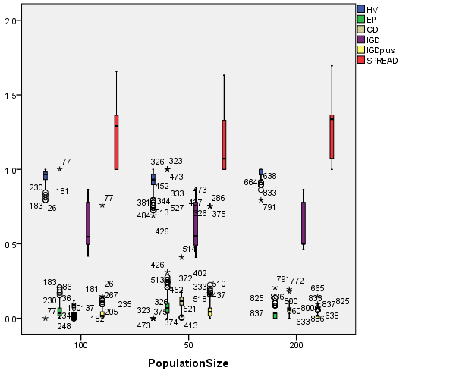

EXAMINE VARIABLES=HV EP GD IGD IGDplus SPREAD BY Crossover MaxEvaluations PopulationSize

/PLOT BOXPLOT

/COMPARE GROUPS

/STATISTICS NONE

/CINTERVAL 95

/MISSING LISTWISE

/NOTOTAL.

**Explore**

|  |  |  |
| --- | --- | --- |
| **Notes** | | |
| Output Created | | 26-MAY-2020 20:20:48 |
| Comments | |  |
| Input | Data | C:\Users\user\Documents\NILAY\Mayis2020\7_NSGAII.sav |
| Active Dataset | DataSet2 |
| Filter | <none> |
| Weight | <none> |
| Split File | <none> |
| N of Rows in Working Data File | 837 |
| Missing Value Handling | Definition of Missing | User-defined missing values for dependent variables are treated as missing. |
| Cases Used | Statistics are based on cases with no missing values for any dependent variable or factor used. |
| Syntax | | EXAMINE VARIABLES=HV EP GD IGD IGDplus SPREAD BY Crossover MaxEvaluations PopulationSize  /PLOT BOXPLOT  /COMPARE GROUPS  /STATISTICS NONE  /CINTERVAL 95  /MISSING LISTWISE  /NOTOTAL. |
| Resources | Processor Time | 00:00:04.00 |
| Elapsed Time | 00:00:03.94 |

[DataSet2] C:\Users\user\Documents\NILAY\Mayis2020\7_NSGAII.sav

**Crossover**

|  |  |  |  |  |  |  |  |
| --- | --- | --- | --- | --- | --- | --- | --- |
| **Case Processing Summary** | | | | | | | |
|  | Crossover | Cases | | | | | |
| Valid | | Missing | | Total | |
| N | Percent | N | Percent | N | Percent |
| HV | 0.7 | 279 | 100.0% | 0 | 0.0% | 279 | 100.0% |
| 0.8 | 279 | 100.0% | 0 | 0.0% | 279 | 100.0% |
| 0.9 | 279 | 100.0% | 0 | 0.0% | 279 | 100.0% |
| EP | 0.7 | 279 | 100.0% | 0 | 0.0% | 279 | 100.0% |
| 0.8 | 279 | 100.0% | 0 | 0.0% | 279 | 100.0% |
| 0.9 | 279 | 100.0% | 0 | 0.0% | 279 | 100.0% |
| GD | 0.7 | 279 | 100.0% | 0 | 0.0% | 279 | 100.0% |
| 0.8 | 279 | 100.0% | 0 | 0.0% | 279 | 100.0% |
| 0.9 | 279 | 100.0% | 0 | 0.0% | 279 | 100.0% |
| IGD | 0.7 | 279 | 100.0% | 0 | 0.0% | 279 | 100.0% |
| 0.8 | 279 | 100.0% | 0 | 0.0% | 279 | 100.0% |
| 0.9 | 279 | 100.0% | 0 | 0.0% | 279 | 100.0% |
| IGDplus | 0.7 | 279 | 100.0% | 0 | 0.0% | 279 | 100.0% |
| 0.8 | 279 | 100.0% | 0 | 0.0% | 279 | 100.0% |
| 0.9 | 279 | 100.0% | 0 | 0.0% | 279 | 100.0% |
| SPREAD | 0.7 | 279 | 100.0% | 0 | 0.0% | 279 | 100.0% |
| 0.8 | 279 | 100.0% | 0 | 0.0% | 279 | 100.0% |
| 0.9 | 279 | 100.0% | 0 | 0.0% | 279 | 100.0% |

**HV**

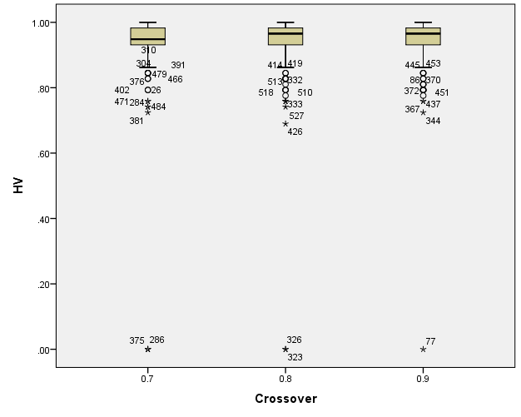

**EP**

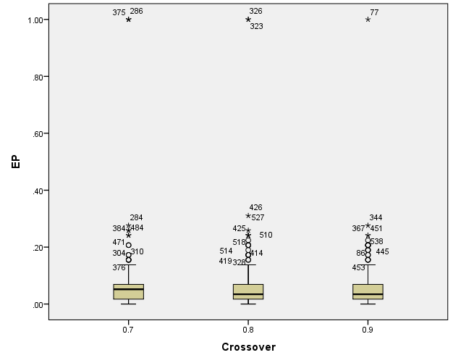

**GD**

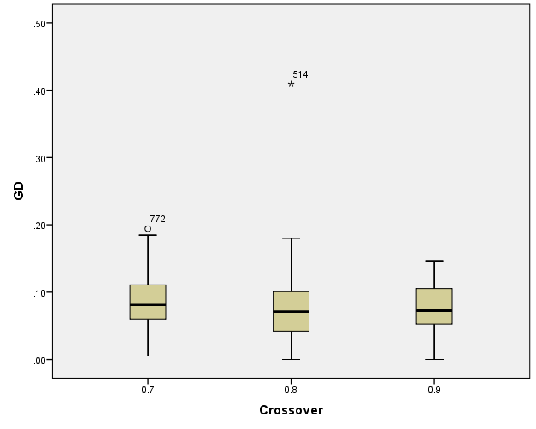

**IGD**

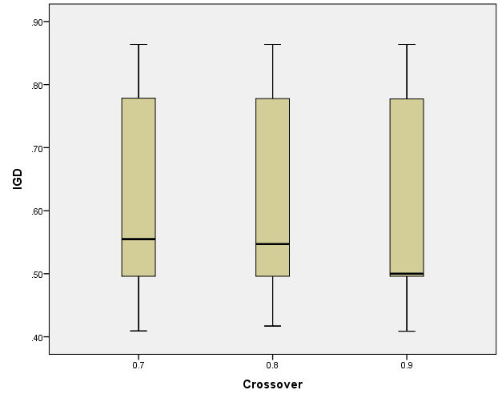

**IGDplus**

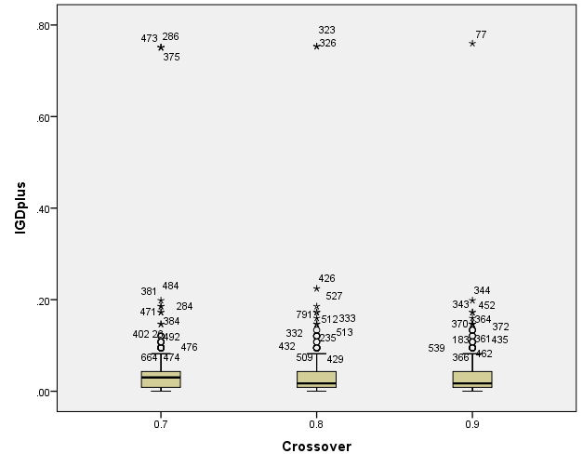

**SPREAD**

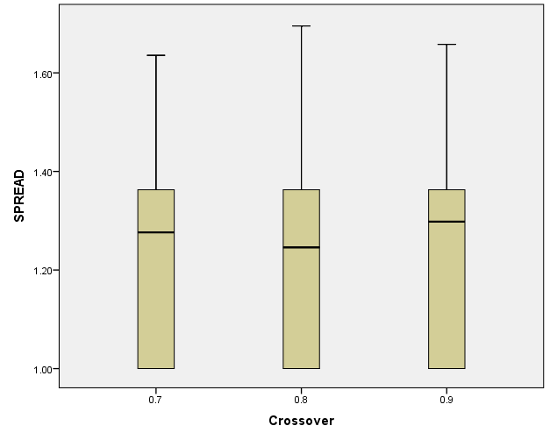

**MaxEvaluations**

|  |  |  |  |  |  |  |  |
| --- | --- | --- | --- | --- | --- | --- | --- |
| **Case Processing Summary** | | | | | | | |
|  | MaxEvaluations | Cases | | | | | |
| Valid | | Missing | | Total | |
| N | Percent | N | Percent | N | Percent |
| HV | 15000 | 279 | 100.0% | 0 | 0.0% | 279 | 100.0% |
| 20000 | 279 | 100.0% | 0 | 0.0% | 279 | 100.0% |
| 25000 | 279 | 100.0% | 0 | 0.0% | 279 | 100.0% |
| EP | 15000 | 279 | 100.0% | 0 | 0.0% | 279 | 100.0% |
| 20000 | 279 | 100.0% | 0 | 0.0% | 279 | 100.0% |
| 25000 | 279 | 100.0% | 0 | 0.0% | 279 | 100.0% |
| GD | 15000 | 279 | 100.0% | 0 | 0.0% | 279 | 100.0% |
| 20000 | 279 | 100.0% | 0 | 0.0% | 279 | 100.0% |
| 25000 | 279 | 100.0% | 0 | 0.0% | 279 | 100.0% |
| IGD | 15000 | 279 | 100.0% | 0 | 0.0% | 279 | 100.0% |
| 20000 | 279 | 100.0% | 0 | 0.0% | 279 | 100.0% |
| 25000 | 279 | 100.0% | 0 | 0.0% | 279 | 100.0% |
| IGDplus | 15000 | 279 | 100.0% | 0 | 0.0% | 279 | 100.0% |
| 20000 | 279 | 100.0% | 0 | 0.0% | 279 | 100.0% |
| 25000 | 279 | 100.0% | 0 | 0.0% | 279 | 100.0% |
| SPREAD | 15000 | 279 | 100.0% | 0 | 0.0% | 279 | 100.0% |
| 20000 | 279 | 100.0% | 0 | 0.0% | 279 | 100.0% |
| 25000 | 279 | 100.0% | 0 | 0.0% | 279 | 100.0% |

**HV**

**Boxplots**

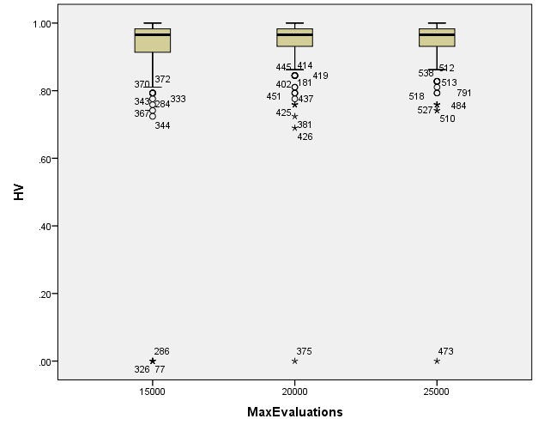

**EP**

**Boxplots**

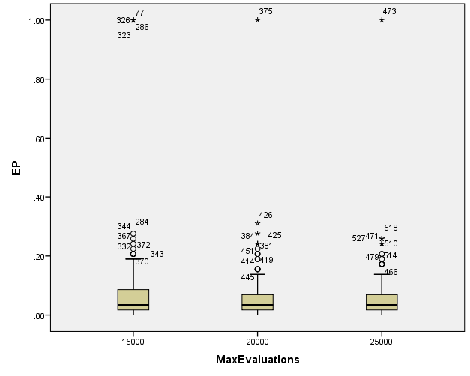

**GD**

**Boxplots**

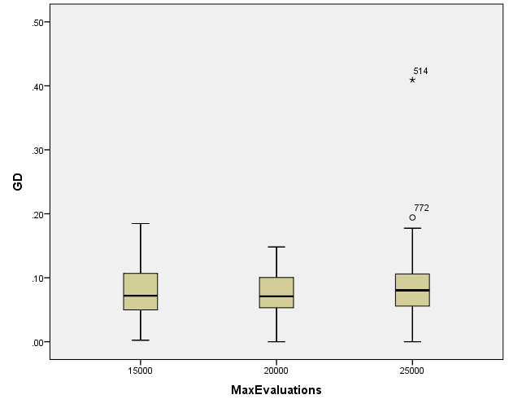

**IGD**

**Boxplots**

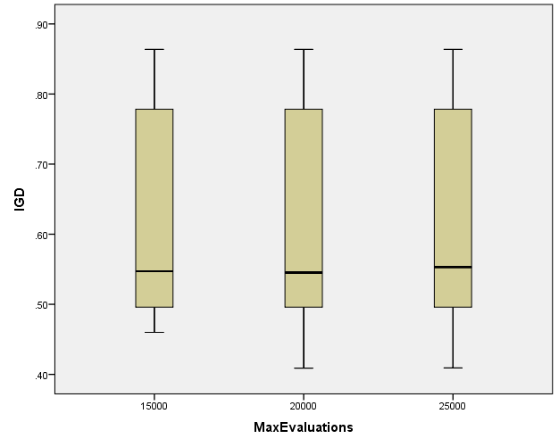

**IGDplus**

**Boxplots**

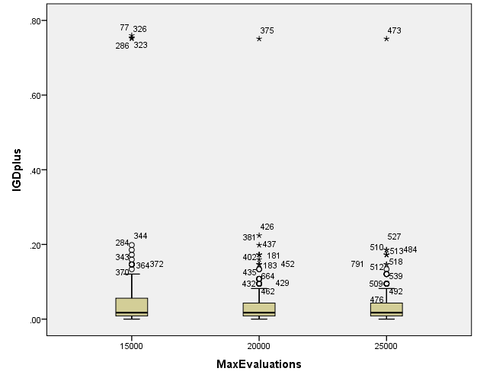

**SPREAD**

**Boxplots**

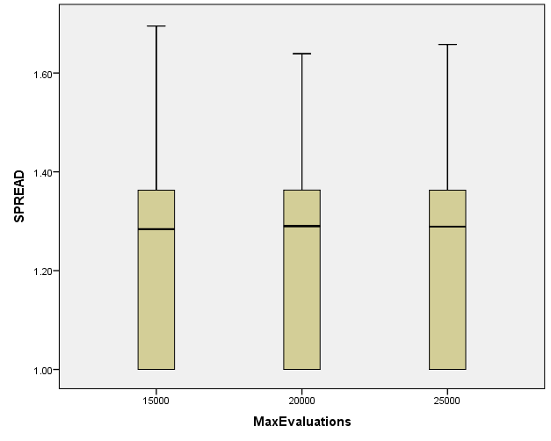

**PopulationSize**

|  |  |  |  |  |  |  |  |
| --- | --- | --- | --- | --- | --- | --- | --- |
| **Case Processing Summary** | | | | | | | |
|  | PopulationSize | Cases | | | | | |
| Valid | | Missing | | Total | |
| N | Percent | N | Percent | N | Percent |
| HV | 100 | 279 | 100.0% | 0 | 0.0% | 279 | 100.0% |
| 50 | 279 | 100.0% | 0 | 0.0% | 279 | 100.0% |
| 200 | 279 | 100.0% | 0 | 0.0% | 279 | 100.0% |
| EP | 100 | 279 | 100.0% | 0 | 0.0% | 279 | 100.0% |
| 50 | 279 | 100.0% | 0 | 0.0% | 279 | 100.0% |
| 200 | 279 | 100.0% | 0 | 0.0% | 279 | 100.0% |
| GD | 100 | 279 | 100.0% | 0 | 0.0% | 279 | 100.0% |
| 50 | 279 | 100.0% | 0 | 0.0% | 279 | 100.0% |
| 200 | 279 | 100.0% | 0 | 0.0% | 279 | 100.0% |
| IGD | 100 | 279 | 100.0% | 0 | 0.0% | 279 | 100.0% |
| 50 | 279 | 100.0% | 0 | 0.0% | 279 | 100.0% |
| 200 | 279 | 100.0% | 0 | 0.0% | 279 | 100.0% |
| IGDplus | 100 | 279 | 100.0% | 0 | 0.0% | 279 | 100.0% |
| 50 | 279 | 100.0% | 0 | 0.0% | 279 | 100.0% |
| 200 | 279 | 100.0% | 0 | 0.0% | 279 | 100.0% |
| SPREAD | 100 | 279 | 100.0% | 0 | 0.0% | 279 | 100.0% |
| 50 | 279 | 100.0% | 0 | 0.0% | 279 | 100.0% |
| 200 | 279 | 100.0% | 0 | 0.0% | 279 | 100.0% |

**HV**

**Boxplots**

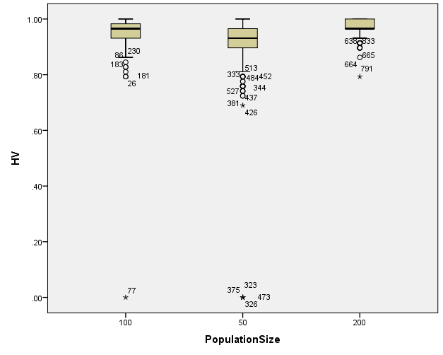

**EP**

**Boxplots**

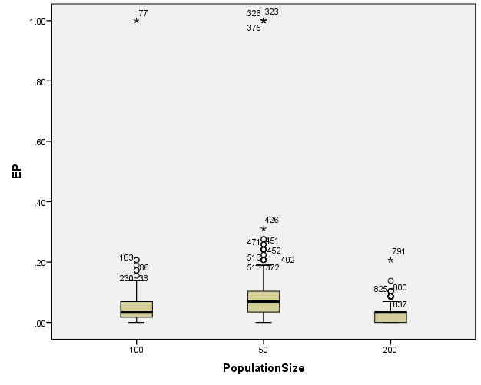

**GD**

**Boxplots**

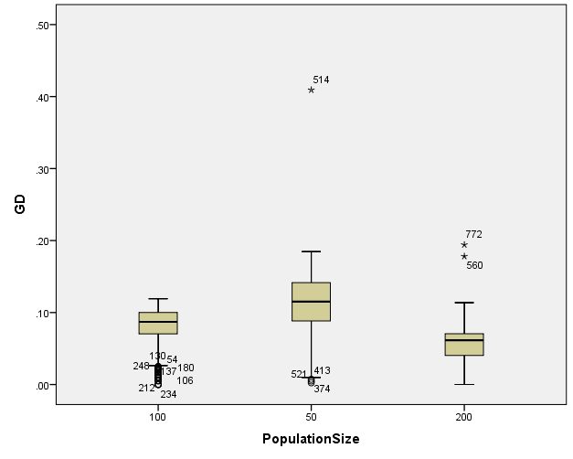

**IGD**

**Boxplots**

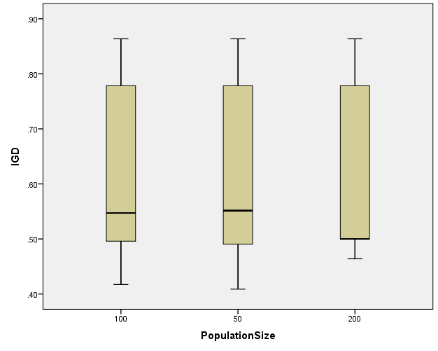

**IGDplus**

**Boxplots**

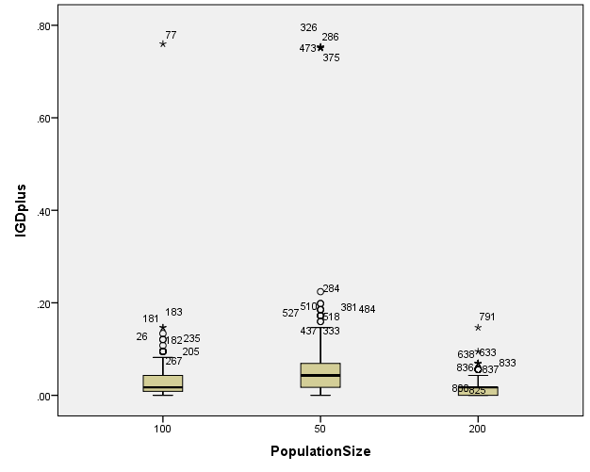

**SPREAD**

**Boxplots**

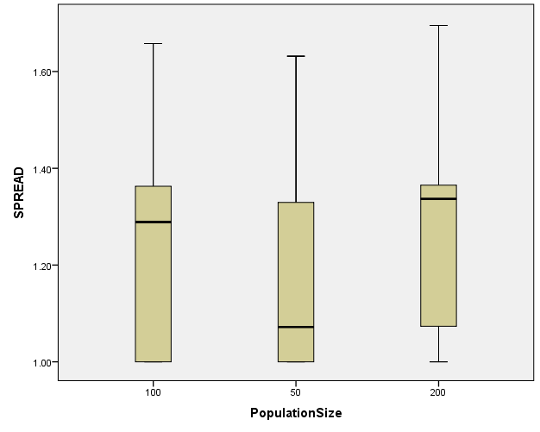

*Nonparametric Tests: Independent Samples.

NPTESTS

/INDEPENDENT TEST (HV EP GD IGD IGDplus SPREAD) GROUP (Crossover) MEDIAN(TESTVALUE=SAMPLE COMPARE=PAIRWISE)

/MISSING SCOPE=ANALYSIS USERMISSING=EXCLUDE

/CRITERIA ALPHA=0.05 CILEVEL=95.

**Nonparametric Tests**

|  |  |  |
| --- | --- | --- |
| **Notes** | | |
| Output Created | | 26-MAY-2020 20:22:39 |
| Comments | |  |
| Input | Data | C:\Users\user\Documents\NILAY\Mayis2020\7_NSGAII.sav |
| Active Dataset | DataSet2 |
| Filter | <none> |
| Weight | <none> |
| Split File | <none> |
| N of Rows in Working Data File | 837 |
| Syntax | | NPTESTS  /INDEPENDENT TEST (HV EP GD IGD IGDplus SPREAD) GROUP (Crossover) MEDIAN(TESTVALUE=SAMPLE COMPARE=PAIRWISE)  /MISSING SCOPE=ANALYSIS USERMISSING=EXCLUDE  /CRITERIA ALPHA=0.05 CILEVEL=95. |
| Resources | Processor Time | 00:00:00.16 |
| Elapsed Time | 00:00:00.21 |

[DataSet2] C:\Users\user\Documents\NILAY\Mayis2020\7_NSGAII.sav

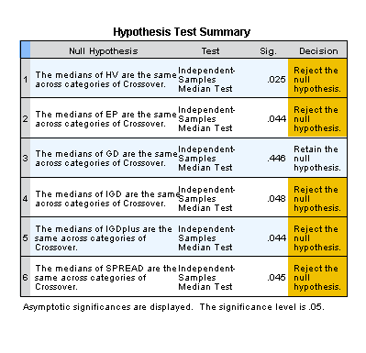

*Nonparametric Tests: Independent Samples.

NPTESTS

/INDEPENDENT TEST (HV EP GD IGD IGDplus SPREAD) GROUP (MaxEvaluations) MEDIAN(TESTVALUE=SAMPLE COMPARE=PAIRWISE)

/MISSING SCOPE=ANALYSIS USERMISSING=EXCLUDE

/CRITERIA ALPHA=0.05 CILEVEL=95.

**Nonparametric Tests**

|  |  |  |
| --- | --- | --- |
| **Notes** | | |
| Output Created | | 26-MAY-2020 20:22:52 |
| Comments | |  |
| Input | Data | C:\Users\user\Documents\NILAY\Mayis2020\7_NSGAII.sav |
| Active Dataset | DataSet2 |
| Filter | <none> |
| Weight | <none> |
| Split File | <none> |
| N of Rows in Working Data File | 837 |
| Syntax | | NPTESTS  /INDEPENDENT TEST (HV EP GD IGD IGDplus SPREAD) GROUP (MaxEvaluations) MEDIAN(TESTVALUE=SAMPLE COMPARE=PAIRWISE)  /MISSING SCOPE=ANALYSIS USERMISSING=EXCLUDE  /CRITERIA ALPHA=0.05 CILEVEL=95. |
| Resources | Processor Time | 00:00:00.13 |
| Elapsed Time | 00:00:00.14 |

[DataSet2] C:\Users\user\Documents\NILAY\Mayis2020\7_NSGAII.sav

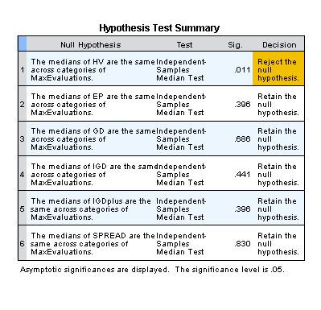

*Nonparametric Tests: Independent Samples.

NPTESTS

/INDEPENDENT TEST (HV EP GD IGD IGDplus SPREAD) GROUP (PopulationSize) MEDIAN(TESTVALUE=SAMPLE COMPARE=PAIRWISE)

/MISSING SCOPE=ANALYSIS USERMISSING=EXCLUDE

/CRITERIA ALPHA=0.05 CILEVEL=95.

**Nonparametric Tests**

|  |  |  |
| --- | --- | --- |
| **Notes** | | |
| Output Created | | 26-MAY-2020 20:23:09 |
| Comments | |  |
| Input | Data | C:\Users\user\Documents\NILAY\Mayis2020\7_NSGAII.sav |
| Active Dataset | DataSet2 |
| Filter | <none> |
| Weight | <none> |
| Split File | <none> |
| N of Rows in Working Data File | 837 |
| Syntax | | NPTESTS  /INDEPENDENT TEST (HV EP GD IGD IGDplus SPREAD) GROUP (PopulationSize) MEDIAN(TESTVALUE=SAMPLE COMPARE=PAIRWISE)  /MISSING SCOPE=ANALYSIS USERMISSING=EXCLUDE  /CRITERIA ALPHA=0.05 CILEVEL=95. |
| Resources | Processor Time | 00:00:00.16 |
| Elapsed Time | 00:00:00.14 |

[DataSet2] C:\Users\user\Documents\NILAY\Mayis2020\7_NSGAII.sav

