GET

FILE='C:\Users\user\Documents\NILAY\Mayis2020\7_SPEA2.sav'.

DATASET NAME DataSet1 WINDOW=FRONT.

GLM HV EP GD IGD IGDplus SPREAD BY Crossover MaxEvaluations PopulationSize

/METHOD=SSTYPE(3)

/INTERCEPT=INCLUDE

/POSTHOC=Crossover MaxEvaluations PopulationSize(BONFERRONI)

/PLOT=PROFILE(Crossover MaxEvaluations PopulationSize)

/CRITERIA=ALPHA(.05)

/DESIGN=Crossover MaxEvaluations PopulationSize.

**General Linear Model**

|  |  |  |
| --- | --- | --- |
| **Notes** | | |
| Output Created | | 26-MAY-2020 19:33:08 |
| Comments | |  |
| Input | Data | C:\Users\user\Documents\NILAY\Mayis2020\7_SPEA2.sav |
| Active Dataset | DataSet1 |
| Filter | <none> |
| Weight | <none> |
| Split File | <none> |
| N of Rows in Working Data File | 837 |
| Missing Value Handling | Definition of Missing | User-defined missing values are treated as missing. |
| Cases Used | Statistics are based on all cases with valid data for all variables in the model. |
| Syntax | | GLM HV EP GD IGD IGDplus SPREAD BY Crossover MaxEvaluations PopulationSize  /METHOD=SSTYPE(3)  /INTERCEPT=INCLUDE  /POSTHOC=Crossover MaxEvaluations PopulationSize(BONFERRONI)  /PLOT=PROFILE(Crossover MaxEvaluations PopulationSize)  /CRITERIA=ALPHA(.05)  /DESIGN=Crossover MaxEvaluations PopulationSize. |
| Resources | Processor Time | 00:00:06.23 |
| Elapsed Time | 00:00:06.31 |

[DataSet1] C:\Users\user\Documents\NILAY\Mayis2020\7_SPEA2.sav

|  |  |  |  |
| --- | --- | --- | --- |
| **Between-Subjects Factors** | | | |
|  | | Value Label | N |
| Crossover | 1 | 0.7 | 279 |
| 2 | 0.8 | 279 |
| 3 | 0.9 | 279 |
| MaxEvaluations | 1 | 15000 | 279 |
| 2 | 20000 | 279 |
| 3 | 25000 | 279 |
| PopulationSize | 1 | 100 | 279 |
| 2 | 50 | 279 |
| 3 | 200 | 279 |

|  |  |  |  |  |  |
| --- | --- | --- | --- | --- | --- |
| **Multivariate Testsa** | | | | | |
| Effect | | Value | F | Hypothesis df | Error df |
| Intercept | Pillai's Trace | 1.000 | 9478638.478b | 5.000 | 826.000 |
| Wilks' Lambda | .000 | 9478638.478b | 5.000 | 826.000 |
| Hotelling's Trace | 57376.746 | 9478638.478b | 5.000 | 826.000 |
| Roy's Largest Root | 57376.746 | 9478638.478b | 5.000 | 826.000 |
| Crossover | Pillai's Trace | .015 | 1.218 | 10.000 | 1654.000 |
| Wilks' Lambda | .985 | 1.218b | 10.000 | 1652.000 |
| Hotelling's Trace | .015 | 1.218 | 10.000 | 1650.000 |
| Roy's Largest Root | .012 | 1.960c | 5.000 | 827.000 |
| MaxEvaluations | Pillai's Trace | .020 | 1.676 | 10.000 | 1654.000 |
| Wilks' Lambda | .980 | 1.675b | 10.000 | 1652.000 |
| Hotelling's Trace | .020 | 1.674 | 10.000 | 1650.000 |
| Roy's Largest Root | .013 | 2.176c | 5.000 | 827.000 |
| PopulationSize | Pillai's Trace | .387 | 39.675 | 10.000 | 1654.000 |
| Wilks' Lambda | .619 | 44.758b | 10.000 | 1652.000 |
| Hotelling's Trace | .606 | 49.957 | 10.000 | 1650.000 |
| Roy's Largest Root | .589 | 97.424c | 5.000 | 827.000 |

|  |  |  |
| --- | --- | --- |
| **Multivariate Testsa** | | |
| Effect | | Sig. |
| Intercept | Pillai's Trace | .000 |
| Wilks' Lambda | .000 |
| Hotelling's Trace | .000 |
| Roy's Largest Root | .000 |
| Crossover | Pillai's Trace | .274 |
| Wilks' Lambda | .274 |
| Hotelling's Trace | .274 |
| Roy's Largest Root | .082 |
| MaxEvaluations | Pillai's Trace | .081 |
| Wilks' Lambda | .081 |
| Hotelling's Trace | .081 |
| Roy's Largest Root | .055 |
| PopulationSize | Pillai's Trace | .000 |
| Wilks' Lambda | .000 |
| Hotelling's Trace | .000 |
| Roy's Largest Root | .000 |

|  |
| --- |
| a. Design: Intercept + Crossover + MaxEvaluations + PopulationSize |
| b. Exact statistic |
| c. The statistic is an upper bound on F that yields a lower bound on the significance level. |

|  |  |  |  |  |  |
| --- | --- | --- | --- | --- | --- |
| **Tests of Between-Subjects Effects** | | | | | |
| Source | Dependent Variable | Type III Sum of Squares | df | Mean Square | F |
| Corrected Model | HV | .335a | 6 | .056 | 8.992 |
| EP | .335b | 6 | .056 | 8.992 |
| GD | .370c | 6 | .062 | 47.229 |
| IGD | .221d | 6 | .037 | 1.765 |
| IGDplus | .172e | 6 | .029 | 8.369 |
| SPREAD | .802f | 6 | .134 | 4.097 |
| Intercept | HV | 768.926 | 1 | 768.926 | 123940.578 |
| EP | 1.443 | 1 | 1.443 | 232.664 |
| GD | 6.104 | 1 | 6.104 | 4676.690 |
| IGD | 297.210 | 1 | 297.210 | 14262.265 |
| IGDplus | .557 | 1 | .557 | 163.165 |
| SPREAD | 1357.942 | 1 | 1357.942 | 41616.903 |
| Crossover | HV | .022 | 2 | .011 | 1.734 |
| EP | .022 | 2 | .011 | 1.734 |
| GD | .008 | 2 | .004 | 2.983 |
| IGD | .107 | 2 | .054 | 2.567 |
| IGDplus | .011 | 2 | .006 | 1.649 |
| SPREAD | .095 | 2 | .048 | 1.458 |
| MaxEvaluations | HV | .023 | 2 | .012 | 1.870 |
| EP | .023 | 2 | .012 | 1.870 |
| GD | .002 | 2 | .001 | .634 |
| IGD | .051 | 2 | .026 | 1.233 |
| IGDplus | .012 | 2 | .006 | 1.752 |
| SPREAD | .143 | 2 | .071 | 2.189 |
| PopulationSize | HV | .290 | 2 | .145 | 23.371 |
| EP | .290 | 2 | .145 | 23.371 |
| GD | .360 | 2 | .180 | 138.070 |
| IGD | .062 | 2 | .031 | 1.493 |
| IGDplus | .148 | 2 | .074 | 21.706 |
| SPREAD | .564 | 2 | .282 | 8.646 |
| Error | HV | 5.149 | 830 | .006 |  |
| EP | 5.149 | 830 | .006 |  |
| GD | 1.083 | 830 | .001 |  |
| IGD | 17.296 | 830 | .021 |  |
| IGDplus | 2.835 | 830 | .003 |  |

|  |  |  |
| --- | --- | --- |
| **Tests of Between-Subjects Effects** | | |
| Source | Dependent Variable | Sig. |
| Corrected Model | HV | .000a |
| EP | .000b |
| GD | .000c |
| IGD | .103d |
| IGDplus | .000e |
| SPREAD | .000f |
| Intercept | HV | .000 |
| EP | .000 |
| GD | .000 |
| IGD | .000 |
| IGDplus | .000 |
| SPREAD | .000 |
| Crossover | HV | .177 |
| EP | .177 |
| GD | .051 |
| IGD | .077 |
| IGDplus | .193 |
| SPREAD | .233 |
| MaxEvaluations | HV | .155 |
| EP | .155 |
| GD | .531 |
| IGD | .292 |
| IGDplus | .174 |
| SPREAD | .113 |
| PopulationSize | HV | .000 |
| EP | .000 |
| GD | .000 |
| IGD | .225 |
| IGDplus | .000 |
| SPREAD | .000 |
| Error | HV |  |
| EP |  |
| GD |  |
| IGD |  |
| IGDplus |  |

|  |  |  |  |  |  |
| --- | --- | --- | --- | --- | --- |
| **Tests of Between-Subjects Effects** | | | | | |
| Source | Dependent Variable | Type III Sum of Squares | df | Mean Square | F |
| Error | SPREAD | 27.083a | 830 | .033 |  |
| Total | HV | 774.410b | 837 |  |  |
| EP | 6.927c | 837 |  |  |
| GD | 7.557d | 837 |  |  |
| IGD | 314.727e | 837 |  |  |
| IGDplus | 3.564f | 837 |  |  |
| SPREAD | 1385.827 | 837 |  |  |
| Corrected Total | HV | 5.484 | 836 |  |  |
| EP | 5.484 | 836 |  |  |
| GD | 1.453 | 836 |  |  |
| IGD | 17.517 | 836 |  |  |
| IGDplus | 3.006 | 836 |  |  |
| SPREAD | 27.885 | 836 |  |  |

|  |  |  |
| --- | --- | --- |
| **Tests of Between-Subjects Effects** | | |
| Source | Dependent Variable | Sig. |
| Error | SPREAD |  |
| Total | HV |  |
| EP |  |
| GD |  |
| IGD |  |
| IGDplus |  |
| SPREAD |  |
| Corrected Total | HV |  |
| EP |  |
| GD |  |
| IGD |  |
| IGDplus |  |
| SPREAD |  |

|  |
| --- |
| a. R Squared = .061 (Adjusted R Squared = .054) |
| b. R Squared = .061 (Adjusted R Squared = .054) |
| c. R Squared = .255 (Adjusted R Squared = .249) |
| d. R Squared = .013 (Adjusted R Squared = .005) |
| e. R Squared = .057 (Adjusted R Squared = .050) |
| f. R Squared = .029 (Adjusted R Squared = .022) |

**Post Hoc Tests**

**Crossover**

|  |  |  |  |  |  |
| --- | --- | --- | --- | --- | --- |
| **Multiple Comparisons** | | | | | |
| Bonferroni | | | | | |
| Dependent Variable | (I) Crossover | (J) Crossover | Mean Difference (I-J) | Std. Error | Sig. |
|
| HV | 0.7 | 0.8 | -.0040 | .00667 | 1.000 |
| 0.9 | .0082 | .00667 | .654 |
| 0.8 | 0.7 | .0040 | .00667 | 1.000 |
| 0.9 | .0122 | .00667 | .205 |
| 0.9 | 0.7 | -.0082 | .00667 | .654 |
| 0.8 | -.0122 | .00667 | .205 |
| EP | 0.7 | 0.8 | .0040 | .00667 | 1.000 |
| 0.9 | -.0082 | .00667 | .654 |
| 0.8 | 0.7 | -.0040 | .00667 | 1.000 |
| 0.9 | -.0122 | .00667 | .205 |
| 0.9 | 0.7 | .0082 | .00667 | .654 |
| 0.8 | .0122 | .00667 | .205 |
| GD | 0.7 | 0.8 | .0055 | .00306 | .223 |
| 0.9 | -.0017 | .00306 | 1.000 |
| 0.8 | 0.7 | -.0055 | .00306 | .223 |
| 0.9 | -.0071 | .00306 | .059 |
| 0.9 | 0.7 | .0017 | .00306 | 1.000 |
| 0.8 | .0071 | .00306 | .059 |
| IGD | 0.7 | 0.8 | .0221 | .01222 | .214 |
| 0.9 | -.0035 | .01222 | 1.000 |
| 0.8 | 0.7 | -.0221 | .01222 | .214 |
| 0.9 | -.0255 | .01222 | .111 |
| 0.9 | 0.7 | .0035 | .01222 | 1.000 |
| 0.8 | .0255 | .01222 | .111 |
| IGDplus | 0.7 | 0.8 | .0024 | .00495 | 1.000 |
| 0.9 | -.0063 | .00495 | .614 |
| 0.8 | 0.7 | -.0024 | .00495 | 1.000 |
| 0.9 | -.0087 | .00495 | .237 |
| 0.9 | 0.7 | .0063 | .00495 | .614 |
| 0.8 | .0087 | .00495 | .237 |
| SPREAD | 0.7 | 0.8 | -.0166 | .01529 | .830 |
| 0.9 | .0091 | .01529 | 1.000 |
| 0.8 | 0.7 | .0166 | .01529 | .830 |

|  |  |  |  |  |
| --- | --- | --- | --- | --- |
| **Multiple Comparisons** | | | | |
| Bonferroni | | | | |
| Dependent Variable | (I) Crossover | (J) Crossover | 95% Confidence Interval | |
| Lower Bound | Upper Bound |
| HV | 0.7 | 0.8 | -.0200 | .0120 |
| 0.9 | -.0078 | .0242 |
| 0.8 | 0.7 | -.0120 | .0200 |
| 0.9 | -.0038 | .0282 |
| 0.9 | 0.7 | -.0242 | .0078 |
| 0.8 | -.0282 | .0038 |
| EP | 0.7 | 0.8 | -.0120 | .0200 |
| 0.9 | -.0242 | .0078 |
| 0.8 | 0.7 | -.0200 | .0120 |
| 0.9 | -.0282 | .0038 |
| 0.9 | 0.7 | -.0078 | .0242 |
| 0.8 | -.0038 | .0282 |
| GD | 0.7 | 0.8 | -.0019 | .0128 |
| 0.9 | -.0090 | .0057 |
| 0.8 | 0.7 | -.0128 | .0019 |
| 0.9 | -.0145 | .0002 |
| 0.9 | 0.7 | -.0057 | .0090 |
| 0.8 | -.0002 | .0145 |
| IGD | 0.7 | 0.8 | -.0073 | .0514 |
| 0.9 | -.0328 | .0258 |
| 0.8 | 0.7 | -.0514 | .0073 |
| 0.9 | -.0549 | .0038 |
| 0.9 | 0.7 | -.0258 | .0328 |
| 0.8 | -.0038 | .0549 |
| IGDplus | 0.7 | 0.8 | -.0094 | .0143 |
| 0.9 | -.0181 | .0056 |
| 0.8 | 0.7 | -.0143 | .0094 |
| 0.9 | -.0206 | .0032 |
| 0.9 | 0.7 | -.0056 | .0181 |
| 0.8 | -.0032 | .0206 |
| SPREAD | 0.7 | 0.8 | -.0533 | .0200 |
| 0.9 | -.0276 | .0458 |
| 0.8 | 0.7 | -.0200 | .0533 |

|  |  |  |  |  |  |
| --- | --- | --- | --- | --- | --- |
| **Multiple Comparisons** | | | | | |
| Bonferroni | | | | | |
| Dependent Variable | (I) Crossover | (J) Crossover | Mean Difference (I-J) | Std. Error | Sig. |
|
| SPREAD | 0.8 | 0.9 | .0257 | .01529 | .278 |
| 0.9 | 0.7 | -.0091 | .01529 | 1.000 |
| 0.8 | -.0257 | .01529 | .278 |

|  |  |  |  |  |
| --- | --- | --- | --- | --- |
| **Multiple Comparisons** | | | | |
| Bonferroni | | | | |
| Dependent Variable | (I) Crossover | (J) Crossover | 95% Confidence Interval | |
| Lower Bound | Upper Bound |
| SPREAD | 0.8 | 0.9 | -.0109 | .0624 |
| 0.9 | 0.7 | -.0458 | .0276 |
| 0.8 | -.0624 | .0109 |

|  |
| --- |
| Based on observed means.  The error term is Mean Square(Error) = .033. |

**Homogeneous Subsets**

**MaxEvaluations**

|  |  |  |  |  |  |
| --- | --- | --- | --- | --- | --- |
| **Multiple Comparisons** | | | | | |
| Bonferroni | | | | | |
| Dependent Variable | (I) MaxEvaluations | (J) MaxEvaluations | Mean Difference (I-J) | Std. Error | Sig. |
|
| HV | 15000 | 20000 | .0055 | .00667 | 1.000 |
| 25000 | -.0074 | .00667 | .811 |
| 20000 | 15000 | -.0055 | .00667 | 1.000 |
| 25000 | -.0129 | .00667 | .163 |
| 25000 | 15000 | .0074 | .00667 | .811 |
| 20000 | .0129 | .00667 | .163 |
| EP | 15000 | 20000 | -.0055 | .00667 | 1.000 |
| 25000 | .0074 | .00667 | .811 |
| 20000 | 15000 | .0055 | .00667 | 1.000 |
| 25000 | .0129 | .00667 | .163 |
| 25000 | 15000 | -.0074 | .00667 | .811 |
| 20000 | -.0129 | .00667 | .163 |
| GD | 15000 | 20000 | -.0010 | .00306 | 1.000 |
| 25000 | -.0033 | .00306 | .825 |
| 20000 | 15000 | .0010 | .00306 | 1.000 |
| 25000 | -.0024 | .00306 | 1.000 |
| 25000 | 15000 | .0033 | .00306 | .825 |
| 20000 | .0024 | .00306 | 1.000 |
| IGD | 15000 | 20000 | -.0076 | .01222 | 1.000 |
| 25000 | .0115 | .01222 | 1.000 |
| 20000 | 15000 | .0076 | .01222 | 1.000 |
| 25000 | .0191 | .01222 | .358 |
| 25000 | 15000 | -.0115 | .01222 | 1.000 |
| 20000 | -.0191 | .01222 | .358 |
| IGDplus | 15000 | 20000 | -.0046 | .00495 | 1.000 |
| 25000 | .0047 | .00495 | 1.000 |
| 20000 | 15000 | .0046 | .00495 | 1.000 |
| 25000 | .0093 | .00495 | .185 |
| 25000 | 15000 | -.0047 | .00495 | 1.000 |
| 20000 | -.0093 | .00495 | .185 |
| SPREAD | 15000 | 20000 | .0125 | .01529 | 1.000 |
| 25000 | -.0192 | .01529 | .626 |
| 20000 | 15000 | -.0125 | .01529 | 1.000 |

|  |  |  |  |  |
| --- | --- | --- | --- | --- |
| **Multiple Comparisons** | | | | |
| Bonferroni | | | | |
| Dependent Variable | (I) MaxEvaluations | (J) MaxEvaluations | 95% Confidence Interval | |
| Lower Bound | Upper Bound |
| HV | 15000 | 20000 | -.0105 | .0215 |
| 25000 | -.0234 | .0086 |
| 20000 | 15000 | -.0215 | .0105 |
| 25000 | -.0289 | .0031 |
| 25000 | 15000 | -.0086 | .0234 |
| 20000 | -.0031 | .0289 |
| EP | 15000 | 20000 | -.0215 | .0105 |
| 25000 | -.0086 | .0234 |
| 20000 | 15000 | -.0105 | .0215 |
| 25000 | -.0031 | .0289 |
| 25000 | 15000 | -.0234 | .0086 |
| 20000 | -.0289 | .0031 |
| GD | 15000 | 20000 | -.0083 | .0064 |
| 25000 | -.0107 | .0040 |
| 20000 | 15000 | -.0064 | .0083 |
| 25000 | -.0097 | .0049 |
| 25000 | 15000 | -.0040 | .0107 |
| 20000 | -.0049 | .0097 |
| IGD | 15000 | 20000 | -.0369 | .0218 |
| 25000 | -.0178 | .0408 |
| 20000 | 15000 | -.0218 | .0369 |
| 25000 | -.0103 | .0484 |
| 25000 | 15000 | -.0408 | .0178 |
| 20000 | -.0484 | .0103 |
| IGDplus | 15000 | 20000 | -.0165 | .0073 |
| 25000 | -.0072 | .0165 |
| 20000 | 15000 | -.0073 | .0165 |
| 25000 | -.0026 | .0211 |
| 25000 | 15000 | -.0165 | .0072 |
| 20000 | -.0211 | .0026 |
| SPREAD | 15000 | 20000 | -.0242 | .0492 |
| 25000 | -.0559 | .0175 |
| 20000 | 15000 | -.0492 | .0242 |

|  |  |  |  |  |  |
| --- | --- | --- | --- | --- | --- |
| **Multiple Comparisons** | | | | | |
| Bonferroni | | | | | |
| Dependent Variable | (I) MaxEvaluations | (J) MaxEvaluations | Mean Difference (I-J) | Std. Error | Sig. |
|
| SPREAD | 20000 | 25000 | -.0318 | .01529 | .114 |
| 25000 | 15000 | .0192 | .01529 | .626 |
| 20000 | .0318 | .01529 | .114 |

|  |  |  |  |  |
| --- | --- | --- | --- | --- |
| **Multiple Comparisons** | | | | |
| Bonferroni | | | | |
| Dependent Variable | (I) MaxEvaluations | (J) MaxEvaluations | 95% Confidence Interval | |
| Lower Bound | Upper Bound |
| SPREAD | 20000 | 25000 | -.0685 | .0049 |
| 25000 | 15000 | -.0175 | .0559 |
| 20000 | -.0049 | .0685 |

|  |
| --- |
| Based on observed means.  The error term is Mean Square(Error) = .033. |

**Homogeneous Subsets**

**PopulationSize**

|  |  |  |  |  |  |
| --- | --- | --- | --- | --- | --- |
| **Multiple Comparisons** | | | | | |
| Bonferroni | | | | | |
| Dependent Variable | (I) PopulationSize | (J) PopulationSize | Mean Difference (I-J) | Std. Error | Sig. |
|
| HV | 100 | 50 | .0261* | .00667 | .000 |
| 200 | -.0193* | .00667 | .012 |
| 50 | 100 | -.0261* | .00667 | .000 |
| 200 | -.0454* | .00667 | .000 |
| 200 | 100 | .0193* | .00667 | .012 |
| 50 | .0454* | .00667 | .000 |
| EP | 100 | 50 | -.0261* | .00667 | .000 |
| 200 | .0193* | .00667 | .012 |
| 50 | 100 | .0261* | .00667 | .000 |
| 200 | .0454* | .00667 | .000 |
| 200 | 100 | -.0193* | .00667 | .012 |
| 50 | -.0454* | .00667 | .000 |
| GD | 100 | 50 | -.0262* | .00306 | .000 |
| 200 | .0247* | .00306 | .000 |
| 50 | 100 | .0262* | .00306 | .000 |
| 200 | .0508* | .00306 | .000 |
| 200 | 100 | -.0247* | .00306 | .000 |
| 50 | -.0508* | .00306 | .000 |
| IGD | 100 | 50 | -.0015 | .01222 | 1.000 |
| 200 | .0175 | .01222 | .456 |
| 50 | 100 | .0015 | .01222 | 1.000 |
| 200 | .0190 | .01222 | .363 |
| 200 | 100 | -.0175 | .01222 | .456 |
| 50 | -.0190 | .01222 | .363 |
| IGDplus | 100 | 50 | -.0196* | .00495 | .000 |
| 200 | .0127* | .00495 | .031 |
| 50 | 100 | .0196* | .00495 | .000 |
| 200 | .0324* | .00495 | .000 |
| 200 | 100 | -.0127* | .00495 | .031 |
| 50 | -.0324* | .00495 | .000 |
| SPREAD | 100 | 50 | .0322 | .01529 | .107 |
| 200 | -.0314 | .01529 | .121 |
| 50 | 100 | -.0322 | .01529 | .107 |

|  |  |  |  |  |
| --- | --- | --- | --- | --- |
| **Multiple Comparisons** | | | | |
| Bonferroni | | | | |
| Dependent Variable | (I) PopulationSize | (J) PopulationSize | 95% Confidence Interval | |
| Lower Bound | Upper Bound |
| HV | 100 | 50 | .0101* | .0421 |
| 200 | -.0353* | -.0033 |
| 50 | 100 | -.0421* | -.0101 |
| 200 | -.0614* | -.0294 |
| 200 | 100 | .0033* | .0353 |
| 50 | .0294* | .0614 |
| EP | 100 | 50 | -.0421* | -.0101 |
| 200 | .0033* | .0353 |
| 50 | 100 | .0101* | .0421 |
| 200 | .0294* | .0614 |
| 200 | 100 | -.0353* | -.0033 |
| 50 | -.0614* | -.0294 |
| GD | 100 | 50 | -.0335* | -.0188 |
| 200 | .0173* | .0320 |
| 50 | 100 | .0188* | .0335 |
| 200 | .0435* | .0582 |
| 200 | 100 | -.0320* | -.0173 |
| 50 | -.0582* | -.0435 |
| IGD | 100 | 50 | -.0308 | .0279 |
| 200 | -.0118 | .0468 |
| 50 | 100 | -.0279 | .0308 |
| 200 | -.0103 | .0483 |
| 200 | 100 | -.0468 | .0118 |
| 50 | -.0483 | .0103 |
| IGDplus | 100 | 50 | -.0315* | -.0077 |
| 200 | .0009* | .0246 |
| 50 | 100 | .0077* | .0315 |
| 200 | .0205* | .0442 |
| 200 | 100 | -.0246* | -.0009 |
| 50 | -.0442* | -.0205 |
| SPREAD | 100 | 50 | -.0045 | .0689 |
| 200 | -.0681 | .0053 |
| 50 | 100 | -.0689 | .0045 |

|  |  |  |  |  |  |
| --- | --- | --- | --- | --- | --- |
| **Multiple Comparisons** | | | | | |
| Bonferroni | | | | | |
| Dependent Variable | (I) PopulationSize | (J) PopulationSize | Mean Difference (I-J) | Std. Error | Sig. |
|
| SPREAD | 50 | 200 | -.0636* | .01529 | .000 |
| 200 | 100 | .0314* | .01529 | .121 |
| 50 | .0636* | .01529 | .000 |

|  |  |  |  |  |
| --- | --- | --- | --- | --- |
| **Multiple Comparisons** | | | | |
| Bonferroni | | | | |
| Dependent Variable | (I) PopulationSize | (J) PopulationSize | 95% Confidence Interval | |
| Lower Bound | Upper Bound |
| SPREAD | 50 | 200 | -.1003* | -.0269 |
| 200 | 100 | -.0053* | .0681 |
| 50 | .0269* | .1003 |

|  |
| --- |
| Based on observed means.  The error term is Mean Square(Error) = .033. |
| *. The mean difference is significant at the .05 level. |

**Profile Plots**

**HV**

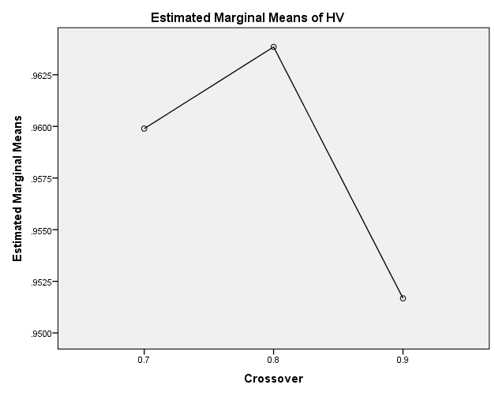

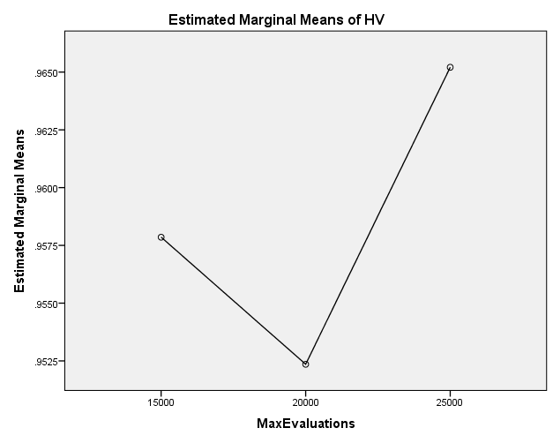

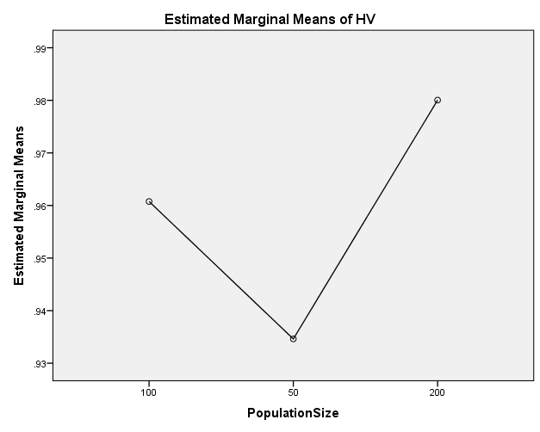

**EP**

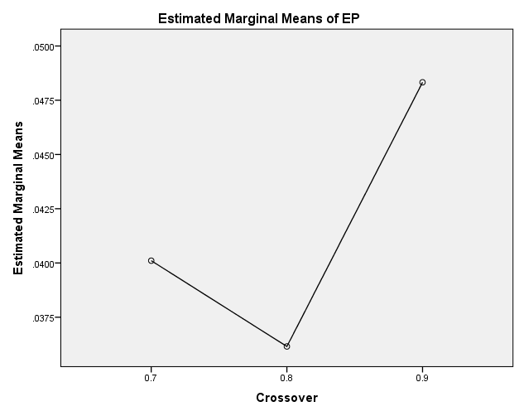

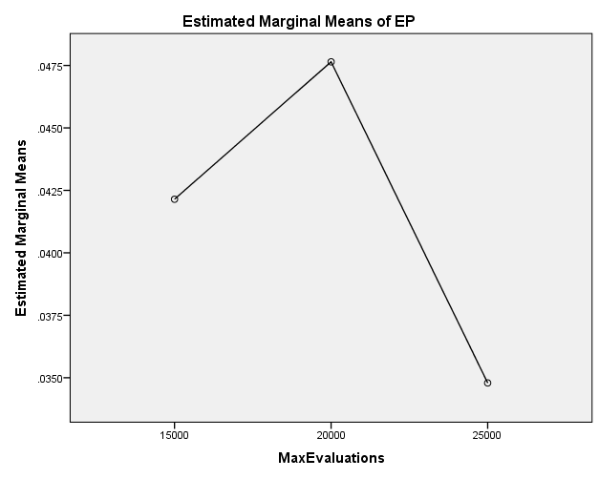

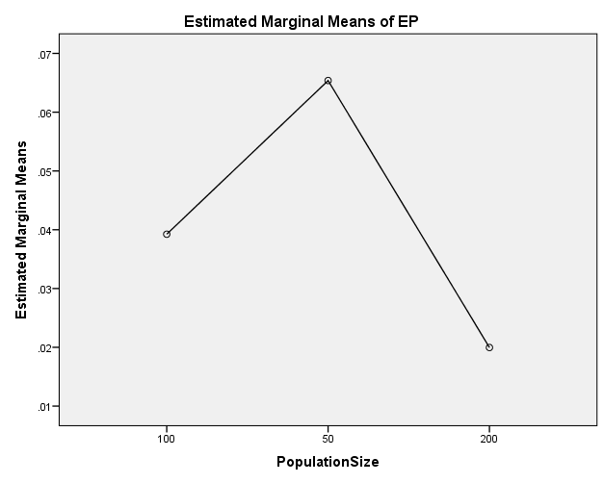

**GD**

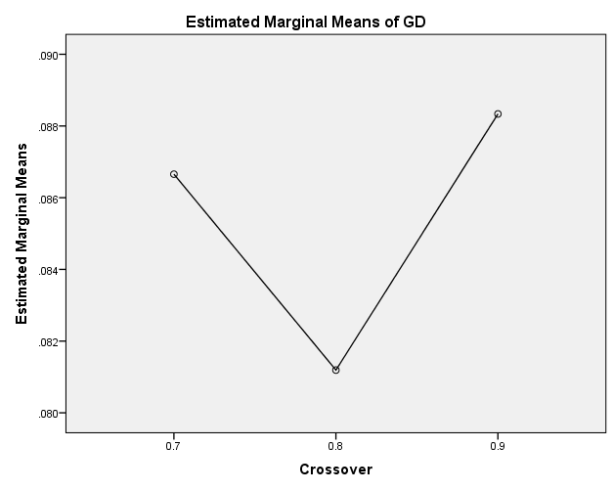

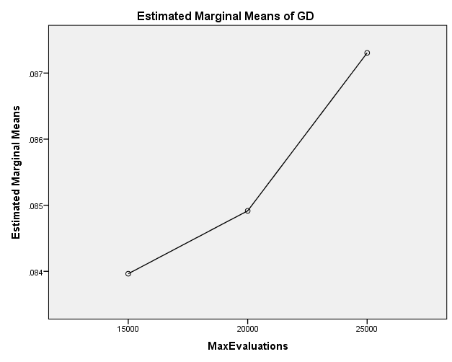

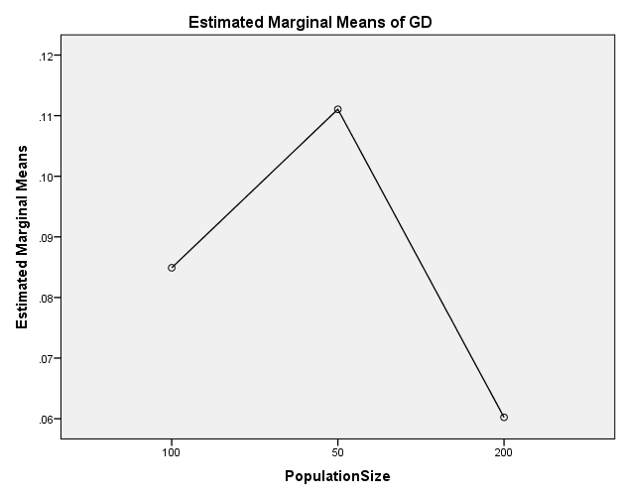

**IGD**

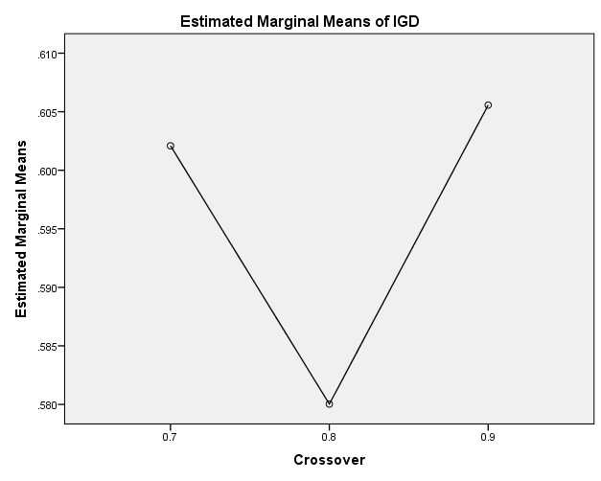

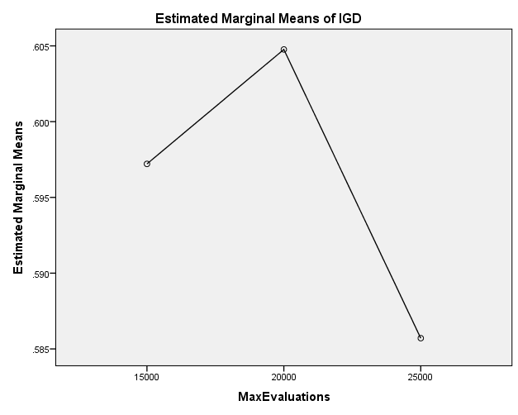

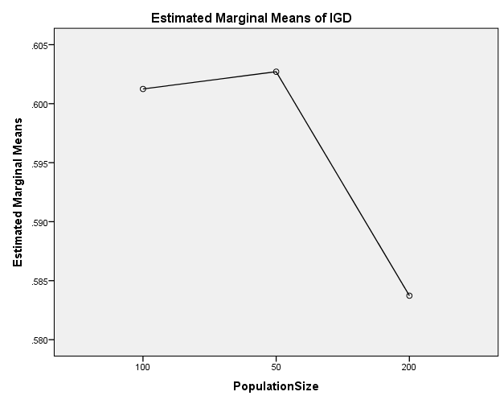

**IGDplus**

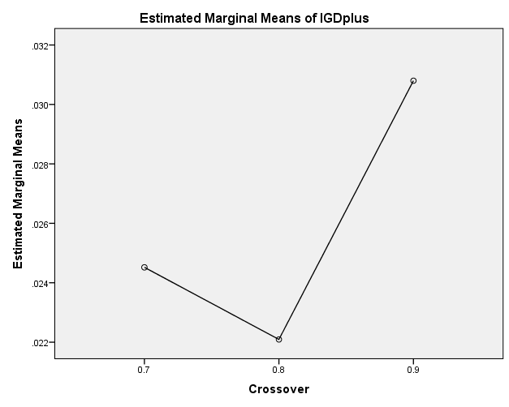

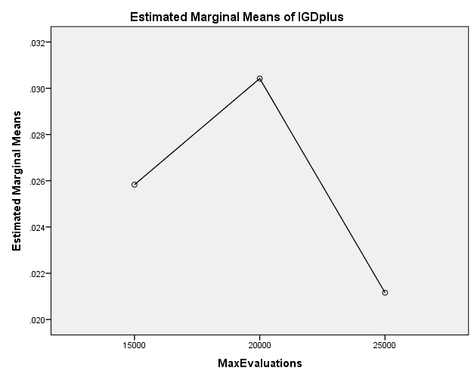

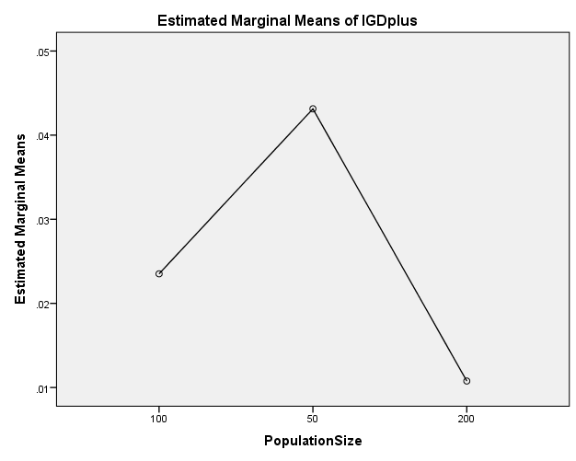

**SPREAD**

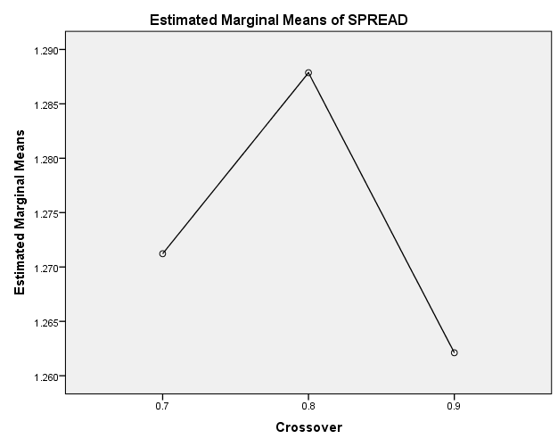

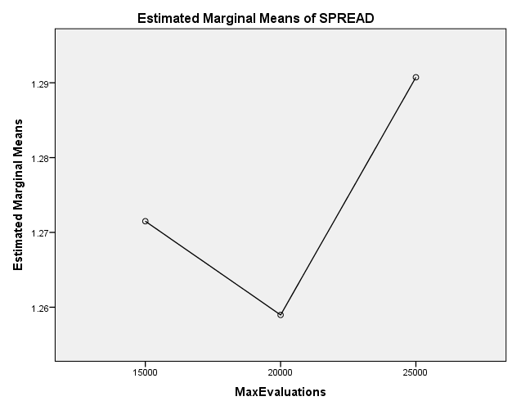

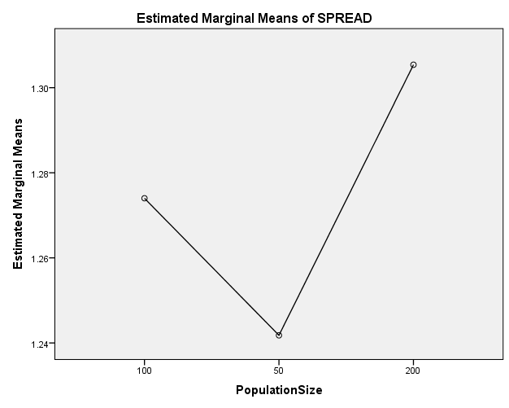

EXAMINE VARIABLES=HV EP GD IGD IGDplus SPREAD BY Crossover MaxEvaluations PopulationSize

/PLOT BOXPLOT

/COMPARE VARIABLES

/STATISTICS NONE

/CINTERVAL 95

/MISSING LISTWISE

/NOTOTAL.

**Explore**

|  |  |  |
| --- | --- | --- |
| **Notes** | | |
| Output Created | | 26-MAY-2020 19:34:28 |
| Comments | |  |
| Input | Data | C:\Users\user\Documents\NILAY\Mayis2020\7_SPEA2.sav |
| Active Dataset | DataSet1 |
| Filter | <none> |
| Weight | <none> |
| Split File | <none> |
| N of Rows in Working Data File | 837 |
| Missing Value Handling | Definition of Missing | User-defined missing values for dependent variables are treated as missing. |
| Cases Used | Statistics are based on cases with no missing values for any dependent variable or factor used. |
| Syntax | | EXAMINE VARIABLES=HV EP GD IGD IGDplus SPREAD BY Crossover MaxEvaluations PopulationSize  /PLOT BOXPLOT  /COMPARE VARIABLES  /STATISTICS NONE  /CINTERVAL 95  /MISSING LISTWISE  /NOTOTAL. |
| Resources | Processor Time | 00:00:01.70 |
| Elapsed Time | 00:00:01.73 |

[DataSet1] C:\Users\user\Documents\NILAY\Mayis2020\7_SPEA2.sav

**Crossover**

|  |  |  |  |  |  |  |  |
| --- | --- | --- | --- | --- | --- | --- | --- |
| **Case Processing Summary** | | | | | | | |
|  | Crossover | Cases | | | | | |
| Valid | | Missing | | Total | |
| N | Percent | N | Percent | N | Percent |
| HV | 0.7 | 279 | 100.0% | 0 | 0.0% | 279 | 100.0% |
| 0.8 | 279 | 100.0% | 0 | 0.0% | 279 | 100.0% |
| 0.9 | 279 | 100.0% | 0 | 0.0% | 279 | 100.0% |
| EP | 0.7 | 279 | 100.0% | 0 | 0.0% | 279 | 100.0% |
| 0.8 | 279 | 100.0% | 0 | 0.0% | 279 | 100.0% |
| 0.9 | 279 | 100.0% | 0 | 0.0% | 279 | 100.0% |
| GD | 0.7 | 279 | 100.0% | 0 | 0.0% | 279 | 100.0% |
| 0.8 | 279 | 100.0% | 0 | 0.0% | 279 | 100.0% |
| 0.9 | 279 | 100.0% | 0 | 0.0% | 279 | 100.0% |
| IGD | 0.7 | 279 | 100.0% | 0 | 0.0% | 279 | 100.0% |
| 0.8 | 279 | 100.0% | 0 | 0.0% | 279 | 100.0% |
| 0.9 | 279 | 100.0% | 0 | 0.0% | 279 | 100.0% |
| IGDplus | 0.7 | 279 | 100.0% | 0 | 0.0% | 279 | 100.0% |
| 0.8 | 279 | 100.0% | 0 | 0.0% | 279 | 100.0% |
| 0.9 | 279 | 100.0% | 0 | 0.0% | 279 | 100.0% |
| SPREAD | 0.7 | 279 | 100.0% | 0 | 0.0% | 279 | 100.0% |
| 0.8 | 279 | 100.0% | 0 | 0.0% | 279 | 100.0% |
| 0.9 | 279 | 100.0% | 0 | 0.0% | 279 | 100.0% |

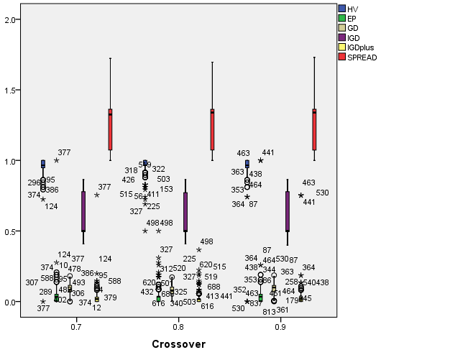

**MaxEvaluations**

|  |  |  |  |  |  |  |  |
| --- | --- | --- | --- | --- | --- | --- | --- |
| **Case Processing Summary** | | | | | | | |
|  | MaxEvaluations | Cases | | | | | |
| Valid | | Missing | | Total | |
| N | Percent | N | Percent | N | Percent |
| HV | 15000 | 279 | 100.0% | 0 | 0.0% | 279 | 100.0% |
| 20000 | 279 | 100.0% | 0 | 0.0% | 279 | 100.0% |
| 25000 | 279 | 100.0% | 0 | 0.0% | 279 | 100.0% |
| EP | 15000 | 279 | 100.0% | 0 | 0.0% | 279 | 100.0% |
| 20000 | 279 | 100.0% | 0 | 0.0% | 279 | 100.0% |
| 25000 | 279 | 100.0% | 0 | 0.0% | 279 | 100.0% |
| GD | 15000 | 279 | 100.0% | 0 | 0.0% | 279 | 100.0% |
| 20000 | 279 | 100.0% | 0 | 0.0% | 279 | 100.0% |
| 25000 | 279 | 100.0% | 0 | 0.0% | 279 | 100.0% |
| IGD | 15000 | 279 | 100.0% | 0 | 0.0% | 279 | 100.0% |
| 20000 | 279 | 100.0% | 0 | 0.0% | 279 | 100.0% |
| 25000 | 279 | 100.0% | 0 | 0.0% | 279 | 100.0% |
| IGDplus | 15000 | 279 | 100.0% | 0 | 0.0% | 279 | 100.0% |
| 20000 | 279 | 100.0% | 0 | 0.0% | 279 | 100.0% |
| 25000 | 279 | 100.0% | 0 | 0.0% | 279 | 100.0% |
| SPREAD | 15000 | 279 | 100.0% | 0 | 0.0% | 279 | 100.0% |
| 20000 | 279 | 100.0% | 0 | 0.0% | 279 | 100.0% |
| 25000 | 279 | 100.0% | 0 | 0.0% | 279 | 100.0% |

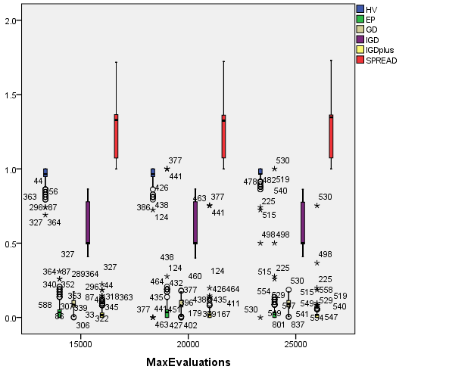

**PopulationSize**

|  |  |  |  |  |  |  |  |
| --- | --- | --- | --- | --- | --- | --- | --- |
| **Case Processing Summary** | | | | | | | |
|  | PopulationSize | Cases | | | | | |
| Valid | | Missing | | Total | |
| N | Percent | N | Percent | N | Percent |
| HV | 100 | 279 | 100.0% | 0 | 0.0% | 279 | 100.0% |
| 50 | 279 | 100.0% | 0 | 0.0% | 279 | 100.0% |
| 200 | 279 | 100.0% | 0 | 0.0% | 279 | 100.0% |
| EP | 100 | 279 | 100.0% | 0 | 0.0% | 279 | 100.0% |
| 50 | 279 | 100.0% | 0 | 0.0% | 279 | 100.0% |
| 200 | 279 | 100.0% | 0 | 0.0% | 279 | 100.0% |
| GD | 100 | 279 | 100.0% | 0 | 0.0% | 279 | 100.0% |
| 50 | 279 | 100.0% | 0 | 0.0% | 279 | 100.0% |
| 200 | 279 | 100.0% | 0 | 0.0% | 279 | 100.0% |
| IGD | 100 | 279 | 100.0% | 0 | 0.0% | 279 | 100.0% |
| 50 | 279 | 100.0% | 0 | 0.0% | 279 | 100.0% |
| 200 | 279 | 100.0% | 0 | 0.0% | 279 | 100.0% |
| IGDplus | 100 | 279 | 100.0% | 0 | 0.0% | 279 | 100.0% |
| 50 | 279 | 100.0% | 0 | 0.0% | 279 | 100.0% |
| 200 | 279 | 100.0% | 0 | 0.0% | 279 | 100.0% |
| SPREAD | 100 | 279 | 100.0% | 0 | 0.0% | 279 | 100.0% |
| 50 | 279 | 100.0% | 0 | 0.0% | 279 | 100.0% |
| 200 | 279 | 100.0% | 0 | 0.0% | 279 | 100.0% |

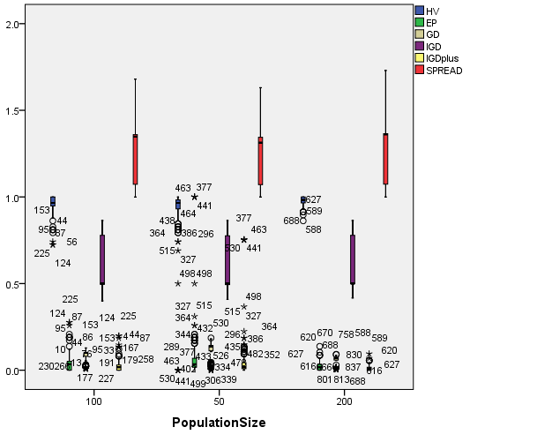

EXAMINE VARIABLES=HV EP GD IGD IGDplus SPREAD BY Crossover MaxEvaluations PopulationSize

/PLOT BOXPLOT

/COMPARE GROUPS

/STATISTICS NONE

/CINTERVAL 95

/MISSING LISTWISE

/NOTOTAL.

**Explore**

|  |  |  |
| --- | --- | --- |
| **Notes** | | |
| Output Created | | 26-MAY-2020 19:36:30 |
| Comments | |  |
| Input | Data | C:\Users\user\Documents\NILAY\Mayis2020\7_SPEA2.sav |
| Active Dataset | DataSet1 |
| Filter | <none> |
| Weight | <none> |
| Split File | <none> |
| N of Rows in Working Data File | 837 |
| Missing Value Handling | Definition of Missing | User-defined missing values for dependent variables are treated as missing. |
| Cases Used | Statistics are based on cases with no missing values for any dependent variable or factor used. |
| Syntax | | EXAMINE VARIABLES=HV EP GD IGD IGDplus SPREAD BY Crossover MaxEvaluations PopulationSize  /PLOT BOXPLOT  /COMPARE GROUPS  /STATISTICS NONE  /CINTERVAL 95  /MISSING LISTWISE  /NOTOTAL. |
| Resources | Processor Time | 00:00:04.13 |
| Elapsed Time | 00:00:04.11 |

[DataSet1] C:\Users\user\Documents\NILAY\Mayis2020\7_SPEA2.sav

**Crossover**

|  |  |  |  |  |  |  |  |
| --- | --- | --- | --- | --- | --- | --- | --- |
| **Case Processing Summary** | | | | | | | |
|  | Crossover | Cases | | | | | |
| Valid | | Missing | | Total | |
| N | Percent | N | Percent | N | Percent |
| HV | 0.7 | 279 | 100.0% | 0 | 0.0% | 279 | 100.0% |
| 0.8 | 279 | 100.0% | 0 | 0.0% | 279 | 100.0% |
| 0.9 | 279 | 100.0% | 0 | 0.0% | 279 | 100.0% |
| EP | 0.7 | 279 | 100.0% | 0 | 0.0% | 279 | 100.0% |
| 0.8 | 279 | 100.0% | 0 | 0.0% | 279 | 100.0% |
| 0.9 | 279 | 100.0% | 0 | 0.0% | 279 | 100.0% |
| GD | 0.7 | 279 | 100.0% | 0 | 0.0% | 279 | 100.0% |
| 0.8 | 279 | 100.0% | 0 | 0.0% | 279 | 100.0% |
| 0.9 | 279 | 100.0% | 0 | 0.0% | 279 | 100.0% |
| IGD | 0.7 | 279 | 100.0% | 0 | 0.0% | 279 | 100.0% |
| 0.8 | 279 | 100.0% | 0 | 0.0% | 279 | 100.0% |
| 0.9 | 279 | 100.0% | 0 | 0.0% | 279 | 100.0% |
| IGDplus | 0.7 | 279 | 100.0% | 0 | 0.0% | 279 | 100.0% |
| 0.8 | 279 | 100.0% | 0 | 0.0% | 279 | 100.0% |
| 0.9 | 279 | 100.0% | 0 | 0.0% | 279 | 100.0% |
| SPREAD | 0.7 | 279 | 100.0% | 0 | 0.0% | 279 | 100.0% |
| 0.8 | 279 | 100.0% | 0 | 0.0% | 279 | 100.0% |
| 0.9 | 279 | 100.0% | 0 | 0.0% | 279 | 100.0% |

**HV**

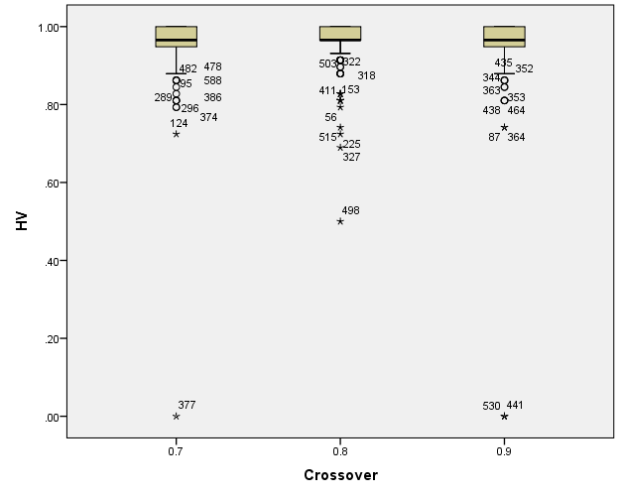

**EP**

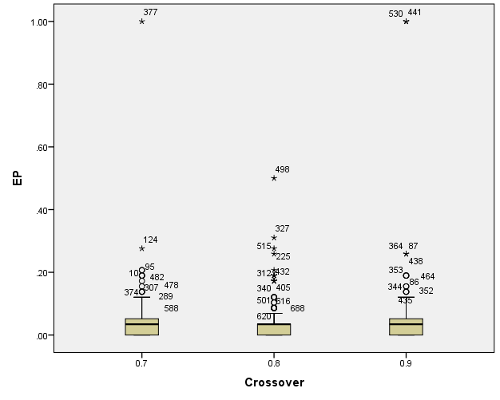

**GD**

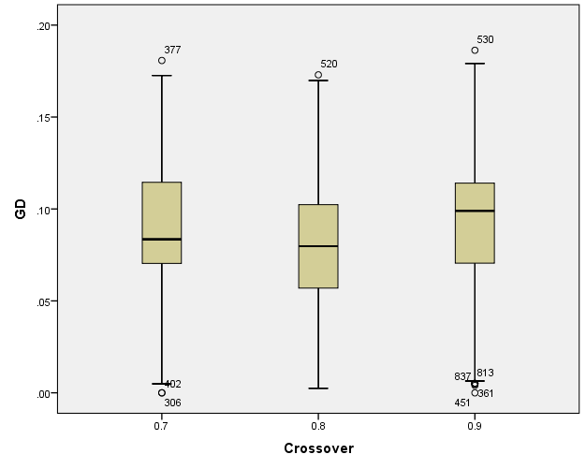

**IGD**

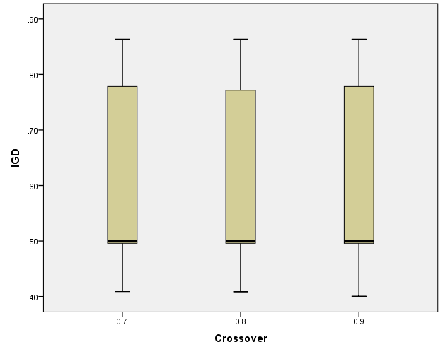

**IGDplus**

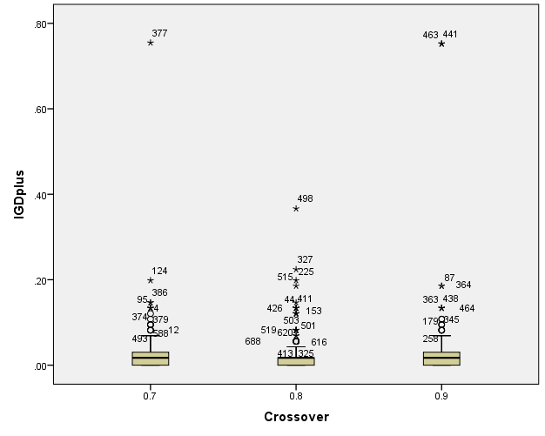

**SPREAD**

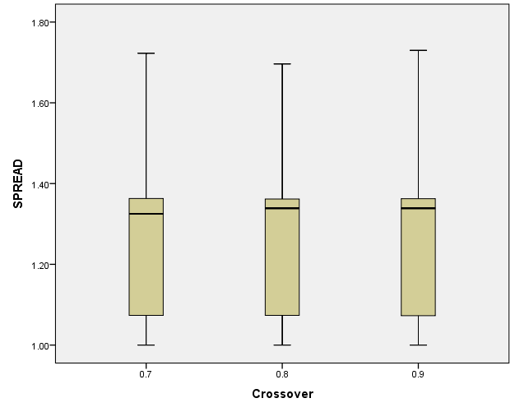

**MaxEvaluations**

|  |  |  |  |  |  |  |  |
| --- | --- | --- | --- | --- | --- | --- | --- |
| **Case Processing Summary** | | | | | | | |
|  | MaxEvaluations | Cases | | | | | |
| Valid | | Missing | | Total | |
| N | Percent | N | Percent | N | Percent |
| HV | 15000 | 279 | 100.0% | 0 | 0.0% | 279 | 100.0% |
| 20000 | 279 | 100.0% | 0 | 0.0% | 279 | 100.0% |
| 25000 | 279 | 100.0% | 0 | 0.0% | 279 | 100.0% |
| EP | 15000 | 279 | 100.0% | 0 | 0.0% | 279 | 100.0% |
| 20000 | 279 | 100.0% | 0 | 0.0% | 279 | 100.0% |
| 25000 | 279 | 100.0% | 0 | 0.0% | 279 | 100.0% |
| GD | 15000 | 279 | 100.0% | 0 | 0.0% | 279 | 100.0% |
| 20000 | 279 | 100.0% | 0 | 0.0% | 279 | 100.0% |
| 25000 | 279 | 100.0% | 0 | 0.0% | 279 | 100.0% |
| IGD | 15000 | 279 | 100.0% | 0 | 0.0% | 279 | 100.0% |
| 20000 | 279 | 100.0% | 0 | 0.0% | 279 | 100.0% |
| 25000 | 279 | 100.0% | 0 | 0.0% | 279 | 100.0% |
| IGDplus | 15000 | 279 | 100.0% | 0 | 0.0% | 279 | 100.0% |
| 20000 | 279 | 100.0% | 0 | 0.0% | 279 | 100.0% |
| 25000 | 279 | 100.0% | 0 | 0.0% | 279 | 100.0% |
| SPREAD | 15000 | 279 | 100.0% | 0 | 0.0% | 279 | 100.0% |
| 20000 | 279 | 100.0% | 0 | 0.0% | 279 | 100.0% |
| 25000 | 279 | 100.0% | 0 | 0.0% | 279 | 100.0% |

**HV**

**Boxplots**

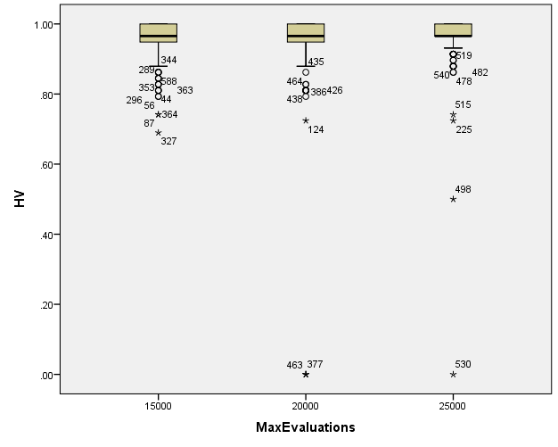

**EP**

**Boxplots**

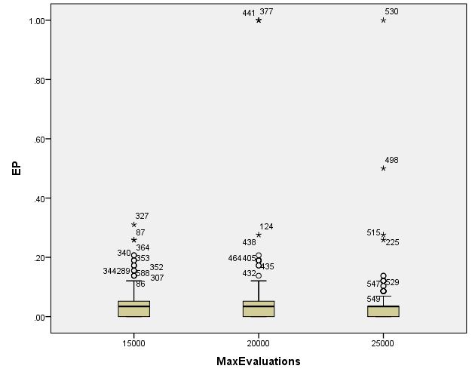

**GD**

**Boxplots**

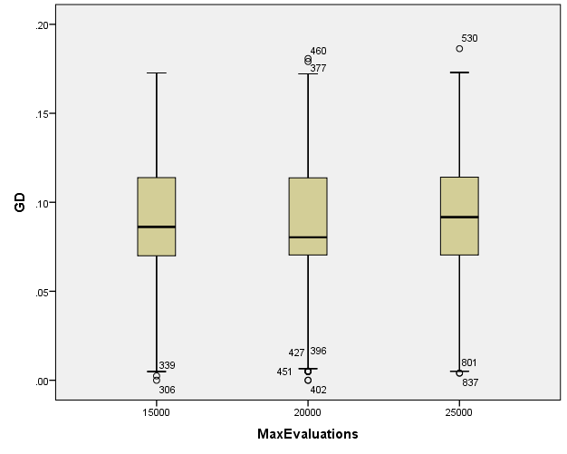

**IGD**

**Boxplots**

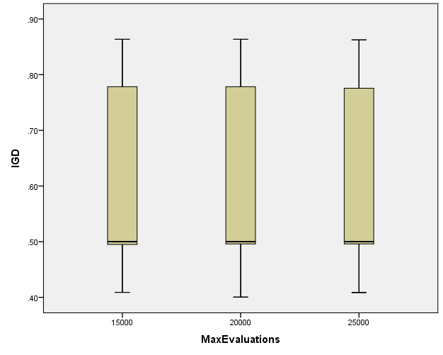

**IGDplus**

**Boxplots**

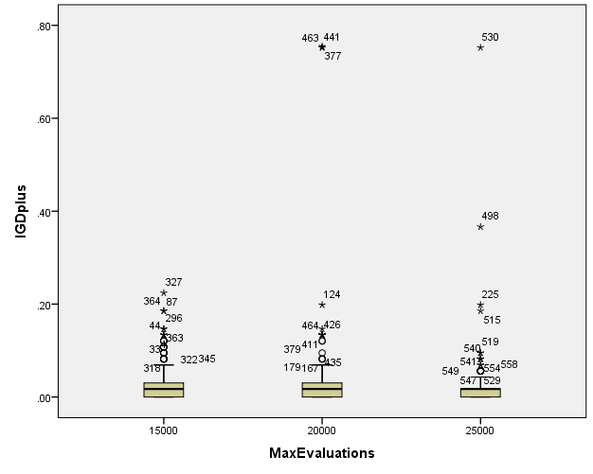

**SPREAD**

**Boxplots**

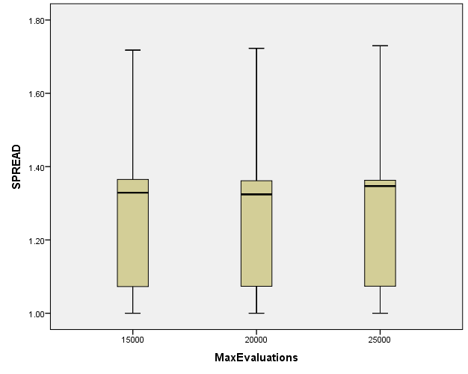

**PopulationSize**

|  |  |  |  |  |  |  |  |
| --- | --- | --- | --- | --- | --- | --- | --- |
| **Case Processing Summary** | | | | | | | |
|  | PopulationSize | Cases | | | | | |
| Valid | | Missing | | Total | |
| N | Percent | N | Percent | N | Percent |
| HV | 100 | 279 | 100.0% | 0 | 0.0% | 279 | 100.0% |
| 50 | 279 | 100.0% | 0 | 0.0% | 279 | 100.0% |
| 200 | 279 | 100.0% | 0 | 0.0% | 279 | 100.0% |
| EP | 100 | 279 | 100.0% | 0 | 0.0% | 279 | 100.0% |
| 50 | 279 | 100.0% | 0 | 0.0% | 279 | 100.0% |
| 200 | 279 | 100.0% | 0 | 0.0% | 279 | 100.0% |
| GD | 100 | 279 | 100.0% | 0 | 0.0% | 279 | 100.0% |
| 50 | 279 | 100.0% | 0 | 0.0% | 279 | 100.0% |
| 200 | 279 | 100.0% | 0 | 0.0% | 279 | 100.0% |
| IGD | 100 | 279 | 100.0% | 0 | 0.0% | 279 | 100.0% |
| 50 | 279 | 100.0% | 0 | 0.0% | 279 | 100.0% |
| 200 | 279 | 100.0% | 0 | 0.0% | 279 | 100.0% |
| IGDplus | 100 | 279 | 100.0% | 0 | 0.0% | 279 | 100.0% |
| 50 | 279 | 100.0% | 0 | 0.0% | 279 | 100.0% |
| 200 | 279 | 100.0% | 0 | 0.0% | 279 | 100.0% |
| SPREAD | 100 | 279 | 100.0% | 0 | 0.0% | 279 | 100.0% |
| 50 | 279 | 100.0% | 0 | 0.0% | 279 | 100.0% |
| 200 | 279 | 100.0% | 0 | 0.0% | 279 | 100.0% |

**HV**

**Boxplots**

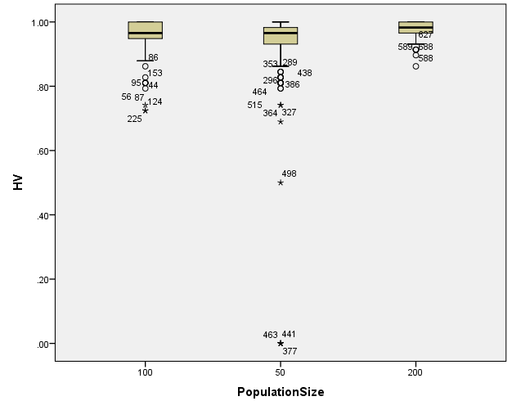

**EP**

**Boxplots**

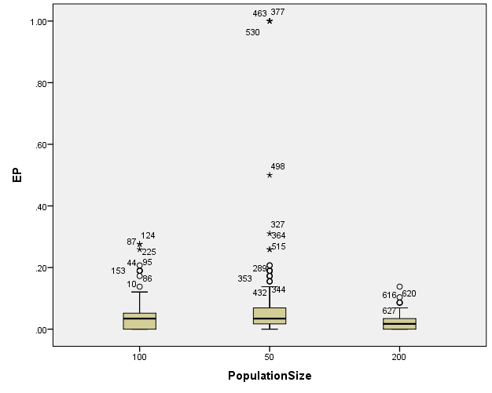

**GD**

**Boxplots**

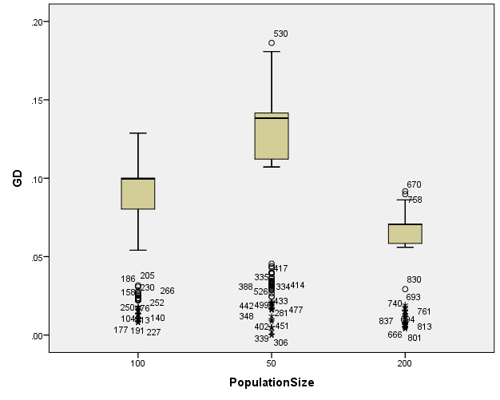

**IGD**

**Boxplots**

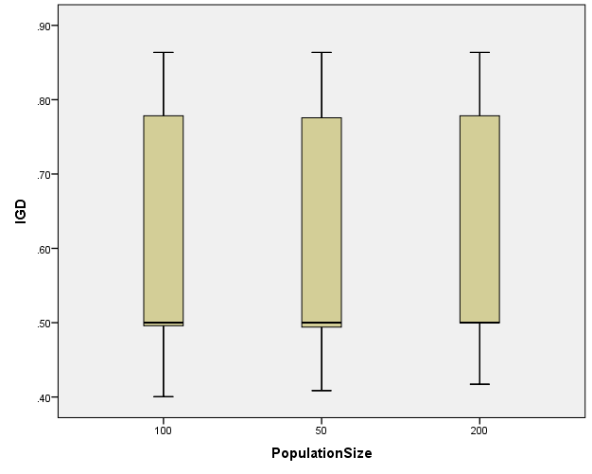

**IGDplus**

**Boxplots**

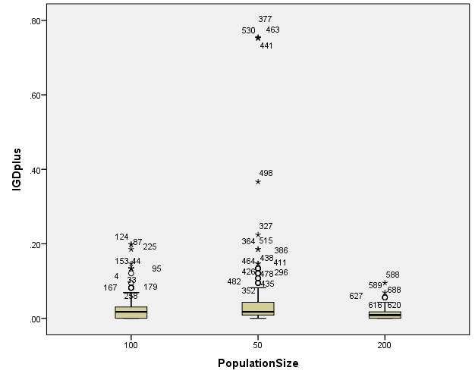

**SPREAD**

**Boxplots**

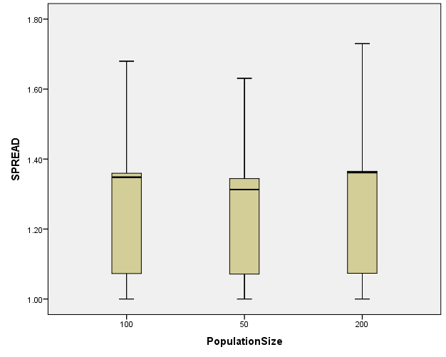

*Nonparametric Tests: Independent Samples.

NPTESTS

/INDEPENDENT TEST (HV EP GD IGD IGDplus SPREAD) GROUP (Crossover) MEDIAN(TESTVALUE=SAMPLE COMPARE=PAIRWISE)

/MISSING SCOPE=ANALYSIS USERMISSING=EXCLUDE

/CRITERIA ALPHA=0.05 CILEVEL=95.

**Nonparametric Tests**

|  |  |  |
| --- | --- | --- |
| **Notes** | | |
| Output Created | | 26-MAY-2020 19:38:04 |
| Comments | |  |
| Input | Data | C:\Users\user\Documents\NILAY\Mayis2020\7_SPEA2.sav |
| Active Dataset | DataSet1 |
| Filter | <none> |
| Weight | <none> |
| Split File | <none> |
| N of Rows in Working Data File | 837 |
| Syntax | | NPTESTS  /INDEPENDENT TEST (HV EP GD IGD IGDplus SPREAD) GROUP (Crossover) MEDIAN(TESTVALUE=SAMPLE COMPARE=PAIRWISE)  /MISSING SCOPE=ANALYSIS USERMISSING=EXCLUDE  /CRITERIA ALPHA=0.05 CILEVEL=95. |
| Resources | Processor Time | 00:00:00.33 |
| Elapsed Time | 00:00:00.80 |

[DataSet1] C:\Users\user\Documents\NILAY\Mayis2020\7_SPEA2.sav

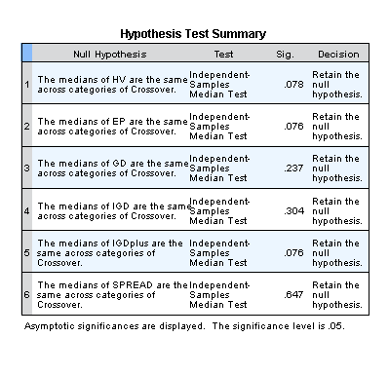

*Nonparametric Tests: Independent Samples.

NPTESTS

/INDEPENDENT TEST (HV EP GD IGD IGDplus SPREAD) GROUP (MaxEvaluations) MEDIAN(TESTVALUE=SAMPLE COMPARE=PAIRWISE)

/MISSING SCOPE=ANALYSIS USERMISSING=EXCLUDE

/CRITERIA ALPHA=0.05 CILEVEL=95.

**Nonparametric Tests**

|  |  |  |
| --- | --- | --- |
| **Notes** | | |
| Output Created | | 26-MAY-2020 19:38:23 |
| Comments | |  |
| Input | Data | C:\Users\user\Documents\NILAY\Mayis2020\7_SPEA2.sav |
| Active Dataset | DataSet1 |
| Filter | <none> |
| Weight | <none> |
| Split File | <none> |
| N of Rows in Working Data File | 837 |
| Syntax | | NPTESTS  /INDEPENDENT TEST (HV EP GD IGD IGDplus SPREAD) GROUP (MaxEvaluations) MEDIAN(TESTVALUE=SAMPLE COMPARE=PAIRWISE)  /MISSING SCOPE=ANALYSIS USERMISSING=EXCLUDE  /CRITERIA ALPHA=0.05 CILEVEL=95. |
| Resources | Processor Time | 00:00:00.19 |
| Elapsed Time | 00:00:00.14 |

[DataSet1] C:\Users\user\Documents\NILAY\Mayis2020\7_SPEA2.sav

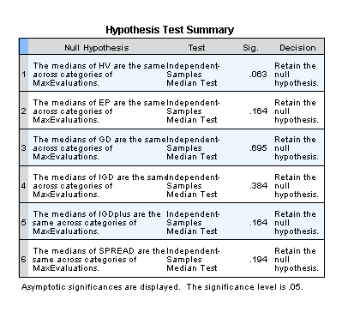

*Nonparametric Tests: Independent Samples.

NPTESTS

/INDEPENDENT TEST (HV EP GD IGD IGDplus SPREAD) GROUP (PopulationSize) MEDIAN(TESTVALUE=SAMPLE COMPARE=PAIRWISE)

/MISSING SCOPE=ANALYSIS USERMISSING=EXCLUDE

/CRITERIA ALPHA=0.05 CILEVEL=95.

**Nonparametric Tests**

|  |  |  |
| --- | --- | --- |
| **Notes** | | |
| Output Created | | 26-MAY-2020 19:38:41 |
| Comments | |  |
| Input | Data | C:\Users\user\Documents\NILAY\Mayis2020\7_SPEA2.sav |
| Active Dataset | DataSet1 |
| Filter | <none> |
| Weight | <none> |
| Split File | <none> |
| N of Rows in Working Data File | 837 |
| Syntax | | NPTESTS  /INDEPENDENT TEST (HV EP GD IGD IGDplus SPREAD) GROUP (PopulationSize) MEDIAN(TESTVALUE=SAMPLE COMPARE=PAIRWISE)  /MISSING SCOPE=ANALYSIS USERMISSING=EXCLUDE  /CRITERIA ALPHA=0.05 CILEVEL=95. |
| Resources | Processor Time | 00:00:00.22 |
| Elapsed Time | 00:00:00.17 |

[DataSet1] C:\Users\user\Documents\NILAY\Mayis2020\7_SPEA2.sav

