SAVE OUTFILE='C:\Users\user\Documents\NILAY\Mayis2020\medium_NSGAII.sav'

/COMPRESSED.

GLM HV EP GD IGD IGDplus SPREAD BY Crossover MaxEvaluations PopulationSize

/METHOD=SSTYPE(3)

/INTERCEPT=INCLUDE

/POSTHOC=Crossover MaxEvaluations PopulationSize(BONFERRONI)

/PLOT=PROFILE(Crossover MaxEvaluations PopulationSize)

/CRITERIA=ALPHA(.05)

/DESIGN=Crossover MaxEvaluations PopulationSize.

**General Linear Model**

|  |  |  |
| --- | --- | --- |
| **Notes** | | |
| Output Created | | 26-MAY-2020 20:14:13 |
| Comments | |  |
| Input | Data | C:\Users\user\Documents\NILAY\Mayis2020\medium_NSGAII.sav |
| Active Dataset | DataSet1 |
| Filter | <none> |
| Weight | <none> |
| Split File | <none> |
| N of Rows in Working Data File | 837 |
| Missing Value Handling | Definition of Missing | User-defined missing values are treated as missing. |
| Cases Used | Statistics are based on all cases with valid data for all variables in the model. |
| Syntax | | GLM HV EP GD IGD IGDplus SPREAD BY Crossover MaxEvaluations PopulationSize  /METHOD=SSTYPE(3)  /INTERCEPT=INCLUDE  /POSTHOC=Crossover MaxEvaluations PopulationSize(BONFERRONI)  /PLOT=PROFILE(Crossover MaxEvaluations PopulationSize)  /CRITERIA=ALPHA(.05)  /DESIGN=Crossover MaxEvaluations PopulationSize. |
| Resources | Processor Time | 00:00:03.30 |
| Elapsed Time | 00:00:03.20 |

[DataSet1] C:\Users\user\Documents\NILAY\Mayis2020\medium_NSGAII.sav

|  |  |  |  |
| --- | --- | --- | --- |
| **Between-Subjects Factors** | | | |
|  | | Value Label | N |
| Crossover | 1 | 0.7 | 279 |
| 2 | 0.8 | 279 |
| 3 | 0.9 | 279 |
| MaxEvaluations | 1 | 15000 | 279 |
| 2 | 20000 | 279 |
| 3 | 25000 | 279 |
| PopulationSize | 1 | 100 | 279 |
| 2 | 50 | 279 |
| 3 | 200 | 279 |

|  |  |  |  |  |  |
| --- | --- | --- | --- | --- | --- |
| **Multivariate Testsa** | | | | | |
| Effect | | Value | F | Hypothesis df | Error df |
| Intercept | Pillai's Trace | 1.000 | 684849.521b | 6.000 | 825.000 |
| Wilks' Lambda | .000 | 684849.521b | 6.000 | 825.000 |
| Hotelling's Trace | 4980.724 | 684849.521b | 6.000 | 825.000 |
| Roy's Largest Root | 4980.724 | 684849.521b | 6.000 | 825.000 |
| Crossover | Pillai's Trace | .043 | 2.992 | 12.000 | 1652.000 |
| Wilks' Lambda | .958 | 3.008b | 12.000 | 1650.000 |
| Hotelling's Trace | .044 | 3.023 | 12.000 | 1648.000 |
| Roy's Largest Root | .039 | 5.365c | 6.000 | 826.000 |
| MaxEvaluations | Pillai's Trace | .144 | 10.705 | 12.000 | 1652.000 |
| Wilks' Lambda | .857 | 11.011b | 12.000 | 1650.000 |
| Hotelling's Trace | .165 | 11.317 | 12.000 | 1648.000 |
| Roy's Largest Root | .153 | 21.106c | 6.000 | 826.000 |
| PopulationSize | Pillai's Trace | .488 | 44.454 | 12.000 | 1652.000 |
| Wilks' Lambda | .521 | 52.920b | 12.000 | 1650.000 |
| Hotelling's Trace | .899 | 61.763 | 12.000 | 1648.000 |
| Roy's Largest Root | .879 | 120.941c | 6.000 | 826.000 |

|  |  |  |
| --- | --- | --- |
| **Multivariate Testsa** | | |
| Effect | | Sig. |
| Intercept | Pillai's Trace | .000 |
| Wilks' Lambda | .000 |
| Hotelling's Trace | .000 |
| Roy's Largest Root | .000 |
| Crossover | Pillai's Trace | .000 |
| Wilks' Lambda | .000 |
| Hotelling's Trace | .000 |
| Roy's Largest Root | .000 |
| MaxEvaluations | Pillai's Trace | .000 |
| Wilks' Lambda | .000 |
| Hotelling's Trace | .000 |
| Roy's Largest Root | .000 |
| PopulationSize | Pillai's Trace | .000 |
| Wilks' Lambda | .000 |
| Hotelling's Trace | .000 |
| Roy's Largest Root | .000 |

|  |
| --- |
| a. Design: Intercept + Crossover + MaxEvaluations + PopulationSize |
| b. Exact statistic |
| c. The statistic is an upper bound on F that yields a lower bound on the significance level. |

|  |  |  |  |  |  |
| --- | --- | --- | --- | --- | --- |
| **Tests of Between-Subjects Effects** | | | | | |
| Source | Dependent Variable | Type III Sum of Squares | df | Mean Square | F |
| Corrected Model | HV | 2.115a | 6 | .352 | 58.875 |
| EP | 1.402b | 6 | .234 | 59.228 |
| GD | 2.206c | 6 | .368 | 77.426 |
| IGD | .144d | 6 | .024 | 13.971 |
| IGDplus | .906e | 6 | .151 | 61.809 |
| SPREAD | .572f | 6 | .095 | 15.901 |
| Intercept | HV | 474.423 | 1 | 474.423 | 79246.389 |
| EP | 23.822 | 1 | 23.822 | 6037.819 |
| GD | 5.905 | 1 | 5.905 | 1243.620 |
| IGD | 154.232 | 1 | 154.232 | 89645.621 |
| IGDplus | 12.857 | 1 | 12.857 | 5265.178 |
| SPREAD | 875.402 | 1 | 875.402 | 146097.696 |
| Crossover | HV | .018 | 2 | .009 | 1.522 |
| EP | .014 | 2 | .007 | 1.798 |
| GD | .017 | 2 | .008 | 1.755 |
| IGD | .023 | 2 | .012 | 6.750 |
| IGDplus | .009 | 2 | .004 | 1.796 |
| SPREAD | .021 | 2 | .011 | 1.775 |
| MaxEvaluations | HV | .522 | 2 | .261 | 43.606 |
| EP | .350 | 2 | .175 | 44.386 |
| GD | .197 | 2 | .099 | 20.766 |
| IGD | .012 | 2 | .006 | 3.470 |
| IGDplus | .236 | 2 | .118 | 48.387 |
| SPREAD | .229 | 2 | .114 | 19.093 |
| PopulationSize | HV | 1.574 | 2 | .787 | 131.496 |
| EP | 1.038 | 2 | .519 | 131.502 |
| GD | 1.992 | 2 | .996 | 209.756 |
| IGD | .109 | 2 | .055 | 31.693 |
| IGDplus | .660 | 2 | .330 | 135.243 |
| SPREAD | .322 | 2 | .161 | 26.835 |
| Error | HV | 4.969 | 830 | .006 |  |
| EP | 3.275 | 830 | .004 |  |
| GD | 3.941 | 830 | .005 |  |
| IGD | 1.428 | 830 | .002 |  |
| IGDplus | 2.027 | 830 | .002 |  |

|  |  |  |
| --- | --- | --- |
| **Tests of Between-Subjects Effects** | | |
| Source | Dependent Variable | Sig. |
| Corrected Model | HV | .000a |
| EP | .000b |
| GD | .000c |
| IGD | .000d |
| IGDplus | .000e |
| SPREAD | .000f |
| Intercept | HV | .000 |
| EP | .000 |
| GD | .000 |
| IGD | .000 |
| IGDplus | .000 |
| SPREAD | .000 |
| Crossover | HV | .219 |
| EP | .166 |
| GD | .174 |
| IGD | .001 |
| IGDplus | .167 |
| SPREAD | .170 |
| MaxEvaluations | HV | .000 |
| EP | .000 |
| GD | .000 |
| IGD | .032 |
| IGDplus | .000 |
| SPREAD | .000 |
| PopulationSize | HV | .000 |
| EP | .000 |
| GD | .000 |
| IGD | .000 |
| IGDplus | .000 |
| SPREAD | .000 |
| Error | HV |  |
| EP |  |
| GD |  |
| IGD |  |
| IGDplus |  |

|  |  |  |  |  |  |
| --- | --- | --- | --- | --- | --- |
| **Tests of Between-Subjects Effects** | | | | | |
| Source | Dependent Variable | Type III Sum of Squares | df | Mean Square | F |
| Error | SPREAD | 4.973a | 830 | .006 |  |
| Total | HV | 481.507b | 837 |  |  |
| EP | 28.499c | 837 |  |  |
| GD | 12.051d | 837 |  |  |
| IGD | 155.805e | 837 |  |  |
| IGDplus | 15.789f | 837 |  |  |
| SPREAD | 880.947 | 837 |  |  |
| Corrected Total | HV | 7.084 | 836 |  |  |
| EP | 4.677 | 836 |  |  |
| GD | 6.146 | 836 |  |  |
| IGD | 1.572 | 836 |  |  |
| IGDplus | 2.932 | 836 |  |  |
| SPREAD | 5.545 | 836 |  |  |

|  |  |  |
| --- | --- | --- |
| **Tests of Between-Subjects Effects** | | |
| Source | Dependent Variable | Sig. |
| Error | SPREAD |  |
| Total | HV |  |
| EP |  |
| GD |  |
| IGD |  |
| IGDplus |  |
| SPREAD |  |
| Corrected Total | HV |  |
| EP |  |
| GD |  |
| IGD |  |
| IGDplus |  |
| SPREAD |  |

|  |
| --- |
| a. R Squared = .299 (Adjusted R Squared = .293) |
| b. R Squared = .300 (Adjusted R Squared = .295) |
| c. R Squared = .359 (Adjusted R Squared = .354) |
| d. R Squared = .092 (Adjusted R Squared = .085) |
| e. R Squared = .309 (Adjusted R Squared = .304) |
| f. R Squared = .103 (Adjusted R Squared = .097) |

**Post Hoc Tests**

**Crossover**

|  |  |  |  |  |  |
| --- | --- | --- | --- | --- | --- |
| **Multiple Comparisons** | | | | | |
| Bonferroni | | | | | |
| Dependent Variable | (I) Crossover | (J) Crossover | Mean Difference (I-J) | Std. Error | Sig. |
|
| HV | 0.7 | 0.8 | .0112 | .00655 | .267 |
| 0.9 | .0034 | .00655 | 1.000 |
| 0.8 | 0.7 | -.0112 | .00655 | .267 |
| 0.9 | -.0078 | .00655 | .711 |
| 0.9 | 0.7 | -.0034 | .00655 | 1.000 |
| 0.8 | .0078 | .00655 | .711 |
| EP | 0.7 | 0.8 | -.0101 | .00532 | .177 |
| 0.9 | -.0056 | .00532 | .871 |
| 0.8 | 0.7 | .0101 | .00532 | .177 |
| 0.9 | .0044 | .00532 | 1.000 |
| 0.9 | 0.7 | .0056 | .00532 | .871 |
| 0.8 | -.0044 | .00532 | 1.000 |
| GD | 0.7 | 0.8 | -.0028 | .00583 | 1.000 |
| 0.9 | -.0105 | .00583 | .213 |
| 0.8 | 0.7 | .0028 | .00583 | 1.000 |
| 0.9 | -.0078 | .00583 | .550 |
| 0.9 | 0.7 | .0105 | .00583 | .213 |
| 0.8 | .0078 | .00583 | .550 |
| IGD | 0.7 | 0.8 | .0008 | .00351 | 1.000 |
| 0.9 | .0115* | .00351 | .003 |
| 0.8 | 0.7 | -.0008 | .00351 | 1.000 |
| 0.9 | .0108* | .00351 | .007 |
| 0.9 | 0.7 | -.0115* | .00351 | .003 |
| 0.8 | -.0108* | .00351 | .007 |
| IGDplus | 0.7 | 0.8 | -.0079 | .00418 | .177 |
| 0.9 | -.0035 | .00418 | 1.000 |
| 0.8 | 0.7 | .0079 | .00418 | .177 |
| 0.9 | .0044 | .00418 | .869 |
| 0.9 | 0.7 | .0035 | .00418 | 1.000 |
| 0.8 | -.0044 | .00418 | .869 |
| SPREAD | 0.7 | 0.8 | .0041 | .00655 | 1.000 |
| 0.9 | .0121 | .00655 | .193 |
| 0.8 | 0.7 | -.0041 | .00655 | 1.000 |

|  |  |  |  |  |
| --- | --- | --- | --- | --- |
| **Multiple Comparisons** | | | | |
| Bonferroni | | | | |
| Dependent Variable | (I) Crossover | (J) Crossover | 95% Confidence Interval | |
| Lower Bound | Upper Bound |
| HV | 0.7 | 0.8 | -.0046 | .0269 |
| 0.9 | -.0123 | .0191 |
| 0.8 | 0.7 | -.0269 | .0046 |
| 0.9 | -.0235 | .0080 |
| 0.9 | 0.7 | -.0191 | .0123 |
| 0.8 | -.0080 | .0235 |
| EP | 0.7 | 0.8 | -.0228 | .0027 |
| 0.9 | -.0184 | .0071 |
| 0.8 | 0.7 | -.0027 | .0228 |
| 0.9 | -.0083 | .0172 |
| 0.9 | 0.7 | -.0071 | .0184 |
| 0.8 | -.0172 | .0083 |
| GD | 0.7 | 0.8 | -.0168 | .0112 |
| 0.9 | -.0245 | .0035 |
| 0.8 | 0.7 | -.0112 | .0168 |
| 0.9 | -.0218 | .0062 |
| 0.9 | 0.7 | -.0035 | .0245 |
| 0.8 | -.0062 | .0218 |
| IGD | 0.7 | 0.8 | -.0076 | .0092 |
| 0.9 | .0031* | .0200 |
| 0.8 | 0.7 | -.0092 | .0076 |
| 0.9 | .0023* | .0192 |
| 0.9 | 0.7 | -.0200* | -.0031 |
| 0.8 | -.0192* | -.0023 |
| IGDplus | 0.7 | 0.8 | -.0179 | .0021 |
| 0.9 | -.0135 | .0066 |
| 0.8 | 0.7 | -.0021 | .0179 |
| 0.9 | -.0056 | .0145 |
| 0.9 | 0.7 | -.0066 | .0135 |
| 0.8 | -.0145 | .0056 |
| SPREAD | 0.7 | 0.8 | -.0117 | .0198 |
| 0.9 | -.0036 | .0279 |
| 0.8 | 0.7 | -.0198 | .0117 |

|  |  |  |  |  |  |
| --- | --- | --- | --- | --- | --- |
| **Multiple Comparisons** | | | | | |
| Bonferroni | | | | | |
| Dependent Variable | (I) Crossover | (J) Crossover | Mean Difference (I-J) | Std. Error | Sig. |
|
| SPREAD | 0.8 | 0.9 | .0081 | .00655 | .657 |
| 0.9 | 0.7 | -.0121 | .00655 | .193 |
| 0.8 | -.0081 | .00655 | .657 |

|  |  |  |  |  |
| --- | --- | --- | --- | --- |
| **Multiple Comparisons** | | | | |
| Bonferroni | | | | |
| Dependent Variable | (I) Crossover | (J) Crossover | 95% Confidence Interval | |
| Lower Bound | Upper Bound |
| SPREAD | 0.8 | 0.9 | -.0077 | .0238 |
| 0.9 | 0.7 | -.0279 | .0036 |
| 0.8 | -.0238 | .0077 |

|  |
| --- |
| Based on observed means.  The error term is Mean Square(Error) = .006. |
| *. The mean difference is significant at the .05 level. |

**Homogeneous Subsets**

**MaxEvaluations**

|  |  |  |  |  |  |
| --- | --- | --- | --- | --- | --- |
| **Multiple Comparisons** | | | | | |
| Bonferroni | | | | | |
| Dependent Variable | (I) MaxEvaluations | (J) MaxEvaluations | Mean Difference (I-J) | Std. Error | Sig. |
|
| HV | 15000 | 20000 | -.0374* | .00655 | .000 |
| 25000 | -.0606* | .00655 | .000 |
| 20000 | 15000 | .0374* | .00655 | .000 |
| 25000 | -.0233* | .00655 | .001 |
| 25000 | 15000 | .0606* | .00655 | .000 |
| 20000 | .0233* | .00655 | .001 |
| EP | 15000 | 20000 | .0319* | .00532 | .000 |
| 25000 | .0494* | .00532 | .000 |
| 20000 | 15000 | -.0319* | .00532 | .000 |
| 25000 | .0175* | .00532 | .003 |
| 25000 | 15000 | -.0494* | .00532 | .000 |
| 20000 | -.0175* | .00532 | .003 |
| GD | 15000 | 20000 | .0185* | .00583 | .005 |
| 25000 | .0376* | .00583 | .000 |
| 20000 | 15000 | -.0185* | .00583 | .005 |
| 25000 | .0191* | .00583 | .003 |
| 25000 | 15000 | -.0376* | .00583 | .000 |
| 20000 | -.0191* | .00583 | .003 |
| IGD | 15000 | 20000 | -.0085* | .00351 | .049 |
| 25000 | -.0075 | .00351 | .101 |
| 20000 | 15000 | .0085* | .00351 | .049 |
| 25000 | .0010 | .00351 | 1.000 |
| 25000 | 15000 | .0075 | .00351 | .101 |
| 20000 | -.0010 | .00351 | 1.000 |
| IGDplus | 15000 | 20000 | .0263* | .00418 | .000 |
| 25000 | .0406* | .00418 | .000 |
| 20000 | 15000 | -.0263* | .00418 | .000 |
| 25000 | .0142* | .00418 | .002 |
| 25000 | 15000 | -.0406* | .00418 | .000 |
| 20000 | -.0142* | .00418 | .002 |
| SPREAD | 15000 | 20000 | -.0150 | .00655 | .068 |
| 25000 | -.0401* | .00655 | .000 |
| 20000 | 15000 | .0150 | .00655 | .068 |

|  |  |  |  |  |
| --- | --- | --- | --- | --- |
| **Multiple Comparisons** | | | | |
| Bonferroni | | | | |
| Dependent Variable | (I) MaxEvaluations | (J) MaxEvaluations | 95% Confidence Interval | |
| Lower Bound | Upper Bound |
| HV | 15000 | 20000 | -.0531* | -.0217 |
| 25000 | -.0763* | -.0449 |
| 20000 | 15000 | .0217* | .0531 |
| 25000 | -.0390* | -.0075 |
| 25000 | 15000 | .0449* | .0763 |
| 20000 | .0075* | .0390 |
| EP | 15000 | 20000 | .0191* | .0446 |
| 25000 | .0367* | .0622 |
| 20000 | 15000 | -.0446* | -.0191 |
| 25000 | .0048* | .0303 |
| 25000 | 15000 | -.0622* | -.0367 |
| 20000 | -.0303* | -.0048 |
| GD | 15000 | 20000 | .0045* | .0325 |
| 25000 | .0236* | .0516 |
| 20000 | 15000 | -.0325* | -.0045 |
| 25000 | .0051* | .0331 |
| 25000 | 15000 | -.0516* | -.0236 |
| 20000 | -.0331* | -.0051 |
| IGD | 15000 | 20000 | -.0169* | .0000 |
| 25000 | -.0159 | .0010 |
| 20000 | 15000 | .0000* | .0169 |
| 25000 | -.0074 | .0094 |
| 25000 | 15000 | -.0010 | .0159 |
| 20000 | -.0094 | .0074 |
| IGDplus | 15000 | 20000 | .0163* | .0364 |
| 25000 | .0305* | .0506 |
| 20000 | 15000 | -.0364* | -.0163 |
| 25000 | .0042* | .0242 |
| 25000 | 15000 | -.0506* | -.0305 |
| 20000 | -.0242* | -.0042 |
| SPREAD | 15000 | 20000 | -.0307 | .0008 |
| 25000 | -.0558* | -.0244 |
| 20000 | 15000 | -.0008 | .0307 |

|  |  |  |  |  |  |
| --- | --- | --- | --- | --- | --- |
| **Multiple Comparisons** | | | | | |
| Bonferroni | | | | | |
| Dependent Variable | (I) MaxEvaluations | (J) MaxEvaluations | Mean Difference (I-J) | Std. Error | Sig. |
|
| SPREAD | 20000 | 25000 | -.0251* | .00655 | .000 |
| 25000 | 15000 | .0401* | .00655 | .000 |
| 20000 | .0251* | .00655 | .000 |

|  |  |  |  |  |
| --- | --- | --- | --- | --- |
| **Multiple Comparisons** | | | | |
| Bonferroni | | | | |
| Dependent Variable | (I) MaxEvaluations | (J) MaxEvaluations | 95% Confidence Interval | |
| Lower Bound | Upper Bound |
| SPREAD | 20000 | 25000 | -.0408* | -.0094 |
| 25000 | 15000 | .0244* | .0558 |
| 20000 | .0094* | .0408 |

|  |
| --- |
| Based on observed means.  The error term is Mean Square(Error) = .006. |
| *. The mean difference is significant at the .05 level. |

**Homogeneous Subsets**

**PopulationSize**

|  |  |  |  |  |  |
| --- | --- | --- | --- | --- | --- |
| **Multiple Comparisons** | | | | | |
| Bonferroni | | | | | |
| Dependent Variable | (I) PopulationSize | (J) PopulationSize | Mean Difference (I-J) | Std. Error | Sig. |
|
| HV | 100 | 50 | .0027 | .00655 | 1.000 |
| 200 | .0933* | .00655 | .000 |
| 50 | 100 | -.0027 | .00655 | 1.000 |
| 200 | .0906* | .00655 | .000 |
| 200 | 100 | -.0933* | .00655 | .000 |
| 50 | -.0906* | .00655 | .000 |
| EP | 100 | 50 | -.0028 | .00532 | 1.000 |
| 200 | -.0760* | .00532 | .000 |
| 50 | 100 | .0028 | .00532 | 1.000 |
| 200 | -.0733* | .00532 | .000 |
| 200 | 100 | .0760* | .00532 | .000 |
| 50 | .0733* | .00532 | .000 |
| GD | 100 | 50 | -.0108 | .00583 | .192 |
| 200 | -.1085* | .00583 | .000 |
| 50 | 100 | .0108 | .00583 | .192 |
| 200 | -.0977* | .00583 | .000 |
| 200 | 100 | .1085* | .00583 | .000 |
| 50 | .0977* | .00583 | .000 |
| IGD | 100 | 50 | -.0009 | .00351 | 1.000 |
| 200 | .0237* | .00351 | .000 |
| 50 | 100 | .0009 | .00351 | 1.000 |
| 200 | .0247* | .00351 | .000 |
| 200 | 100 | -.0237* | .00351 | .000 |
| 50 | -.0247* | .00351 | .000 |
| IGDplus | 100 | 50 | -.0015 | .00418 | 1.000 |
| 200 | -.0603* | .00418 | .000 |
| 50 | 100 | .0015 | .00418 | 1.000 |
| 200 | -.0588* | .00418 | .000 |
| 200 | 100 | .0603* | .00418 | .000 |
| 50 | .0588* | .00418 | .000 |
| SPREAD | 100 | 50 | .0271* | .00655 | .000 |
| 200 | .0479* | .00655 | .000 |
| 50 | 100 | -.0271* | .00655 | .000 |

|  |  |  |  |  |
| --- | --- | --- | --- | --- |
| **Multiple Comparisons** | | | | |
| Bonferroni | | | | |
| Dependent Variable | (I) PopulationSize | (J) PopulationSize | 95% Confidence Interval | |
| Lower Bound | Upper Bound |
| HV | 100 | 50 | -.0131 | .0184 |
| 200 | .0776* | .1090 |
| 50 | 100 | -.0184 | .0131 |
| 200 | .0749* | .1064 |
| 200 | 100 | -.1090* | -.0776 |
| 50 | -.1064* | -.0749 |
| EP | 100 | 50 | -.0155 | .0100 |
| 200 | -.0888* | -.0633 |
| 50 | 100 | -.0100 | .0155 |
| 200 | -.0860* | -.0605 |
| 200 | 100 | .0633* | .0888 |
| 50 | .0605* | .0860 |
| GD | 100 | 50 | -.0248 | .0032 |
| 200 | -.1225* | -.0945 |
| 50 | 100 | -.0032 | .0248 |
| 200 | -.1116* | -.0837 |
| 200 | 100 | .0945* | .1225 |
| 50 | .0837* | .1116 |
| IGD | 100 | 50 | -.0093 | .0075 |
| 200 | .0153* | .0322 |
| 50 | 100 | -.0075 | .0093 |
| 200 | .0162* | .0331 |
| 200 | 100 | -.0322* | -.0153 |
| 50 | -.0331* | -.0162 |
| IGDplus | 100 | 50 | -.0115 | .0086 |
| 200 | -.0704* | -.0503 |
| 50 | 100 | -.0086 | .0115 |
| 200 | -.0689* | -.0488 |
| 200 | 100 | .0503* | .0704 |
| 50 | .0488* | .0689 |
| SPREAD | 100 | 50 | .0114* | .0429 |
| 200 | .0321* | .0636 |
| 50 | 100 | -.0429* | -.0114 |

|  |  |  |  |  |  |
| --- | --- | --- | --- | --- | --- |
| **Multiple Comparisons** | | | | | |
| Bonferroni | | | | | |
| Dependent Variable | (I) PopulationSize | (J) PopulationSize | Mean Difference (I-J) | Std. Error | Sig. |
|
| SPREAD | 50 | 200 | .0207 | .00655 | .005 |
| 200 | 100 | -.0479* | .00655 | .000 |
| 50 | -.0207 | .00655 | .005 |

|  |  |  |  |  |
| --- | --- | --- | --- | --- |
| **Multiple Comparisons** | | | | |
| Bonferroni | | | | |
| Dependent Variable | (I) PopulationSize | (J) PopulationSize | 95% Confidence Interval | |
| Lower Bound | Upper Bound |
| SPREAD | 50 | 200 | .0050 | .0364 |
| 200 | 100 | -.0636* | -.0321 |
| 50 | -.0364 | -.0050 |

|  |
| --- |
| Based on observed means.  The error term is Mean Square(Error) = .006. |
| *. The mean difference is significant at the .05 level. |

**Profile Plots**

**HV**

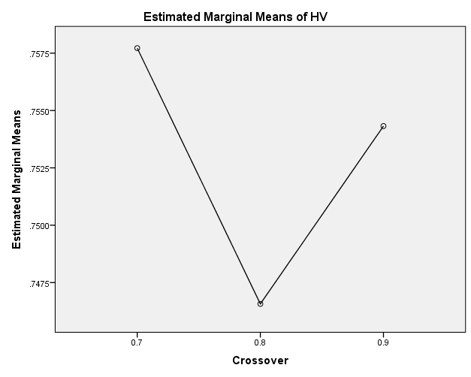

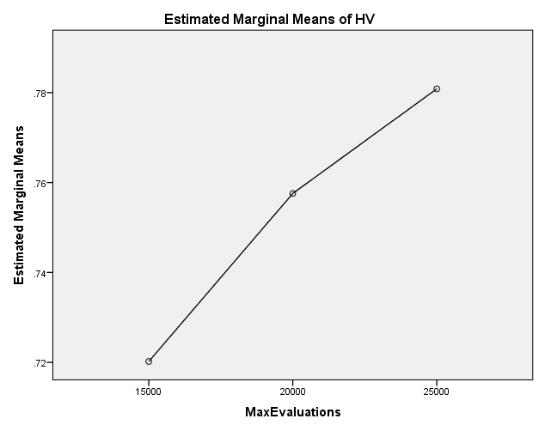

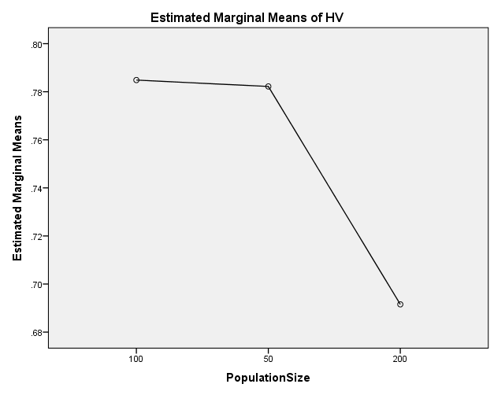

**EP**

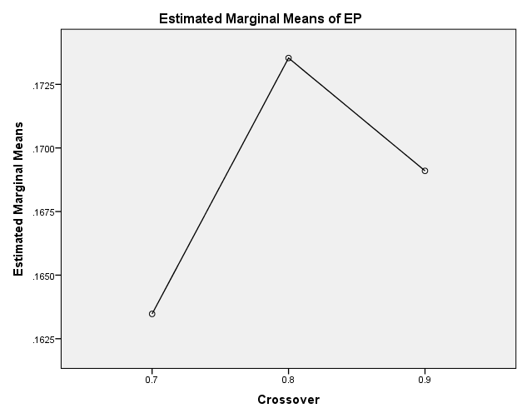

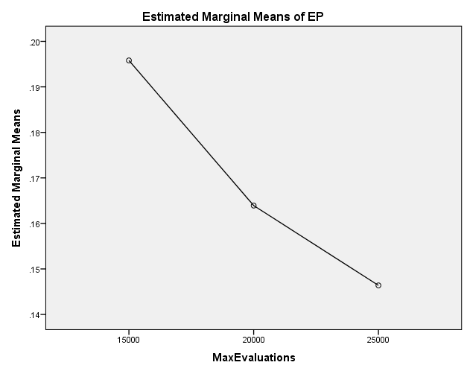

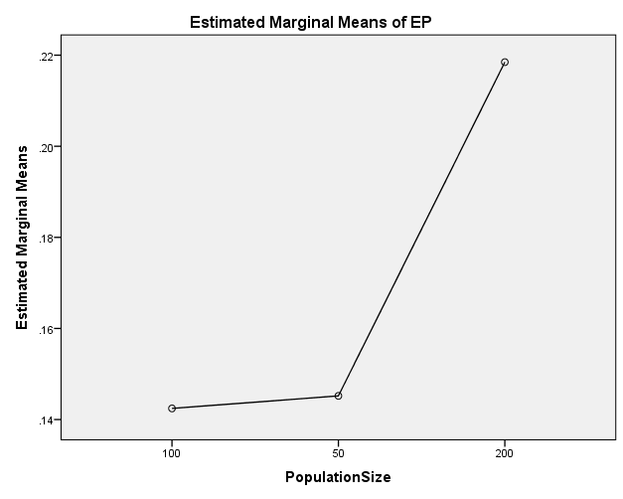

**GD**

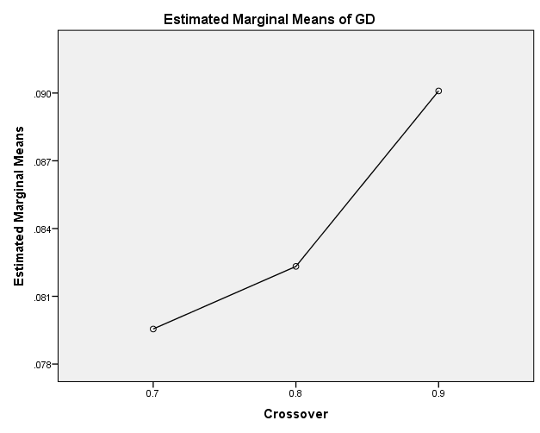

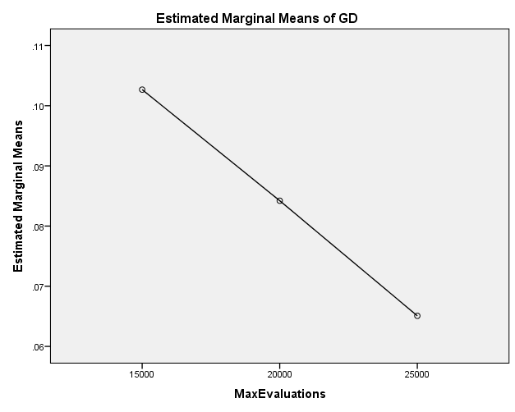

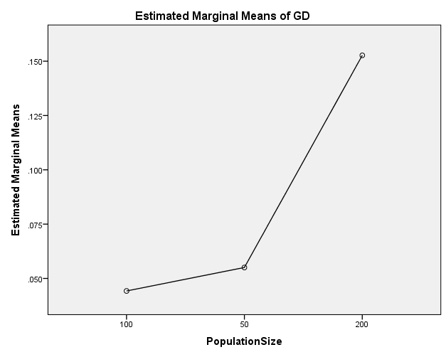

**IGD**

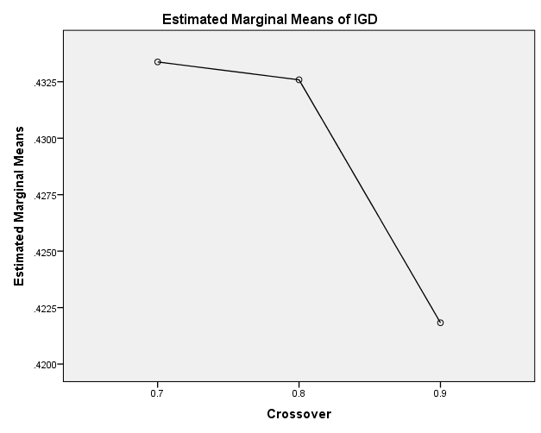

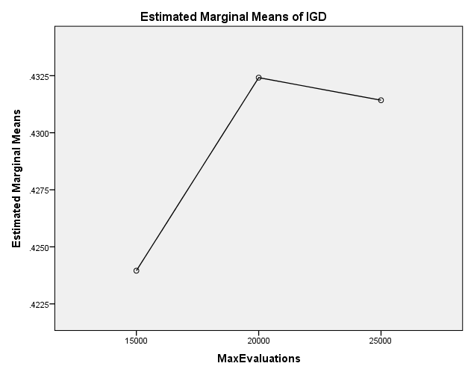

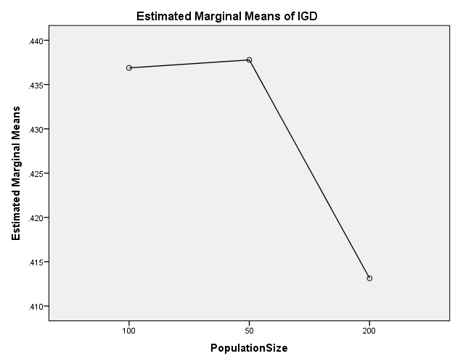

**IGDplus**

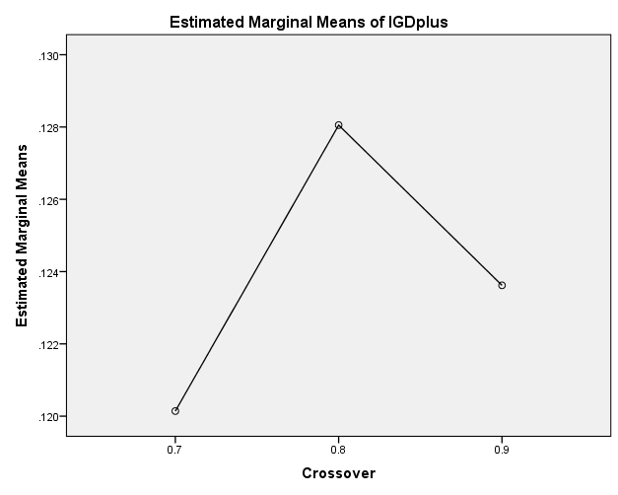

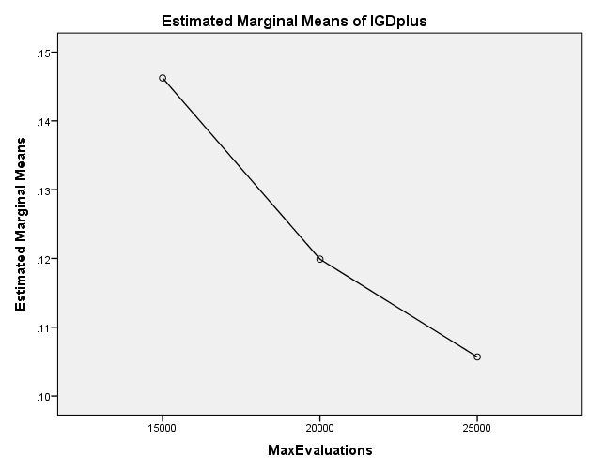

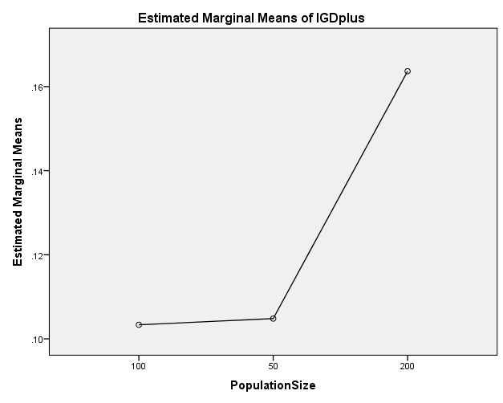

**SPREAD**

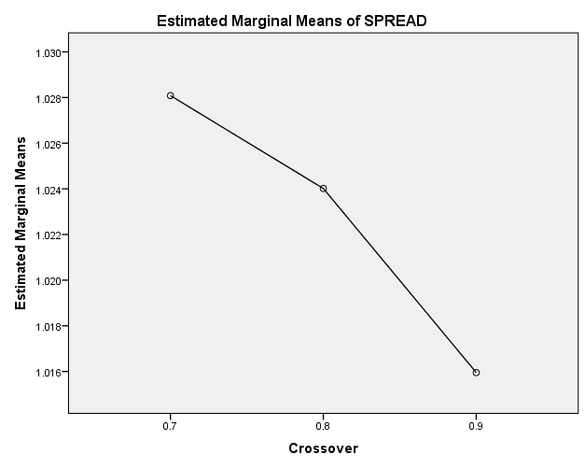

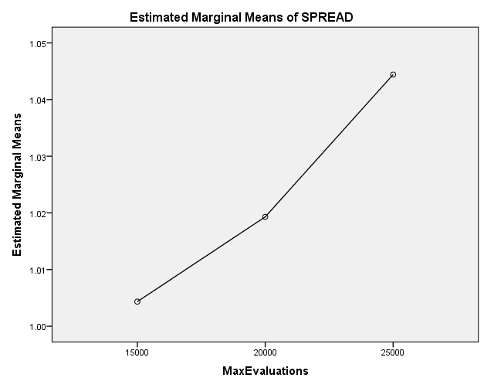

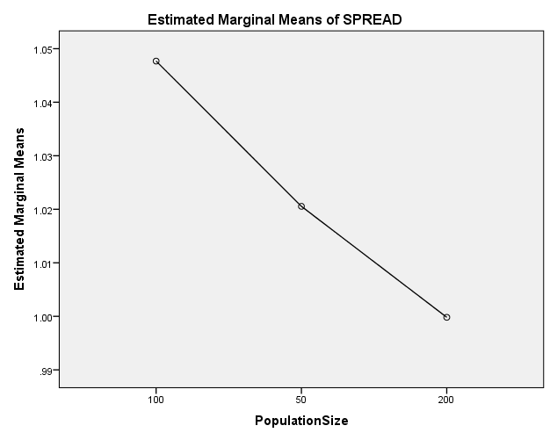

EXAMINE VARIABLES=HV EP GD IGD IGDplus SPREAD BY Crossover MaxEvaluations PopulationSize

/PLOT BOXPLOT

/COMPARE VARIABLES

/STATISTICS NONE

/CINTERVAL 95

/MISSING LISTWISE

/NOTOTAL.

**Explore**

|  |  |  |
| --- | --- | --- |
| **Notes** | | |
| Output Created | | 26-MAY-2020 20:15:07 |
| Comments | |  |
| Input | Data | C:\Users\user\Documents\NILAY\Mayis2020\medium_NSGAII.sav |
| Active Dataset | DataSet1 |
| Filter | <none> |
| Weight | <none> |
| Split File | <none> |
| N of Rows in Working Data File | 837 |
| Missing Value Handling | Definition of Missing | User-defined missing values for dependent variables are treated as missing. |
| Cases Used | Statistics are based on cases with no missing values for any dependent variable or factor used. |
| Syntax | | EXAMINE VARIABLES=HV EP GD IGD IGDplus SPREAD BY Crossover MaxEvaluations PopulationSize  /PLOT BOXPLOT  /COMPARE VARIABLES  /STATISTICS NONE  /CINTERVAL 95  /MISSING LISTWISE  /NOTOTAL. |
| Resources | Processor Time | 00:00:01.78 |
| Elapsed Time | 00:00:01.81 |

[DataSet1] C:\Users\user\Documents\NILAY\Mayis2020\medium_NSGAII.sav

**Crossover**

|  |  |  |  |  |  |  |  |
| --- | --- | --- | --- | --- | --- | --- | --- |
| **Case Processing Summary** | | | | | | | |
|  | Crossover | Cases | | | | | |
| Valid | | Missing | | Total | |
| N | Percent | N | Percent | N | Percent |
| HV | 0.7 | 279 | 100.0% | 0 | 0.0% | 279 | 100.0% |
| 0.8 | 279 | 100.0% | 0 | 0.0% | 279 | 100.0% |
| 0.9 | 279 | 100.0% | 0 | 0.0% | 279 | 100.0% |
| EP | 0.7 | 279 | 100.0% | 0 | 0.0% | 279 | 100.0% |
| 0.8 | 279 | 100.0% | 0 | 0.0% | 279 | 100.0% |
| 0.9 | 279 | 100.0% | 0 | 0.0% | 279 | 100.0% |
| GD | 0.7 | 279 | 100.0% | 0 | 0.0% | 279 | 100.0% |
| 0.8 | 279 | 100.0% | 0 | 0.0% | 279 | 100.0% |
| 0.9 | 279 | 100.0% | 0 | 0.0% | 279 | 100.0% |
| IGD | 0.7 | 279 | 100.0% | 0 | 0.0% | 279 | 100.0% |
| 0.8 | 279 | 100.0% | 0 | 0.0% | 279 | 100.0% |
| 0.9 | 279 | 100.0% | 0 | 0.0% | 279 | 100.0% |
| IGDplus | 0.7 | 279 | 100.0% | 0 | 0.0% | 279 | 100.0% |
| 0.8 | 279 | 100.0% | 0 | 0.0% | 279 | 100.0% |
| 0.9 | 279 | 100.0% | 0 | 0.0% | 279 | 100.0% |
| SPREAD | 0.7 | 279 | 100.0% | 0 | 0.0% | 279 | 100.0% |
| 0.8 | 279 | 100.0% | 0 | 0.0% | 279 | 100.0% |
| 0.9 | 279 | 100.0% | 0 | 0.0% | 279 | 100.0% |

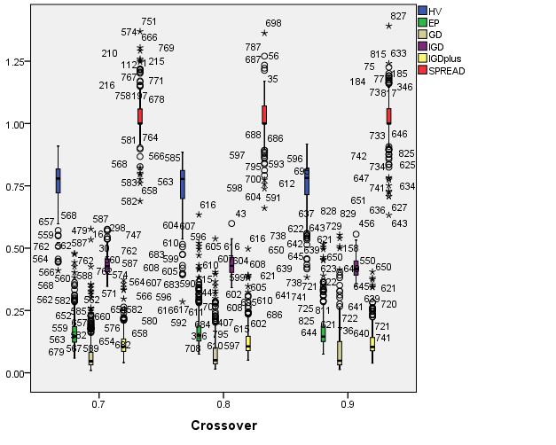

**MaxEvaluations**

|  |  |  |  |  |  |  |  |
| --- | --- | --- | --- | --- | --- | --- | --- |
| **Case Processing Summary** | | | | | | | |
|  | MaxEvaluations | Cases | | | | | |
| Valid | | Missing | | Total | |
| N | Percent | N | Percent | N | Percent |
| HV | 15000 | 279 | 100.0% | 0 | 0.0% | 279 | 100.0% |
| 20000 | 279 | 100.0% | 0 | 0.0% | 279 | 100.0% |
| 25000 | 279 | 100.0% | 0 | 0.0% | 279 | 100.0% |
| EP | 15000 | 279 | 100.0% | 0 | 0.0% | 279 | 100.0% |
| 20000 | 279 | 100.0% | 0 | 0.0% | 279 | 100.0% |
| 25000 | 279 | 100.0% | 0 | 0.0% | 279 | 100.0% |
| GD | 15000 | 279 | 100.0% | 0 | 0.0% | 279 | 100.0% |
| 20000 | 279 | 100.0% | 0 | 0.0% | 279 | 100.0% |
| 25000 | 279 | 100.0% | 0 | 0.0% | 279 | 100.0% |
| IGD | 15000 | 279 | 100.0% | 0 | 0.0% | 279 | 100.0% |
| 20000 | 279 | 100.0% | 0 | 0.0% | 279 | 100.0% |
| 25000 | 279 | 100.0% | 0 | 0.0% | 279 | 100.0% |
| IGDplus | 15000 | 279 | 100.0% | 0 | 0.0% | 279 | 100.0% |
| 20000 | 279 | 100.0% | 0 | 0.0% | 279 | 100.0% |
| 25000 | 279 | 100.0% | 0 | 0.0% | 279 | 100.0% |
| SPREAD | 15000 | 279 | 100.0% | 0 | 0.0% | 279 | 100.0% |
| 20000 | 279 | 100.0% | 0 | 0.0% | 279 | 100.0% |
| 25000 | 279 | 100.0% | 0 | 0.0% | 279 | 100.0% |

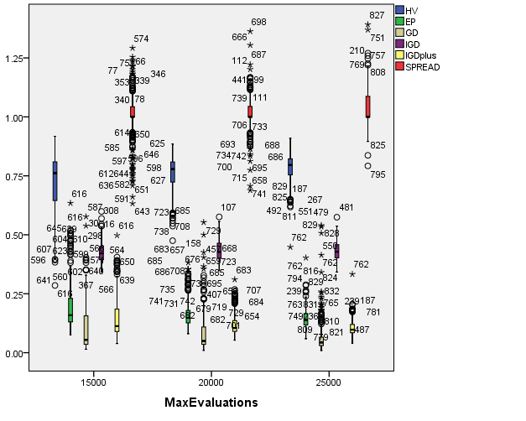

**PopulationSize**

|  |  |  |  |  |  |  |  |
| --- | --- | --- | --- | --- | --- | --- | --- |
| **Case Processing Summary** | | | | | | | |
|  | PopulationSize | Cases | | | | | |
| Valid | | Missing | | Total | |
| N | Percent | N | Percent | N | Percent |
| HV | 100 | 279 | 100.0% | 0 | 0.0% | 279 | 100.0% |
| 50 | 279 | 100.0% | 0 | 0.0% | 279 | 100.0% |
| 200 | 279 | 100.0% | 0 | 0.0% | 279 | 100.0% |
| EP | 100 | 279 | 100.0% | 0 | 0.0% | 279 | 100.0% |
| 50 | 279 | 100.0% | 0 | 0.0% | 279 | 100.0% |
| 200 | 279 | 100.0% | 0 | 0.0% | 279 | 100.0% |
| GD | 100 | 279 | 100.0% | 0 | 0.0% | 279 | 100.0% |
| 50 | 279 | 100.0% | 0 | 0.0% | 279 | 100.0% |
| 200 | 279 | 100.0% | 0 | 0.0% | 279 | 100.0% |
| IGD | 100 | 279 | 100.0% | 0 | 0.0% | 279 | 100.0% |
| 50 | 279 | 100.0% | 0 | 0.0% | 279 | 100.0% |
| 200 | 279 | 100.0% | 0 | 0.0% | 279 | 100.0% |
| IGDplus | 100 | 279 | 100.0% | 0 | 0.0% | 279 | 100.0% |
| 50 | 279 | 100.0% | 0 | 0.0% | 279 | 100.0% |
| 200 | 279 | 100.0% | 0 | 0.0% | 279 | 100.0% |
| SPREAD | 100 | 279 | 100.0% | 0 | 0.0% | 279 | 100.0% |
| 50 | 279 | 100.0% | 0 | 0.0% | 279 | 100.0% |
| 200 | 279 | 100.0% | 0 | 0.0% | 279 | 100.0% |

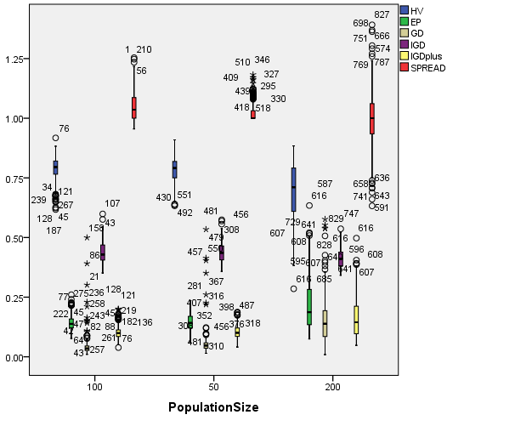

EXAMINE VARIABLES=HV EP GD IGD IGDplus SPREAD BY Crossover MaxEvaluations PopulationSize

/PLOT BOXPLOT

/COMPARE GROUPS

/STATISTICS NONE

/CINTERVAL 95

/MISSING LISTWISE

/NOTOTAL.

**Explore**

|  |  |  |
| --- | --- | --- |
| **Notes** | | |
| Output Created | | 26-MAY-2020 20:15:31 |
| Comments | |  |
| Input | Data | C:\Users\user\Documents\NILAY\Mayis2020\medium_NSGAII.sav |
| Active Dataset | DataSet1 |
| Filter | <none> |
| Weight | <none> |
| Split File | <none> |
| N of Rows in Working Data File | 837 |
| Missing Value Handling | Definition of Missing | User-defined missing values for dependent variables are treated as missing. |
| Cases Used | Statistics are based on cases with no missing values for any dependent variable or factor used. |
| Syntax | | EXAMINE VARIABLES=HV EP GD IGD IGDplus SPREAD BY Crossover MaxEvaluations PopulationSize  /PLOT BOXPLOT  /COMPARE GROUPS  /STATISTICS NONE  /CINTERVAL 95  /MISSING LISTWISE  /NOTOTAL. |
| Resources | Processor Time | 00:00:04.14 |
| Elapsed Time | 00:00:04.11 |

[DataSet1] C:\Users\user\Documents\NILAY\Mayis2020\medium_NSGAII.sav

**Crossover**

|  |  |  |  |  |  |  |  |
| --- | --- | --- | --- | --- | --- | --- | --- |
| **Case Processing Summary** | | | | | | | |
|  | Crossover | Cases | | | | | |
| Valid | | Missing | | Total | |
| N | Percent | N | Percent | N | Percent |
| HV | 0.7 | 279 | 100.0% | 0 | 0.0% | 279 | 100.0% |
| 0.8 | 279 | 100.0% | 0 | 0.0% | 279 | 100.0% |
| 0.9 | 279 | 100.0% | 0 | 0.0% | 279 | 100.0% |
| EP | 0.7 | 279 | 100.0% | 0 | 0.0% | 279 | 100.0% |
| 0.8 | 279 | 100.0% | 0 | 0.0% | 279 | 100.0% |
| 0.9 | 279 | 100.0% | 0 | 0.0% | 279 | 100.0% |
| GD | 0.7 | 279 | 100.0% | 0 | 0.0% | 279 | 100.0% |
| 0.8 | 279 | 100.0% | 0 | 0.0% | 279 | 100.0% |
| 0.9 | 279 | 100.0% | 0 | 0.0% | 279 | 100.0% |
| IGD | 0.7 | 279 | 100.0% | 0 | 0.0% | 279 | 100.0% |
| 0.8 | 279 | 100.0% | 0 | 0.0% | 279 | 100.0% |
| 0.9 | 279 | 100.0% | 0 | 0.0% | 279 | 100.0% |
| IGDplus | 0.7 | 279 | 100.0% | 0 | 0.0% | 279 | 100.0% |
| 0.8 | 279 | 100.0% | 0 | 0.0% | 279 | 100.0% |
| 0.9 | 279 | 100.0% | 0 | 0.0% | 279 | 100.0% |
| SPREAD | 0.7 | 279 | 100.0% | 0 | 0.0% | 279 | 100.0% |
| 0.8 | 279 | 100.0% | 0 | 0.0% | 279 | 100.0% |
| 0.9 | 279 | 100.0% | 0 | 0.0% | 279 | 100.0% |

**HV**

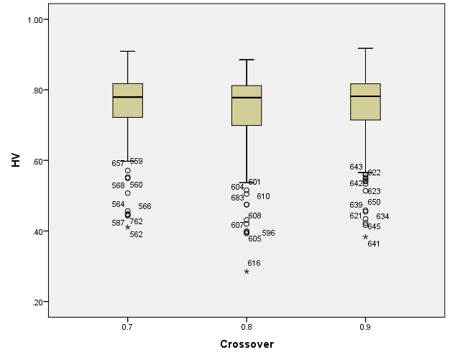

**EP**

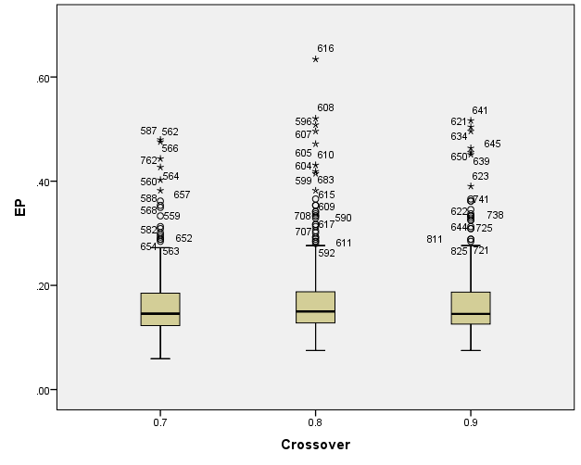

**GD**

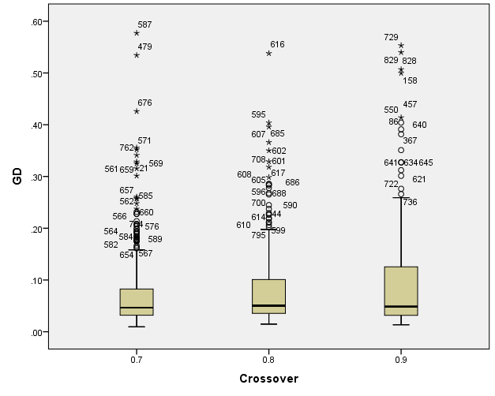

**IGD**

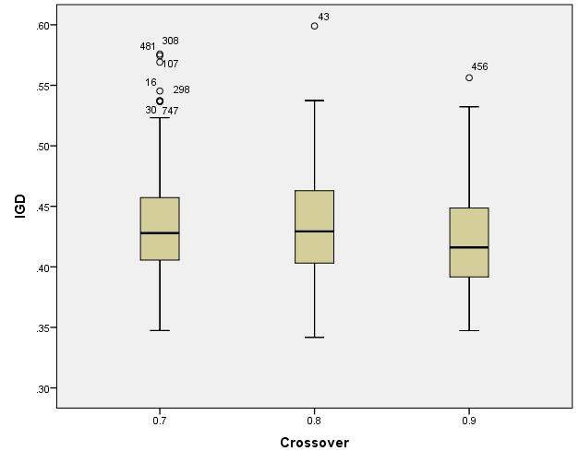

**IGDplus**

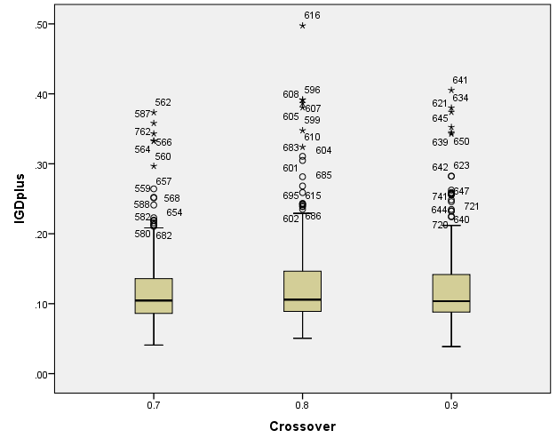

**SPREAD**

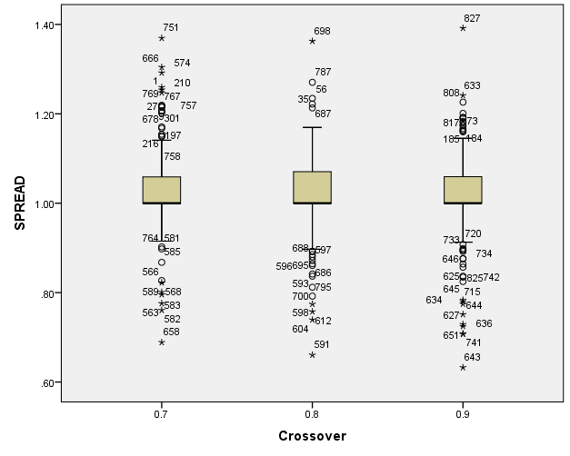

**MaxEvaluations**

|  |  |  |  |  |  |  |  |
| --- | --- | --- | --- | --- | --- | --- | --- |
| **Case Processing Summary** | | | | | | | |
|  | MaxEvaluations | Cases | | | | | |
| Valid | | Missing | | Total | |
| N | Percent | N | Percent | N | Percent |
| HV | 15000 | 279 | 100.0% | 0 | 0.0% | 279 | 100.0% |
| 20000 | 279 | 100.0% | 0 | 0.0% | 279 | 100.0% |
| 25000 | 279 | 100.0% | 0 | 0.0% | 279 | 100.0% |
| EP | 15000 | 279 | 100.0% | 0 | 0.0% | 279 | 100.0% |
| 20000 | 279 | 100.0% | 0 | 0.0% | 279 | 100.0% |
| 25000 | 279 | 100.0% | 0 | 0.0% | 279 | 100.0% |
| GD | 15000 | 279 | 100.0% | 0 | 0.0% | 279 | 100.0% |
| 20000 | 279 | 100.0% | 0 | 0.0% | 279 | 100.0% |
| 25000 | 279 | 100.0% | 0 | 0.0% | 279 | 100.0% |
| IGD | 15000 | 279 | 100.0% | 0 | 0.0% | 279 | 100.0% |
| 20000 | 279 | 100.0% | 0 | 0.0% | 279 | 100.0% |
| 25000 | 279 | 100.0% | 0 | 0.0% | 279 | 100.0% |
| IGDplus | 15000 | 279 | 100.0% | 0 | 0.0% | 279 | 100.0% |
| 20000 | 279 | 100.0% | 0 | 0.0% | 279 | 100.0% |
| 25000 | 279 | 100.0% | 0 | 0.0% | 279 | 100.0% |
| SPREAD | 15000 | 279 | 100.0% | 0 | 0.0% | 279 | 100.0% |
| 20000 | 279 | 100.0% | 0 | 0.0% | 279 | 100.0% |
| 25000 | 279 | 100.0% | 0 | 0.0% | 279 | 100.0% |

**HV**

**Boxplots**

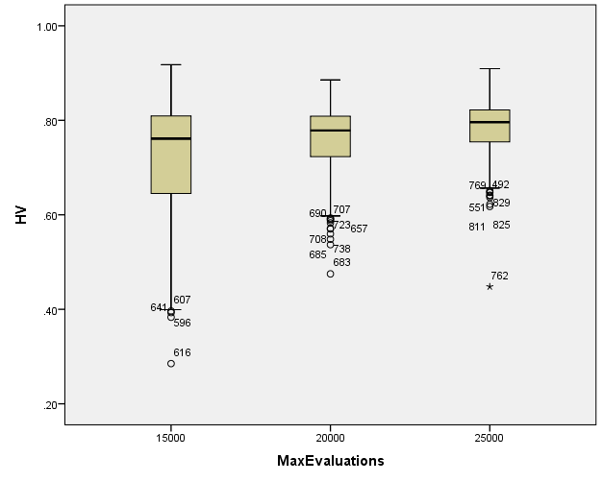

**EP**

**Boxplots**

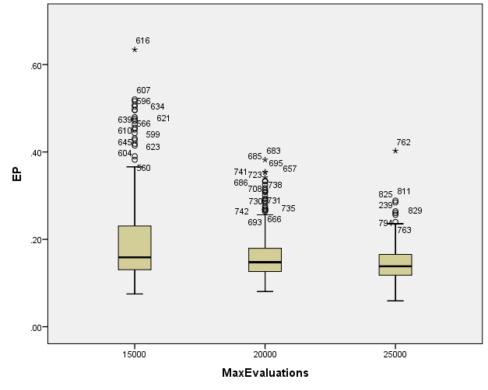

**GD**

**Boxplots**

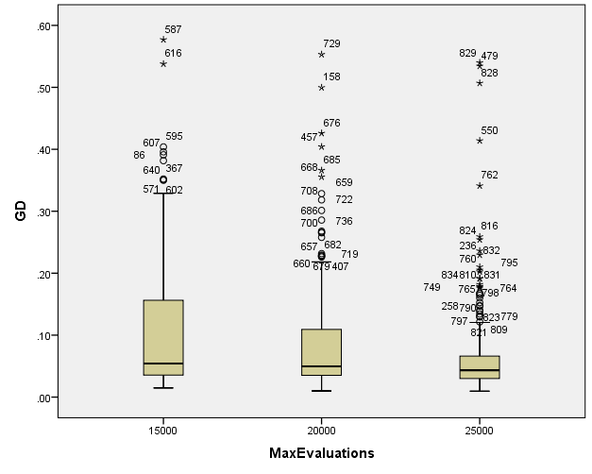

**IGD**

**Boxplots**

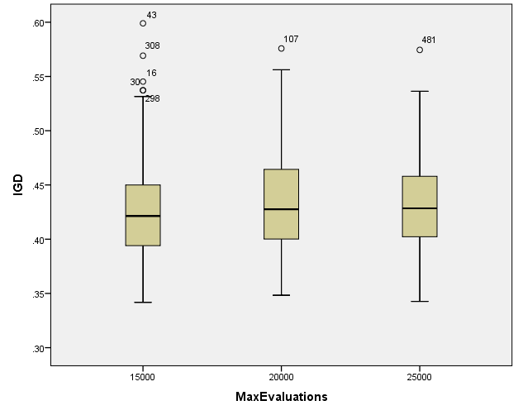

**IGDplus**

**Boxplots**

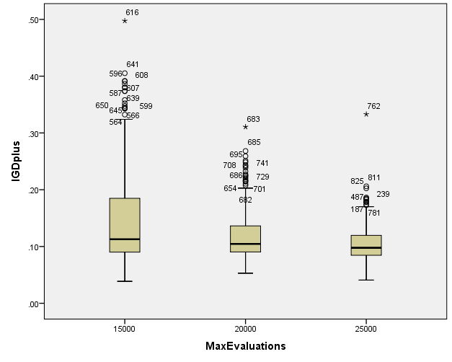

**SPREAD**

**Boxplots**

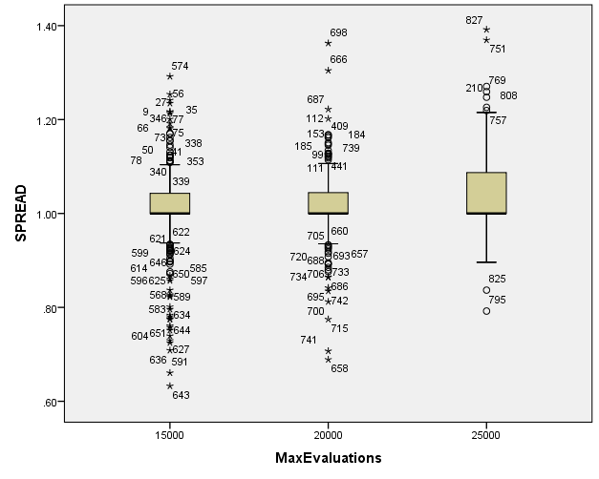

**PopulationSize**

|  |  |  |  |  |  |  |  |
| --- | --- | --- | --- | --- | --- | --- | --- |
| **Case Processing Summary** | | | | | | | |
|  | PopulationSize | Cases | | | | | |
| Valid | | Missing | | Total | |
| N | Percent | N | Percent | N | Percent |
| HV | 100 | 279 | 100.0% | 0 | 0.0% | 279 | 100.0% |
| 50 | 279 | 100.0% | 0 | 0.0% | 279 | 100.0% |
| 200 | 279 | 100.0% | 0 | 0.0% | 279 | 100.0% |
| EP | 100 | 279 | 100.0% | 0 | 0.0% | 279 | 100.0% |
| 50 | 279 | 100.0% | 0 | 0.0% | 279 | 100.0% |
| 200 | 279 | 100.0% | 0 | 0.0% | 279 | 100.0% |
| GD | 100 | 279 | 100.0% | 0 | 0.0% | 279 | 100.0% |
| 50 | 279 | 100.0% | 0 | 0.0% | 279 | 100.0% |
| 200 | 279 | 100.0% | 0 | 0.0% | 279 | 100.0% |
| IGD | 100 | 279 | 100.0% | 0 | 0.0% | 279 | 100.0% |
| 50 | 279 | 100.0% | 0 | 0.0% | 279 | 100.0% |
| 200 | 279 | 100.0% | 0 | 0.0% | 279 | 100.0% |
| IGDplus | 100 | 279 | 100.0% | 0 | 0.0% | 279 | 100.0% |
| 50 | 279 | 100.0% | 0 | 0.0% | 279 | 100.0% |
| 200 | 279 | 100.0% | 0 | 0.0% | 279 | 100.0% |
| SPREAD | 100 | 279 | 100.0% | 0 | 0.0% | 279 | 100.0% |
| 50 | 279 | 100.0% | 0 | 0.0% | 279 | 100.0% |
| 200 | 279 | 100.0% | 0 | 0.0% | 279 | 100.0% |

**HV**

**Boxplots**

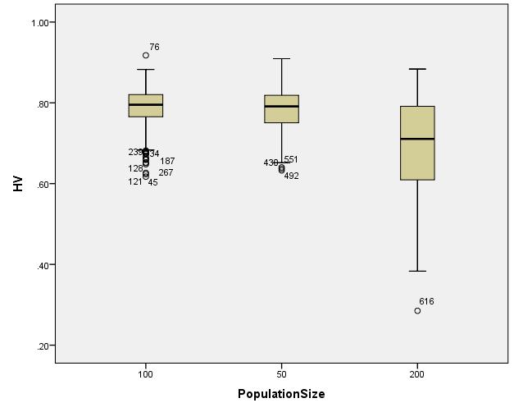

**EP**

**Boxplots**

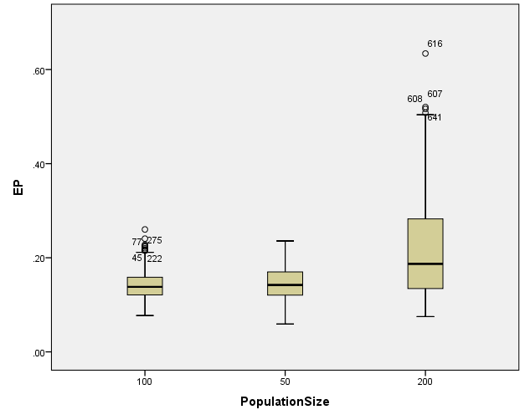

**GD**

**Boxplots**

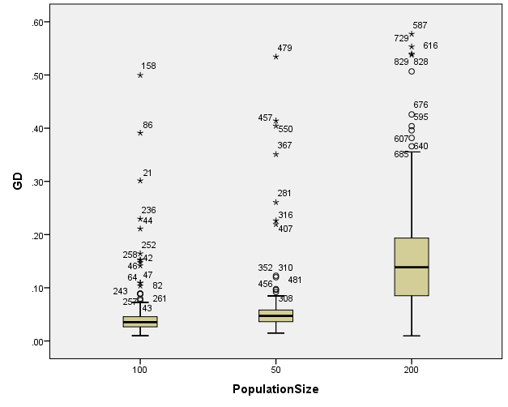

**IGD**

**Boxplots**

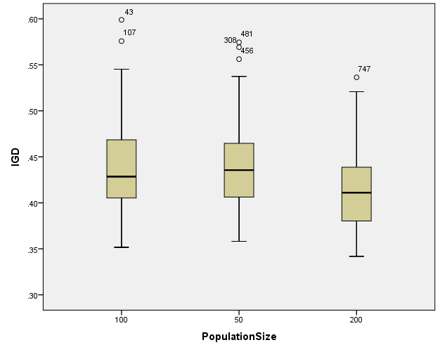

**IGDplus**

**Boxplots**

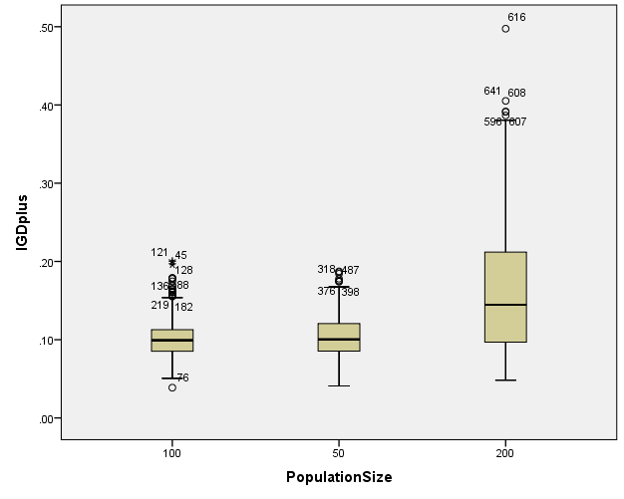

**SPREAD**

**Boxplots**

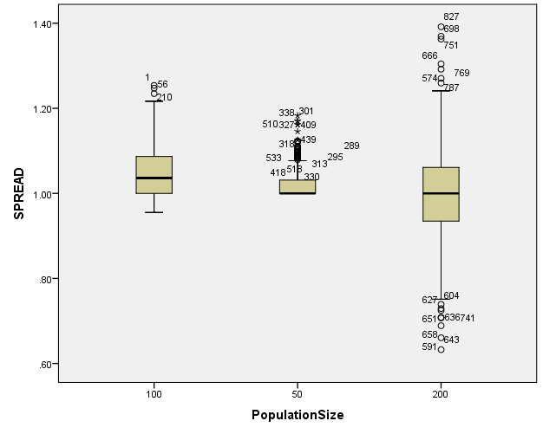

*Nonparametric Tests: Independent Samples.

NPTESTS

/INDEPENDENT TEST (HV EP GD IGD IGDplus SPREAD) GROUP (Crossover) MEDIAN(TESTVALUE=SAMPLE COMPARE=PAIRWISE)

/MISSING SCOPE=ANALYSIS USERMISSING=EXCLUDE

/CRITERIA ALPHA=0.05 CILEVEL=95.

**Nonparametric Tests**

|  |  |  |
| --- | --- | --- |
| **Notes** | | |
| Output Created | | 26-MAY-2020 20:15:56 |
| Comments | |  |
| Input | Data | C:\Users\user\Documents\NILAY\Mayis2020\medium_NSGAII.sav |
| Active Dataset | DataSet1 |
| Filter | <none> |
| Weight | <none> |
| Split File | <none> |
| N of Rows in Working Data File | 837 |
| Syntax | | NPTESTS  /INDEPENDENT TEST (HV EP GD IGD IGDplus SPREAD) GROUP (Crossover) MEDIAN(TESTVALUE=SAMPLE COMPARE=PAIRWISE)  /MISSING SCOPE=ANALYSIS USERMISSING=EXCLUDE  /CRITERIA ALPHA=0.05 CILEVEL=95. |
| Resources | Processor Time | 00:00:00.17 |
| Elapsed Time | 00:00:00.27 |

[DataSet1] C:\Users\user\Documents\NILAY\Mayis2020\medium_NSGAII.sav

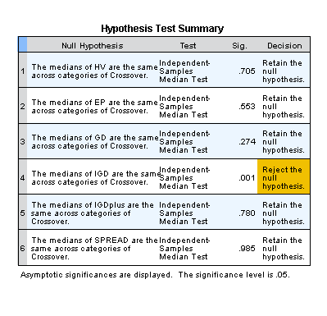

*Nonparametric Tests: Independent Samples.

NPTESTS

/INDEPENDENT TEST (HV EP GD IGD IGDplus SPREAD) GROUP (MaxEvaluations) MEDIAN(TESTVALUE=SAMPLE COMPARE=PAIRWISE)

/MISSING SCOPE=ANALYSIS USERMISSING=EXCLUDE

/CRITERIA ALPHA=0.05 CILEVEL=95.

**Nonparametric Tests**

|  |  |  |
| --- | --- | --- |
| **Notes** | | |
| Output Created | | 26-MAY-2020 20:16:09 |
| Comments | |  |
| Input | Data | C:\Users\user\Documents\NILAY\Mayis2020\medium_NSGAII.sav |
| Active Dataset | DataSet1 |
| Filter | <none> |
| Weight | <none> |
| Split File | <none> |
| N of Rows in Working Data File | 837 |
| Syntax | | NPTESTS  /INDEPENDENT TEST (HV EP GD IGD IGDplus SPREAD) GROUP (MaxEvaluations) MEDIAN(TESTVALUE=SAMPLE COMPARE=PAIRWISE)  /MISSING SCOPE=ANALYSIS USERMISSING=EXCLUDE  /CRITERIA ALPHA=0.05 CILEVEL=95. |
| Resources | Processor Time | 00:00:00.16 |
| Elapsed Time | 00:00:00.16 |

[DataSet1] C:\Users\user\Documents\NILAY\Mayis2020\medium_NSGAII.sav

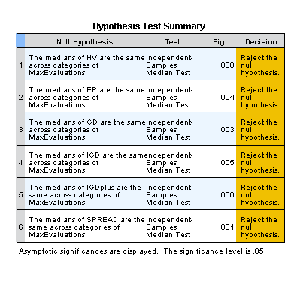

*Nonparametric Tests: Independent Samples.

NPTESTS

/INDEPENDENT TEST (HV EP GD IGD IGDplus SPREAD) GROUP (PopulationSize) MEDIAN(TESTVALUE=SAMPLE COMPARE=PAIRWISE)

/MISSING SCOPE=ANALYSIS USERMISSING=EXCLUDE

/CRITERIA ALPHA=0.05 CILEVEL=95.

**Nonparametric Tests**

|  |  |  |
| --- | --- | --- |
| **Notes** | | |
| Output Created | | 26-MAY-2020 20:16:30 |
| Comments | |  |
| Input | Data | C:\Users\user\Documents\NILAY\Mayis2020\medium_NSGAII.sav |
| Active Dataset | DataSet1 |
| Filter | <none> |
| Weight | <none> |
| Split File | <none> |
| N of Rows in Working Data File | 837 |
| Syntax | | NPTESTS  /INDEPENDENT TEST (HV EP GD IGD IGDplus SPREAD) GROUP (PopulationSize) MEDIAN(TESTVALUE=SAMPLE COMPARE=PAIRWISE)  /MISSING SCOPE=ANALYSIS USERMISSING=EXCLUDE  /CRITERIA ALPHA=0.05 CILEVEL=95. |
| Resources | Processor Time | 00:00:00.14 |
| Elapsed Time | 00:00:00.16 |

[DataSet1] C:\Users\user\Documents\NILAY\Mayis2020\medium_NSGAII.sav

