GET

FILE='C:\Users\user\Documents\NILAY\Mayis2020\medium_SPEA2.sav'.

DATASET NAME DataSet1 WINDOW=FRONT.

GLM HV EP GD IGD IGDplus SPREAD BY Crossover MaxEvaluations PopulationSize

/METHOD=SSTYPE(3)

/INTERCEPT=INCLUDE

/POSTHOC=Crossover MaxEvaluations PopulationSize(BONFERRONI)

/PLOT=PROFILE(Crossover MaxEvaluations PopulationSize)

/CRITERIA=ALPHA(.05)

/DESIGN=Crossover MaxEvaluations PopulationSize.

**General Linear Model**

|  |  |  |
| --- | --- | --- |
| **Notes** | | |
| Output Created | | 26-MAY-2020 20:30:52 |
| Comments | |  |
| Input | Data | C:\Users\user\Documents\NILAY\Mayis2020\medium_SPEA2.sav |
| Active Dataset | DataSet1 |
| Filter | <none> |
| Weight | <none> |
| Split File | <none> |
| N of Rows in Working Data File | 837 |
| Missing Value Handling | Definition of Missing | User-defined missing values are treated as missing. |
| Cases Used | Statistics are based on all cases with valid data for all variables in the model. |
| Syntax | | GLM HV EP GD IGD IGDplus SPREAD BY Crossover MaxEvaluations PopulationSize  /METHOD=SSTYPE(3)  /INTERCEPT=INCLUDE  /POSTHOC=Crossover MaxEvaluations PopulationSize(BONFERRONI)  /PLOT=PROFILE(Crossover MaxEvaluations PopulationSize)  /CRITERIA=ALPHA(.05)  /DESIGN=Crossover MaxEvaluations PopulationSize. |
| Resources | Processor Time | 00:00:06.76 |
| Elapsed Time | 00:00:04.78 |

[DataSet1] C:\Users\user\Documents\NILAY\Mayis2020\medium_SPEA2.sav

|  |  |  |  |
| --- | --- | --- | --- |
| **Between-Subjects Factors** | | | |
|  | | Value Label | N |
| Crossover | 1 | 0.7 | 279 |
| 2 | 0.8 | 279 |
| 3 | 0.9 | 279 |
| MaxEvaluations | 1 | 15000 | 279 |
| 2 | 20000 | 279 |
| 3 | 25000 | 279 |
| PopulationSize | 1 | 100 | 279 |
| 2 | 50 | 279 |
| 3 | 200 | 279 |

|  |  |  |  |  |  |
| --- | --- | --- | --- | --- | --- |
| **Multivariate Testsa** | | | | | |
| Effect | | Value | F | Hypothesis df | Error df |
| Intercept | Pillai's Trace | 1.000 | 479544.148b | 6.000 | 825.000 |
| Wilks' Lambda | .000 | 479544.148b | 6.000 | 825.000 |
| Hotelling's Trace | 3487.594 | 479544.148b | 6.000 | 825.000 |
| Roy's Largest Root | 3487.594 | 479544.148b | 6.000 | 825.000 |
| Crossover | Pillai's Trace | .140 | 10.327 | 12.000 | 1652.000 |
| Wilks' Lambda | .862 | 10.605b | 12.000 | 1650.000 |
| Hotelling's Trace | .158 | 10.883 | 12.000 | 1648.000 |
| Roy's Largest Root | .147 | 20.213c | 6.000 | 826.000 |
| MaxEvaluations | Pillai's Trace | .220 | 17.035 | 12.000 | 1652.000 |
| Wilks' Lambda | .792 | 17.052b | 12.000 | 1650.000 |
| Hotelling's Trace | .249 | 17.069 | 12.000 | 1648.000 |
| Roy's Largest Root | .149 | 20.521c | 6.000 | 826.000 |
| PopulationSize | Pillai's Trace | 1.014 | 141.706 | 12.000 | 1652.000 |
| Wilks' Lambda | .194 | 174.919b | 12.000 | 1650.000 |
| Hotelling's Trace | 3.088 | 212.041 | 12.000 | 1648.000 |
| Roy's Largest Root | 2.688 | 370.078c | 6.000 | 826.000 |

|  |  |  |
| --- | --- | --- |
| **Multivariate Testsa** | | |
| Effect | | Sig. |
| Intercept | Pillai's Trace | .000 |
| Wilks' Lambda | .000 |
| Hotelling's Trace | .000 |
| Roy's Largest Root | .000 |
| Crossover | Pillai's Trace | .000 |
| Wilks' Lambda | .000 |
| Hotelling's Trace | .000 |
| Roy's Largest Root | .000 |
| MaxEvaluations | Pillai's Trace | .000 |
| Wilks' Lambda | .000 |
| Hotelling's Trace | .000 |
| Roy's Largest Root | .000 |
| PopulationSize | Pillai's Trace | .000 |
| Wilks' Lambda | .000 |
| Hotelling's Trace | .000 |
| Roy's Largest Root | .000 |

|  |
| --- |
| a. Design: Intercept + Crossover + MaxEvaluations + PopulationSize |
| b. Exact statistic |
| c. The statistic is an upper bound on F that yields a lower bound on the significance level. |

|  |  |  |  |  |  |
| --- | --- | --- | --- | --- | --- |
| **Tests of Between-Subjects Effects** | | | | | |
| Source | Dependent Variable | Type III Sum of Squares | df | Mean Square | F |
| Corrected Model | HV | 4.341a | 6 | .724 | 110.558 |
| EP | 6.588b | 6 | 1.098 | 39.335 |
| GD | .053c | 6 | .009 | 54.508 |
| IGD | .444d | 6 | .074 | 41.644 |
| IGDplus | 1.893e | 6 | .315 | 112.980 |
| SPREAD | 12.402f | 6 | 2.067 | 150.972 |
| Intercept | HV | 445.629 | 1 | 445.629 | 68093.972 |
| EP | 40.555 | 1 | 40.555 | 1452.712 |
| GD | 1.393 | 1 | 1.393 | 8523.125 |
| IGD | 147.743 | 1 | 147.743 | 83204.196 |
| IGDplus | 16.179 | 1 | 16.179 | 5795.200 |
| SPREAD | 1149.580 | 1 | 1149.580 | 83965.891 |
| Crossover | HV | .050 | 2 | .025 | 3.815 |
| EP | 2.079 | 2 | 1.040 | 37.237 |
| GD | 1.193E-005 | 2 | 5.967E-006 | .037 |
| IGD | .002 | 2 | .001 | .465 |
| IGDplus | .017 | 2 | .008 | 3.003 |
| SPREAD | .288 | 2 | .144 | 10.506 |
| MaxEvaluations | HV | .472 | 2 | .236 | 36.092 |
| EP | 2.222 | 2 | 1.111 | 39.800 |
| GD | .000 | 2 | .000 | 1.299 |
| IGD | .025 | 2 | .013 | 7.176 |
| IGDplus | .244 | 2 | .122 | 43.708 |
| SPREAD | .086 | 2 | .043 | 3.133 |
| PopulationSize | HV | 3.819 | 2 | 1.909 | 291.767 |
| EP | 2.287 | 2 | 1.144 | 40.967 |
| GD | .053 | 2 | .027 | 162.189 |
| IGD | .417 | 2 | .208 | 117.290 |
| IGDplus | 1.632 | 2 | .816 | 292.230 |
| SPREAD | 12.028 | 2 | 6.014 | 439.277 |
| Error | HV | 5.432 | 830 | .007 |  |
| EP | 23.171 | 830 | .028 |  |
| GD | .136 | 830 | .000 |  |
| IGD | 1.474 | 830 | .002 |  |
| IGDplus | 2.317 | 830 | .003 |  |

|  |  |  |
| --- | --- | --- |
| **Tests of Between-Subjects Effects** | | |
| Source | Dependent Variable | Sig. |
| Corrected Model | HV | .000a |
| EP | .000b |
| GD | .000c |
| IGD | .000d |
| IGDplus | .000e |
| SPREAD | .000f |
| Intercept | HV | .000 |
| EP | .000 |
| GD | .000 |
| IGD | .000 |
| IGDplus | .000 |
| SPREAD | .000 |
| Crossover | HV | .022 |
| EP | .000 |
| GD | .964 |
| IGD | .629 |
| IGDplus | .050 |
| SPREAD | .000 |
| MaxEvaluations | HV | .000 |
| EP | .000 |
| GD | .273 |
| IGD | .001 |
| IGDplus | .000 |
| SPREAD | .044 |
| PopulationSize | HV | .000 |
| EP | .000 |
| GD | .000 |
| IGD | .000 |
| IGDplus | .000 |
| SPREAD | .000 |
| Error | HV |  |
| EP |  |
| GD |  |
| IGD |  |
| IGDplus |  |

|  |  |  |  |  |  |
| --- | --- | --- | --- | --- | --- |
| **Tests of Between-Subjects Effects** | | | | | |
| Source | Dependent Variable | Type III Sum of Squares | df | Mean Square | F |
| Error | SPREAD | 11.364a | 830 | .014 |  |
| Total | HV | 455.401b | 837 |  |  |
| EP | 70.314c | 837 |  |  |
| GD | 1.582d | 837 |  |  |
| IGD | 149.660e | 837 |  |  |
| IGDplus | 20.389f | 837 |  |  |
| SPREAD | 1173.345 | 837 |  |  |
| Corrected Total | HV | 9.773 | 836 |  |  |
| EP | 29.759 | 836 |  |  |
| GD | .189 | 836 |  |  |
| IGD | 1.917 | 836 |  |  |
| IGDplus | 4.210 | 836 |  |  |
| SPREAD | 23.765 | 836 |  |  |

|  |  |  |
| --- | --- | --- |
| **Tests of Between-Subjects Effects** | | |
| Source | Dependent Variable | Sig. |
| Error | SPREAD |  |
| Total | HV |  |
| EP |  |
| GD |  |
| IGD |  |
| IGDplus |  |
| SPREAD |  |
| Corrected Total | HV |  |
| EP |  |
| GD |  |
| IGD |  |
| IGDplus |  |
| SPREAD |  |

|  |
| --- |
| a. R Squared = .444 (Adjusted R Squared = .440) |
| b. R Squared = .221 (Adjusted R Squared = .216) |
| c. R Squared = .283 (Adjusted R Squared = .277) |
| d. R Squared = .231 (Adjusted R Squared = .226) |
| e. R Squared = .450 (Adjusted R Squared = .446) |
| f. R Squared = .522 (Adjusted R Squared = .518) |

**Post Hoc Tests**

**Crossover**

|  |  |  |  |  |  |
| --- | --- | --- | --- | --- | --- |
| **Multiple Comparisons** | | | | | |
| Bonferroni | | | | | |
| Dependent Variable | (I) Crossover | (J) Crossover | Mean Difference (I-J) | Std. Error | Sig. |
|
| HV | 0.7 | 0.8 | -.0188* | .00685 | .019 |
| 0.9 | -.0075 | .00685 | .827 |
| 0.8 | 0.7 | .0188* | .00685 | .019 |
| 0.9 | .0113 | .00685 | .296 |
| 0.9 | 0.7 | .0075 | .00685 | .827 |
| 0.8 | -.0113 | .00685 | .296 |
| EP | 0.7 | 0.8 | .0104 | .01415 | 1.000 |
| 0.9 | -.1001* | .01415 | .000 |
| 0.8 | 0.7 | -.0104 | .01415 | 1.000 |
| 0.9 | -.1105* | .01415 | .000 |
| 0.9 | 0.7 | .1001* | .01415 | .000 |
| 0.8 | .1105* | .01415 | .000 |
| GD | 0.7 | 0.8 | .0001 | .00108 | 1.000 |
| 0.9 | -.0002 | .00108 | 1.000 |
| 0.8 | 0.7 | -.0001 | .00108 | 1.000 |
| 0.9 | -.0003 | .00108 | 1.000 |
| 0.9 | 0.7 | .0002 | .00108 | 1.000 |
| 0.8 | .0003 | .00108 | 1.000 |
| IGD | 0.7 | 0.8 | -.0008 | .00357 | 1.000 |
| 0.9 | .0025 | .00357 | 1.000 |
| 0.8 | 0.7 | .0008 | .00357 | 1.000 |
| 0.9 | .0033 | .00357 | 1.000 |
| 0.9 | 0.7 | -.0025 | .00357 | 1.000 |
| 0.8 | -.0033 | .00357 | 1.000 |
| IGDplus | 0.7 | 0.8 | .0109* | .00447 | .046 |
| 0.9 | .0042 | .00447 | 1.000 |
| 0.8 | 0.7 | -.0109* | .00447 | .046 |
| 0.9 | -.0066 | .00447 | .416 |
| 0.9 | 0.7 | -.0042 | .00447 | 1.000 |
| 0.8 | .0066 | .00447 | .416 |
| SPREAD | 0.7 | 0.8 | .0049 | .00991 | 1.000 |
| 0.9 | .0416* | .00991 | .000 |
| 0.8 | 0.7 | -.0049 | .00991 | 1.000 |

|  |  |  |  |  |
| --- | --- | --- | --- | --- |
| **Multiple Comparisons** | | | | |
| Bonferroni | | | | |
| Dependent Variable | (I) Crossover | (J) Crossover | 95% Confidence Interval | |
| Lower Bound | Upper Bound |
| HV | 0.7 | 0.8 | -.0352* | -.0024 |
| 0.9 | -.0239 | .0090 |
| 0.8 | 0.7 | .0024* | .0352 |
| 0.9 | -.0051 | .0277 |
| 0.9 | 0.7 | -.0090 | .0239 |
| 0.8 | -.0277 | .0051 |
| EP | 0.7 | 0.8 | -.0235 | .0443 |
| 0.9 | -.1341* | -.0662 |
| 0.8 | 0.7 | -.0443 | .0235 |
| 0.9 | -.1445* | -.0766 |
| 0.9 | 0.7 | .0662* | .1341 |
| 0.8 | .0766* | .1445 |
| GD | 0.7 | 0.8 | -.0025 | .0027 |
| 0.9 | -.0028 | .0024 |
| 0.8 | 0.7 | -.0027 | .0025 |
| 0.9 | -.0029 | .0023 |
| 0.9 | 0.7 | -.0024 | .0028 |
| 0.8 | -.0023 | .0029 |
| IGD | 0.7 | 0.8 | -.0094 | .0078 |
| 0.9 | -.0061 | .0111 |
| 0.8 | 0.7 | -.0078 | .0094 |
| 0.9 | -.0053 | .0119 |
| 0.9 | 0.7 | -.0111 | .0061 |
| 0.8 | -.0119 | .0053 |
| IGDplus | 0.7 | 0.8 | .0001* | .0216 |
| 0.9 | -.0065 | .0150 |
| 0.8 | 0.7 | -.0216* | -.0001 |
| 0.9 | -.0174 | .0041 |
| 0.9 | 0.7 | -.0150 | .0065 |
| 0.8 | -.0041 | .0174 |
| SPREAD | 0.7 | 0.8 | -.0188 | .0287 |
| 0.9 | .0178* | .0653 |
| 0.8 | 0.7 | -.0287 | .0188 |

|  |  |  |  |  |  |
| --- | --- | --- | --- | --- | --- |
| **Multiple Comparisons** | | | | | |
| Bonferroni | | | | | |
| Dependent Variable | (I) Crossover | (J) Crossover | Mean Difference (I-J) | Std. Error | Sig. |
|
| SPREAD | 0.8 | 0.9 | .0366* | .00991 | .001 |
| 0.9 | 0.7 | -.0416 | .00991 | .000 |
| 0.8 | -.0366* | .00991 | .001 |

|  |  |  |  |  |
| --- | --- | --- | --- | --- |
| **Multiple Comparisons** | | | | |
| Bonferroni | | | | |
| Dependent Variable | (I) Crossover | (J) Crossover | 95% Confidence Interval | |
| Lower Bound | Upper Bound |
| SPREAD | 0.8 | 0.9 | .0129* | .0604 |
| 0.9 | 0.7 | -.0653 | -.0178 |
| 0.8 | -.0604* | -.0129 |

|  |
| --- |
| Based on observed means.  The error term is Mean Square(Error) = .014. |
| *. The mean difference is significant at the .05 level. |

**Homogeneous Subsets**

**MaxEvaluations**

|  |  |  |  |  |  |
| --- | --- | --- | --- | --- | --- |
| **Multiple Comparisons** | | | | | |
| Bonferroni | | | | | |
| Dependent Variable | (I) MaxEvaluations | (J) MaxEvaluations | Mean Difference (I-J) | Std. Error | Sig. |
|
| HV | 15000 | 20000 | -.0353* | .00685 | .000 |
| 25000 | -.0577* | .00685 | .000 |
| 20000 | 15000 | .0353* | .00685 | .000 |
| 25000 | -.0224* | .00685 | .003 |
| 25000 | 15000 | .0577* | .00685 | .000 |
| 20000 | .0224* | .00685 | .003 |
| EP | 15000 | 20000 | -.0756* | .01415 | .000 |
| 25000 | .0498* | .01415 | .001 |
| 20000 | 15000 | .0756* | .01415 | .000 |
| 25000 | .1253* | .01415 | .000 |
| 25000 | 15000 | -.0498* | .01415 | .001 |
| 20000 | -.1253* | .01415 | .000 |
| GD | 15000 | 20000 | .0017 | .00108 | .345 |
| 25000 | .0012 | .00108 | .850 |
| 20000 | 15000 | -.0017 | .00108 | .345 |
| 25000 | -.0005 | .00108 | 1.000 |
| 25000 | 15000 | -.0012 | .00108 | .850 |
| 20000 | .0005 | .00108 | 1.000 |
| IGD | 15000 | 20000 | -.0067 | .00357 | .178 |
| 25000 | -.0135* | .00357 | .000 |
| 20000 | 15000 | .0067 | .00357 | .178 |
| 25000 | -.0068 | .00357 | .173 |
| 25000 | 15000 | .0135* | .00357 | .000 |
| 20000 | .0068 | .00357 | .173 |
| IGDplus | 15000 | 20000 | .0246* | .00447 | .000 |
| 25000 | .0416* | .00447 | .000 |
| 20000 | 15000 | -.0246* | .00447 | .000 |
| 25000 | .0170* | .00447 | .000 |
| 25000 | 15000 | -.0416* | .00447 | .000 |
| 20000 | -.0170* | .00447 | .000 |
| SPREAD | 15000 | 20000 | -.0202 | .00991 | .125 |
| 25000 | -.0225 | .00991 | .069 |
| 20000 | 15000 | .0202 | .00991 | .125 |

|  |  |  |  |  |
| --- | --- | --- | --- | --- |
| **Multiple Comparisons** | | | | |
| Bonferroni | | | | |
| Dependent Variable | (I) MaxEvaluations | (J) MaxEvaluations | 95% Confidence Interval | |
| Lower Bound | Upper Bound |
| HV | 15000 | 20000 | -.0517* | -.0189 |
| 25000 | -.0741* | -.0413 |
| 20000 | 15000 | .0189* | .0517 |
| 25000 | -.0389* | -.0060 |
| 25000 | 15000 | .0413* | .0741 |
| 20000 | .0060* | .0389 |
| EP | 15000 | 20000 | -.1095* | -.0416 |
| 25000 | .0158* | .0837 |
| 20000 | 15000 | .0416* | .1095 |
| 25000 | .0914* | .1593 |
| 25000 | 15000 | -.0837* | -.0158 |
| 20000 | -.1593* | -.0914 |
| GD | 15000 | 20000 | -.0009 | .0043 |
| 25000 | -.0014 | .0038 |
| 20000 | 15000 | -.0043 | .0009 |
| 25000 | -.0031 | .0021 |
| 25000 | 15000 | -.0038 | .0014 |
| 20000 | -.0021 | .0031 |
| IGD | 15000 | 20000 | -.0153 | .0018 |
| 25000 | -.0221* | -.0050 |
| 20000 | 15000 | -.0018 | .0153 |
| 25000 | -.0153 | .0018 |
| 25000 | 15000 | .0050* | .0221 |
| 20000 | -.0018 | .0153 |
| IGDplus | 15000 | 20000 | .0139* | .0354 |
| 25000 | .0309* | .0523 |
| 20000 | 15000 | -.0354* | -.0139 |
| 25000 | .0062* | .0277 |
| 25000 | 15000 | -.0523* | -.0309 |
| 20000 | -.0277* | -.0062 |
| SPREAD | 15000 | 20000 | -.0440 | .0035 |
| 25000 | -.0463 | .0012 |
| 20000 | 15000 | -.0035 | .0440 |

|  |  |  |  |  |  |
| --- | --- | --- | --- | --- | --- |
| **Multiple Comparisons** | | | | | |
| Bonferroni | | | | | |
| Dependent Variable | (I) MaxEvaluations | (J) MaxEvaluations | Mean Difference (I-J) | Std. Error | Sig. |
|
| SPREAD | 20000 | 25000 | -.0023* | .00991 | 1.000 |
| 25000 | 15000 | .0225* | .00991 | .069 |
| 20000 | .0023* | .00991 | 1.000 |

|  |  |  |  |  |
| --- | --- | --- | --- | --- |
| **Multiple Comparisons** | | | | |
| Bonferroni | | | | |
| Dependent Variable | (I) MaxEvaluations | (J) MaxEvaluations | 95% Confidence Interval | |
| Lower Bound | Upper Bound |
| SPREAD | 20000 | 25000 | -.0261* | .0214 |
| 25000 | 15000 | -.0012* | .0463 |
| 20000 | -.0214* | .0261 |

|  |
| --- |
| Based on observed means.  The error term is Mean Square(Error) = .014. |
| *. The mean difference is significant at the .05 level. |

**Homogeneous Subsets**

**PopulationSize**

|  |  |  |  |  |  |
| --- | --- | --- | --- | --- | --- |
| **Multiple Comparisons** | | | | | |
| Bonferroni | | | | | |
| Dependent Variable | (I) PopulationSize | (J) PopulationSize | Mean Difference (I-J) | Std. Error | Sig. |
|
| HV | 100 | 50 | .0062 | .00685 | 1.000 |
| 200 | .1463* | .00685 | .000 |
| 50 | 100 | -.0062 | .00685 | 1.000 |
| 200 | .1401* | .00685 | .000 |
| 200 | 100 | -.1463* | .00685 | .000 |
| 50 | -.1401* | .00685 | .000 |
| EP | 100 | 50 | -.1061* | .01415 | .000 |
| 200 | -.1152* | .01415 | .000 |
| 50 | 100 | .1061* | .01415 | .000 |
| 200 | -.0091 | .01415 | 1.000 |
| 200 | 100 | .1152* | .01415 | .000 |
| 50 | .0091 | .01415 | 1.000 |
| GD | 100 | 50 | -.0131* | .00108 | .000 |
| 200 | .0059* | .00108 | .000 |
| 50 | 100 | .0131* | .00108 | .000 |
| 200 | .0190* | .00108 | .000 |
| 200 | 100 | -.0059* | .00108 | .000 |
| 50 | -.0190* | .00108 | .000 |
| IGD | 100 | 50 | -.0024 | .00357 | 1.000 |
| 200 | .0461* | .00357 | .000 |
| 50 | 100 | .0024 | .00357 | 1.000 |
| 200 | .0485* | .00357 | .000 |
| 200 | 100 | -.0461* | .00357 | .000 |
| 50 | -.0485* | .00357 | .000 |
| IGDplus | 100 | 50 | -.0035 | .00447 | 1.000 |
| 200 | -.0954* | .00447 | .000 |
| 50 | 100 | .0035 | .00447 | 1.000 |
| 200 | -.0919* | .00447 | .000 |
| 200 | 100 | .0954* | .00447 | .000 |
| 50 | .0919* | .00447 | .000 |
| SPREAD | 100 | 50 | .0543* | .00991 | .000 |
| 200 | -.2228* | .00991 | .000 |
| 50 | 100 | -.0543* | .00991 | .000 |

|  |  |  |  |  |
| --- | --- | --- | --- | --- |
| **Multiple Comparisons** | | | | |
| Bonferroni | | | | |
| Dependent Variable | (I) PopulationSize | (J) PopulationSize | 95% Confidence Interval | |
| Lower Bound | Upper Bound |
| HV | 100 | 50 | -.0103 | .0226 |
| 200 | .1298* | .1627 |
| 50 | 100 | -.0226 | .0103 |
| 200 | .1237* | .1565 |
| 200 | 100 | -.1627* | -.1298 |
| 50 | -.1565* | -.1237 |
| EP | 100 | 50 | -.1400* | -.0721 |
| 200 | -.1491* | -.0812 |
| 50 | 100 | .0721* | .1400 |
| 200 | -.0431 | .0248 |
| 200 | 100 | .0812* | .1491 |
| 50 | -.0248 | .0431 |
| GD | 100 | 50 | -.0157* | -.0105 |
| 200 | .0033* | .0085 |
| 50 | 100 | .0105* | .0157 |
| 200 | .0165* | .0216 |
| 200 | 100 | -.0085* | -.0033 |
| 50 | -.0216* | -.0165 |
| IGD | 100 | 50 | -.0110 | .0061 |
| 200 | .0375* | .0546 |
| 50 | 100 | -.0061 | .0110 |
| 200 | .0399* | .0570 |
| 200 | 100 | -.0546* | -.0375 |
| 50 | -.0570* | -.0399 |
| IGDplus | 100 | 50 | -.0142 | .0072 |
| 200 | -.1061* | -.0846 |
| 50 | 100 | -.0072 | .0142 |
| 200 | -.1026* | -.0811 |
| 200 | 100 | .0846* | .1061 |
| 50 | .0811* | .1026 |
| SPREAD | 100 | 50 | .0305* | .0780 |
| 200 | -.2466* | -.1990 |
| 50 | 100 | -.0780* | -.0305 |

|  |  |  |  |  |  |
| --- | --- | --- | --- | --- | --- |
| **Multiple Comparisons** | | | | | |
| Bonferroni | | | | | |
| Dependent Variable | (I) PopulationSize | (J) PopulationSize | Mean Difference (I-J) | Std. Error | Sig. |
|
| SPREAD | 50 | 200 | -.2771 | .00991 | .000 |
| 200 | 100 | .2228* | .00991 | .000 |
| 50 | .2771 | .00991 | .000 |

|  |  |  |  |  |
| --- | --- | --- | --- | --- |
| **Multiple Comparisons** | | | | |
| Bonferroni | | | | |
| Dependent Variable | (I) PopulationSize | (J) PopulationSize | 95% Confidence Interval | |
| Lower Bound | Upper Bound |
| SPREAD | 50 | 200 | -.3008 | -.2533 |
| 200 | 100 | .1990* | .2466 |
| 50 | .2533 | .3008 |

|  |
| --- |
| Based on observed means.  The error term is Mean Square(Error) = .014. |
| *. The mean difference is significant at the .05 level. |

**Profile Plots**

**HV**

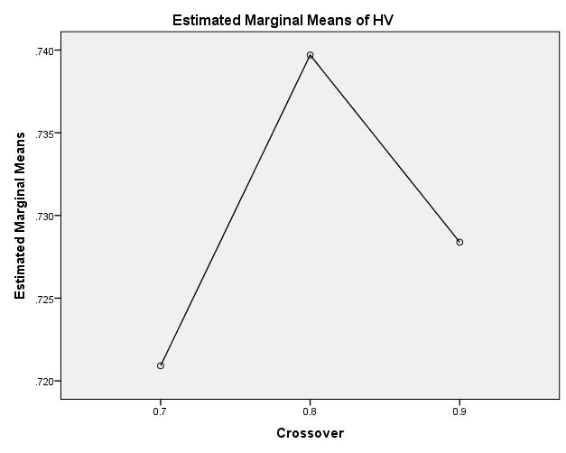

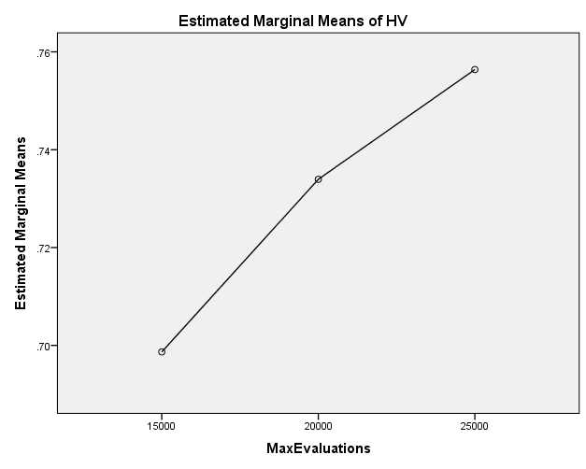

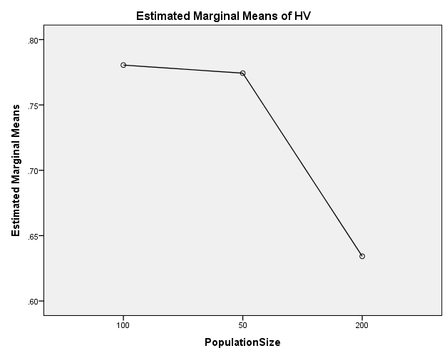

**EP**

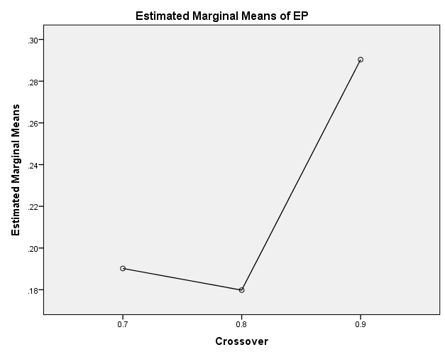

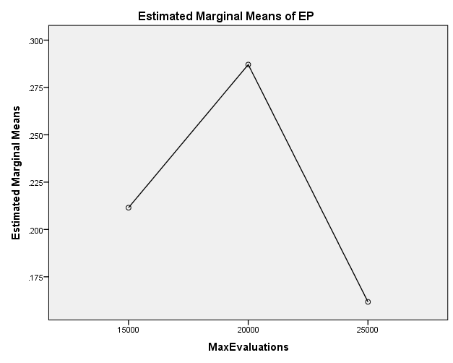

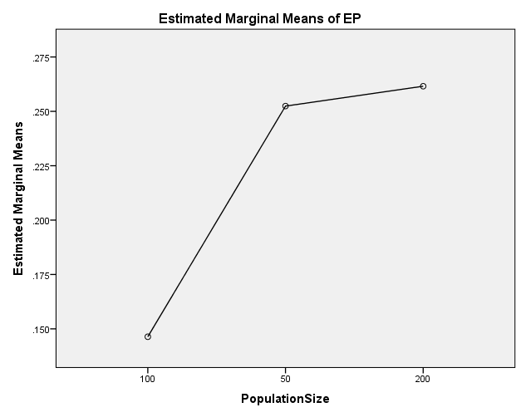

**GD**

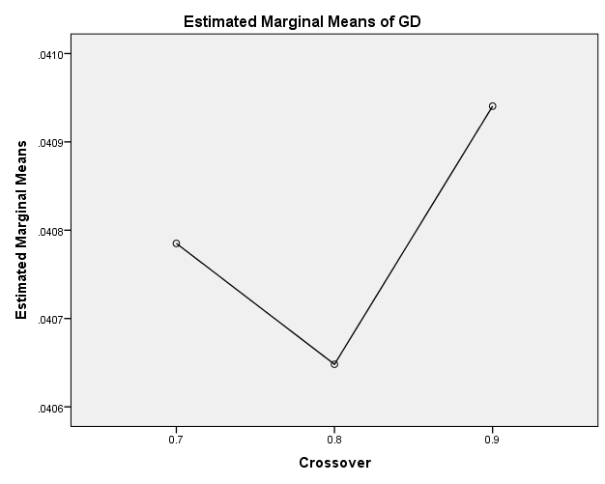

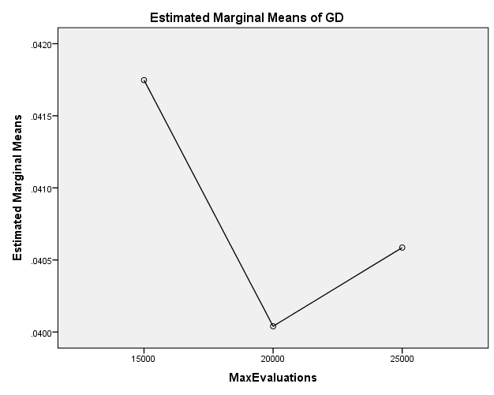

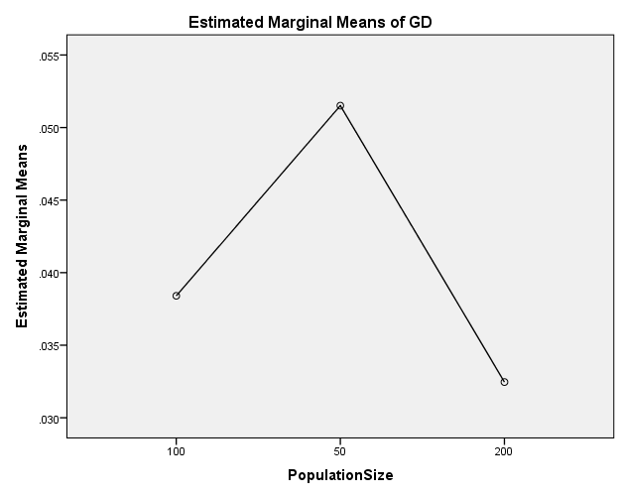

**IGD**

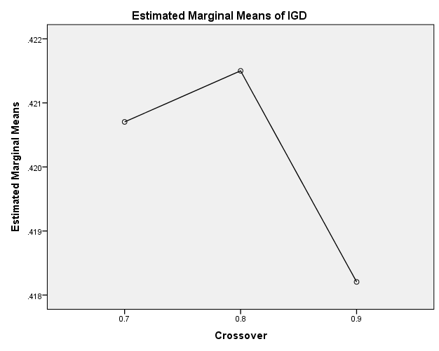

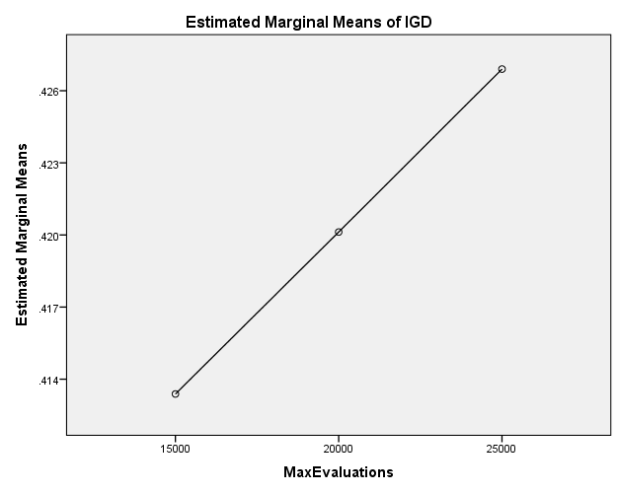

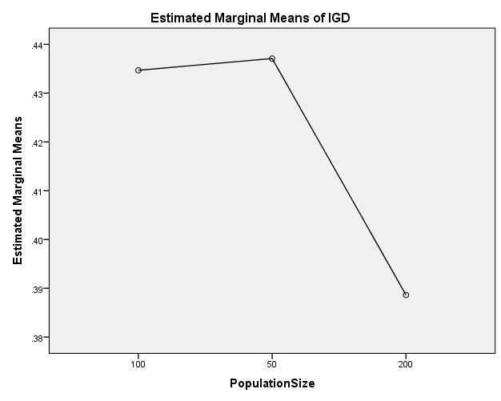

**IGDplus**

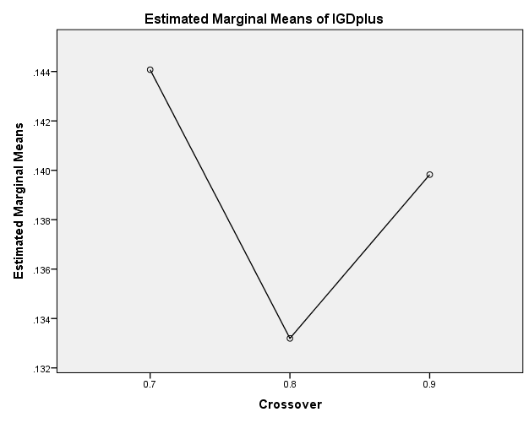

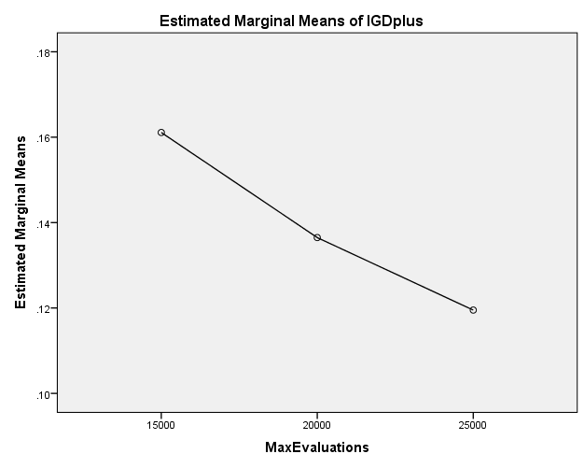

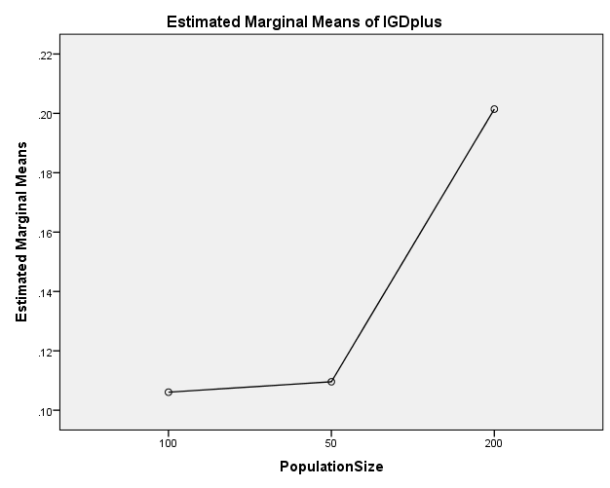

**SPREAD**

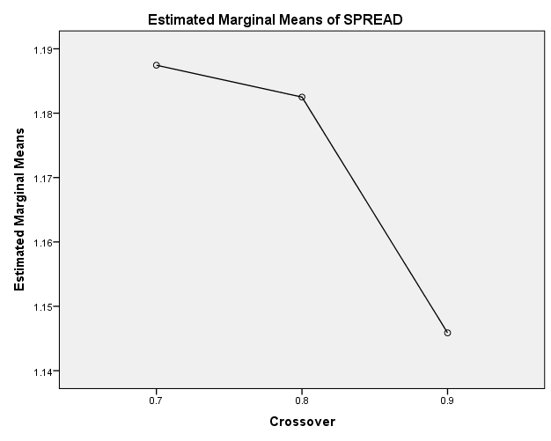

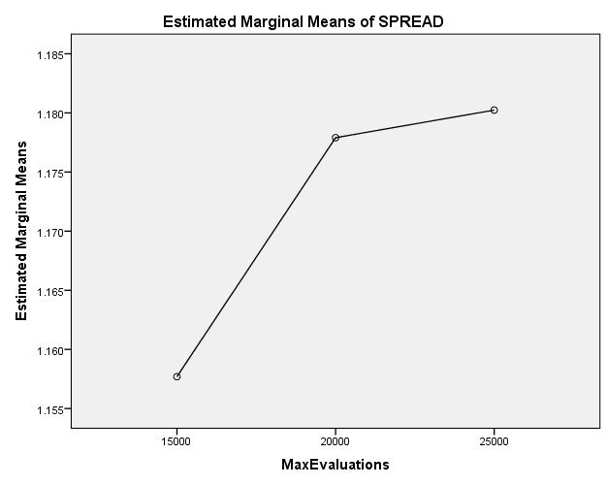

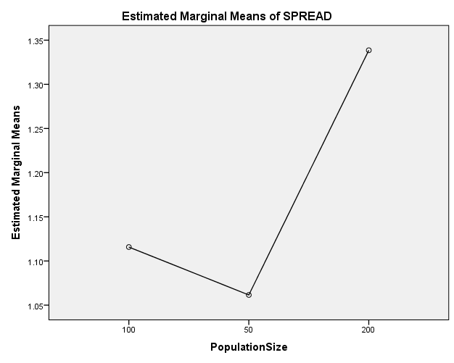

EXAMINE VARIABLES=HV EP GD IGD IGDplus SPREAD BY Crossover MaxEvaluations PopulationSize

/PLOT BOXPLOT

/COMPARE VARIABLES

/STATISTICS NONE

/CINTERVAL 95

/MISSING LISTWISE

/NOTOTAL.

**Explore**

|  |  |  |
| --- | --- | --- |
| **Notes** | | |
| Output Created | | 26-MAY-2020 20:32:31 |
| Comments | |  |
| Input | Data | C:\Users\user\Documents\NILAY\Mayis2020\medium_SPEA2.sav |
| Active Dataset | DataSet1 |
| Filter | <none> |
| Weight | <none> |
| Split File | <none> |
| N of Rows in Working Data File | 837 |
| Missing Value Handling | Definition of Missing | User-defined missing values for dependent variables are treated as missing. |
| Cases Used | Statistics are based on cases with no missing values for any dependent variable or factor used. |
| Syntax | | EXAMINE VARIABLES=HV EP GD IGD IGDplus SPREAD BY Crossover MaxEvaluations PopulationSize  /PLOT BOXPLOT  /COMPARE VARIABLES  /STATISTICS NONE  /CINTERVAL 95  /MISSING LISTWISE  /NOTOTAL. |
| Resources | Processor Time | 00:00:01.72 |
| Elapsed Time | 00:00:01.74 |

[DataSet1] C:\Users\user\Documents\NILAY\Mayis2020\medium_SPEA2.sav

**Crossover**

|  |  |  |  |  |  |  |  |
| --- | --- | --- | --- | --- | --- | --- | --- |
| **Case Processing Summary** | | | | | | | |
|  | Crossover | Cases | | | | | |
| Valid | | Missing | | Total | |
| N | Percent | N | Percent | N | Percent |
| HV | 0.7 | 279 | 100.0% | 0 | 0.0% | 279 | 100.0% |
| 0.8 | 279 | 100.0% | 0 | 0.0% | 279 | 100.0% |
| 0.9 | 279 | 100.0% | 0 | 0.0% | 279 | 100.0% |
| EP | 0.7 | 279 | 100.0% | 0 | 0.0% | 279 | 100.0% |
| 0.8 | 279 | 100.0% | 0 | 0.0% | 279 | 100.0% |
| 0.9 | 279 | 100.0% | 0 | 0.0% | 279 | 100.0% |
| GD | 0.7 | 279 | 100.0% | 0 | 0.0% | 279 | 100.0% |
| 0.8 | 279 | 100.0% | 0 | 0.0% | 279 | 100.0% |
| 0.9 | 279 | 100.0% | 0 | 0.0% | 279 | 100.0% |
| IGD | 0.7 | 279 | 100.0% | 0 | 0.0% | 279 | 100.0% |
| 0.8 | 279 | 100.0% | 0 | 0.0% | 279 | 100.0% |
| 0.9 | 279 | 100.0% | 0 | 0.0% | 279 | 100.0% |
| IGDplus | 0.7 | 279 | 100.0% | 0 | 0.0% | 279 | 100.0% |
| 0.8 | 279 | 100.0% | 0 | 0.0% | 279 | 100.0% |
| 0.9 | 279 | 100.0% | 0 | 0.0% | 279 | 100.0% |
| SPREAD | 0.7 | 279 | 100.0% | 0 | 0.0% | 279 | 100.0% |
| 0.8 | 279 | 100.0% | 0 | 0.0% | 279 | 100.0% |
| 0.9 | 279 | 100.0% | 0 | 0.0% | 279 | 100.0% |

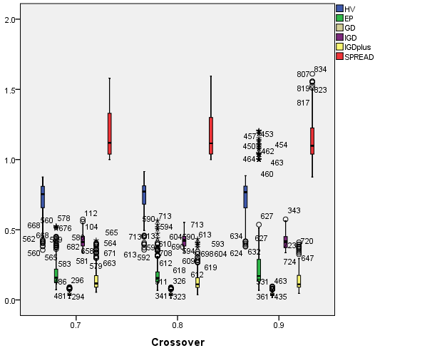

**MaxEvaluations**

|  |  |  |  |  |  |  |  |
| --- | --- | --- | --- | --- | --- | --- | --- |
| **Case Processing Summary** | | | | | | | |
|  | MaxEvaluations | Cases | | | | | |
| Valid | | Missing | | Total | |
| N | Percent | N | Percent | N | Percent |
| HV | 15000 | 279 | 100.0% | 0 | 0.0% | 279 | 100.0% |
| 20000 | 279 | 100.0% | 0 | 0.0% | 279 | 100.0% |
| 25000 | 279 | 100.0% | 0 | 0.0% | 279 | 100.0% |
| EP | 15000 | 279 | 100.0% | 0 | 0.0% | 279 | 100.0% |
| 20000 | 279 | 100.0% | 0 | 0.0% | 279 | 100.0% |
| 25000 | 279 | 100.0% | 0 | 0.0% | 279 | 100.0% |
| GD | 15000 | 279 | 100.0% | 0 | 0.0% | 279 | 100.0% |
| 20000 | 279 | 100.0% | 0 | 0.0% | 279 | 100.0% |
| 25000 | 279 | 100.0% | 0 | 0.0% | 279 | 100.0% |
| IGD | 15000 | 279 | 100.0% | 0 | 0.0% | 279 | 100.0% |
| 20000 | 279 | 100.0% | 0 | 0.0% | 279 | 100.0% |
| 25000 | 279 | 100.0% | 0 | 0.0% | 279 | 100.0% |
| IGDplus | 15000 | 279 | 100.0% | 0 | 0.0% | 279 | 100.0% |
| 20000 | 279 | 100.0% | 0 | 0.0% | 279 | 100.0% |
| 25000 | 279 | 100.0% | 0 | 0.0% | 279 | 100.0% |
| SPREAD | 15000 | 279 | 100.0% | 0 | 0.0% | 279 | 100.0% |
| 20000 | 279 | 100.0% | 0 | 0.0% | 279 | 100.0% |
| 25000 | 279 | 100.0% | 0 | 0.0% | 279 | 100.0% |

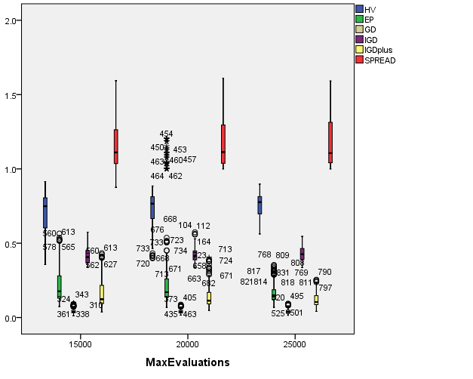

**PopulationSize**

|  |  |  |  |  |  |  |  |
| --- | --- | --- | --- | --- | --- | --- | --- |
| **Case Processing Summary** | | | | | | | |
|  | PopulationSize | Cases | | | | | |
| Valid | | Missing | | Total | |
| N | Percent | N | Percent | N | Percent |
| HV | 100 | 279 | 100.0% | 0 | 0.0% | 279 | 100.0% |
| 50 | 279 | 100.0% | 0 | 0.0% | 279 | 100.0% |
| 200 | 279 | 100.0% | 0 | 0.0% | 279 | 100.0% |
| EP | 100 | 279 | 100.0% | 0 | 0.0% | 279 | 100.0% |
| 50 | 279 | 100.0% | 0 | 0.0% | 279 | 100.0% |
| 200 | 279 | 100.0% | 0 | 0.0% | 279 | 100.0% |
| GD | 100 | 279 | 100.0% | 0 | 0.0% | 279 | 100.0% |
| 50 | 279 | 100.0% | 0 | 0.0% | 279 | 100.0% |
| 200 | 279 | 100.0% | 0 | 0.0% | 279 | 100.0% |
| IGD | 100 | 279 | 100.0% | 0 | 0.0% | 279 | 100.0% |
| 50 | 279 | 100.0% | 0 | 0.0% | 279 | 100.0% |
| 200 | 279 | 100.0% | 0 | 0.0% | 279 | 100.0% |
| IGDplus | 100 | 279 | 100.0% | 0 | 0.0% | 279 | 100.0% |
| 50 | 279 | 100.0% | 0 | 0.0% | 279 | 100.0% |
| 200 | 279 | 100.0% | 0 | 0.0% | 279 | 100.0% |
| SPREAD | 100 | 279 | 100.0% | 0 | 0.0% | 279 | 100.0% |
| 50 | 279 | 100.0% | 0 | 0.0% | 279 | 100.0% |
| 200 | 279 | 100.0% | 0 | 0.0% | 279 | 100.0% |

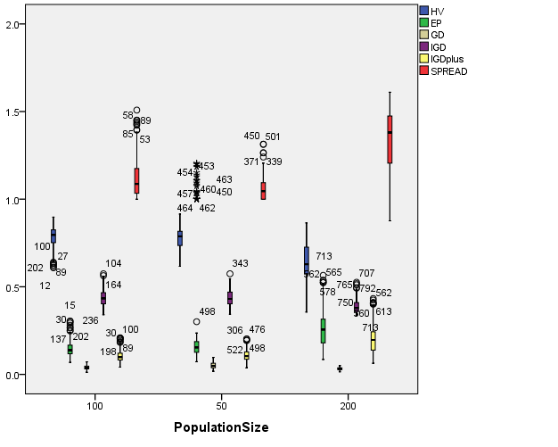

EXAMINE VARIABLES=HV EP GD IGD IGDplus SPREAD BY Crossover MaxEvaluations PopulationSize

/PLOT BOXPLOT

/COMPARE GROUPS

/STATISTICS NONE

/CINTERVAL 95

/MISSING LISTWISE

/NOTOTAL.

**Explore**

|  |  |  |
| --- | --- | --- |
| **Notes** | | |
| Output Created | | 26-MAY-2020 20:32:59 |
| Comments | |  |
| Input | Data | C:\Users\user\Documents\NILAY\Mayis2020\medium_SPEA2.sav |
| Active Dataset | DataSet1 |
| Filter | <none> |
| Weight | <none> |
| Split File | <none> |
| N of Rows in Working Data File | 837 |
| Missing Value Handling | Definition of Missing | User-defined missing values for dependent variables are treated as missing. |
| Cases Used | Statistics are based on cases with no missing values for any dependent variable or factor used. |
| Syntax | | EXAMINE VARIABLES=HV EP GD IGD IGDplus SPREAD BY Crossover MaxEvaluations PopulationSize  /PLOT BOXPLOT  /COMPARE GROUPS  /STATISTICS NONE  /CINTERVAL 95  /MISSING LISTWISE  /NOTOTAL. |
| Resources | Processor Time | 00:00:04.01 |
| Elapsed Time | 00:00:03.98 |

[DataSet1] C:\Users\user\Documents\NILAY\Mayis2020\medium_SPEA2.sav

**Crossover**

|  |  |  |  |  |  |  |  |
| --- | --- | --- | --- | --- | --- | --- | --- |
| **Case Processing Summary** | | | | | | | |
|  | Crossover | Cases | | | | | |
| Valid | | Missing | | Total | |
| N | Percent | N | Percent | N | Percent |
| HV | 0.7 | 279 | 100.0% | 0 | 0.0% | 279 | 100.0% |
| 0.8 | 279 | 100.0% | 0 | 0.0% | 279 | 100.0% |
| 0.9 | 279 | 100.0% | 0 | 0.0% | 279 | 100.0% |
| EP | 0.7 | 279 | 100.0% | 0 | 0.0% | 279 | 100.0% |
| 0.8 | 279 | 100.0% | 0 | 0.0% | 279 | 100.0% |
| 0.9 | 279 | 100.0% | 0 | 0.0% | 279 | 100.0% |
| GD | 0.7 | 279 | 100.0% | 0 | 0.0% | 279 | 100.0% |
| 0.8 | 279 | 100.0% | 0 | 0.0% | 279 | 100.0% |
| 0.9 | 279 | 100.0% | 0 | 0.0% | 279 | 100.0% |
| IGD | 0.7 | 279 | 100.0% | 0 | 0.0% | 279 | 100.0% |
| 0.8 | 279 | 100.0% | 0 | 0.0% | 279 | 100.0% |
| 0.9 | 279 | 100.0% | 0 | 0.0% | 279 | 100.0% |
| IGDplus | 0.7 | 279 | 100.0% | 0 | 0.0% | 279 | 100.0% |
| 0.8 | 279 | 100.0% | 0 | 0.0% | 279 | 100.0% |
| 0.9 | 279 | 100.0% | 0 | 0.0% | 279 | 100.0% |
| SPREAD | 0.7 | 279 | 100.0% | 0 | 0.0% | 279 | 100.0% |
| 0.8 | 279 | 100.0% | 0 | 0.0% | 279 | 100.0% |
| 0.9 | 279 | 100.0% | 0 | 0.0% | 279 | 100.0% |

**HV**

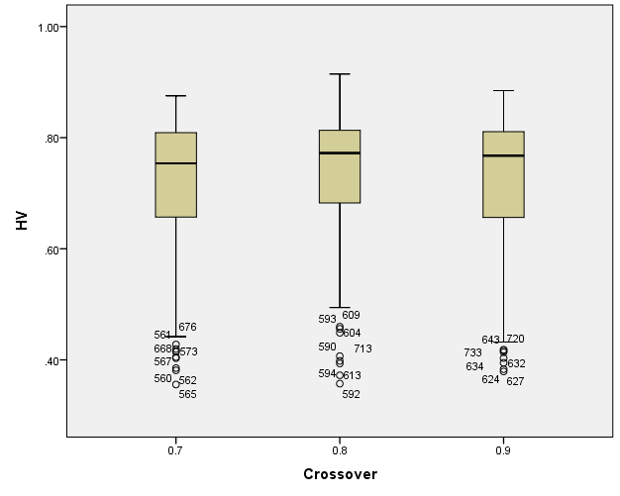

**EP**

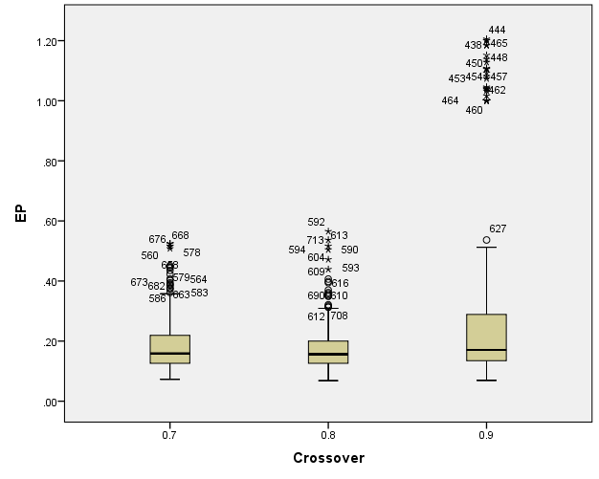

**GD**

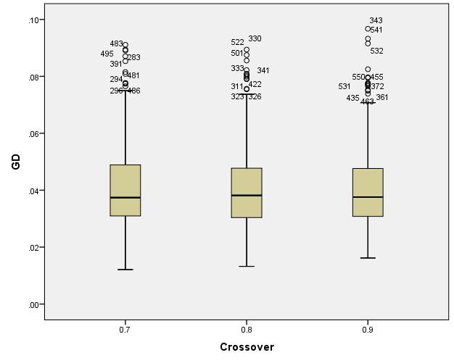

**IGD**

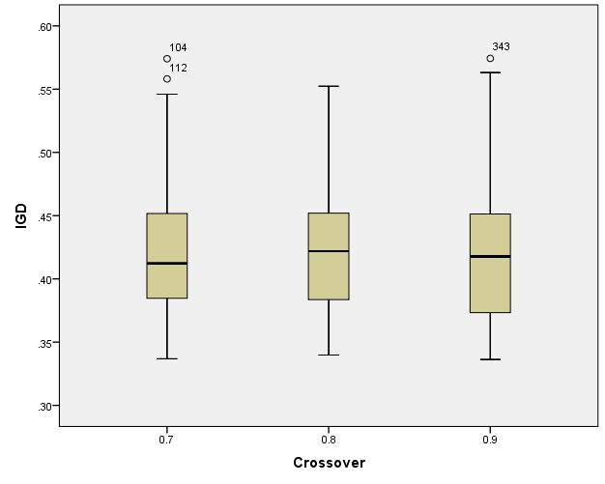

**IGDplus**

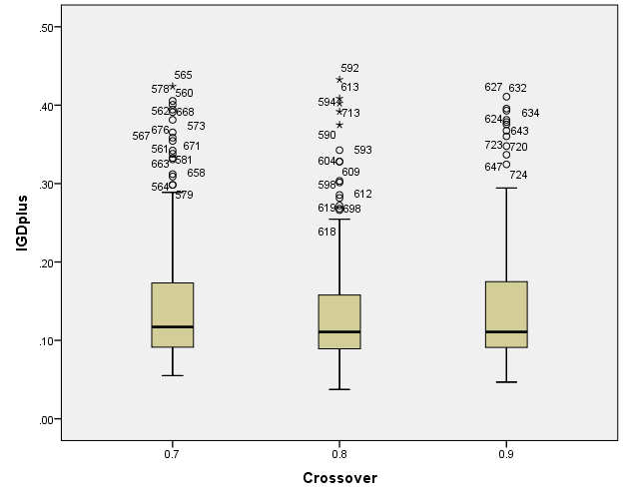

**SPREAD**

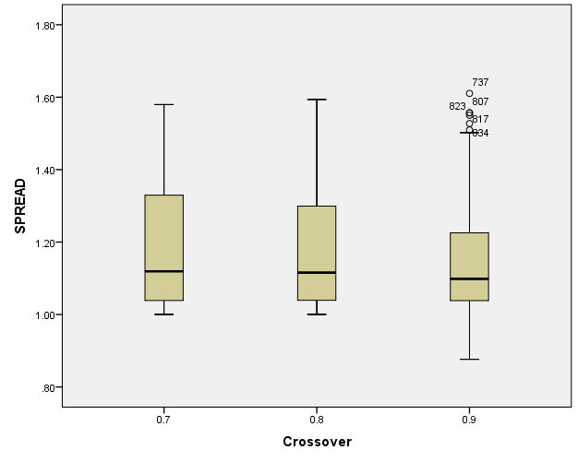

**MaxEvaluations**

|  |  |  |  |  |  |  |  |
| --- | --- | --- | --- | --- | --- | --- | --- |
| **Case Processing Summary** | | | | | | | |
|  | MaxEvaluations | Cases | | | | | |
| Valid | | Missing | | Total | |
| N | Percent | N | Percent | N | Percent |
| HV | 15000 | 279 | 100.0% | 0 | 0.0% | 279 | 100.0% |
| 20000 | 279 | 100.0% | 0 | 0.0% | 279 | 100.0% |
| 25000 | 279 | 100.0% | 0 | 0.0% | 279 | 100.0% |
| EP | 15000 | 279 | 100.0% | 0 | 0.0% | 279 | 100.0% |
| 20000 | 279 | 100.0% | 0 | 0.0% | 279 | 100.0% |
| 25000 | 279 | 100.0% | 0 | 0.0% | 279 | 100.0% |
| GD | 15000 | 279 | 100.0% | 0 | 0.0% | 279 | 100.0% |
| 20000 | 279 | 100.0% | 0 | 0.0% | 279 | 100.0% |
| 25000 | 279 | 100.0% | 0 | 0.0% | 279 | 100.0% |
| IGD | 15000 | 279 | 100.0% | 0 | 0.0% | 279 | 100.0% |
| 20000 | 279 | 100.0% | 0 | 0.0% | 279 | 100.0% |
| 25000 | 279 | 100.0% | 0 | 0.0% | 279 | 100.0% |
| IGDplus | 15000 | 279 | 100.0% | 0 | 0.0% | 279 | 100.0% |
| 20000 | 279 | 100.0% | 0 | 0.0% | 279 | 100.0% |
| 25000 | 279 | 100.0% | 0 | 0.0% | 279 | 100.0% |
| SPREAD | 15000 | 279 | 100.0% | 0 | 0.0% | 279 | 100.0% |
| 20000 | 279 | 100.0% | 0 | 0.0% | 279 | 100.0% |
| 25000 | 279 | 100.0% | 0 | 0.0% | 279 | 100.0% |

**HV**

**Boxplots**

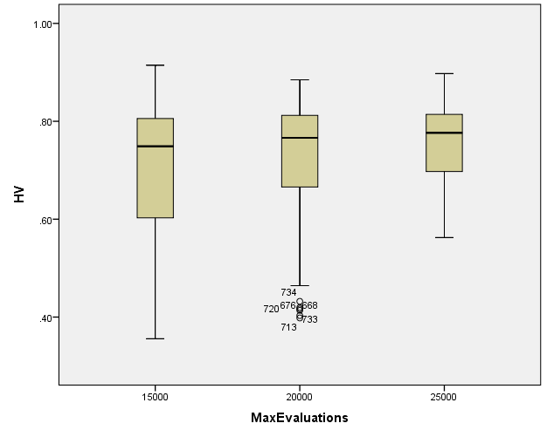

**EP**

**Boxplots**

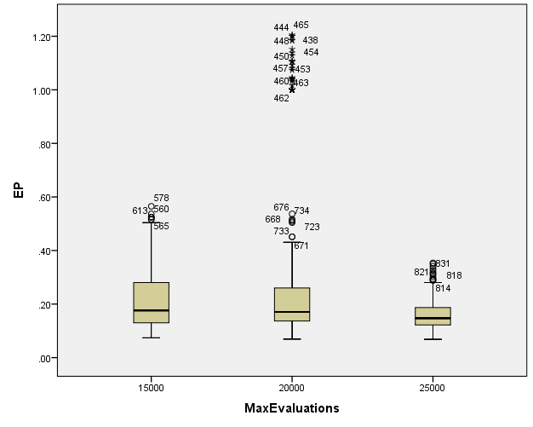

**GD**

**Boxplots**

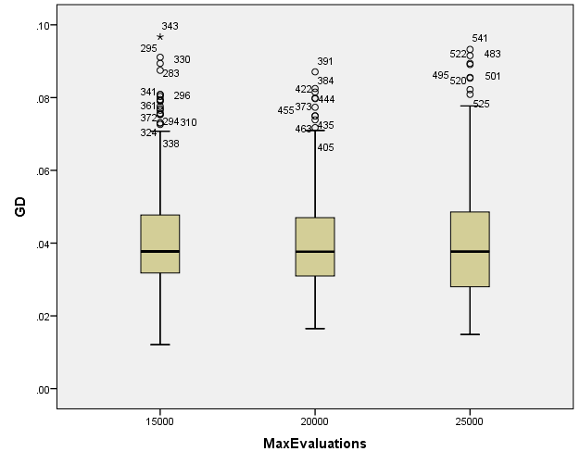

**IGD**

**Boxplots**

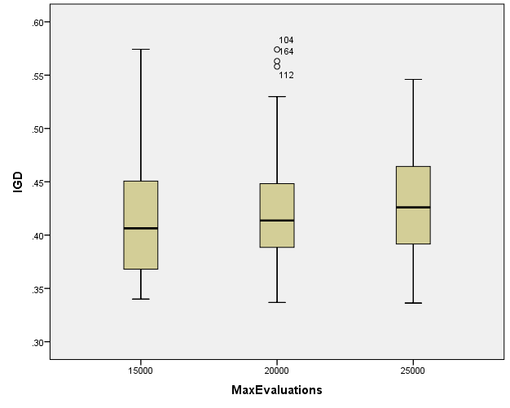

**IGDplus**

**Boxplots**

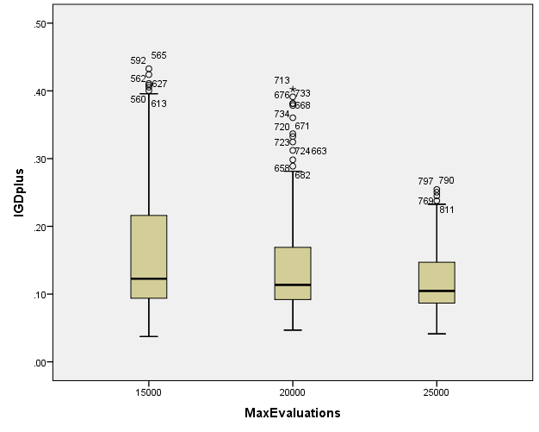

**SPREAD**

**Boxplots**

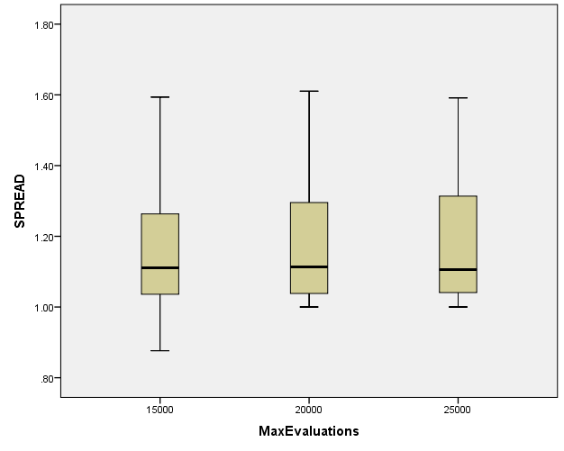

**PopulationSize**

|  |  |  |  |  |  |  |  |
| --- | --- | --- | --- | --- | --- | --- | --- |
| **Case Processing Summary** | | | | | | | |
|  | PopulationSize | Cases | | | | | |
| Valid | | Missing | | Total | |
| N | Percent | N | Percent | N | Percent |
| HV | 100 | 279 | 100.0% | 0 | 0.0% | 279 | 100.0% |
| 50 | 279 | 100.0% | 0 | 0.0% | 279 | 100.0% |
| 200 | 279 | 100.0% | 0 | 0.0% | 279 | 100.0% |
| EP | 100 | 279 | 100.0% | 0 | 0.0% | 279 | 100.0% |
| 50 | 279 | 100.0% | 0 | 0.0% | 279 | 100.0% |
| 200 | 279 | 100.0% | 0 | 0.0% | 279 | 100.0% |
| GD | 100 | 279 | 100.0% | 0 | 0.0% | 279 | 100.0% |
| 50 | 279 | 100.0% | 0 | 0.0% | 279 | 100.0% |
| 200 | 279 | 100.0% | 0 | 0.0% | 279 | 100.0% |
| IGD | 100 | 279 | 100.0% | 0 | 0.0% | 279 | 100.0% |
| 50 | 279 | 100.0% | 0 | 0.0% | 279 | 100.0% |
| 200 | 279 | 100.0% | 0 | 0.0% | 279 | 100.0% |
| IGDplus | 100 | 279 | 100.0% | 0 | 0.0% | 279 | 100.0% |
| 50 | 279 | 100.0% | 0 | 0.0% | 279 | 100.0% |
| 200 | 279 | 100.0% | 0 | 0.0% | 279 | 100.0% |
| SPREAD | 100 | 279 | 100.0% | 0 | 0.0% | 279 | 100.0% |
| 50 | 279 | 100.0% | 0 | 0.0% | 279 | 100.0% |
| 200 | 279 | 100.0% | 0 | 0.0% | 279 | 100.0% |

**HV**

**Boxplots**

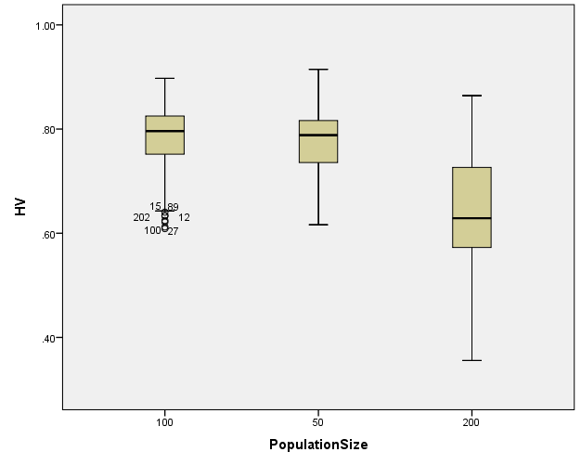

**EP**

**Boxplots**

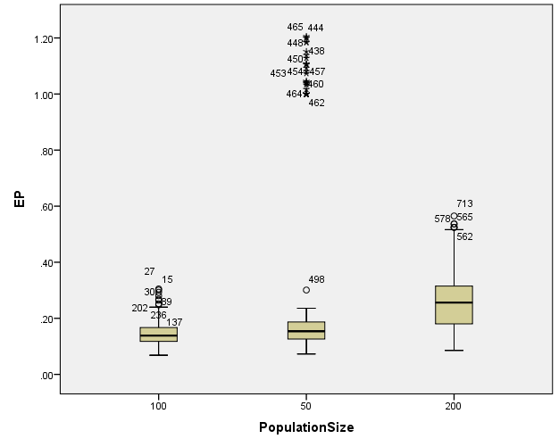

**GD**

**Boxplots**

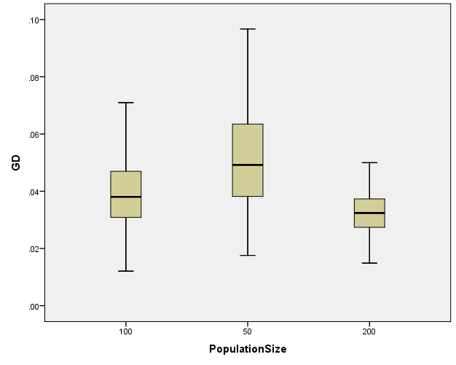

**IGD**

**Boxplots**

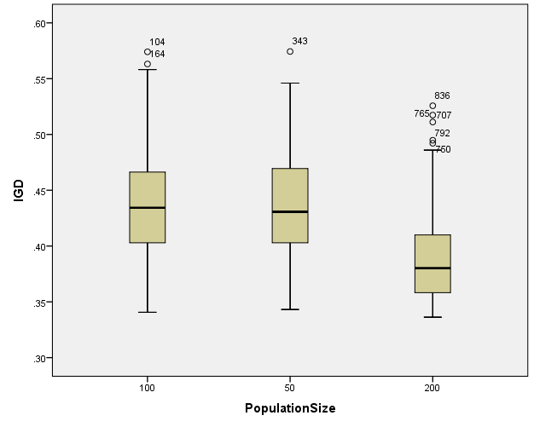

**IGDplus**

**Boxplots**

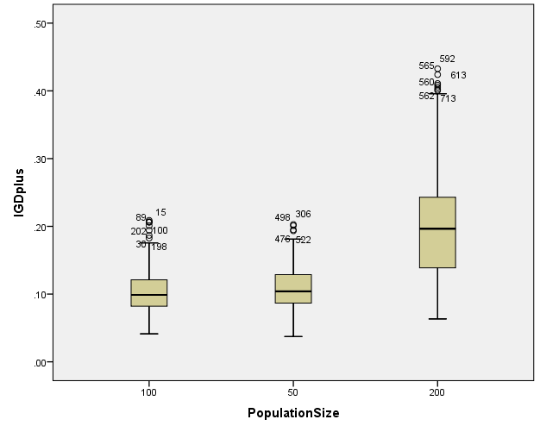

**SPREAD**

**Boxplots**

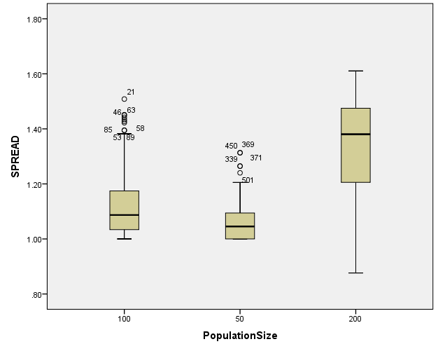

*Nonparametric Tests: Independent Samples.

NPTESTS

/INDEPENDENT TEST (HV EP GD IGD IGDplus SPREAD) GROUP (Crossover) MEDIAN(TESTVALUE=SAMPLE COMPARE=PAIRWISE)

/MISSING SCOPE=ANALYSIS USERMISSING=EXCLUDE

/CRITERIA ALPHA=0.05 CILEVEL=95.

**Nonparametric Tests**

|  |  |  |
| --- | --- | --- |
| **Notes** | | |
| Output Created | | 26-MAY-2020 20:34:07 |
| Comments | |  |
| Input | Data | C:\Users\user\Documents\NILAY\Mayis2020\medium_SPEA2.sav |
| Active Dataset | DataSet1 |
| Filter | <none> |
| Weight | <none> |
| Split File | <none> |
| N of Rows in Working Data File | 837 |
| Syntax | | NPTESTS  /INDEPENDENT TEST (HV EP GD IGD IGDplus SPREAD) GROUP (Crossover) MEDIAN(TESTVALUE=SAMPLE COMPARE=PAIRWISE)  /MISSING SCOPE=ANALYSIS USERMISSING=EXCLUDE  /CRITERIA ALPHA=0.05 CILEVEL=95. |
| Resources | Processor Time | 00:00:00.42 |
| Elapsed Time | 00:00:00.51 |

[DataSet1] C:\Users\user\Documents\NILAY\Mayis2020\medium_SPEA2.sav

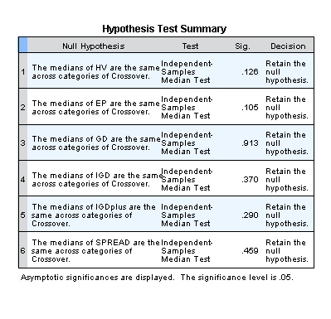

*Nonparametric Tests: Independent Samples.

NPTESTS

/INDEPENDENT TEST (HV EP GD IGD IGDplus SPREAD) GROUP (MaxEvaluations) MEDIAN(TESTVALUE=SAMPLE COMPARE=PAIRWISE)

/MISSING SCOPE=ANALYSIS USERMISSING=EXCLUDE

/CRITERIA ALPHA=0.05 CILEVEL=95.

**Nonparametric Tests**

|  |  |  |
| --- | --- | --- |
| **Notes** | | |
| Output Created | | 26-MAY-2020 20:34:26 |
| Comments | |  |
| Input | Data | C:\Users\user\Documents\NILAY\Mayis2020\medium_SPEA2.sav |
| Active Dataset | DataSet1 |
| Filter | <none> |
| Weight | <none> |
| Split File | <none> |
| N of Rows in Working Data File | 837 |
| Syntax | | NPTESTS  /INDEPENDENT TEST (HV EP GD IGD IGDplus SPREAD) GROUP (MaxEvaluations) MEDIAN(TESTVALUE=SAMPLE COMPARE=PAIRWISE)  /MISSING SCOPE=ANALYSIS USERMISSING=EXCLUDE  /CRITERIA ALPHA=0.05 CILEVEL=95. |
| Resources | Processor Time | 00:00:00.23 |
| Elapsed Time | 00:00:00.20 |

[DataSet1] C:\Users\user\Documents\NILAY\Mayis2020\medium_SPEA2.sav

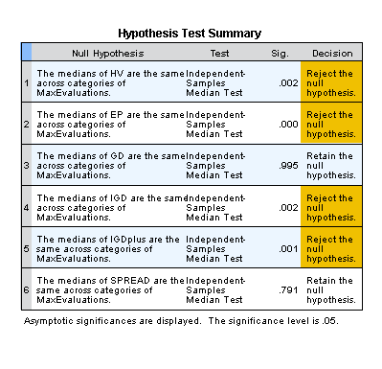

*Nonparametric Tests: Independent Samples.

NPTESTS

/INDEPENDENT TEST (HV EP GD IGD IGDplus SPREAD) GROUP (PopulationSize) MEDIAN(TESTVALUE=SAMPLE COMPARE=PAIRWISE)

/MISSING SCOPE=ANALYSIS USERMISSING=EXCLUDE

/CRITERIA ALPHA=0.05 CILEVEL=95.

**Nonparametric Tests**

|  |  |  |
| --- | --- | --- |
| **Notes** | | |
| Output Created | | 26-MAY-2020 20:34:37 |
| Comments | |  |
| Input | Data | C:\Users\user\Documents\NILAY\Mayis2020\medium_SPEA2.sav |
| Active Dataset | DataSet1 |
| Filter | <none> |
| Weight | <none> |
| Split File | <none> |
| N of Rows in Working Data File | 837 |
| Syntax | | NPTESTS  /INDEPENDENT TEST (HV EP GD IGD IGDplus SPREAD) GROUP (PopulationSize) MEDIAN(TESTVALUE=SAMPLE COMPARE=PAIRWISE)  /MISSING SCOPE=ANALYSIS USERMISSING=EXCLUDE  /CRITERIA ALPHA=0.05 CILEVEL=95. |
| Resources | Processor Time | 00:00:00.17 |
| Elapsed Time | 00:00:00.22 |

[DataSet1] C:\Users\user\Documents\NILAY\Mayis2020\medium_SPEA2.sav

