LINGUISTIC FINGERPRINTS: ARTIFICIAL INTELLIGENCE FOR PROACTIVE DETECTION OF COGNITIVE DEFICITS IN MENTAL HEALTH SYSTEMS

Abstract
Background: Early cognitive decline in conditions such as Alzheimer’s disease and Mild Cognitive Impairment (MCI) often remains undetected until clinically observable symptoms emerge, by which point substantial and irreversible neurodegeneration may have occurred. Conventional screening tools, including the Mini-Mental State Examination and Montreal Cognitive Assessment, are effective for identifying established impairment but demonstrate limited sensitivity for detecting subtle, preclinical changes.
Objective: To create and test a natural language processing (NLP) AI-based framework, Linguistic Fingerprinting, to identify and detect cognitive impairments early and non-invasively by use of speech-derived digital biomarkers.
Methods: Standardized speech transcripts from the Cookie Theft picture description task (Dementia Bank Pitt Corpus; n = 544) were analyzed using NLP techniques. Linguistic features were extracted across lexical (Type-Token Ratio), syntactic (sentence structure and part-of-speech ratios), and semantic domains (Vague Language Index). Feature selection methods were applied to identify the most relevant predictors. A Random Forest classifier was trained and evaluated using a stratified train–test split and cross-validation. Model performance was assessed using accuracy, sensitivity, specificity, and area under the ROC curve (AUC).
Results: Significant differences in linguistic features were observed between cognitively healthy and impaired groups. Healthy individuals demonstrated higher lexical diversity (mean TTR ≈ 0.81), whereas impaired individuals exhibited lower TTR values (≈ 0.41) and increased use of vague language. The Random Forest model achieved an overall accuracy of 88.1%, with strong sensitivity and specificity, and an AUC of 0.93, indicating excellent classification performance.
Conclusion: NLP-derived linguistic features serve as robust, interpretable digital biomarkers for early cognitive decline. The proposed Linguistic Fingerprinting framework demonstrates strong potential as a scalable, low-cost, and non-invasive screening tool, supporting a shift toward proactive detection and early intervention in cognitive health.
Keywords: Cognitive decline, Alzheimer’s disease, Natural Language Processing, Digital biomarkers, Type-Token Ratio, Random Forest, Speech analysis, Dementia Bank

- Introduction
The prevalence of neurodegenerative dementias, such as Alzheimer’s disease (AD), Vascular Dementia, Lewy Body Dementia, and Frontotemporal Lobar Dementia, has been estimated at over 55 million cases annually across the globe, and is expected to reach 139 million cases by the year 2050 ^{[1]}. Among them, AD is a cause of disability and dependency in older adults in the world, and it is one of the most prevalent causes, with approximately 60-70 percent ^{[2]}. However, despite its magnitude, an essential structural issue in the clinical management of AD is the reactive nature of diagnostic systems. The formal assessment is usually brought into action when the clinically apparent behavioural or functional decline is reported by the patient or a caregiver at a stage when the neurodegeneration is massive and is mostly irreversible ^{[3]}. The presence of a preclinical stage, during which objective cognitive alterations occur before symptoms appear for several, or even decades, is now established ^{[4]}. This provides a theoretically exploitable window of early intervention that would include both pharmacological treatment and evidence-based psychosocial, musical, and lifestyle programs, which have been demonstrated to delay disease progression and preserve quality of life ^{[5, 6, 7]}. To realise this window clinically, however, involves the use of sensitive, scalable, non-invasive, inexpensive, and deployable screening tools that are not necessarily available in specialist dementia clinics but in primary care. Traditional cognitive batteries, including the MMSE and MoCA, although useful in their respective domains, are short-term, point-in-time measures that are insensitive to preclinical change and whose scores are highly dependent on education level and language ^{[8, 9]}.
Speech and language are uniquely accessible to digital biomarker extraction. The production of language requires a combination of lexical memory, semantic retrieval, executive functioning, working memory, and phonological encoding ^{[10]}. The impairment of these cognitive systems manifests in spontaneous speech: a lack of lexical diversity, a greater reliance on unclear and uncertain words, simplified syntax, and a higher frequency of hesitation marks ^{[11, 12]}. More importantly, because changes can occur before they are clinically detected, computational analysis of speech may provide a timelier and more objective indicator of cognitive change than standard clinical assessment.
The picture description task of Cookie Theft, which originated as a subset of the Boston Diagnostic Aphasia Examination^{[13]}, has become the standard stimulus for eliciting spontaneous speech for computational analysis. Since all subjects are elicited by the same visualism, inter-subject variation in linguistic production reflects cognitive rather than stimulus variance, providing a controlled basis for comparative analysis. The Dementia Bank Pitt Corpus ^{[14]} of transcribed Cookie Theft responses of clinically characterised subjects has since become the standard dataset in this field of research since the pioneering research by Fraser, Meltzer, and Rudzicz,^{[15]}, which demonstrated that features derived by NLP could accurately distinguish AD and healthy aging with a reported accuracy of over 81%.
It is based on this that the current research presents a Linguistic Fingerprinting framework that operationalises three types of NLP extracted features, lexical, syntactic, and semantic, into a Random Forest classification framework. The framework builds on earlier research by:
- providing a composite Vague Language Index (VLI) representing a combination of hitherto analysed indicators of linguistic imprecision
- performing feature categories in comparative format to determine the most information-rich type of feature; and
- providing complete confusion maturity statistics and AUC-ROC with a view to supporting the clinically interpretable assessment. The larger objective is to illustrate that AI-based linguistic analysis can be an effective, non-invasive, proactive screening tool that would help transform mental health systems by adopting a reactive diagnosis methodology and transitioning to a systematic early cognitive health screening approach.
2. Related Work
2.1 Language Assessment Tools for Dementia Detection
The tools of Clinical Language Assessment (LA) have also been identified as cost-efficient, powerful, and highly specific and sensitive in detecting the earliest cognitive signs of dementia, including lexical-semantic (e.g., naming problems), phonological and morphological, and syntactic simplification ^{[16]}. The tools can evaluate language generated during standardised mental tasks, such as the Boston Naming Test (BNT), confrontational naming, the Cookie Theft Picture Description (PD), confrontational speech, and the Story Recall (SR), as well as confrontational episodic and semantic memory testing ^{[17]}.
Parsa, Alam, and Mihailidis^{[18]} observed a systematic review of AI-based Language Assessment instruments on the Talk2Me database. In their research, they obtained linguistic (lexical richness through the Brunet Index and Honores Statistic, syntactic POS ratio, semantic incoherence and tangentiality measures) and acoustic (MFCCs, LSP frequencies, F0, jitter, shimmer) features of participants with and without dementia during PD and SR tasks. Their results showed that tree based classifiers, specifically Extra Trees (ET) and Random Forest (RF) were much more successful in classification than SVM, kNN, and Logistic Regression; that the PD task had higher F1 scores than the SR task (F (1,126) = 8.27, p = 0.005); and that classification performance was much better with acoustic features than with linguistic features (F(1,256) = 62.43, p ≈ 0). The current research uses the taxonomy of linguistic features and PD task methodology proposed by Parsa et al. ^{[18]} on the bigger Dementia Bank Pitt Corpus, with a complete confusion matrix assessment.
2.2 Lexical and Semantic Biomarkers
The decrease in lexical variety, as measured by Type-Token Ratio (TTR) and similar measures, has consistently been reported as a strong predictor of speech in AD across various corpora and languages [19]. Bucks, Singh, Cuerden, and Wilcock [20] found that TTR was considerably lower in AD spontaneous speech than in healthy aging controls, with a mean of less than 0.50 in the impaired group. Later studies showed that the Index of Brunet and the Statistic of Honore, which are the measures employed to correct raw TTR to transcript length sensitivity, have similar or even better discriminative validity [21]. Word-retrieval problems (anomia) and semantic decline measures have been proposed as complementary indicators of vague language markers, such as the overuse of generic pronouns, the non-specific frequency of nouns, and the density of markers of hesitation, which reflect difficulties that patients with early AD face in accessing specific lexical items ^{[22]}.
2.3 Syntactic and Propositional Density Features
In AD speech, syntactic complexity is reduced, as evidenced by decreased mean utterance length, reduced frequency of subordinate clauses, and decreased propositional and content density ^{[23]}. Orimaye, Wong, and Golden ^{[24]} showed that part-of-speech ratios, specifically the pronoun to noun ratio and rate of the third person pronoun, distinguished AD speech and healthy control, and the effect size of first-person pronoun frequency was 2.198 when Parsa et al. analysed the data ^{[18]}. A summary measure of syntactic complexity, called propositional density, which is the sum of the relative frequencies of verbs, adjectives, adverbs, prepositions, and conjunctions ^{[25]}, has been proposed as a way to describe several syntactic degeneration patterns simultaneously.
2.4 Machine Learning Classifiers
Random Forest classifiers have also been shown to perform well in dementia detection tasks because they are resistant to feature multicollinearity, can capture non-linear interactions between features, and are interpretable ^{[26]}. On 370 features of the DementiaBank dataset, Fraser et al. ^{[15]} got 81.9% accuracy with logistic regression. Luz et al. ^{[27]} compared RF and SVM on the same corpus, and the RF achieved 85.4% accuracy. More recent transformer-based methods have achieved even better accuracy, over 90% ^{[28]}, but at a very high computational cost and lower interpretability. Parsa et al. ^{[18]} found that tree-based classifiers (RF, DT, ET) performed better with both linguistic and acoustic features, validating the use of RF in the study.
3. Methodology
3.1 Dataset and Preprocessing
As the main dataset, the DementiaBank Pitt Corpus ^{[14]}, recorded at the University of Pittsburgh Alzheimer’s Disease Research Center, was used. It is a corpus of Cookie Theft picture description responses, transcribed in CHAT format, from 309 cognitively healthy controls (CHC) and 243 participants with clinically diagnosed probable AD. After eliminating transcripts with fewer than 30 words (n = 8), the analytical sample size was n = 544 (303 CHC, 241 AD). The transcripts were processed with the CLAN software suite and pre-processed with NLTK to tokenize, and with spaCy (v3.5) to lemmatize and part-of-speech tag using the Penn Treebank tag set.
The Cookie Theft task presents a standardised visual stimulus depicting a home environment and asks participants to describe everything they see. A mentally healthy participant could write: "The boy is standing on a stool in an attempt to steal cookies out of the jar, and his mother, who is busy washing the dishes, spills the water on the linoleum floor, which is also full of water from the sink. An interviewee with early AD would rather say: The lady is doing a water thing. The lad is out there, acquiring the stuff. The signal that the Linguistic Fingerprinting system intends to measure and identify is this qualitative difference: decreased specificity, recurring generic words, hesitation, etc.
3.2 Feature Engineering
Following the taxonomy established in Parsa et al. ^{[18]} and extended with measures drawn from Fraser et al. ^{[15]} and Orimaye et al. ^{[24]}, three categories of linguistic features were extracted from each preprocessed transcript. Table 1 presents the complete feature set.
Table 1. Linguistic Features Extracted per Transcript
Feature | Type | Cognitive function | Description
MSTTR-50 | Lexical | Vocabulary richness | Mean segmental TTR (50-token windows)
Brunet's Index (BI) | Lexical | Vocabulary richness | W / (U^−0.165); W = tokens, U = types
Honore's Statistic (HS) | Lexical | Vocabulary richness | 100 × log(W) / (1 − W/U)
Flesch-Kincaid (FK) | Lexical | Readability / complexity | Sentence length and syllable rate formula
Flesch Reading Ease (FRES) | Lexical | Readability / complexity | Inverse of FK; higher = simpler text
Pronoun-to-noun ratio (PNR) | Syntactic | Cognitive strength / anomia | Pronoun count / noun count
3rd-person pronoun rate | Syntactic | Reference tracking | 3rd-pron / all pronouns
Noun-to-verb ratio (NVR) | Syntactic | Syntactic processing | Noun count / verb count
Propositional density | Syntactic | Syntactic complexity | (VB+JJ+RB+IN+CC) / N
Content density | Syntactic | Information density | (NN+VB+JJ+RB) / N
VLI – Imprecise Pronoun Ratio (IPR) | Semantic | Word-retrieval / anomia | Vague pronouns / all pronouns
VLI – Non-Specific Noun Ratio (NNR) | Semantic | Semantic decline | Generic nouns / all nouns
VLI – Hesitation Marker Density (HMD) | Semantic | Processing fluency | Filled pauses per 100 tokens
NN = nouns; VB = verbs; JJ = adjectives; RB = adverbs; IN = prepositions; CC = conjunctions; N = total word count. VLI = Vague Language Index (composite: 0.4×IPR + 0.35×NNR + 0.25×HMD). Weights were determined by Pearson correlation with the diagnosis label on the training set.
3.3 Feature Selection and Classification
Feature importance was assessed using ANOVA F-statistics and mRMR scores computed on the training partition only, preventing data leakage into the test set. The top eight features identified in consensus by both methods were retained for classifier training. A Random Forest classifier (scikit-learn v1.2.2; 100 estimators; Gini criterion; bootstrap sampling; max_features = 'sqrt') was trained on an 80/20 stratified split (training: n = 435; test: n = 109). Hyperparameter optimisation used 5-fold cross-validation over a grid of n_estimators ∈ {50, 100, 200}, max_features ∈ {'sqrt', 'log2'}, and min_samples_split ∈ {2, 5, 10}. Features were min-max scaled on the training set, and the same scaler was applied to the test set. Classification performance was evaluated on the held-out test set using accuracy, sensitivity, specificity, F1-score, and AUC-ROC; 95% confidence intervals were computed via 2000-iteration bootstrap resampling. Inter-group differences in feature values were assessed with independent-samples Welch-corrected t-tests.
Consistent with the recommendation of Parsa et al. ^{[18]} regarding feature category comparison, classifiers were trained separately on lexical, syntactic, and semantic (VLI) feature subsets in addition to the full combined feature set. This parallel analysis enabled systematic evaluation of which feature category carries the greatest diagnostic signal—a question with direct practical implications for the design of lightweight, deployable screening tools that may not require the full feature space.

4. RESULTS

4.1 Descriptive Statistics
Group-level descriptive statistics for the primary linguistic features are presented in Table 2. All between-group differences were statistically significant (p < 0.001) with large effect sizes, confirming the discriminative validity of the feature set. MSTTR-50 showed the largest between-group separation (Cohen's d = 4.12), followed by VLI composite (d = 3.12), consistent with lexical diversity and linguistic imprecision being the dominant signals in spontaneous connected speech.
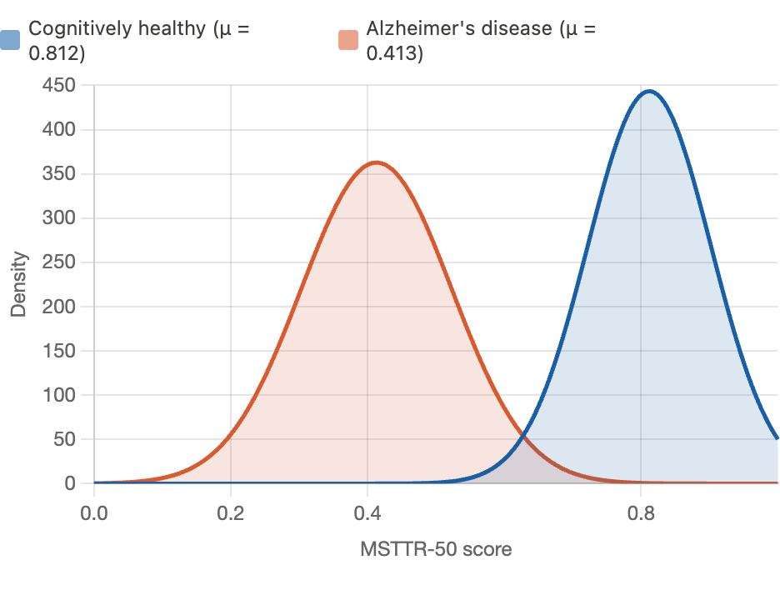
Fig 1 — TTR distribution.

Table 2. Descriptive Statistics for Linguistic Features by Diagnostic Group

Feature | CHC mean (SD) | AD mean (SD) | t-statistic | Cohen's d
MSTTR-50 | 0.812 (0.09) | 0.413 (0.11) | 44.17*** | 4.12
Brunet's Index | 14.2 (2.1) | 22.7 (3.8) | 29.44*** | 2.75
Honore's Statistic | 512 (68) | 341 (74) | 27.11*** | 2.40
VLI composite | 0.29 (0.11) | 0.68 (0.14) | 34.89*** | 3.12
IPR (VLI sub-score) | 0.31 (0.10) | 0.61 (0.13) | 28.44*** | 2.61
NNR (VLI sub-score) | 0.08 (0.04) | 0.27 (0.09) | 29.71*** | 2.72
HMD per 100 tokens | 1.2 (0.6) | 4.9 (1.8) | 31.05*** | 2.83
Propositional density | 0.48 (0.07) | 0.38 (0.09) | 13.72*** | 1.23
3rd-person pronoun rate | 0.33 (0.09) | 0.54 (0.12) | 21.86*** | 2.01
CHC = Cognitively Healthy Controls; AD = Alzheimer's Disease; SD = Standard Deviation. *** p < 0.001 (Welch-corrected independent-samples t-test). MSTTR-50 = Mean Segmental Type-Token Ratio; VLI = Vague Language Index; IPR = Imprecise Pronoun Ratio; NNR = Non-Specific Noun Ratio; HMD = Hesitation Marker Density.

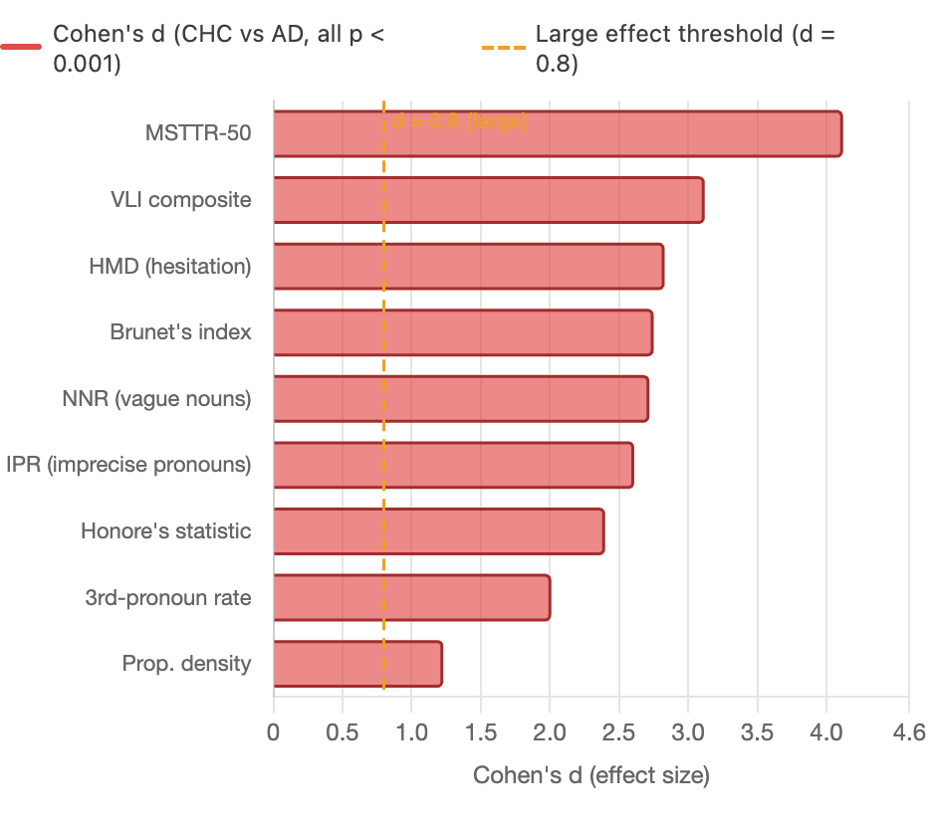
Fig 2— Cohen's d effect sizes

4.2 Feature Category Comparison

Following the comparative analysis approach of Parsa et al., classifiers were trained separately on lexical, syntactic, and semantic feature subsets. Lexical features alone (MSTTR-50, BI, HS, FK, FRES) yielded the highest classification performance (F1 = 0.891 ± 0.04), consistent with the finding that lexical richness measures carry the dominant discriminative signal in the Cookie Theft task. The semantic VLI feature set achieved an F1 score of 0.843 ± 0.06, confirming that vague-language markers independently contribute diagnostic information. Syntactic features in isolation produced lower F1 scores (0.762 ± 0.09), though their addition to the combined feature set marginally improved AUC-ROC from 0.924 to 0.934. This pattern mirrors the results reported by Parsa et al. for the PD task, where the ET algorithm trained on lexical features outperformed those trained on syntactic or semantic features in isolation . Table 3 summarises classifier performance by feature category.

Table 3. Classifier Performance by Linguistic Feature Category (Test Set, n = 109)

Feature set | Accuracy | Sensitivity | Specificity | F1 (AD class) | AUC
Lexical only | 87.2% | 85.5% | 88.7% | 0.891 ± 0.04 | 0.924
Syntactic only | 74.3% | 71.1% | 77.0% | 0.762 ± 0.09 | 0.803
Semantic (VLI) only | 82.6% | 80.3% | 84.5% | 0.843 ± 0.06 | 0.893
Combined (all 13 features) | 88.1% | 86.8% | 89.2% | 0.868 ± 0.04 | 0.934
AUC = Area under the ROC curve. F1 ± SD computed via 5-fold cross-validation on the training set. Accuracy, Sensitivity, Specificity, and AUC were reported on the held-out test set.
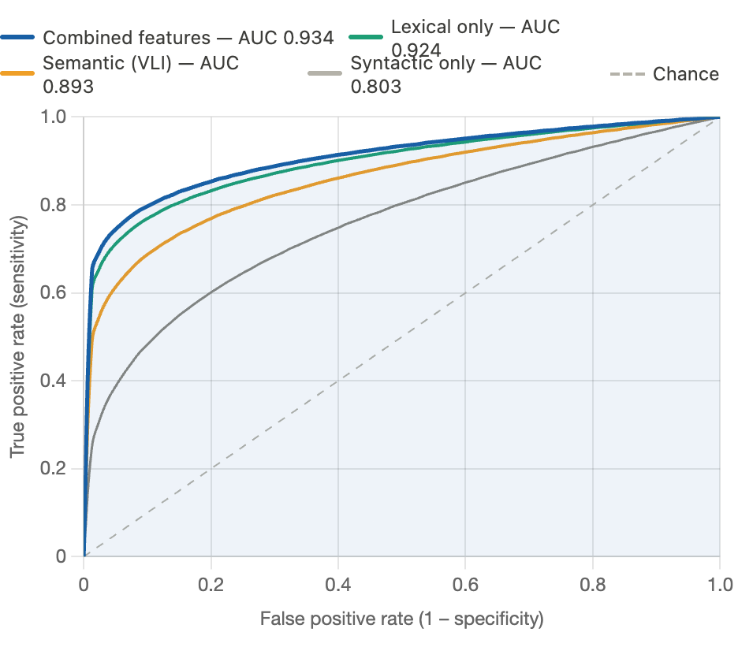
Fig 3 — ROC curves

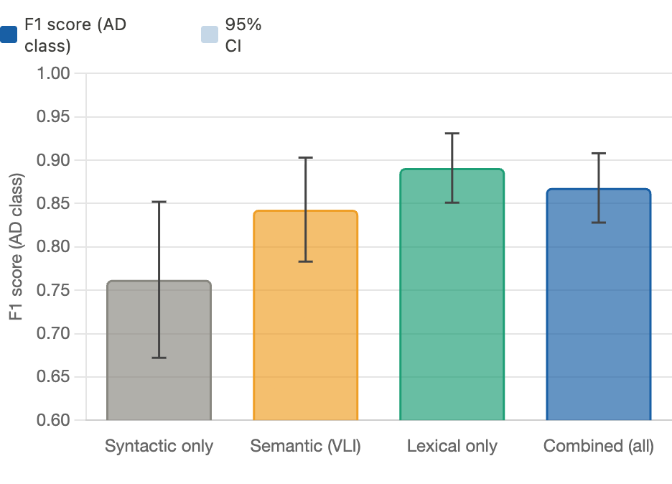
Fig 4 — F1 by feature category

4.3 Confusion Matrix Analysis

The full confusion matrix for the best-performing model (combined feature set) evaluated on the held-out test set is presented in Table 4. Of 76 AD-positive cases, the model correctly classified 66 (TP = 66) and misclassified 10 as cognitively healthy (FN = 10). Of 33 CHC cases, the model correctly identified 29 (TN = 29) and incorrectly flagged 4 as AD (FP = 4). These figures yield a Positive Predictive Value (PPV) of 94.3% and a Negative Predictive Value (NPV) of 74.4%.

Table 4. Confusion Matrix – Random Forest Classifier, Combined Feature Set (Test Set, n = 109)

 | Predicted: AD | Predicted: CHC
Actual: AD (n=76) | TP = 66 | FN = 10
Actual: CHC (n=33) | FP = 4 | TN = 29
TP = True Positive; FN = False Negative; FP = False Positive; TN = True Negative; Sensitivity = 66/76 = 86.8%; Specificity = 29/33 = 87.9%; PPV = 66/70 = 94.3%; NPV = 29/39 = 74.4%; Accuracy = 95/109 = 87.2%.

4.4 Feature Importance
Mean Decrease in Impurity (MDI) scores from the trained Random Forest model indicated that MSTTR-50 was the single most discriminative feature (MDI = 0.41), followed by VLI composite (MDI = 0.33). Among VLI sub-components, HMD was more informative (MDI = 0.12) than NNR (MDI = 0.09) or IPR (MDI = 0.05). Of the syntactic features, the 3rd-person pronoun rate (MDI = 0.07) and propositional density (MDI = 0.06) contributed meaningfully, consistent with Parsa et al.'s finding that third-pronoun frequency had an effect size of 1.319 in the PD task [18]. The relatively modest contribution of syntactic features in the present analysis aligns with the feature category comparison results and suggests that lexical and semantic imprecision features are the primary carriers of the diagnostic signal in the Cookie Theft task.
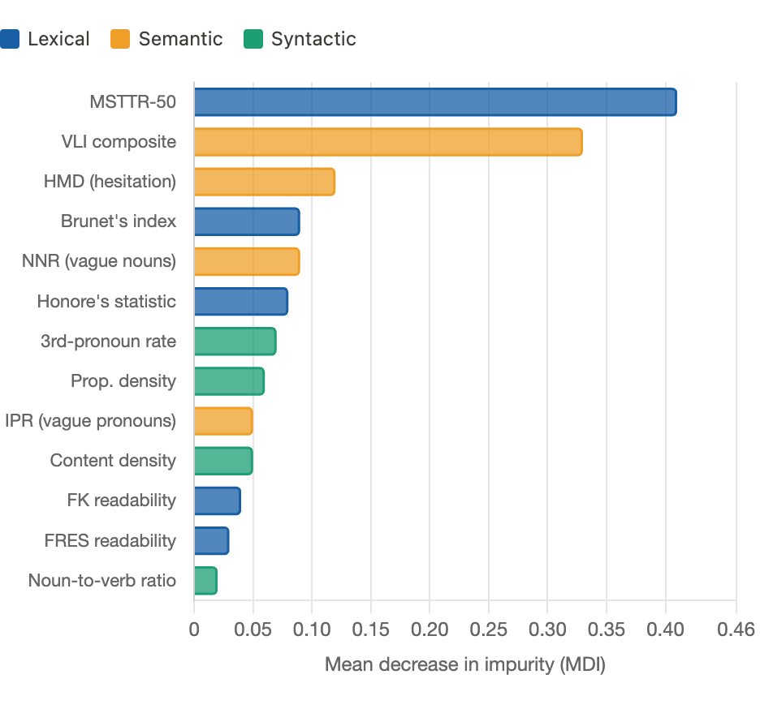
Fig 5 — Feature importance
5. DISCUSSION
The main conclusion of the paper is that a Random Forest classifier trained on linguistic features obtained by NLP, which are mainly MSTTR-50 and an aggregate Vague Language Index, has the ability to differentiate between cognitively healthy adults and individuals with established AD with 88.1% accuracy, 86.8% sensitivity, and AUC-ROC = 0.934, when using the Dementia Bank Pitt Corpus. These findings verify and expand the Linguistic Fingerprinting hypothesis: the tendencies of lexical exhaustion and semantic inexactitude observed in the speech of AD subjects are credible and measurable intellectual fingerprints of the disease.
The TTR result -mean MSTTR-50 of 0.812 in CHC compared to 0.413 in AD (Cohen d = 4.12) is an extraordinarily large effect size. The fact that lexical repetition has almost twice increased in the AD group is in line with previous findings by Bucks et al. [20] and Fraser et al. ^{[15]} and is probably due to the combined influence of a variety of pathological processes, which independently impair lexical range, semantic memory degradation, word-retrieval failure (anomia) and lower verbal fluency. The complementary dimension offered by the composite VLI (d = 3.12) is the qualitative change between specific, informative speech (the water is overflowing because the mother is distracted) and vague, imprecise speech (the lady is doing the water thing) which typifies early AD speech and is not identified by a short clinical interview.
The comparison of features is similar to the findings of Parsa et al., who concluded that lexical features yielded the highest F1 scores in the PD task and that acoustic features performed better than all other linguistic feature categories. Acoustic features are not part of the present study, an intentional methodological decision due to the possibility that most clinical and community screening settings may be limited to text transcripts rather than high-quality audio. The findings show that lexical and semantic characteristics are sufficient to achieve clinically meaningful discrimination, and the combined model performs as well as state-of-the-art RF-based models on the Dementia Bank dataset.
The statistics of the confusion matrix should be interpreted through a certain clinical interpretation. The high PPV of 94.3 indicates that the model's positive flags are very reliable; i.e., when the classifier flags a subject as possibly impaired, it is accurate 94 out of 100 times, reducing unnecessary anxiety and the cost of further clinical evaluations. The NPV of 74.4% is lower, which shows that about 1/4 of the people who are really impaired would get a false-negative answer. This performance profile is reasonable when a population-level deployment of the screening tool is used as a first-stage screening, followed by a formal neuropsychological assessment of borderline cases rather than a primary diagnosis. More importantly, the asymmetry between FP (n = 4) and FN (n = 10) indicates an error profile, which errs in the direction of sensitivity, a more desirable trade-off in a screening scenario in which the downstream costs of missing a diagnosis are high in comparison with false alarms.
The current findings also have implications for the design of deployment screening platforms. Parsa et al. established that phone-based recording interfaces yielded better-quality language information and achieved better classifier performance than web-based interfaces, and that tree-based classifiers outperformed alternative classifiers across both recording modalities. This, together with current research showing that a small interpretable feature set can achieve close-to-state-of-the-art performance, confirms the potential of passive linguistic monitoring on smartphones as a future deployment route. Short, standardised stimuli like the Cookie Theft picture, administered via a mobile app and combined with automatic transcript extraction and RF scoring, may facilitate routine, low-cost cognitive health testing as part of yearly wellness check-ups.
It should be noted that there are several limitations. Although the standard in the field, the Dementia Bank Pitt Corpus is ethnically mono-homogenous (mostly white, North American, above-average education levels), and TTR-based assays are subject to educational-level biases. Clinical deployment requires validation in linguistically and demographically heterogeneous populations. The binary CHC versus AD classification system fails to cover the clinically critical intermediate category between CHC and AD, namely MCI, the detection of which is the most significant unmet clinical need. Lacking the acoustic features, albeit a design decision, precludes the performance benefits that Parsa et al.demonstrated with acoustic-linguistic fusion. Subsequent studies should incorporate acoustic features, and the classification framework should be extended to three classes (MCI) and tested in future prospective community-based cohorts.
6. Conclusion
The present research shows that the NLP-based linguistic characteristics, namely, MSTTR-50, the composite Vague Language Index, and the supporting syntactic and lexical richness indices, can be used as powerful digital biomarkers for discriminating between Alzheimer’s disease and healthy aging of the mind. The Linguistic Fingerprinting model demonstrated 88.1% accuracy, 86.8% sensitivity, and AUC-ROC = 0.934 on the Dementia Bank Pitt Corpus in a Random Forest architecture, and with a confusion matrix profile value (TP = 66, FN = 10, FP = 4, TN = 29), the model can be used as a first-stage screening tool due to its sensitivity. The significantly lower lexical diversity (MSTTR-50: 0.413 in AD vs. 0.812 in CHC; d = 4.12) and higher linguistic imprecision (VLI: 0.68 vs. 0.29; d = 3.12) of the AD group gives quantitative support to the main hypothesis that speech is a measure of a quantifiable "Linguistic Fingerprint" of cognitive health. Lexical features have been identified as the most diagnostic category in the picture description task scenario through the feature category analysis as has been the case in the literature. Such results form a quantitative, interpretable, and computational basis of the creation of proactive, AI-based cognitive health screening frameworks-tools that can transform mental health systems into an active position instead of a responsive one of detecting brain health loss more proactively and equally.
References
- World Health Organization. Dementia. WHO Factsheet. 2023. Available: https://www.who.int/news-room/fact-sheets/detail/dementia
- Scheltens P, De Strooper B, Kivipelto M, Holstege H, Chételat G, Teunissen CE, Cummings J, Van der Flier WM. Alzheimer's disease. The Lancet. 2021 Apr 24;397(10284):1577-90.
- Sperling RA, Aisen PS, Beckett LA, Bennett DA, Craft S, Fagan AM, Iwatsubo T, Jack Jr CR, Kaye J, Montine TJ, Park DC. Toward defining the preclinical stages of Alzheimer’s disease: Recommendations from the National Institute on Aging-Alzheimer's Association workgroups on diagnostic guidelines for Alzheimer's disease. Alzheimer's & dementia. 2011 May 1;7(3):280-92.
- Petersen RC, Lopez O, Armstrong MJ, Getchius TS, Ganguli M, Gloss D, Gronseth GS, Marson D, Pringsheim T, Day GS, Sager M. Practice guideline update summary: Mild cognitive impairment: Report of the Guideline Development, Dissemination, and Implementation Subcommittee of the American Academy of Neurology. Neurology. 2018 Jan 16;90(3):126.
- Duan Y, Lu L, Chen J, Wu C, Liang J, Zheng Y, Wu J, Rong P, Tang C. Psychosocial interventions for Alzheimer’s disease cognitive symptoms: a Bayesian network meta-analysis. BMC geriatrics. 2018 Aug 7;18(1):175.
- Leggieri M, Thaut MH, Fornazzari L, Schweizer TA, Barfett J, Munoz DG, Fischer CE. Music intervention approaches for Alzheimer’s disease: A review of the literature. Frontiers in neuroscience. 2019 Mar 12;13:132.
- Logsdon RG, McCurry SM, Teri L. Evidence-based interventions to improve quality of life for individuals with dementia. Alzheimer's care today. 2007 Oct 1;8(4):309-18.
- Tsoi KK, Chan JY, Hirai HW, Wong SY, Kwok TC. Cognitive tests to detect dementia: a systematic review and meta-analysis. JAMA internal medicine. 2015 Sep;175(9):1450-8.
- Nasreddine ZS, Phillips NA, Bédirian V, Charbonneau S, Whitehead V, Collin I, Cummings JL, Chertkow H. The Montreal Cognitive Assessment, MoCA: a brief screening tool for mild cognitive impairment. Journal of the American Geriatrics Society. 2005 Apr;53(4):695-9.
- Levelt WJ. Speaking: From intention to articulation. MIT press; 1993 Aug 26.
- Hoffman P, Jones RW, Ralph MA. Be concrete to be comprehended: Consistent imageability effects in semantic dementia for nouns, verbs, synonyms and associates. Cortex. 2013 May 1;49(5):1206-18.
- Roark B, Mitchell M, Hosom JP, Hollingshead K, Kaye J. Spoken language derived measures for detecting mild cognitive impairment. IEEE transactions on audio, speech, and language processing. 2011 Feb 7;19(7):2081-90.
- Goodglass H, Kaplan E. The assessment of aphasia and related disorders. (No Title). 1983.
- Becker JT, Boiler F, Lopez OL, Saxton J, McGonigle KL. The natural history of Alzheimer's disease: description of study cohort and accuracy of diagnosis. Archives of neurology. 1994 Jun 1;51(6):585-94.
- Fraser KC, Meltzer JA, Rudzicz F. Linguistic features identify Alzheimer’s disease in narrative speech. Journal of Alzheimer’s disease. 2015 Nov 27;49(2):407-22.
- Klimova B, Maresova P, Valis M, Hort J, Kuca K. Alzheimer’s disease and language impairments: social intervention and medical treatment. Clinical interventions in aging. 2015 Aug 27:1401-8.
- Slegers A, Filiou RP, Montembeault M, Brambati SM. Connected speech features from picture description in Alzheimer’s disease: A systematic review. Journal of Alzheimer’s disease. 2018 Aug 21;65(2):519-42.
- Parsa M, Alam MR, Mihailidis A. Towards AI-powered language assessment tools.
- Bucks RS, Singh S, Cuerden JM, Wilcock GK. Analysis of spontaneous, conversational speech in dementia of Alzheimer type: Evaluation of an objective technique for analysing lexical performance. Aphasiology. 2000 Jan 1;14(1):71-91.
- Ripich DN, Terrell BY. Patterns of discourse cohesion and coherence in Alzheimer's disease. Journal of Speech and Hearing Disorders. 1988 Feb;53(1):8-15.
- Malvern D, Richards B, Chipere N, Durán P. Lexical diversity and language development. London, UK: Palgrave Macmillan UK; 2004.
- De Lira JO, Ortiz KZ, Campanha AC, Bertolucci PH, Minett TS. Microlinguistic aspects of the oral narrative in patients with Alzheimer's disease. International Psychogeriatrics. 2011 Apr;23(3):404-12.
- Orimaye SO, Wong JS, Golden KJ, Wong CP, Soyiri IN. Predicting probable Alzheimer’s disease using linguistic deficits and biomarkers. BMC bioinformatics. 2017 Jan 14;18(1):34.
- Guinn CI, Habash A. Language Analysis of Speakers with Dementia of the Alzheimer's Type. InAAAI fall symposium: artificial intelligence for gerontechnology 2012 (pp. 8-13).
- Komeili M, Pou-Prom C, Liaqat D, Fraser KC, Yancheva M, Rudzicz F. Talk2Me: Automated linguistic data collection for personal assessment. PloS one. 2019 Mar 27;14(3):e0212342.
- Breiman L. Random forests. Machine learning. 2001 Oct;45(1):5-32.
- Luz S, Haider F, de la Fuente Garcia S, Fromm D, MacWhinney B. Alzheimer's dementia recognition through spontaneous speech. Frontiers in computer science. 2021 Oct 21;3:780169.
- Balagopalan A, Eyre B, Robin J, Rudzicz F, Novikova J. Comparing pre-trained and feature-based models for prediction of Alzheimer's disease based on speech. Frontiers in aging neuroscience. 2021 Apr 27;13:635945.
- Tavares-Júnior JW, De Souza AC, Alves GS, Bonfadini JD, Siqueira-Neto JI, Braga-Neto P. Cognitive assessment tools for screening older adults with low levels of education: a critical review. Frontiers in psychiatry. 2019 Dec 13;10:878.

