Maze
10th March
I plan to make the game in python, using pygame or text based output for the user interface.
By doing so, the programs should easily be able to run in school as python is preinstalled. I will start developing a dummy model that is purely text based so I understand the requirements of building each game
17th March
A large portion of the maze game has been coded, although some of the logic needs cleaning up on, for example, when I convert a cardinal direction (North, South, etc) into a vector (1 up 0 across etc), the player treats upwards as + and downwards as negative. However, the maze and its children cells treat it the other way round, with down being described as positive, this is due to the nature of python arrays. As each row in a maze is its own independent array, so if I want the row immediately above, the index I must reference is one less than the one I am currently in, but by coordinates it is one more than the one I am currently in – So I need to ensure that I stick to a single convention, referencing cells either by their python index or their geometric coordinates.
18th March
Successfully created a version of the game that bridges the inconsistencies of geometric and index coordinates. The game is fully runnable, all that I need to do is figure out how to render it in text.
19th March
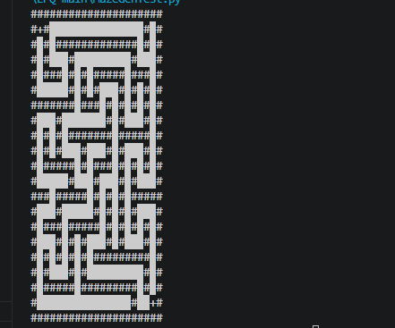
The python version of the game seems to be coming along very well, no new bugs or anything to report, everything has been fixed so far. The only minor grudge is that it isn’t too aesthetically pleasing.
20th March
I have completed the maze game in python and have realised that a text-based approach is not wise, as it is hard on the eyes which may make people unwilling to play it. I am contemplating whether to swap to “pygame” or to swap to HTML and produce a website. However, by completing it in python first, I now understand the requirements of a maze game; Usage of stacks, recursion, and helper functions are all quintessential in the development of a maze. I think the python text-based version will serve as a good framework if I ever decide to move to HTML as it is incredibly organized and neat, which will help me when I come to learn and program the maze in JavaScript for the first time.

28th March
I have watched a few tutorials on the basics of HTML and JavaScript, and it doesn’t seem too difficult, I have noted that there isn’t a simple way to import modules like python which uses one line. Although JavaScript does have a lot of inbuilt functionality that I could leverage instead. I have also began developing the maze website itself, with it originally being programmed as a dynamic table which changes its values, however this is even uglier than the python text based version, and the rendering logic is incredibly convoluted this time. Tomorrow I’ll try to learn the <canvas> element as I know it is typically used for games like this.
29th March
The canvas element works exactly the way I wanted it to; although it is tedious to use as I must instruct it to colour every individual line, it is very customisable – I can draw anything anywhere. If all goes well, I’ll finish the maze game completely before the end of May.
1st April
The way today went was quite bad, I decided to scrap using the <canvas> for the foreseeable future as I am struggling to implement the recursive backtracker, that I used in python, in JavaScript. I have read Wikipedia pages and online forums, my specific issue is trying to implement a Stack data structure that I can use like I did in python, I would rather not have to create my own data type as I’m only new to JavaScript but I think it may have to be done.
2nd April
I explored creating my own Stack data type in JavaScript and it honestly wasn’t too different from python. This allowed me to finally finish the recursive backtracking algorithm elegantly, as I already filled in all the code that did not rely on the Stack, so I wasn’t wasting time. I spent the majority of today researching the <canvas> element, looking online at other peoples’ attempts at doing what I’m doing and looking for general practices to use that will make the rendering function more elegant. I have settled on the idea of drawing each cell of the maze independently, using for loops to progressively work on drawing each cell.
4th April
The <canvas> implementation fully works now! And so does the whole website, all I need to do is hook it up to some user input, maybe a UI with buttons or simply keyboard input, and the maze is finished.
I have dealt with the input, but I feel like the maze is too easy, even at maximum difficulty the mazes generated have obvious solutions. There aren’t enough winding paths or dead ends to make it truly difficult, I researched and this is a key property of mazes generated by a recursive backtracking algorithm.
11th April

