Farmer Tools Expansion

Director Q Review Brief

Author | Nile
Team | Detroit Root Network
Prepared for | Quinn — Director Q
Date | September 2026
Status | Proposed scope for review

1 Recommendation and Review Purpose
Quinn, I recommend expanding Detroit Root Network so farms can grow, sell, or do both within one profile. This creates a path from seasonal planning to recorded harvests and, later, opt-in forecasts and volunteer suggestions. The purpose of this brief is to review that sequence, the value for Detroiters, and the controls farmers need before we commit development scope.
Grow and Sell are selectable farm capabilities. Plan, Track, and Anticipate are delivery stages, not separate account types. The proposed features below are not yet implemented. We should validate the first stage with farmers before committing later-stage scope or delivery dates. No adoption, yield, or community-impact results are assumed.

Proposed delivery stages
Stage | Farmer outcome | Detroiter value | Key boundary | Progression
Plan | Seasonal plots and crop plans | Approved Coming soon outlooks | Plans private by default | Validate the basic workflow
Track | Actual events and harvest history | Confirmed availability updates | Harvest is not sales stock | Establish reliable records
Anticipate | Forecasts and volunteer drafts | Approved timely opportunities | Opt-in and approval required | Proceed only with evidence
Table 1 Stage scope and community value

2 Farm Capabilities and Community Value
Keep one farm identity, team, and history. A farm can enable Grow, Sell, or Both and switch workspaces without copying records or creating a second account. Capabilities control which tools are visible; they do not grant permissions or publish data. A grow-only farm can share an approved seasonal outlook or volunteer opportunity without running a sales stall.

How the three capability choices work
Capability | Tools | Public option | When changed
Grow | Plan and record crops | Approved outlooks and volunteer needs | Keep plot and season history
Sell | Maintain inventory and selling details | Confirmed stock and sales locations | Retain previous sales records
Both | Link growing and selling workspaces | Approved outlook plus confirmed stock | No duplicate farm identity
Switching | Enable or hide tools | Review active listings separately | Never erase data or auto-publish
Table 2 Farm capabilities and switching behavior

3 What Each Stage Includes

Stage One Plan
Farmer tools. Add Grow/Sell/Both settings, seasons, named plots or beds, and crop entries. Record planned planting dates or windows, expected harvest windows, area and units, intended use, and optional farmer-entered yield ranges. Provide a calendar or simple plot overview; a geographic drawing tool is not required for the first release.
Planning and public value. Start with farmer-entered estimates. If crop-duration guidance is offered, identify its source and treat it as an editable assumption, not a local guarantee. Farmers can preview and publish selected crops as Coming soon, with a broad harvest window and last-confirmed date. Detroiters gain seasonal awareness without seeing private plot details.
Boundary. Do not publish plans automatically or convert them into available inventory. Detailed growing maps, commercial notes, and projected quantities stay private unless a separate publishing choice permits them. Automated yield forecasting and predicted volunteer demand wait for later stages.
Exit check. A farmer can create and revise a season plan, switch capabilities without losing history, preview exactly what will become public, and withdraw a seasonal listing. Reviewers must understand that Coming soon is an estimate.

Stage Two Track
Farmer tools. Record actual planting, preparation, and harvest events against a plot and crop. Capture date, quantity, unit, recorder, and optional notes; record loss or no harvest without inventing a zero when data is missing. Show a season timeline and simple planned-versus-actual comparisons. Offer a usable export of the farm history.
Connection to selling. A blended farm can explicitly allocate part of a recorded harvest to sale inventory. Separate gross harvest from stock available for sale, donation, seed, household use, or loss. Require review before updating the public inventory so a harvest entry cannot silently become a sales promise.
Value for Detroiters. Farmer-confirmed inventory and update dates make discovery more useful. Grow-only farms may choose to publish harvest updates or a distribution location, but recording a harvest alone does not establish public access, opening hours, or permission to visit.
Exit check. Corrections preserve who changed what and when. Units remain consistent or are converted through a recorded rule. Partial harvests, repeated entries, and inventory allocations cannot double-count output. Public information changes only through an authorized publishing action.

Stage Three Anticipate
Forecasts. Use recorded farm history and current plans to suggest harvest windows, output ranges, and preparation needs. Begin with explainable rules and farmer-set task templates. Use more complex models only if data quality and measured performance justify them. Where evidence is sparse, say Insufficient data rather than presenting a precise prediction.
Opt-in volunteer suggestions. Keep predictive volunteer assistance off by default. An authorized farm manager opts in to a stated purpose and data scope. Generate private drafts with task, proposed date window, estimated effort or staffing range, and the basis for the suggestion. Farmers edit, accept, reject, or dismiss each draft; opt-in never means automatic publication.
Value for Detroiters. Only farmer-approved opportunities reach public discovery. They explain the work, timing, participation requirements, and contact route. Farmer-approved harvest outlooks can help residents plan ahead, but remain separate from confirmed availability.
Exit check. Test forecasts against observed outcomes and review missed needs, false alerts, and farmer override rates. Explain stale inputs and uncertainty. Withdrawal stops future suggestions and follow-up processing; the farmer explicitly decides whether already published opportunities remain open or need cancellation notices.

Public data contracts across stages
Information | Plan | Track | Anticipate
Crop timing | Expected window | Observed dates | Suggested range
Quantity | Optional estimate with units | Recorded actual quantity | Estimate with stated basis
Available food | Never inferred from a plan | Farmer-confirmed allocation | No automatic stock promise
Public visibility | Preview and approve | Approve selected updates | Approve every suggested update
Volunteer help | Manually published opportunity | Record prep or harvest needs | Private opt-in suggestion first
Gate | Farmer understands estimate | History and totals stay accurate | Consent and quality checks pass
Table 3 Required distinctions in the interface
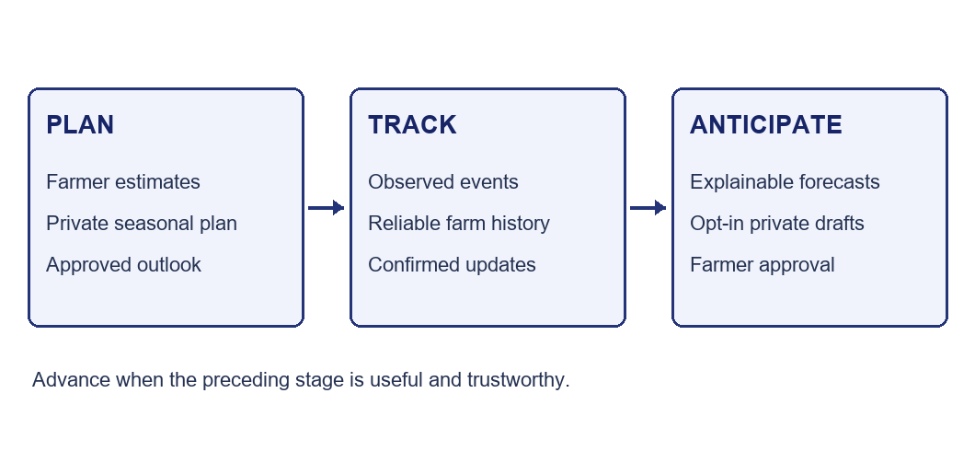
Figure 1 Build the foundation before prediction
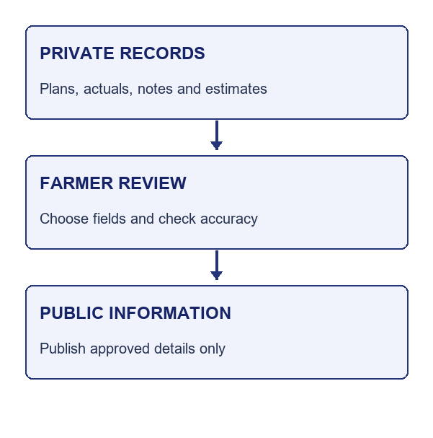
Figure 2 Farmer control over publication

4 Farmer Security and Product Safety
Private farm records and public discovery should be separate data views. Publish only an approved subset, never a direct copy of every plot or harvest record. Grow/Sell/Both choices must remain independent of authorization, public visibility, and prediction consent. Existing T2 records remain read-only fixtures and must not be treated as real farm observations or forecasting training data.

Access and consent requirements
- Farm access: enforce ownership and membership in Supabase Row Level Security, including direct API calls, exports, and history. Define who can record, correct, publish, and manage consent. Protect against access through guessed plot, crop, event, or attachment identifiers.
- Director access: Quinn’s existing cross-T1 access must not silently extend to detailed growing logs. Before implementation, agree whether Director Q can see private growing records by default, by explicit farm invitation, or only through shared summaries. Apply the selected policy in the database.
- Prediction consent: explain what records support suggestions, who can view the results, and how to stop them. Record consent scope, version, actor, and time. Keep cross-farm analysis or model training outside default consent; any future use needs a separate decision and farmer-facing explanation.
- Public and volunteer safety: hide precise private plot layouts, access instructions, and sensitive notes. Before publishing a work opportunity, require the farmer to confirm date, capacity, meeting details, supervision, and relevant task requirements. The product must not infer that a task is safe or suitable for someone based only on a forecast.

Risks and required controls
Risk | Who is affected | Required control
Estimates mistaken for stock | Residents and farmers | Separate labels, time windows, confirmation dates, and publishing actions
Private farm details exposed | Farm teams | RLS, explicit Director access, limited public fields, export checks
Incorrect or stale records | Farmers and downstream forecasts | Provenance, units, edit history, duplicate prevention, stale-input warnings
Unwanted or unsafe volunteer suggestions | Farmers and volunteers | Opt-in, explainable drafts, farmer review, task details, withdrawal controls
Table 4 Review risks before stage approval

5 Suggested Review Responsibilities
- Nile — turn agreed scope into requirements, data contracts, permissions, acceptance criteria, and release gates. Confirm technical feasibility before setting dates.
- Quinn — review the grower workflows and language, identify representative Grow/Sell/Both participants, and test whether privacy and forecast labels are understood. These are proposed responsibilities for agreement.
- Together — review farmer feedback after each stage, prioritize the next increment, and document unresolved decisions rather than treating this brief as final approval.
- Farm participants — validate the minimum useful planning and harvest records, acceptable effort to maintain them, and whether volunteer suggestions solve a real need. Participation remains voluntary.

6 Data Fidelity and Farmer Trust
Keep planned, observed, estimated, and published values distinct. Every record should retain its farm and season, crop or plot reference, event date or range, unit, source, actor, and update time as appropriate. Identify manually entered values, imported records, and calculated outputs. Unknown data is not zero; do not combine incompatible units or silently assign a precise date to a broad estimate.
Corrections must preserve the original value and a change history or equivalent trace. Distinguish partial harvests from final totals, and prevent repeat submissions from creating duplicate output. Capability switching must not erase old seasons. Define an archive, export, and deletion policy with farmers before launch; clarify how deletion affects derived forecasts and public summaries.

Forecast quality and honest presentation
Show forecast ranges and the inputs used. Version the rule or model, retain the calculation time, and flag stale inputs. Display low confidence only when a defined method supports that label; otherwise describe the limitation in plain language. A forecast does not become a confirmed harvest, available stock, or a published opportunity without a separate verified event or approval.
Evaluate suggested windows against actual harvests and assess quantity error only where comparable units and sufficiently complete records exist. Track missing data, overrides, false alerts, and canceled tasks. Agree evaluation thresholds after initial observation; do not invent accuracy percentages before pilot evidence exists.

When to narrow or stop a feature
If farmers cannot maintain the inputs, reduce the required fields or provide assisted entry before adding predictive complexity. If people mistake estimates for available food, change the language and publishing flow before expansion. If suggestions create unwanted work, frequent false alerts, or privacy concerns, disable suggestions for the affected farm and correct the design. A rules-based reminder may be more useful than a model when historical data is sparse.

Pilot sequence and evidence
Start with a small group representing grow-only, sell-only, and blended operations. Test the profile choices and a single season plan. Follow with harvest logging and explicit public updates. Add predictive volunteer assistance only for farms that choose it after experiencing the basic workflow.
For each stage, observe whether farmers can finish the key task without help, how much entry effort it takes, whether information stays current, and whether public/private distinctions are clear. Ask Detroiters whether seasonal outlooks and confirmed availability help them plan a visit or volunteer action. These are evaluation questions, not demonstrated outcomes.
Schedule around actual farm seasons and participants’ capacity. Agree timing with Quinn and farmers before assigning deadlines. Weather data, automated geocoding, notifications, and predictive models introduce additional costs and dependencies; they are not assumed prerequisites for Stage One.
Before any broader demo, complete email authentication and live farm-isolation tests, confirm T2 protection, verify public projections exclude private records, and remove temporary Owner/Director Q code login. A read-only recruiter presentation must never provide access to growing records. Set a rollback plan for each new publishing or prediction feature.

Director Q Review Decisions
1 Profile model. Does one farm with Grow, Sell, or Both match the people Quinn expects to involve? Identify exceptions such as multiple plots, shared growing sites, or farms that distribute food without selling.
2 First release. Are seasonal plots, crop entries, a calendar, and optional Coming soon listings enough to create value? Which fields should be required, and which would discourage participation?
3 Community value. Which public information helps Detroiters most: broad harvest outlooks, distribution details, confirmed stock, or volunteer needs? Which should remain private even if publication is optional?
4 Permissions. What private growing information should Director Q and other team members be able to see or change? Who can approve public updates and manage prediction consent?
5 Volunteer consent. Is the opt-in explanation understandable? Who should receive draft suggestions, and what should happen to an open opportunity when consent is withdrawn or a forecast changes?
6 Pilot and readiness. Who can test each capability, what evidence should determine progress, and which stage should wait? Record Approve, Revise, or Defer for each stage with comments and a proposed next action.

