Detroit Root Network

Technical Project Brief

STATUS  Deployed private beta |  | TEAM  Nile and Quinn |  | UPDATED  September 2026

Team | Nile and Quinn
Audience | Recruiters, technical teams, competition reviewers
Related material | Live discovery and project deployment guide
Scope | Product leadership, architecture, configuration, and pilot readiness

1 Project Overview
Detroit Root Network starts with a practical question: where can someone find locally grown food, and is the information current enough to act on? We built a shared discovery experience and a simple operations workspace so growers can maintain the information customers need. The project demonstrates how product leadership, technical business analysis, program management, and UX research can guide AI-assisted development from requirements through a working cloud deployment. The next step is a controlled farmer pilot to measure whether the workflows improve information freshness and ease of use.
Prepared for recruiters, technical teams, and the Agentic Development Competition for Detroit needs. The current product is a deployed private beta. This brief explains the implementation, configuration, decisions, and evidence behind it; measurable community outcomes will be evaluated through the planned farmer pilot.

2 Goals and Scope
Goals | Outside the current scope
Help visitors find local farms and available produce | Payment processing and checkout
Make operational updates practical for farmers | Automatic geocoding of edited addresses
Enforce roles and read-only T2 fixtures | Claims of completed security audit or load certification
Evaluate a controlled farmer pilot | Claims of adoption, revenue, or measured food-access impact

3 Product Leadership and Problem Definition
I led Detroit Root Network as a Senior Project Manager and Technical Business Analyst. My work connected product requirements to implementation choices: searchable discovery, timely inventory updates, clear farmer workflows, role boundaries, and a practical release process. I directed AI-assisted development, evaluated changes, configured the cloud services, and worked through deployment and authentication issues rather than stopping at a visual prototype.
Quinn is the Technical Program Manager and UX Researcher. The Director Q role supports cross-T1 review and contextual product feedback, with planned pilot access through farmers in her network. The shared delivery approach combines operational requirements, usability refinement, and controlled testing. AI assisted implementation and documentation; human judgment set the scope, corrected results, and determined readiness.

4 Architecture and Technology Stack

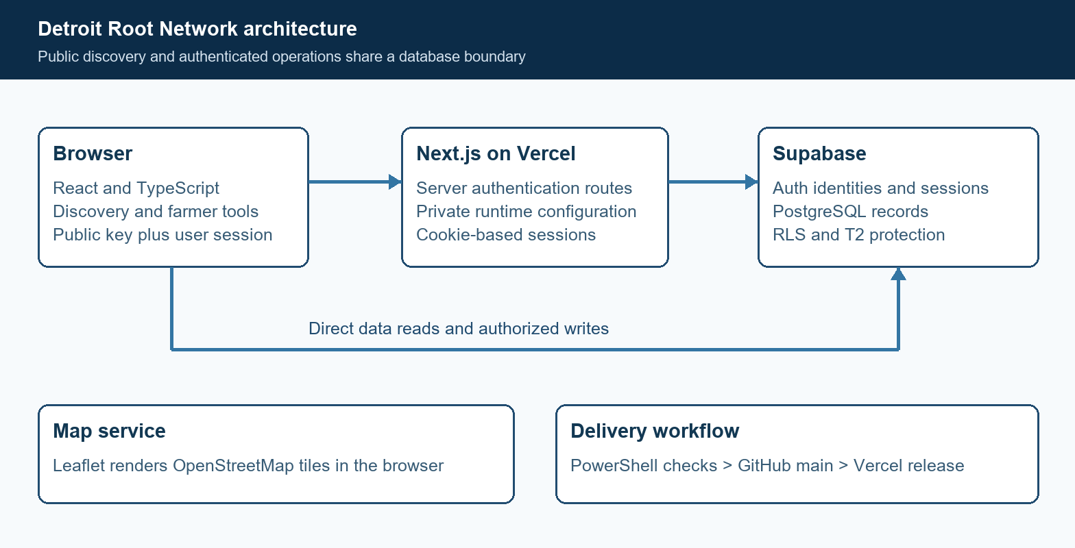
Figure 1 Application components and access boundaries

Core components

Component | Responsibility | Dependency | Failure behavior
Next.js 16 and React 19 | Typed discovery, operations, and feedback UI; server Auth routes | Vercel and TypeScript | Builds checked before release; client notices for many write errors
Supabase Auth | Email links and ordinary authenticated sessions | Supabase session cookies | Invalid beta credentials or identity mismatch fail closed
PostgreSQL | Farm data, roles, memberships, RLS and T2 triggers | Existing Supabase database | Rejected writes must not be treated as successful updates
Leaflet | Map markers and discovery navigation | OpenStreetMap tiles; seeded coordinates | Unknown farm slugs have no mapped coordinate
GitHub and Vercel | Version control, builds, deployment and secret configuration | main branch and environment variables | Failed release remains a deployment issue to investigate

5 User and Release Workflows
- Discovery starts with the browser requesting farm records and related inventory, selling locations, and volunteer opportunities. Search and filters narrow the results; the map links known seeded coordinates to stall details.
- Farmer email sign-in starts through Supabase Auth. The Next.js callback exchanges an authorization code for a session. This flow depends on the correct production Site URL, allowlisted callback, and the browser that initiated sign-in.
- After authentication, the app loads the user profile role and farm memberships. The interface exposes eligible T1 operations, while database RLS and mutation triggers enforce the actual boundary.
- Inventory actions create or update produce, quantity, unit, price, and stock status. Successful writes are followed by reloading data into the interface. SQL normalization reconciles zero quantity with sold-out status.
- Owner and Director Q can temporarily use separate private beta codes. Server-side validation checks the configured code, existing confirmed identity, and database role before obtaining an ordinary Supabase session. This path does not send email or grant a service-role session.
- Changes are validated locally with lint, authentication tests, and a production build. Selected files are committed and pushed to GitHub main, which triggers the connected Vercel deployment. Runtime configuration changes require a redeployment.
- After Vercel reports Ready, live access and workflows are checked. The project owner reported successful beta-code access. Farmer email login still requires a successful retest after the Site URL and callback corrections.

6 Data Model and Service Contracts

Key relational fields

Field | Type | Required | Meaning
profiles.id | UUID | Yes | Matches the Supabase Auth user identity
profiles.role | App role | Yes | Owner, Director Q, or farmer permission category
farm_members.farm_id | UUID | Yes | Relates a membership to a farm
farm_members.user_id | UUID | Yes | Relates the membership to an authenticated user
farms.test_tier | Tier | For trials | T1 editable trial stalls and T2 discovery fixtures
inventory_items.farm_id | UUID | Yes | Associates produce records with their stall
inventory_items.quantity | Numeric | Yes | Drives availability and zero-quantity stock handling

Contract boundaries

- Application writes use the public Supabase client and the authenticated user session. Database policies, not the presence or absence of a button, govern permissions.
- Farm memberships connect users to farms. Owner and Director Q profiles receive cross-T1 permissions. T2 stalls are read-only for app users, including privileged operators.
- Migration files version database changes. The beta-authentication release was committed as 8175d66; Vercel environment values remain separate from source control.
- Discovery reflects farmer-maintained records. It is not a guarantee that produce, opening hours, or volunteer availability will remain unchanged after a visitor views the page.
Implementation references are maintained in the project repository at
https://github.com/Nilejt/detroit-root-network. The repository includes application source, migration files, tests, and deployment instructions.

7 Failure Handling and Consistency

The current system uses ordinary database writes and explicit reloads after confirmed changes. It does not claim offline synchronization, exactly-once processing, or cross-device real-time updates. The remaining recovery and failure scenarios below are important review points for the pilot.
Scenario | Current behavior | Review implication
Repeated inventory submission | No explicit idempotency token is implemented | Assess duplicate prevention during pilot use
Supabase read failure | Discovery can retain demo or previously loaded records | Add clearer degraded-state messaging before wider use
Email callback failure | No usable session is established; errors require diagnosis | Confirm redirect settings and same-browser flow
Kill switch changed | New deployment changes beta-login availability | Existing sessions and old deployments need separate retirement

8 Security and Access Design

- Supabase provides identity and session management. Application profile roles and farm memberships support authorization. SQL triggers protect T2 records against direct edits, retiering, and moving child records between T1 and T2.
- Actual access codes and service keys are excluded from GitHub, downloadable source packages, and NEXT_PUBLIC variables. Public portfolio material omits account UUIDs, passwords, codes, and detailed operational credentials.
- Private Vercel environment variables hold beta codes, identity mappings, and the service-role key. The server uses that key for identity/profile reads and Auth link generation, never to issue a privileged database session to a browser.
- The kill switch defaults code login to disabled unless explicitly enabled. A Vercel firewall rule limits attempts. Existing Supabase sessions require separate revocation; changing a code or disabling new login does not immediately invalidate previously issued JWTs.
- Before a larger demo, remove temporary Owner and Director Q code login, revoke beta sessions, and retire older deployments. The separate recruiter presentation gate does not grant farm access. Privacy policy, operational retention, and audit procedures remain pilot-readiness work.

9 Operational Evidence and Readiness
Evidence | Result or remaining check | Responsibility | Readiness
Production release | Vercel Ready; Owner reported successful beta access | Product delivery | Observed
Local validation | Lint, build, and eight beta Auth tests passed | Implementation validation | Passed
Role configuration | Migration 005 succeeded; profile roles checked | Project administration | Observed
Farmer email flow | Retest after correcting Site URL and redirect allowlist | Project administration | Pending
Backup recovery | Archive listed successfully; full test restore not performed | Project administration | Partial
Rollout requirement: remove temporary operator code login and complete live RLS and farmer email checks before a larger demo.

10 Technology Tradeoffs

Option | Potential benefit | Current decision or constraint
Google Maps | Familiar maps and optional location services | Leaflet and OpenStreetMap chosen for the current map
Only email links | Individual passwordless authentication | Retained for farmers; email quotas affected beta testing
Browser-only access-code check | Simple prototype interaction | Server validation and ordinary Supabase sessions used instead
Automatic geocoding | Markers follow address changes | Deferred; current map uses predefined coordinates

11 Questions for the Pilot
- Usability: Can farmers complete sign-in and their first inventory update without assistance? Observe completion and time to first update before selecting performance targets.
- Information quality: How quickly do selling hours and stock change, and what reminders or expiration rules would keep public listings useful?
- Scale and delivery: What email provider and map tile service should support the pilot and later public traffic? No load-tested capacity or uptime commitment is claimed.
- Program ownership: How will onboarding, support, feedback triage, data retention, and access removal be assigned between product delivery, program management, and UX research?

12 Competition Story and Next Steps
This project demonstrates senior delivery leadership across product definition, technical requirements, role design, cloud configuration, release validation, operational recovery, and an evolving user experience. Its strongest evidence is a working integration and documented decisions; community impact is the next hypothesis to validate. The competition pitch is a working local integration with a testable next step: a controlled farmer pilot that evaluates information freshness and task completion before expansion.
Milestone | Deliverable | Exit evidence
Current beta | Deployed discovery and operations | Owner reports working code login and access behavior
Authentication readiness | Verified farmer email flow and direct API authorization tests | Successful email retest and documented RLS outcomes
Controlled pilot | Initial observed farmer cohort, then up to 15 participants | Onboarding and task-completion measurements
Larger demo | Individual operator authentication and pilot findings | Temporary operator code login removed; readiness gaps addressed

Use footnotes for definitions, assumptions, or terms that need precision without interrupting the main narrative.

