Functional Requirement

Specification For

Attendance Module

**Version History:**

|  |  |  |  |
| --- | --- | --- | --- |
| **Version** | **Description of Change** | **Author** | **Date** |
| 1.0 | Draft | Sreeraj | 04/12/2018 |
| 1.1 | Modifications to Attendance Registry | Sreeraj | 06/12/2018 |

Contents

1. INTRODUCTION 5

1.1. Purpose 5

1.2. Scope / Considerations 5

1.3. Out of Scope 5

1.4. Assumptions and Constraints 5

2. FUNCTIONAL REQUIREMENTS 5

2.1. Attendance Listing 5

2.1.1. Acceptance Criteria 5

2.1.3. Detailed User Stories 6

2.1.4. Error Handling & Validations 6

2.2. Attendance Registry 7

2.2.1. Acceptance Criteria 7

2.2.2. Mock-Ups 7

2.2.3. Detailed User Stories 7

2.2.4. Error Handling and Validations 8

2.3. Daily Report 8

2.3.1. Mock Ups 8

2.3.2. Detailed User Stories 8

2.3.3. Error Handling & Validations 9

2.4. Status Report 9

2.4.1. Mock-Ups 9

2.4.2. Detailed User Stories 9

2.5. Shifts 10

2.5.1. Acceptance Criteria 10

2.5.2. Mock-Ups 10

2.5.3. Detailed User Stories 10

2.5.4. Error Handling & Validations 11

2.6. Regularization 11

2.6.1. Acceptance Criteria 11

2.6.2. Mock-Ups 11

2.6.3. Detailed User Stories 11

2.7. Absent Schedule 12

2.7.1. Acceptance Criteria 12

2.7.2. Mock-Ups 12

2.7.3. Detailed User Stories 12

2.8. General Settings 14

2.8.1. Mock-Ups 14

2.8.2. Detailed User Stories 14

# **INTRODUCTION**

The Attendance module manages the attendace data of the employees. The following fucntions can be performed through the attendance module :

* Mark Attendance
* View Reports
* Manage Shifts
* Manage Absent Schedule
* Regularize attendance
* Manage Attendance settings

## Purpose

Purpose of the document is to cover the fucntionalities needed to implement the Attendance module for HR System.

# **FUNCTIONAL REQUIREMENTS**

## Attendance Listing

## Acceptance Criteria

The data should only be available for HR and Admin level users. Data mentioned in the requirements should be listed with filter and export options.

* + 1. **Mock-Ups**

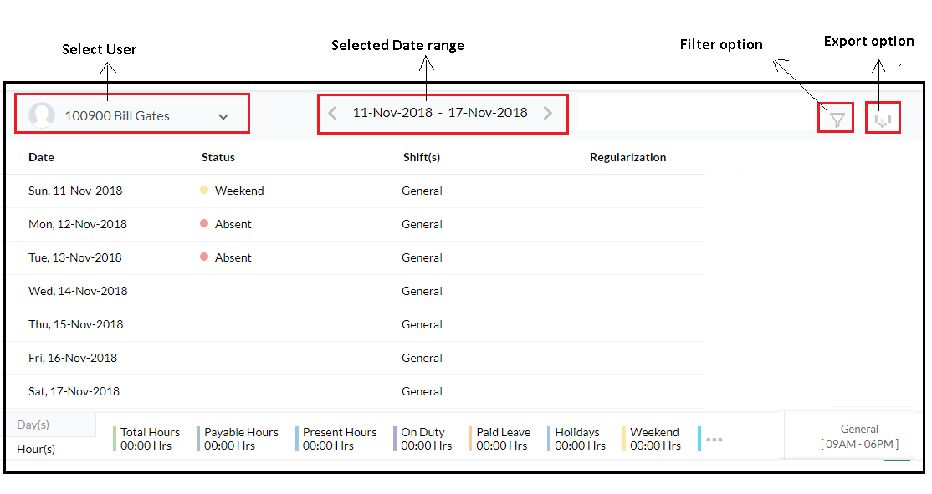

## Detailed User Stories

Attendance Listing page will be available to users under the roles Admin and HR. They can view the attendance data of the employee. They can select the employee from the Drop down available, search functionality will be available using employee name of Employee ID. The following fields will be available in the listing page:

* Date
* Status – Present/Absent/Leave/Weekend/On Duty etc.
* Regularization – lists any regularization made for the specific date

Based on the attendance log the following details will be displayed for each employee in the listing page:

* Present days
* On duty
* Paid leave
* Holidays
* Weekend
* Absent
* Unpaid leave
* Payable Days

User will be able to filter the data for a specific date range. Export option will be available, user the export the data in ‘. XSLX ‘format.

## Error Handling & Validations

While applying the date filter, user should not be able to select a date range beyond the current date

## Attendance Registry

## Acceptance Criteria

User should be able to mark attendance, and edit attendance data for previous dates. User should not be allowed to edit the data once the pay period locking takes place. The system must restrict the user from adding attendance log for future dates.

## Mock-Ups

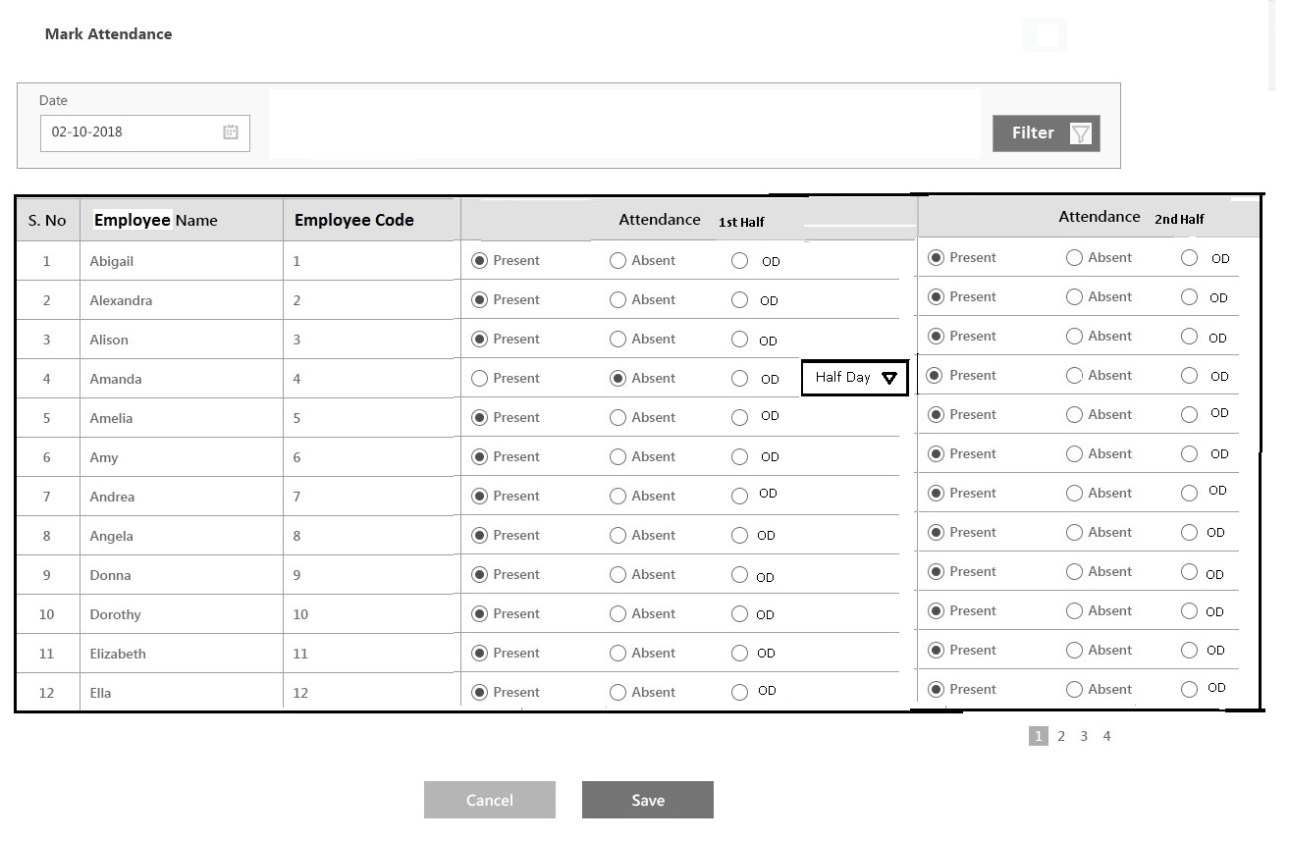

## Detailed User Stories

* The Attendance registry will be accessible for users under HR department and Admin user.
* The attendance registry will be used to perform mainly 2 functions:
  + View/ Edit attendance log of previous dates
  + Add attendance log
* The listing page will have the attendance log of all previous dates for which the attendance has been marked. User can edit the log of previous dates using the ‘Edit’ button, attendance log cannot be edited once the Pay Period locking takes place.
* User can add attendance log using the ‘Mark Attendance’ button. While adding a log the date can be selected using the date picker provided, by default the current date will be selected. User cannot mark the attendance for future dates.
* There will be option to mark attendance for both the sessions of the day separately. User can mark an employee as ‘Present’ , ‘Absent’ or OD(on duty) . If Absent/OD is selected then it can be specified if its for Half day or Full day using the drop down that appears at that time. By default, ‘Full Day’ will be selected in the dropdown. Clicking on ‘Save’ button will save the details, clicking ‘Cancel’ will redirect to Attendance Registry page.
* If a user has applied for leave and the same has been approved then the user will be automatically marked as ‘Absent’ for the corresponding dates.

## Daily Report

## Mock Ups

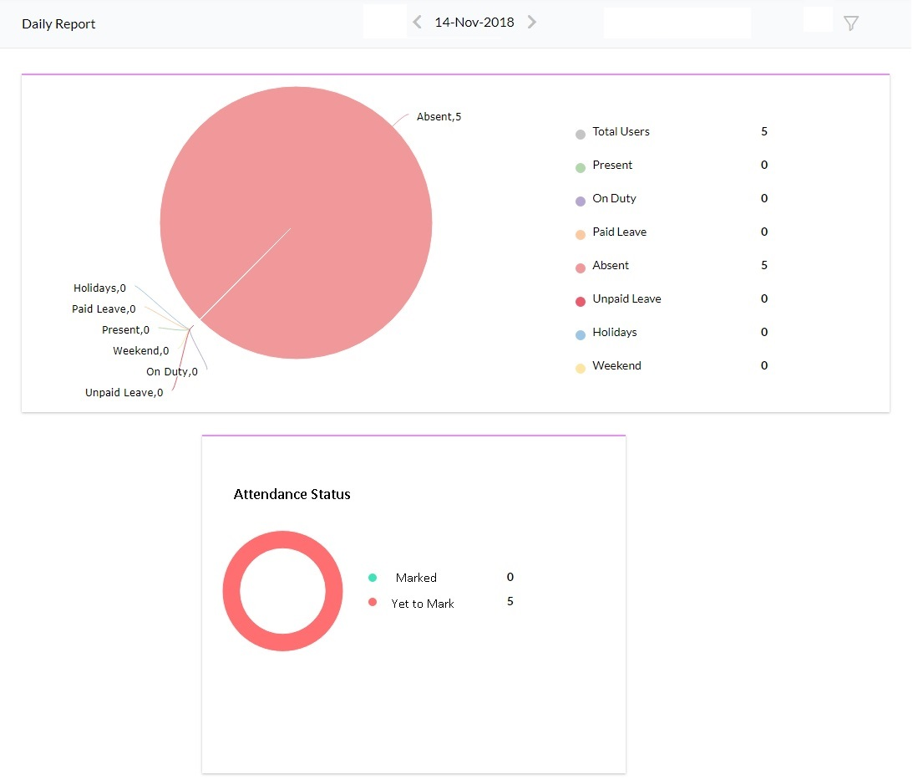

## Detailed User Stories

The daily report will be available for the Admin and HR department users. It will display the attendance data of all the users as a graphical report.

The following data will be displayed:

* Total users – the total number of users in the system
* Present – number of present employees
* On duty – number of employees marked as on duty
* Paid Leave
* Absent
* Unpaid Leave
* Holidays – users for which the selected date is a holiday
* Weekend – users for which the selected date is a weekend

The report will have information regarding the users for which attendance data has been marked and number of users for which the data is yet to be entered.

User can filter the data based on the following:

* + - Status – Attendance marked/ Yet to mark
    - Date
    - Location
    - Department
    - Employee

## Status Report

## Mock-Ups

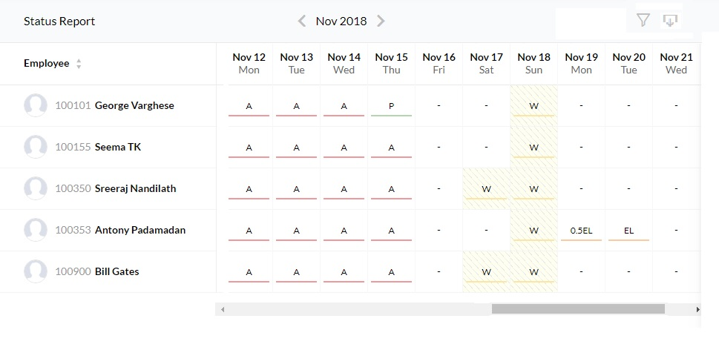

## Detailed User Stories

Status Report will be available for all users in the system. The employees can view their attendance report only, Reporting head can view report of all users under them, admin and users under HR department can view reports of all employees in the organization. The attendance report of users will be displayed for a specific date range, the status will show if the user was present, absent, leave or on duty. The weekend days and holidays will also be mentioned. User can filter the data using the following:

* Location
* Department
* Employee
* From – To date
* Users

Users can download the data in ‘.XLSX’ format.

## Shifts

## Acceptance Criteria

## Mock-Ups

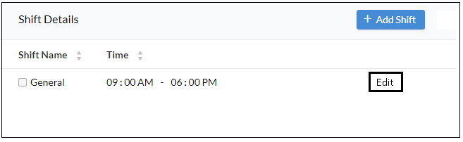

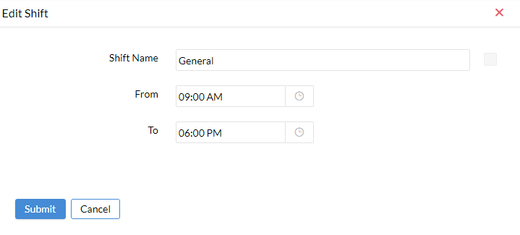

## Detailed User Stories

Only Admin user can manage the shifts, only one shift can be added at a time. User can add shift using the ‘Add Shift’ button. Shift name and timings can be edited using the ‘Edit’ button.

## Error Handling & Validations

If the user tries to add multiple shift an error message should be displayed stating that the user cannot add multiple shifts

## Regularization

## Acceptance Criteria

* User should be able to create a regularization request
* Reporting manager should be able to accept or reject request. They should be able to add regularization for employees under them
* Admin/ HR manager should be able to add regularization for all employees under the organization
* Regularization settings/ validations should work as specified in the general settings

## Mock-Ups

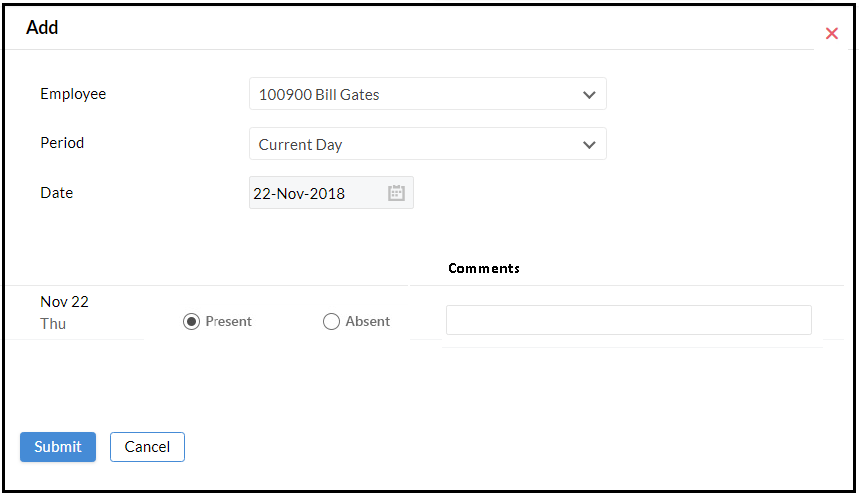

## Detailed User Stories

Regularization request can be placed by a user or it can be added directly by the Reporting head of a user, HR manager and Admin user. HR manager and Admin user can add regularization for all employees but the Reporting head can add regularization for employees who are reporting to him.

* User can select the employee for which the regularization needs to be added. Their own name will be pre-selected in the ‘Employee’ field.
* For normal users, they cannot change the name as they can add request for themselves only.
* The period needs to be selected (Current Day/ Date Range). If user selects ‘Date Range’ option they will have 2 date pickers using which regularization can be added for multiple dates
* User needs to specify whether the user has to be marked as ‘Present’ or ‘Absent’ on that particular date(s).
* Comment can be mentioned to keep track of the reason for regularization, this comment can be viewed in the request received by the reporting head.
* Clicking on submit will sent the request to the reporting head, who can accept or reject the request. In case the Reporting head of the user /HR Manager/ Admin is adding the regularization, then it will be auto approved.

The request once added will be sent to the respective reporting heads for approval, once the reporting head approves, the corresponding change will be implemented in the system.

## Absent Schedule

## Mock-Ups

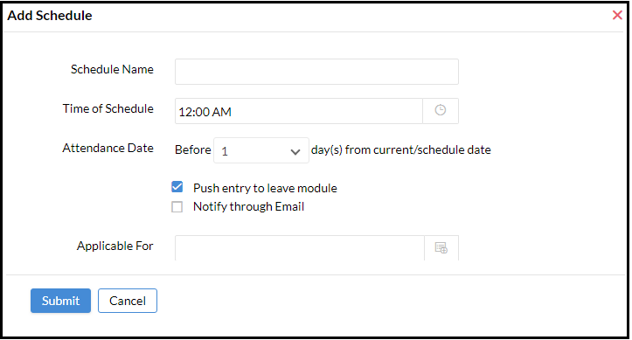

## Detailed User Stories

Absent schedule is used to manage cases where the employee doesn’t apply for leave and is absent on a date. In this case the employee is given time to apply for leave, if the employee fails to apply for leave after a specific time then the absent date can be considered as an LOP or the employee can be notified via mail about the same.

The absent schedule will be accessible to HR Manager and Admin user only.

* For creating a schedule, the name has been specified
* The ‘Time of Schedule’ defines the time (each day) at which this checking will be performed.
* ‘Attendance Date’ is where the user can specify the date limit after which this processing will be done. E.g. If user selects ‘3’ in the drop down then the system will check for any absent record of users before 3 days from the current date which has not yet been converted to a leave.
* There will be 2 check boxes:
  + Push entry to leave module – consider the date as LOP
  + Notify through email – notify the user via email

Checking both options will push the absent date into leave modules (consider as LOP) and will notify the same to the user.

If ‘Notify through email’ is checked the user will be notified about the absent date via email this date will not be pushed to the leave module.

If only ‘Push entry to leave module’ is checked then the absent date will be considered as LOP but no email notification will be sent to the user.

* ‘Applicable For’ can be used to select the users for which this policy needs to be associated with. There will be options to select users based on:
  + Location
  + Department
  + Role
  + Group
  + User
* Multiple absent schedule can be added to manage policies of different user groups

## General Settings

## Mock-Ups

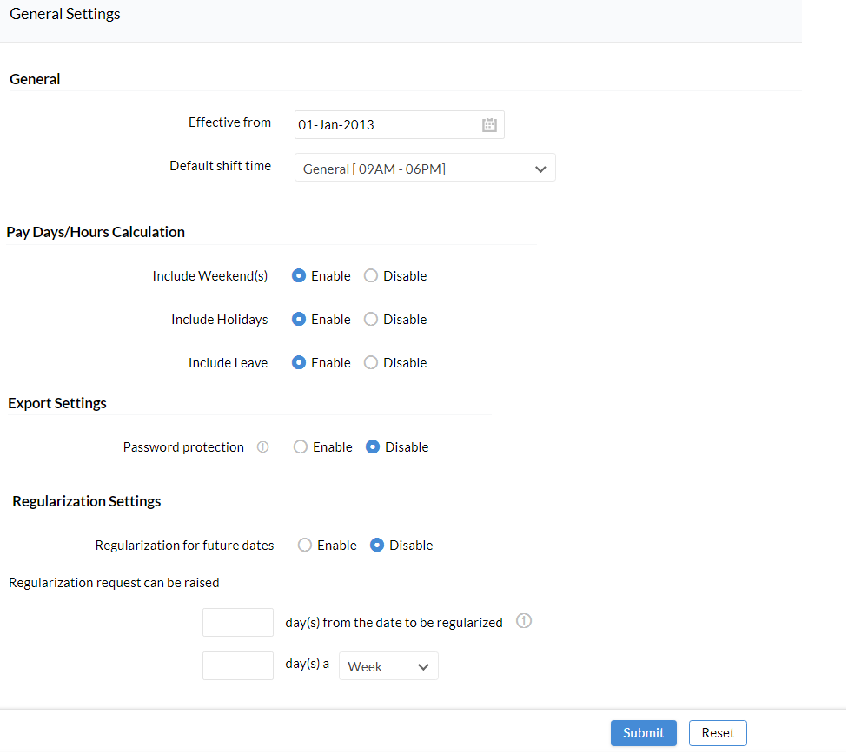

## Detailed User Stories

The settings options will be available for Admin user only.

Admin can manage the following:

* Effective Date – date from which the system should start functioning
* Default Shift Time
* Pay Day Hours Calculation
  + Include Weekends - unchecking this option will remove weekends from pay days calculation
  + Include Holidays – unchecking this option will remove holidays from pay days calculation
  + Include leave – unchecking this option will remove leaves taken by the user from pay days
* Export Settings
  + Password protection (Enable/disable) – this option enable password protection for the data exported. Enabling this option will prompt the user to set the password for opening the files
* Regularization settings
  + Regularization for future dates (Enable/disable) – this option can be used to define whether the user must be allowed to apply for regularization in advance.
  + ‘Regularization request can be raised’ defines the date limit till which the regularization request can be raised for a past date.
  + The maximum number of regularization request that can be placed in a Week/Month/Year can also be specified

Clicking on ‘Submit’ will apply the settings selected. Clicking ‘Cancel’ will direct users to the previous page