Functional Requirement

Specification For

Leave Module

**Version History:**

|  |  |  |  |
| --- | --- | --- | --- |
| **Version** | **Description of Change** | **Author** | **Date** |
| 1.0 | Draft | Sreeraj, Antony | 06/12/18 |
|  |  |  |  |

Contents

**1.** **INTRODUCTION** 4

**1.1** **Purpose** 4

**1.2** **Scope / Considerations** 4

**1.3** **Out of Scope** 4

**1.4** **Assumptions and Constraints** 4

**2.** **FUNCTIONAL REQUIREMENTS** 4

**2.1** **Req 1** 4

**2.1.1** **Acceptance Criteria** 4

**2.1.2** **Mock-Ups** 4

**2.1.3** **Detailed User Stories** 5

**2.1.4** **Error Handling & Validations** 5

**3.** **DATABASE CONSIDERATIONS** 5

**4.** **NON-FUNCTIONAL REQUIREMENTS [NFR]** 5

**5.** **CLARIFICATIONS** 5

**6.** **REFERENCES** 5

**7.** **APPENDIX A - GLOSSARY** 6

# **INTRODUCTION**

The leave module will be used to entitle users with leave days and manage the requesting and approval process.

The following are the major items focused by implementing leave module

* Apply leave through the system
* Cancel/Approve/Reject leave by manager
* View leave balance & details of leave already availed before applying leave
* Reports of LOP, leave balance, leave taken

# **FUNCTIONAL REQUIREMENTS**

# **Leave Listing Screen**

* + 1. The user will have a list/calendar view to see all the leaves availed over a financial year
    2. **Detailed User Story**
* The leave listing screen will be common for staff, manager and admin
* In the listing screen, the grid view will have all the following
  + Date of leave applied
  + Leave type
  + No.of days leave applied for
  + Reason for leave
  + Status
* In the listing, only need to show the leaves availed by the user during the active financial year, not need to display leaves availed during previous financial years
* The different status for leave are as follows
  + Pending
    - Status shown soon after user create a leave application
  + Approved
    - Status shown when manager approve leave submitted by user
  + Rejected
    - Status shown when manager approve leave submitted by user
  + Canceled
    - Status shown when manager or user cancel the request raised
* The user will also be able to view the leave balance under different leave types in the listing screen. It will be a mini report section with following details
  + Absent
  + Compensatory leave
  + Leave type
* The mini report in the listing screen should have basic information’s such as
  + Total leaves already availed
  + Total leave
* There should be an Export button in the listing screen for the user to export the leave report to excel
* In calendar view, the user can view the availed leaves marked under the particular date/s, where user can view the details when clicked on it
  + 1. **Mock-Ups**

1. 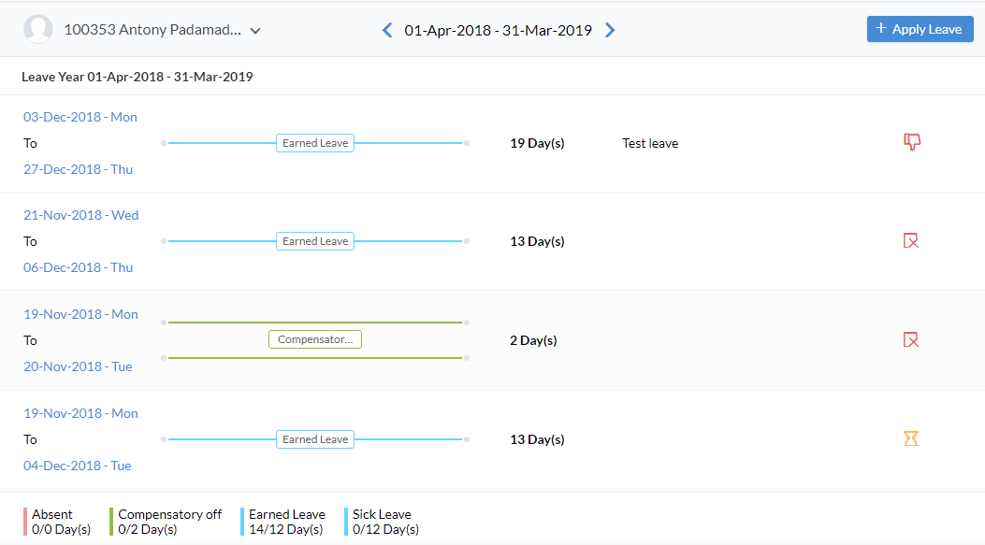***Fig1: Leave Listing Screen – List View***
2. 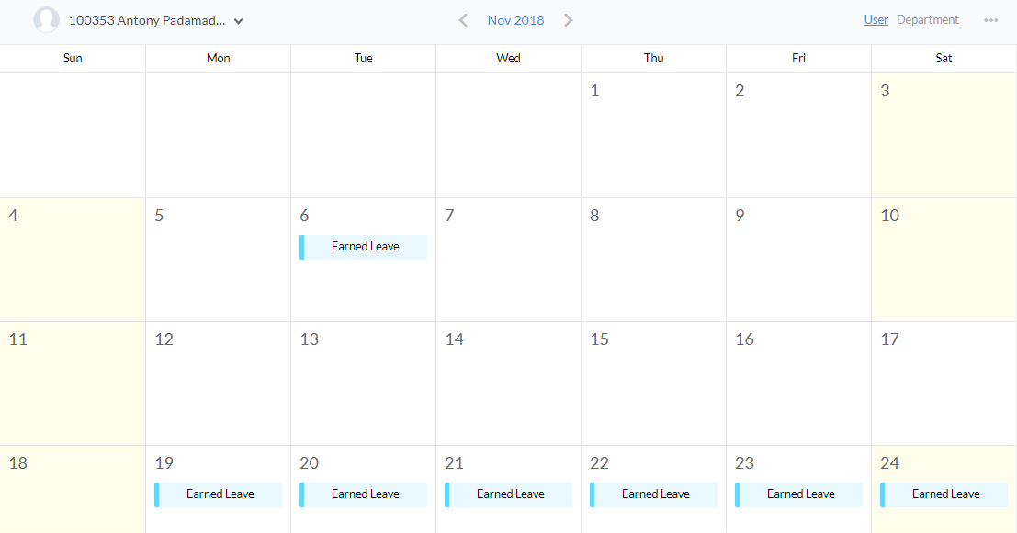***Fig2: Leave Listing Screen – Calendar View***
   1. **Leave Application Form**

* The users can apply leave through the system
  + 1. **Detailed User Story**
* The leave application form will be common for staff, manager and admin
* In the listing screen there will be a button for the user to apply leave
* A leave form will be opened as user click on the Apply Leave button
* The leave form will have the following fields
  + Employee Name(ID)
  + Leave Type
  + Date – From & To
  + Email ID
  + Reason for Leave
* By default, the employee name(ID)
  + Will be auto filled and will be in disabled state for staff
  + Will be auto filled and will be a drop down for manager & admin which allows them to apply leave for the users reporting under him
* The leave type will be drop down where the user can choose from the list of data set by the admin
  + The selection options will differ based on the user groups i.e. ‘General’ or ‘Developer’
    - General – Sick Leave, Annual Leave, Earned Leave
    - Developer – Earned Leaves
* The available leave balance for the leave type will be displayed on the screen as user select the leave type
* The user can choose the date using the date picker, holidays & weekends need to be integrated to the calendar in order to avoid counting leave on those days
  + The admin have settings to manage sandwich leaves
* The user will be able to manage leave of each date if multiple days are chosen
  + User can select whether the leave is for half-day or full-day
  + If selected half-day, user can choose either first half or second half
* Email ID section is to provide the mail id of users who need to be notified regarding the leave applied. Multiple mail ID’s can be provided by separating with comma(’,’)
  + The mail will be only triggered after manager approve the leave
* Reason for leave is the area where user can provide the reason for applying the leave
* Except ‘Email ID’, all fields are mandatory in order to apply a leave
  + 1. **Mock-Ups**

1. 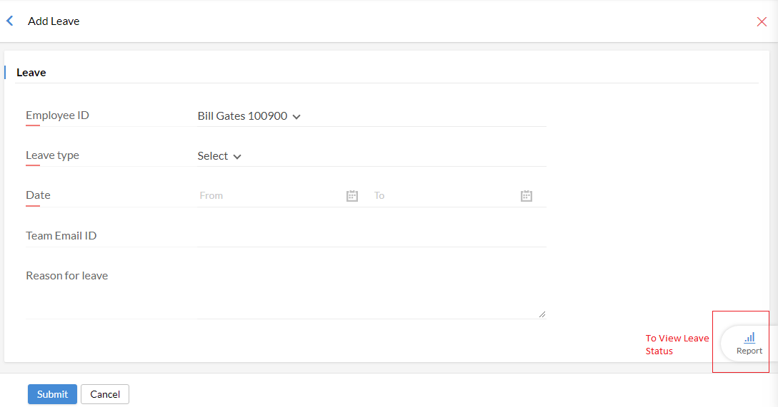***Fig2: Leave Application Form***
   1. **Leave Details Screen**

* When user click on a leave, the leave details screen will be opened.
  + 1. **Detailed User Story**
* The leave details screen is common for staff, manager and admin but the features differ based on user role
* The details screen will show the leave form information’s such as
  + Employee Name(ID)
  + Leave Type
  + Date – From & To
  + Email ID
  + Reason For Leave
  + Date of Request
* There will be a ‘Cancel’ button available for the users to cancel the leave which will be changed to ‘Close’ button after the date of leave applied
* The user can cancel an applied leave on or before the leave date, even after approval.
  + A notification should be send to the manager and email ID(if mentioned) regarding the cancellation of the leave
* Consider user have applied for three days, user can cancel leave for one day
* Once availed, user won’t be permitted to cancel the leave
* User will be able to convert an absent(leave taken without approval) to leave up to a time period specified by the admin(considering the pay period setting)
  + Note – Leave taken without approval of leave application will be considered as absent. Total absent count will be taken for calculating LOP
* There will be an option for the user to view the timeline of the application
* For managers, there will be an option to manage the leave status
  + 1. **Mock-Ups**

1. 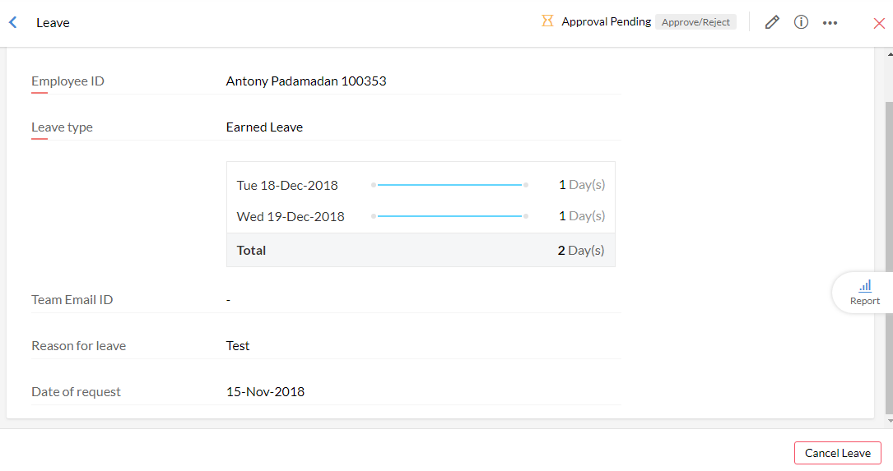***Fig3: Leave Details Screen before leave date***
2. 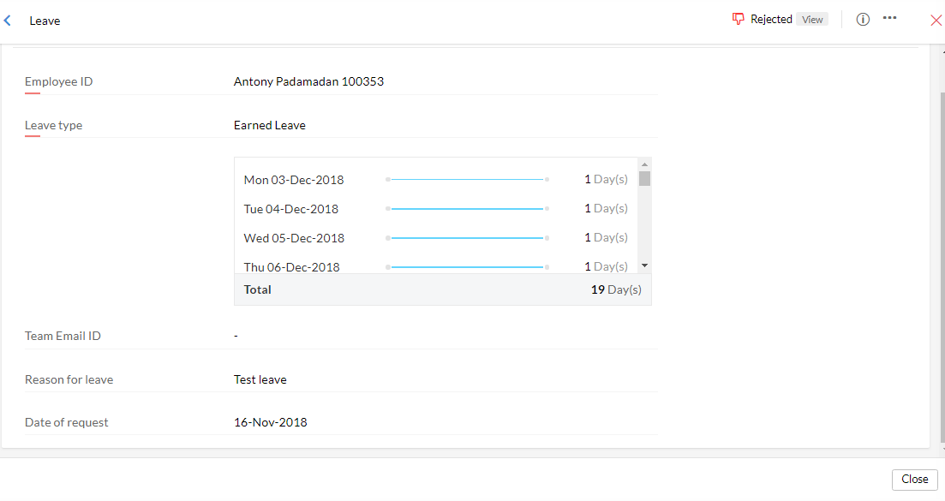***Fig4: Leave Details Screen after leave date***
   1. **Leave Application Listing for Approval**

* This screen is for managers. The managers can view the leave forms submitted for approval under this screen
  + 1. **Detailed User Story**
* The leave application screen is for managers to manage the leave requests submitted for approval
* The leave applications screen will have the following in the list view
  + Status
  + Employee Name
  + Leave Type
  + Leave period
  + Days taken
  + Date of Request
* The user can enter the details screen by clicking on the leave
  + 1. **Mock-Ups**

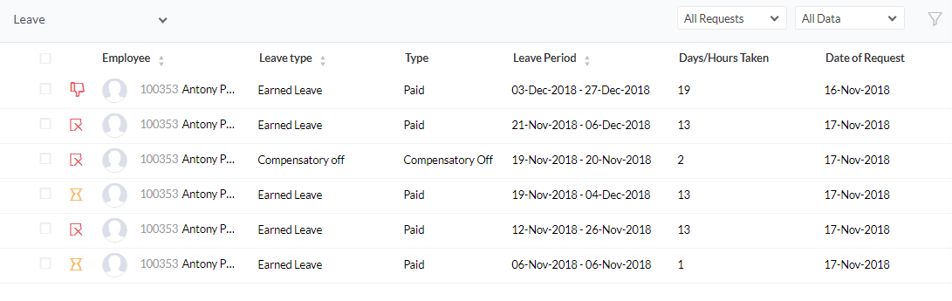

## **Manage Leave Types**

* + 1. **Mock-Ups**

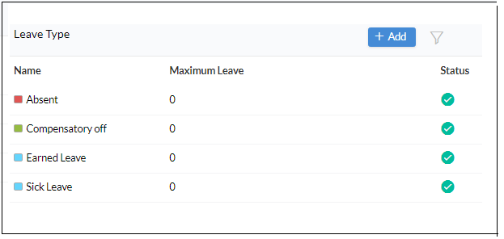

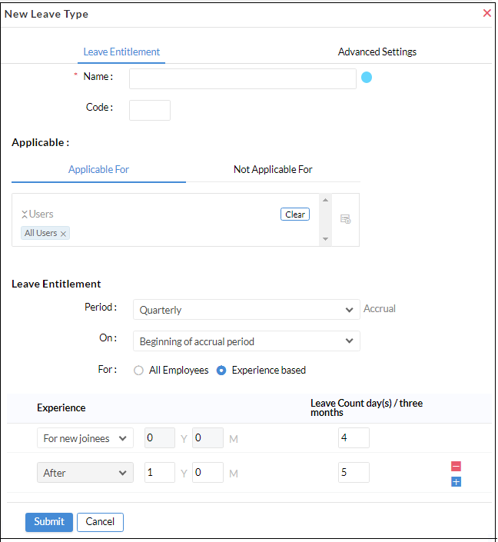

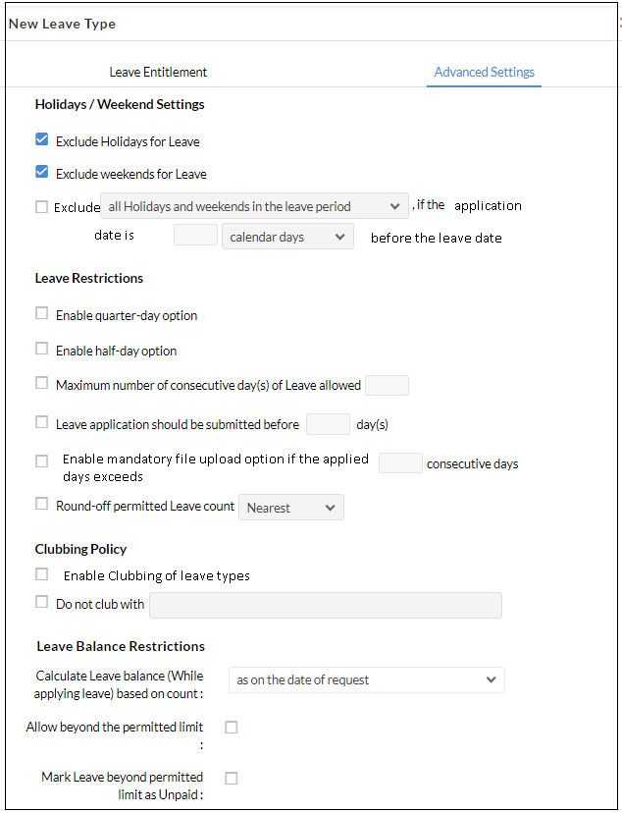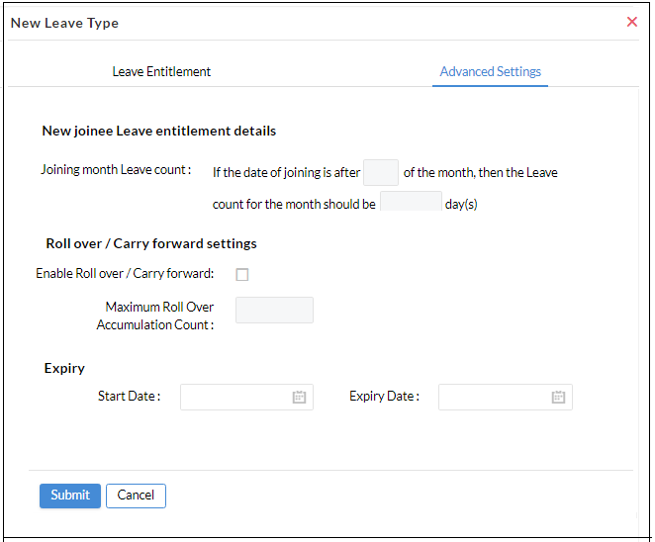

* + 1. **Detailed User Stories**

Leave type listing will be available for Admin user only. Admin can view the leave types already added. The following fields will be there in leave type listing:

* Name
* Maximum Leave
* Status

User can filter the leave types using Departments, Designation, Roles and Employee.

Admin can add a new leave type by clicking on the ‘Add’ button from the listing page.

Following information need to be provided in order to add a new Leave Type: -

* + - Name
    - Code – Unique identification number (if needed)
    - Description
    - Applicable
      * Applicable For
      * Not Applicable For
    - Leave Entitlement
      * Period of Leave Entitlement – Annual/Monthly/Quarterly/ Weekly
      * Entitled On – user can decide if the leave needs to be credited at the beginning of accrual period or end of it. If its selected as end of accrual period then user will only be able to avail the leave after completing the leave entitlement period.
      * Entitled For - using this option Admin user can decide if the leave count needs to be the same for all employees or if it should differ based on their work experience. If experience based is selected then user can define how many leave days needs to be assigned to new joiners and how the number of leave days will differ based on the experience. User can add multiple entries using the’+’ button and delete any entry using ‘-- ‘ (minus) button.
      * Leave Count Marking – here user can enter the leave count (in days) that needs to be credited to the applicable employees
    - Advanced Settings
      * User can manage the sandwiching policy using the ‘Exclude Holidays for Leave’ and ‘Exclude Weekends for leave’ options. If these are unchecked then sandwiching policy will not be applied. User will have an option to manage sandwiching policy if the leave application is submitted before a specific time. User can choose to exclude holiday/weekends/or both holidays and weekends from the leave dates if the application date is before the specific day limit.
      * User can enable/disable Quarter day and Half day leaves
      * There will be option to limit number of consecutive leave days
      * By default, there will be option to upload file while applying for leave, but this field can be made mandatory. Also, this setting can be applied if leave dates exceeds a particular limit.
      * User can round off the leave count to:
        + Nearest value
        + Maximum value
        + Minimum value
      * User can specify if clubbing of leave types needs to be allowed or not
        + If clubbing is allowed then user can restrict clubbing of any specific leave types
      * Leave balance restrictions perform the following functions:
        + Enables the user to specify if the leave balance needs to be calculated based on the date of request/ start date of leave/ or at the calendar year end
        + User can allow/ restrict the application of leave beyond the permitted limit, i.e. allow users can take leave even if they have exhausted their allotted leave days
        + If the user allows the application of leave beyond permitted limit then it can be specified if these leave dates has to be marked as unpaid/LOP.
      * For new joiners, user can restrict the leave count if the joining date is after a specific day of the month
      * Roll over/carry forward functionality can be used to carry forward the leave dates to next financial year. If this is unchecked then the remaining leave dates will be considered invalid, the leave balance of previous year can be viewed under reports.  
        While applying carry forward function the user can specify the maximum accumulation count, if the leave count exceeds this number then the extra days will be rendered as invalid
      * Expiry date(optional) can be set to define when the particular leave category will start and when it should expire

Clicking on submit will save the leave type, clicking on cancel will redirect user to the Leave type listing page