1. Write an HTML code to display images as in the following given output by using table and image tags

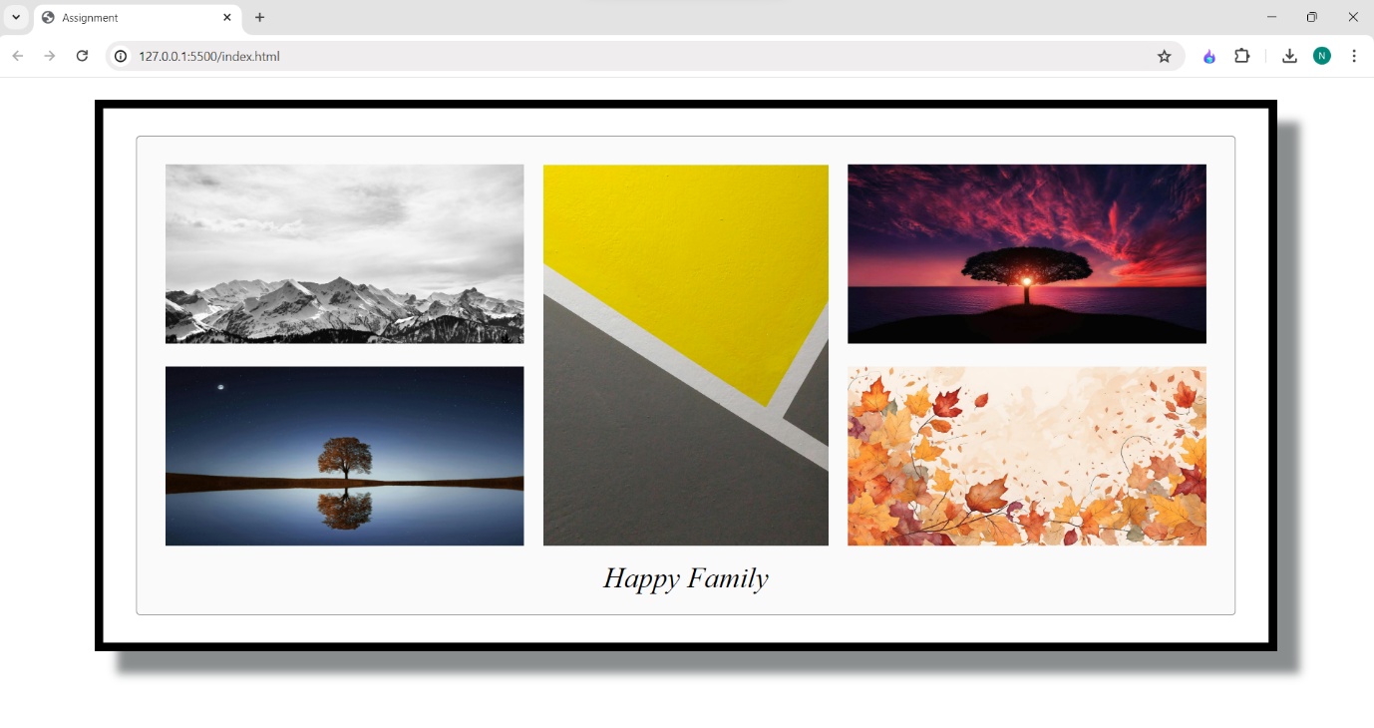  
  
code:  
  
<!DOCTYPE html>

<html lang="en">

<head>

<meta charset="UTF-8" />

<meta name="viewport" content="width=device-width, initial-scale=1.0" />

<title>Assignment</title>

</head>

<style>

.tabledata {

padding: 10px;

}

</style>

<body>

<div

style="

padding: 30px;

border: 10px solid black;

margin: 0 100px;

margin-top: 25px;

box-shadow: 25px 25px 10px rgba(0, 7, 9, 0.457);

"

>

<table

style="

border: 1px solid rgba(0, 0, 0, 0.491);

border-radius: 5px;

background-color: rgba(128, 128, 128, 0.039);

padding: 20px;

margin: auto;

"

>

<tr>

<td class="tabledata">

<img src="/img/img2.jpg" alt="" height="200" width="400" />

</td>

<td rowspan="2" class="tabledata">

<img src="/img/img1.jpg" alt="" height="425" />

</td>

<td class="tabledata">

<img src="/img/img3.jpg" alt="" height="200" width="400" />

</td>

</tr>

<tr>

<td class="tabledata">

<img src="/img/img6.jpg" alt="" height="200" width="400" />

</td>

<td class="tabledata">

<img src="/img/img9.jpg" alt="" height="200" width="400" />

</td>

</tr>

<tr>

<td colspan="3" style="text-align: center; font-size: xx-large">

<i> Happy Family</i>

</td>

</tr>

</table>

</div>

</body>

</html>

1. Write an HTML document table with lists of veg food and Non-veg with unordered lists.

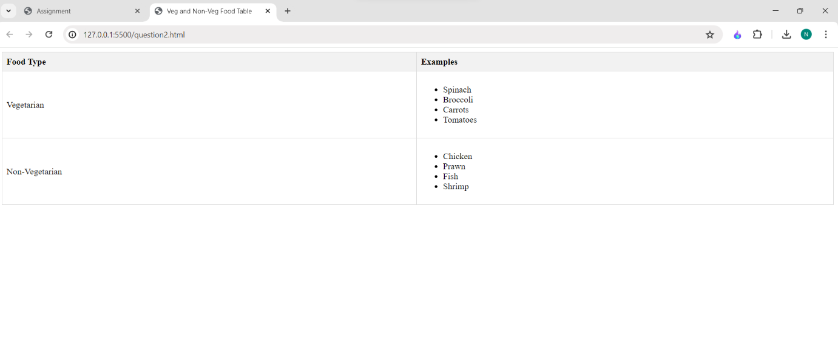

Code:-

<!DOCTYPE html>

<html lang="en">

<head>

<meta charset="UTF-8">

<meta name="viewport" content="width=device-width, initial-scale=1.0">

<title>Veg and Non-Veg Food Table</title>

<style>

table {

width: 100%;

border-collapse: collapse;

}

th, td {

border: 1px solid #ddd;

padding: 8px;

text-align: left;

}

th {

background-color: #f2f2f2;

}

</style>

</head>

<body>

<table>

<thead>

<tr>

<th>Food Type</th>

<th>Examples</th>

</tr>

</thead>

<tbody>

<tr>

<td>Vegetarian</td>

<td>

<ul>

<li>Spinach</li>

<li>Broccoli</li>

<li>Carrots</li>

<li>Tomatoes</li>

</ul>

</td>

</tr>

<tr>

<td>Non-Vegetarian</td>

<td>

<ul>

<li>Chicken</li>

<li>Prawn</li>

<li>Fish</li>

<li>Shrimp</li>

</ul>

</td>

</tr>

</tbody>

</table>

</body>

</html>

1. Write an HTML document to play audio and video files.

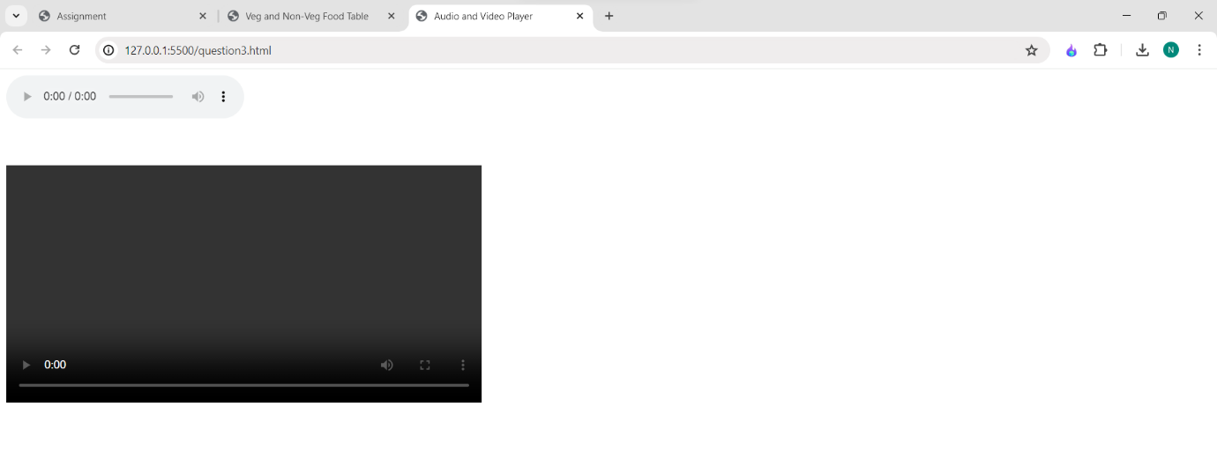

Code:-

<!DOCTYPE html>

<html lang="en">

<head>

<meta charset="UTF-8">

<meta name="viewport" content="width=device-width, initial-scale=1.0">

<title>Audio and Video Player</title>

</head>

<body>

<audio controls>

<source src="" type="audio">

</audio>

<br>

<br>

<br>

<br>

<video controls width="600">

<source src="" type="video">

</video>

</body>

</html>