TASK

Form Creation With CSS

Description:-

Create a Login Page where we have 2 parts

Top: Register Page

part 1: image

part2 : form

* User Name
* Email
* Password
* button

success

Redirect to Login

Top: LoginPage

part 1: Image

part2 : Form

* Email
* Password
* button

register.html

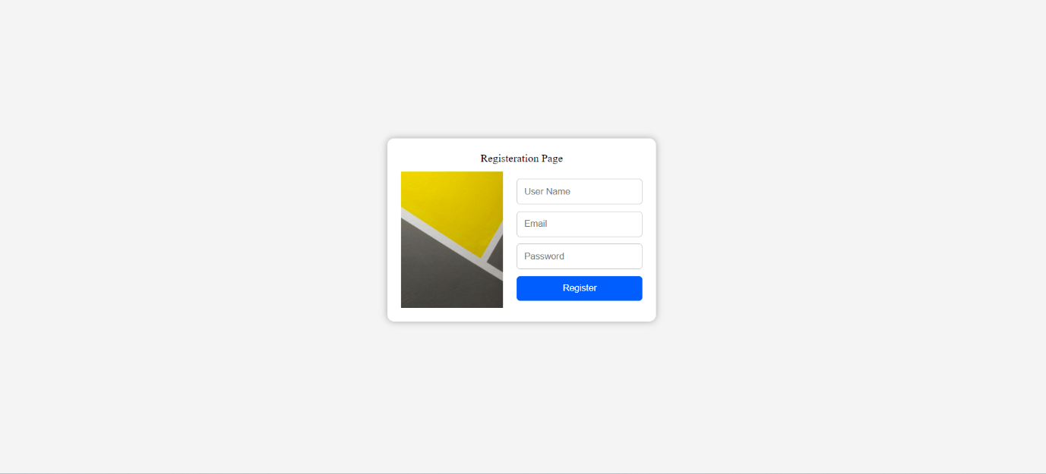

Code:-

<!DOCTYPE html>

<html lang="en">

<head>

<meta charset="UTF-8">

<meta name="viewport" content="width=device-width, initial-scale=1.0">

<title>Registeration Page</title>

<style>

.container {

display: flex;

flex-direction: column;

align-items: center;

justify-content: center;

height: 100vh;

background-color: #cccccc36;

}

.box{

background-color: #fff;

padding: 20px;

border-radius: 10px;

box-shadow: 0 0 10px rgba(0, 0, 0, 0.313);

margin-bottom: 20px;

display: flex;

flex-direction: column;

align-items: center;

}

.form-container {

margin-top: 10px;

display: flex;

flex-direction: row;

align-items: center;

}

.image{

width: 150px;

margin-right: 20px;

}

.form {

display: flex;

flex-direction: column;

}

.input {

margin-bottom: 10px;

padding: 10px;

border: 1px solid #ccc;

border-radius: 5px;

}

#btn:hover {

background-color: #0056b3 !important;

}

</style>

</head>

<body style="margin: 0;padding: 0;">

<div class="container">

<div class="box">

<div>Registeration Page</div>

<div class="form-container">

<img class="image" src="./img1.jpg" alt="Registration Image">

<div>

<form class="form">

<input class="input" type="text" id="username" placeholder="User Name">

<input class="input" type="email" id="email" placeholder="Email">

<input class="input" type="password" id="password" placeholder="Password">

<button type="button" id="btn" onclick="registerUser()" style="padding: 10px;background-color: #005eff;color: #fff;border: none;border-radius: 5px;cursor: pointer;">Register</button>

</form>

</div>

</div>

</div>

</div>

<script>

function registerUser(){

alert("Registeration Successfull...... Please Login");

window.location.href = "login.html";

}

</script>

</body>

</html>

Login.html

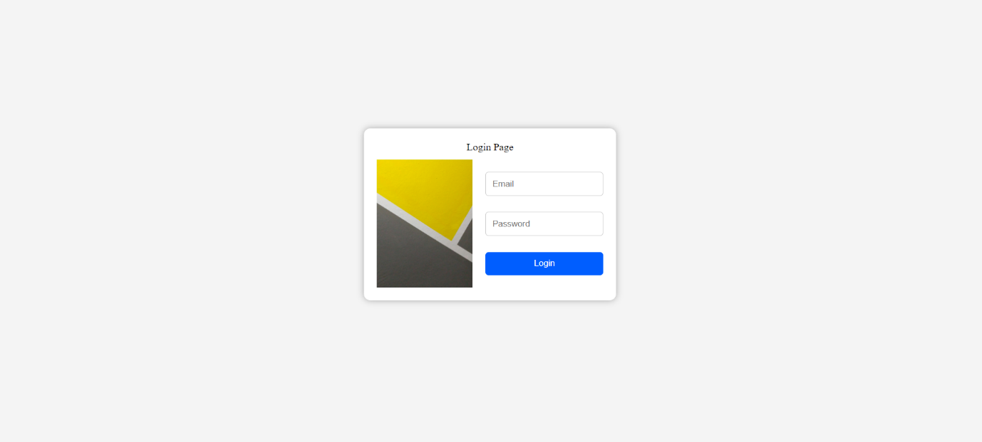  
  
code:-

<!DOCTYPE html>

<html lang="en">

<head>

<meta charset="UTF-8">

<meta name="viewport" content="width=device-width, initial-scale=1.0">

<title>Login Page</title>

<style>

.container {

display: flex;

flex-direction: column;

align-items: center;

justify-content: center;

height: 100vh;

background-color: #cccccc36;

}

.box{

background-color: #fff;

padding: 20px;

border-radius: 10px;

box-shadow: 0 0 10px rgba(0, 0, 0, 0.313);

margin-bottom: 20px;

display: flex;

flex-direction: column;

align-items: center;

}

.form-container {

margin-top: 10px;

display: flex;

flex-direction: row;

align-items: center;

}

.image{

width: 150px;

margin-right: 20px;

}

.form {

display: flex;

flex-direction: column;

}

.input {

margin-bottom: 25px;

padding: 10px;

border: 1px solid #ccc;

border-radius: 5px;

}

#btn:hover {

background-color: #0056b3 !important;

}

</style>

</head>

<body style="margin: 0;padding: 0;">

<div class="container">

<div class="box">

<div>Login Page</div>

<div class="form-container">

<img class="image" src="./img1.jpg" alt="Registration Image">

<div>

<form class="form">

<input class="input" type="email" id="email" placeholder="Email">

<input class="input" type="password" id="password" placeholder="Password">

<button type="button" id="btn" onclick="loginuser()" style="padding: 10px;background-color: #005eff;color: #fff;border: none;border-radius: 5px;cursor: pointer;">Login</button>

</form>

</div>

</div>

</div>

</div>

<script>

function loginuser(){

alert("Login Successfull");

window.location.href = "loginsuccess.html";

}

</script>

</body>

</html>

Loginsuccess.html



Code:-

<!DOCTYPE html>

<html lang="en">

<head>

<meta charset="UTF-8">

<meta name="viewport" content="width=device-width, initial-scale=1.0">

<title>Login Success</title>

<style>

.container {

display: flex;

flex-direction: column;

align-items: center;

justify-content: center;

height: 100vh;

background-color: #cccccc36;

}

.box{

background-color: #fff;

padding: 20px;

border-radius: 10px;

box-shadow: 0 0 10px rgba(0, 0, 0, 0.313);

margin-bottom: 20px;

display: flex;

flex-direction: column;

align-items: center;

}

.form-container {

margin-top: 10px;

display: flex;

flex-direction: row;

align-items: center;

}

.image{

width: 150px;

margin-right: 20px;

}

.form {

margin-top: 25px;

display: flex;

flex-direction: column;

}

.btn{

padding: 10px;

background-color: #005eff;

color: #fff;

border: none;

border-radius: 5px;

cursor: pointer;

margin-bottom: 40px;

}

.btn:hover {

background-color: #0056b3 !important;

}

</style>

</head>

<body style="margin: 0;padding: 0;">

<div class="container">

<div class="box">

<div>Login Success</div>

<div class="form-container">

<div>

<form class="form">

<button type="button" class="btn" onclick="redirecttoregister()" style="padding: 10px;background-color: #005eff;color: #fff;border: none;border-radius: 5px;cursor: pointer;">Back to Registration</button>

<button type="button" class="btn" onclick="redirecttologin()" style="padding: 10px;background-color: #005eff;color: #fff;border: none;border-radius: 5px;cursor: pointer;">Back to Login</button>

</form>

</div>

</div>

</div>

</div>

<script>

function redirecttoregister(){

alert("Redirecting to Register");

window.location.href = "register.html";

}

function redirecttologin(){

alert("Redirecting to Login");

window.location.href = "login.html";

}

</script>

</body>

</html>