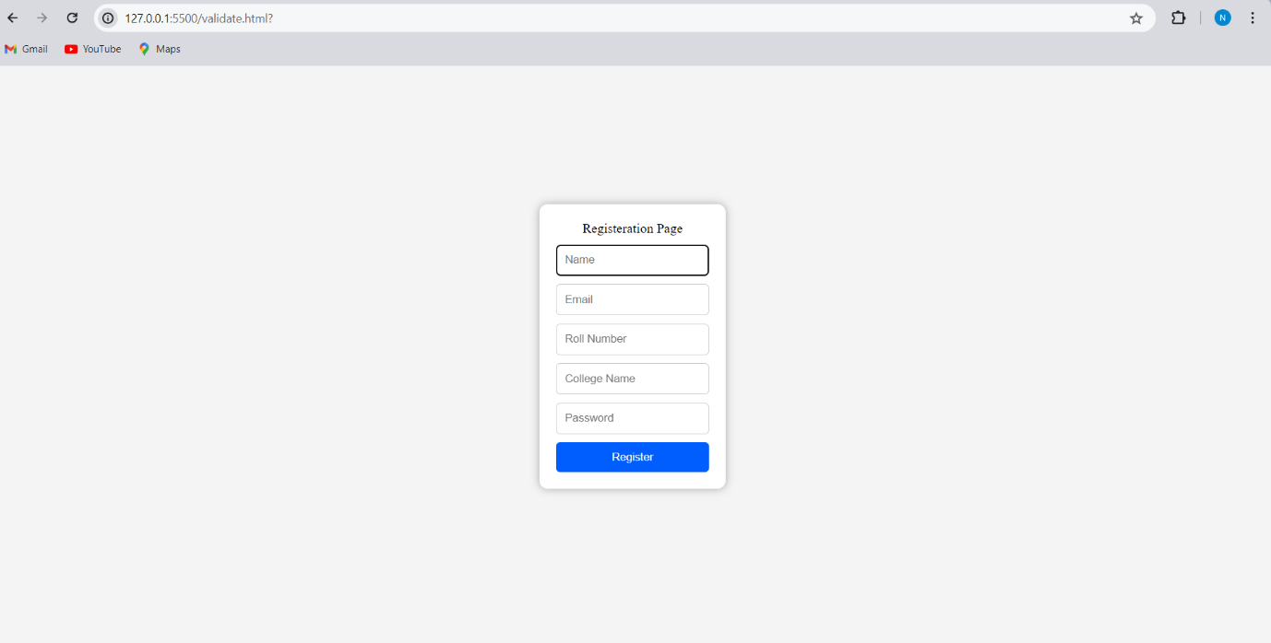

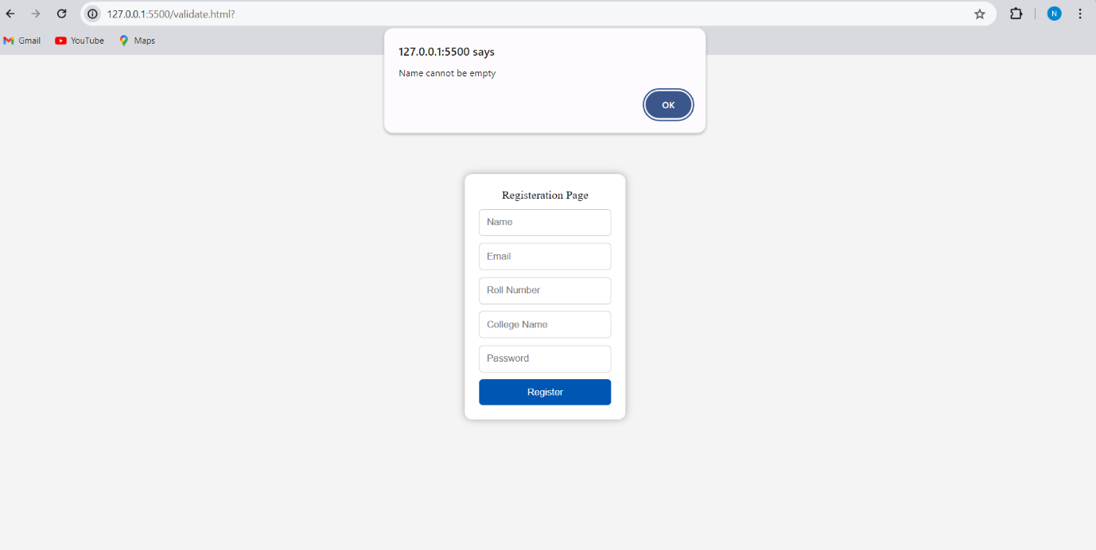

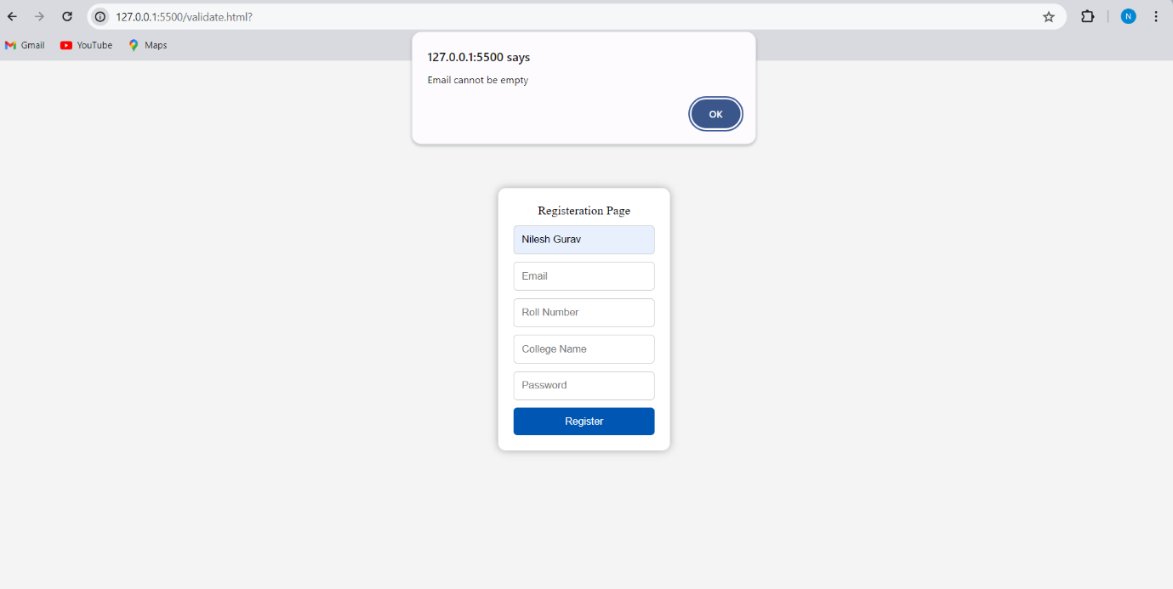

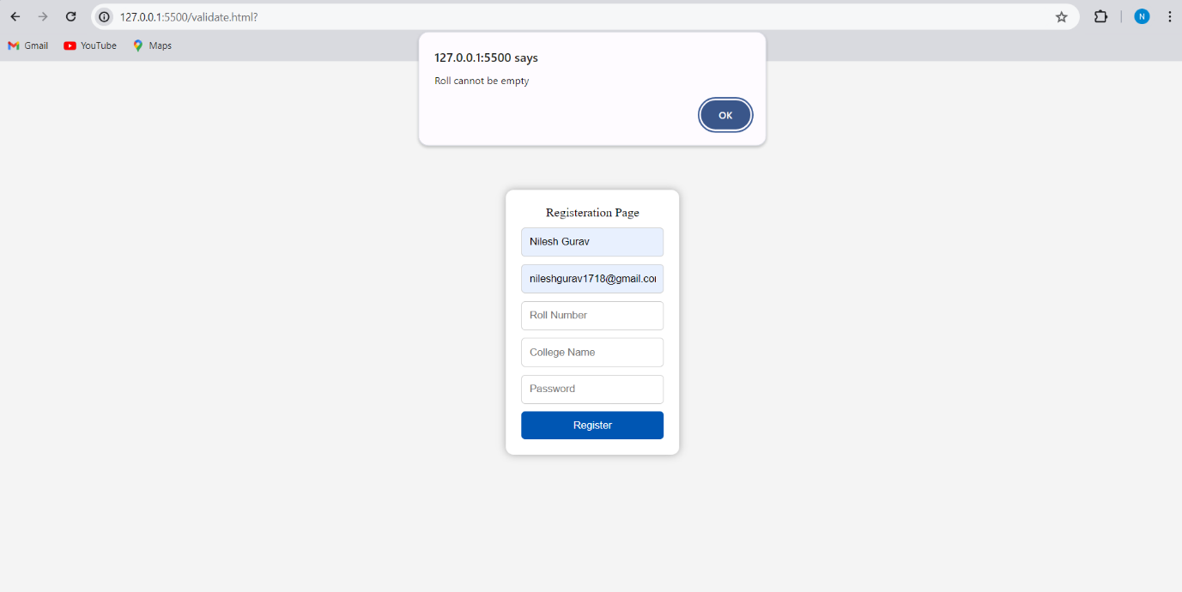

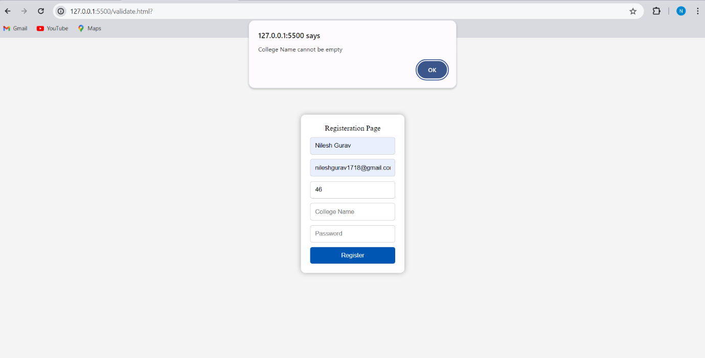

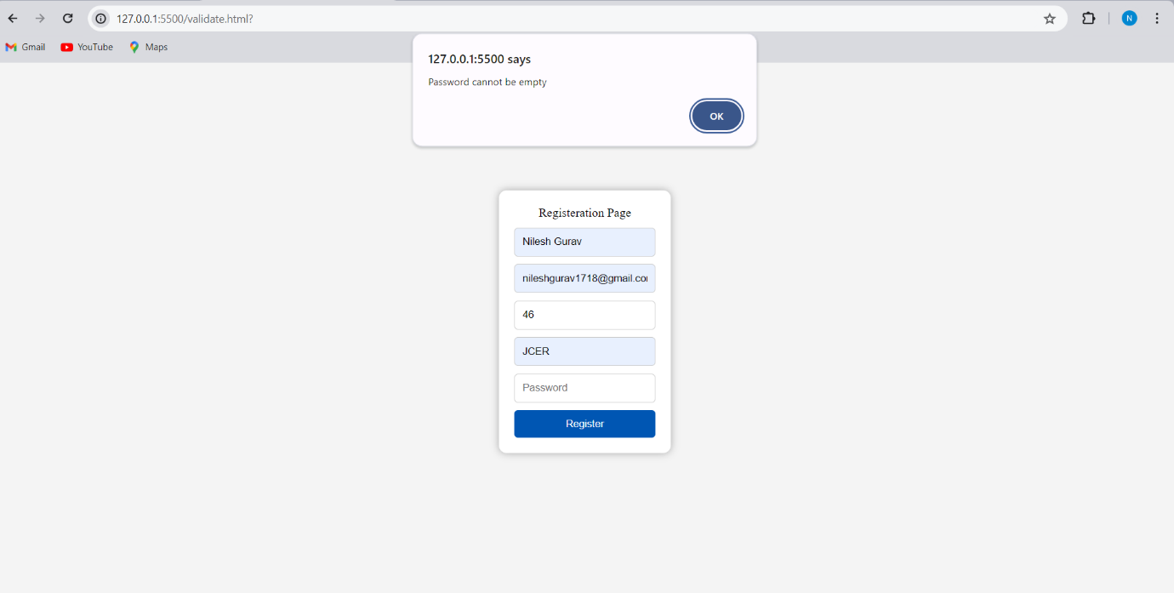

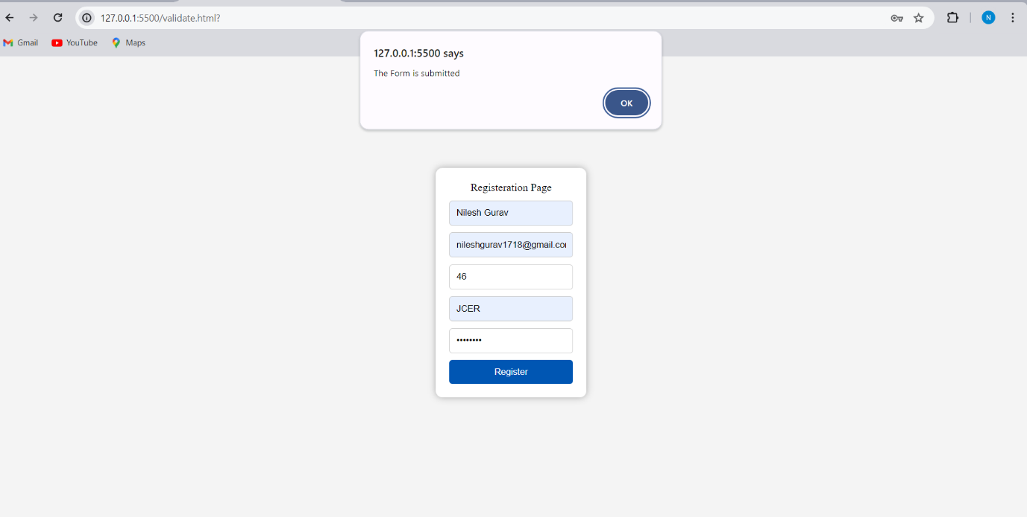

Code:-

<!DOCTYPE html>

<html lang="en">

<head>

<meta charset="UTF-8">

<meta name="viewport" content="width=device-width, initial-scale=1.0">

<title>Registeration Page</title>

<style>

.container {

display: flex;

flex-direction: column;

align-items: center;

justify-content: center;

height: 100vh;

background-color: #cccccc36;

}

.box{

background-color: #fff;

padding: 20px;

border-radius: 10px;

box-shadow: 0 0 10px rgba(0, 0, 0, 0.313);

margin-bottom: 20px;

display: flex;

flex-direction: column;

align-items: center;

}

.form-container {

margin-top: 10px;

display: flex;

flex-direction: row;

align-items: center;

}

.image{

width: 150px;

margin-right: 20px;

}

.form {

display: flex;

flex-direction: column;

}

.input {

margin-bottom: 10px;

padding: 10px;

border: 1px solid #ccc;

border-radius: 5px;

}

#btn:hover {

background-color: #0056b3 !important;

}

</style>

</head>

<body style="margin: 0;padding: 0;">

<div class="container">

<div class="box">

<div>Registeration Page</div>

<div class="form-container">

<div>

<form class="form" onsubmit="return validateform()">

<input class="input" type="text" id="name" placeholder="Name">

<input class="input" type="email" id="email" placeholder="Email">

<input class="input" type="text" id="rollnumber" placeholder="Roll Number">

<input class="input" type="text" id="collegename" placeholder="College Name">

<input class="input" type="password" id="password" placeholder="Password">

<button type="submit" id="btn" onclick="registerUser()" style="padding: 10px;background-color: #005eff;color: #fff;border: none;border-radius: 5px;cursor: pointer;">Register</button>

</form>

</div>

</div>

</div>

</div>

<script>

function validateform() {

var name = document.getElementById('name').value;

var email = document.getElementById('email').value;

var rollnumber = document.getElementById('rollnumber').value;

var collegename = document.getElementById('collegename').value;

var password = document.getElementById('password').value;

if (name.trim() == "") {

alert("Name cannot be empty");

return false;

}

if (email.trim() == "") {

alert("Email cannot be empty");

return false;

} else {

var emailRegex = /^[^\s@]+@[^\s@]+\.[^\s@]+$/;

if (!emailRegex.test(email)) {

alert("Invalid email address");

return false;

}

}

if (rollnumber.trim() == "") {

alert("Roll cannot be empty");

return false;

}

if (collegename.trim() == "") {

alert("College Name cannot be empty");

return false;

}

if (password.trim() == "") {

alert("Password cannot be empty");

return false;

}

alert("The Form is submitted")

return true;

}

</script>

</body>

</html>