**1 Use Case: Electricity Bill Generation.**

import *java.util.Scanner*;

*public* *class* problem1{

*public* *static* void main(String[] args) {

        Scanner sc = new Scanner(System.in);

        System.out.print("ENTER THE SERVICE NUMBER : ");

        String serviceno = sc.nextLine();

        System.out.print("ENTER PREVIOUS READING : ");

        int previousreading = sc.nextInt();

        System.out.print("ENTER CURRENT READING : ");

        int currentreading = sc.nextInt();

        int units= currentreading - previousreading;

        double cost;

        if (units < 100) {

            cost = units* 1;

        } else if (units < 150) {

            cost = units * 1.5;

        } else if (units < 200) {

            cost = units * 2;

        } else {

            cost = units * 2.5;

        }

        double cgst = cost * 0.05;

        double sgst = cost * 0.15;

        double totalamount = cost + cgst + sgst;

        System.out.println("SERVICE NO : " + serviceno);

        System.out.println("PREVIOUS READING : " + previousreading);

        System.out.println("CURRENT READING : " + currentreading);

        System.out.println("UNITS CONSUMED : " + units);

        System.out.println("COST PER UNIT : " + cost/units+" RUPEES");

        System.out.println("CGST (5%) : " + cgst + " RUPEES");

        System.out.println("SGST (15%) : " + sgst + " RUPEES");

        System.out.println("AMOUNT TO PAY : " + totalamount + " RUPEES");

    }

}

OUTPUT:-

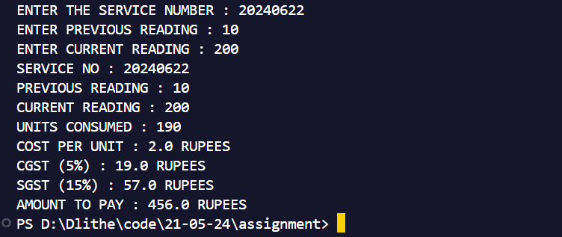

**2 Use Case: Bus Ticket Generation**

import *java.util.Scanner*;

*public* *class* problem2{

*public* *static* void main(String[] args) {

        Scanner sc = new Scanner(System.in);

        System.out.print("ENTER THE NUMBER OF BOARDING STOPS : ");

        int boardingstops = sc.nextInt();

        System.out.print("ENTER NUMBER OF DESTINATION STOPS : ");

        int destinationstops = sc.nextInt();

        System.out.print("ENTER NUMBER OF ADULT PASSENGERS : ");

        int adultpassengers = sc.nextInt();

        System.out.print("ENTER NUMBER OF CHILDREN PASSENGERS : ");

        int childpassengers = sc.nextInt();

        int numberofstops = destinationstops - boardingstops;

        int costforadult = 10;

        int costforchild = 5;

        int totaladultcost = costforadult * adultpassengers * numberofstops;

        int totalchildcost = costforchild * childpassengers * numberofstops;

        int totalcost = totaladultcost + totalchildcost;

        double discount = 0;

        if (adultpassengers >= 5) {

            discount = 0.20 * totalcost;

        } else if (adultpassengers == 4) {

            discount = 0.15 * totalcost;

        } else if (adultpassengers == 3) {

            discount = 0.10 * totalcost;

        } else if (adultpassengers == 2) {

            discount = 0.05 * totalcost;

        }

        double totalcostwithdiscount = totalcost - discount;

        double tax = 0.10 * totalcostwithdiscount;

        double totalPriceIncludingTax = totalcostwithdiscount + tax;

        System.out.println("BOARDING STOPS : " + boardingstops);

        System.out.println("DESTINATION STOPS : " + destinationstops);

        System.out.println("NUMBER OF ADULT PASSENGERS : " + adultpassengers);

        System.out.println("NUMBER OF CHILD PASSENGERS : " + childpassengers);

        System.out.println("NUMBER OF STOPS TRAVELLED : " + numberofstops);

        System.out.println("COST OF ADULT PASSENGERS : Rs." + totaladultcost);

        System.out.println("COST OF CHILDREN PASSENGERS : Rs." + totalchildcost);

        System.out.println("TOTAL COST OF TICKET WITHOUT DISCOUNT : Rs." + totalcost);

        System.out.println("DISCOUNT ON THE TICKET : " + ((discount/totalcost)*100)+"%");

        System.out.println("TOTAL COST OF TICKET WITH DISCOUNT (WITHOUT TAX) : Rs." + totalcostwithdiscount);

        System.out.println("TAX (10%) : Rs." + tax);

        System.out.println("TOTAL PRICE OF TICKET (INCLUDING TAX) : Rs." + totalPriceIncludingTax);

    }

}

OUTPUT:-

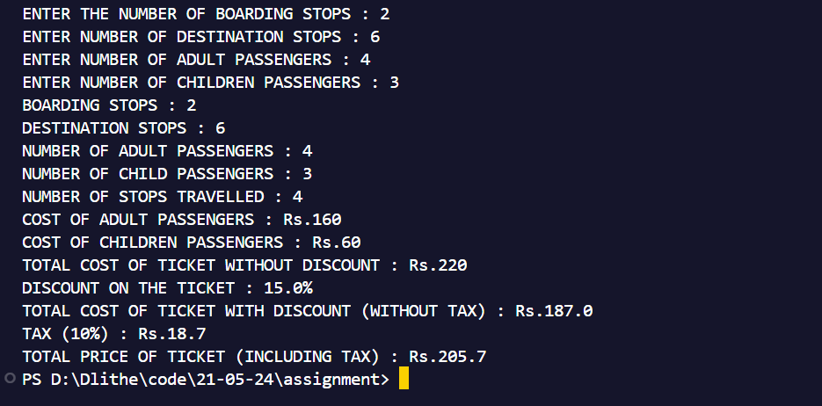

**3 Use Case: ATM Withdraw.**

import *java.util.Scanner*;

*public* *class* problem3{

*public* *static* void main(String[] args) {

        Scanner scanner = new Scanner(System.in);

        int accountbalance = 10000;

        int atmpin = 1234;

        int cashinatm = 8000;

        System.out.print("ENTER ATM PIN : ");

        int enteredpin = scanner.nextInt();

        if (enteredpin != atmpin) {

            System.out.println("INCORRECT PIN....");

        } else {

            System.out.print("ENTER THE AMOUNT TO WITHDRAW: ");

            int amount = scanner.nextInt();

            if (amount % 100 != 0) {

                System.out.println("INVALID AMOUNT... MUST BE MULTIPLE OF 100.");

            } else if (amount > accountbalance) {

                System.out.println("INSUFFICIENT BALANCE....");

            } else if (amount > cashinatm) {

                System.out.println("INSUFFICIENT CASH IN ATM....");

            } else {

                accountbalance = accountbalance - amount;

                cashinatm = cashinatm-amount;

                System.out.println("TRANSACTION SUCCESSFULL.... \nAVAILABLE BALANCE : " + accountbalance);

            }

        }

    }

}

OUPUT:-

