# **Introduction**

A stock price predictor is a system that learns about a company's performance and predicts future stock prices. Our project leverages Long Short-Term Memory (LSTM), a type of Recurrent Neural Network (RNN), to enhance the accuracy of stock price predictions. LSTM networks are particularly well-suited for time series prediction due to their ability to learn long-term dependencies and retain information over extended periods. This makes them ideal for capturing the complex patterns and trends inherent in stock market data. The main goal of this project is to develop a robust and reliable prediction model that can analyze historical stock prices and generate accurate forecasts.

# **Problem Statement**

The stock market, known for its volatility and complex dynamics, presents a significant challenge for investors aiming to predict future stock prices. With the advent of advanced machine learning techniques, particularly Long Short-Term Memory (LSTM) networks, there is potential to improve the accuracy of these predictions significantly. LSTM, a type of recurrent neural network (RNN), excels in capturing temporal dependencies and patterns, making it an ideal choice for time-series forecasting tasks such as stock price prediction. This project, titled "Stock Market Prediction Using LSTM," aims to leverage the power of LSTM networks to forecast stock prices more accurately. By developing a model from scratch, this project will provide insights of stock market behavior and offer a robust predictive tool for investors and financial analysts.

# **Objectives**

* **Efficient Forecasting**

Predict future stock prices or price movements with high accuracy using historical data, technical indicators.

* **Market Analysis**

Analyze market trends and patterns to identify profitable investment opportunities and potential market entry or exit points.

* **Risk Management**

Help investors manage risk by providing insights into potential price volatility and market trends, enabling them to make informed decisions.

# **Methodology**

**4.1 Requirement identification**

**4.1.1 Literature review**

* LSTM networks, introduced by Hochreiter and Schmidhuber in 1997, are a type of Recurrent Neural Network (RNN) designed to overcome the limitations of standard RNNs in learning long-term dependencies.
* Studies by Fischer and Krauss (2018) and Zheng et al. (2018) show that LSTMs can outperform traditional models like ARIMA and basic neural networks in terms of prediction accuracy.
* Almeida, M., & Pereira, F. (2020) - "Enhancing stock price prediction using deep learning: LSTM with attention mechanism"

**4.1.2 Requirement analysis**

1. **Functional requirements**

* Data Collection
* Data Processing
* Real-time Prediction
* Performance Evaluation

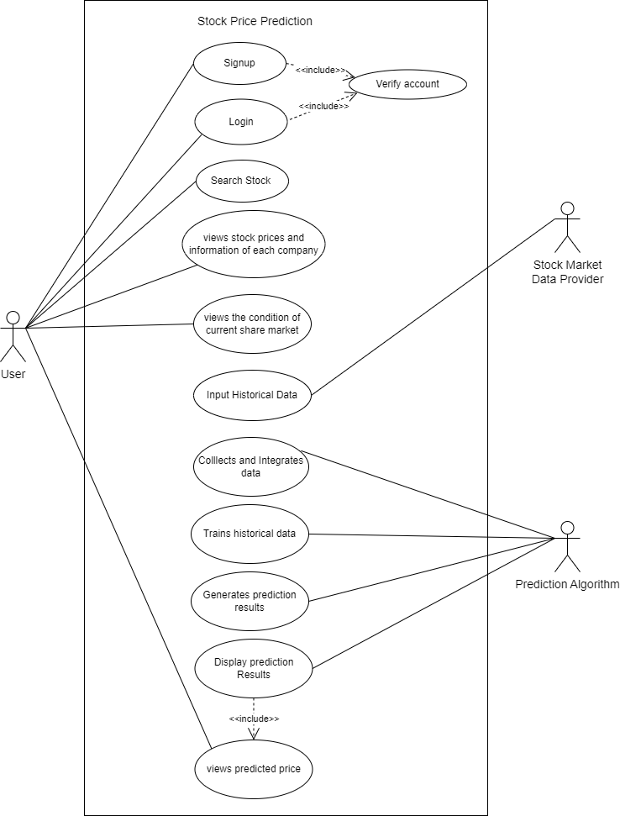

Fig: Use case diagram

**4.1.2 Requirement analysis**

**2. Non-Functional requirements**

* Security
* Performance
* Maintainability
* Usability
* Documentation

**4.2 Feasibility analysis**

1. Technical feasibility

The project can be managed within an academic environment where team members can collaborate effectively using common tools like Git for version control. The scope of the project is manageable for a student team, allowing them to develop, test, and refine the application within the typical timeframe of an academic semester. We will use Django for Backend api integration and use React/Next for Frontend Development.

1. Economic feasibility

Economically, the project is highly feasible. As an academic endeavor, the primary resources required are time and effort from the project team. The reliance on open-source technologies minimizes financial costs, making advanced tools and libraries accessible without monetary investment. This approach ensures that financial barriers do not impede the progress and success of the project.

1. Operational feasibility

Operationally, the project is well-suited to an academic setting. The scope is designed to be manageable within a typical semester, allowing students to develop, test, and refine their application systematically. Collaboration tools such as Git facilitate effective teamwork. This operational framework supports a cohesive and productive project development cycle. By using LSTM algorithm we have estimated above 90% accuracy for our system.

1. Schedule feasibility

The schedule feasibility is shown as:

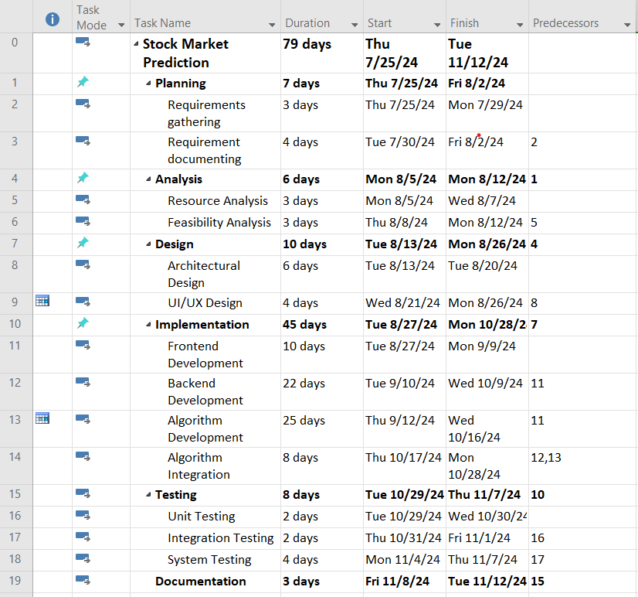

Fig: Work breakdown structure

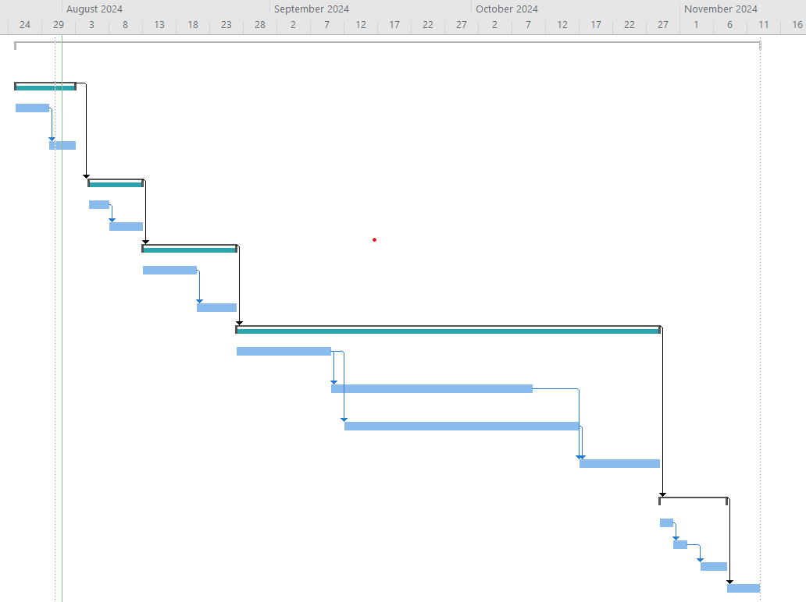

Fig: Gantt Chart

**4.3 High level design**

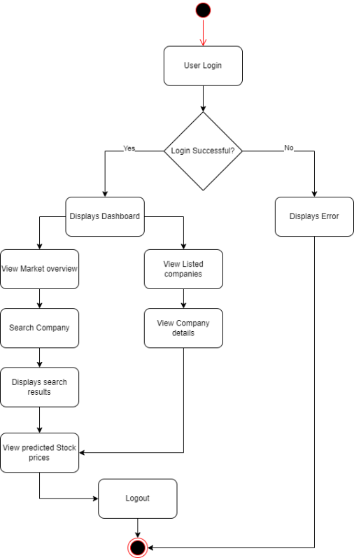

Fig: Activity Diagram

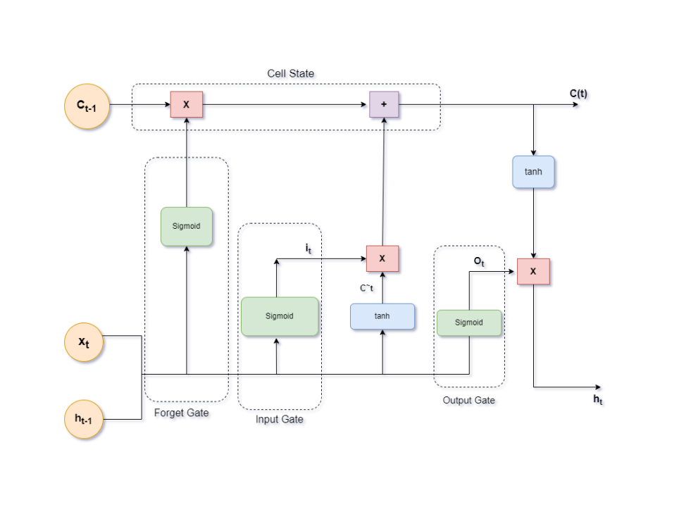

Fig: Architecture of LSTM

# **Expected outcomes**

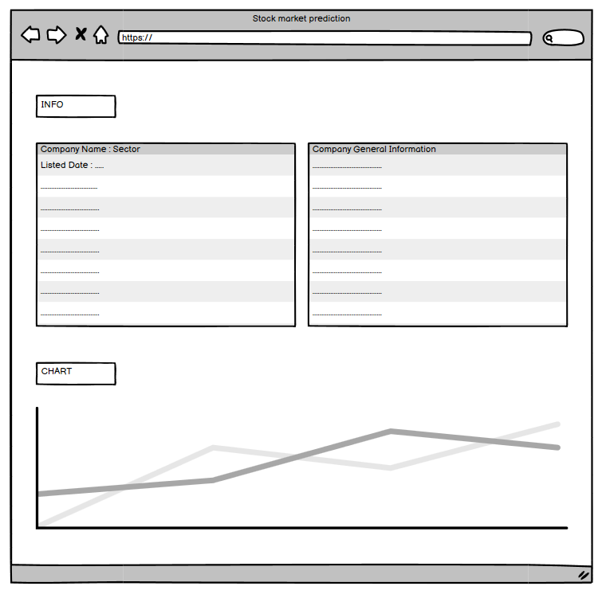

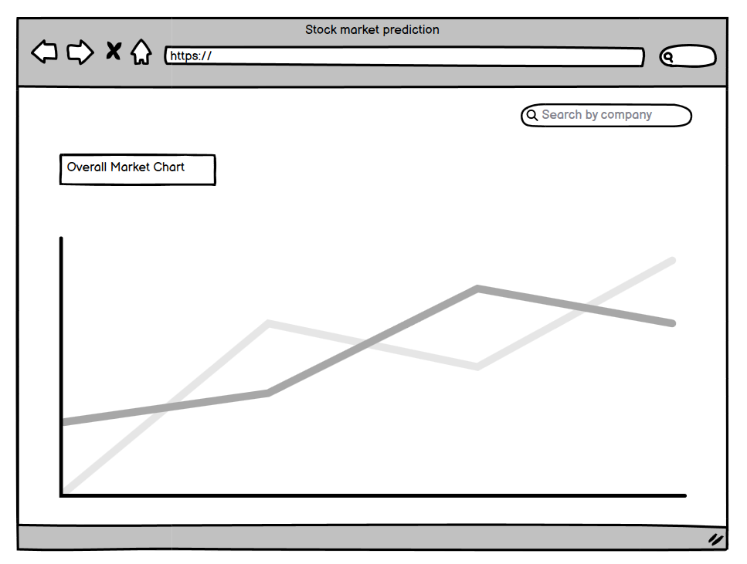

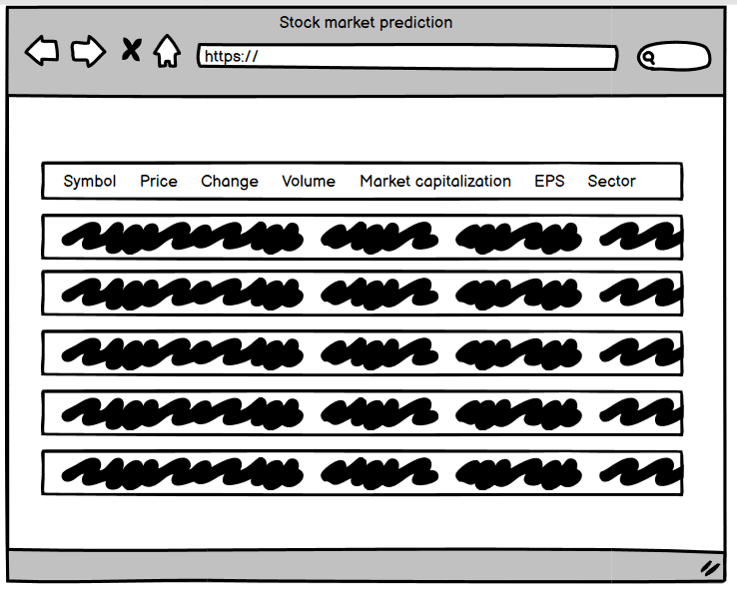

# **References**

* [1]G. Sonkavde, D. S. Dharrao, A. M. Bongale, S. T. Deokate, D. Doreswamy, and S. K. Bhat, “Forecasting Stock Market Prices Using Machine Learning and Deep Learning Models: A Systematic Review, Performance Analysis and Discussion of Implications,” International Journal of Financial Studies, vol. 11, no. 3, p. 94, Sep. 2023, doi: <https://doi.org/10.3390/ijfs11030094>.
* [2]“Papers with Code - Stock Market Prediction,” paperswithcode.com. [https://paperswithcode.com/task/stock-market-prediction](https://paperswithcode.com/task/stock-market-prediction?fbclid=IwZXh0bgNhZW0CMTAAAR16zMiDpfNUGFzm97jXFXUUuOL-g6MZMpp_MAs4PdVZuiWLH2CRoR3Uuu0_aem_3WraVE_CEj9zpK6c2hsUTg) (accessed Aug. 01, 2024).
* [3]K. Pawar, R. S. Jalem, and V. Tiwari, “Stock Market Price Prediction Using LSTM RNN,” Advances in Intelligent Systems and Computing, pp. 493–503, Nov. 2018, doi: <https://doi.org/10.1007/978-981-13-2285-3_58>.
* [4]”Stock market analysis + Prediction using LSTM,” kaggle.com. [https://www.kaggle.com/code/faressayah/stock-market-analysis-prediction-using-lstm](https://www.kaggle.com/code/faressayah/stock-market-analysis-prediction-using-lstm?fbclid=IwZXh0bgNhZW0CMTAAAR1YQOcntFtEEFbWFEEYmN9NbCy9J2FpTgjMHiqqr7DHzfUwlppxUuI7btk_aem_Mb7EOBSKZVGrfYeFO32jjg) ‌

Fig: Use case diagram