Lab-3: Flowchart and algorithum

1) | Calculate addition of two numbers.
Algorithm :-
- Start
- Read value of a,b
- Initialize sum<--0
- sum<-- a+b
- Print sum
- End
 | Flowchart :-
 | 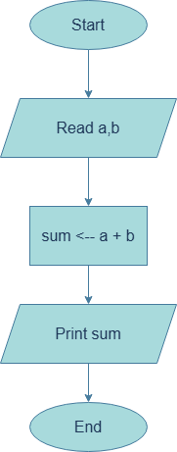
2) | Calculate average of three numbers.
 | Algorithm :-
- Start
- Read a,b,c
- Initialize avg<--0,sum<--0
- sum<-- a+b+c
- avg<--sum/3
- Print avg
- End

 | Flowchart :-
 | 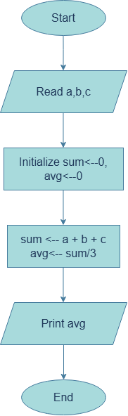
3) | Find area of circle. (pie*r*r).
 | Algorithm :-
- Start
- Read radius.
- Initialize area<--0,pie<--3.14
- area<-- pie*radius*radius
- Print area
- End

 | Flowchart :-
 | 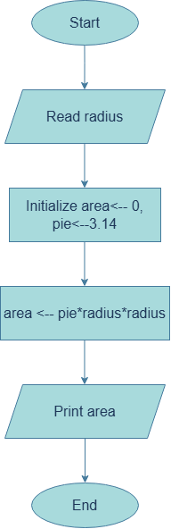
- Find area of triangle. ((height*base)/2)
Algorithm :-
- Start
- Read height,base.
- Initialize area<--0.
- area<-- ((height * base)/2)
- Print area
- End

Flowchart :-
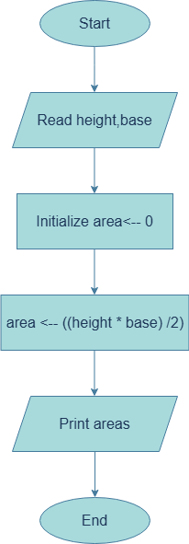

- Calculate simple interest. (principal*roi*time period)/100.
Algorithm :-
- Start
- Read p , roi , time.
- Initialize SI 0
- SI (p * roi * time)/100
- Print SI
- End
Flowchart :-

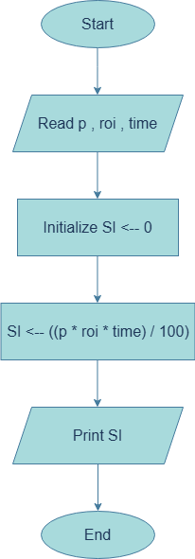

- Convert temperature from Fahrenheit to Celsius. (Formula: c=(((f-32)*5))/9) (A).
Algorithm :-
- Start
- Read F.
- Initialize C<--0
- C (((F-32)*5) / 9)
- Print Celsius C
- End

Flowchart :-

