Practical-4: INTRODUCTION

1) | Convert given feet into inches (feet*12).
 | Algorithm :-
Step 1: Start
Step 2: Read value of Feet
Step 3: Inches ← Feet × 12
Step 4: Print Inches
Step 5: Stop

 | Flowchart :-
 | 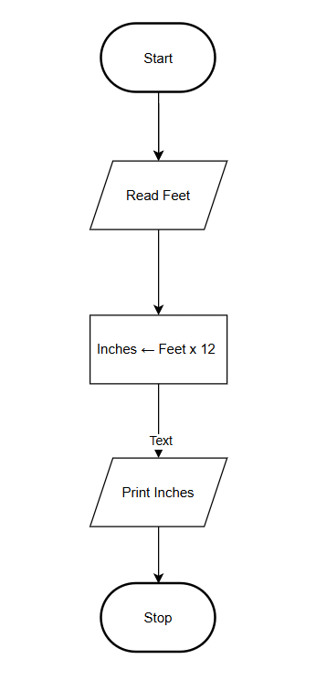
2) | Swap two numbers. (Using temporary variable and without using temporary variable)
 | Algorithm (Without Temp Variable):-
Step 1: Start
Step 2: Read values of a and b
Step 3: a ← a + b
Step 4: b ← a - b
Step 5: a ← a - b
Step 6: Print a, b
Step 7: Stop

 | Flowchart :-
 | 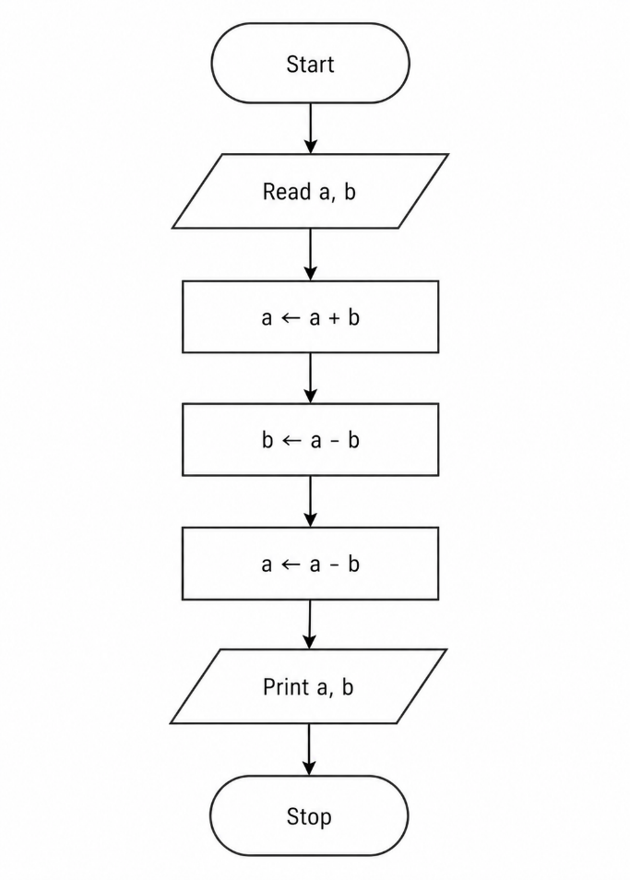
3) | Algorithm (With Temp Variable):-  Step 1: Start  Step 2: Read values of a and b  Step 3: a ← a + b  Step 4: b ← a - b  Step 5: a ← a - b  Step 6: Print a, b  Step 7: Stop  Flowchart :-  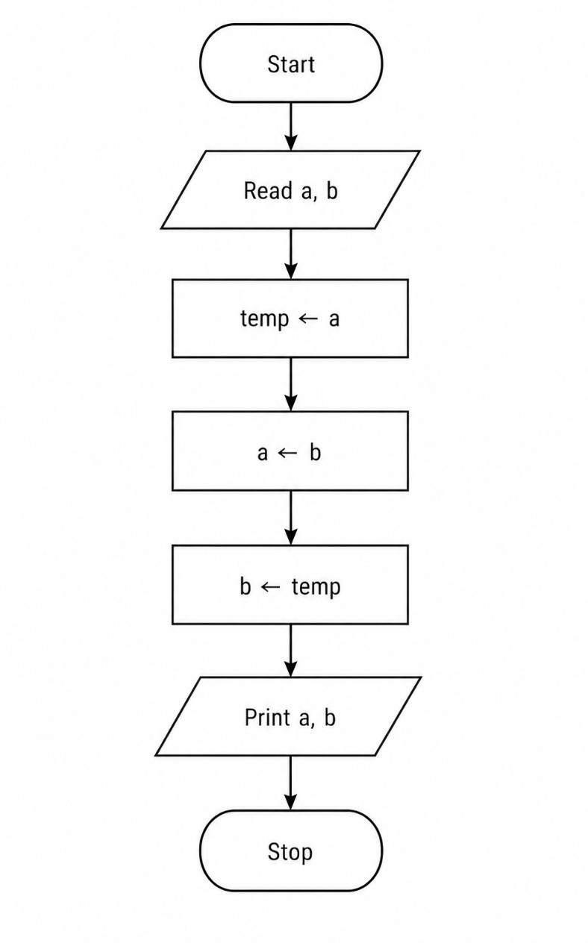  Number is Positive or Negative
 | Algorithm :-
Step 1: Start
Step 2: Read value of r (radius)
Step 3: Area ← π × r × r
Step 4: Print Area
Step 5: Stop

 | Flowchart :-
 | 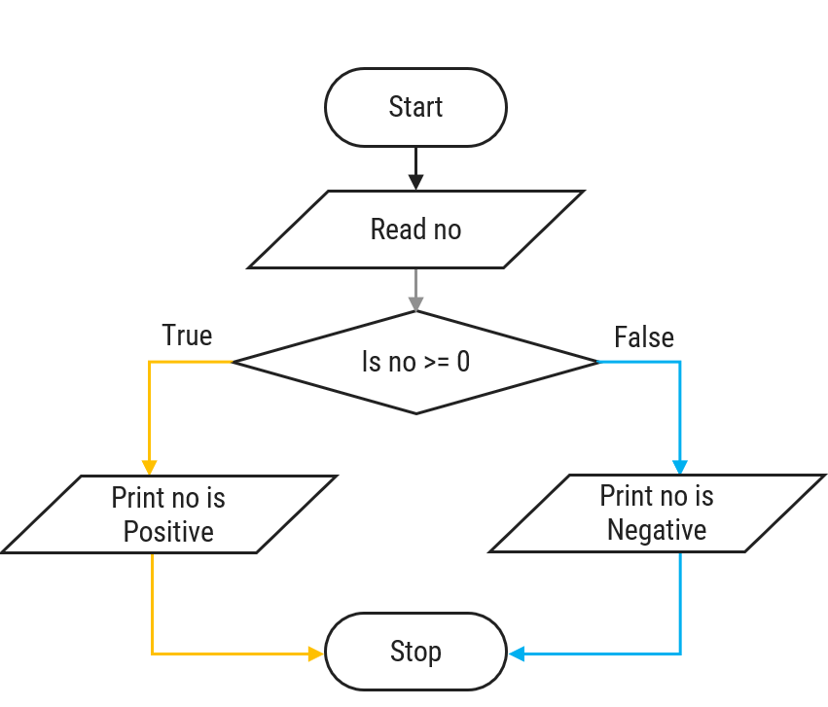

4) Number is odd or even:

Algorithm:
Step 1: Read no.
Step 2: If no mod 2 = 0, go to Step 4.
Step 3: Print no is odd, go to Step 5.
Step 4: Print no is even.
Step 5: Stop.

Flowchart:

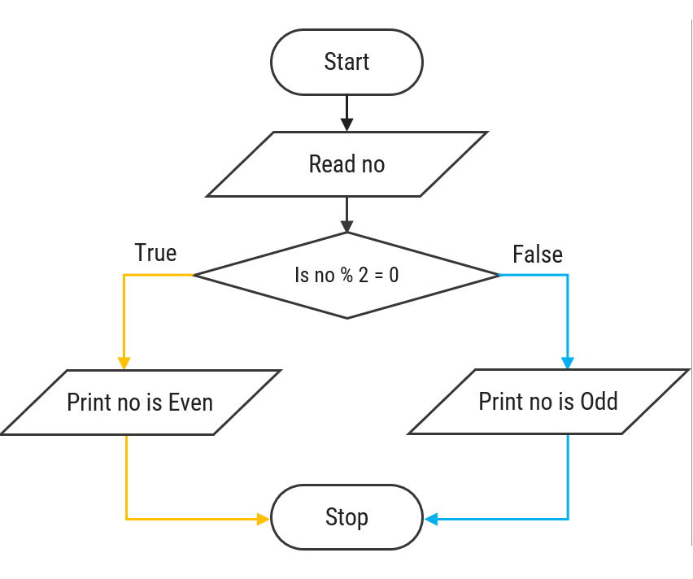

5) Find out the largest number from given 2 numbers:

Algorithm:

Step 1: Read a, b.
Step 2: If a > b, go to Step 4.
Step 3: Print b is largest number, go to Step 5.
Step 4: Print a is largest number.
Step 5: Stop.

Flowchart:

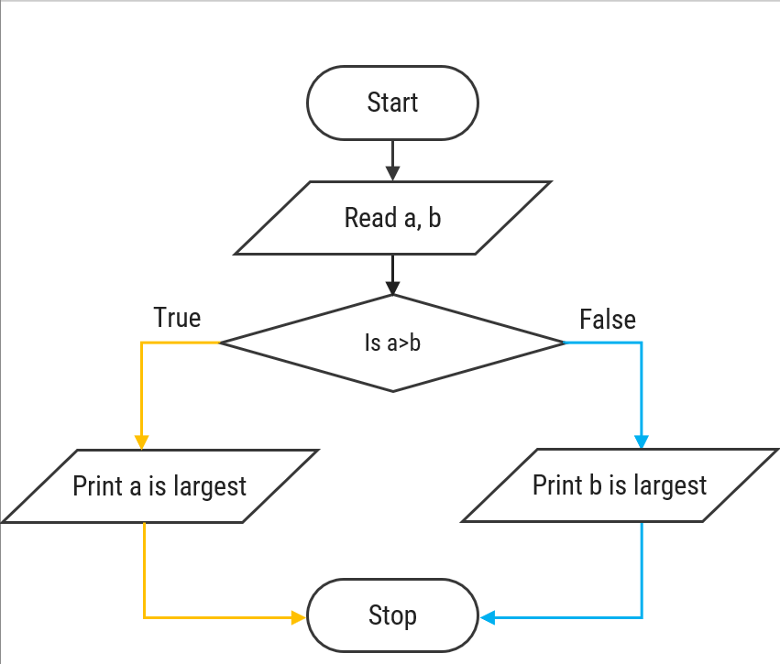

6) Find Out Largest Number from Given Three Numbers

Algorithm:

Step 1: Read a, b, c.
Step 2: If a > b, go to Step 5.
Step 3: If b > c, go to Step 8.
Step 4: Print c is largest number, go to Step 9.
Step 5: If a > c, go to Step 7.
Step 6: Print c is largest number, go to Step 9.
Step 7: Print a is largest number, go to Step 9.
Step 8: Print b is largest number.
Step 9: Stop.

Flowchart:
