Practical-9: algorithm and Flowchart

1) | Display day name for the given number.
 | Algorithm :-
Step 1: Start
Step 2: Read day number (1–7)
Step 3: If day = 1, print "Monday"
Step 4: Else if day = 2, print "Tuesday"
Step 5: Else if day = 3, print "Wednesday"
Step 6: Else if day = 4, print "Thursday"
Step 7: Else if day = 5, print "Friday"
Step 8: Else if day = 6, print "Saturday"
Step 9: Else if day = 7, print "Sunday"
Step 10: Else print "Invalid Day Number"
Step 11: Stop

 | Flowchart :-
 | 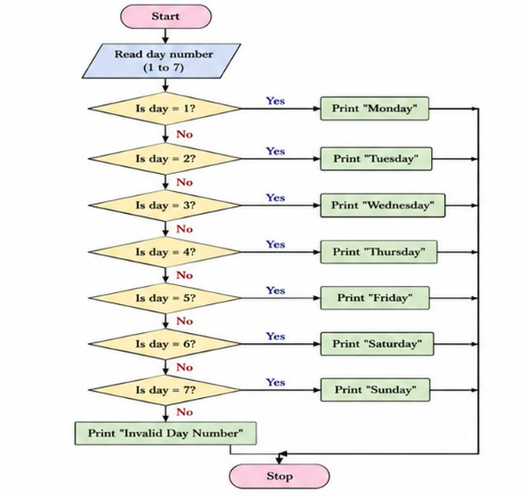
2) | Accept three numbers from user and print them in ascending and descending order.
 | Algorithm :-
Step 1: Start
Step 2: Read a, b, c and order
Step 3: Check if order == ascending then go to step 4 else go to step 8
Step 4: if a>b , swap a and b and go to step 5
Step 5: if a>c , swap a and c and go to step 6
Step 6: if b>c , swap b and c and go to step 7
Step 7: print “a, b, c (Ascending order)” then go to step 12
Step 8: if a<b , swap a and b and go to step 9
Step 9: if a<c , swap a and c and go to step 10
Step 10: if b<c , swap b and c and go to step 11
Step 11: print “a, b, c (Descending order)” then go to step 12
Step 12: Stop

 | Flowchart :-
 | 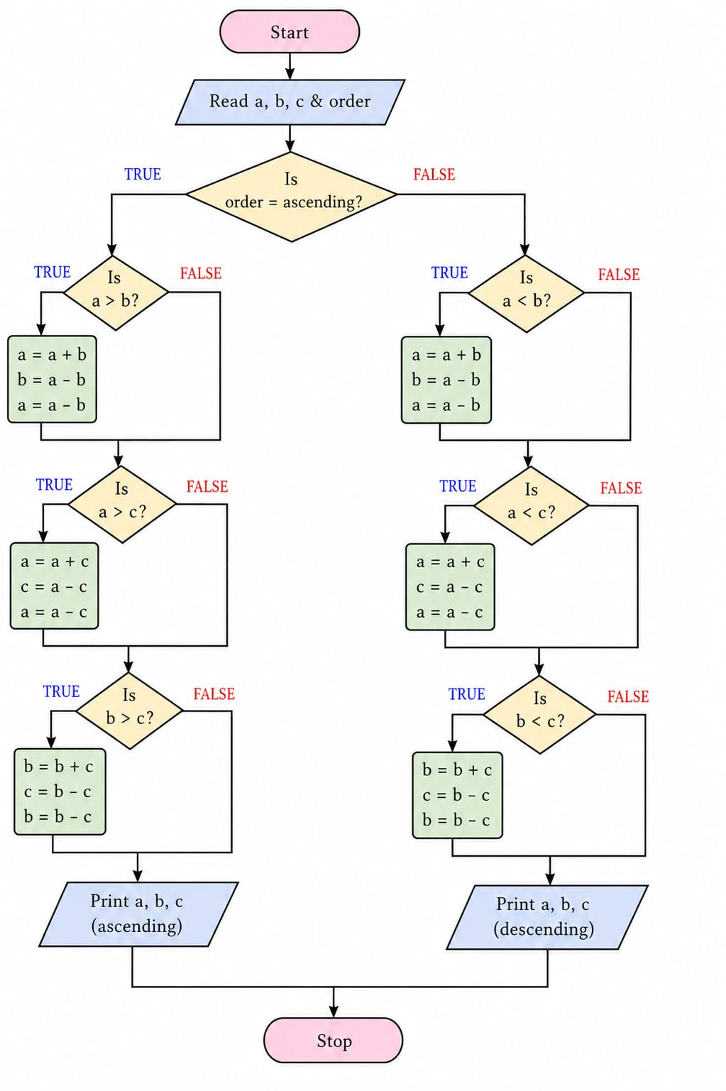
3) | Check whether the given year is leap year or not. [If a year can be divisible by 4 but not divisible by 100 then it is leap year but if it is divisible by 400 then it is leap year].
 | Algorithm :-
Step 1: Start
Step 2: Read year
Step 3: If year is divisible by 4 ,go to step 5
Step 4: print “common year” go to step 9
Step 5: If year is divisible by 100 then go to step 7
Step 6: else print “Leap Year” and go to step 9
Step 7: if year is divisible by 400 then go to step 6
Step 8: go to step 4
Step 9: Stop

 | Flowchart :-
 | 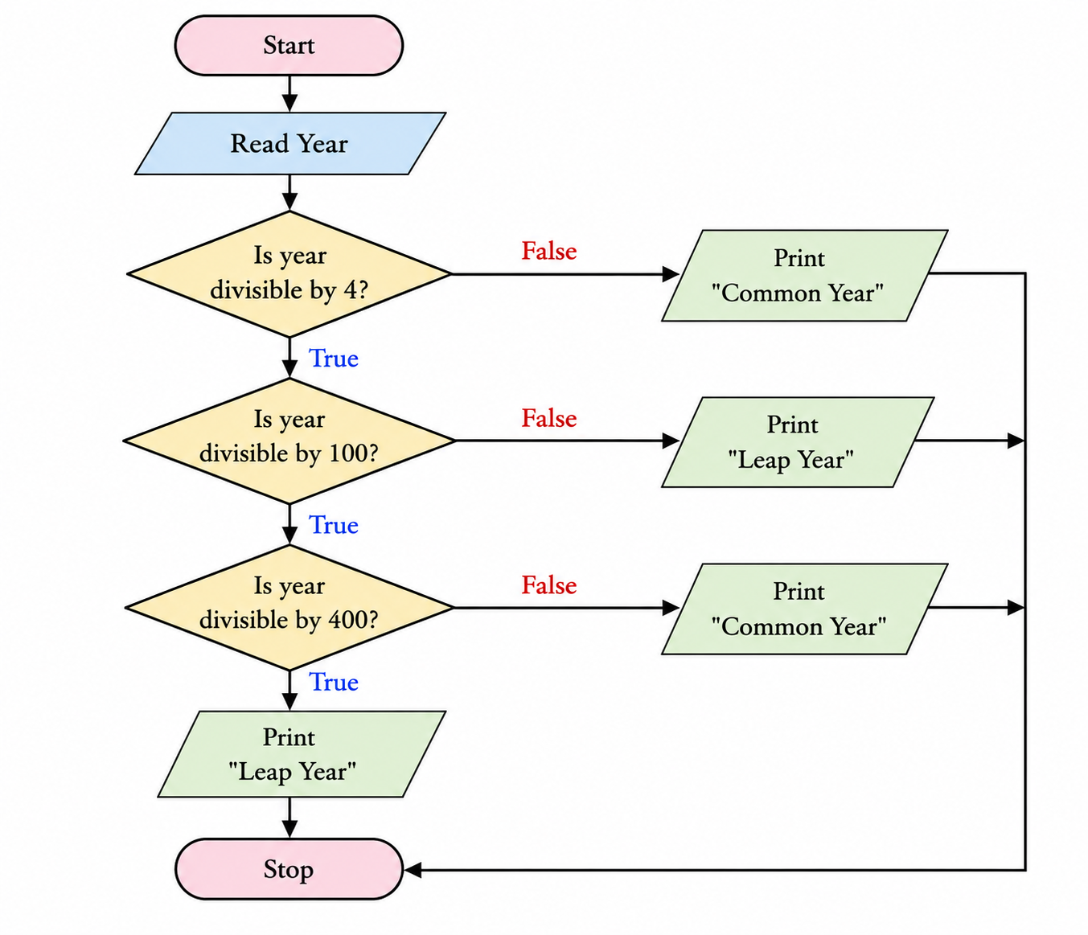
4) Input electricity unit charge and calculate the total electricity bill according to the given condition:
• For first 50 units Rs. 0.50/unit
• For next 100 units Rs. 0.75/unit
• For next 100 units Rs. 1.20/unit
• For unit above 250 Rs. 1.50/unit
An additional surcharge of 20% is added to the bill.

Algorithm :-
Step 1: Start
Step 2: Read Units
Step 3: If Units ≤ 50,
then Bill = Units × 0.50 and go to step 7
Step 4: If Units ≤ 150,
then Bill = 50 × 0.50 + (Units − 50) × 0.75 and go to step 7
Step 5: If Units ≤ 250
then Bill = 50 × 0.50 + 100 × 0.75 + (Units − 150) × 1.20 and go to step 7
Step 6: Else
Bill = 50 × 0.50 + 100 × 0.75 + 100 × 1.20 + (Units − 250) × 1.50
Step 7: Bill = Bill + (Bill × 20 / 100)
Step 8: Print Bill
Step 9: Stop

Flowchart :-
