CHAPTER 1: INTRODUCTION

1.1 Background

Getting the right healthcare begins with one decision: which doctor should the patient see? For many people, that decision is not simple.
- A person with joint pain may not know whether to consult an orthopedic specialist or a general physician.
- A person with a persistent cough may be unsure whether it belongs with a general physician, a pulmonologist or an ENT specialist.
- Choosing the wrong type of doctor costs time and money, and putting off a visit altogether can delay treatment.
-Online doctor directories exist, but most assume the patient already knows which specialty to search for. Symptom-checking tools try to close that gap, but many present lists of possible diseases.There is still a gap between "I have a symptom" and "I know which doctor to visit".
SuggestDoc is a web-based doctor discovery application built to close this gap. The patient selects a district, then searches or browses a predefined list of common symptoms. The system shows doctors from all the specialties relevant to that symptom, grouped clearly, with clinic address, consultation hours, contact number and map directions.
The application suggests who can help. It never names or implies a diagnosis.

1.2 Problem Statement
Patients often lack the medical knowledge to decide which specialist a symptom calls for.
Gap | Description
Existing directories | Require the patient to know the specialty beforehand
Symptom checkers | Risk giving diagnosis-like output without clinical oversight
Patients | Need local, contactable doctors whose credentials have been checked
Doctors | Need a simple way to be listed, with a verification step before they become public

1.3 Objectives
- To design a symptom-to-specialty mapping so that one symptom can lead to several relevant specialties, letting patients find suitable doctors without prior medical knowledge.
- To let patients narrow results by district, using the 36 districts of Maharashtra.
- To present doctors in a clear, neutral format that includes specialty, qualifications, experience, clinic address, consultation hours, phone number and map directions.
- To provide role-based registration for patients and doctors, with a verification status so that unverified doctors stay hidden from patients.
- To protect data using database-level access control, so users can read and change only what they are allowed to.
- To deploy the system as a responsive web application that works on both desktop and mobile devices.
- To lay the groundwork for a digital token system that reduces waiting-room crowding. It will work as in Built Appointment System

1.4 Scope of the Project
Within Scope | Outside Scope
Patient-facing application: select a district, search 60 common symptoms, view matching doctors | Diagnosis, treatment advice or prescriptions
Thirteen medical specialties linked to symptoms through a many-to-many mapping | Online consultations
Doctor and patient registration, doctor certificate upload, and a verification status for doctors | Payments
Coverage of Maharashtra, with an initial focus on Nagpur and Gondia | Emergency services
 | Real-time clinic management beyond the token structure described in later chapters

Note: The demonstration version uses a small set of doctors, some of which are sample data created for testing. They are actual doctors and the data is from publicly available resources.

1.5 Significance of the Project
The project shows that a carefully designed symptom-to-specialty mapping can guide patients toward appropriate care without any diagnosis.

- It reduces the effort patients spend deciding whom to consult.
- It gives doctors a structured and verified way to be found.
- It provides a low-cost architecture built on free-tier cloud services, which makes it practical for small towns and districts.

1.6 Organization of the Thesis

Chapter | Content
1 | Introduction
2 | Review of existing systems and their gaps
3 | System analysis: requirements and feasibility
4 | System design: architecture, database and security
5 | Implementation and the challenges met
6 | Testing
7 | Results
8 | Ethical and legal considerations
9 | Limitations and future scope
10 | Conclusion

CHAPTER 2: REVIEW OF EXISTING SYSTEMS
2.1 Introduction
This chapter looks at the ways patients currently look for a doctor and identifies what each approach leaves unsolved. The systems are grouped into categories, and the descriptions are general. [If your university expects a literature review, add specific named products and published papers under each category, with references.]

2.2 Categories of Existing Systems
A. Online doctor directories and appointment platforms
These listed doctors with their specialty, location and contact details, and many allow appointment booking.
- Strengths: large listings, search by city and specialty, and ease of use.
- Limitations: the patient must already know which specialty to search for. A patient who only knows "my knee hurts" has no clear starting point.
B. Hospital and clinic websites
Individual hospitals and clinics publish their own doctor lists and timings.
- Strengths: accurate information about that one institution.
- Limitations: the information covers a single provider only, so patients can't compare options across a district. Small clinics often have no website at all.
C. Symptom-checker tools
These ask about symptoms and produce a list of possible conditions.
- Strengths: they help patients who don't know where to begin.
- Limitations: the output often lists diseases. This can cause anxiety, can be mistaken for a diagnosis, and raises the question of clinical accountability. Many also don't connect the result to local doctors.
D. Informal methods
Word of mouth, phone calls to clinics, and general web searches.
- Strengths: familiar and free.
- Limitations: inconsistent and hard to verify. Information may be outdated, and there is no structured link between a symptom and a type of doctor.

2.3 Gaps Identified
- The specialty gap: directories expect patients to name a specialty, which many patients cannot do.
- The diagnosis risk: symptom checkers move from guidance into disease prediction without clinical oversight.
- The single-specialty assumption: a symptom is usually linked to one specialty, although several kinds of doctors can reasonably help (for example, joint pain can go to an orthopedic specialist or a general physician).
- The local-access gap: guidance is rarely connected to nearby, contactable doctors in the patient's own district.
- The trust gap: patients need doctors whose details have been checked, and doctors need a controlled way to be listed.

2.4 How SuggestDoc Addresses These Gaps
Gap | SuggestDoc's response
Specialty gap | Patients search symptoms, not specialties, from a predefined list of 60
Diagnosis risk | Only suggests who can help, never names a disease. A disclaimer appears on every page
Single-specialty assumption | A many-to-many mapping links each symptom to all relevant specialties, and results are grouped
Local-access gap | Results are filtered by district, with clinic address, hours, phone and map directions
Trust gap | Doctors register with a certificate upload and stay hidden until verified

2.5 Summary
Existing approaches each solve part of the problem. Directories offer local doctors but assume the patient knows the specialty, and symptom checkers guide patients but risk diagnosis-like output. SuggestDoc combines the strengths of both, a symptom-based starting point and a local, verified doctor list, while deliberately staying on the guidance side of the line. The next chapter turns these observations into formal requirements.

CHAPTER 3: SYSTEM ANALYSIS

3.1 Introduction
This chapter turns the gaps found in Chapter 2 into formal requirements. It defines who uses the system, what the system must do, how well it must do it, and whether building it is feasible.

3.2 System Users
Role | Who they are | What they do in the system
Patient | Any person looking for a doctor | Registers, selects a district, searches symptoms, views doctors, calls them or gets directions
Doctor | A practising medical professional | Registers with qualifications and a certificate, then provides clinic details and consultation hours
Administrator | The system owner | Reviews doctor registrations and changes a doctor's status to verified

Note: In the current version, administrator actions are performed directly in the database. A dedicated admin dashboard is listed as future scope.

3.3 Functional Requirements
- Users can sign up and sign in, choosing a role of patient or doctor
- Doctors upload a registration certificate at sign-up
- New doctors start as pending and stay hidden until verified
- Patients select a district from the 36 districts of Maharashtra
- Patients search a list of 60 predefined symptoms, with live suggestions as they type
- Each symptom maps to one or more of the 13 specialties
- Results show doctors from all mapped specialties, grouped by specialty
- Each doctor card shows specialty, qualifications, experience, clinic address, hours and phone
- Patients can call a doctor or open map directions in one tap
- The system suggests doctors only and never displays a diagnosis
- Recent searches are remembered on the patient's device
- The token queue shows how many patients are ahead for doctors who use it
- Patients join a queue and track a live token
- Doctors manage their profile and queue from a dashboard
- Administrators manage verification, specialties and symptoms from a dashboard

3.4 Non-Functional Requirements
- Users can read and change only their own records, enforced by database access rules. Unverified doctors are never visible to patients. Secret keys never appear in the front end
- Patient searches are stored only on the patient's own device. Doctor emails and certificates are not exposed to patients
- Simple search-first interface with no medical jargon, suitable for first-time users
- Works in modern browsers on desktop and mobile screens
- Symptom suggestions appear instantly while typing, and doctor lists load in a few seconds on an ordinary connection
- Clear messages when data cannot load, and empty states when no doctors match
- Symptoms, specialties and mappings live in database tables, so they can change without editing code
- The design supports more districts and doctors, since it is driven by data rather than fixed lists

3.5 Feasibility Study
- Technical feasibility
Every component uses mature, well-documented web technology. The tools were learned and used by a single developer, and the working deployed system proves the approach is technically achievable.
- Economic feasibility
The project runs on free tiers of cloud services and needs no paid software or licences.
Item | Cost
Hosting (Vercel) | Free tier
Database, authentication and file storage (Supabase) | Free tier
Maps | Plain Google Maps links, no API key or billing
Development tools (VS Code, Git, browser) | Free

- Operational feasibility
The interface needs no training: patients choose a district and type a symptom. Doctors need only basic web skills. Because the content is stored in tables, the administrator can update symptoms and mappings without touching code.
- Legal and ethical feasibility
The system avoids diagnosis and shows a disclaimer on every page, which keeps it in the role of a directory and guide. Collecting doctors' certificates and contact details requires their consent and careful handling. These points are discussed in Chapter 8.

3.6 Technology Stack and Justification

Layer | Technology | Why it was chosen
Front end | Next.js (React framework) with TypeScript | Fast pages, file-based routing, and type checking that catches errors early
Styling | Tailwind CSS | Quick, consistent, responsive design
Database | PostgreSQL (through Supabase) | Reliable relational database, well suited to the symptom-specialty-doctor relationships
Authentication | Supabase Auth | Secure sign-up and login without building it from scratch
Access control | Row-level security policies | Enforces who can see or change each record inside the database itself
File storage | Supabase Storage (private bucket) | Keeps doctors' certificates private
Hosting | Vercel | Automatic deployment from GitHub, with a public link
Version control | Git and GitHub | Tracks changes and connects to hosting
Maps | Google Maps links | Directions with no API key or billing

3.7 Hardware and Software Requirements
 | Requirement
Development machine | Windows 11 PC, VS Code, Node.js, Git
Server side | Cloud-hosted, so no server hardware to maintain
User side | Any modern web browser, on a phone or computer, with an internet connection

CHAPTER 4: SYSTEM DESIGN
4.1 Introduction
This chapter describes how SuggestDoc is built: its architecture, its database, the way symptoms connect to doctors, how data is protected, and how the interface is organized. Diagrams appear as text sketches that you can redraw in your preferred tool.

4.2 System Architecture
The system has three layers. The browser holds the interface, Vercel serves it, and Supabase provides the database, login and file storage.
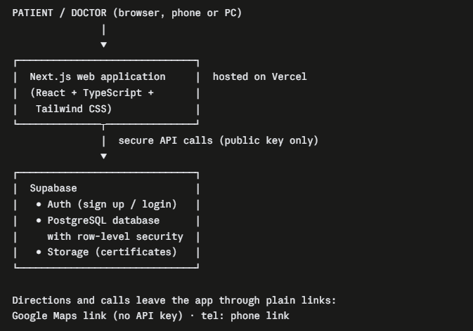

Key points

- The browser never holds a secret key. It uses only Supabase's public key, and the database rules decide what each user may read or write.
- The interface loads data directly from the database, so no separate backend server is needed.
- Hosting and database both run on free tiers.

4.3 Database Design

A) Entity relationship diagram
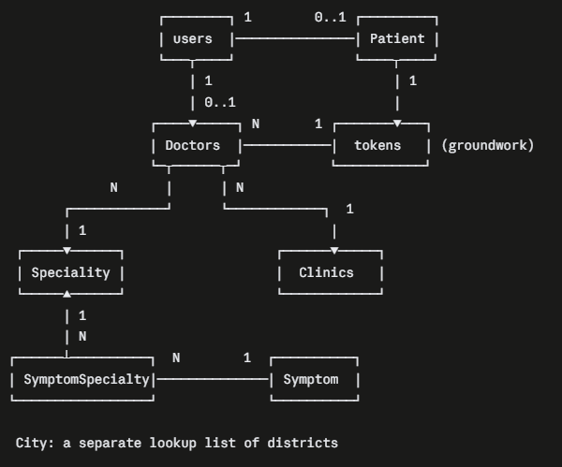

Relationships
- One user is either one patient or one doctor.
- One doctor has one specialty and one clinic. A specialty or clinic can have many doctors.
- Symptom and Speciality have a many-to-many relationship, resolved through the SymptomSpecialty table.
- A token links one patient to one doctor for one date.
B) Data dictionary
- Users
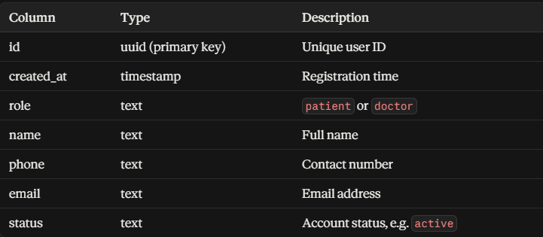

- Patients
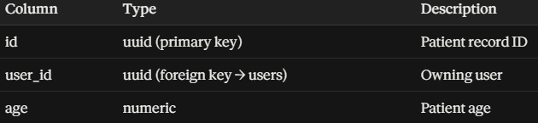
- Doctors
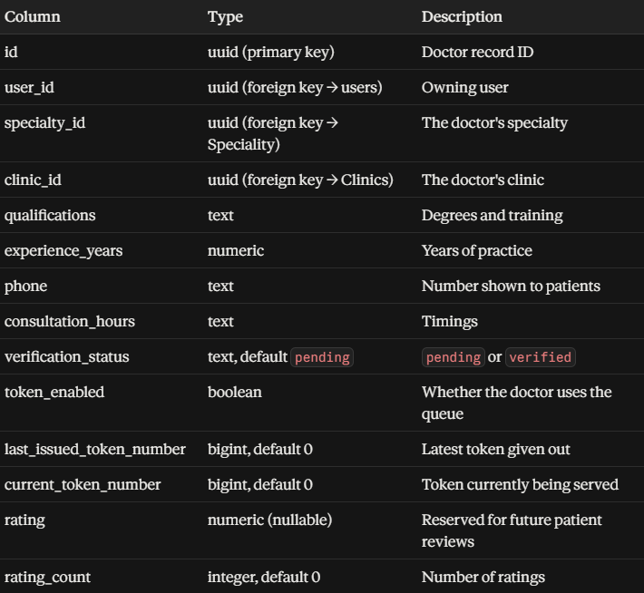
- Speciality
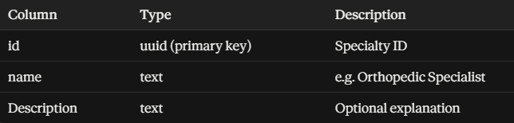
- Clinics
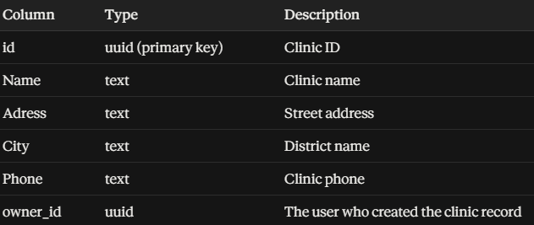
- Symptom
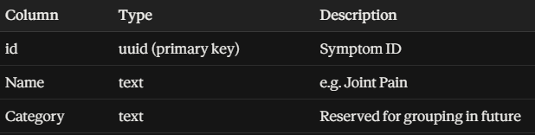
- SymptomSpecialty
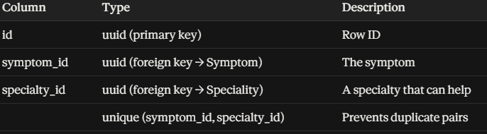
- City
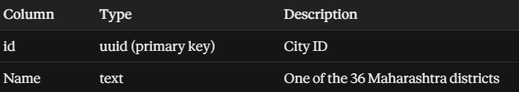
4.4 Symptom-to-Specialty Mapping
The problem with a simple link. If each symptom stored one specialty_id, then "Joint Pain" could point only to Orthopedics. Patients would miss general physicians, who can reasonably help too, and the system would force one answer where several are valid.
The solution. A join table SymptomSpecialty lets one symptom link to any number of specialties.
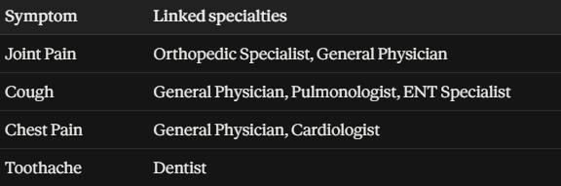
Coverage of the data
- 60 symptoms, 13 specialties, and about 130 symptom-specialty links.
- General Physician is linked to 55 of the 60 symptoms, so nearly every search returns at least some doctors.
- The mapping is deliberately conservative: it lists the specialties a clinic would normally point a patient toward, and it never names a condition. [State clearly that the mapping is a first draft that hasn't been clinically reviewed, and that a doctor should validate it before real use.]
4.5 Search and Results Flow
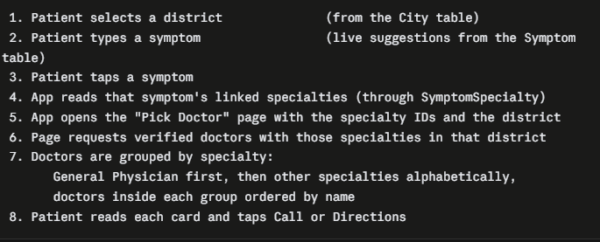
Result-ordering rules
- No ranking of individual doctors. Names are ordered alphabetically, never by "best".
- The General Physician group comes first because it applies to nearly every symptom. Specialty groups are separated by a simple divider line.
- A specialty group with no doctors in the chosen district is skipped.
4.6 Security Design
Security is enforced by the database itself through row-level security (RLS), so it holds even if someone bypasses the interface.
4.6.A) Access rules
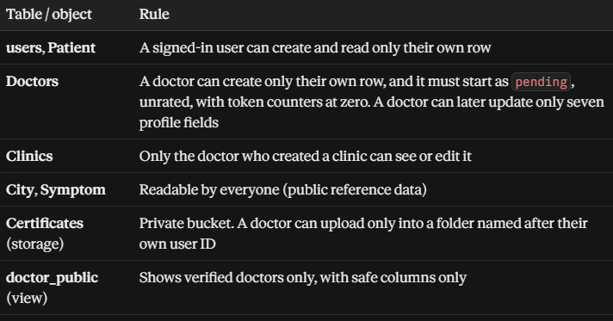
4.6.B) Preventing self-verification
During development, a security review found that the original doctor-insert rule only checked ownership. A user signing up as a doctor could have set their own status to verified. This was fixed in two ways:
- The insert rule now requires verification_status = 'pending', zero token counters and no rating.
- Column-level permissions allow doctors to update only these seven fields: specialty, clinic, qualifications, experience, phone, token setting and consultation hours. They can never change their own verification status, rating or token counters.
4.6.C) Other protections
- Only the public browser key is used in the front end. Secret keys are never included in the code.
- Recent searches are stored in the browser on the patient's own device.

4.7 Token Queue Design (Groundwork)
Each doctor row holds two counters:
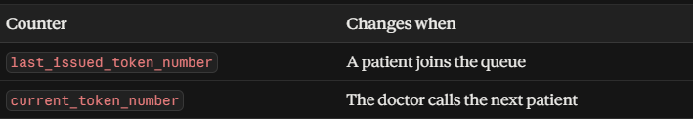
A patient's position is calculated as:
people ahead = last_issued_token_number − current_token_number
The doctor card already shows this position for doctors who enable the queue. The booking and live-tracking screens are future scope. To avoid two patients receiving the same number, the design calls for issuing tokens through a single atomic database function. This function is designed but yet to be implemented.

4.8 Data Flow Diagrams
Level 0 (context diagram)
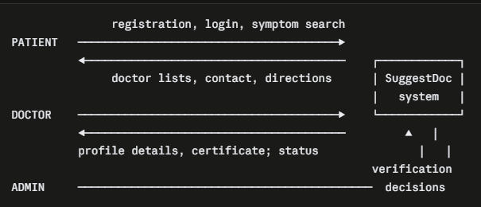
Level 1 (main processes)
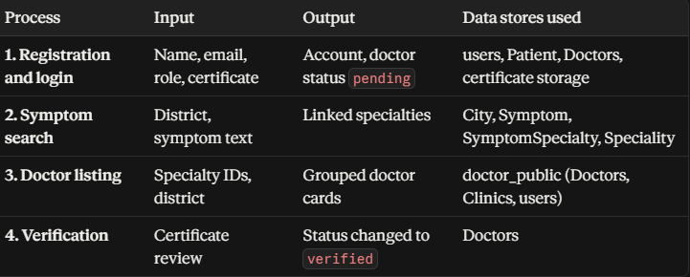
4.9 User Interface Design

4.9.A) Screens
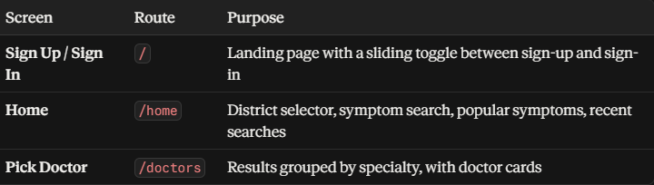

4.9.B) Design decisions
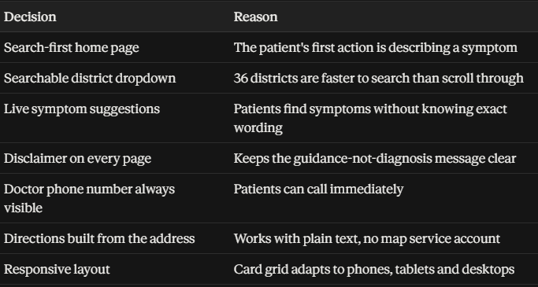

4.9.C) Visual identity
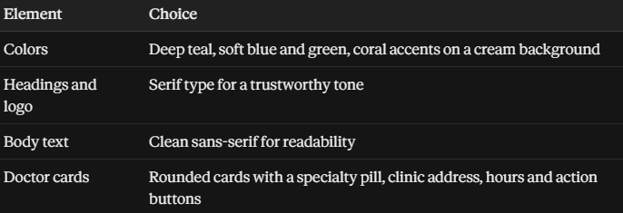

CHAPTER 5: IMPLEMENTATION
5.1 Introduction
This chapter explains how the design was turned into a working, deployed application. It covers the project structure, each module, the deployment process, and the problems met along the way and how they were solved.

5.2 Development Environment
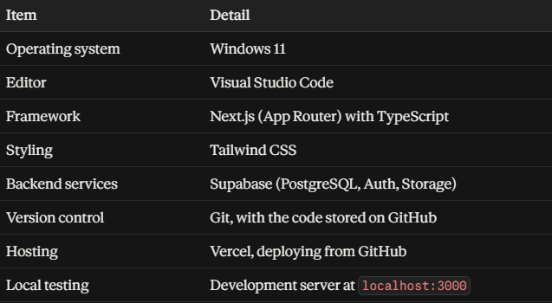

5.3 Project Structure
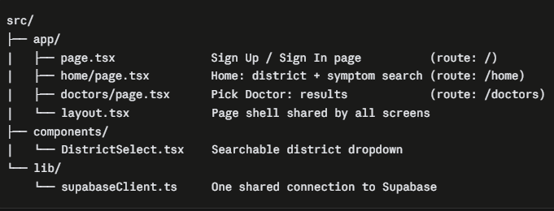

Next.js turns each folder containing a page.tsx file into a web address, so the folder names double as routes.

5.4 Module 1: Database Setup
The database was created first, and its content was loaded with SQL scripts.
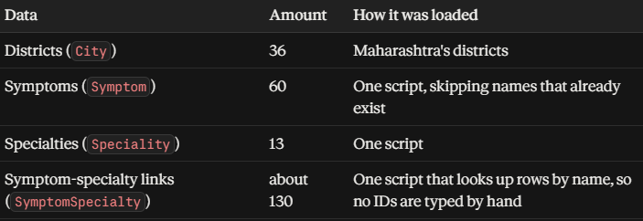
Verification of the mapping. The mapping script ends with a query that lists any pair whose symptom or specialty name didn't match. An empty result meant every link was inserted. A second query lists symptoms with no specialty at all, which should also return nothing.
5.5 Module 2: Registration and Login
The landing page (/) combines sign-up and sign-in in one screen, with a sliding toggle between the two.
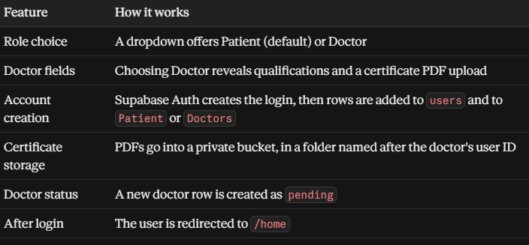
5.6 Module 3: Home Page (District and Symptom Search)
District selection
A custom dropdown replaced the browser's default select box, because the default list cannot be styled to match the design. The custom version has a search box, keyboard support (arrow keys, Enter, Escape), a clear button and a check mark on the chosen district. The districts are loaded from the City table, sorted A to Z.

Symptom search
All symptoms are loaded once when the page opens, together with their linked specialties, in a single query:
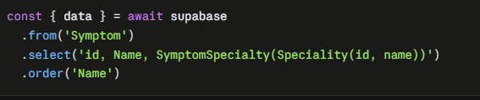
Because the list is small, typing is filtered in the browser, so suggestions appear instantly with no request per keystroke. Results that begin with the typed text are shown first.
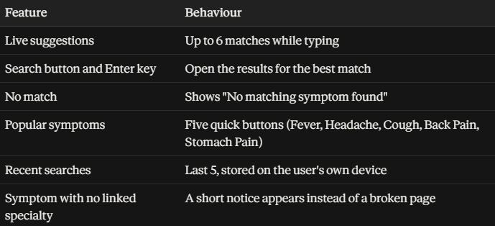
Handing off to the results page
Choosing a symptom sends all its specialties to the results page, with no extra step:
5.7 Module 4: Pick Doctor Page
Loading doctors
The page reads the specialty IDs and district from the address, then asks the database for matching doctors:
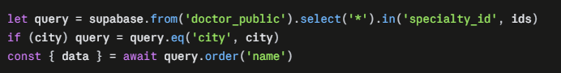
It reads the doctor_public view (Chapter 4), so unverified doctors never appear and only safe columns are returned.
Grouping and ordering
Doctors are split into one group per specialty:
- The General Physician group is placed first, then other specialties alphabetically.
- Doctors inside a group are ordered by name.
- A group with no doctors is left out.
- A thin divider line separates groups, and no doctor is ranked above another.
Doctor card
Each card shows the following:
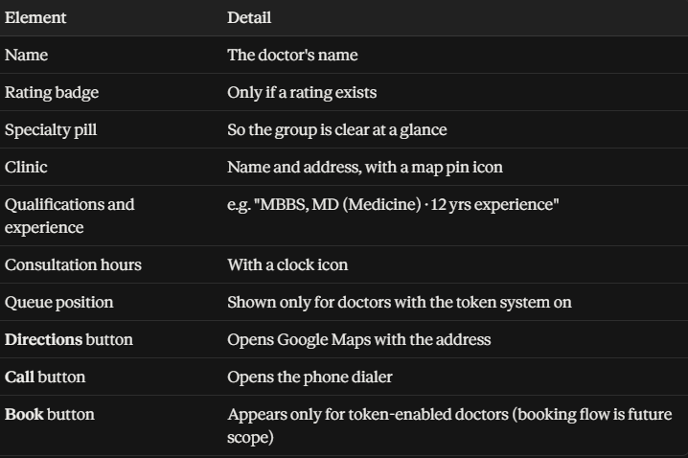
Directions need no map account. The link is built from the plain address text:

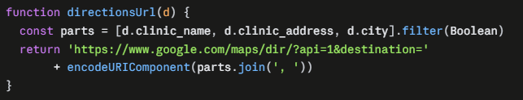
Page states
Loading spinner, error message, "no doctors found yet" (naming the district), and a prompt to return to the home page when no symptom was chosen.

6. TESTING
6.1 Testing Approach
SuggestDoc was tested using manual black-box functional testing, in which each feature is exercised through the user interface without reference to the underlying code. Testing took place in two stages: first on the local development server (http://localhost:3000), then on the deployed Vercel site [insert deployed URL].
All tests were run against sample data. The database contained 60 symptoms, 13 specialties, 36 Maharashtra districts, two sample clinics (Nagpur and Gondia) and three sample doctors. The three doctors are:
- Dr. Test Ortho, an Orthopedic Specialist in Nagpur, with a rating.
- Dr. Test Physician One, a General Physician in Nagpur, with a rating.
- Dr. Test Physician Two, a General Physician in Gondia, with no rating and the token system turned off.
This gave a small but deliberate spread of cases: two districts, two specialties, rated and unrated doctors, and token-enabled and token-disabled doctors.

6.2 Access Control and Security Test Cases
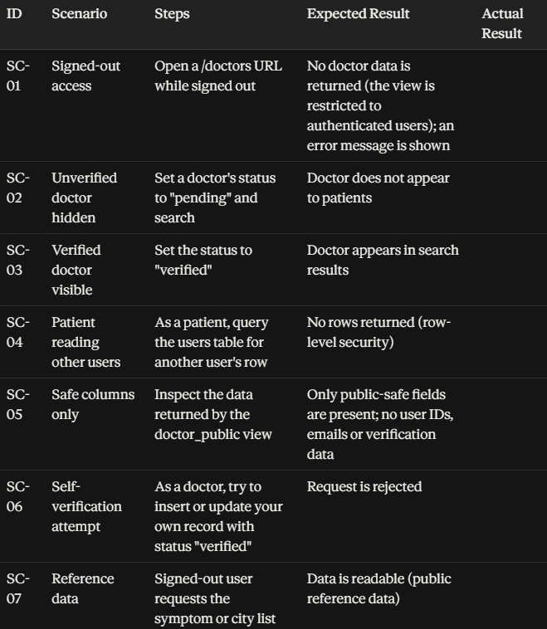

6.4 Deployed-Site Testing
After deployment, the most important cases were repeated on the live site, because some faults appear only in production. The differences between the two environments are:
- Case sensitivity. The production server runs Linux, where folder names are case-sensitive, so routes such as /doctors had to be verified explicitly.
- Environment variables. The Supabase URL and public key must be configured in the hosting dashboard, so a full search flow was run end to end.
- Real devices. The site was opened on a mobile phone and a desktop browser to check layout, the Directions link and the Call button.
- Direct URLs. A Pick Doctor URL was opened directly and refreshed, to confirm the page loads correctly from the URL parameters alone.
7. RESULTS AND SCREENSHOTS
This chapter presents the implemented screens of SuggestDoc as they appear on the deployed system. All screenshots were captured on the live site using sample data (three sample doctors and two sample clinics), so the doctors and ratings shown are not real. Screens that are designed but not yet built, such as the token booking flow, doctor profile page and admin dashboard, are listed in Section 9 and are not shown here.

7.1 Sign-Up and Sign-In Page
Figure 7.1: Landing page with sliding Sign Up / Sign In toggle
The root page of the application (/) serves as both the landing page and the authentication screen. A sliding toggle switches between registration and login without leaving the page. During registration, the user selects a role, patient or doctor, and supplies basic details such as name, phone number and email. Passwords are handled by Supabase Authentication. After a successful sign-in, the user is redirected to the home page (/home).
Capture: both toggle states (Sign Up and Sign In), and if possible one validation error, such as a wrong password.

7.2 Home Page: Location Selection
Figure 7.2: District selector on the home page
The first card on the home page asks the user to choose a district. The dropdown is searchable, is filled from the City table, and lists all 36 districts of Maharashtra in alphabetical order. No district is pinned or given priority. A short tip beneath the selector explains that choosing a district narrows the results. Once a district is chosen, the heading text updates to include it, for example "Find the perfect doctor in Gondia, Maharashtra".
Capture: the dropdown open with the search box in use, and then the page after a district has been selected.

7.3 Home Page: Symptom Search
Figure 7.3: Symptom search with live suggestions
The main search card lets the user find a symptom from the fixed list of 60. As the user types, up to six matching symptoms are suggested, with names that begin with the typed text shown first. Matching ignores letter case. Beneath the search box, quick-select pills offer five common symptoms (Fever, Headache, Cough, Back Pain and Stomach Pain), so a patient can begin without typing at all.
Figure 7.4: No-match and unlinked-symptom messages
If the typed text matches no symptom, the system says so in plain words and asks the user to try a different word. If a symptom exists but has no specialty linked to it, a notice explains that no doctors are linked to it yet, and the user is not sent to an empty page.
Capture: a partly typed query with the suggestion list visible, and the no-match message.

7.4 Home Page: Recent Searches
Figure 7.5: Recent Searches card
Each symptom the user selects is remembered, and the last five appear in a Recent Searches card so that a search can be repeated with one click. This list is stored only in the browser on the user's own device. It is not sent to the server, which is a deliberate privacy choice.
Capture: the card after two or three searches have been made.

7.5 Home Page: Footer and Disclaimer
Figure 7.6: Footer with disclaimer and creator credit
The footer shows the application name, a highlighted disclaimer stating that SuggestDoc is for guidance only and not medical advice, and a line addressed to the people of the selected district. The credit block at the bottom names the creator and developer. The disclaimer sits on the same page where users start their search, so it is seen before any results are shown.
Capture: the footer in full.

7.4 Pick Doctor Page
Selecting a symptom sends the user to the Pick Doctor page. The symptom's linked specialties and the chosen district are passed in the address of the page, so a result page can be refreshed or opened directly without losing its content.
Figure 7.7: Grouped results across several specialties
The page heading reads "Doctors who can help", followed by the district and the names of the specialties involved. A small counter shows how many doctors were found. Doctors from every specialty linked to the symptom appear together. For a symptom such as Joint Pain, both General Physicians and Orthopedic Specialists are listed. General Physicians come first, followed by other specialties in alphabetical order, and a thin divider line separates the groups. The groups have no headings, because each card already names its own specialty.
Doctors within a group are sorted alphabetically by name. This keeps the listing neutral, since no doctor is placed above another because of a rating or any other measure of merit.
Capture: Joint Pain with Nagpur selected, showing both groups and the divider.
Figure 7.8: Doctor card
Each doctor is shown on a card containing:
- the doctor's name and, when one exists, a rating badge with a star
- the specialty
- the clinic name and address
- qualifications and years of experience
- consultation hours
- the queue position, for doctors who have the token system enabled
- a Directions button, a phone button and, for token-enabled doctors, a Book button
The Directions button opens Google Maps with the clinic address as the destination. The phone button opens the device's dialler with the doctor's number. The number is always available, whether or not the doctor uses the token system. The Book button is a placeholder, as the booking flow is planned and not yet built.
Capture: one card at full size, ideally with the mouse over it to show the hover effect.
Figure 7.9: Rated and unrated doctors side by side
A doctor with a rating shows a star badge. A doctor with no rating shows no badge at all, instead of a misleading "0" or "N/A". This allows a new doctor to be listed fairly before any rating exists. In the sample data, Dr. Test Physician Two has no rating and shows no badge, while the other two doctors display theirs.
Capture: Nagpur results next to a Gondia result, or any screen where a rated and an unrated card are both visible.
Figure 7.10: District filtering
The same symptom gives different results in different districts. Selecting Nagpur shows the two Nagpur doctors, and selecting Gondia shows only the Gondia doctor. A specialty group with no doctors in the chosen district is left out completely, with no empty section or divider.
Capture: the same symptom with Nagpur and then with Gondia.
Figure 7.11: Empty and loading states
When a district has no matching doctors, the page shows a plain message such as "No doctors found yet in Pune." While data is loading, a small spinner and the text "Loading doctors..." are displayed. If the request fails, an error message asks the user to try again.
Capture: a district with no doctors, for example Pune.

7.5 Responsive Layout
Figure 7.12: Pick Doctor page on desktop and mobile
The doctor cards are arranged in three columns on wide screens, two on tablets and one on phones. The soft background shapes and card styling follow the same design as the home page, so the two screens look like one application. On mobile the Directions and phone buttons remain easy to reach with a thumb.
Capture: the results page in a desktop browser and on a real phone, both from the deployed site.

7.6 Backend and Security Views (optional)
Figure 7.13: Database tables and public view in Supabase
Screenshots of the Supabase dashboard can support the security design in Section 4. Useful views are the list of tables, the doctor_public view (marked as restricted), and the row-level security policies on the main tables. Do not show API keys, the project URL with keys, or any real user data in these captures.

7.7 Summary of Results
The screens above show that the main patient journey works end to end on the deployed site. A user can sign in, choose a district, search for a symptom, and see doctors from all relevant specialties, grouped and sorted neutrally, with working Directions and Call actions. Empty, loading and error situations are handled with clear messages. The results were produced with sample data, and the token booking flow, doctor profile page, admin dashboard and patient reviews remain future work.
8. ETHICAL AND LEGAL CONSIDERATIONS
Healthcare software affects real decisions about people's health, so ethical design was treated as a core requirement of SuggestDoc, on the same level as functionality. This chapter describes the ethical principles built into the system, and the legal points that would need attention before a public launch.

8.1 A Guidance Tool, Not a Diagnostic Tool
The most important principle in SuggestDoc is that it never diagnoses. The system does not accept free-text descriptions of illness, does not interpret symptoms, and never names a disease or condition. The patient chooses from a fixed list of 60 everyday symptoms, and the system answers only with the kinds of doctor who commonly help with that symptom.
This was a deliberate decision. Automated diagnosis without clinical oversight can give false reassurance or cause unnecessary alarm, and either can delay proper care. Keeping the system to a directory-and-guidance role removes this risk by design. The wording throughout the application reflects this, with headings such as "Doctors who can help" instead of anything that suggests a conclusion about the patient's condition.

8.2 Disclaimer
The home page footer carries a clearly highlighted disclaimer stating that SuggestDoc is for guidance only, is not medical advice, and that users should consult a licensed doctor for proper diagnosis and treatment. It sits on the page where every user begins their search, so it is seen before any results appear.
At present the disclaimer appears on the home page only. Extending it to the Pick Doctor page, where users actually see doctors and act on them, is a small improvement listed in Section 9.

8.3 Emergency Situations
Some symptoms, such as chest pain, shortness of breath and palpitations, can signal a medical emergency, where searching a directory is the wrong first step. A short warning for these symptoms has been designed, advising users to go to the nearest emergency room if the problem is severe or sudden. This warning is planned and not yet implemented, and it is listed as future work in Section 9. Until it is built, the general disclaimer is the only safeguard, and the thesis does not claim more than that.

8.4 Fairness in Listing Doctors
The system is designed so that it does not judge one doctor as better than another.
- Doctors within the same specialty are listed alphabetically by name. They are not ordered by rating, popularity or any other measure of merit.
- Specialty groups are shown with General Physicians first, followed by other specialties in alphabetical order. This reflects that a general physician is the usual first point of contact, and is not a statement about quality.
- A doctor with no rating shows no badge at all, so a new doctor is not shown with a misleading score.
- A doctor's phone number is always visible, whether or not the doctor uses the token system, so patients are never forced to use the queue to reach a doctor.
Sorting by rating was considered and rejected. Early ratings are based on very few reviews and are unreliable, and ranking on them would quietly favour doctors who happen to have collected reviews over equally capable doctors who have not.

8.5 Doctor Data and Verification
Doctors who register through the application start with a "pending" status and are hidden from patients until an administrator verifies them. Verification is based on a certificate that the doctor uploads to a private storage bucket. That bucket is restricted so that a doctor can upload only into a folder named after their own user ID, and certificates are never exposed through the public view that patients query.
Patients see only professional information that a doctor would normally make public: name, specialty, qualifications, experience, clinic details, consultation hours and phone number. Internal data, such as account identifiers, email addresses and verification status, is not included in the public view.
At present, verification is done by editing the database directly, because the admin dashboard is not yet built. This is listed as a limitation in Section 9.

8.6 Patient Privacy
The system follows a principle of data minimisation, collecting only what it needs to work.
- What is collected. Name, phone number, email address and age.
- Passwords. These are handled entirely by Supabase Authentication and are not stored in the application's own tables.
- Symptom searches. These are not stored on the server. The Recent Searches feature keeps its list only in the user's own browser, on their own device.
- Access control. Row-level security in the database ensures that a signed-in user can read only their own records. A patient cannot read another user's profile.
- Secrets. No secret keys are placed in the frontend code. Only the public keys designed for browser use are included.

8.7 Sample Data and Ratings
All doctors, clinics and ratings shown in this project are sample data created for development and testing. They do not describe real doctors or real clinics. The ratings were entered manually by the developer, and no real patient feedback has been collected. They should not be read as a measure of any real doctor's quality.
When patient reviews are introduced in the future, they should be limited to patients who have actually used a doctor's queue, to reduce fake or malicious reviews. The average rating should then be calculated by the system and not typed in by hand.

8.8 Medical Validation of the Symptom Mapping
The links between symptoms and specialties were written as a conservative first draft and have not been reviewed by a medical professional. A wrong link could send a patient to a less suitable kind of doctor. Clinical review of the mapping is therefore a requirement before any real-world use, and it is stated as a limitation in Section 9. The many-to-many design softens this risk, because most symptoms are linked to a General Physician as well as a specialist, but it does not replace medical review.

8.9 Legal Considerations
The project is an academic prototype, and a public launch would need the following to be confirmed with proper legal advice. They are listed here as requirements and are not claimed as already met.
- Data protection. A privacy policy and a clear consent notice consistent with India's Digital Personal Data Protection Act, 2023, covering the personal data collected from patients and doctors.
- Listing of doctors. Professional rules on how doctors may be listed or promoted, including the medical council's restrictions on advertising by doctors, and consent from each doctor to be listed.
- Medical regulation. Confirmation that the service's role as a directory and guidance tool, and not a diagnostic or telemedicine service, is stated consistently in its wording and terms of use.
- Terms of use. A document that sets out the disclaimer, the limits of the service and the responsibilities of users and doctors.
9. LIMITATIONS AND FUTURE SCOPE
9.1 Current Limitations
- Token queue is partly built. The database holds the two queue counters, and the doctor card displays queue position. The Book button, however, is a placeholder, and no patient-side booking or doctor-side queue control exists yet.
- Sample data. The system contains sample doctors and ratings only.
- Symptom mapping is a first draft. The links between symptoms and specialties were written conservatively, but have not been reviewed by a medical professional.
- Fixed symptom list. Users can search only the 60 predefined symptoms, and only in English.
- Two districts. All 36 districts are in the database, but doctors are planned only for Nagpur and Gondia at first.
- One specialty per doctor. A doctor can currently be listed under a single specialty.
- No distance sorting. Results are not ordered by how close a clinic is. Directions work from the clinic's address text, but the system stores no coordinates.
- Manual verification and rating entry. Without an admin dashboard, these are done directly in the database.
9.2 Future Scope
- Complete token queue. Add an atomic database function for issuing tokens, so two patients joining at once never receive the same number, along with a patient tracking page and a doctor queue-management screen using real-time updates.
- Doctor profile page. A full page per doctor with all details and actions.
- Admin dashboard. A verification queue, plus management of specialties, symptoms, districts and mappings.
- Patient reviews. A reviews table restricted to patients who completed a visit, with ratings recalculated automatically.
- Emergency guidance. The warning banner for high-risk symptoms.
- Clinical validation. Review of the symptom-to-specialty mapping by qualified doctors.
- Language support. Marathi and Hindi interfaces and symptom names.
- More districts, and multi-specialty doctors through a join table.
- Stronger sign-up protection. Re-enable email confirmation and add a login guard on protected pages.
10. CONCLUSION, REFERENCES AND APPENDICES
10.1 Conclusion
This project addressed a common everyday problem: patients often do not know which kind of doctor to see for a symptom. SuggestDoc lets a patient choose a district, pick a symptom from a fixed list and immediately see doctors from every relevant specialty. It does this without diagnosing anything.
The key design decision was to link symptoms to specialties through a many-to-many mapping, which lets one symptom return several kinds of doctor at once. Security was built into the database through row-level security, a restricted public view and a verification status for doctors, and not left to the interface alone. The application was built with Next.js, Supabase and Vercel, all of which have free tiers, so the whole project needed no paid services.
The search, district filtering, grouped results and doctor cards are working and tested. The token queue, doctor profile page, admin dashboard and patient reviews are designed but not yet built, and the data in the system is sample data. With clinical review of the mapping, real doctors and a completed queue system, the project could grow from a working prototype into a useful public service.
10.2 References
Add the sources you actually used. Suggested official documentation:
- Next.js Documentation. Vercel. https://nextjs.org/docs
- Supabase Documentation. Supabase Inc. https://supabase.com/docs
- PostgreSQL Documentation: Row Security Policies. PostgreSQL Global Development Group. https://www.postgresql.org/docs/current/ddl-rowsecurity.html
- Vercel Documentation. Vercel Inc. https://vercel.com/docs
- Tailwind CSS Documentation. Tailwind Labs. https://tailwindcss.com/docs
- The Digital Personal Data Protection Act, 2023. Government of India.
Add an access date to each web source. If you cite research papers or books on health information systems, list only ones you have read yourself. I haven't invented any academic citations for you.
10.3 Appendices
Appendix A: SQL Scripts. Paste, in order: the symptom insert, the specialty insert, the symptom-to-specialty mapping insert, the join table and read policies, the token columns and doctor_public view, the ratings columns and updated view, and the sample-data script. All of these are in the handoff document.
Appendix B: Specialties (13). General Physician, Neurologist, Pulmonologist, ENT Specialist, Gastroenterologist, Orthopedic Specialist, Cardiologist, Dermatologist, Ophthalmologist, Dentist, Urologist, Endocrinologist, Psychiatrist.
Appendix C: Symptom-to-Specialty Mapping (first draft, not medically validated). The left column is the full list of 60 symptoms.

