# DEPARTMENT OF INFORMATION TECHNOLOGY

**COURSE CODE: DJ19ITL504 DATE:22/10/22**

# COURSE NAME: Artificial Intelligence Laboratory CLASS: TY-IT

**EXPERIMENT NO.04**

**CO/LO:** Formulate the problem as a state space and select appropriate technique from blind, heuristic or adversarial search to generate the solution.

**AIM / OBJECTIVE:** To implement informed search techniques on a given problem. (Greedy BFS & A*)

# DESCRIPTION OF EXPERIMENT:

We need to implement Best First Search and A* Search and study them based on Time Complexity, Space Complexity, Optimality and Completeness.

**Algorithm astar(graph,h):**

1. Append a touple of start state and its heuristic(h) to queue
2. While front of queue doesn’t contain goal state do:
3. Dequeue front
4. Calculate the fx value for all next node as fx = gx + h
5. Sort queue based on fx value
6. Remove cycles
7. Remove overlapping paths

**Algorithm bestFirst(graph,h):**

1. Append start state to queue
2. If path contains goal node:

Success

Else if leaf node reached with no goal node encounter:

Terminate search goal not found

Else:

Find the neighbor with minimum heuristic

Add this neighbor to traversal path

Traverse bestFirst(neighbours of the last added node)

# Explanation/Solutions(Design):

**Code:**

**A*:**

#graph={"s":[("b",3),("c",4)] , "b":[("c",1),("d",2),("g",3),("s",3)] , "c":[("e",1),("f",3),("g",4),("s",4),("b",1)] , "d":[("g",1),("b",2)] , "e":[("c",1)], "f":[("c",3)], "g":[("b",3),("c",4),("d",1)]}

#h={"s":11,"b":2,"c":4,"d":6,"e":4,"f":1,"g":0}

graph={}

h={}

n=int(input("enter the number of states : "))

for i in range(0,n):

    state=input("enter the state : ")

    huristic=int(input("enter the heurixtic of current state : "))

    h[state]=huristic

    n_line=input("enter the neighbours,distance of neighbour : ")

    neighbours=n_line.split()

    ni=[]

    for i in neighbours:

        ele=i.split(",")

        ni.append((ele[0],int(ele[1])))

    graph[state]=ni

q=[]

def dq(q):

    top=q[0]

    del q[0]

    return top[0]

def calculatefx(top,h,graph):

    f=0

    for i in range(1,len(top),1):

        n1=graph[top[i-1]]

        for j in n1:

            if(top[i]==j[0]):

                f=f+j[1]

    return f+h[top[-1]]

def removecycle(q):

    cycli=[]

    for i in range(0,len(q)):

        if(len(q[i][0])!=len(set(q[i][0]))):

            print("removing cycle " ,q[i])

            cycli.append(q[i])

    for i in cycli:

        del q[q.index(i)]

    print("--> ",q)

def removeoverlap(q):

    olapi=[]

    for i in range(0,len(q)-1):

        for j in range(i+1,len(q)):

            if(q[i][0][0]==q[j][0][0] and q[i][0][-1]==q[j][0][-1]):

                print("removing overlap " ,q[j])

                olapi.append(q[j])

    for i in olapi:

        del q[q.index(i)]

    print("--> ",q)

def traverse(graph,h):

    q.append(("s",h["s"]))

    #print(q)

    #print(q[0][0])

    while(True):

        top=dq(q)

        #print("top ",top)

        n=graph[top[-1]]

        for i in n:

            f=calculatefx(top+i[0],h,graph)

            q.append((top+i[0],f))

        q.sort(key = lambda x: x[1])

        print("--> ",q)

        removecycle(q)

        removeoverlap(q)

        if(q[0][0][-1]=="g"):

            return q[0]

print(traverse(graph,h))

**best first search:**

'''

graph={"s":["b","c"] , "b":["c","d","g","s"] , "c":["e","f","g","s","b"] , "d":["g","b"] , "e":["c"], "f":["c"], "g":["b","c","d"]}

h={"s":11,"b":2,"c":4,"d":6,"e":4,"f":1,"g":0}

'''

graph={}

h={}

n=int(input("enter the number of states : "))

for i in range(0,n):

    state=input("enter the state : ")

    huristic=int(input("enter the heurixtic of current state : "))

    h[state]=huristic

    n_line=input("enter the neighbours: ")

    neighbours=n_line.split()

    graph[state]=neighbours

def traversal(path,graph,h):

    if(path[-1]=="g"):

        print("search complete goal reached : ",path)

        return

    elif len(graph[path[-1]])==0:

        print("search terminated at :",path)

        return

    else:

        min=(h[graph[path[-1]][0]],graph[path[-1]][0])

        for i in graph[path[-1]]:

            if(h[i]<min[0]):

                min=(h[i],i)

        return traversal(path+min[1],graph,h)

traversal("s",graph,h)

**traversal paths:**

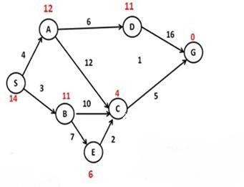

**example**



A*

Best first search

**Output:**

**Best first search:**

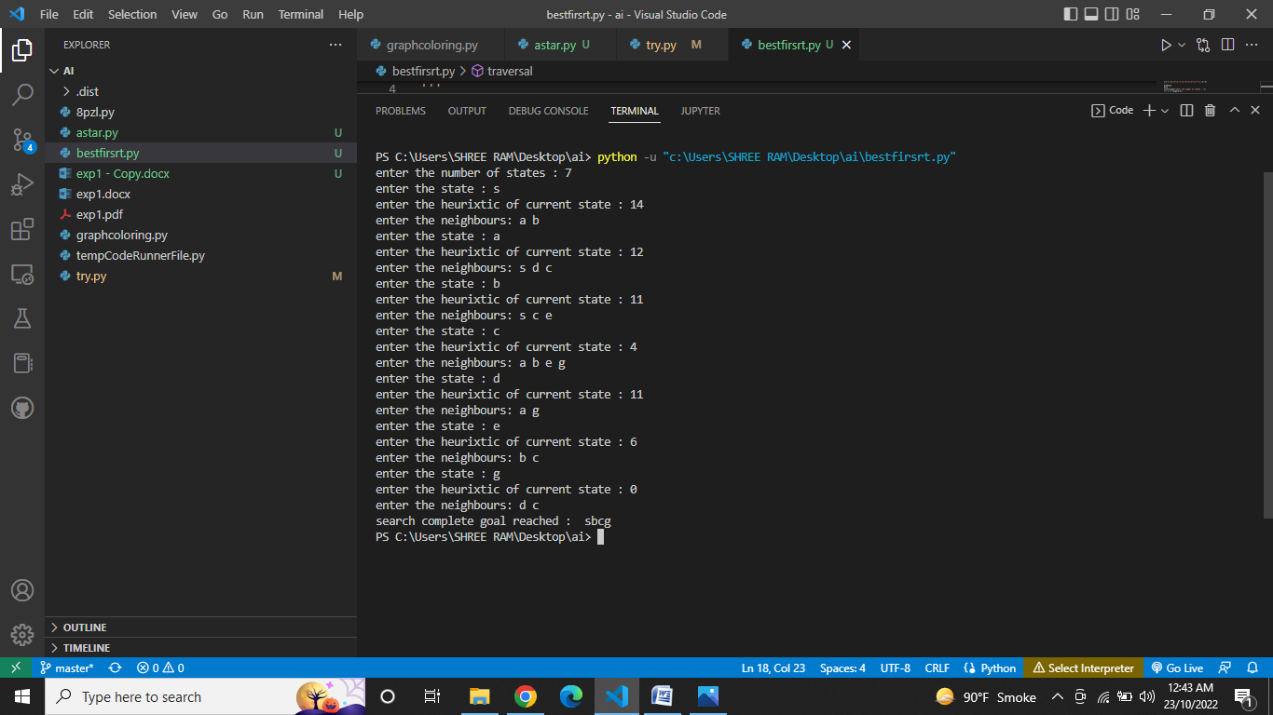

**A*:**

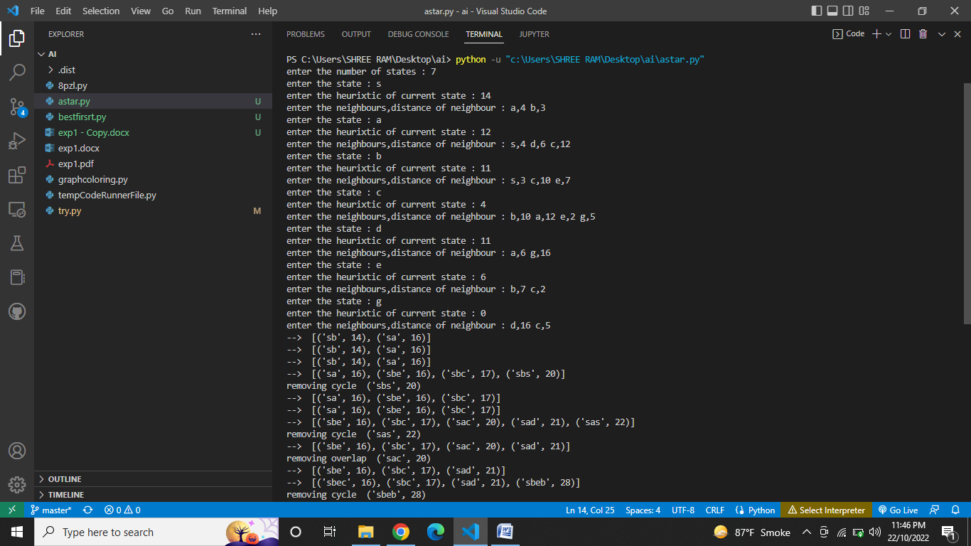

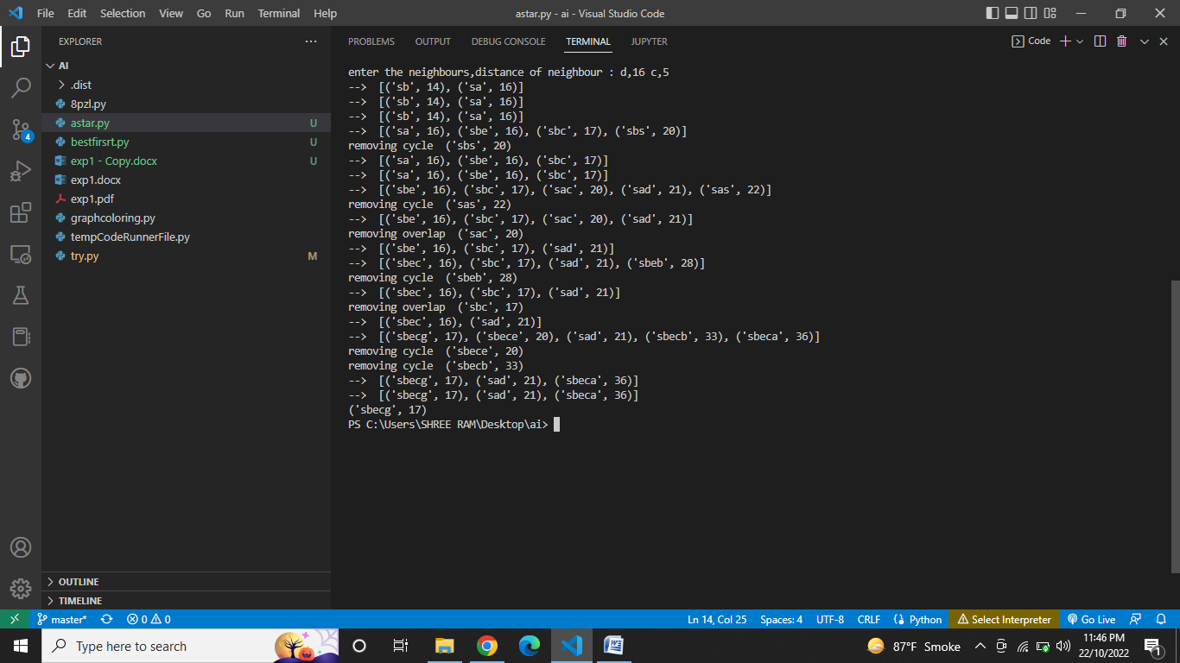

**comparison for Greedy best first search & A*:**

|  |  |  |
| --- | --- | --- |
| **Parameters** | **Best first search** | **A\*** |
| **completeness** | No | Yes |
| **Time complexity** | O(b^d) | O(b^d) |
| **Space complexity** | O(b^d) | O(b^d) |
| **optimality** | No | Yes |

# CONCLUSION:

# Hence, we have successfully implemented A* and Best First Search