**DEPARTMENT OF INFORMATION TECHNOLOGY**

**COURSE CODE: DJ19ITL504 DATE: 26/10/2021**

**COURSE NAME: Artificial Intelligence Laboratory CLASS:TY-IT**

**EXPERIMENT NO.05**

**CO/LO:** Formulate the problem as a state space and select appropriate technique from blind, heuristic, or adversarial search to generate the solution.

**AIM / OBJECTIVE:**To implement the constraint satisfaction problem.

**DESCRIPTION OF EXPERIMENT:**

* Student should implement the state space for a CSP problem [graph coloring].
* The traversal path for obtaining the solution should be displayed.

**Explanation/Solutions (Design):**

Constraint satisfaction problem:

A constraint satisfaction problem (CSP) consists of

* a set of variables,
* a domain for each variable, and
* a set of constraints.

The aim is to choose a value for each variable so that the resulting possible world satisfies the constraints; we want a model of the constraints.

A finite CSP has a finite set of variables and a finite domain for each variable

Graph coloring:

The problem is, given m colors, find a way of coloring the vertices of a graph such that no two adjacent vertices are colored using same color.

**Chromatic Number:** The smallest number of colors needed to color a graph G is called its chromatic number. For example, the following can be colored minimum 2 colors. 

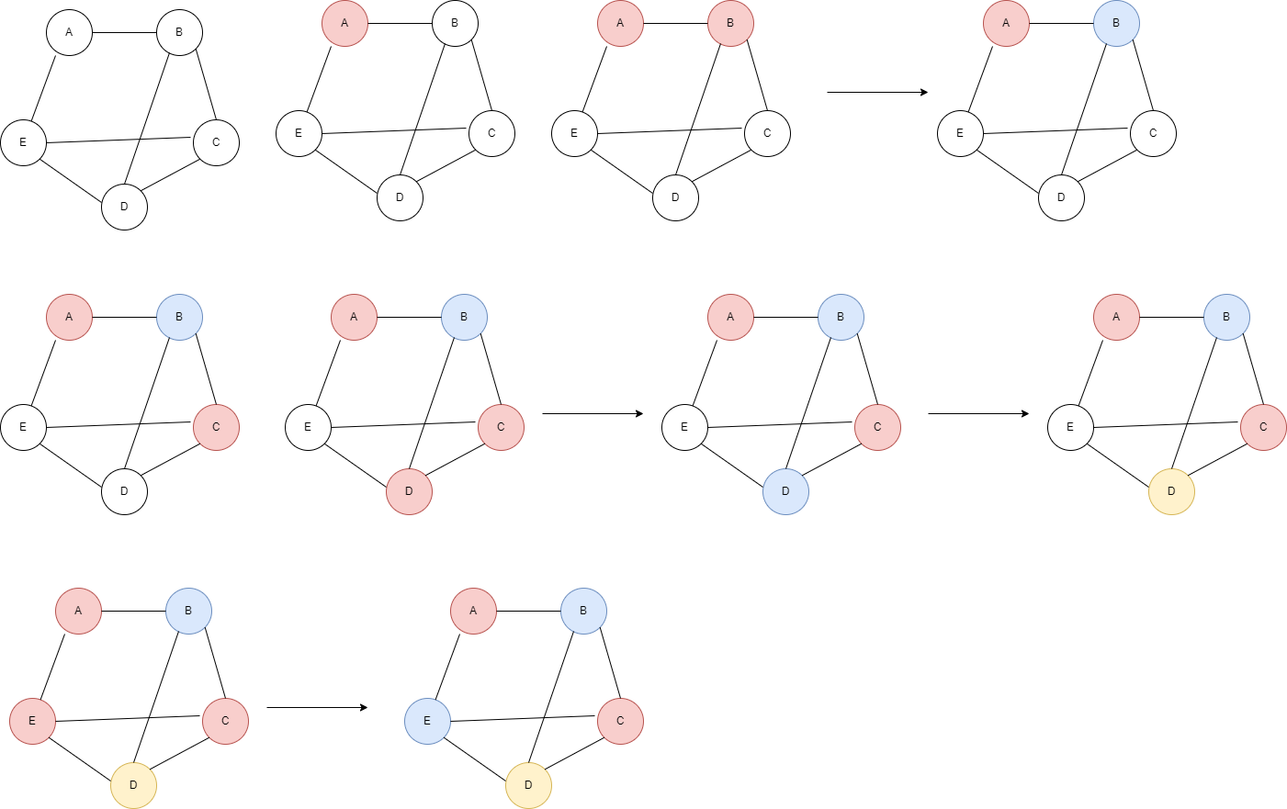Example :



Step 1)



Step 2)



Step 3)



Step 4)



Step 5)

Algorithm graphColoring(graph):

For all nodes in graph do:

Color the current node with color “0”

Check for all neighbours of current node:

If colored same as current node then increment color by 1

**Source code:**

#given graph colormin

#graph={"a":["b","c"] , "b":["c","a"] , "c":["d","e","a","b"] , "d":["c"] , "e":["c"]}

color={}

graph={}

n=int(input("enter the number of states : "))

for i in range(0,n):

    state=input("enter the state : ")

    n_line=input("enter the neighbours : ")

    neighbours=n_line.split()

    graph[state]=neighbours

def sort(color):

    a= sorted(color.items(), key=lambda x: x[1])

    color={}

    for i in a:

        color[i[0]]=i[1]

    return color

def colorthis(e):

    global color

    color=sort(color)

    #print(color,graph[e])

    #color[e]=0

    for i in  color.keys():

        if i in graph[e]:

            if(color[i]==color[e]):

                #print(color,(e,i),color[e],color[i])

                color[e]=color[e]+1

def colornode(graph):

    for e in graph.keys():

        colorthis(e)

    print(color)

    #print("given graph can be colored in ",max(color.values)+1 ," colors")

#print(graph.keys())

colornode(graph)

**Output:**

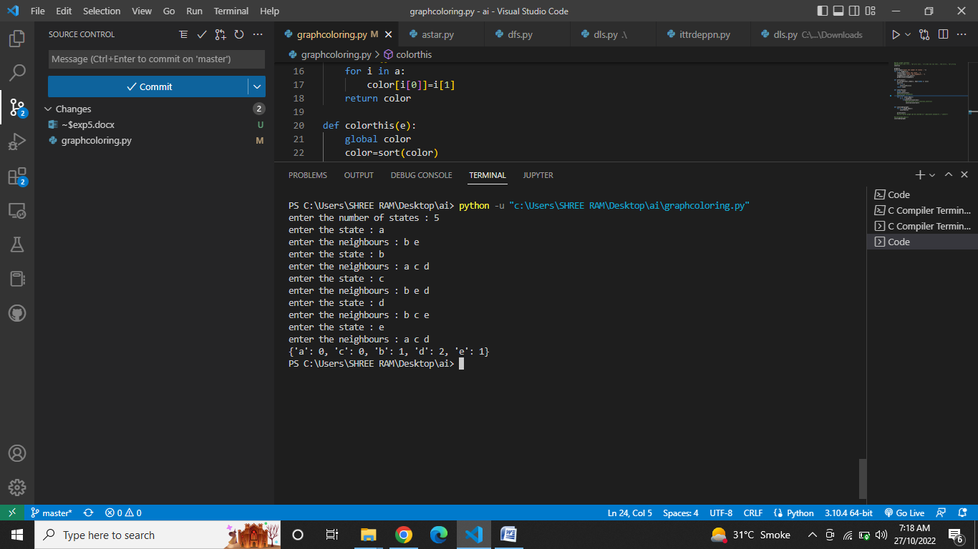

**CONCLUSION:**

Thus we have implemented graph coloring constraint satisfaction problem(csp).