**DEPARTMENT OF INFORMATION TECHNOLOGY**

**Course: Web Programming Lab Academic Year: 2020 -21**

**Course Code: DJ19ITL405 Semester: IV**

**NAME: Nilesh Navalkar SAPID:60003200076**

**EXPERIMENT NO.1**

**Aim:** HTML

a) Create a class timetable using HTML.

b) Create a registration form using HTML.

c ) Create a web page using HTML5 tags.

**Theory:**

**HTML elements used to implement class timetable:**

Class timetable can be created using the following tags:

<table border=”2”></table> : This defines the start and end of table.

<tr></tr> : This defines the table row

<td></td> : This defines table data

<th></th> : This defines table header

In <td> tags we use the attributes ‘colspan’ and ‘rowspan’ to merge two or more columns and to merge two or more rows respectively.

**HTML elements used to implement registration form:**

Registration form can be created using the following tags:

<form></form> : This defines the start and end of form.

<label></label> : This is used to give label to input fields.

<input type=”text”> : This is used to get password input field.

<input type=”password”> : This is used to get text input field.

<input type=”email”> : This is used to get e mail input field.

<input type=”tel”> : This is used to get telephone input field.

<input type=”date”> : This is used to get date input field.

<input type=”checkbox”> : This is used to get checkbox input field.

<textarea cols=”c” rows=”r”></textarea> : This is used to get a bigger text input field.

<select> </select> : This is used to create drop down select input field.

<option value=”x”></option>:this is used inside <select> tags to add options in the select field.

<button></button> : This is used to create a button.

We use the attributes ‘required’ to make a field mandatory to be filled, ‘placeholder=”x” ’ is used to add the default display in the input fields.

**HTML elements used to implement web page using HTML5 tags:**

<header></header > : This is used to define the header section of the page.

<nav></nav> : This is used to define the navigation bar of the page.

<footer ></footer > : This is used to define the footer section of the page.

<div></div> : This tag is used to define a container to hold other tags.

**Implementation:**

1. 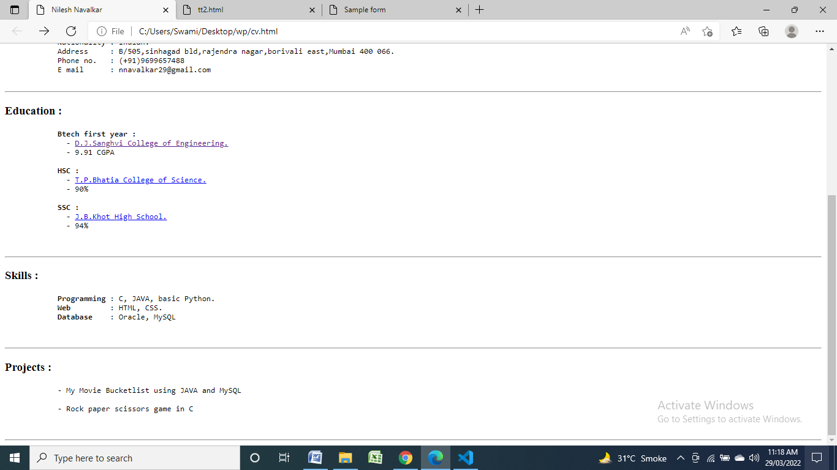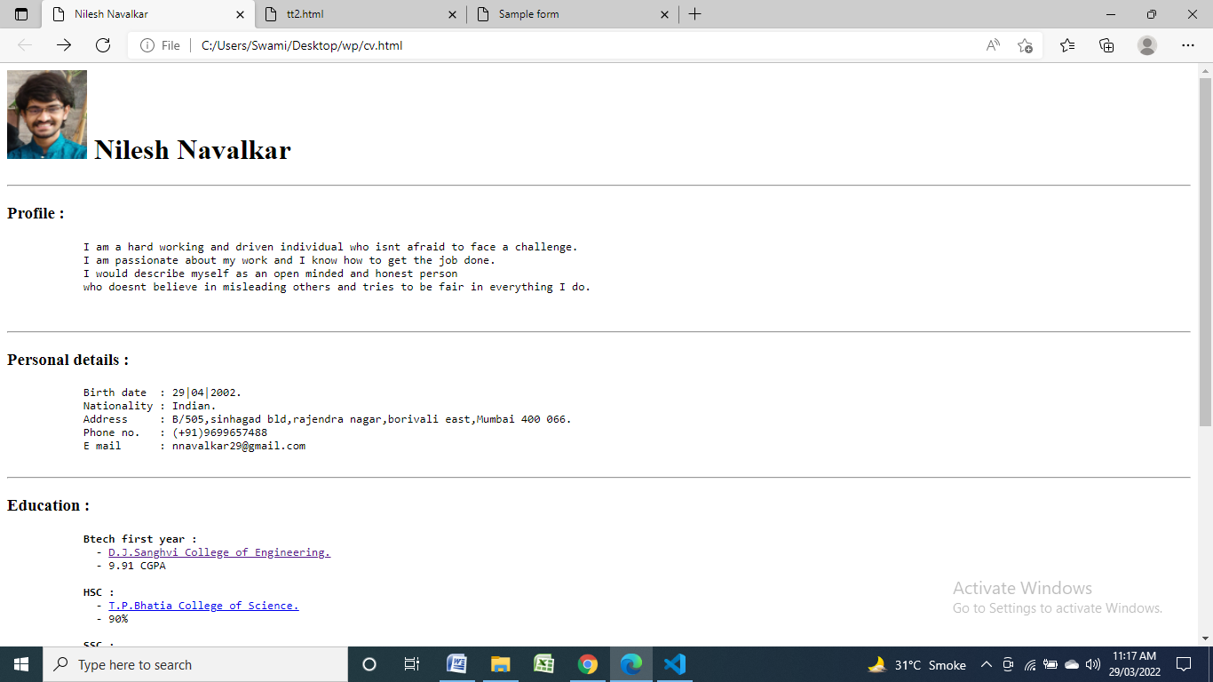**Static web page using HTML**

**Code:**

<html lang="en">

<head>

    <title>Nilesh Navalkar</title>

</head>

<body>

    <div>

        <h1> <img src="self.jpg" alt="self" height="100px" width="90px"> Nilesh Navalkar</h1>

    </div>

    <hr>

    <div>

        <h3>Profile :</h3>

        <pre>

            I am a hard working and driven individual who isnt afraid to face a challenge.

            I am passionate about my work and I know how to get the job done.

            I would describe myself as an open minded and honest person

            who doesnt believe in misleading others and tries to be fair in everything I do.

        </pre>

    </div>

    <hr>

    <div>

        <h3>Personal details :</h3>

        <pre>

            Birth date  : 29|04|2002.

            Nationality : Indian.

            Address     : B/505,sinhagad bld,rajendra nagar,borivali east,Mumbai 400 066.

            Phone no.   : (+91)9699657488

            E mail      : nnavalkar29@gmail.com

        </pre>

    </div>

    <hr>

    <div>

        <h3>Education :</h3>

        <pre>

            <b>Btech first year :</b>

              - <a href="https://www.djsce.ac.in/">D.J.Sanghvi College of Engineering.</a>

              - 9.91 CGPA

            <b>HSC :</b>

              - <a href="https://tpbhatiacollege.com/">T.P.Bhatia College of Science.</a>

              - 90%

            <b>SSC :</b>

              - <a href="https://m.facebook.com/profile.php?id=106099892753974">J.B.Khot High School.</a>

              - 94%

        </pre>

    </div>

    <hr>

    <div>

        <h3>Skills :</h3>

        <pre>

            <b>Programming </b>: C, JAVA, basic Python.

            <b>Web         </b>: HTML, CSS.

            <b>Database    </b>: Oracle, MySQL

        </pre>

    </div>

    <hr>

    <div>

        <h3>Projects :</h3>

        <pre>

            - My Movie Bucketlist using JAVA and MySQL

            - Rock paper scissors game in C

        </pre>

    </div>

    <hr>

</body>

</html>

1. 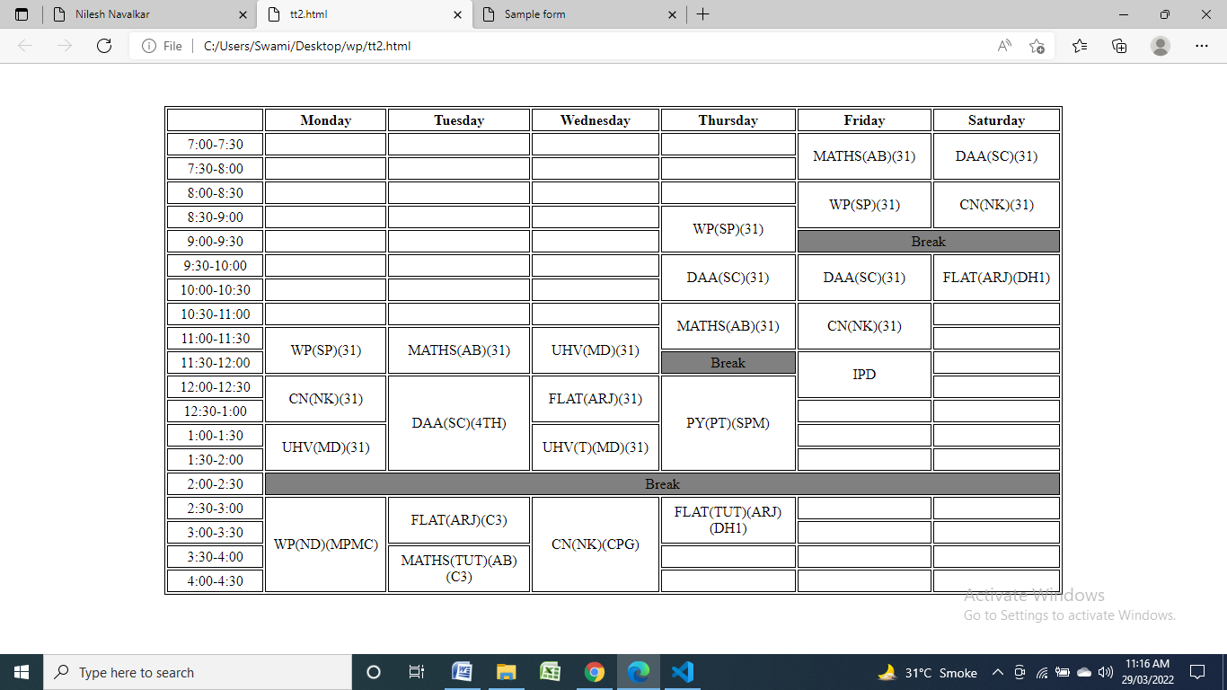**class timetable using HTML**

**code:**

<html>

<head>

<style>

table {

    margin-top: 3.5%;

}

table, th, td {

border: 0.5px solid black;

width: 1000px;

height: 25px;

}

</style>

</head>

<body>

<div align="center">

<table>

<tr align="center">

<th></th>

<th>Monday</th>

<th>Tuesday</th>

<th>Wednesday</th>

<th>Thursday</th>

<th>Friday</th>

<th>Saturday</th>

</tr>

<tr align="center">

<td>7:00-7:30</td>

<td></td>

<td></td>

<td></td>

<td></td>

<td rowspan="2">MATHS(AB)(31)</td>

<td rowspan="2">DAA(SC)(31)</td>

</tr>

<tr align="center">

<td>7:30-8:00</td>

<td></td>

<td></td>

<td></td>

<td></td>

</tr>

<tr align="center">

<td>8:00-8:30</td>

<td></td>

<td></td>

<td></td>

<td></td>

<td rowspan="2">WP(SP)(31)</td>

<td rowspan="2">CN(NK)(31)</td>

</tr>

<tr align="center">

<td>8:30-9:00</td>

<td></td>

<td></td>

<td></td>

<td rowspan="2">WP(SP)(31)</td>

</tr>

<tr align="center">

<td>9:00-9:30</td>

<td></td>

<td></td>

<td></td>

<td colspan="2" bgcolor="gray">Break</td>

</tr>

<tr align="center">

<td>9:30-10:00</td>

<td></td>

<td></td>

<td></td>

<td rowspan="2">DAA(SC)(31)</td>

<td rowspan="2">DAA(SC)(31)</td>

<td rowspan="2">FLAT(ARJ)(DH1)</td>

</tr>

<tr align="center">

<td>10:00-10:30</td>

<td></td>

<td></td>

<td></td>

</tr>

<tr align="center">

<td>10:30-11:00</td>

<td></td>

<td></td>

<td></td>

<td rowspan="2">MATHS(AB)(31)</td>

<td rowspan="2">CN(NK)(31)</td>

<td></td>

</tr>

<tr align="center">

<td>11:00-11:30</td>

<td rowspan="2">WP(SP)(31)</td>

<td rowspan="2">MATHS(AB)(31)</td>

<td rowspan="2">UHV(MD)(31)</td>

<td></td>

</tr>

<tr align="center">

<td>11:30-12:00</td>

<td bgcolor="gray">Break</td>

<td rowspan="2">IPD</td>

<td></td>

</tr>

<tr align="center">

<td>12:00-12:30</td>

<td rowspan="2">CN(NK)(31)</td>

<td rowspan="4">DAA(SC)(4TH)</td>

<td rowspan="2">FLAT(ARJ)(31)</td>

<td rowspan="4">PY(PT)(SPM)</td>

<td></td>

</tr>

<tr align="center">

<td>12:30-1:00</td>

<td></td>

<td></td>

</tr>

<tr align="center">

<td>1:00-1:30</td>

<td rowspan="2">UHV(MD)(31)</td>

<td rowspan="2">UHV(T)(MD)(31)</td>

<td></td>

<td></td>

</tr>

<tr align="center">

<td>1:30-2:00</td>

<td></td>

<td></td>

</tr>

<tr align="center">

<td>2:00-2:30</td>

<td colspan="6" bgcolor="gray">Break</td>

</tr>

<tr align="center">

<td>2:30-3:00</td>

<td rowspan="4">WP(ND)(MPMC)</td>

<td rowspan="2">FLAT(ARJ)(C3)</td>

<td rowspan="4">CN(NK)(CPG)</td>

<td rowspan="2">FLAT(TUT)(ARJ)(DH1)</td>

<td></td>

<td></td>

</tr>

<tr align="center">

<td>3:00-3:30</td>

<td></td>

<td></td>

</tr>

<tr align="center">

<td>3:30-4:00</td>

<td rowspan="2">MATHS(TUT)(AB)(C3)</td>

<td></td>

<td></td>

<td></td>

</tr>

<tr align="center">

<td>4:00-4:30</td>

<td></td>

<td></td>

<td></td>

</tr>

</table>

</div>

</body>

</html>

1. 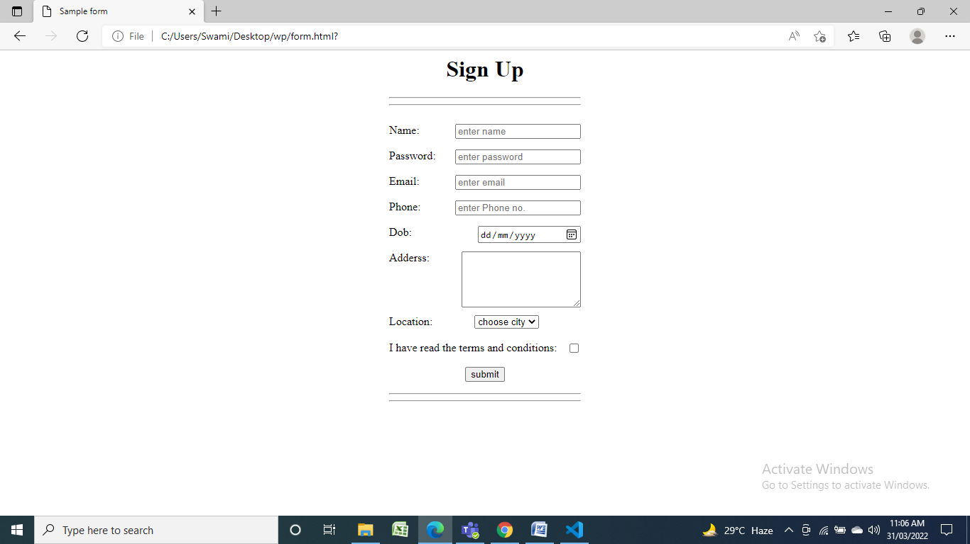**registration form using HTML**

**code:**

<html>

<head>

    <title>Sample form</title>

    <style>

        div{

            margin-left:40%;

            margin-right:40%;

        }

        input,textarea{

            float: right;

        }

        label{

            float: left;

        }

    </style>

</head>

<body>

    <div align="center" id="1">

        <h1 align="center">Sign Up</h1>

        <hr><hr>

        <form>

            <br>

            <label for="name">Name:</label>

            <input type="text" required placeholder="enter name" id="name"><br><br>

            <label for="pass">Password:</label>

            <input type="password" required placeholder="enter password" id="pass"><br><br>

            <label for="em">Email:</label>

            <input type="email" required placeholder="enter email" id="em"><br><br>

            <label for="phone">Phone:</label>

            <input type="tel" required placeholder="enter Phone no." id="phone"><br><br>

            <label for="dob">Dob:</label>

            <input type="date" id="dob"><br><br>

            <label for="add">Adderss:</label>

            <textarea cols="20" rows="5" id="add"></textarea><br><br><br><br><br>

            <label for="loc">Location:</label>

            <select id="loc">

                <option value="">choose city</option>

                <option value="1">Mumbai</option>

                <option value="2">Chennai</option>

                <option value="3">Kolkata</option>

            </select><br><br>

            <label for="check">I have read the terms and conditions:</label>

            <input type="checkbox" required><br><br>

            <button>submit</button>

        </form>

        <hr><hr>

    </div>

</body>

</html>

1. 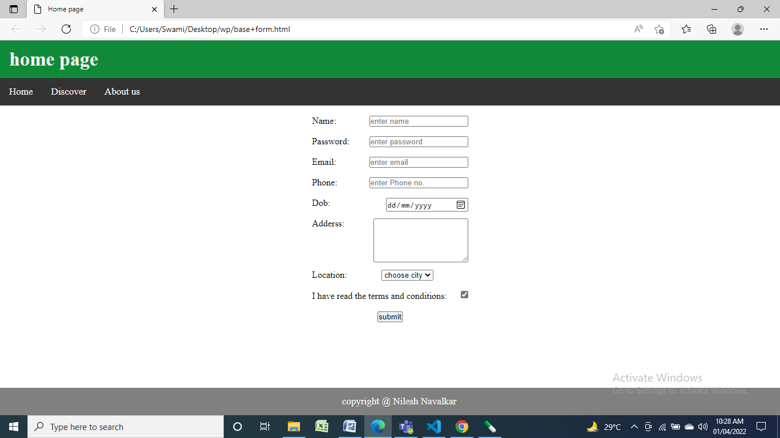**Web page using HTML5 elements:**

**Code:**

<html lang="en">

<head>

    <style>

        *{

            margin: 0;

            padding: 0;

        }

        header{

            background-color: rgb(16, 138, 57);

  color: #f2f2f2;

  text-align: left;

  padding: 14px 16px;

  text-decoration: none;

  font-size: 17px;

            position: sticky;

        }

        nav{

            background-color: #333;

            overflow: hidden;

        }

        a{

            float: left;

  color: #f2f2f2;

  text-align: center;

  padding: 14px 16px;

  text-decoration: none;

  font-size: 17px;

        }

        li{

            list-style-type: none;

            display :inline;

        }

        li :hover {

            background-color: gray;

        }

        footer{

            background-color: gray;

            float: left;

  color: #f2f2f2;

  text-align: center;

  padding: 14px 16px;

  text-decoration: none;

  font-size: 17px;

            position:fixed;

            bottom:0;

            width: 100%;

        }

        .this {

            margin-left:40%;

            margin-right:40%;

        }

        input,textarea{

            float: right;

        }

        label{

            float: left;

        }

    </style>

    <title>Home page</title>

</head>

<body>

    <header>

        <h1>home page</h1>

    </header>

    <nav>

        <div>

            <ul>

                <li><a href="">Home</a></li>

                <li><a href="">Discover</a></li>

                <li><a href="">About us</a></li>

            </ul>

        </div>

    </nav>

    <div align="center" class="this">

        <form>

            <br>

            <label for="name">Name:</label>

            <input type="text" required placeholder="enter name" id="name"><br><br>

            <label for="pass">Password:</label>

            <input type="password" required placeholder="enter password" id="pass"><br><br>

            <label for="em">Email:</label>

            <input type="email" required placeholder="enter email" id="em"><br><br>

            <label for="phone">Phone:</label>

            <input type="tel" required placeholder="enter Phone no." id="phone"><br><br>

            <label for="dob">Dob:</label>

            <input type="date" id="dob"><br><br>

            <label for="add">Adderss:</label>

            <textarea cols="20" rows="5" id="add"></textarea><br><br><br><br><br>

            <label for="loc">Location:</label>

            <select id="loc">

                <option value="">choose city</option>

                <option value="1">Mumbai</option>

                <option value="2">Chennai</option>

                <option value="3">Kolkata</option>

            </select><br><br>

            <label for="check">I have read the terms and conditions:</label>

            <input type="checkbox" required><br><br>

            <button>submit</button>

        </form>

    </div>

    <footer>

            <p>copyright @ Nilesh Navalkar </p>

    </footer>

</body>

</html>