

**DEPARTMENT OF INFORMATION TECHNOLOGY**

**Course: Web Programming Lab Academic Year: 2020 -21**

**Course Code: DJ19ITL405 Semester: IV**

**NAME: Nilesh Navalkar SAPID:60003200076**

**EXPERIMENT NO.2**

**AIM:** CSS

(a) Design a web page using External or Embedded Style Sheet.

**THEORY:**

1. **Using internal CSS stylesheets**

Rather than linking an external .css file, HTML files with an internal stylesheet include a set of rules in their head section. CSS rules are wrapped in <style> tags, like this:

<head>

<style type="text/css"> h1 {

color:#fff

margin-left: 20px;

}

p {

font-family: Arial, Helvetica, Sans Serif;

}

</style>

</head>

**Advantages of Internal CSS:**

* + You can use class and ID selectors in this style sheet. Here’s an example:
  + Since you’ll only add the code within the same HTML file, you don’t need to upload multiple files.

**Disadvantages of Internal CSS:**

* + Adding the code to the HTML document can increase the page’s size and loading time.

1. **Using inline CSS stylesheets**

Inline CSS is used to style a specific HTML element. For this CSS style, you’ll only need to add the **style** attribute to each HTML tag, without using selectors.

This CSS type is not really recommended, as each HTML tag needs to be styled individually. Managing your website may become too hard if you only use inline CSS.

In the example below, we add an inline CSS to the **<p>** and **<h1>** tag:

<!DOCTYPE html>

<html>

<body style="background-color:black;">

<h1 style="color:white;padding:30px;">Hostinger Tutorials</h1>

<p style="color:white;">Something usefull here.</p>

</body>

</html>

**Advantages of Inline CSS:**

* + You can easily and quickly insert CSS rules to an HTML page. That’s why this method is useful for testing or previewing the changes, and performing quick-fixes to your website.
  + You don’t need to create and upload a separate document as in the external style.

**Disadvantages of Inline CSS:**

* + Adding CSS rules to every HTML element is time-consuming and makes your HTML structure messy.
  + Styling multiple elements can affect your page’s size and download time.

1. **Using external CSS stylesheets**

An HTML page styled by an external CSS stylesheet must reference the .css file in the document head. Once you create the CSS file, it must be uploaded to your server and linked in the HTML file with code, for example:

For example:

<link href="style.css" rel="stylesheet" type="text/css">

You can name your stylesheet whatever you wish, but it should have a .css file extension.

**Advantages of External CSS:**

* + Since the CSS code is in a separate document, your HTML files will have a cleaner structure and are smaller in size.
  + You can use the same .css file for multiple pages.

**Disadvantages of External CSS:**

* + Your pages may not be rendered correctly until the external CSS is loaded.
  + Uploading or linking to multiple CSS files can increase your site’s download time.



**HTML Tags:**

* + The <form> tag is used to create an HTML form for user input.

The <form> element can contain one or more of the following form elements:

* + - [<input>](https://www.w3schools.com/tags/tag_input.asp)
    - [<button>](https://www.w3schools.com/tags/tag_button.asp)
    - [<label>](https://www.w3schools.com/tags/tag_label.asp)
    - [<output>](https://www.w3schools.com/tags/tag_output.asp)
  + The <input> tag specifies an input field where the user can enter data. The <input> element is the most important form element.

The <input> element can be displayed in several ways, depending on the type attribute. The different input types are as follows:

* + - <input type="button">
    - <input type="checkbox">
    - <input type="color">
    - <input type="date">
  + The type attribute specifies the type of <input> element to display. If the type attribute is not specified, the default type is "text".
  + The <label> tag defines a label for several elements like:

<input type="checkbox">

<input type="text">

<input type="password">

<input type="date">

* + The <hr> tag defines a thematic break in an HTML page (e.g. a shift of topic). The <hr> element is most often displayed as a horizontal rule that is used to separate content (or define a change) in an HTML page.
  + Many web sites contain HTML code like: <div id="nav"> <div class="header"> <div id="footer"> to indicate navigation, header, and footer.

In HTML there are some semantic elements that can be used to define different parts of a web page.

* + The <section> element defines a section in a document. A web page could normally be split into sections for introduction, content, and contact information.
  + The <footer> element defines a footer for a document or section.
  + The <div> tag defines a division or a section in an HTML document.

The <div> tag is used as a container for HTML elements - which is then styled with CSS or manipulated with JavaScript.



The <div> tag is easily styled by using the class or id attribute. Any sort of content can be put inside the <div> tag.

* + The <ul> tag defines an unordered (bulleted) list. We use the <ul> tag together with the

<li> tag to create unordered lists.

* + The <p> tag defines a paragraph. Browsers automatically add a single blank line before and after each <p> element.

**IMPLEMENTATION:**

**Home page:**

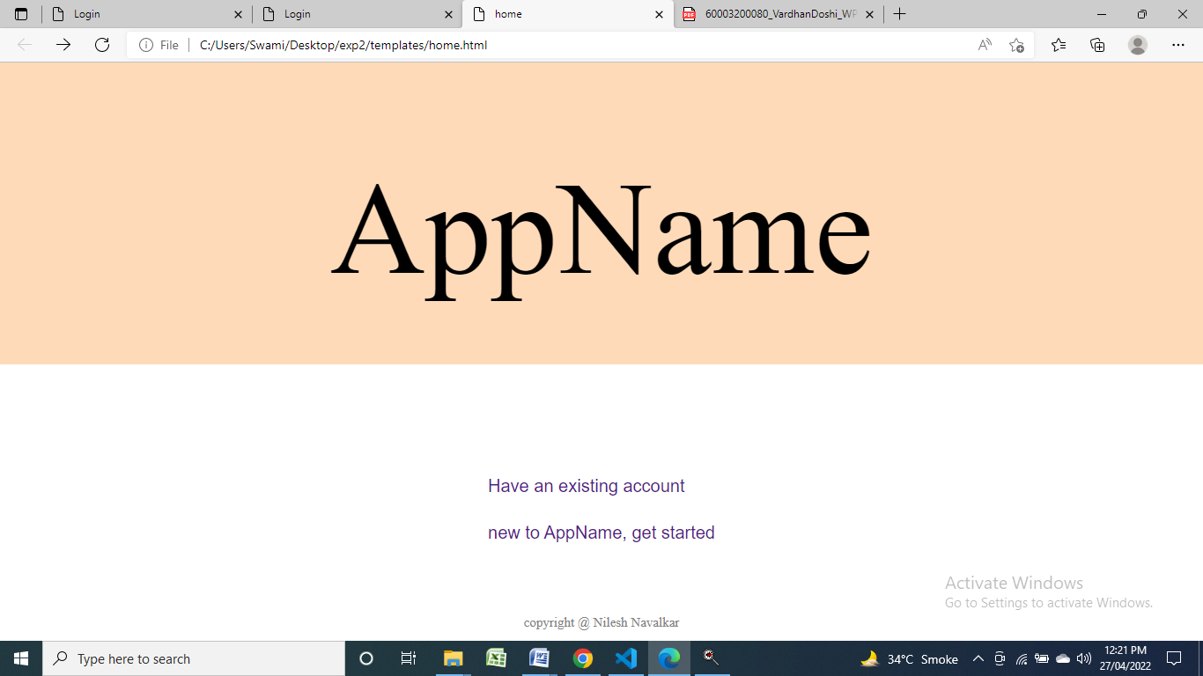

**Sign up:**

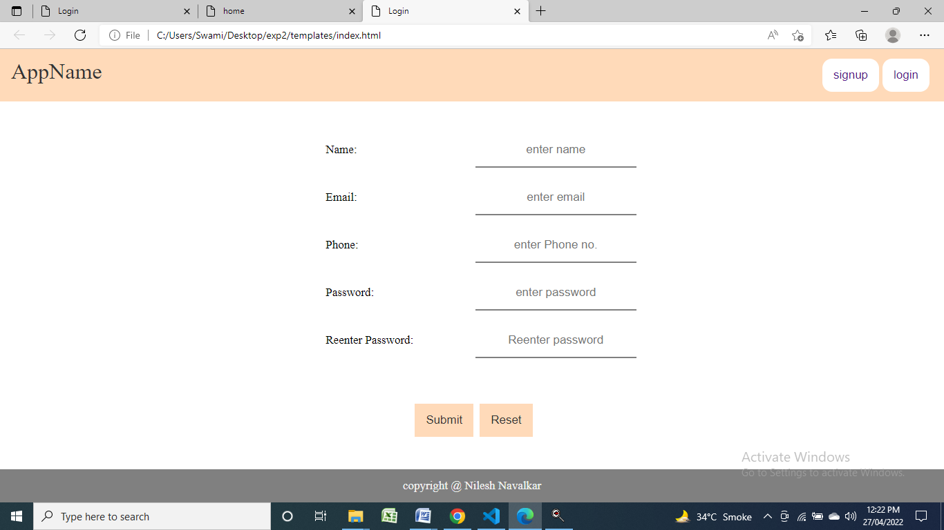

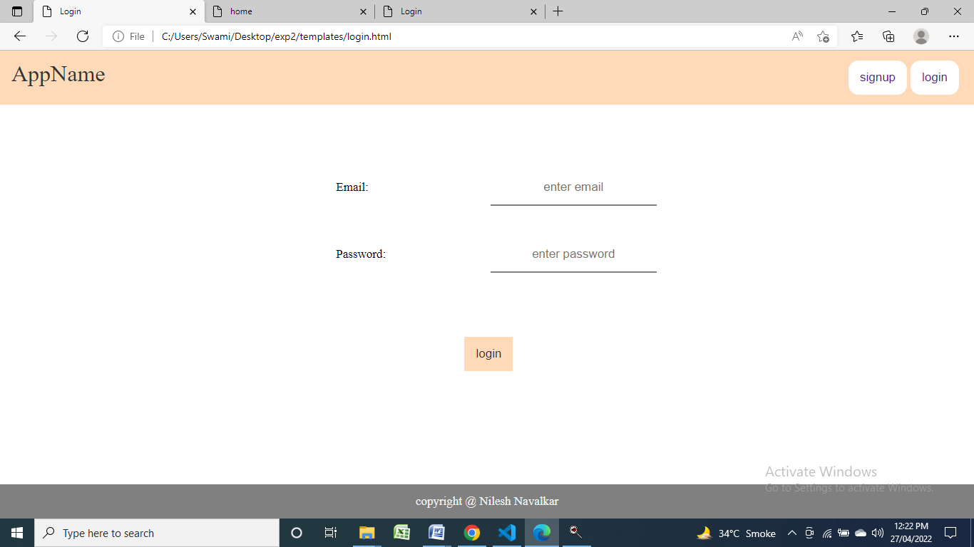

**Login:**

**Code:**

Home.html:

<html lang="en">

<head>

    <link rel="stylesheet" href="style.css"></link>

    <title>home</title>

</head>

<body id="b">

    <div  id="main">

        <p id="id">AppName</p>

    </div>

    <div class="container">

        <div class="center">

        <button class="btn"><a href="login.html">Have an existing account</a></button>

        <button class="btn"><a href="index.html">new to AppName, get started</a></button>

    </div></div>

    <footer id="mf">

        <p>copyright @ Nilesh Navalkar </p>

    </footer>

</body>

</html>

Index.html:

<html lang="en">

<head>

    <link rel="stylesheet" href="style.css"></link>

    <title>Login</title>

</head>

<body>

    <header>

        <p id="head">AppName</p>

        <button ><a href="login.html">login</a></button>

        <button ><a href="index.html">signup</a></button>

    </header>

    <div class="this" align="center">

        <div></div>

        <div>

        <form action = "{{ request.path }}" method = "post">

            <br>

            <div class="name"><label for="name" class="lname">Name:</label>

            <input type="text" required placeholder="enter name" id="name" class="iname"><br></div>

            <div class="em"> <label for="em" class="lem">Email:</label>

            <input type="email" required placeholder="enter email" id="em" class="iem"><br></div>

            <div class="phone"><label for="phone" class="lphone">Phone:</label>

            <input type="tel" required placeholder="enter Phone no." id="phone" class="iphone"><br></div>

            <div class="pass"><label for="pass" class="lpass">Password:</label>

            <input type="password" required placeholder="enter password" id="pass" class="ipass"><br></div>

            <div class="rpass"><label for="rpass" class="lrpass">Reenter Password:</label>

            <input type="password" required placeholder="Reenter password" id="rpass" class="irpass"><br></div>

            <div class="s"><input type="submit">

            <input type="reset"></div>

        </form></div>

        <div></div>

    </div>

    <footer>

            <p>copyright @ Nilesh Navalkar </p>

    </footer>

</body>

</html>

Login.html:

<html lang="en">

<head>

    <link rel="stylesheet" type="text/css" href="style.css"></link>

    <title>Login</title>

</head>

<body>

    <header>

        <p id="head">AppName</p>

        <button ><a href="login.html">login</a></button>

        <button ><a href="index.html">signup</a></button>

    </header>

    <div class="this" align="center">

        <div></div>

        <div>

        <form>

            <br>

            <div class="em"> <label for="em" class="lem">Email:</label>

            <input type="email" required placeholder="enter email" id="em" class="iem"><br></div>

            <div class="pass"><label for="pass" class="lpass">Password:</label>

            <input type="password" required placeholder="enter password" id="pass" class="ipass"><br></div>

            <div class="s"><input type="submit" value="login">

            </div>

        </form></div>

        <div></div>

    </div>

    <footer>

            <p>copyright @ Nilesh Navalkar </p>

    </footer>

</body>

</html>

Style.css:

* {

    margin: 0;

    padding: 0;

    box-sizing: border-box;

}

a{

    text-decoration: none;

}

header {

    background-color: peachpuff;

    color: #333;

    padding: 14px 16px;

    overflow: hidden;

}

header p{

    float: left;

    font-size: 32px;

}

header button{

    background-color: white;

    color: #333;

    padding: 14px 16px;

    margin-right: 5px;

    font-size: 17px;

    float: right;

    border: 0;

    border-radius: 14px;

}

header button:hover{

    background-color: black;

    color: #f2f2f2;

}

header button:active{

    background-color: black;

    color: #f2f2f2;

}

.this {

    display: grid;

    grid-template-columns: repeat(3,33.33%);

}

form{

    display: grid;

    grid-template-columns: repeat(2,50%);

    grid-template-rows: repeat(6,14%);

    grid-gap: 10px;

    grid-template-areas:"n n" "e e" "p p" "ps ps" "r r" "b b";

    margin-top: 10%;

    position: relative;

}

.name{

    grid-area: n;

}

.em{

    grid-area: e;

}

.phone{

    grid-area: p;

}

.pass{

    grid-area: ps;

}

.rpass{

    grid-area: r;

}

.s{

    grid-area: b;

}

label,input{

    text-align: center;

    padding: 14px 16px;

    text-decoration: none;

    font-size: 17px;

    /*border-radius: 14px;*/

    border: 0;

    border-bottom:2px solid gray;

}

label{

    border: 0;

    float: left;

}

input{

    float: right;

    width: 50%;

}

input[type="submit"],input[type="reset"]{

    background-color:peachpuff;

    color: #333;

    padding: 14px 16px;

    margin-right: 5px;

    font-size: 17px;

    border: 0;

    float: none;

    margin-top: 10%;

    width: auto;

}

input[type="submit"]:hover,input[type="reset"]:hover{

    background-color: black;

    color: #f2f2f2;

}

footer {

    background-color: gray;

    color: #f2f2f2;

    text-align: center;

    padding: 14px 16px;

    text-decoration: none;

    font-size: 17px;

    width: 100%;

    bottom: 0;

    position: fixed;

}

#mf {

    background-color: white;

    color: gray;

    text-align: center;

    padding: 12px 14px;

    font-size: 15px;

}

#b {

    background-color: peachpuff;

}

#main {

    text-align: center;

    font-size: 150px;

    margin: 7.5% auto 5% auto;

}

.btn {

    background-color: white;

    border: none;

    display: block;

    text-align: center;

    font-size: 20px;

    margin-top: 30px;

    color: #333;

    text-decoration: none;

}

.container {

    background-color: white;

    height: 300px;

    position: relative;

  }

.center {

    margin: 0;

    position: absolute;

    top: 50%;

    left: 50%;

    -ms-transform: translate(-50%, -50%);

    transform: translate(-50%, -50%);

  }

.btn:hover {

    font-size: 23px;

}