

**DEPARTMENT OF INFORMATION TECHNOLOGY**

**Course: Web Programming Lab Academic Year: 2020 -21**

**Course Code: DJ19ITL405 Semester: IV**

**NAME: Nilesh Navalkar SAPID:60003200076**

**EXPERIMENT NO.3**

**Aim: CSS3**

a) Design a responsive web page using media queries and CSS3.

b) Design a web page using Bootstrap.

c) Design the admission form using Bootstrap.

**THEORY:**

## Responsive Web Design:

Responsive Web design is the approach that suggests that design and development should respond to the user’s behavior and environment based on screen size, platform and orientation.

Media query is a CSS technique introduced in CSS3.

It uses the @media rule to include a block of CSS properties only if a certain condition is true

* A media type, which tells the browser what kind of media this code is for (e.g. print, or screen).
* A media expression, which is a rule, or test that must be passed for the contained CSS to be applied.
* A set of CSS rules that will be applied if the test passes and the media type is correct.

### [Media types](https://developer.mozilla.org/en-US/docs/Learn/CSS/CSS_layout/Media_queries#media_types)

The possible types of media you can specify are:

* all
* print
* screen

The following media query will only set the body to 12pt if the page is printed. It will not apply when the page is loaded in a browser.

@media print {

body {

font-size: 12pt;

}

}

**Implementation:**

**a) Design a responsive web page using media query**

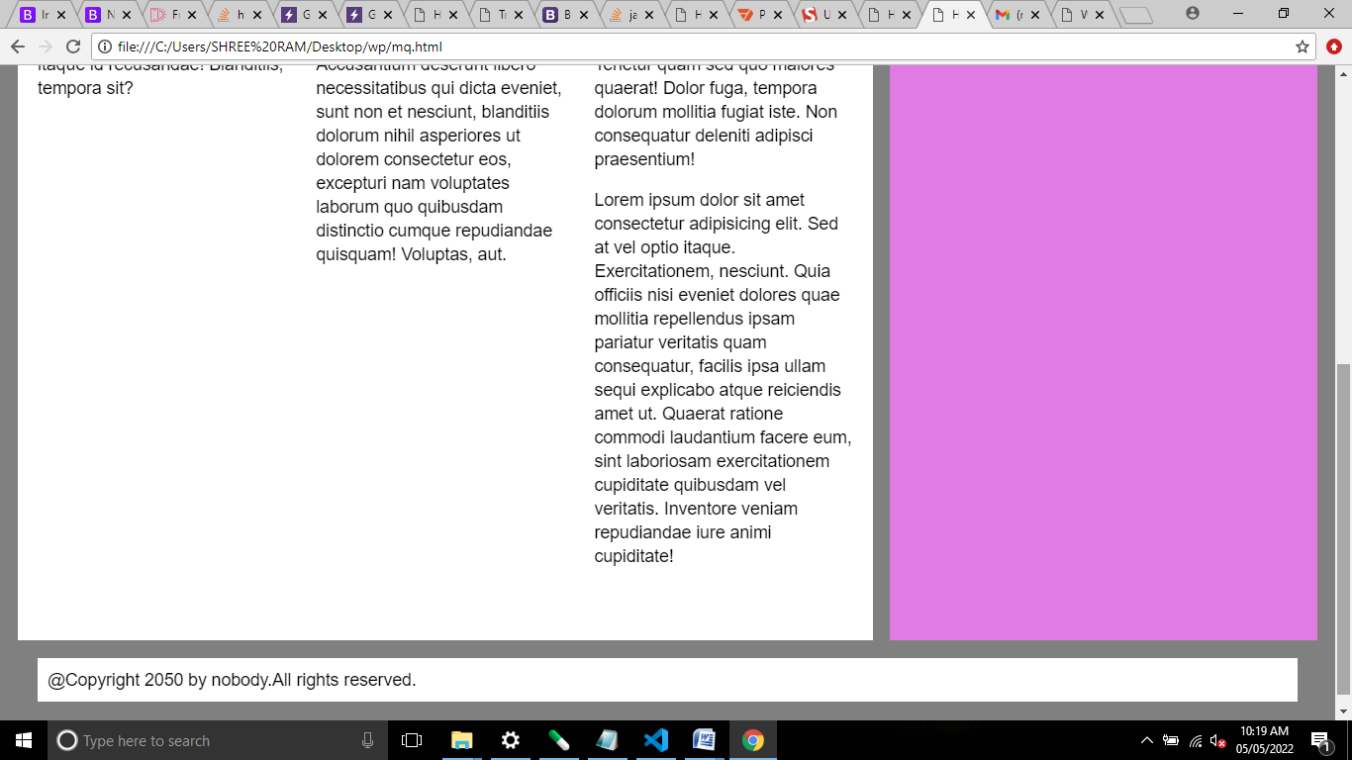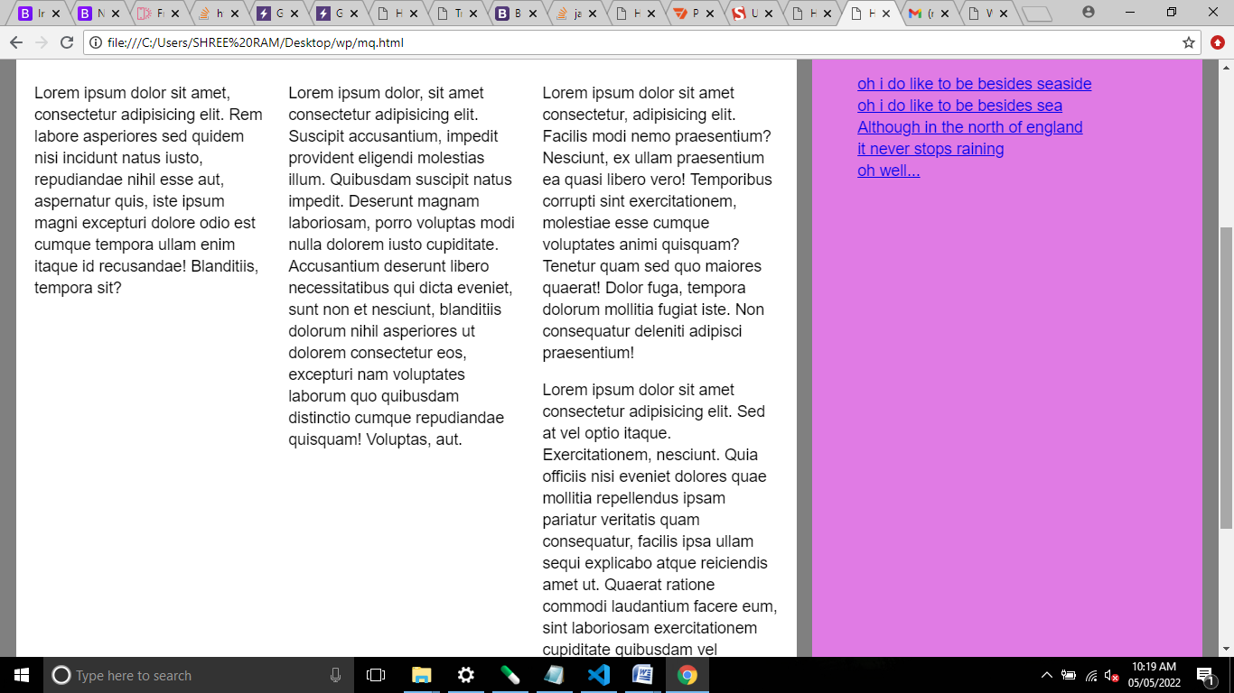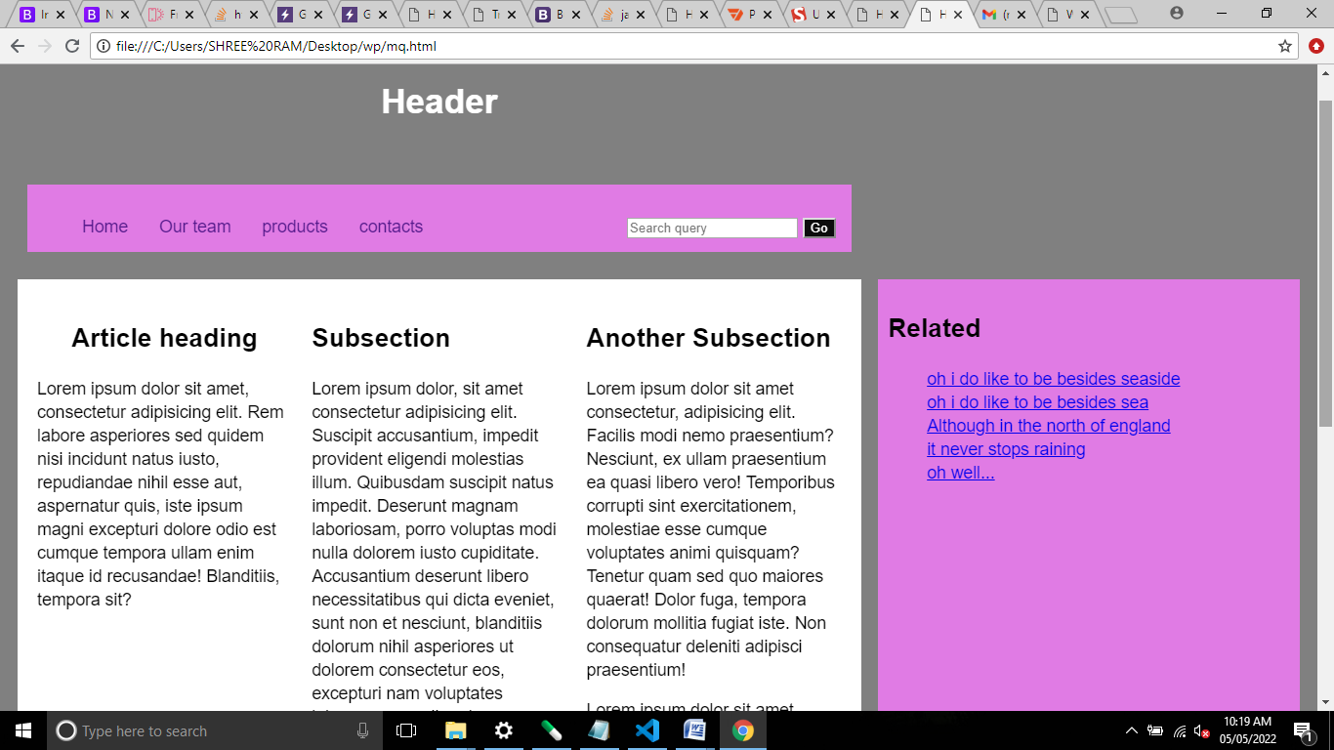

<!doctype html>

<html lang="en">

  <head>

      <link rel="stylesheet" href="media.css">

    <meta charset="utf-8">

    <meta name="viewport" content="width=device-width, initial-scale=1">

    <title>Hello, world!</title>

  </head>

  <body class ="grid" style="background-color: gray; margin-bottom: 25px ; margin-top: 10px ;">

    <h1 style="text-align: center;  color: white;">Header</h1>

    <br>

    <div>

    <nav >

        <div>

            <ul class="this">

                <li><a href="">Home</a></li>

                <li><a href="">Our team</a></li>

                <li><a href="">products</a></li>

                <li><a href="">contacts</a></li>

            </ul>

</div><div class="why">

            <input  type="search" placeholder="Search query" aria-label="Search">

        <button  style="background-color: #0c0c0c;" type="submit">Go</button>

        </div>

    </nav>

</div>

<br><br>

<div style="background-color: white; ">

<article  class="media">

    <div><h1  style="text-align: center; ">Article heading</h1>

    <p class="content">Lorem ipsum dolor sit amet, consectetur adipisicing elit. Rem labore asperiores sed quidem nisi incidunt natus iusto, repudiandae nihil esse aut, aspernatur quis, iste ipsum magni excepturi dolore odio est cumque tempora ullam enim itaque id recusandae! Blanditiis, tempora sit?</p>

</div>

<div>

    <h1>Subsection</h1>

    <p class="content">Lorem ipsum dolor, sit amet consectetur adipisicing elit. Suscipit accusantium, impedit provident eligendi molestias illum. Quibusdam suscipit natus impedit. Deserunt magnam laboriosam, porro voluptas modi nulla dolorem iusto cupiditate. Accusantium deserunt libero necessitatibus qui dicta eveniet, sunt non et nesciunt, blanditiis dolorum nihil asperiores ut dolorem consectetur eos, excepturi nam voluptates laborum quo quibusdam distinctio cumque repudiandae quisquam! Voluptas, aut.</p>

</div>

<div>

    <h1>Another Subsection</h1>

    <p class="content">Lorem ipsum dolor sit amet consectetur, adipisicing elit. Facilis modi nemo praesentium? Nesciunt, ex ullam praesentium ea quasi libero vero! Temporibus corrupti sint exercitationem, molestiae esse cumque voluptates animi quisquam? Tenetur quam sed quo maiores quaerat! Dolor fuga, tempora dolorum mollitia fugiat iste. Non consequatur deleniti adipisci praesentium!</p>

    <p class="content">Lorem ipsum dolor sit amet consectetur adipisicing elit. Sed at vel optio itaque. Exercitationem, nesciunt. Quia officiis nisi eveniet dolores quae mollitia repellendus ipsam pariatur veritatis quam consequatur, facilis ipsa ullam sequi explicabo atque reiciendis amet ut. Quaerat ratione commodi laudantium facere eum, sint laboriosam exercitationem cupiditate quibusdam vel veritatis. Inventore veniam repudiandae iure animi cupiditate!</p>

</div>

</article>

</div>

<div style="background-color: #e07be4; ">

 <aside  >

    <h1>Related</h1>

    <ul>

        <li><a href="#">oh i do like to be besides seaside</a></li>

        <li><a href="#">oh i do like to be besides sea</a></li>

        <li><a href="#">Although in the north of england</a></li>

        <li><a href="#">it never stops raining</a></li>

        <li><a href="#">oh well...</a></li>

    </ul>

</aside>

</div>

 <footer style="background-color: white; bottom: 0; margin: 0 20px; ">@Copyright 2050 by nobody.All rights reserved.</footer>

  </body>

</html>

**Css:**

html {

    font: 1.1em/1.4 Helvetica, sans-serif;

  }

  nav{

    background-color: #e07be4;

    overflow: hidden;

    grid-column: 1/3;

}

ul{

    list-style-type: none;

}

.this li a{

    float: left;

text-align: center;

padding: 14px 16px;

text-decoration: none;

}

.why{

    float: right;

    text-align: center;

padding: 14px 16px;

text-decoration: none;

}

button{

    color: white;

}

  * { box-sizing: border-box; }

  .grid {

    display: grid;

    grid-gap: 1em;

    grid-template-columns: 1fr;

    border-radius: 5px;

    padding: 10px;

  }

  .grid > * {

    padding: 10px;

  }

  @media (min-width: 40em) {

    .grid {

      grid-template-columns: 2fr 1fr;

    }

    header,

    footer {

      grid-column: 1 / 3;

    }

  }

  .media {

    display: flex;

    flex-wrap: wrap;

    margin-bottom: 2em;

  }

  .media > * {

    flex: 1 1 250px;

    margin: 10px;

  }

**b) Design above web page also using Bootstrap.**

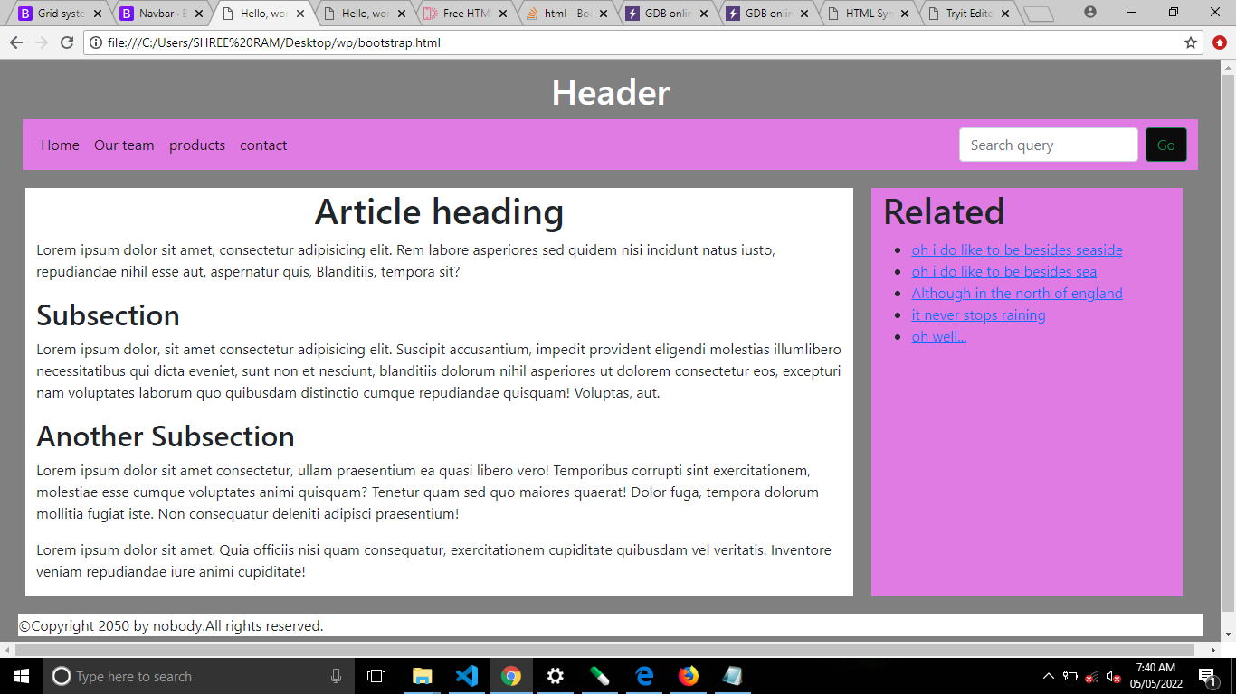

<!doctype html>

<html lang="en">

<head>

<meta charset="utf-8">

<meta name="viewport" content="width=device-width, initial-scale=1">

<!-- Bootstrap CSS -->

<link href="https://cdn.jsdelivr.net/npm/bootstrap@5.1.3/dist/css/bootstrap.min.css" rel="stylesheet" integrity="sha384-1BmE4kWBq78iYhFldvKuhfTAU6auU8tT94WrHftjDbrCEXSU1oBoqyl2QvZ6jIW3" crossorigin="anonymous">

<title>Hello, world!</title>

</head>

<body style="background-color: gray; margin-bottom: 25px ; margin-top: 10px ;">

<h1 style="text-align: center; color: white;">Header</h1>

<nav class="navbar navbar-expand-lg navbar-light " style="background-color: #e07be4; margin: 0 25px;">

<div class="container-fluid">

<button class="navbar-toggler" type="button" data-bs-toggle="collapse" data-bs-target="#navbarSupportedContent" aria-controls="navbarSupportedContent" aria-expanded="false" aria-label="Toggle navigation">

<span class="navbar-toggler-icon"></span>

</button>

<div class="collapse navbar-collapse" id="navbarSupportedContent">

<ul class="navbar-nav me-auto mb-2 mb-lg-0">

<li class="nav-item">

<a class="nav-link active" aria-current="page" href="#">Home</a>

</li>

<li class="nav-item">

<a class="nav-link active" aria-current="page" href="#">Our team</a>

</li>

<li class="nav-item">

<a class="nav-link active" aria-current="page" href="#">products</a>

</li>

<li class="nav-item">

<a class="nav-link active" aria-current="page" href="#">contact</a>

</li>

</ul>

<form class="d-flex">

<input class="form-control me-2" type="search" placeholder="Search query" aria-label="Search">

<button class="btn btn-outline-success" style="background-color: #0c0c0c;" type="submit">Go</button>

</form>

</div>

</div>

</nav>

<div class="row" >

<article style="background-color: white; margin-left: 40px;margin-top:20px;margin-bottom:20px;margin-right:20px" class="col-8">

<h1 style="text-align:center;">Article heading</h1>

<p>Lorem ipsum dolor sit amet, consectetur adipisicing elit. Rem labore asperiores sed quidem nisi incidunt natus iusto, repudiandae nihil esse aut, aspernatur quis, Blanditiis, tempora sit?</p>

<h2>Subsection</h2>

<p>Lorem ipsum dolor, sit amet consectetur adipisicing elit. Suscipit accusantium, impedit provident eligendi molestias illumlibero necessitatibus qui dicta eveniet, sunt non et nesciunt, blanditiis dolorum nihil asperiores ut dolorem consectetur eos, excepturi nam voluptates laborum quo quibusdam distinctio cumque repudiandae quisquam! Voluptas, aut.</p>

<h2>Another Subsection</h2>

<p>Lorem ipsum dolor sit amet consectetur, ullam praesentium ea quasi libero vero! Temporibus corrupti sint exercitationem, molestiae esse cumque voluptates animi quisquam? Tenetur quam sed quo maiores quaerat! Dolor fuga, tempora dolorum mollitia fugiat iste. Non consequatur deleniti adipisci praesentium!</p>

<p>Lorem ipsum dolor sit amet. Quia officiis nisi quam consequatur, exercitationem cupiditate quibusdam vel veritatis. Inventore veniam repudiandae iure animi cupiditate!</p>

</article>

<aside style="background-color: #e07be4; margin-right: 20px;margin-top:20px;margin-bottom:20px" class="col-3">

<h1>Related</h1>

<ul>

<li><a href="#">oh i do like to be besides seaside</a></li>

<li><a href="#">oh i do like to be besides sea</a></li>

<li><a href="#">Although in the north of england</a></li>

<li><a href="#">it never stops raining</a></li>

<li><a href="#">oh well...</a></li>

</ul>

</aside>

</div>

<footer style="background-color: white; bottom: 0; margin: 0 20px; border: 20px 0;">&copy;Copyright 2050 by nobody.All rights reserved.</footer>

<script src="https://cdn.jsdelivr.net/npm/bootstrap@5.1.3/dist/js/bootstrap.bundle.min.js" integrity="sha384-ka7Sk0Gln4gmtz2MlQnikT1wXgYsOg+OMhuP+IlRH9sENBO0LRn5q+8nbTov4+1p" crossorigin="anonymous"></script>

</body>

</html>

**c) Design a responsive admission form using Bootstrap.**

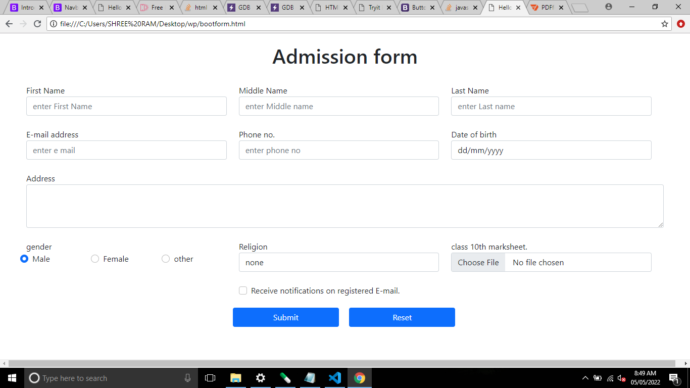

<!doctype html>

<html lang="en">

  <head>

    <meta charset="utf-8">

    <meta name="viewport" content="width=device-width, initial-scale=1">

    <!-- Bootstrap CSS -->

    <link href="https://cdn.jsdelivr.net/npm/bootstrap@5.1.3/dist/css/bootstrap.min.css" rel="stylesheet" integrity="sha384-1BmE4kWBq78iYhFldvKuhfTAU6auU8tT94WrHftjDbrCEXSU1oBoqyl2QvZ6jIW3" crossorigin="anonymous">

    <title>Hello, world!</title>

  </head>

  <body>

    <div class="row" style="margin-bottom:25px;">

        <h1 style="text-align: center; margin-top: 20px;">Admission form</h1>

    </div>

    <form class="row" style="margin: 20px 40px;">

        <div class="row" style="margin-bottom:25px;">

                <div class="form-group col-4">

                  <label for="formGroupExampleInput">First Name</label>

                  <input type="text" class="form-control" id="formGroupExampleInput" placeholder="enter First Name">

                </div>

                <div class="form-group col-4">

                  <label for="formGroupExampleInput2">Middle Name</label>

                  <input type="text" class="form-control" id="formGroupExampleInput2" placeholder="enter Middle name">

                </div>

                <div class="form-group col-4">

                    <label for="formGroupExampleInput2">Last Name</label>

                    <input type="text" class="form-control" id="formGroupExampleInput2" placeholder="enter Last name">

                  </div>

        </div>

        <div class="row" style="margin-bottom:25px;">

            <div class="form-group col-4">

              <label for="formGroupExampleInput">E-mail address</label>

              <input type="email" class="form-control" id="formGroupExampleInput" placeholder="enter e mail">

            </div>

            <div class="form-group col-4">

              <label for="formGroupExampleInput2">Phone no.</label>

              <input type="tel" class="form-control" id="formGroupExampleInput2" placeholder="enter phone no">

            </div>

            <div class="form-group col-4">

                <label for="formGroupExampleInput2">Date of birth</label>

                <input type="date" class="form-control" id="formGroupExampleInput2" >

              </div>

    </div>

        <div class="form-group col-12" style="margin-bottom:25px;">

          <label for="exampleFormControlTextarea1">Address</label>

          <textarea class="form-control" id="exampleFormControlTextarea1" rows="3"></textarea>

        </div>

        <div class="row" style="margin-bottom:25px;">

            <div class="col-4">

            <label>gender</label>

            <div class="row">

            <div class="form-check col-4" >

                <input class="form-check-input" type="radio" name="exampleRadios" id="exampleRadios1" value="option1" checked>

                <label class="form-check-label" for="exampleRadios1">

                  Male

                </label>

              </div>

              <div class="form-check col-4" >

                <input class="form-check-input" type="radio" name="exampleRadios" id="exampleRadios2" value="option2">

                <label class="form-check-label" for="exampleRadios2">

                  Female

                </label>

            </div>

            <div class="form-check col-4" >

                <input class="form-check-input" type="radio" name="exampleRadios" id="exampleRadios2" value="option2">

                <label class="form-check-label" for="exampleRadios2">

                  other

                </label>

            </div>

              </div>

            </div>

            <div class="form-group col-4">

                <label for="exampleFormControlSelect1">Religion</label>

                <select class="form-control" id="exampleFormControlSelect1">

                <option>none</option>

                <option>Hindu</option>

                  <option>Muslim</option>

                  <option>Sikh</option>

                  <option>Christian</option>

                </select>

              </div>

              <div class="form-group col-4">

                <label for="formGroupExampleInput2">class 10th marksheet.</label>

                <input type="file" class="form-control" id="formGroupExampleInput2" >

              </div>

    </div>

    <div class="row">

        <div class="col-4"></div>

    <div class="form-group col-6" style="margin-bottom: 20px;">

        <div class="form-check">

          <input class="form-check-input" type="checkbox" value="" id="invalidCheck2" required>

          <label class="form-check-label" for="invalidCheck2">

            Receive notifications on registered E-mail.

          </label>

        </div>

      </div>

    </div>

<div class="row">

    <div class="col-4"></div>

<input class="btn btn-primary col-2" type="submit" value="Submit" style="margin-right:20px;">

<input class="btn btn-primary col-2" type="reset" value="Reset">

<div class="col-4"></div>

</div>

      </form>

    <script src="https://cdn.jsdelivr.net/npm/bootstrap@5.1.3/dist/js/bootstrap.bundle.min.js" integrity="sha384-ka7Sk0Gln4gmtz2MlQnikT1wXgYsOg+OMhuP+IlRH9sENBO0LRn5q+8nbTov4+1p" crossorigin="anonymous"></script>

  </body>

</html>