

**DEPARTMENT OF INFORMATION TECHNOLOGY**

**Course: Web Programming Lab Academic Year: 2020 -21**

**Course Code: DJ19ITL405 Semester: IV**

**NAME: Nilesh Navalkar SAPID:60003200076**

**EXPERIMENT NO.4**

**Aim: JavaScript**

**a) Programs based on objects in JavaScript.**

1. Collect information from the user and store in a variable for later user.

* Create a basic page in html.
* Using a prompt box, prompt the user to supply his or her name.
* Save the name in a variable.
* Then, using a document.write() statement, use the information stored in variables to display Hello username! in big, bold letters, i.e. surrounded by <h1> tags. username should, of course, be what the user actually typed into the prompt box.
* Using the same variable, also display Hello username! in an alert message on the same page.

2. Display the following items in the page using only one or more document.write() statements:

* Information about the web browser that the user is viewing this page with (hint: use the navigator.appName property).
* The height and width of the user's monitor, i.e. the resolution(hint: use window.screen.availHeight and window.screen.availWidth)
* The date that the page was created or last modified (hint: use the document.lastModified property).

3. String Manipulation(First read inbuilt methods of string object)

* Create a function ucFirst(str) which returns str with uppercased first character.
* Display the result using alert box. (Hint : Use CharAt)
* For example:

ucFirst(john) == “John”

**b) Program to design a calculator using JavaScript.**

**THEORY:**

**Document object: represents the HTML document that is displayed in that window**

**Document.write():**

* The write() method writes directly to an open (HTML) document stream.
* The write() method deletes all existing HTML when used on a loaded document.

**document.getElementById():**

* The getElementById() method returns an element with a specified value.
* The getElementById() method returns null if the element does not exist.
* The getElementById() method is one of the most common methods in the HTML DOM. It is used almost every time you want to read or edit an HTML element

**The window object represents an open window in a browser.**

**Alert():**

* window. alert() instructs the browser to display a dialog with an optional message, and to wait until the user dismisses the dialog.
* The alert box takes the focus away from the current window, and forces the user to read the message.

**Navigator:**

* The  navigator object is used for browser detection.
* It can be used to get browser information such as appName, appCodeName, userAgent etc.

**availWidth/ availHeight**

* The availWidth property returns the width of the user's screen.
* The availHeight property returns the Height of the user's screen.
* The availWidth/availHeight property returns the width in pixels

**Implementation: 4a 1)**

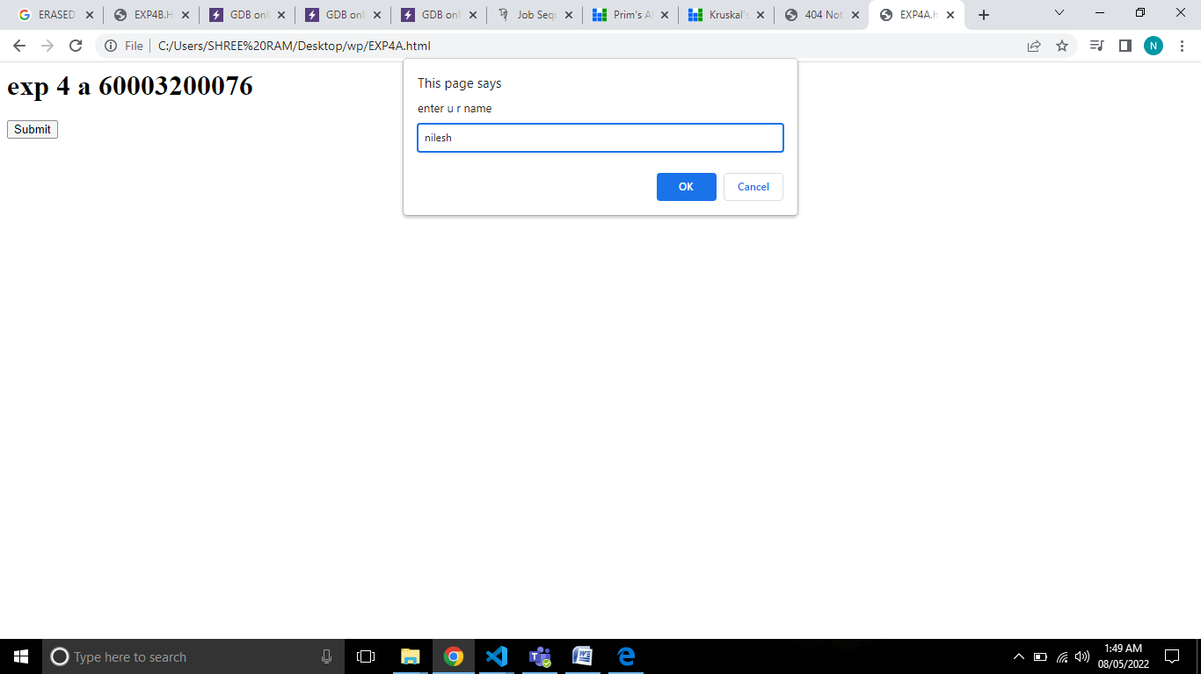

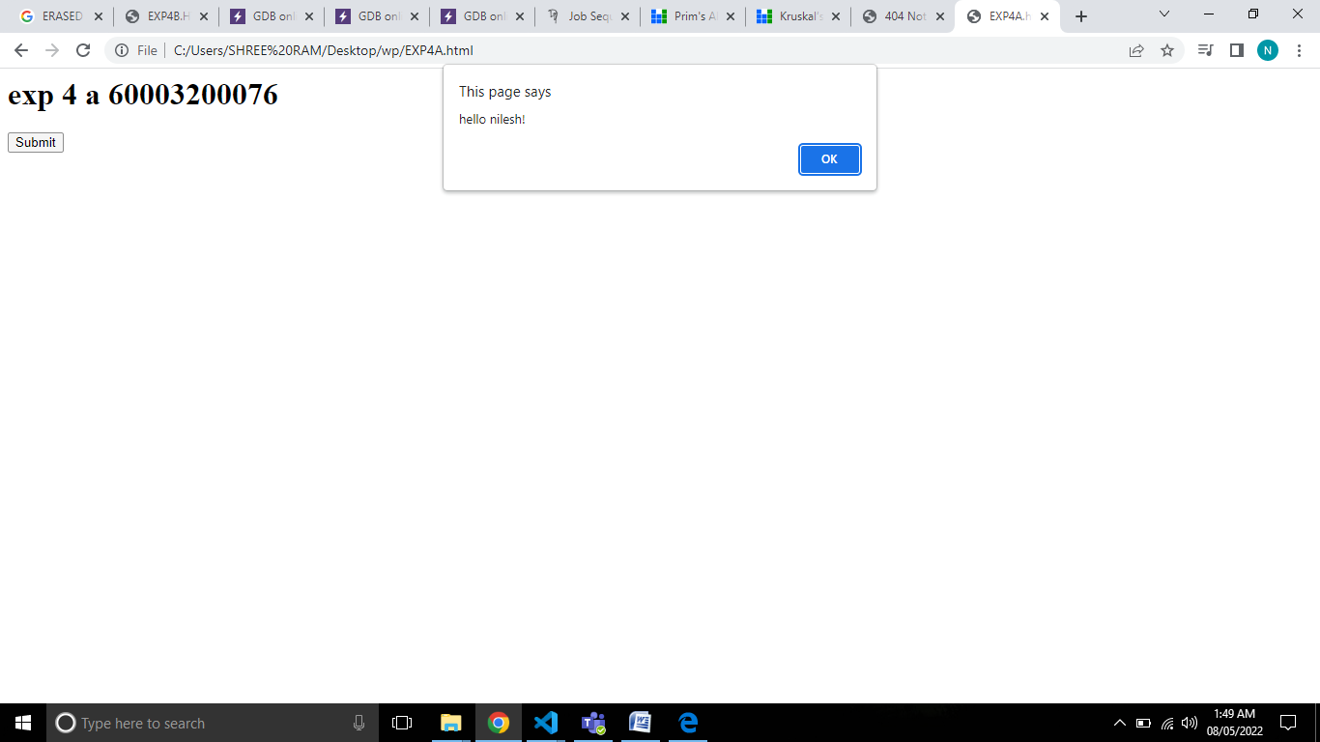

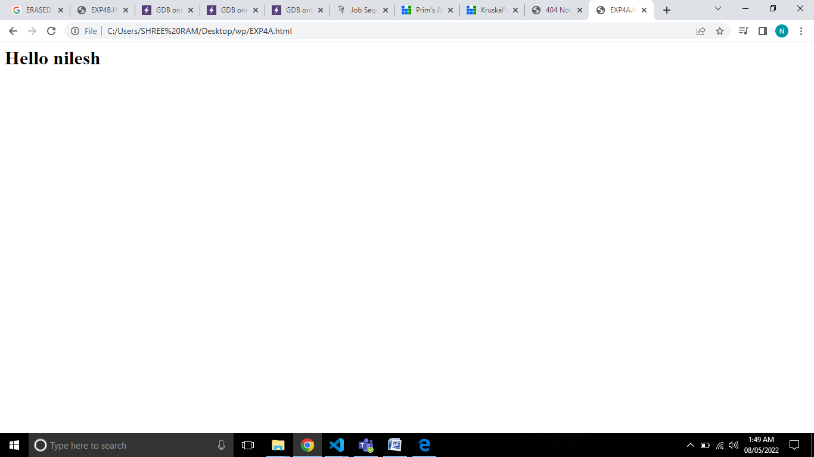

<html>

<head></head>

<body>

<div align="centre">

<h1> exp 4 a 60003200076</h1>

<input type="submit" onclick="pri()">

</div>

</body>

<script>

function pri()

{

let name=prompt("enter u r name");

alert("hello "+name+"!");

document.write("<h1>Hello  "+name+" </h1>");

}

</script>

</html>

**4a 2)**

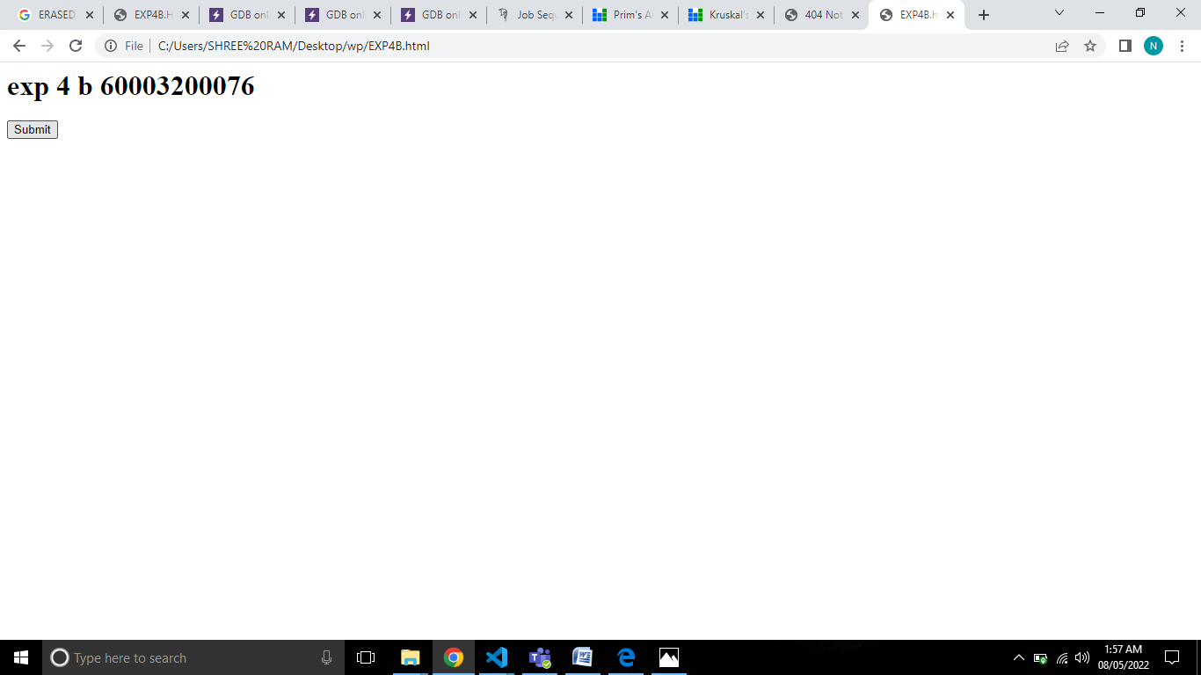

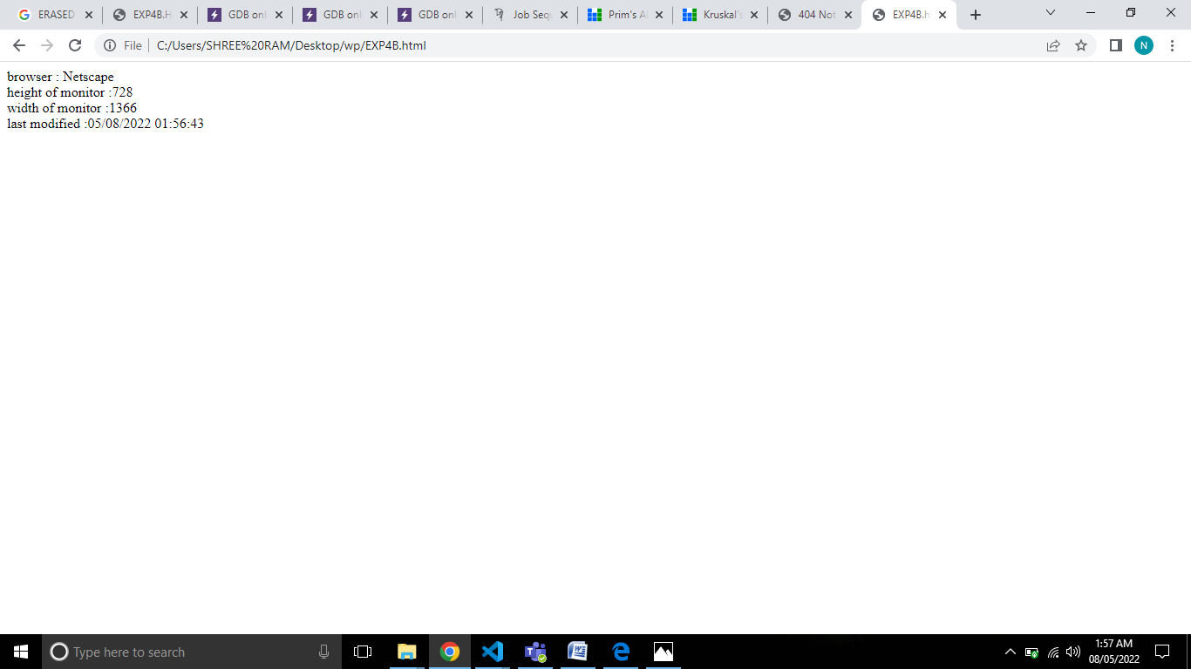

<html>

<head></head>

<body>

<div align="centre">

<h1> exp 4 b 60003200076</h1>

<input type="submit" onclick="info()">

</div>

</body>

<script>

function info()

{

document.write("browser : "+ navigator.appName +"<br> height of monitor :"+window.screen.availHeight+"<br> width of monitor :"+window.screen.availWidth+"<br> last modified :"+document.lastModified)

}

</script>

</html>

**4a 3)**

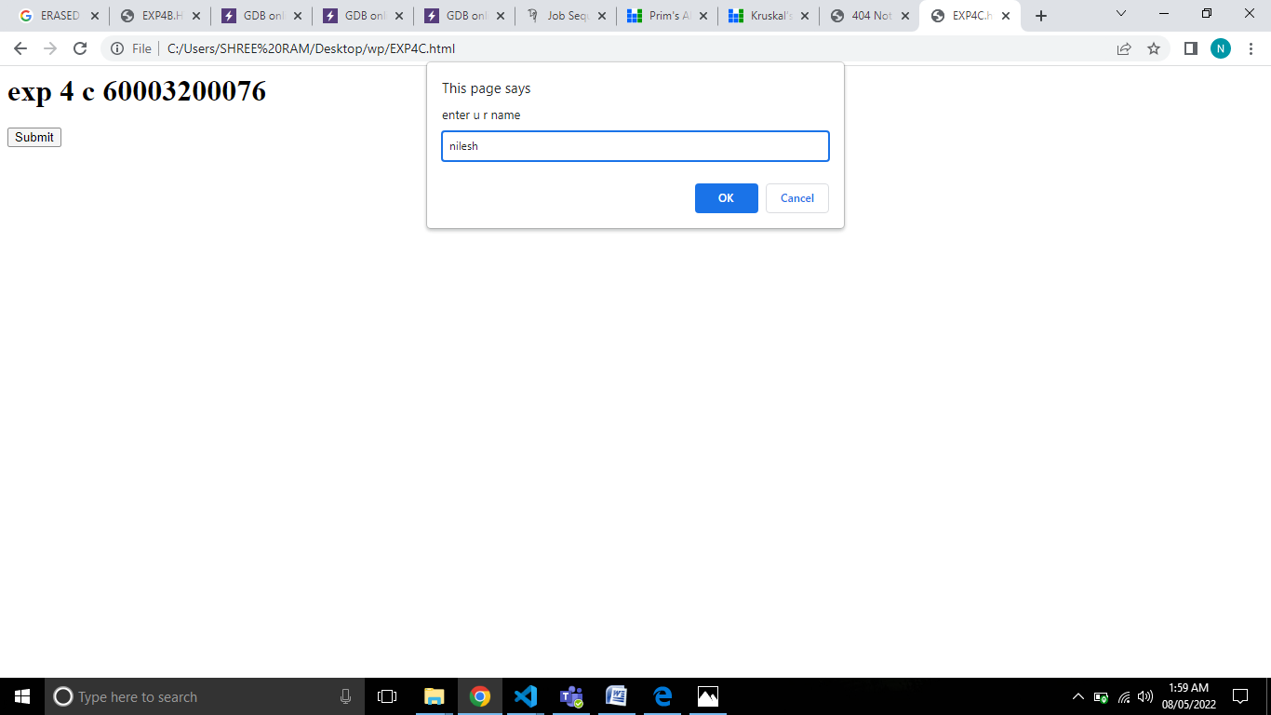

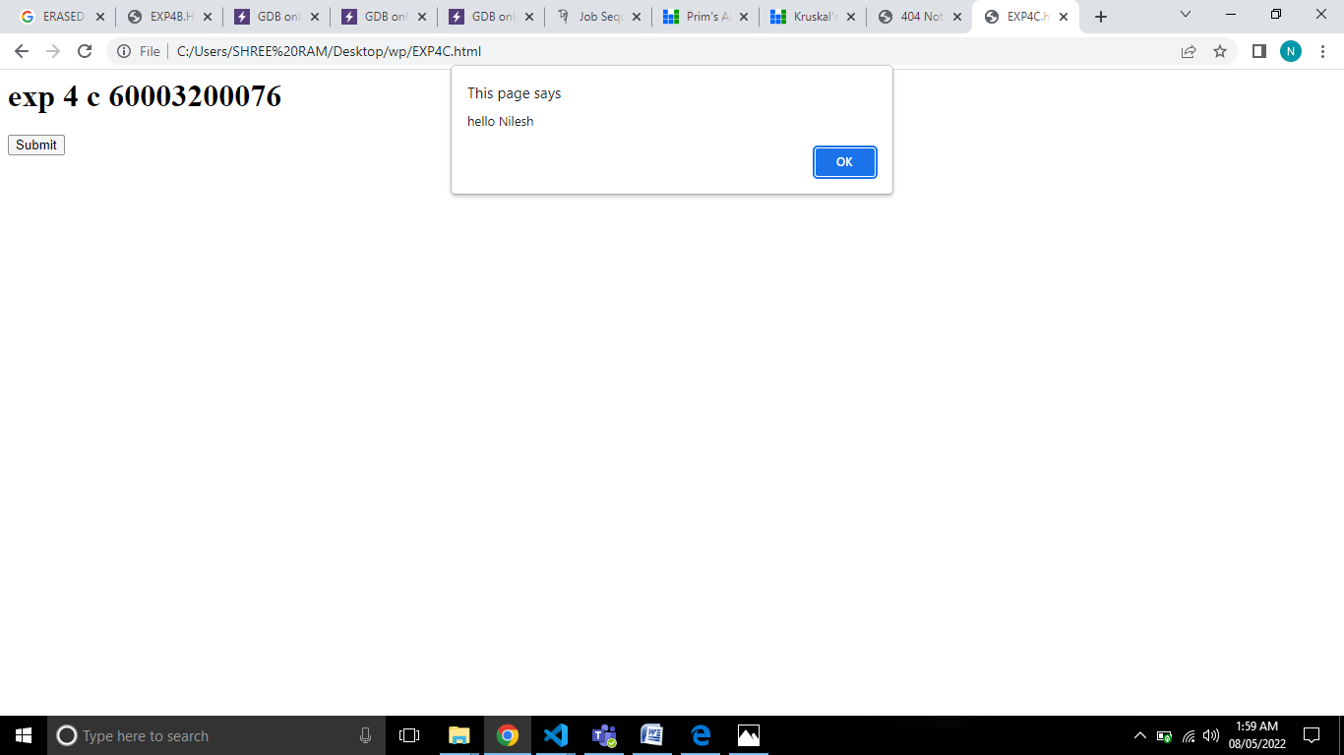

<html>

<head></head>

<body>

<div align="centre">

<h1> exp 4 c 60003200076</h1>

<input type="submit" onclick="caps()">

</div>

</body>

<script>

function caps()

{

let c=prompt("enter u r name");

let capsc=c.charAt(0).toUpperCase();

let i;

for(i=1;i<c.length;i++)

capsc=capsc+c[i];

alert("hello "+capsc);

}

</script>

</html>

**4 b)**

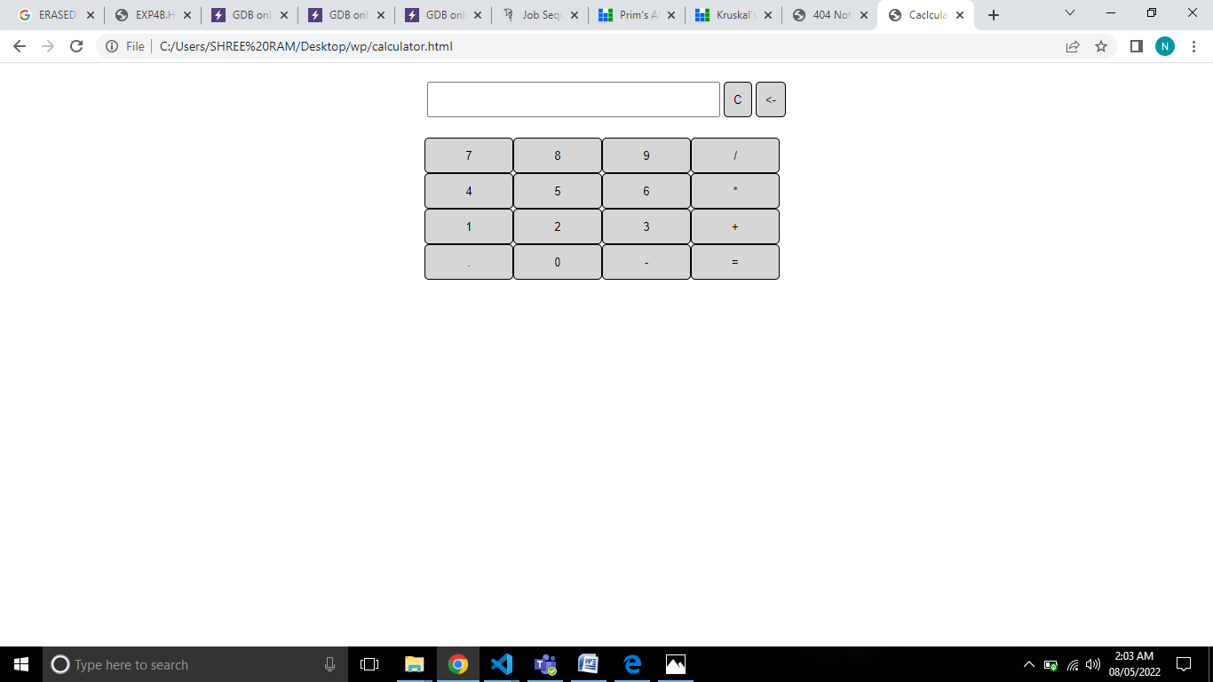

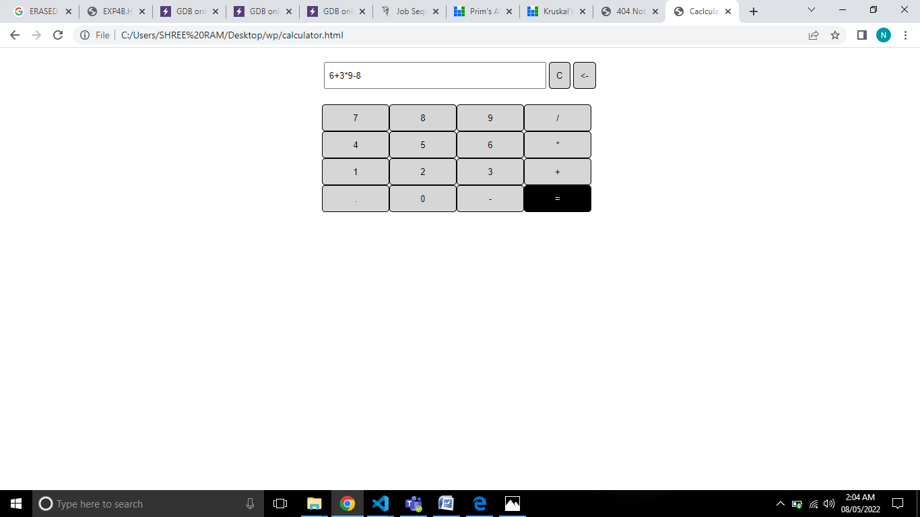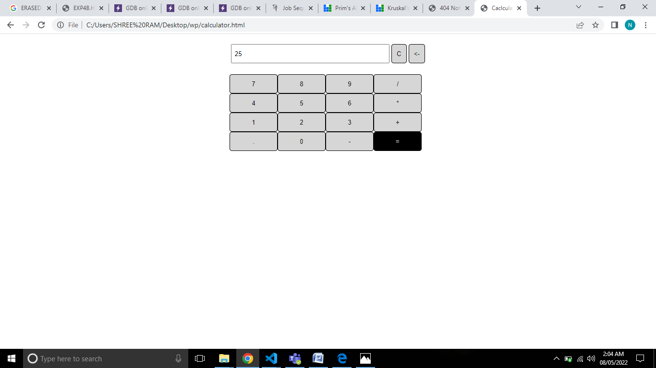

<DOCTYPE! html>

<title>Caclculator</title>

<head>

<style>

.container {

position: center;

padding: 10px;

width: 450px;

height: 400px;

}

.res{

    height:40px;

    width: 330px;

}

.keys {

display: grid;

grid-template-columns: repeat(4, 100px);

padding: 10px;

margin:10px;

}

.button {

background-color: rgb(214, 214, 214);

height: 40px;

padding: 10px;

border-radius: 5px;

border:0.1px solid black;

}

.button:hover{

    background-color: black;

    color: white;

}

.button:active{

    border-radius: 15px;

}

</style>

</head>

<body>

<div align="center">

<div class="container">

<table align="center">

<tr>

<td><input type='text' id='result' class ='res' value=" "></td>

<td><input type='button' value = 'C' onclick="clearScreen()" class="button"></td>

<td><input type='button' value = '<-' onclick="back()" class="button"></td>

</tr>

</table>

<div class="keys">

<input type="button" value="7" class="button" onClick="display('7')">

<input type="button" value="8" class="button" onClick="display('8')">

<input type="button" value="9" class="button" onClick="display('9')">

<input type="button" value="/" class="button" onClick="displayo('/')">

<input type="button" value="4" class="button" onClick="display('4')">

<input type="button" value="5" class="button" onClick="display('5')">

<input type="button" value="6" class="button" onClick="display('6')">

<input type="button" value="*" class="button" onClick="displayo('*')">

<input type="button" value="1" class="button" onClick="display('1')">

<input type="button" value="2" class="button" onClick="display('2')">

<input type="button" value="3" class="button" onClick="display('3')">

<input type="button" value="+" class="button" onClick="displayo('+')">

<input type="button" value="." class="button" onClick="displayo('.')">

<input type="button" value="0" class="button" onClick="display('0')">

<input type="button" value="-" class="button" onClick="displayo('-')">

<input type="button" value= "=" class="button" onClick="solve()">

</div>

</div>

</div>

<script>

function displayo(val){

let x=document.getElementById('result').value;

let last=x.length-1;

let op=['*','+','-','/',' ','.'];

let i,counter=0;

for(i=0;i<op.length;i++)

if(x[last]==op[i] )

counter++;

if(counter==0 && last>-1)

{

document.getElementById('result').value += val;

return val;

}

}

function display(val){

document.getElementById('result').value += val;

return val;

}

function solve(){

let x = document.getElementById('result').value;

let y = eval(x);

document.getElementById('result').value = " "+y;

return y;

}

function clearScreen(){

document.getElementById('result').value = ' ';

}

function back(){

let x = document.getElementById('result').value;

let last=x.length-1;

let y= x.slice(0,last);

if(x[last]!=' ')

document.getElementById('result').value = y;

}

</script>

</body>

</html>