

**DEPARTMENT OF INFORMATION TECHNOLOGY**

**Course: Web Programming Lab Academic Year: 2020 -21**

**Course Code: DJ19ITL405 Semester: IV**

**NAME: Nilesh Navalkar SAPID:60003200076**

**EXPERIMENT NO.5**

**Aim:** JavaScript   
a) Programs based on form validation

* Create given form.
* When clicking on “Submit Form” button, it will call the function validateForm().

This function will check whether the inserted data is correct or not. If any of the inserted data is not in proper format, it will display the alert box specifying the error.

If all inserted data are in correct format it will display alert box “Your data has been validated!!!!”

**THEORY:**

Form validation is a “technical process where a [web-form checks](https://designmodo.com/ux-form-validation/) if the information provided by a user is correct.”

The form will either alert the user that they messed up and need to fix something to proceed, or the form will be validated and the user will be able to continue with their registration process.

**Username/ Password:**

Username and password can be validated by checking string length of username/password as us.length.

**Confirm password:**

This can be validated by checking if both the values of password fields match.

**Firstname/email/website:**

These can be validated by using regular expressions that is specifying the format of allowed input.

**Age/phone:**

These can be validated by using isNaN() function which checks if the string is not a number.

**Gender/disclaimer:**

These can be validated by checking the state of these variables that is if checked or not.

**IMPLEMENTATION:**

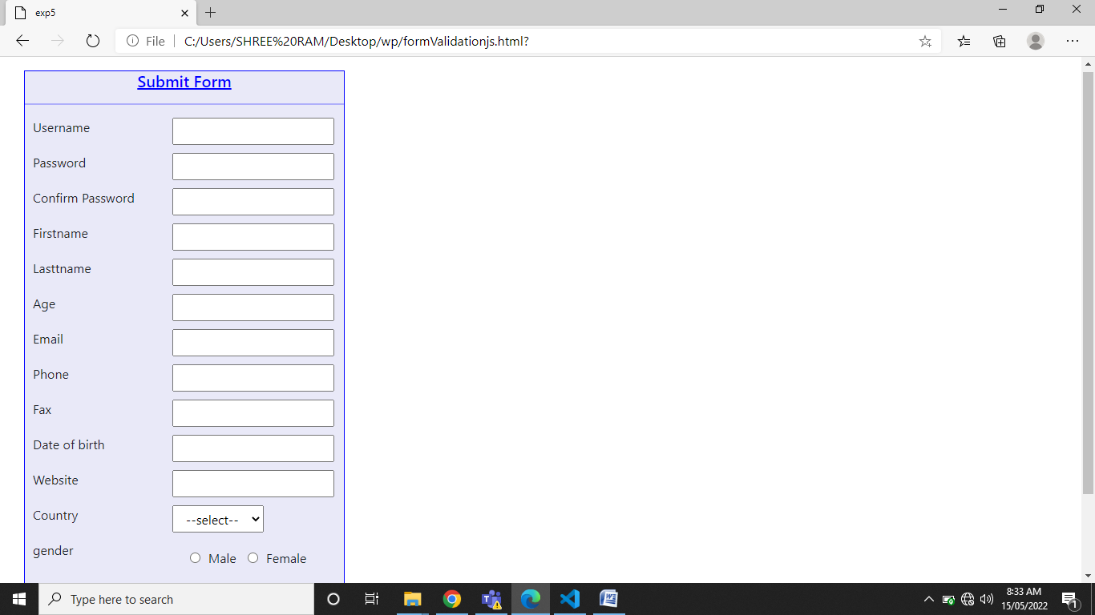

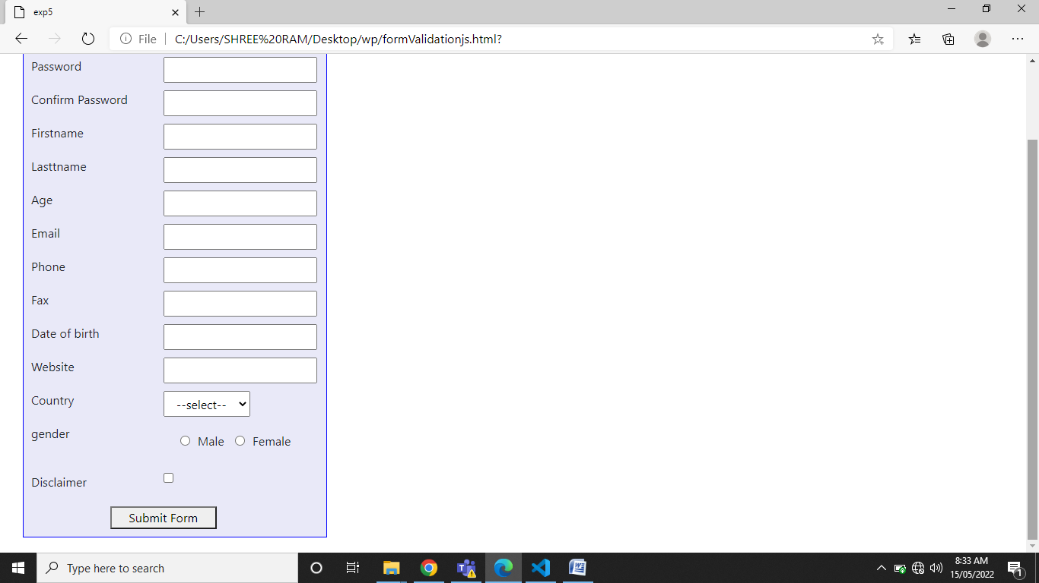

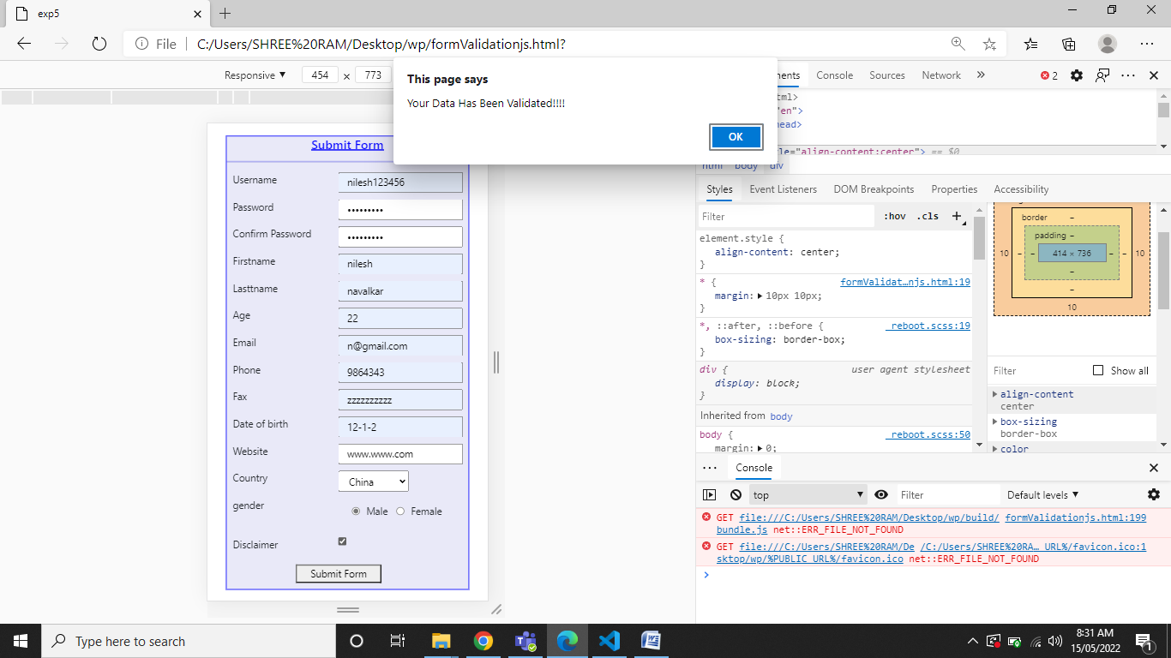

**SOURCE CODE:**

<!DOCTYPE html>

<html lang="en">

  <head>

    <meta charset="utf-8" />

    <link rel="icon" href="%PUBLIC_URL%/favicon.ico" />

    <meta name="viewport" content="width=device-width, initial-scale=1" />

    <meta name="theme-color" content="#000000" />

    <meta

      name="description"

      content="Web site created using create-react-app"

    />

    <link rel="apple-touch-icon" href="%PUBLIC_URL%/logo192.png" />

    <link rel="manifest" href="%PUBLIC_URL%/manifest.json" />

    <link href="https://cdn.jsdelivr.net/npm/bootstrap@5.1.3/dist/css/bootstrap.min.css" rel="stylesheet" integrity="sha384-1BmE4kWBq78iYhFldvKuhfTAU6auU8tT94WrHftjDbrCEXSU1oBoqyl2QvZ6jIW3" crossorigin="anonymous">

    <title>exp5</title>

    <style>

        *{

            margin: 10px 10px;

        }

    </style>

  </head>

  <body>

      <div style="align-content:center">

        <form onsubmit="return false" style="background-color: rgb(233, 233, 248); max-width: 400px;overflow: hidden;border: blue solid 1px;">

            <h5 style="color:blue;text-align: center;"><u>Submit Form</u></h5>

            <hr style="border:blue solid 1px ;">

            <div class="row">

            <label for="un" class="col-5">Username</label>

            <input type="text" id="un" class="col-auto">

            </div>

            <div class="row">

                <label for="pass" class="col-5">Password</label>

                <input type="password" id="pass" class="col-auto">

            </div>

            <div class="row">

                <label for="cpass" class="col-5">Confirm Password</label>

                <input type="password" id="cpass" class="col-auto">

            </div>

            <div class="row">

                <label for="fn" class="col-5">Firstname</label>

                <input type="text" id="fn" class="col-auto">

            </div>

            <div class="row">

                <label for="ln" class="col-5">Lasttname</label>

                <input type="text" id="ln" class="col-auto">

            </div>

            <div class="row">

                <label for="age" class="col-5">Age</label>

                <input type="text" id="age" class="col-auto">

            </div>

            <div class="row">

                <label for="em" class="col-5">Email</label>

                <input type="text" id="em" class="col-auto">

            </div>

            <div class="row">

                <label for="phone" class="col-5">Phone</label>

                <input type="text" id="phone" class="col-auto">

            </div>

            <div class="row">

                <label for="fax" class="col-5">Fax</label>

                <input type="text" id="fax" class="col-auto">

            </div>

            <div class="row">

                <label for="dob" class="col-5">Date of birth</label>

                <input type="text" id="dob" class="col-auto">

            </div>

            <div class="row">

                <label for="web" class="col-5">Website</label>

                <input type="text" id="web" class="col-auto">

            </div>

            <div class="row">

                <label for="country" class="col-5">Country</label>

                <select id="country" class="col-auto">

                    <option value="">--select--</option>

                    <option value="1">India</option>

                    <option value="2">China</option>

                    <option value="3">Japan</option>

                    <option value="4">USA</option>

                    <option value="5">UK</option>

                </select>

            </div>

            <div class="row">

                <label for="gender" class="col-5">gender</label>

                <div class="col-auto">

                <input type="radio"  name="rdio" id="r1" ><label for="r1" >Male</label>

                <input type="radio" name="rdio" id="r2" ><label for="r2" >Female</label>

                </div>

            </div>

            <div class="row">

                <label for="check" class="col-5">Disclaimer</label>

                <input type="checkbox" id="check" class="col-auto"  >

            </div>

            <div class="row">

                <div class="col-3"></div>

                <button class="col-4" onclick="validate()"  >Submit Form</button>

            </div>

        </form>

      </div>

      <script>

          function validate()

          {

              let u=document.getElementById("un").value;

              let p=document.getElementById("pass").value;

              let cp=document.getElementById("cpass").value;

              let fn=document.getElementById("fn").value;

              let age=document.getElementById("age").value;

              let em=document.getElementById("em").value;

              let phone=document.getElementById("phone").value;

              let dob=document.getElementById("dob").value;

              let web=document.getElementById("web").value;

              let country=document.getElementById("country").value;

              let check=document.getElementById("check");

              let gmale=document.getElementById("r1");

              let gfmale=document.getElementById("r2");

              if(u.length<7 || u.length>12)

              {

                  alert("username too small");

              }

              else if(p.length<5 || p.length>10)

              {

                  alert("password too small");

              }

              else if(p!=cp)

              {

                  alert("password dont match");

              }

              else if(/[^a-zA-Z]/.test(fn)  ||  !fn)

              {

                  alert("name must be non empty non numberic");

              }

              else if(age<22 || isNaN(age))

              {

                  alert("age must be number greater than 22");

              }

              else if(!/[a-zA-Z0-9._-]+@[a-zA-Z0-9._-]+\.[a-zA-Z]{2,4}$/.test(em) ||  !em)

              {

                  alert("enter a valid email");

              }

              else if(isNaN(phone) ||  !phone)

              {

                  alert("phone number must be number and cannot be empty");

              }

              else if(!Date.parse(dob) ||  !dob)

              {

                  alert("dob must be number and cannot be empty");

              }

              else if(!/[a-zA-Z0-9.]+\.[a-zA-Z0-9._-]+\.[a-zA-Z]/.test(web) ||  !web)

              {

                  alert("enter a valid website");

              }

              else if(!country)

              {

                  alert("select a country");

              }

              else if(!gmale.checked && !gmale.checked)

              {

                  alert("please select gender");

              }

              else if(!check.checked)

              {

                  alert("please tick to proceed");

              }

              else

              alert("Your Data Has Been Validated!!!!");

          }

      </script>

    <script src="./build/bundle.js"></script>

  </body>

  <script src="https://cdn.jsdelivr.net/npm/bootstrap@5.1.3/dist/js/bootstrap.bundle.min.js" integrity="sha384-ka7Sk0Gln4gmtz2MlQnikT1wXgYsOg+OMhuP+IlRH9sENBO0LRn5q+8nbTov4+1p" crossorigin="anonymous"></script>

</html>