**DEPARTMENT OF INFORMATION TECHNOLOGY**

**COURSE CODE:** DJ19ITL406 **DATE:** 05-06-2022

**COURSE NAME:** Programing Laboratory 2 (Python)  **CLASS:** SYBTech-A

**EXPERIMENT NO. 2**

**CO/LO:**

CO1: Students will be able to write clean python code/Code correctly in Python with a clean coding standards

CO2: Students will be able to debug the programs

**AIM / OBJECTIVE:**

Write a Python program to implement functions of List, Tuples, and Dictionaries

**DESCRIPTION OF EXPERIMENT:**

**Python Collections (Arrays)**

There are four collection data types in the Python programming language:

List is a collection which is ordered and changeable. Allows duplicate members.

[Tuple](https://www.w3schools.com/python/python_tuples.asp) is a collection which is ordered and unchangeable. Allows duplicate members.

[Set](https://www.w3schools.com/python/python_sets.asp) is a collection which is unordered, unchangeable*, and unindexed. No duplicate members.

[Dictionary](https://www.w3schools.com/python/python_dictionaries.asp) is a collection which is ordered** and changeable. No duplicate members.

**List**

Lists are used to store multiple items in a single variable.

Lists are one of 4 built-in data types in Python used to store collections of data, the other 3 are Tuple, Set, and Dictionary, all with different qualities and usage.

Lists are created using square brackets:

thislist = ["apple", "banana", "cherry"]  
print(thislist)

**List Items**

List items are ordered, changeable, and allow duplicate values.

List items are indexed, the first item has index [0], the second item has index [1] etc.

**Ordered**

When we say that lists are ordered, it means that the items have a defined order, and that order will not change.

If you add new items to a list, the new items will be placed at the end of the list.

Changeable

The list is changeable, meaning that we can change, add, and remove items in a list after it has been created.

**List Length**

To determine how many items a list has, use the len() function:

print(len(thislist))

**Tuple**

Tuples are used to store multiple items in a single variable.

Tuple is one of 4 built-in data types in Python used to store collections of data, the other 3 are [List](https://www.w3schools.com/python/python_lists.asp), [Set](https://www.w3schools.com/python/python_sets.asp), and [Dictionary](https://www.w3schools.com/python/python_dictionaries.asp), all with different qualities and usage.

A tuple is a collection which is ordered and **unchangeable**.

Tuples are written with round brackets.

thistuple = ("apple", "banana", "cherry")  
print(thistuple)

**Tuple Items**

Tuple items are ordered, unchangeable, and allow duplicate values.

Tuple items are indexed, the first item has index [0], the second item has index [1] etc.

Unchangeable

Tuples are unchangeable, meaning that we cannot change, add or remove items after the tuple has been created.

**Allow Duplicates**

Since tuples are indexed, they can have items with the same value:

thistuple = ("apple", "banana", "cherry", "apple", "cherry")  
print(thistuple)

**Tuple Length**

To determine how many items a tuple has, use the len() function:

thistuple = ("apple", "banana", "cherry")  
print(len(thistuple))

**Dictionary**

Dictionaries are used to store data values in key:value pairs.

A dictionary is a collection which is ordered*, changeable and do not allow duplicates.

As of Python version 3.7, dictionaries are *ordered*. In Python 3.6 and earlier, dictionaries are *unordered*.

Dictionaries are written with curly brackets, and have keys and values:

thisdict = {  
  "brand": "Ford",  
  "model": "Mustang",  
  "year": 1964  
}  
print(thisdict)

**Dictionary Items**

Dictionary items are ordered, changeable, and does not allow duplicates.

Dictionary items are presented in key:value pairs, and can be referred to by using the key name.

thisdict = {  
  "brand": "Ford",  
  "model": "Mustang",  
  "year": 1964  
}  
print(thisdict["brand"])

When we say that dictionaries are ordered, it means that the items have a defined order, and that order will not change.

Unordered means that the items does not have a defined order, you cannot refer to an item by using an index.

## **Changeable**

Dictionaries are changeable, meaning that we can change, add or remove items after the dictionary has been created.

## **Duplicates Not Allowed**

Dictionaries cannot have two items with the same key:

**QUES**T**IONS:**

1. Create a list of 10 random players in football team. perform following operations on list and discuss on each output 1. Display list, Sorts the list, use remove to Remove the first item with the specified value
2. Write a program to randomly select 10 integer elements from range 100 to 200 and find the smallest among all.
3. Create a dictionary of 5 countries with their currency details and display them.

**CODE:**

# 1. Create a list of 10 random players in football team. Perform following operations on list and discuss on each output

# Display list, Sorts the list, use remove to Remove the first item with the specified value

fblist=[]

for i in range(0,10):

    player=input("add a player to ur team")

    fblist.append(player)

print("your team :",fblist)

fblist.sort()

print("your sorted team : ",fblist)

bad=input("enter the player u want to remove from team : ")

fblist.remove(bad)

print("after removing :",fblist)

OUTPUT:

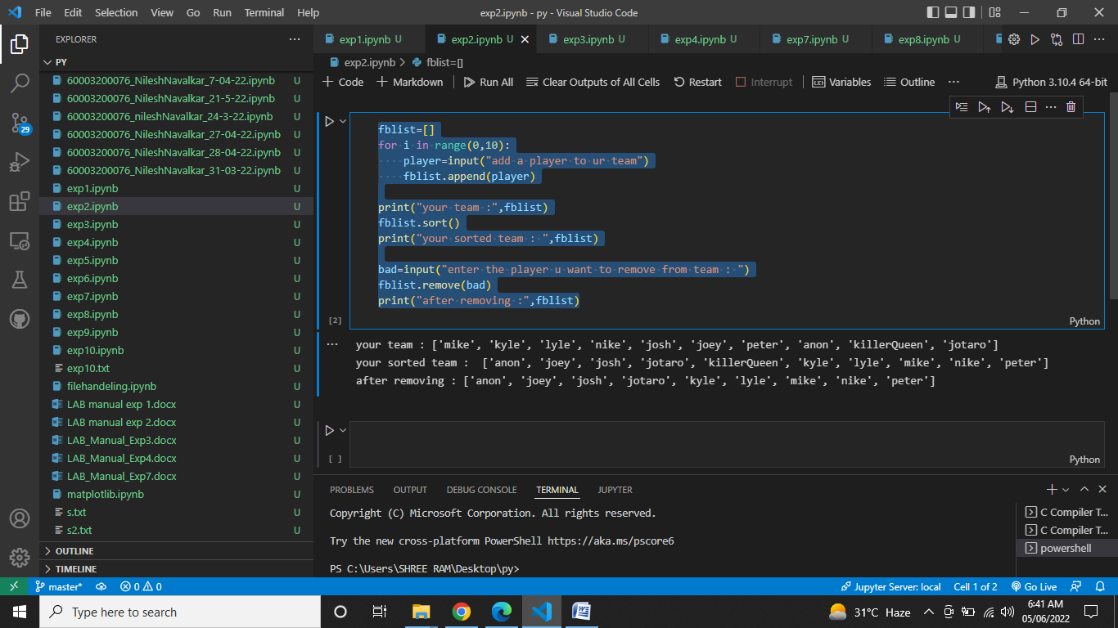

#2.Write a program to randomly select 10 integer elements from range 100 to 200 and find the smallest among all.

import random as r

myint=[]

i=0

for i in range(0,10):

    myint.append(r.randrange(100,200))

print(myint)

print("the smallest random integer is : ",min(myint))

OUTPUT:

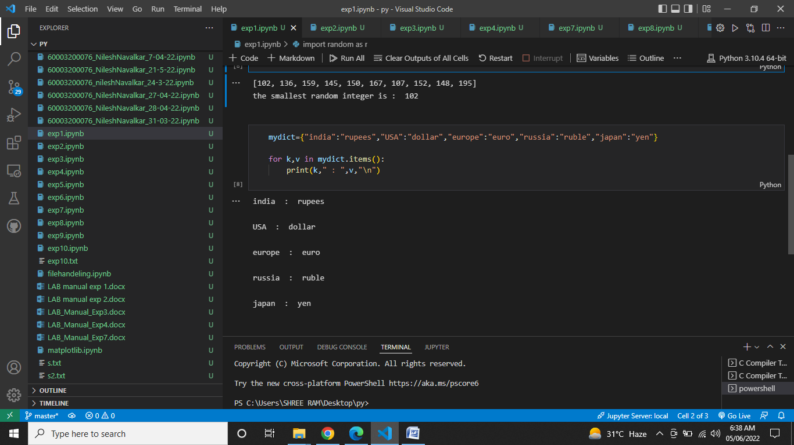

# 3.Create a dictionary of 5 countries with their currency details and display them.

mydict={"india":"rupees","USA":"dollar","europe":"euro","russia":"ruble","japan":"yen"}

for k,v in mydict.items():

    print(k," : ",v,"\n")

OUTPUT:



**OBSERVATIONS / DISCUSSION OF RESULT:**

1)We observed that python comes with a random inbuilt function used to find a random number using the randrange function.

2)The list can do operations like appending an element, deleting an element from a specified index.

3)We also saw the use of dictionary which stores data in key value pairs.

**CONCLUSION:**

This experiment was meant to make the students understand about the different inbuilt functions in python and to introduce the students to dictionaries in python.

**REFERENCES:**

**Website References:​**

[1] https://www.w3schools.com/python