**DEPARTMENT OF INFORMATION TECHNOLOGY**

**COURSE CODE:** DJ19ITL406 **DATE:** 05-06-2022

**COURSE NAME:** Programing Laboratory 2 (Python)  **CLASS:** SYBTECH

**EXPERIMENT NO. 3**

**CO/LO: CO1, CO2.**

**AIM / OBJECTIVE:**

Write a Python program to implement Arrays / Numpy Array (1D, 2D) applications

**DESCRIPTION OF EXPERIMENT:**

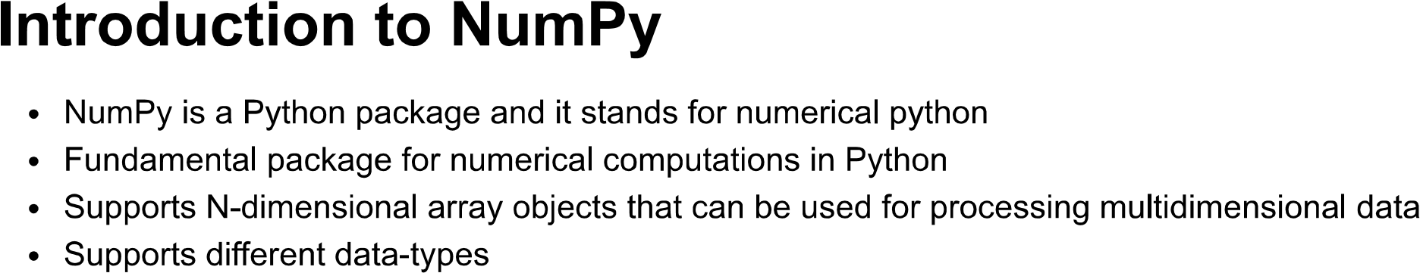

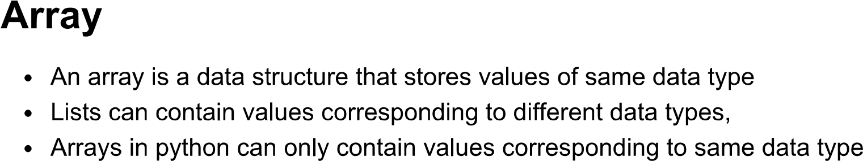

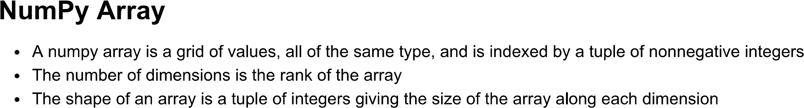

NumPy is used to work with arrays. The array object in NumPy is called ndarray.

We can create a NumPy ndarray object by using the array() function.

import numpy as np

# Create a 3x1 numpy array

a = np.array([1,2,3])

print(a)

# Print object type

print(type(a))

# Print shape

print(a.shape) # 3,

# Print some values in a

print(a[0], a[1], a[2])

#Create a 2x2 numpy array

b = np.array([[1,2],[3,4]])

print(b)

# Print shape

print(b.shape)

# Print some values in b

print(b[0,0], b[0,1], b[1,1])

#Create Random Array

g = np.random.random((3,3))

# Indexing

import numpy as np  
arr = np.array([1, 2, 3, 4])  
print(arr[0])

#Data Types in Array

The NumPy array object has a property called dtype that returns the data type of the array

#Slicing

We pass slice instead of index like this: [*start*:*end*].

We can also define the step, like this: [*start*:*end*:*step*].

#Copy

The copy *owns* the data and any changes made to the copy will not affect original array, and any changes made to the original array will not affect the copy.

#Interating

As we deal with multi-dimensional arrays in numpy, we can do this using basic for loop of python

**QUESTIONS:**

1. [Create a Numpy array filled with all ones](https://www.geeksforgeeks.org/create-a-numpy-array-filled-with-all-ones/)
2. [Check whether a Numpy array contains a specified row](https://www.geeksforgeeks.org/check-whether-a-numpy-array-contains-a-specified-row/)
3. Compute mathematical operations on Array, Add & Multiply two matrices
4. [Find the most frequent value in a NumPy array](https://www.geeksforgeeks.org/find-the-most-frequent-value-in-a-numpy-array/)
5. [Flatten a 2d numpy array into 1d array](https://www.geeksforgeeks.org/python-flatten-a-2d-numpy-array-into-1d-array/)
6. [Calculate the sum of all columns in a 2D NumPy array](https://www.geeksforgeeks.org/calculate-the-sum-of-all-columns-in-a-2d-numpy-array/)
7. [Calculate the average, variance and standard deviation in Python using NumPy](https://www.geeksforgeeks.org/calculate-the-average-variance-and-standard-deviation-in-python-using-numpy/)
8. [Insert a space between characters of all the elements of a given NumPy array?](https://www.geeksforgeeks.org/how-to-insert-a-space-between-characters-of-all-the-elements-of-a-given-numpy-array/)
9. Plot line graph from NumPy array
10. [Sort the values in a matrix](https://www.geeksforgeeks.org/python-numpy-matrix-sort/)

**CODE:**

# 1.Create a Numpy array filled with all ones

import numpy as np

l=[]

n=int(input("enter number of ones "))

for i in range(0,n):

    l.append(1)

allones=np.array(l)

print(allones)

OUTPUT:

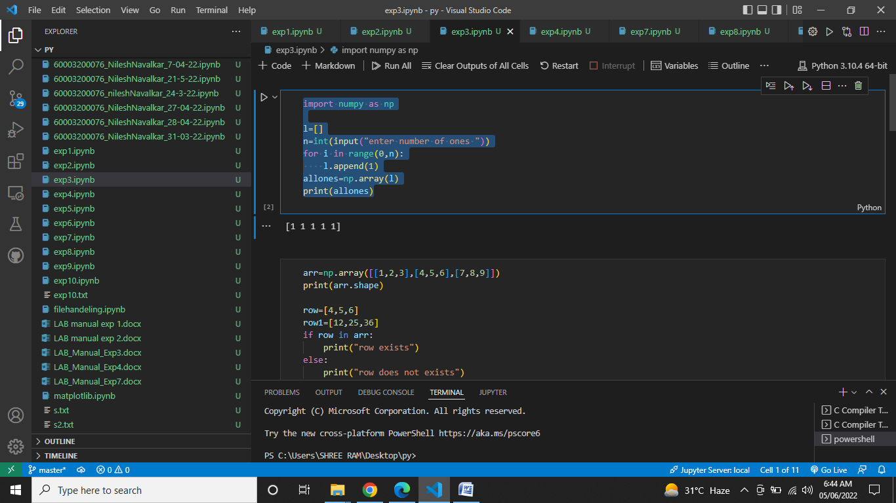

# 2.Check whether a Numpy array contains a specified row

arr=np.array([[1,2,3],[4,5,6],[7,8,9]])

print(arr.shape)

row=[4,5,6]

row1=[12,25,36]

if row in arr:

    print("row exists")

else:

    print("row does not exists")

if row1 in arr:

    print("row1 exists")

else:

    print("row1 does not exists")

OUTPUT:

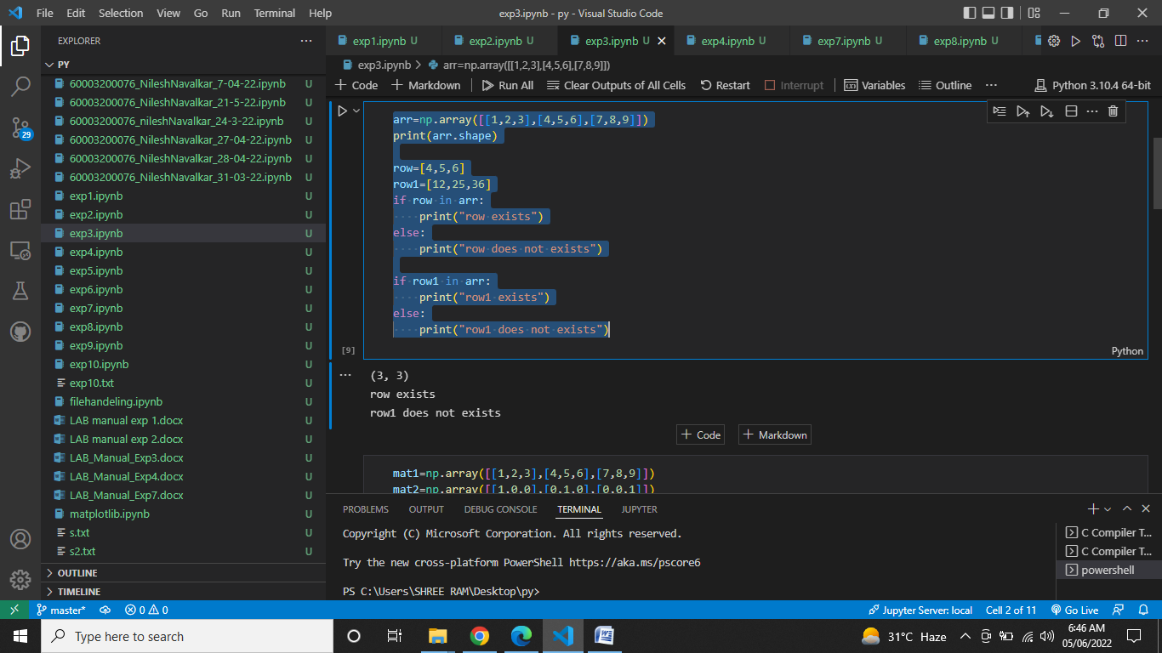

# 3.Compute mathematical operations on Array, Add & Multiply two matrices

mat1=np.array([[1,2,3],[4,5,6],[7,8,9]])

mat2=np.array([[1,0,0],[0,1,0],[0,0,1]])

print("Addition of matrices:\n",mat1+mat2)

print("multiplication of matrices:\n",mat1@mat2)

OUTPUT:

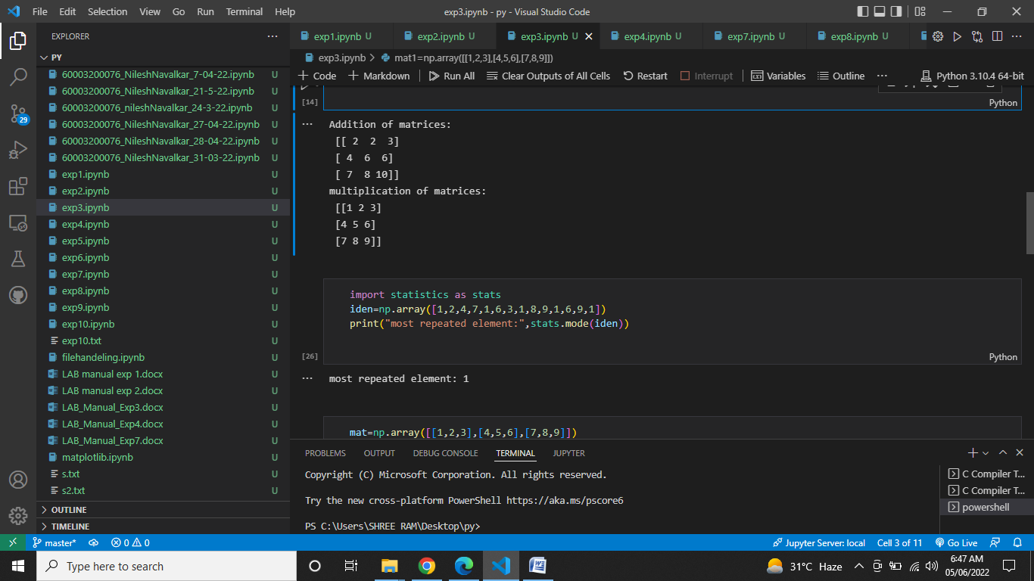

# 4.Find the most frequent value in a NumPy array

import statistics as stats

iden=np.array([1,2,4,7,1,6,3,1,8,9,1,6,9,1])

print("most repeated element:",stats.mode(iden))

OUTPUT:

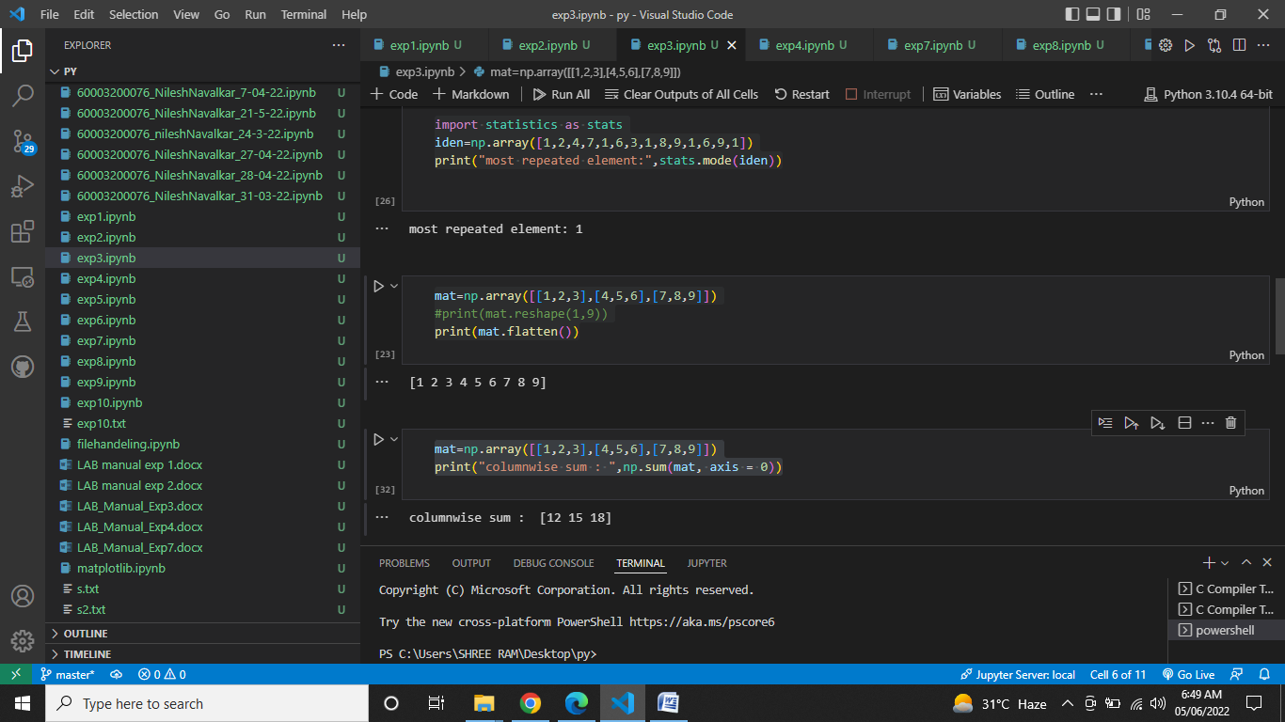

# 5.Flatten a 2d numpy array into 1d array

mat=np.array([[1,2,3],[4,5,6],[7,8,9]])

#print(mat.reshape(1,9))

print(mat.flatten())

OUTPUT:



# 6.Calculate the sum of all columns in a 2D NumPy array

mat=np.array([[1,2,3],[4,5,6],[7,8,9]])

print("columnwise sum : ",np.sum(mat, axis = 0))

OUTPUT:



# 7.Calculate the average, variance and standard deviation in Python using NumPy

iden=np.array([1,2,4,7,1,6,3,1,8,9,1,6,9,1])

print("avg = ",np.mean(iden))

print("variance = ",np.var(iden))

print("standard deviation = ",np.std(iden))

OUTPUT:

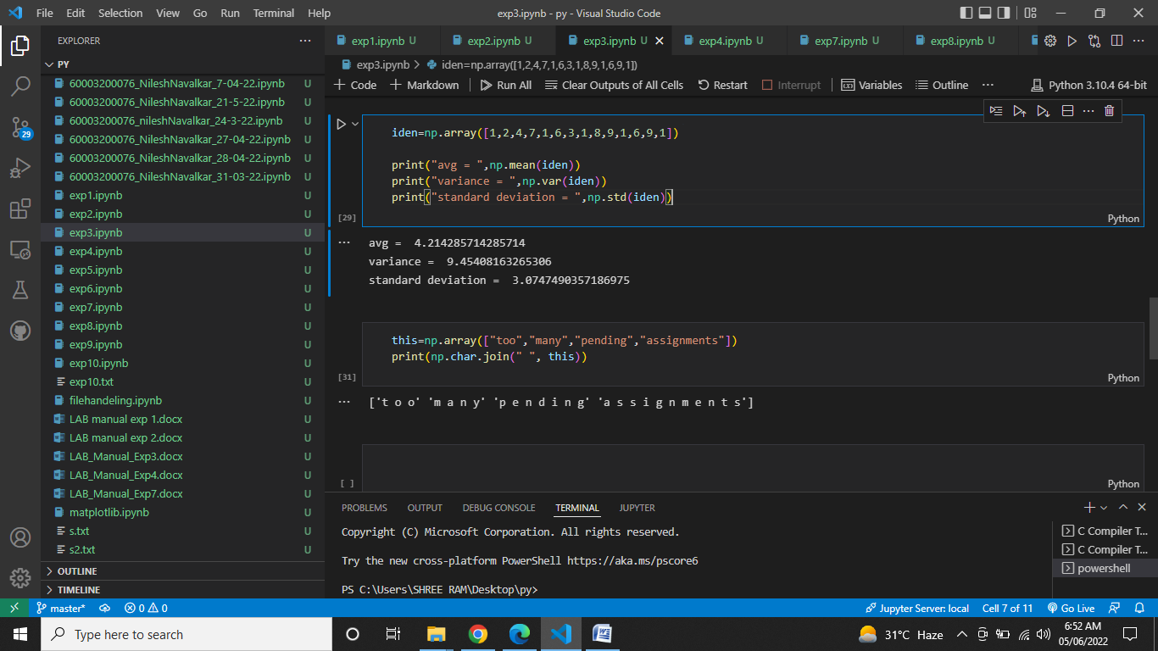

# 8.Insert a space between characters of all the elements of a given NumPy array?

this=np.array(["too","many","pending","assignments"])

print(np.char.join(" ", this))

OUTPUT:



# 9.Plot line graph from NumPy array

import matplotlib.pyplot  as mp

x=np.array([1,2])

y=np.array([3,4])

mp.xlabel("x axis")

mp.ylabel("y axis")

mp.plot(x,y,"o-g")

mp.show()

OUTPUT:

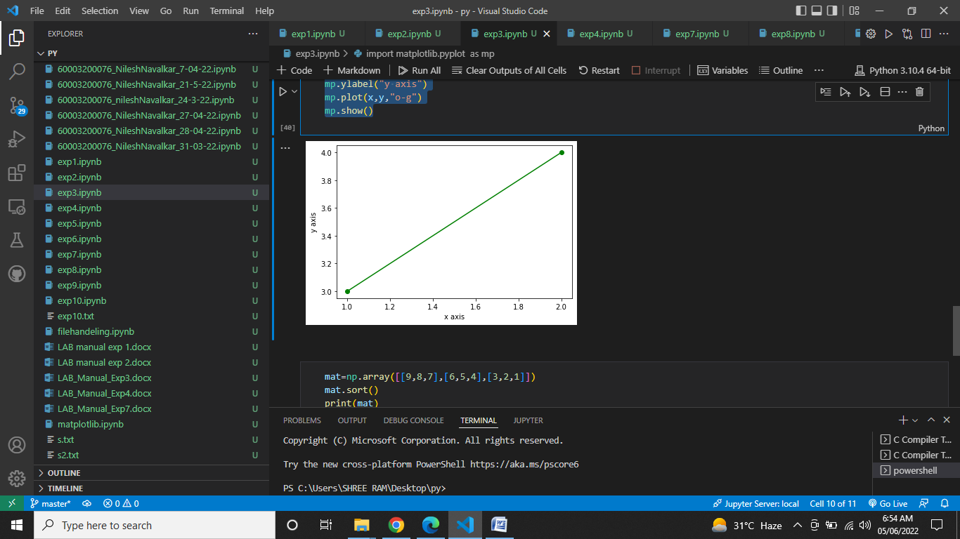

# 10.Sort the values in a matrix

mat=np.array([[9,8,7],[6,5,4],[3,2,1]])

mat.sort()

print(mat)

OUTPUT:

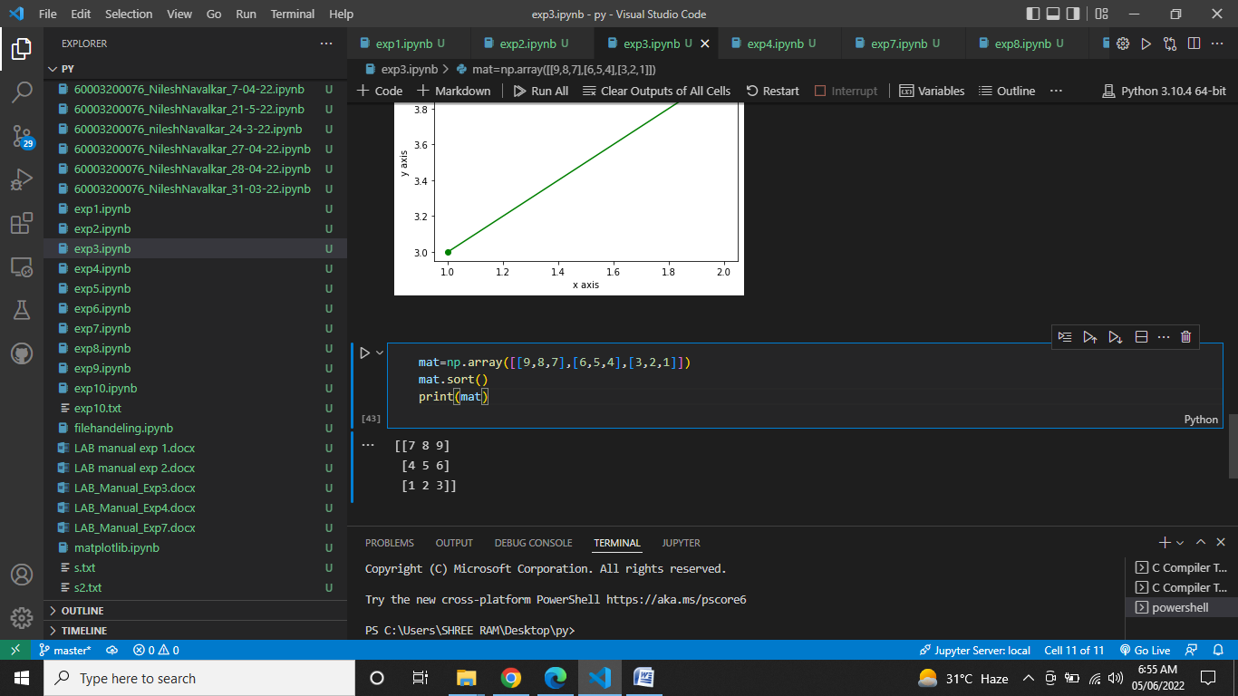

**OBSERVATIONS / DISCUSSION OF RESULT:**

1)It was observed that numpy has a lot of built in function for various data calculations such as avg, variance and standard deviation.

2)It was observed that in order to sort a matrix in python, we first copy all the elements of the matrix in single dimension list and then sort the list using sort() and copy the elements back into the original matrix.

3)The function bincount works a little different than expected as it is supposed to return the occurrence of the elements in the array, it does so by making an array of the numbers from 0 to the largest element in the original array. So if the array is [1,2,2,1] then the array produced by bincount will be [0,2,2] where the first element represents the occurrence of 0 in the original array which is zero, the second element showing the occurrence of 1 which is 2 and so on. The drawback of this is that if the array contains a bigger number like 100 then the bincount will make an array of 100 elements which is not needed.

**CONCLUSION:**

The experiment showed the different functions of numpy and how powerful it is at manipulating data. It also showed the way to plot a graph using numpy which is a handy tool to see the data growth etc.

**REFERENCES:**

**Website References:​**

[1] https://www.w3schools.com/python