**DEPARTMENT OF INFORMATION TECHNOLOGY**

**COURSE CODE:** DJ19ITL406 **DATE:** 26/04/22

**COURSE NAME:** Programing Laboratory 2 (Python)  **CLASS:** SYBTECH

**EXPERIMENT NO. 5**

**CO/LO: CO1, CO2.**

**AIM / OBJECTIVE:**

Write a python program to implement Functions and recursion

**DESCRIPTION OF EXPERIMENT:**

1. Functions and methods Defining, calling, returning from a function (single, multiple values)
2. Call/ pass by value,
3. call/ pass by reference
4. Types of actual arguments
5. Local and global variables
6. Recursive functions
7. Anonymous functions/ lambdas.

**QUESTIONS:**

1. WAPP to define 1 function inside another function, pass a function as a parameter to another function, show how a function returns another function
2. WA function to calculate arithmetic mean of variable number of values (use variable length arguments)
3. WA python function to demonstrate keyword variable length argument
4. WA recursive function to solve towers of Hanoi problem
5. WA lambda function to find largest of 2 numbers
6. WAPP to implement simple banking application. Application should read the customer name, account number, initial balance, rate of interest, contact number and address field etc. Application should have following methods.

1. createAccount()

2. deposit()

3. withdraw()

4. computeInterest()

5. displayBalance()

**Procedure:**

1. Define 1 function inside which define another function which returns the function passed in parameter
2. Pass *args as parameter to function, calculate average using numpymean()
3. Pass **kwargs as parameter to function, loop through the dictionary to print values
4. Define function toh which takes number of disks, and rods names, using recursion shift disks from rod to another such that all disks are transferred from 1 rod to another in same order
5. Use lambda function to return max value
6. Create a class bank with given methods. For createAccount() take name, phone, address as input and create account with balance 0, deposit() - update balance if account exists, withdraw() – if balance is sufficient, deduct balance with amount withdrawn, computeInterest() – computes simple interest, displayBalance() – displays balance

**Code:**

1)

def say(this):

    return this.lower()

def shout(this):

    return this.upper()

def speak(method):

    print(method("hell u world"))

speak(shout)

speak(say)

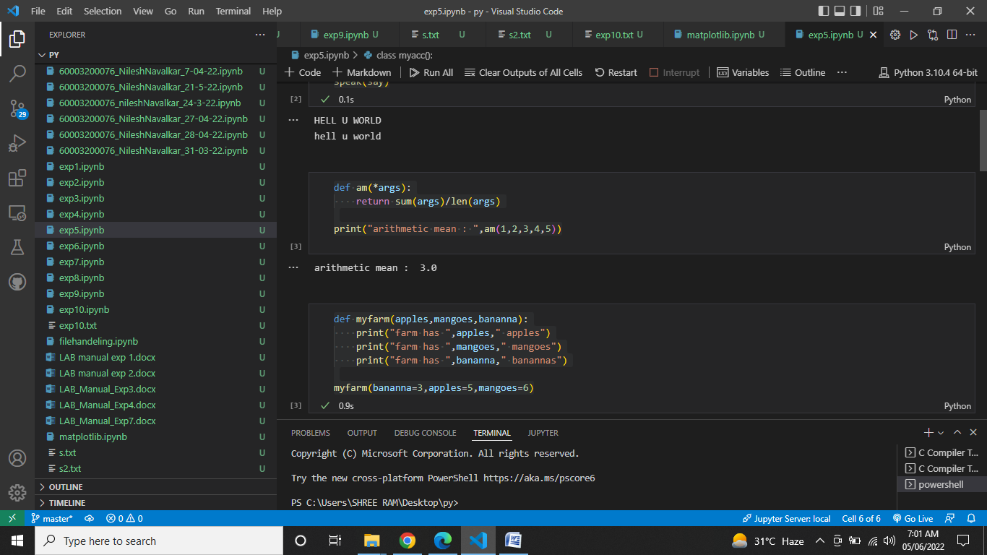

2)

def am(*args):

    return sum(args)/len(args)

print("arithmetic mean : ",am(1,2,3,4,5))



3)

def myfarm(apples,mangoes,bananna):

    print("farm has ",apples," apples")

    print("farm has ",mangoes," mangoes")

    print("farm has ",bananna," banannas")

myfarm(bananna=3,apples=5,mangoes=6)

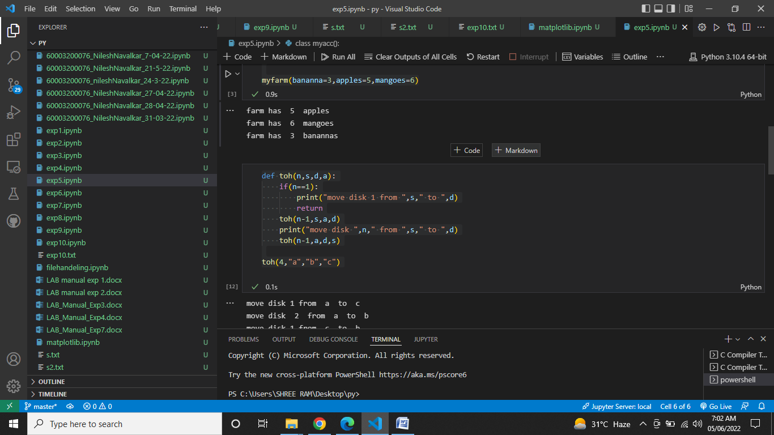

4)

def toh(n,s,d,a):

    if(n==1):

        print("move disk 1 from ",s," to ",d)

        return

    toh(n-1,s,a,d)

    print("move disk ",n," from ",s," to ",d)

    toh(n-1,a,d,s)

toh(4,"a","b","c")

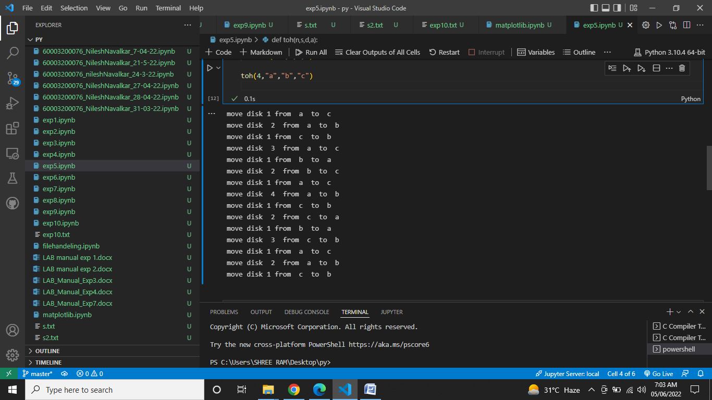

5)

a=lambda n1,n2 : n1 if n1>n2 else n2

print(a(2,3))

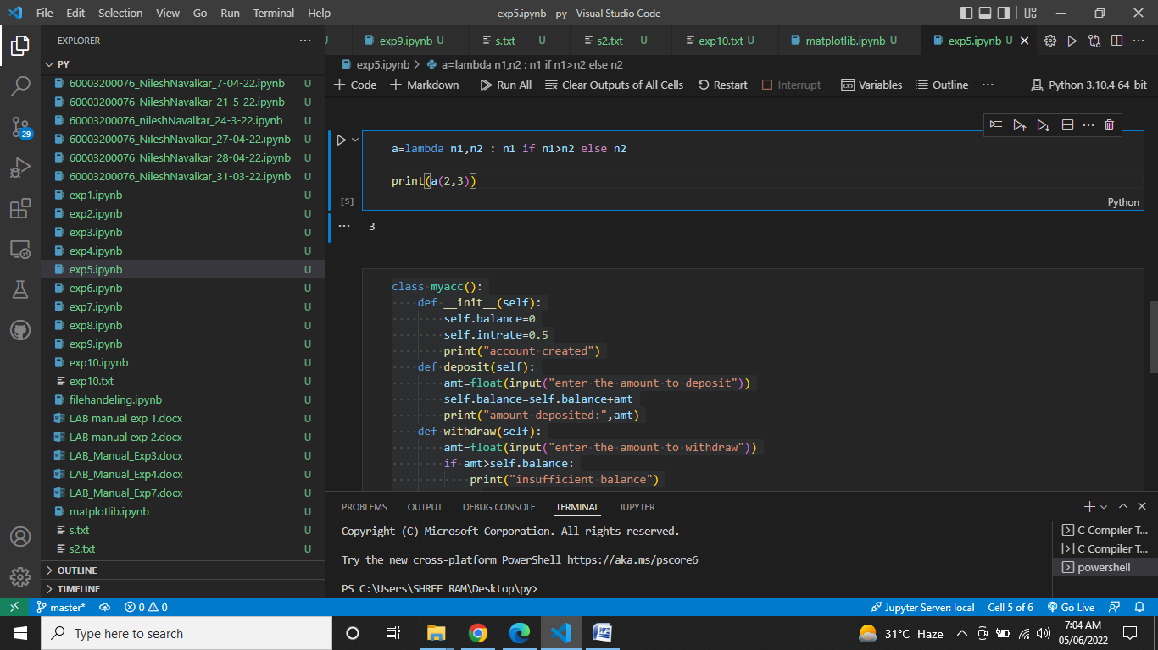

6)

class myacc():

    def __init__(self):

        self.balance=0

        self.intrate=0.5

        print("account created")

    def deposit(self):

        amt=float(input("enter the amount to deposit"))

        self.balance=self.balance+amt

        print("amount deposited:",amt)

    def withdraw(self):

        amt=float(input("enter the amount to withdraw"))

        if amt>self.balance:

            print("insufficient balance")

        else:

            self.balance=self.balance-amt

            print("amount withdrawn:",amt)

    def computeinterest(self):

        print("your interest is :",self.balance*self.intrate)

    def displaybal(self):

        print("current balance : ",self.balance)

a=myacc()

a.deposit()

a.withdraw()

a.computeinterest()

a.displaybal()

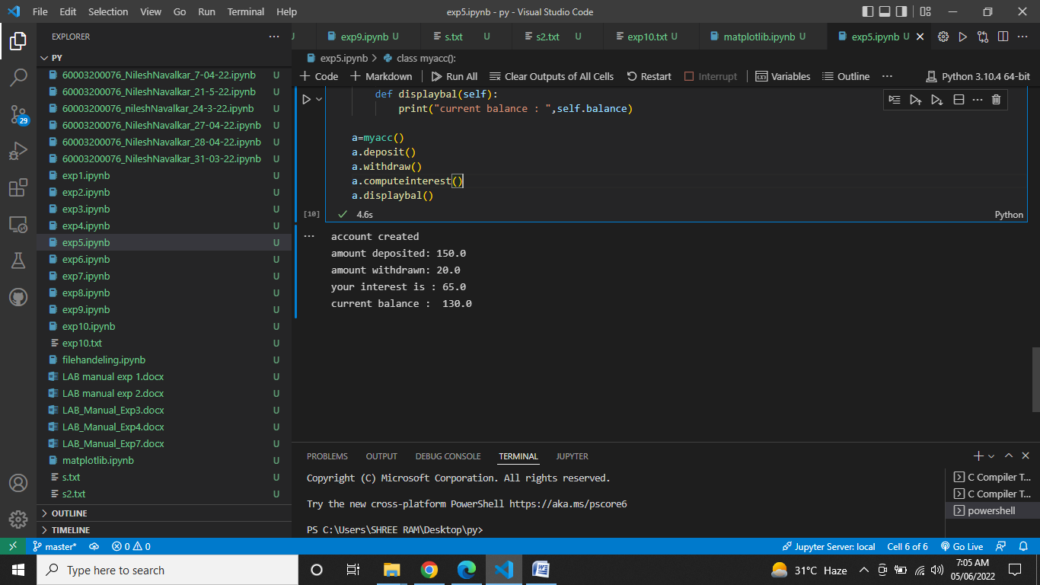

**OBSERVATIONS / DISCUSSION OF RESULT:**

1)

The program defines 1 function inside another function and pass a function as a parameter to another function. The function inside returns the function which was passed as an argument.

2)

The program prints average of arguments of variable length. The numpymean() method is used to calculate the mean. List can be passed as argument

3)

The program prints the key-value pairs passed as keyword arguments to a function. Dictionary cannot be passed as argument

4)

The program solves tower of Hanoi is a mathematical puzzle where we have three rods and n disks. The objective of the puzzle is to move the entire stack to another rod, obeying the following simple rules:

1. Only one disk can be moved at a time.
2. Each move consists of taking the upper disk from one of the stacks and placing it on top of another stack i.e. a disk can only be moved if it is the uppermost disk on a stack.
3. No disk may be placed on top of a smaller disk

Recurssion is used to solve this problem

5)

The program returns the largest of 2 numbers using lambda function which returns largest number using max()

6)

The program implements a banking application which has 5 methods. createAccount() creates account and assigns an account number. depost() adds amount to balance withdraw() deducts amount from balance, computeInterest() calculates simple interest, displayBalance() displays balance.

computeInterest() does not calculate compound interest and interest available on depositing,

**CONCLUSION:**

Thus we have successfully written python program to demonstrate

1. Functions and methods Defining, calling, returning from a function (single, multiple values)

2. Call/ pass by value,

3. call/ pass by reference

4. Types of actual arguments

5. Local and global variables

6. Recursive functions

7. Anonymous functions/ lambdas

**REFERENCES:**

**Website References:​**

[1] https://www.w3schools.com/python