

Academic Year 2021-22

SAP ID: 60003200076

# DEPARTMENT OF INFORMATION TECHNOLOGY

**COURSE CODE:** DJ19ITL406 **DATE**: 04-06-2022

**COURSE NAME:** Programing Laboratory 2 (Python) **CLASS:** SYBTECH

# EXPERIMENT NO. 8

**CO/LO: CO1, CO2,CO4. AIM / OBJECTIVE:**

Write a Python program to implement data analysis using pandas& matplotlib.

**DESCRIPTION OF EXPERIMENT:**

**Describe how to:**

1. Create data frame from excelsheet, csv format
   * Read excel files using read_excel() method in pandas.
   * Read csv files using read_csv() method in pandas.
2. Create data frame from objects (list, tuple dictionary) and from excel sheet, .csv files.
   * We can create dataframes from objects by using DataFrame() method
3. Data cleaning for missing data or incomplete data
   * Using the isnull() method, we can confirm that both the missing value and “NA” were recognized as missing values. Then we can use methods like fillna(),etc. to fill the missing values
4. Analyzing data by sorting, finding mean quartiles etc.
   * For sorting the data we use sort_values() method in pandas.
   * For finding quartiles we can use quantile() method in numpy.
5. Extracting best and last five records, sort records and data column wise
   * We sort records and data by sort_values() method.
   * For extracting last five best and worst records we can use head(5) and tail(5) methods.
6. Searching for a record by the id.
   * We can use where(df.id=’ ‘) method to search for a record by id in a dataframe.

**QUESTIONS:** (We have used Jupyter Notebook)

1. Load the students datasheet shared in a data frame and sort the data as per the marks
   * CODE:

import pandas as pd



Academic Year 2021-22

SAP ID: 60003200076

import xlrd

#creating dataframe from csv and excel file, and json object.

df1=pd.read_csv(r'\Users\aakas\Downloads\student (1).csv')

#sorting the data as per marks in df1 df1=df1.sort_values(by=['mark'],ascending=[False])

df1

* + OUTPUT:

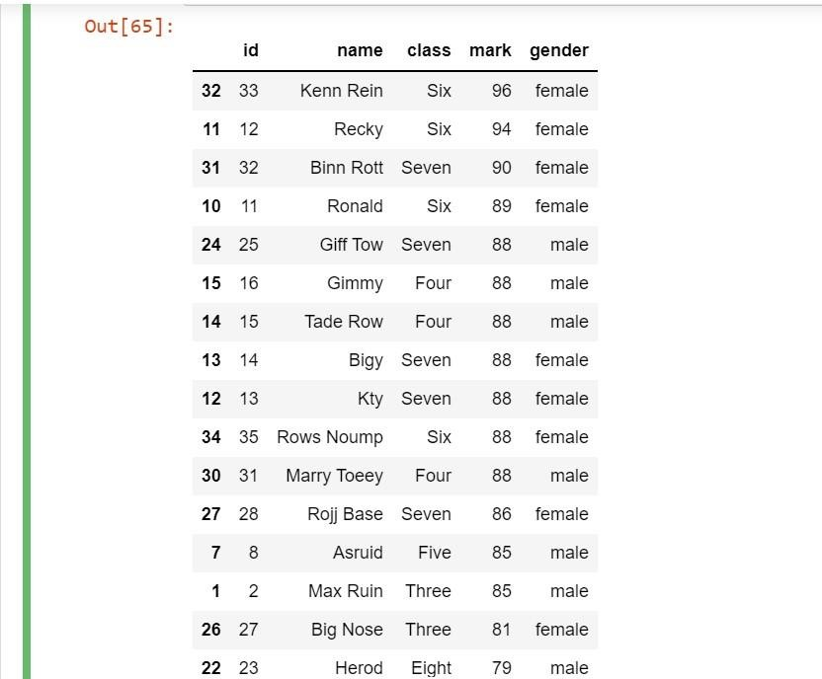

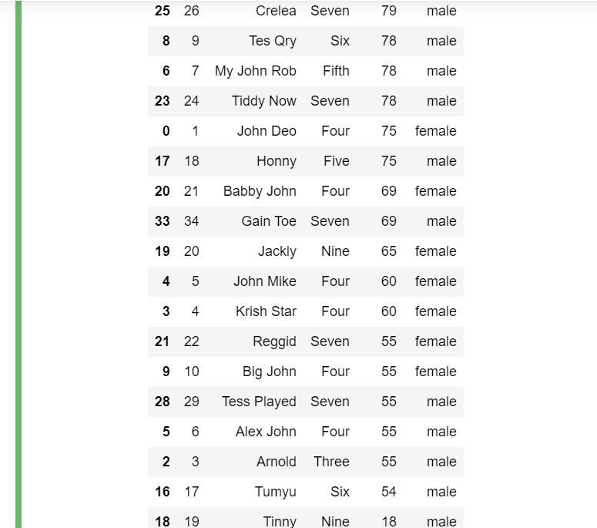

Academic Year 2021-22

SAP ID: 60003200076

1. Extract three best scoring and worse scoring students
   * CODE:

# 3 best scoring students df1[['name','mark']].head(3)

* + OUTPUT:

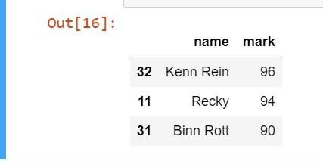

* + CODE:

# 3 worst scoring students

df1[['name','mark']].tail(3)

* + OUTPUT:

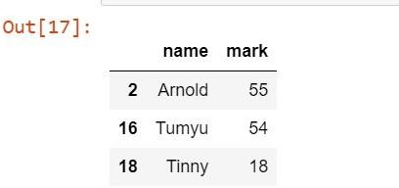

1. Display the number of students scoring 88 marks
   * CODE:

df1[['name','mark']][df1.mark==88]

* + OUTPUT:

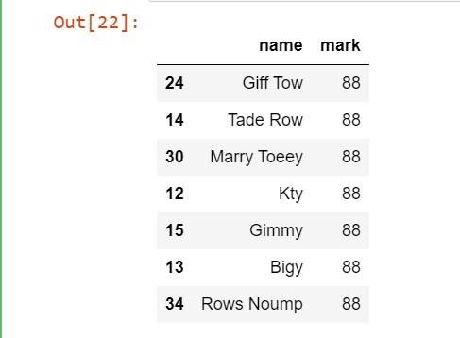

1. Sort the list in descending marks and people having same marks should be sorted in ascending order of names.
   * CODE:

df1.sort_values(by=['mark','name'],ascending=[False,True])

* + OUTPUT:

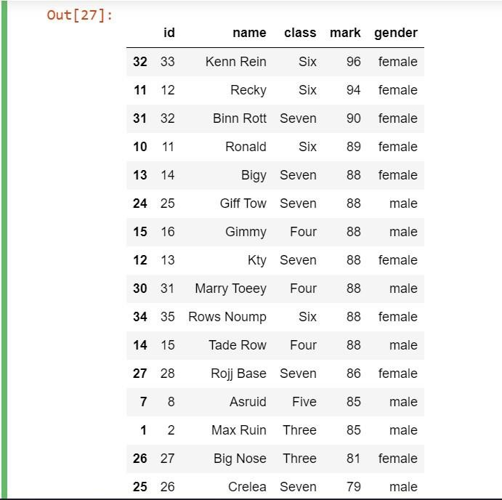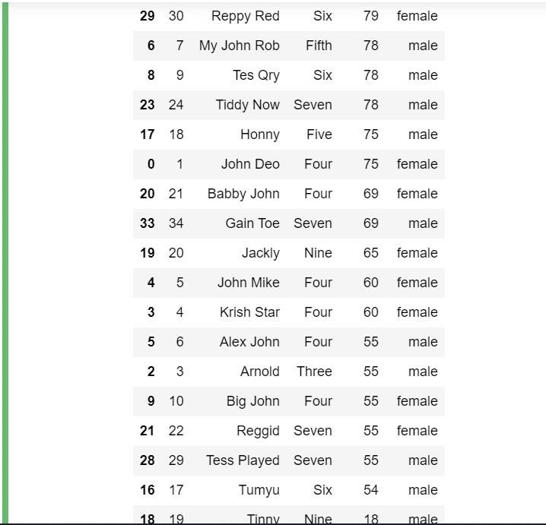

1. Generate a histogram of marks scored by students.[give different bin size]
   * CODE:

from matplotlib import pyplot as plt import numpy as np



Academic Year 2021-22

SAP ID: 60003200076

#plotting of histogram

x=plt.hist(df1.mark, bins=[0,10,20,30,40,50,60,70,80,90,100],facecolor='b')

plt.title('Histogram',color='r') plt.xlabel('Marks -->') plt.ylabel('No. Of Students -->')

plt.show()

* + OUTPUT:

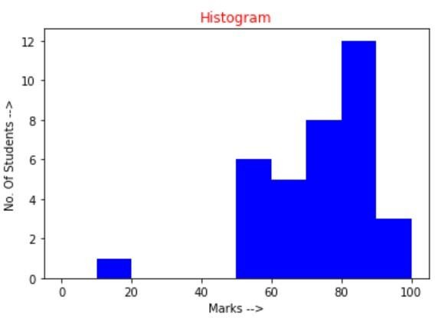

1. Generate a bar plot of student marks
   * CODE:

import pandas as pd import xlrd

import numpy as np

import matplotlib.pyplot as plt df1=pd.read_csv(r'\Users\aakas\Downloads\student (1).csv')

plt.bar(df1.name,df1.mark, facecolor='g') plt.tick_params(axis='x', labelrotation = 90) plt.title("Bar Plot",color='r')

plt.show()

* + OUTPUT:

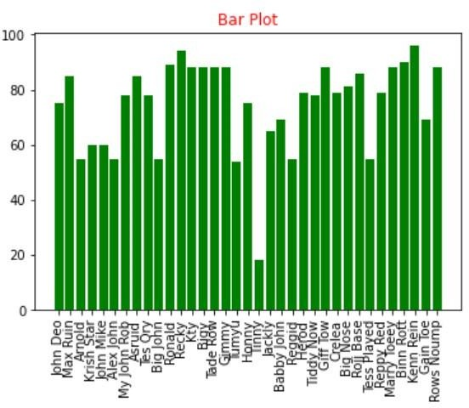

1. Generate a pie chart of marks distribution
   * CODE:

list1 = [0,0,0,0,0]

for i in df1.mark:

if i<50:

list1[0] = list1[0] + 1 if i>50 and i<=60:

list1[1] = list1[1] + 1 if i>60 and i<=70:

list1[2] = list1[2] + 1 if i>70 and i<=80:

list1[3] = list1[3] + 1 if i>80 and i<=100:

list1[4] = list1[4] + 1 print(list1)

labels = ['Fail','Third Class','Second Class','First Class','Distinction'] plt.pie(list1, labels=labels)

plt.title("Marks distribution",color='r')

plt.show()

* + OUTPUT:

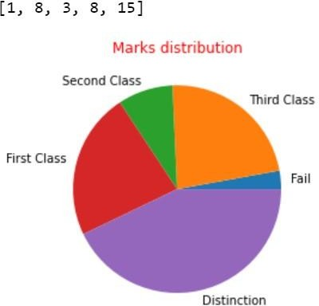

# OBSERVATIONS / DISCUSSION OF RESULT:

We saw above by using pandas and matplotlib in python, we were able to create dataframes and perform operations on them, and also plot the values to the graphs.

The results showed that we were able to retrieve different types of data easily and plot them to graphs. Just by importing pandas and matplotlib, our work to analyze the data and visualize them became easier.

Thus this experiment demonstrated the implementation of pandas and matplotlib and various ways to achieve desired results.

# CONCLUSION:

Thus by using pandas, we can work with relational or labeled data both easily and intuitively. It provide various data structures and operations for manipulating numerical data and time series.

By using matplotlib we can visualize the data. It allows us visual access to huge amounts of data in easily digestible visuals. It comes with a variety of plots like line, bar, scatter, histogram, etc. which helps us to understand trends, patterns and make co-relations.

# REFERENCES:

**Website References:**

1. <https://www.w3schools.com/python>
2. <https://www.geeksforgeeks.org/python-introduction-matplotlib/>
3. [https://www.geeksforgeeks.org/introduction-to-pandas-in-](https://www.geeksforgeeks.org/introduction-to-pandas-in-python/#%3A~%3Atext%3DPandas%20is%20an%20open%2Dsource%2Ctop%20of%20the%20NumPy%20library) [python/#:~:text=Pandas%20is%20an%20open%2Dsource,top%20of%20the%20NumPy%20libr](https://www.geeksforgeeks.org/introduction-to-pandas-in-python/#%3A~%3Atext%3DPandas%20is%20an%20open%2Dsource%2Ctop%20of%20the%20NumPy%20library) [ary.](https://www.geeksforgeeks.org/introduction-to-pandas-in-python/#%3A~%3Atext%3DPandas%20is%20an%20open%2Dsource%2Ctop%20of%20the%20NumPy%20library)