SHOPNEST STORE

# **TOP CATEGORIES BY TOTAL PRICE**

**Question Statement:**

Identify and visually represent the top 10 product categories by total sales

**Visualization:**

**Explanation:**

The bar chart highlights the top 10 product categories by total sales, offering valuable insights into revenue generation. Leading the chart, Health Beauty (Beleza Saude) achieves $1.26 million in sales, followed by Watches Gifts (relogios_presentes) with $1.21 million, and Bed Bath Table (cama_mesa_banho) with $1.04 million. Sports Leisure (esporte_lazer) and Furniture Décor (informatica_acessorios) also show strong performance, each exceeding $0.9 million in sales. Additionally, Garden Tools (Ferramentas_jardim) and Auto (Automotivo) report sales of $0.49 million and $0.59 million, respectively. These findings emphasize the importance of these top-selling categories, providing strategic insights for optimizing product offerings, marketing efforts, and customer engagement to drive business growth and profitability.

# **DELAYED ORDERS ANALYSIS**

**Question** **Statement :**

Determine the number of delayed orders in each category. An order is considered delayed if the actual delivery date is later than the estimated delivery date.

**Visualization:**

**Explanation:**

The bar chart analysis reveals significant insights into sales performance and fulfilment efficiency across various product categories, highlighting key areas for improvement. "Bed bath table" stands out with the highest number of delayed orders at 811, indicating logistical challenges. "Health beauty" and "Sports leisure" also show high delays with 775 and 584 orders respectively, emphasizing the need for better coordination and streamlined processes. Other categories such as "Furniture decor" (535 delays), "Computers accessories" (503 delays), and "Watches gifts" (468 delays) also face substantial delays, suggesting systemic issues. Conversely, "Diapers and hygiene" and "Flowers" have only 1 delayed order each, showcasing their efficient handling and delivery. This visualization helps stakeholders identify delay patterns and root causes, guiding resource allocation and corrective actions. For example, "Home appliances" (50 delays) and "Electronics" (247 delays) might benefit from improved inventory forecasting and replenishment strategies. Overall, the visualization is a valuable tool for driving continuous improvement and maintaining a customer-centric approach in the competitive e-commerce landscape.

# **MONTHLY COMPARISON OF DELAYED AND ON-TIME ORDERS**

**Question Statement:**

Create a dynamic visual that compares the number of delayed orders to the number of orders received earlier for each month. Utilize the Drill-through cross-report feature to provide a detailed analysis of late and on-time deliveries.

**Visualization:**

**Explanation:**

The line chart reveals key insights into order fulfilment performance throughout the year, highlighting significant differences between delayed and earlier orders each month. August stands out with the highest efficiency, showing 11,620 earlier orders and only 996 delayed orders. In contrast, July has the smallest difference, with 9,078 earlier orders and 216 delayed orders. The remaining months follow a similar trend: September has 3,790 earlier and 231 delayed orders, October has 4,480 earlier and 222 delayed orders, and November has 4,483 earlier and 245 delayed orders, indicating a consistent strong performance in prompt order fulfilment. However, December and January experience increased delays, with 767 and 667 delayed orders respectively, likely due to holiday demand. Meanwhile, May and June show fewer delays, with 696 and 691 delayed orders respectively, reflecting effective logistics management. These insights can help the organization address operational bottlenecks, optimize resources, and implement strategies to reduce delays, enhancing customer satisfaction and loyalty.

# **PAYMENT METHOD ANALYSIS**

**Question Statement:**

Analyze the most frequently used payment methods by customers using a visually appealing representation, such as a pie chart or other suitable visuals.

**Visualization:**

**Explanation:**

The pie chart highlights the distribution of payment types among customers, revealing that credit cards are the predominant payment method, used by 76,795 customers or approximately 73.9% of the customer base. Boleto is the second most popular option, with 19,784 customers (19.0%), followed by vouchers and debit cards, used by 5,775 (5.6%) and 1,529 customers (1.5%), respectively. This data underscores the importance of offering various payment methods to cater to different customer preferences and needs. While credit card payments dominate, the presence of other payment options like boleto, voucher, and debit card is crucial for accommodating diverse customer demographics. The chart also aids decision-makers in optimizing resource allocation, enhancing payment processing, and improving transaction efficiency to meet customer demands.

# **PRODUCT RATING ANALYSIS**

**Question Statement:**

Determine the top 10 highest-rated products and the bottom 10 lowest-rated products using a bar or column chart.

**Visualization:**

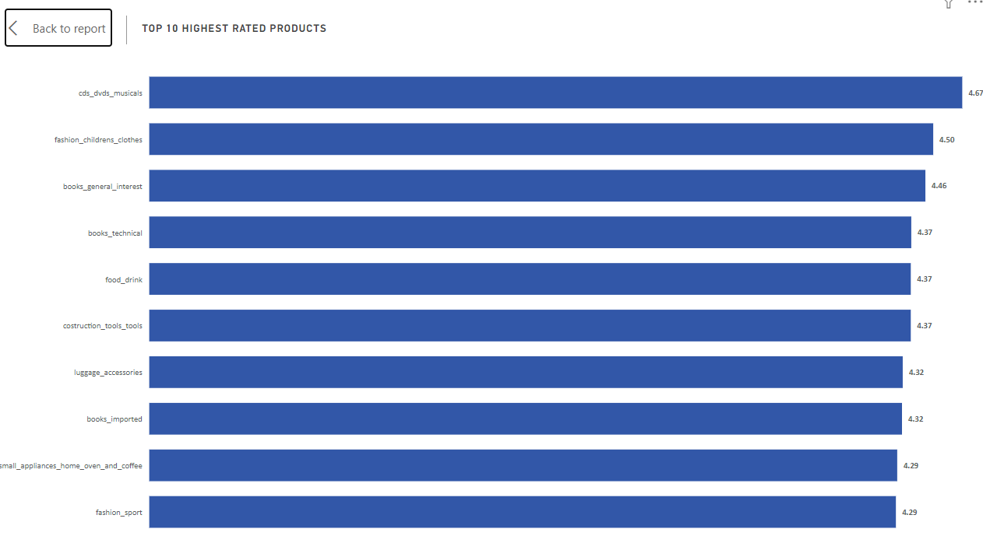

**Explanation:**

The bar chart presents a succinct overview of the top 10 highest-rated product categories based on average customer ratings, offering valuable insights into customer satisfaction and preferences. Topping the list is "CDs, DVDs, and musicals," boasting an impressive average rating of 4.67, indicating exceptional customer satisfaction within this category. Following closely, "Fashion children's clothes" and "Books general interest" secure the second and third positions with average ratings of 4.50 and 4.46 respectively, highlighting the high quality and appeal of these products among customers. Additionally, "Books technical," "Food drink," and "Construction tools tools" share similar average ratings of 4.37, underscoring consistent customer satisfaction across diverse product categories. Notably, "Small appliances home oven and coffee" and "Fashion sport" also garner commendable average ratings of 4.29, suggesting strong positive feedback from customers within these segments. The visualization underscores the importance of product quality and customer experience in driving overall satisfaction and loyalty.

Moreover, the bar chart offers insights into specific product categories that consistently receive high ratings from customers, providing valuable guidance for strategic decision-making and product development initiatives. The presence of "Books imported" and "Luggage accessories" among the top 10 highest-rated products suggests a demand for premium and specialized offerings, while the popularity of "Fashion children's clothes" and "Fashion sport" underscores the significance of style and functionality in consumer preferences. Overall, the visualization serves as a valuable tool for businesses to gauge customer sentiment, refine product offerings, and prioritize investments to enhance overall customer satisfaction and drive sustained business growth.

# **STATE-WISE SALES ANALYSIS**

**Question Statement:**

Identify and visually represent states with high and low sales, providing a clear understanding of regional sales performance.

**Visualization:**

**Explanation:**

The map chart provides a comprehensive overview of sales performance across various states, highlighting notable variations in revenue generation. São Paulo (SP) emerges as the top-performing state, with sales exceeding $5.20 million, representing a substantial 38.3% of the total sales. Rio de Janeiro (RJ) follows closely, exhibiting considerable sales figures, with approximately $1.82 million in revenue, contributing significantly to the overall revenue at 13.4%.

Additionally, Minas Gerais (MG) and Rio Grande do Sul (RS) demonstrate noteworthy sales, with approximately $1.59 million and $0.75 million in revenue, respectively, comprising 11.7% and 5.5% of the total sales. Conversely, states such as Roraima (RR) and Amapá (AP) present lower sales figures falling within the lowest sales bucket. Roraima records sales of $0.007 million, while Amapá registers sales of $0.013 million, with each contributing less than 0.1% to the total revenue.

The map chart's gradient representation showcases states with high, medium, and low sales values, providing clear insights into regional sales trends. It underscores the dominance of key states like São Paulo and Rio de Janeiro in driving overall sales performance, while also highlighting opportunities for growth and expansion in regions with lower sales figures.

Furthermore, the visualization emphasizes the importance of strategic planning and resource allocation to maximize sales potential across different regions. While São Paulo and Rio de Janeiro command significant market shares, states such as Roraima and Amapá present untapped opportunities for growth. This analysis enables decision-makers to gain valuable insights into regional sales trends, guiding strategic planning and operational decisions to optimize sales performance and foster sustainable business growth across diverse geographic regions.

# **SEASONAL SALES PATTERN**

**Question Statement:**

Investigate and visualize any seasonal patterns (Quarterly) or trends in sales data over the course of the year.

**Visualization :**

**Explanation :**

The combo chart provides a comprehensive overview of quarterly sales data across different years, offering valuable insights into sales performance over time.

The bar charts represent year-wise quarter-wise sales, showcasing distinct trends for each quarter. Notably, there is a clear upward trend in sales across all quarters, with significant fluctuations observed between different years. For instance, in the first quarter, sales surged from $0.71 Million in 2017 to $2.7 Million in 2018, indicating substantial growth year over year. Similarly, sales in the second quarter increased from $1.25 Million in 2017 to $2.81 Million in 2018, reflecting continued expansion and market demand. The line chart complements this analysis by illustrating the total sales for each quarter, providing a holistic view of overall sales performance over time.

Furthermore, the combo chart highlights the seasonality of sales, with distinct patterns observed across different quarters. The sum of sales are observed to be highest in the second quarter over the years, with a value of $4.1 Million, followed by Q1 at $3.4 Million and Q3 at $3.3 Million . This seasonal variation underscores the importance of strategic planning and resource allocation to capitalize on peak periods of consumer spending while ensuring consistent performance throughout the year. Overall, the combo chart offers valuable insights into sales trends and seasonality, empowering businesses to make informed decisions and optimize sales strategies to drive sustainable growth.

# **REVENUE ANALYSIS**

**Question Statement :**

Determine the total revenue generated by ShopNest Store  and analyze how it changes over time(Yearly). Represent this information through suitable visuals to highlight trends and patterns.

**Visualization :**

**Explanation :**

The tree chart provides a visual representation of revenue trends across different years, offering insightful observations into revenue performance over time.

Notably, there is a significant increase in revenue from 2016 to 2017, with revenue soaring from $47k in 2016 to $6.92 Million in 2017, showcasing a substantial growth trajectory. This remarkable rise underscores positive market dynamics and the effectiveness of business strategies implemented during that period. Furthermore, the chart reveals a continued upward trend in revenue, with a notable spike to $8.45 Million in 2018, indicating sustained growth and continued success in revenue generation. This significant increase in revenue from 2017 to 2018 highlights the organization's ability to capitalize on opportunities and adapt to changing market conditions, ultimately driving robust financial performance.