**Experiment No:03**

**Aim:To include icons, images, fonts in Flutter app**

**Theory:**

Including icons, images, and custom fonts in a Flutter app allows developers to enhance the visual appeal and functionality of their applications. Here's a brief overview of how to include these assets:

1. **Icons:**
   1. Flutter provides built-in support for icons through the Icons class, which includes a wide range of Material Design icons.
   2. You can use the Icon widget to display icons in your app. Simply specify the desired icon using the Icons class, along with properties like size and color.
2. **Images:**
   1. To include images in a Flutter app, you can add image files to the assets directory within your project.
   2. Use the Image widget to display images. Specify the image asset path using the Image.asset() constructor.
3. **Fonts:**
   1. Custom fonts can be added to a Flutter app by including font files (e.g., .ttf or .otf) in the project's fonts directory.
   2. Declare the custom fonts in the pubspec.yaml file under the flutter section using the fonts property.
   3. Once declared, you can apply the custom font to text in your app using the fontFamily property in the TextStyle widget.

**Here's a summarized step-by-step guide:**

1. **Add Icons:**
   1. Use the Icon widget with the desired icon from the Icons class.
   2. Customize the icon size and color as needed.
2. **Add Images:**
   1. Place image files in the assets directory of your Flutter project.
   2. Use the Image.asset() widget to load images from the asset bundle.
   3. Specify the image asset path as a parameter to the Image.asset() constructor.
3. **Add Fonts:**
   1. Place custom font files in the fonts directory of your Flutter project.
   2. Declare the custom fonts in the pubspec.yaml file under the flutter section using the fonts property.
   3. Apply the custom font to text using the fontFamily property in the TextStyle widget.

**Code:**

import 'package:flutter/material.dart';

void main() {

runApp(MyApp());

}

class MyApp extends StatelessWidget {

@override

Widget build(BuildContext context) {

return MaterialApp(

title: 'Flutter Icons, Images, and Fonts Example',

theme: ThemeData(

primarySwatch: Colors.blue,

),

home: MyHomePage(),

);

}

}

class MyHomePage extends StatelessWidget {

@override

Widget build(BuildContext context) {

return Scaffold(

appBar: AppBar(

title: Text('Expt-3'),

),

body: Center(

child: Column(

mainAxisAlignment: MainAxisAlignment.center,

children: <Widget>[

Text(

'Flutter-Expt:3 Nilesh',

style:TextStyle(

fontSize: 40,

color: Colors.red,

),

),

Icon(

Icons.favorite,

size: 50,

color: Colors.red,

),

SizedBox(height: 20),

Image.asset(

'assets/comp.png',

width: 100,

height: 100,

),

SizedBox(height: 20),

Text(

'Custom Font Example',

style: TextStyle(

fontFamily: 'Roboto', // Custom font family

fontSize: 24,

fontWeight: FontWeight.bold,

),

),

],

),

),

);

}

}

**Pubsec.yaml:**

assets:

- assets/comp.png

fonts:

- family: Roboto

fonts:

- asset: fonts/Roboto-BoldCondensedItalic.ttf

**File Structure :**

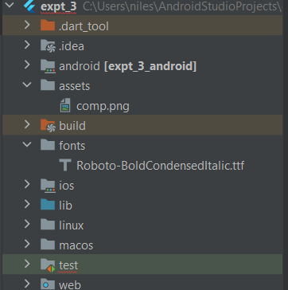

**Output:**

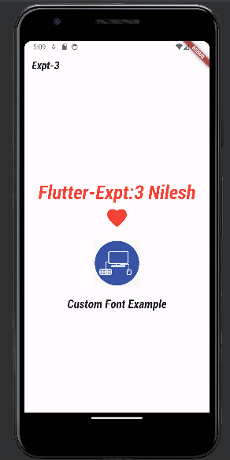

**Conclusion:**

I have successfully understood and implemented the images , fonts and Icons in a Flutter Application.