**Task – Alpha Technology**

Program to demonstrate java skills

1. Read list of 10 students from a text file and store it in an arrary

2. sort the array in ascending order and print the array

3. ask user to enter a student name and print ""present"" if name is in arrary

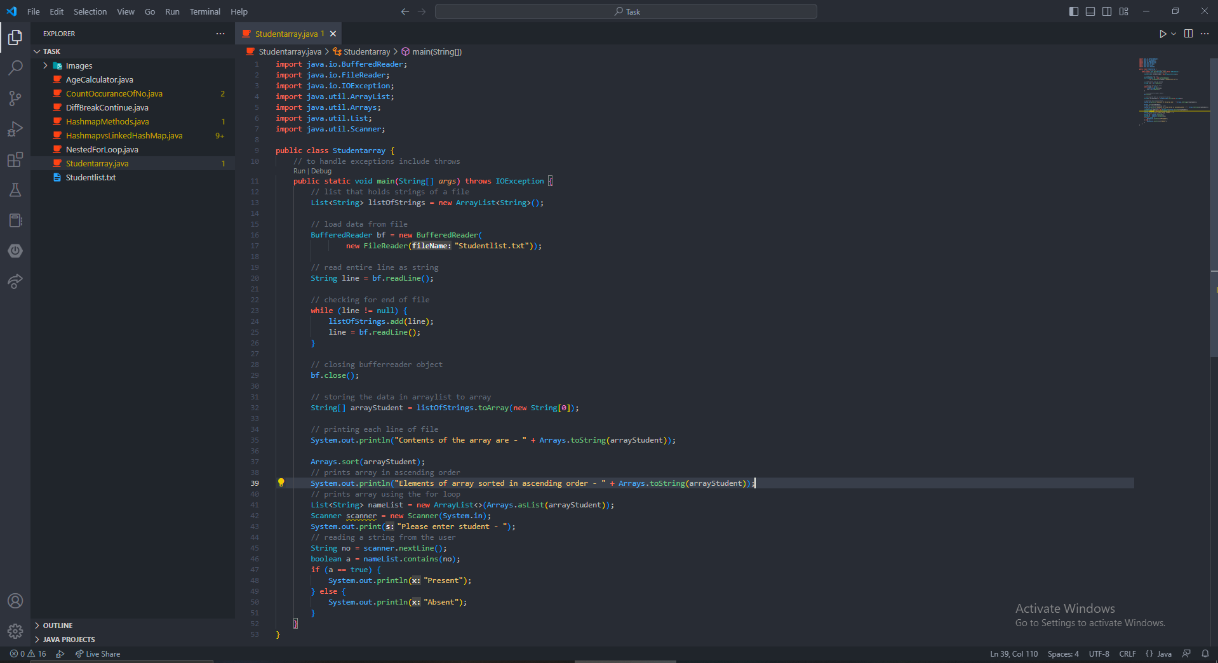

Output –

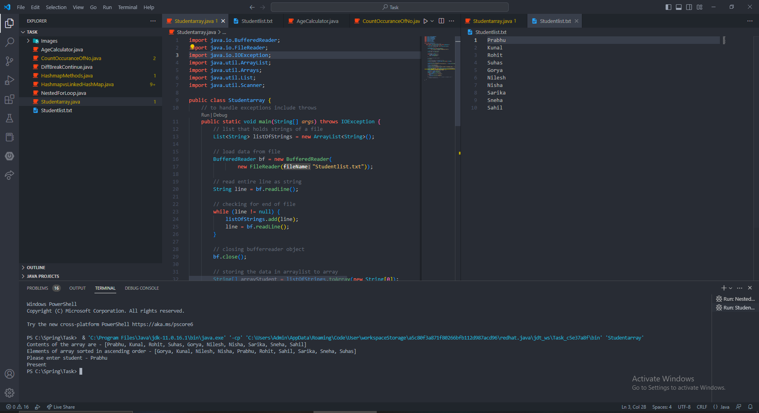

4. using while loop, ask user to enter numbers 0 to 9 again and again 20 times. '

Use hashmap to count how many times each number was entered by user.

print the hashmap.

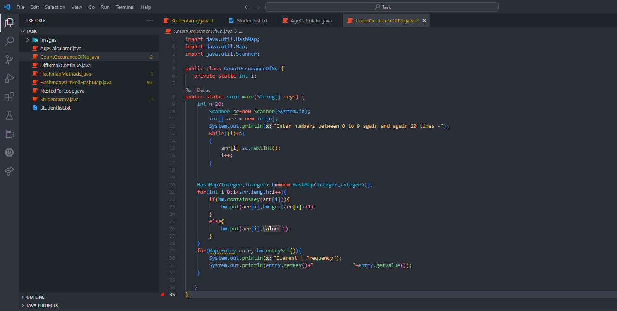

Output -

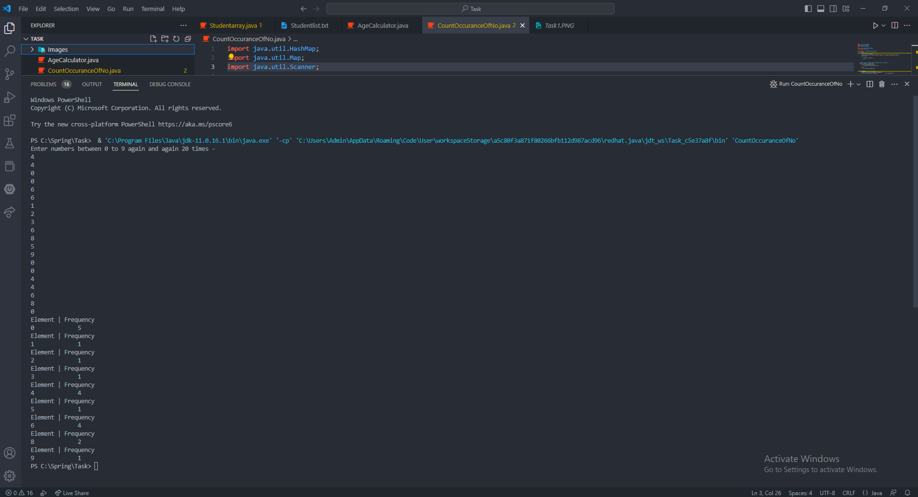

5. write a program to show the different between ""continue"" and ""break""

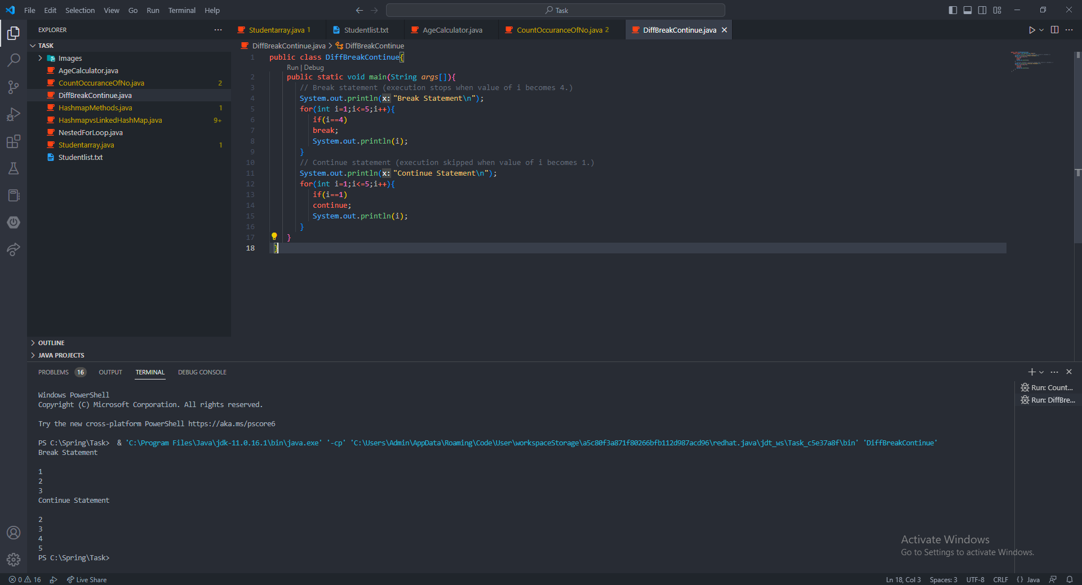

6. write a program to show user of nested for loop.

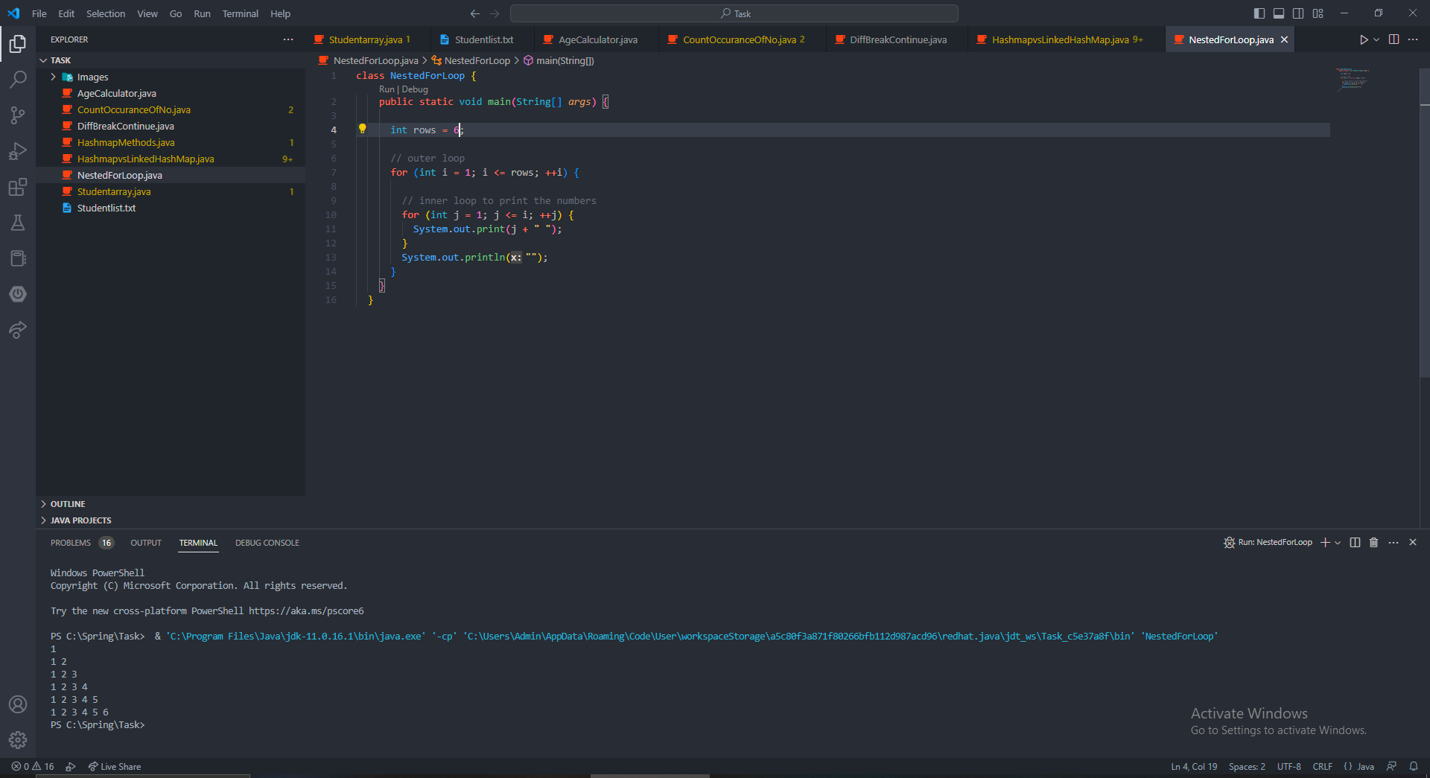

7. write a program to add, edit, remove, get data from hashmap

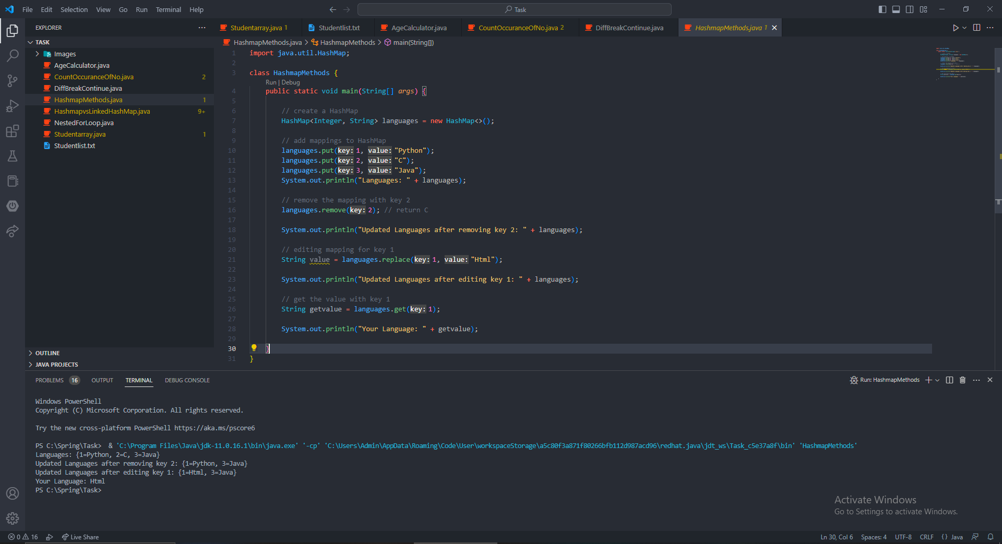

8. write a program to show difference between hashmap and linked hashmap

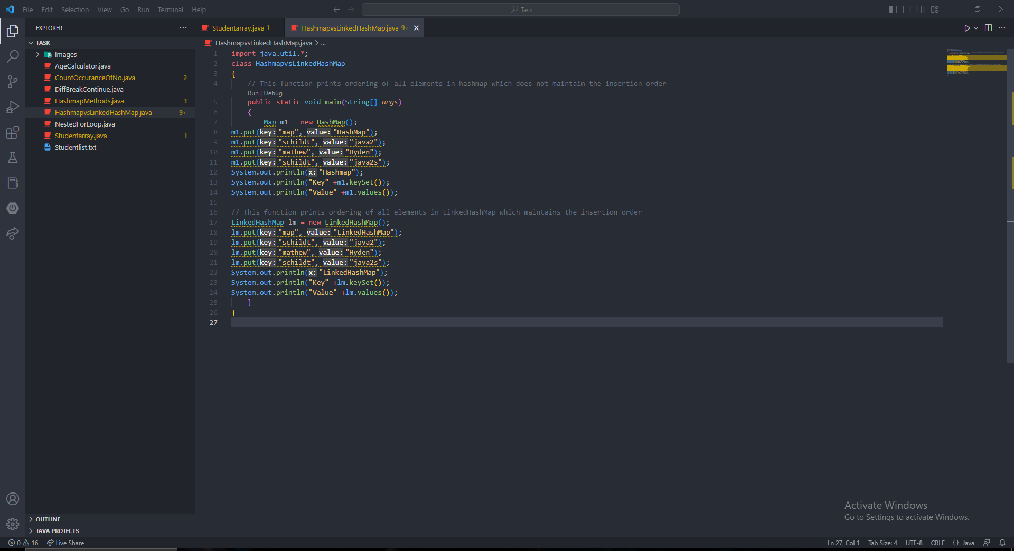

9. write a program print age of user after getting date of birth from them

