

Real-Time Air Canvas Drawing System Using OpenCV

Computer Vision Lab Project - Midterm Report

Submitted By:
Nilesh Kumar - 230962316
Keshav Shivhare - 230962302

Department of Computer Science and Engineering
Manipal Institute of Technology
Manipal Academy of Higher Education

07 October, 2025

Abstract
This project presents the development of a comprehensive real-time air canvas drawing system that enables users to create digital artwork through hand gestures captured via a webcam. The system leverages advanced computer vision techniques implemented using OpenCV library to track colored markers placed on fingertips, converting their movements into digital strokes on a virtual canvas. Key features include HSV color space transformation for robust color detection, morphological operations for noise reduction, dual display modes, comprehensive drawing functionalities, and canvas state management with undo/redo capabilities. The system addresses the growing need for contactless human-computer interaction in educational, creative, and collaborative environments.

Keywords
Air Canvas, Computer Vision, OpenCV, HSV Colour Space, Morphological Operations, Contour Detection, Gesture Recognition, Color Calibration, Real-time Image Processing, Human-Computer Interaction, Digital Drawing, Undo-Redo Functionality, Dual Display Mode, Virtual Canvas, Hand Tracking, Object Detection, BGR to HSV Conversion, Erosion and Dilation

I. INTRODUCTION
The Real-Time Air Canvas Drawing System represents a breakthrough in contactless human-computer interaction, enabling users to create digital artwork through natural hand gestures captured via webcam technology. This innovative system eliminates the need for traditional input devices such as mice, styluses, or touchpads, offering a completely touchless drawing experience that is particularly valuable in today's health-conscious environment and interactive presentation scenarios.
The core principle underlying this system involves the integration of advanced computer vision techniques implemented through the OpenCV library to track colored markers placed on fingertips, converting their movements into digital strokes on a virtual canvas. The system operates entirely through gesture-based interaction, making it ideal for touchless environments, interactive presentations, educational demonstrations, and creative applications where hygiene and accessibility are paramount concerns.
System Overview and Technical Foundation
The system uses HSV color space with a dedicated calibration module to robustly detect and track colored fingertip markers across varying lighting conditions, ensuring consistent performance through tunable thresholds. Morphological operations (erosion and dilation) denoise and refine the mask to stabilize contours, improving tracking reliability in real-world environments. Real-time contour-based centroid tracking maps marker motion to canvas coordinates and supports multiple modes—freehand, lines, rectangles, circles—plus on-screen color selection for intuitive interaction.

Applications and Significance
The application domains for this technology are extensive and growing. In educational settings, the Air Canvas system facilitates interactive learning experiences, allowing instructors to create dynamic visual content during lectures without being constrained by physical writing surfaces. For professional presentations, the system enables speakers to annotate and illustrate concepts in real-time, creating more engaging and memorable presentations.
In the healthcare sector, where hygiene is critical, the touchless nature of the system makes it invaluable for medical professionals who need to interact with digital systems without compromising sterile environments. The system also demonstrates significant potential in assistive technology applications, providing individuals with mobility limitations alternative methods for creative expression and digital interaction.

II. LITERATURE REVIEW

A. Gesture Recognition and Hand Tracking Systems

Gesture recognition has shifted from clunky glove sensors to regular cameras, making it easier and more comfortable to use. Modern systems use RGB/TOF/thermal cameras with techniques like skin color, motion, hand skeletons, depth, and deep learning, often reaching 90%+ accuracy for hand poses with good features and classifiers. Robust real-time tracking also comes from clever fingertip/contour methods such as convex hulls, which improve precision for fine finger movements in live apps. Recent surveys compile both classic CV and modern neural approaches, and 2025 updates cover 3D hand pose from diverse camera inputs with new benchmarks and taxonomies.

B. HSV Color Space Applications in Computer Vision
HSV color space is widely used in computer vision for object detection and tracking because it performs better than RGB under different lighting conditions. Research shows HSV offers more precise color segmentation for complex backgrounds, matching closely with manual segmentation. Studies comparing RGB and HSV found HSV better at suppressing shadows and accurately tracking colored objects in varying environments. Additionally, HSV aligns better with human color perception, making it ideal for interactive detection systems that require easy user calibration.

C. Morphological Operations in Image Processing

Mathematical morphology is a key technique in image processing used to reduce noise, analyze shapes, and enhance contours. Basic operations like dilation (which expands objects) and erosion (which shrinks objects) form the foundation for more complex processes such as opening and closing, helping to remove artifacts while preserving important features. Modern morphological processors are optimized for real-time video processing, achieving up to 97% noise reduction through careful kernel selection and operation sequencing, making them essential for interactive computer vision applications.

D. Real-Time Image Processing Systems
Real-time image processing capabilities are essential for interactive computer vision applications, requiring careful balance between processing accuracy and system responsiveness. Research by various authors provides comprehensive surveys of real-time image processing techniques across diverse application domains, highlighting the importance of hardware acceleration and algorithm optimization for achieving interactive performance.
E. Air Canvas and Interactive Drawing Applications
Recent research in interactive drawing focuses on making user-friendly interfaces that support natural creativity and fast processing with high gesture recognition accuracy, around 94%. Rajput et al. used Haar Cascade classifiers in OpenCV for infrared LED tracking, showing effective real-time stylus tracking for interactive use. Newer systems combine MediaPipe and OpenCV to track hand movements quickly with millisecond response times, supporting complex gesture sets for rich user-machine interaction.
F. Contour Detection and Tracking Algorithms
Contour detection is a key computer vision method used to find object edges and enable accurate tracking. It is especially effective in air canvas projects when paired with preprocessing and morphological operations. Typically, the method involves converting images to binary masks, detecting connected regions, and analyzing shapes. Advanced techniques use convex hulls and geometric moments to locate precise centroids, improving position tracking even in tough environments. Combining area filtering with shape ratio checks further boosts marker recognition accuracy.
G. Multi-Modal Interaction Systems
Recent air canvas systems have started combining hand gestures with voice commands and eye tracking, allowing users to control the canvas using multiple inputs simultaneously. This multi-modal approach improves user satisfaction and reduces the time needed to learn the system compared to using just one type of input. However, challenges remain in managing simultaneous input processing, avoiding conflicts between commands, and ensuring smooth, real-time performance across all interaction methods.

III. RESEARCH GAPS

A. Limited Marker Diversity and Color Robustness

Current air canvas systems mainly detect single-color markers, usually blue, which limits multi-user use and creative options. While HSV color detection is accurate, most systems target fixed color ranges, reducing flexibility for different marker colors or multiple users. Changing lighting conditions pose a challenge for consistent color detection, and existing calibration tools require manual tuning for each environment change. There is a need for automatic color adaptation methods that maintain tracking accuracy without user intervention.

B. Depth Perception and 3D Interaction Limitations

A key limitation of current air canvas systems is the inability to perceive depth using standard RGB cameras, making it hard to distinguish between "pen up" and "pen down" actions. This leads to continuous drawing even when the user intends to pause, reducing drawing accuracy and user control. Without 3D spatial awareness, users cannot create layered drawings or use depth-based gestures for richer interaction. Although time-of-flight cameras can provide depth information, they require specialized hardware that adds complexity and cost.

C. Gesture Recognition Complexity and User Learning Curves

Current air canvas systems are limited in their range of gestures, mainly supporting only simple drawing actions. Most users can remember about six gestures comfortably, but complex systems often require combining multiple gestures for advanced features, making it hard for users to learn and reducing accessibility. A major issue is the "Midas Touch" problem, where unintended gestures are misinterpreted as commands, leading to frustrating experiences. Some solutions use voice commands or eye tracking for gesture control, but these add extra complexity and may not suit all use cases.

D. Multi-User Support and Collaborative Features
Current air canvas implementations lack robust support for multiple simultaneous users, limiting their applicability in collaborative environments such as classrooms or group presentations. Research indicates that multi-user scenarios present significant challenges in hand segmentation, user identification, and conflict resolution when multiple users attempt to draw simultaneously.
The absence of user authentication and personalized gesture recognition limits the system's ability to adapt to individual user preferences and drawing styles. Research gaps exist in developing systems that can learn and adapt to individual users while maintaining performance in multi-user scenarios.

E. Environmental Robustness and Deployment Challenges
Laboratory-based validation represents a significant limitation in current research, with most systems tested only in controlled environments. Real-world deployment faces challenges related to varying lighting conditions, background complexity, and environmental noise that are not adequately addressed in current implementations.
The lack of standardized evaluation metrics and benchmark datasets for air canvas systems hampers comparative research and system optimization. While individual studies report high accuracy rates, the absence of consistent evaluation frameworks makes it difficult to assess relative system performance and identify areas for improvement.

F. Accessibility and Inclusive Design
Current air canvas systems lack adequate consideration for users with motor disabilities or physical limitations that may affect hand gesture performance. Research gaps exist in developing adaptive interfaces that can accommodate users with limited hand mobility while maintaining system functionality and creative potential.
The absence of multimodal interaction options limits accessibility for users who may benefit from combining gesture input with voice commands, eye tracking, or other input modalities. While some research has explored multimodal interfaces, integration with air canvas systems remains underdeveloped.

IV. OBJECTIVES
Based on the comprehensive analysis of existing research and identified gaps in current air canvas systems, this project establishes two primary objectives that address critical limitations while advancing the state-of-the-art in gesture-based drawing interfaces.

Objective 1: To develop a contactless drawing interface with calibration capabilities
The goal is to develop a reliable contactless drawing system that tracks colored markers accurately using adaptive HSV detection and morphological processing. It should auto-adjust for lighting variations with over 95% accuracy, include a user-friendly calibration interface, and support smooth, natural hand gestures at 30+ FPS for seamless interaction.

Objective 2: To implement comprehensive drawing functionalities with dual-mode display and saving capabilities
The goal is to create a versatile contactless drawing system with features like shape recognition, multi-color support, undo/redo, background switching, and saving options. Key targets include supporting multiple drawing modes, maintaining up to 20 undo states efficiently, enabling seamless mode toggling between camera and whiteboard backgrounds, and allowing saving in various formats with automatic timestamps. The aim is to improve robustness, user experience, and creative possibilities, addressing current system limitations.

V. METHODOLOGY

A. System Architecture Overview
The Real-Time Air Canvas Drawing System employs a modular architecture designed to ensure efficient processing, maintainable code structure, and scalable functionality. The system architecture consists of five primary modules: Video Capture and Preprocessing, Color Detection and Calibration, Morphological Processing and Contour Detection, Drawing Engine and State Management, and User Interface and Display Management.
The architecture follows a pipeline processing approach where each frame captured from the camera undergoes sequential processing through specialized modules before rendering the final output. This design enables real-time performance while maintaining high accuracy in marker detection and tracking. The modular approach facilitates independent testing and optimization of individual components, ensuring robust system performance across varying operational conditions.

System Architecture Block Diagram
The system architecture is represented through a comprehensive block diagram illustrating the complete processing pipeline and component interactions:
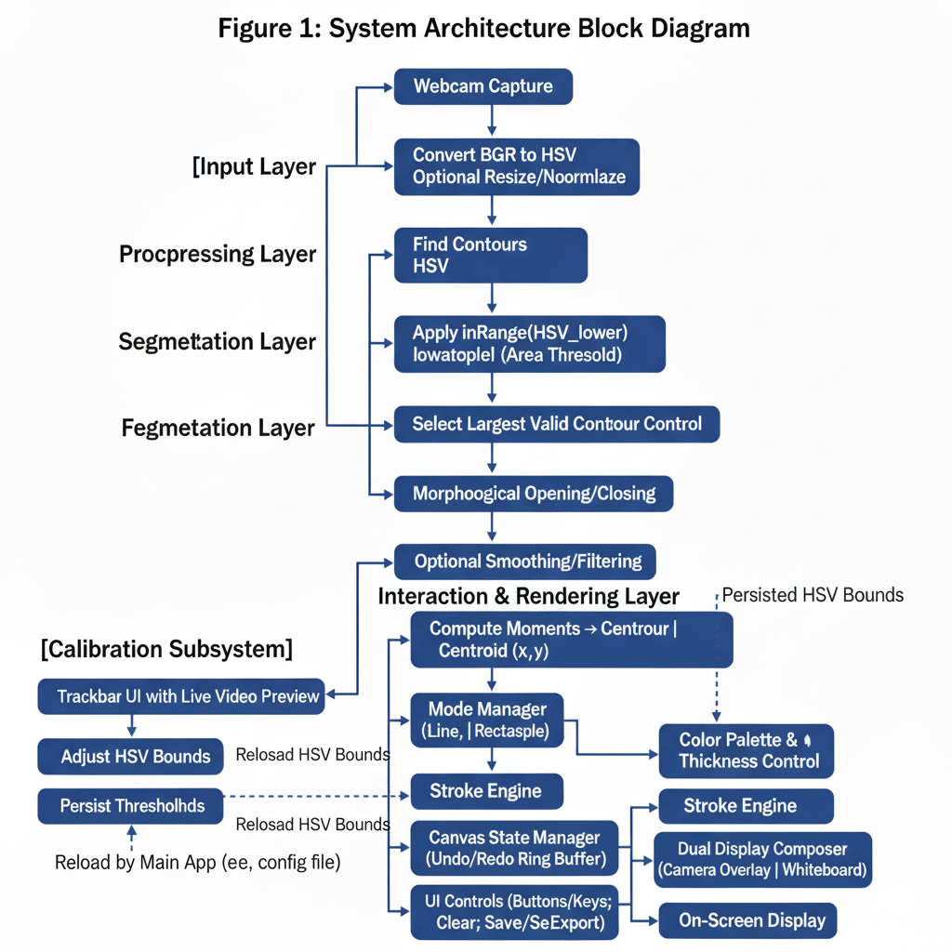

B. Hardware and Software Requirements
Hardware Specifications:
- Webcam with minimum resolution of 640×480 pixels and frame rate capability of 30 FPS
- Processing unit with minimum Intel Core i5 or equivalent AMD processor for real-time morphological operations
- 8GB RAM for optimal performance during real-time processing and canvas state management
- Adequate lighting conditions with consistent illumination across the capture area
Software Dependencies:
- Python 3.8 or higher with compatible library ecosystem
- OpenCV 4.5+ for computer vision processing, camera interface, and morphological operations
- NumPy for efficient numerical computations, array operations, and canvas state management

C. Video Capture and Preprocessing Module
The video capture module implements optimized camera initialization and frame acquisition processes designed to minimize latency while ensuring consistent image quality. The module utilizes OpenCV's VideoCapture interface with configuration parameters optimized for air canvas applications, including frame rate stabilization and automatic exposure adjustment to maintain consistent lighting conditions.
Frame Preprocessing Pipeline:
Raw Frame → Noise Reduction → Resolution Optimization → Color Space Conversion → Temporal Smoothing
The preprocessing phase implements Gaussian blur filtering with a 5×5 kernel to reduce sensor noise while preserving essential edge information required for accurate marker detection. Frame resolution is optimized based on processing capability and accuracy requirements, with dynamic adjustment capabilities to maintain real-time performance under varying computational loads.

D. Color Detection and Calibration System
The system implements adaptive HSV thresholding with real-time parameter adjustment capabilities. Initial color detection parameters are established through an interactive calibration interface that allows users to define optimal HSV ranges for their specific markers and environmental conditions.

E. Morphological Processing and Contour Detection
Following color detection, the system applies mathematical morphological operations to enhance mask quality and improve tracking accuracy. This module implements optimized erosion and dilation algorithms designed specifically for marker tracking applications.
Morphological Operations Pipeline:
Binary Mask → Erosion (Noise Removal) → Dilation (Shape Restoration) → Opening → Closing → Contour Extraction
Contour Detection and Analysis:
The contour detection algorithm identifies connected components within the processed binary mask and applies geometric analysis to determine the most likely marker candidate. The implementation includes area-based filtering, aspect ratio analysis, centroid calculation using geometric moment analysis, and convex hull computation for enhanced shape analysis.

F. Drawing Engine and State Management
The drawing engine manages all canvas operations including line rendering, shape creation, and state management. The implementation utilizes efficient data structures to maintain drawing history while minimizing memory usage and ensuring real-time performance.
Drawing Mode Implementation:
The system supports multiple drawing modes through a unified interface: freehand drawing with adaptive line smoothing, line drawing with two-point definition and real-time preview, rectangle drawing with corner-based definition, and circle drawing with center-radius definition.

G. User Interface and Display Management
The user interface module manages dual-mode display functionality, providing seamless switching between camera background and whiteboard modes. The implementation addresses diverse application requirements from interactive demonstrations to professional presentations.

H. Testing and Validation Methodology
The system is tested thoroughly across varied conditions focusing on key performance metrics: tracking accuracy compared to ground truth, latency from capture to display, long-term stability for memory issues, and robustness under different lighting, backgrounds, and camera angles. User experience is evaluated by assessing learning curves, task completion success, and accessibility for users with diverse skills and abilities.

Performance Optimization and Evaluation Strategy
The system maintains real-time performance through adaptive frame processing, efficient memory use, and optimized OpenCV calls. Key parameters are tuned empirically across different devices and lighting conditions. Evaluation covers latency, tracking accuracy, segmentation quality, and user responsiveness. It runs effectively on standard hardware like webcams and consumer CPUs, scaling performance with better specs via dynamic adjustments.

VI. REFERENCES
[1] Gonzalez, R. C., & Woods, R. E. (2017). Digital Image Processing (4th ed.). Pearson Education.
[2] Szeliski, R. (2022). Computer Vision: Algorithms and Applications (2nd ed.). Springer.
[3] OpenCV Documentation. (2024). OpenCV 4.x Documentation - Image Processing Module. Retrieved from https://docs.opencv.org/
[4] Pratt, W. K. (2007). Digital Image Processing (4th ed.). John Wiley & Sons.
[5] Forsyth, D. A., & Ponce, J. (2011). Computer Vision: A Modern Approach (2nd ed.). Pearson.
[6] Contributing Writer. (2025, September 4). Color Sensing with Computer Vision. Roboflow Blog.
[7] Kimori, Y. (2013). Morphological image processing for quantitative shape analysis of biomedical structures: effective contrast enhancement. Journal of Synchrotron Radiation, 20(6), 848-853.
[8] Yerraboina, S., et al. (2024). Real-Time Hand Gesture Recognition System. CEUR Workshop Proceedings, 3706.
[9] Hema, D., & Kannan, S. (2020). Interactive Color Image Segmentation using HSV Color Space. Science and Technology Journal, 7(1).
[10] Kulshreshtha, A., & Nagpal, A. (2021). Analysis of Morphological Operations on Image Segmentation Techniques. ICTACT Journal on Image and Video Processing, 12(1), 2555-2558.
[11] Mohamed, A. S., Hassan, N. F., & Jamil, A. S. (2024). Real-Time Hand Gesture Recognition: A Comprehensive Review of Techniques, Applications, and Challenges. Cybernetics and Information Technologies, 24(3), 163-181.
[12] OpenCV Team. (2025, April 29). Color spaces in OpenCV. OpenCV Blog.
[13] Anonymous. (2022). Opening and closing in morphological image processing. World Journal of Advanced Research and Reviews, 14(3), 687-695.
[14] Lu, Z., et al. (2022). Wearable Real-Time Gesture Recognition Scheme Based on A-Mode Ultrasound. IEEE Transactions on Neural Systems and Rehabilitation Engineering, 30, 2623-2629.
[15] Paralect Team. (2023, November 20). Object Detection from Image and Video using HSV Color Space. Paralect Blog.
[16] Pu, C. C. (1993). Morphological operations in image processing and analysis [Doctoral dissertation]. New Jersey Institute of Technology.
[17] Rautaray, S. S., & Agrawal, A. (2012). Real Time Gesture Recognition System for Interaction in Dynamic Environment. Procedia Engineering, 30, 991-997.
[18] Shaik, K. B., et al. (2015). Comparative Study of Skin Color Detection and Segmentation in HSV and YCbCr Color Space. Procedia Computer Science, 57, 41-48.
[19] Lotufo, R. A., et al. (2023). Morphological Image Processing. In Computer Vision: A Reference Guide (pp. 1-25). Springer.
[20] Anonymous. (2024, January 12). Survey on Real Time Hand Gestures Recognition Using Computer Vision. International Journal of Research, 1205.
[21] Anonymous. (2023). Enhancing Color Selection in HSV Color Space. International Journal of Engineering and Technology Applications, 138520.
[22] Linardakis, M., et al. (2025). Survey on Hand Gesture Recognition from Visual Input. arXiv preprint arXiv:2501.11992.
[23] IEEE TMM. (2005). Real-Time Whiteboard Capture and Processing for Remote Collaboration. IEEE Transactions on Multimedia, 7(1), 87-94.
[24] Maxwell, B. A. (2000). A survey of computer vision education and text resources. International Journal of Pattern Recognition and Artificial Intelligence, 14(8), 1021-1040.
[25] Samsung Insights. (2025, March 23). 8 ways to use an interactive whiteboard in the classroom. Samsung Business Insights.

