**QUEST: QUSETION AND ANSWER FORUM**

**PROJECT REPORT**

***Submitted by***

**ADITHYA BIJUR (ROLL NO 02)**

**NILESH CHAVAN (ROLL NO 04)**

**MOKSH JAIN (ROLL NO 06)**

*To*

*The Mumbai University*

*in partial fulfillment of the requirements for third year of degree of*

*Bachelor of Computer Engineering*



**DEPERTMENT OF COMPUTER ENGINEERING**

**VIDYAVARDHINI’S COLLEGE OF ENGINEERING AND TECHNOLOGY**

**K. T. MARG, VASAI ROAD (W.) DIST-THANE, PIN:401202**

**(Affiliated to University of Mumbai )**

**2014-2015**

**VIDYAVARDHINI’S COLLEGE OF ENGINEERING AND TECHNOLOGY**

**K. T. MARG, VASAI ROAD (W.) DIST-THANE, PIN:401202**

**DEPERTMENT OF COMPUTER ENGINEERING**



**CERTIFICATE**

*This is to certify that the mini project report entitled* **“QUEST: QUSETION AND ANSWER FORUM”** *is submitted by* **“ADITHYA BIJUR (02)”,”NILESH CHAVAN(04)”,”MOKSH JAIN(06)”** *in partial fulfillment of the requirements for the award of third year of the degree of Bachelor of Engineering in Computer Engineering to the Mumbai University as a record of work done by him/her under our supervision and guidance.*

**Prof.Sweety Rupani Prof.Swapna Borde**

**Project Guide Head of Department**

**External Examiner Internal Examiner**

**ACKNOWLEDGEMENT**

It gives us a great pleasure to express our deep sense of gratitude and indebtedness to our guide **Prof.Sweety Rupani** for her valuable support and encouraging mentality throughout the project. We are highly obliged to her for providing us this opportunity to carry out her ideas and work during our project period and helping us to gain the successful completion of our Project.

Our special thanks is going to Head of the Department of Computer Engineering of our college, **Prof. Swapna Borde** and to all of the faculties for allowing us to come here and encouraging us constantly to work hard in this project.

We are highly grateful to the Honorable Principal of VCET, **Dr. Harish Vankudre** for giving us this golden opportunity to be a part of this organization for this period.

**ABSTRACT:**

We all have questions in our mind but don’t know where and to whom ask our question. Our project aims in providing online platform where people around the world share information and knowledge via Questions and Answers.

Our project’s mission is to share and grow the people’s knowledge. A vast amount of the knowledge that would be valuable to many people is currently only available to a few — either locked in people’s heads, or only accessible to select groups. We want to connect the people who have knowledge to the people who need it, to bring together people with different perspectives so they can understand each other better, and to empower everyone to share their knowledge for the benefit of the rest of the world.

Quest connects you to everything you want to know about. It aims to be the easiest place to write new content and share content from the web. We organize people and their interests so you can find, collect and share the information most valuable to you.

In Quest, a registered user can ask questions which will be answered by other users which are expert in the category to which the question belongs. Not only this, users can also view others questions and answers according to their interests. Users can also gather information regarding any category by viewing the Questions and Answers present in the dedicated page of the respective category.

We all have some questions to ask to our seniors and college mates regarding any matter in the college in which we study. Quest automatically adds the registered user to user the dedicated group created to the college to which user belongs.

All the answers are seen and verified by the admin .Admin has the authority to delete a Question or Answer if they are irrelevant.

**INDEX**

|  |  |  |
| --- | --- | --- |
| **Sr No** | **Topic** | **Page No** |
| **1** | **Problem Definition** | **1** |
| **2** | **Scope of Project** | **2** |
| **5** | **Requirements Analysis** | **2** |
| **6** | **Project Design** | **3** |
| **7** | **Implementation methodology** | **7** |
| **8** | **Sample Code** | **8** |
| **9** | **Result** | **10** |
| **10** | **Conclusion** | **11** |
| **11** | **References** | **12** |

**PROBLEM DEFINITION**

To design a Question and Answer Forum, where a registered user can ask questions which will be answered by other users which are expert in the category to which the question belongs. Not only this, users must be able to view other’s questions and answers according to their interests. Users must be able to gather information regarding any category by viewing the Questions and Answers present in the dedicated page of the respective category.

User must be given a dedicated profile page, where the users can add their description, profile image, etc. Users must be able to choose their interests and the categories in which they are expert.

The functionalities must be provided to the users to up vote the answers, so that quality answers can be given a higher rank and displayed first. Questions displayed in the user feed must be sorted according to their views so that popular questions must be displayed first. A dedicated group for college must be provided where users from same college can ask questions and share answers.

All of this must be done under the supervision of the Admin who must have the authority to delete inappropriate answers. The website must be user friendly whose functioning must be understood by the novice users.

**SCOPE OF PROJECT**

There are many well established questions and answer sites, but Quest differs from its predecessors in three main ways: it puts a heavy emphasis on the quality of questions and, in particular, answers; it allows users to vote on answers and encourages accountability amongst users, and it allows users to follow topics that interest them.

The project has a very vast scope in future. The project can be implemented on internet in future and can be updated in near future as and when requirement for the same arises. With the help of Internet Quest will be a continually growing user generated collection of questions and answers. All the questions and answers are created, edited, and organized by the people who use it. While people can use Quest as a resource for research, information, and general interest, and also to ­add and build their social network .It can further be used for SEO and marketing purposes.

**REQUIREMENTS ANALYSIS:**

* HARDWARE REQUIREMENTS:

1.Personal Computer

2.Server

* SOFTWARE REQUIREMENTS:

1. Web browser
2. VS Code
3. Xampp

**PROJECT DESIGN**

1. **ER Diagram:**

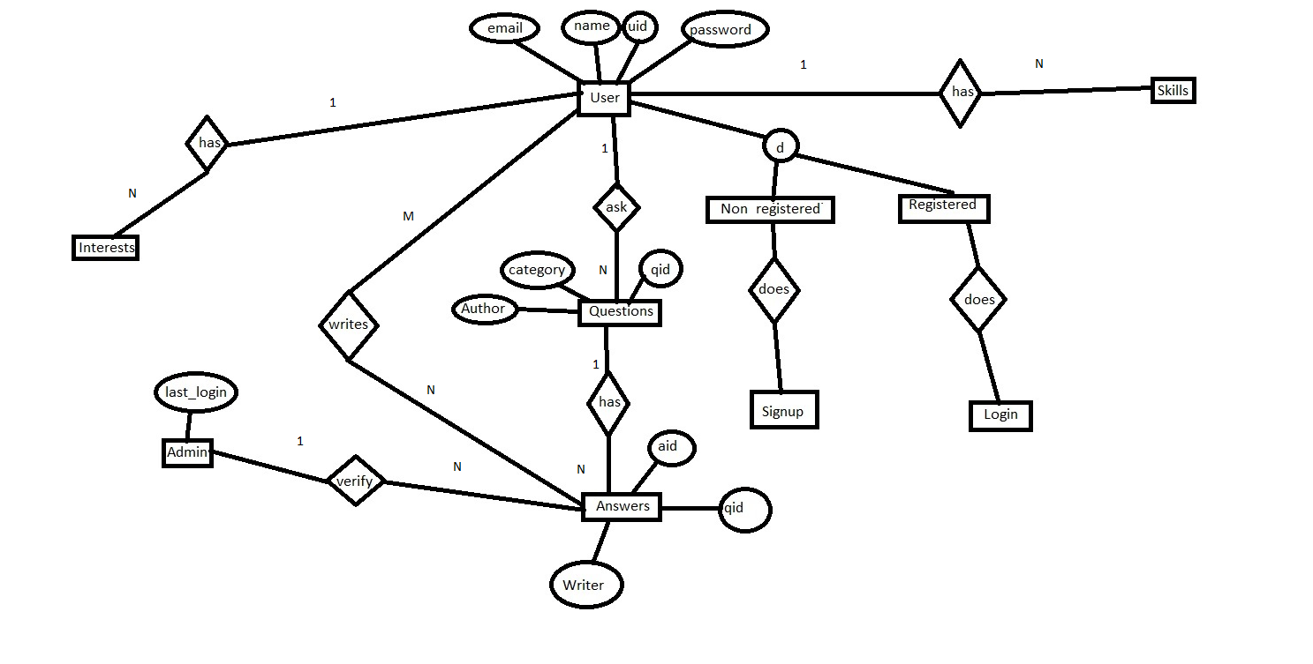

**2.FLOWCHART**

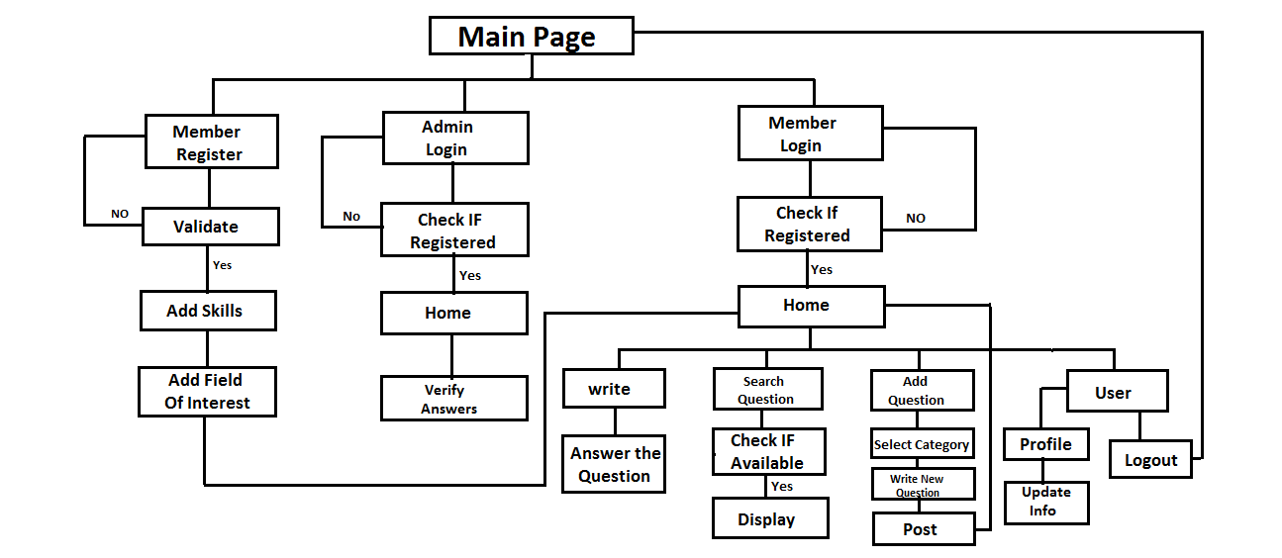

Fig 2

**IMPLEMENTATION METHODOLOGY**

**Modules:**

**1.Registration:** Quest has an user friendly sign up system. By going to the signup page, user can register with an email address. Once registered, user be guided through a number of easy steps. User will be given the chance to select particular topics he/she want to follow; users are free to select as many or as few as they wish. Once user registration is complete, user be brought to the main page.

**2.Login:** After registering, the user can login on the website. User has to provide correct UserId and Password to login into the account. User will be directed to main page(User Feed) after login.

**3.Profile:** A dedicated profile page to each user where the users can add their description, profile image, details, etc.

**3.User Feed:** In user feeds all the question related to user's interest are displayed ranked according to the views of the question so that the popular questions will be displayed first. The answers having a higher up votes will be given first priority to encourage quality answers. The user can up vote a particular answer if he/she likes it.

**4.Asking Questions:** User can ask questions by clicking on the ask question tab in menu on the top right corner. To post a question the user has to select the category of the question.

**5.Writing Answers:** Whenever a user posts a question belonging to a particular category , users who are expert in that category can answer that question by going to the Write page.

**6.Notification:**Whenever someone answers a question asked by the user, the user gets a notification.

**7.Category page**: All the questions and answers belonging to the respective category of the page is displayed here, thus enabling users to directly access information regarding a particular category.

**7.College Page:** All the users of the same college are automatically added to their college group. A dedicated page is provided to each college.

**6.Logout:**This module allows the user to log out of the web site.

**SAMPLE CODE**

**1.Homepage**

<?php

session_start();

include 'config.php';

if ($_SESSION['username'] == 'admin')

header('Location: admin.php');

if (!isset($_SESSION['uid'])) {

header('Location: login.php');

}

?>

<html>

<head>

<meta charset="utf-8" />

<meta http-equiv="X-UA-Compatible" content="IE=edge">

<title>Page Title</title>

<meta name="viewport" content="width=device-width, initial-scale=1">

<link rel="stylesheet" type="text/css" media="screen" href="main.css" />

<script src="main.js"></script>

<link href="https://fonts.googleapis.com/css?family=Rubik" rel="stylesheet">

<link href="https://fonts.googleapis.com/css?family=Timmana" rel="stylesheet">

<link href="https://fonts.googleapis.com/css?family=Ubuntu|Ubuntu+Condensed|Ubuntu+Mono" rel="stylesheet">

<script src="https://ajax.googleapis.com/ajax/libs/jquery/3.3.1/jquery.min.js"></script>

<link rel="stylesheet" type="text/css" href="https://stackpath.bootstrapcdn.com/font-awesome/4.7.0/css/font-awesome.min.css">

</head>

<style>

body {

background-color: #FAFAFA;

}

.menu {

position: relative;

top: 0px;

width: 100%;

height: 50px;

border: solid 1px #DDDDDD;

}

.feeds {

float: left;

position: relative;

font-family: "Helvetica Neue", Helvetica, Arial, sans-serif;

width: 25%;

padding-left:10%;

padding-top:50px;

background-color: #FAFAFA;

font-weight: 400;

font-size: 15px;

line-height: 25px;

color: #666666;

}

.feeds a

{

font-family: "Helvetica Neue", Helvetica, Arial, sans-serif;

text-decoration:none;

font-weight: 400;

font-size: 15px;

line-height: 25px;

color: #666666;

}

.main {

float: left;

position:absolute;

left: 25%;

width: 50%;

background-color: #FAFAFA;

}

.ques_tab {

position: relative;

margin: 2%;

padding: 3%;

background-color: white;

width: 90%;

border: solid #E2E2E2 1px;

border-radius: 10px;

box-shadow: 1px 1px 1px #aaaaaa;

}

.question {

font-family: q_serif, "Georgia", Times, "Times New Roman", "Hiragino Kaku Gothic Pro", Meiryo, serif;

font-weight: 700;

font-size: 18px;

line-height: 23px;

color: #262626;

}

.ans {

font-size: 15px;

font-family: 'Ubuntu', sans-serif;

line-height: 24px;

font-weight: 400;

color: #333333;

outline:none;

}

.writer {

line-height: 18px;

}

.profile {

float: left;

position: absolute;

left: 75%;

width: 25%;

background-color: #FAFAFA;

}

.topic,

.time {

font-family: "Helvetica Neue", Helvetica, Arial, sans-serif;

font-size: 13px;

line-height: 18px;

font-weight: 400;

color: #999999;

}

#down

{

float: right;

}

#up

{

float: left;

}

#up button,#down button

{

border:none;

background-color: Transparent;

outline:none;

}

#down :hover

{

font-size:15px;

}

#up :hover {font-size:15px;}

a{

text-decoration:none;

}

</style>

<body>

<div class="menu">

<?php include 'menu.php'; ?>

</div>

<div class="feeds">

<h3>Feeds</h3><hr>

<ul>

<li>Topics</li>

<li><a href="topic.php?topic=Programming">Programming</a></li>

<li><a href="topic.php?topic=Science">Science</a></li>

<li><a href="topic.php?topic=books">Books</a></li>

<li><a href="topic.php?topic=economics">Economics</a></li>

<li><a href="topic.php?topic=movies">Movies</a></li>

<li><a href="topic.php?topic=music">Music</a></li>

<li><a href="topic.php?topic=sports">Sports</a></li>

<li><a href="topic.php?topic=gaming">Gaming</a></li>

<li><a href="topic.php?topic=food">Food</a></li>

<li><a href="topic.php?topic=travelling">Travelling</a></li>

<li><a href="group.php" >Goto your Group</a></li>

</ul>

</div>

<div class="main">

<?php

$uid = $_SESSION['uid'];

$sql = "select * from interest where id=$uid";

$result = mysqli_query($db, $sql);

$row = mysqli_fetch_assoc($result);

$prefernum = array($row['programming'], $row['science'], $row['books'], $row['economics'], $row['movies'], $row['music'], $row['sports'], $row['gaming'], $row['food'], $row['travelling']);

$prefer = array('programming', 'science', 'books', 'economics', 'movies', 'music', 'sports', 'gaming', 'food', 'travelling');

for ($i = 0; $i < sizeof($prefernum); $i++) {

if ($prefernum[$i] == 1) {

$category = "'" . $prefer[$i] . "'";

$sql = "Select * from questions where category=" . "'" . $prefer[$i] . "' and area='open'"

$result = mysqli_query($db, $sql);

$qresults = mysqli_num_rows($result);

if ($qresults > 0) {

while ($row = mysqli_fetch_assoc($result)) {

$sqla = 'select * from answers where qid=' . $row['qid'] . ' order by upvotes desc limit 1';

$resulta = mysqli_query($db, $sqla);

$qresultsa = mysqli_num_rows($resulta);

if ($qresultsa > 0) {

echo '<div class="ques_tab"><div class="ques" ><span class="topic">' . $row["category"] . '</span><br>

<a href="./question.php?question=' . $row["qid"] . '"> <span class="question" >' . $row["ques"] . '</span></a><br>

<span class="writer">Written by:' . $row["author"] . '</span><br>

<span class="time">' . $row["time"] . '</span>';

$rowa = mysqli_fetch_assoc($resulta);

echo '<div class="ans" color="#333333">' . $rowa['answer'] . ' </div><div id="up"><br><button class="upbut" id=' . $rowa["aid"] . ' value=0><i class="fa fa-thumbs-o-up w3-text-indigo" style="font-size:20px;"></i> Upvote</button></div><br><br> </div> </div>'; }

}}

} } ?>

<div class="profile"></div>

</body>

</html>

<script>

$(document).ready(function () {

$('button').click(function(){

var a=$(this).attr('value');

if (a==0)

{ console.log(this.id);

$(this).css({'color':'green','font-size':'15px'});

$(this).attr('value','1');

$.post("upvote.php",{aid:this.id,value:a},function(data,status){

console.log(count);

}); }

else {

$(this).attr('value','0');

$.post("upvote.php",{aid:this.id,value:a},function(data,status){

console.log(count);

})

$(this).css({'color':'black','font-size':'15px'});

}

});

});

</script>

**SNAPSHOTS**

**Login Page**

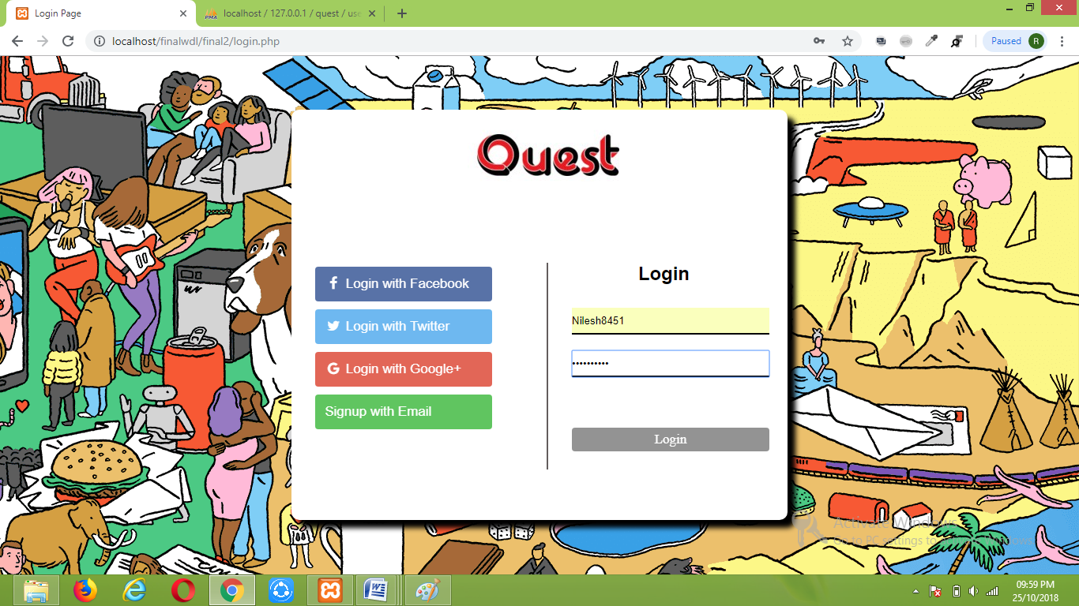

**Sign up Page**

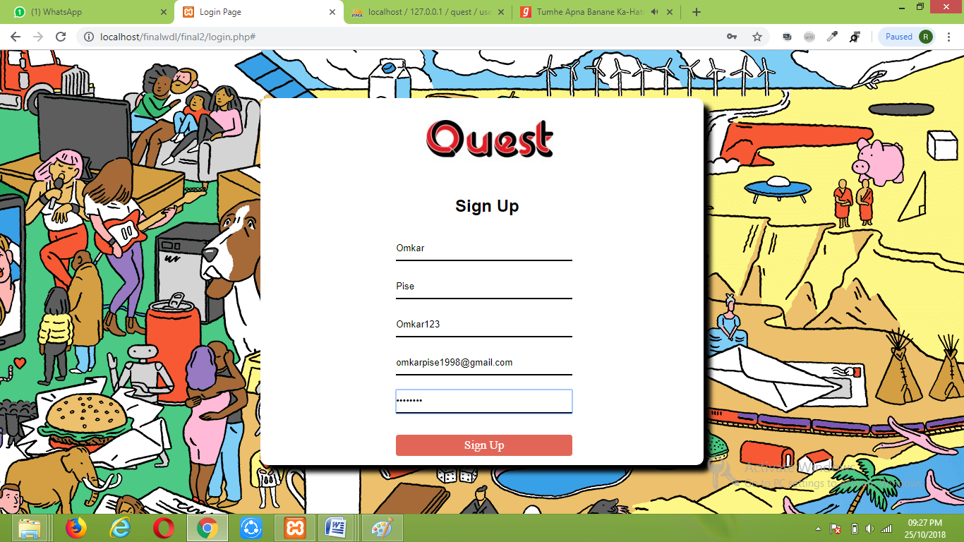

**Interest Page**

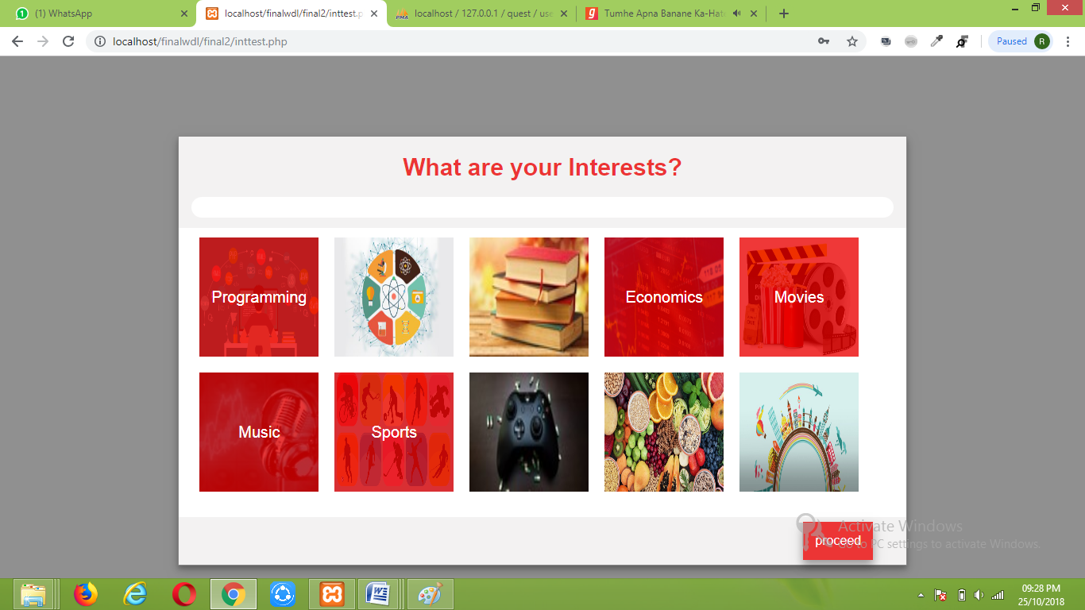

**Admin Home Page**

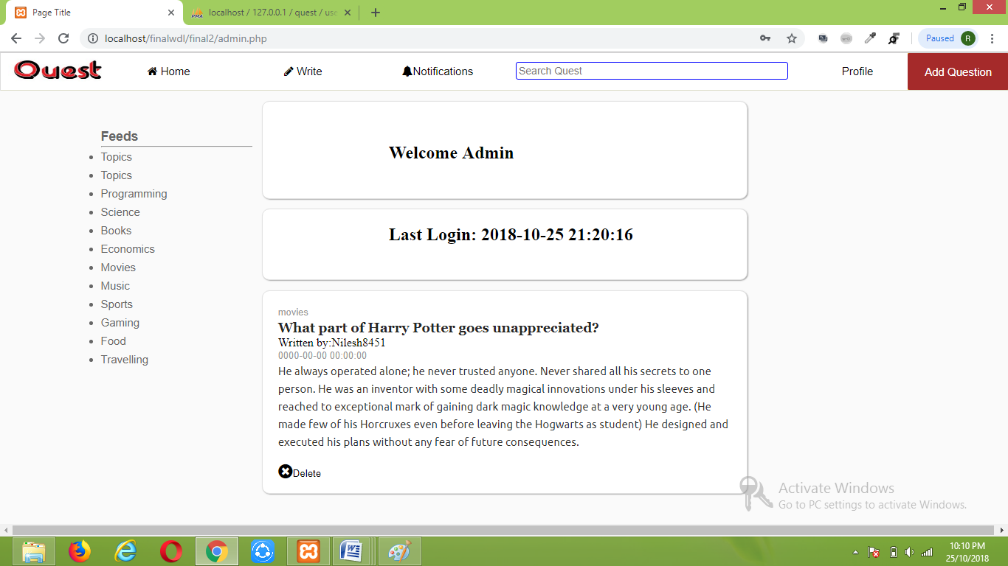

**Home Page**

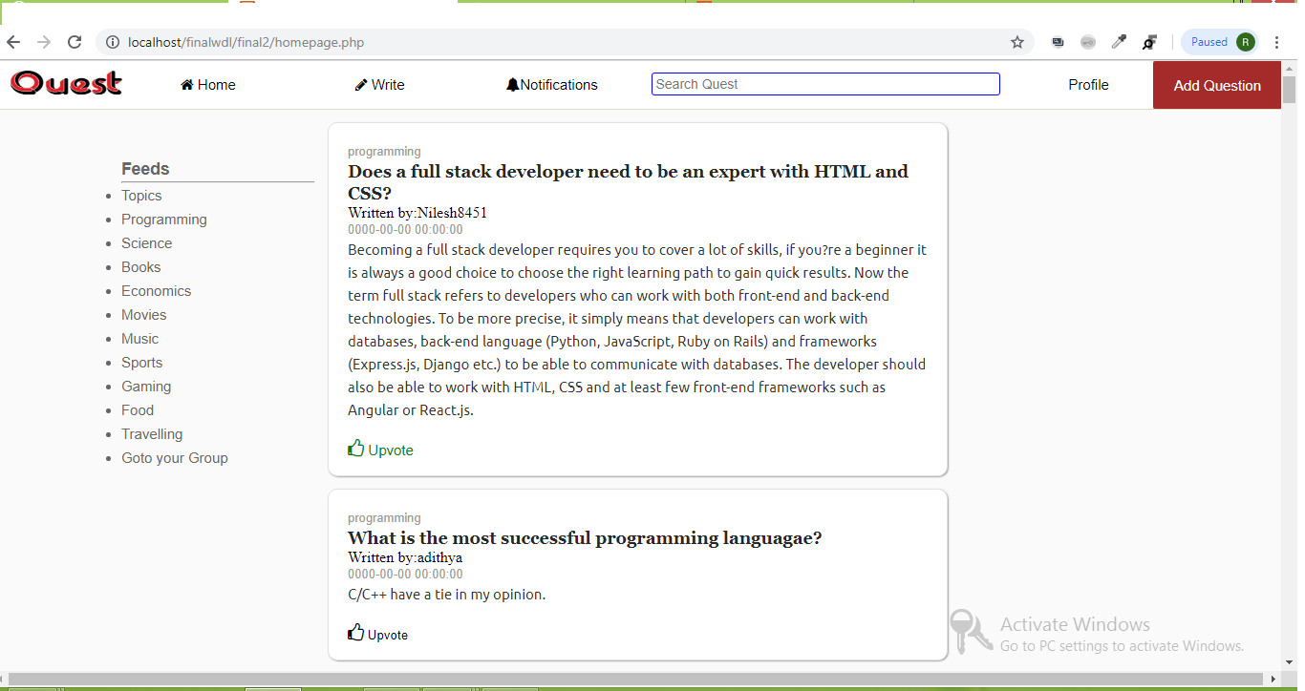

**Feeds**

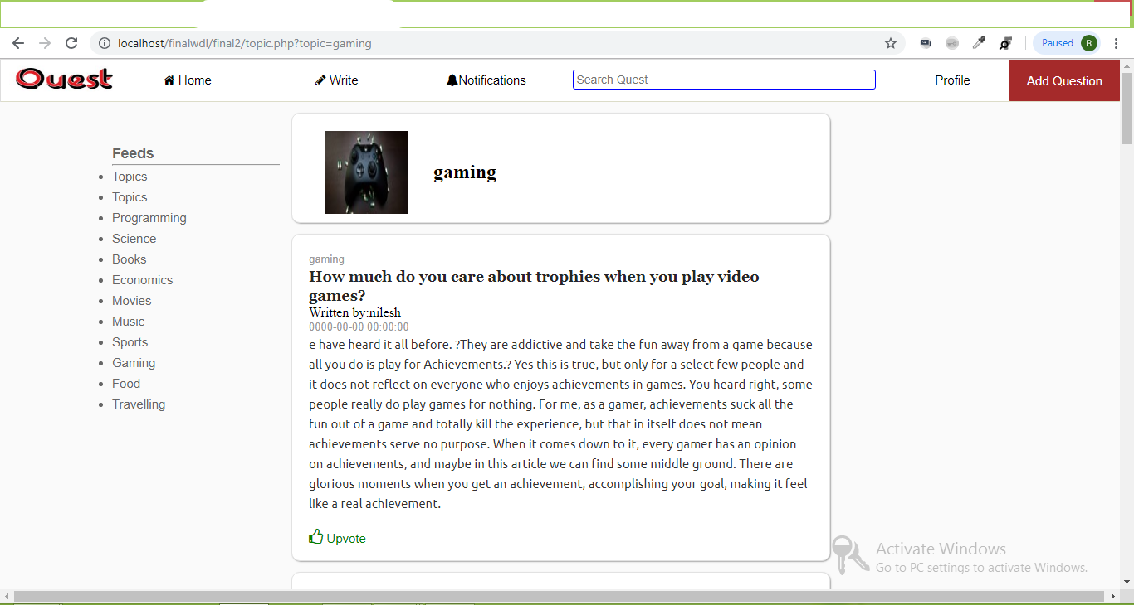

**Writing Answer** 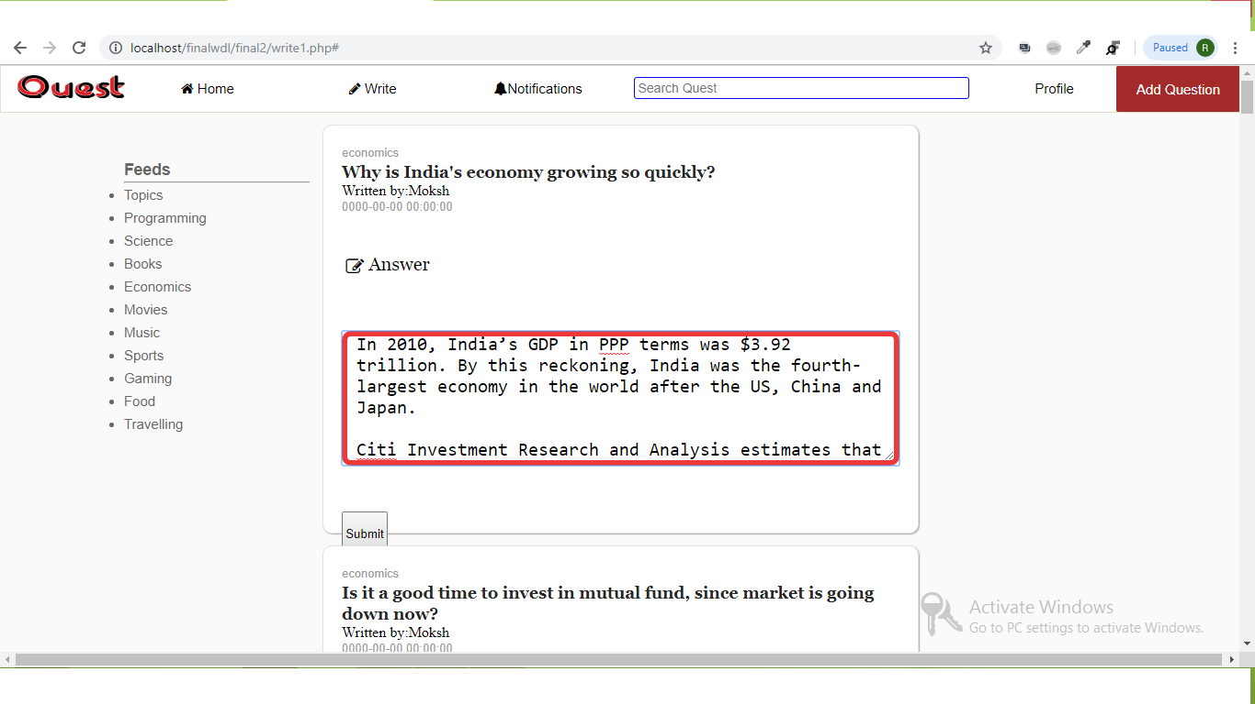

**Search**

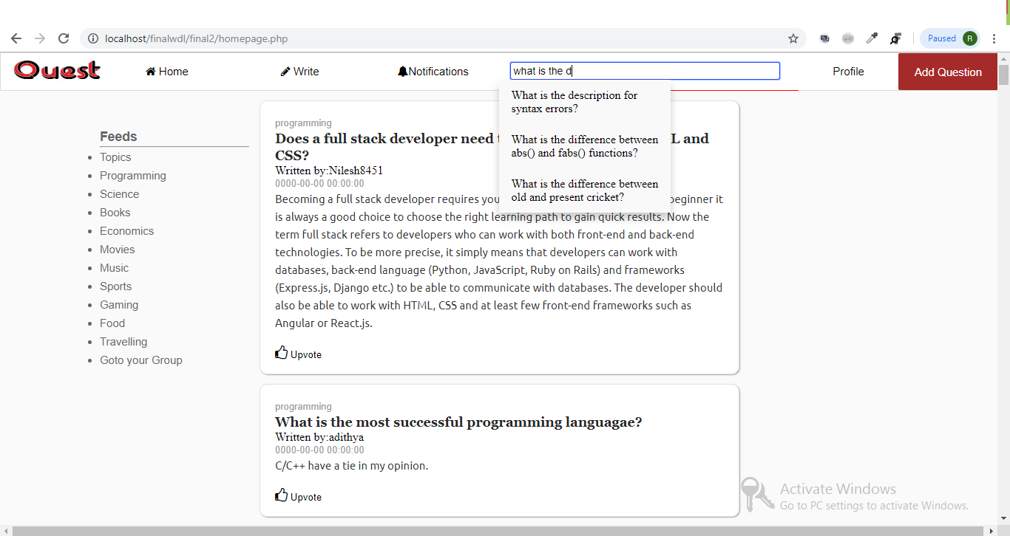

**Add New Questions**

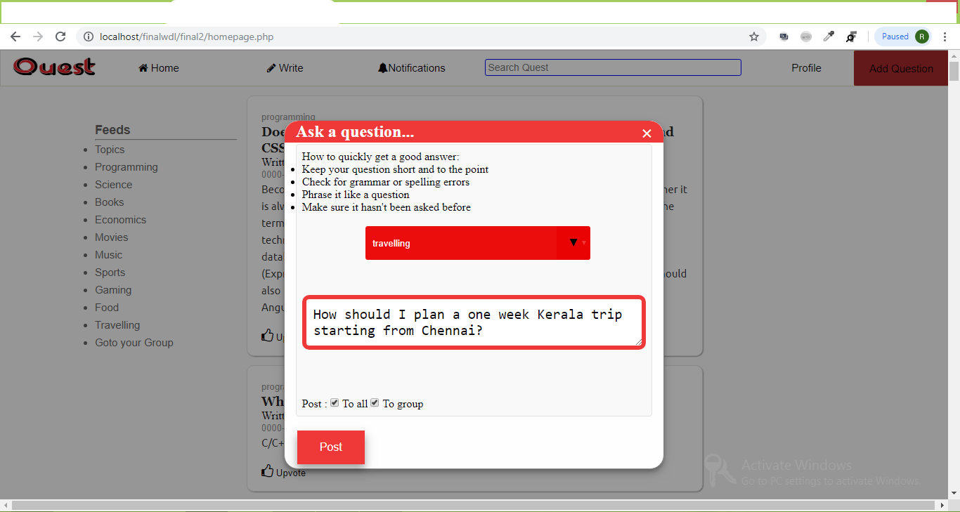

**Profile Page**

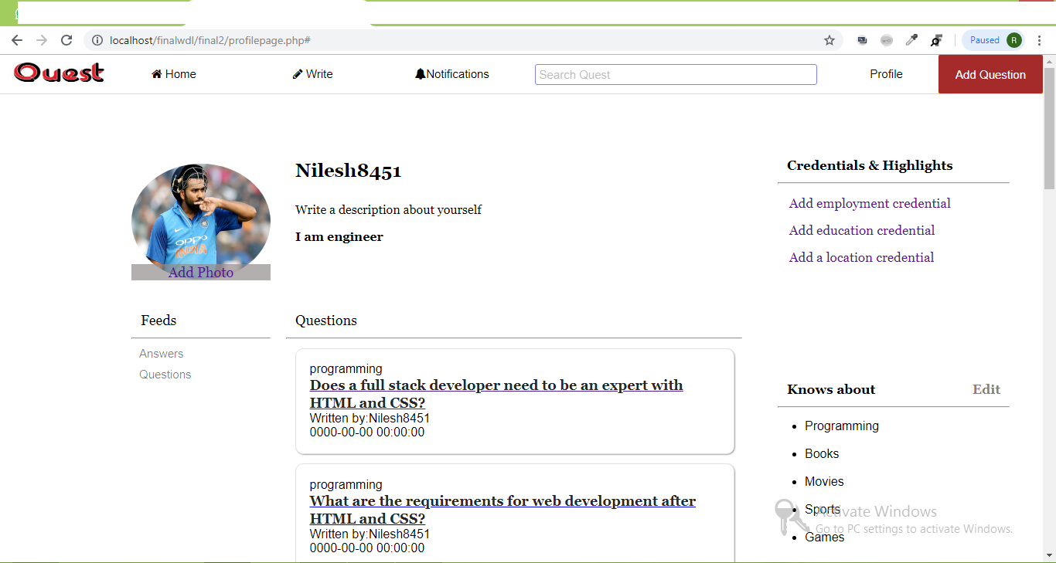

**Database**

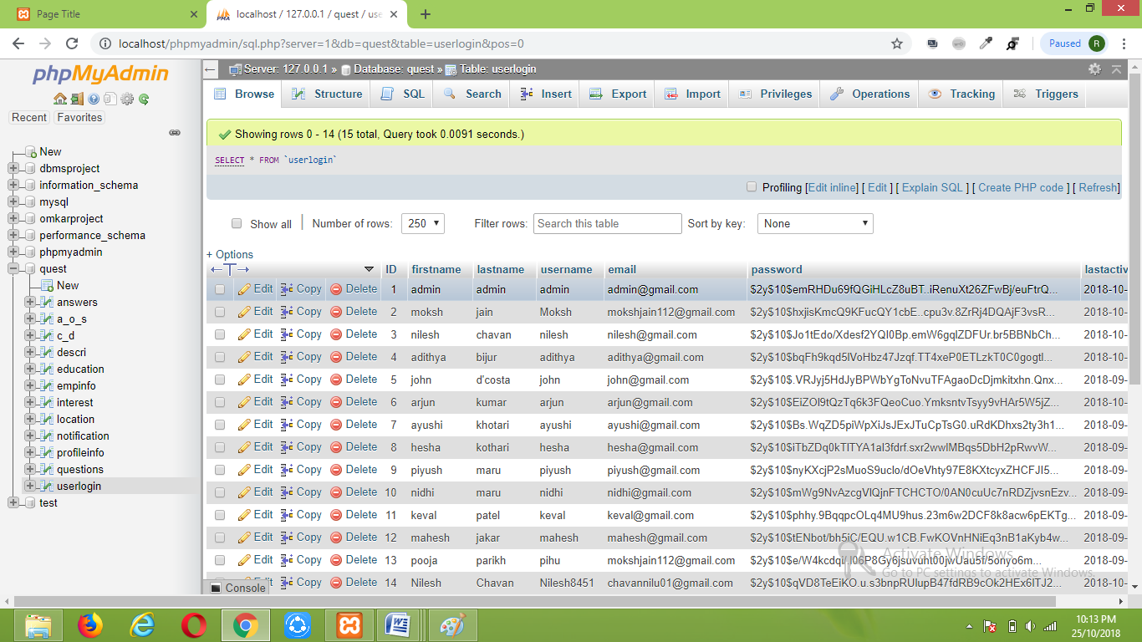

**RESULT**

Our Project connects you to everything you want to know about. It aims to be the easiest place to write new content and share content from the web. We organize people and their interests so you can find, collect and share the information most valuable to you.

The project takes basic idea of efficient Question and Answer Forum turning it into software implementation. The front end of the project makes use of HTML with CSS used for adding additional style, as well as structure to the web pages. JavaScript and PHP languages are used to add dynamic content as well as Database connectivity. The website is hosted on a local server created using PHPmyAdmin.

The flow of the project is easy to understand .In Quest, a registered user can ask questions which will be answered by other users which are expert in the category to which the question belongs. Not only this, users can also view others questions and answers according to their interests. Users can also gather information regarding any category by viewing the Questions and Answers present in the dedicated page of the respective category. Quest automatically adds the registered user to the dedicated group created for the college to which user belongs.

Thus our project meets all the requirements of a Modern and Efficient Question and Answer Forum.

**CONCLUSION**

It has been a great pleasure for us to work on this project. This project provided us practical knowledge of creating our own website. It also provided us an experience of handling all the procedures related to ‘Question and Answer Forum’. Here, we also handled the various tables of data which were essential for our college database which gave us plenty of knowledge how to work on data and manage data efficiently.

While working on the project, we gained knowledge about various software used for web development.The project helped to nurture our mindset what thinking is required to develop a project in a real sense which has an application in real world. We also got an idea about what problems or hinderances can occur during project development and discovered ways to tackle them and resolve them. The project also gave an opprtunity to us for working together as a team thus providing us with a useful experience in working in a project management team.

This project will provide better opportunities and guidance in future in developing projects independently.

**REFERENCES**

1.[www.google.com](http://www.google.com)

2.w3schools.com

3.pagetutor.com

4.cssportal.com

5.designmodo.com