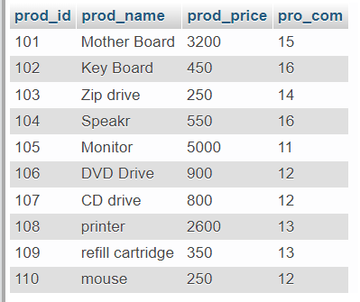

CREATE TABLE product (prod_id int(20),prod_name varchar(100),prod_price REAL,pro_com int(20));

**(INSERT QUERY):**

**INSERT INTO product(prod_id,prod_name,prod_price,pro_com)VALUES(101,'Mother Board',3200.00,15),(102,'Key Board',450.00,16),(103,'Zip drive',250.00,14),(104,'Speaker',550.00,16),(105,'Monitor',5000.00,11),(106,'DVD Drive',900.00,12),(107,'CD drive',800.00,12),(108,'printer',2600.00,13),(109,'refill cartridge',350.00,13),(110,'mouse',250.00,12);**