MEET2MOM: EVIDENCE-GROUNDED AND VERIFIED MINUTES OF MEETING FROM LIVE AND RECORDED MEETINGS
SUBMITTED IN PARTIAL FULFILLMENT OF THE REQUIREMENTS
OF THE DEGREE OF
BACHELOR OF TECHNOLOGY IN COMPUTER ENGINEERING
BY
Shashwat Devendra Patil (ROLL NO. 23102C0048)
Madhura Vilas Suroshe (ROLL NO. 24102C2002)
Asmee Dattaram Jadhav (ROLL NO. 24102C2003)
Samarth Balu Burkul(ROLL NO. 24102C2004)
UNDER THE GUIDANCE OF
PROF. Snehal Andhare
DEPARTMENT OF COMPUTER ENGINEERING

(AN AUTONOMOUS INSTITUTE AFFILIATED TO UNIVERSITY OF MUMBAI)
VIDYALANKAR INSTITUTE OF TECHNOLOGY
WADALA (E), MUMBAI – 400437
UNIVERSITY OF MUMBAI
2026–27

CERTIFICATE OF APPROVAL
This is to certify that the project entitled
"Meet2MoM: Evidence-Grounded and Verified Minutes of Meeting from Live and Recorded Meetings"
is a bonafide work of
Shashwat Devendra Patil (ROLL NO. 23102C0048)
Madhura Vilas Suroshe (ROLL NO. 24102C2002)
Asmee Dattaram Jadhav (ROLL NO. 24102C2003)
Samarth Balu Burkul(ROLL NO. 24102C2004)
submitted to the University of Mumbai in partial fulfillment of the requirement for the award of the degree of Undergraduate in "Computer Engineering".
______________________  Guide | ______________________  Head of Department | ______________________  Principal
Project Report Approval for B.Tech in Computer Engineering
This project report entitled Meet2MoM: Evidence-Grounded and Verified Minutes of Meeting from Live and Recorded Meetings by
1. Shashwat Devendra Patil (ROLL NO. 23102C0048)
2. Madhura Vilas Suroshe (ROLL NO. 24102C2002)
3. Asmee Dattaram Jadhav (ROLL NO. 24102C2003)
4. Samarth Balu Burkul(ROLL NO. 24102C2004)
is approved for the degree of Bachelor of Technology in Computer Engineering.
Examiners
1. ____________________________________
2. ____________________________________
Date: ______________
Place: ______________
Declaration
I declare that this written submission represents my ideas in my own words and where others' ideas or words have been included, I have adequately cited and referenced the original sources. I also declare that I have adhered to all principles of academic honesty and integrity and have not misrepresented or fabricated or falsified any idea/data/fact/source in my submission. I understand that any violation of the above will be cause for disciplinary action by the Institute and can also evoke penal action from the sources which have thus not been properly cited or from whom proper permission has not been taken when needed.
Sr. No. | Name of Student | Roll No. | Signature
1. | Shashwat Devendra Patil | 23102C0048
2. | Madhura Vilas Suroshe | 24102C2002
3. | Asmee Dattaram Jadhav | 24102C2003
4. | Samarth Balu Burkul | 24102C2004
Date: ______________

Acknowledgement
We express our sincere gratitude to our project guide, Prof. <Guide Name>, for continuous guidance, critical feedback and encouragement throughout this project. We thank <Head of Department Name>, Head of the Department of Computer Engineering, and <Principal Name>, Principal, Vidyalankar Institute of Technology, for providing the facilities and environment that made this work possible. We are grateful to the faculty and staff of the department for their support, and to the project coordinators for their timely reviews and suggestions.
We acknowledge the creators of the AMI Meeting Corpus, whose data made the quantitative evaluation in this report possible. We also acknowledge the open-source communities behind Whisper, faster-whisper, pyannote.audio, Hugging Face Transformers, sentence-transformers, LiveKit, FastAPI and React, on whose work this project builds.
Finally, we thank our families and friends, and the classmates who joined our test meetings, for their patience and support throughout the development of this project.
Shashwat Devedra Patil
Madhura Vilas Suroshe
Asmee Dattaram Jadhav
Samarth Balu Burkul

Abstract
Minutes of Meeting (MoM) are the formal record of what a meeting decided and who agreed to do what. They are usually written by hand, circulate slowly, and rarely show where in the discussion each decision was made. Automatic speech recognition and large language models (LLMs) can draft minutes quickly, but generated text can contain statements that the conversation does not support, and recording people creates consent obligations.
This project presents Meet2MoM, a web application that converts live and recorded meetings into reviewer-approved minutes in which every decision and action item cites the transcript and is checked against it. Live meetings run over LiveKit. A hidden server-side recorder captures each participant's own audio track only while every connected participant has consented, and it stops at once if anyone withdraws consent. Each track is transcribed separately with a quantised Whisper model, so speech is attributed to the right person; uploaded recordings use neural speaker diarization. Decisions and action items are proposed by a configurable LLM or by local rule-based and learned extractors. Every item must cite utterance identifiers that the database validates, and any owner or deadline that the cited words do not contain is removed. An independent verifier then combines text matching, hybrid embedding and BM25 retrieval, and multilingual natural language inference into a status with stated reasons. Unsupported claims are held for a human reviewer, who edits, approves and exports the minutes as PDF or JSON with an evidence appendix.
The FastAPI and React implementation passes 352 backend and 55 frontend automated tests. Two-browser live tests confirmed consent gating, immediate halting on revocation and correct two-speaker attribution. Quantised speech recognition runs about 3.7 times faster than real time on a laptop CPU. An evaluation on 39 held-out AMI meetings and on deliberately corrupted claims showed that the verifier caught every corruption while conservatively holding many true claims for human review. Transcript imports, authentication and pilot deployment form the future scope of the work.
Keywords: minutes of meeting, speech recognition, speaker attribution, evidence grounding, natural language inference, large language models, recording consent, human-in-the-loop review.
Table of Contents

List of Figures

List of Tables

List of Symbols and Abbreviations
Symbols
Symbol | Meaning
α | Weight of dense similarity in hybrid retrieval (0.65); the BM25 weight is 1 − α
k | Number of retrieved candidate spans per claim (8)
e_cited | NLI entailment of a claim by its cited utterances, with one utterance of context on each side
e_strict | NLI entailment of a claim by its cited utterances alone
x | NLI contradiction probability
P, R, F1 | Precision, recall and their harmonic mean
RTF | Real-time factor = processing time ÷ audio duration

Abbreviations
Abbreviation | Expansion
AMI | Augmented Multi-party Interaction (meeting corpus)
API | Application Programming Interface
ASR | Automatic Speech Recognition
BM25 | Best Matching 25 (lexical ranking function)
CORS | Cross-Origin Resource Sharing
CPU / GPU | Central / Graphics Processing Unit
DFD | Data Flow Diagram
DPDP | Digital Personal Data Protection (Act, 2023)
ER | Entity–Relationship
FK | Foreign Key
HTTP | Hypertext Transfer Protocol
JSON | JavaScript Object Notation
JWT | JSON Web Token
LLM | Large Language Model
MoM | Minutes of Meeting
MNLI / XNLI | Multi-Genre / Cross-lingual Natural Language Inference
NLI | Natural Language Inference
PCM | Pulse-Code Modulation (raw audio samples)
PDF | Portable Document Format
REST | Representational State Transfer
SQL | Structured Query Language
TF-IDF | Term Frequency–Inverse Document Frequency
UI | User Interface
VAD | Voice Activity Detection
WAV | Waveform Audio File Format
WebRTC | Web Real-Time Communication
WER | Word Error Rate

Chapter 1: Introduction

1.1 Background and Motivation
Most organisations record their meetings as Minutes of Meeting (MoM): a short written account of what was decided, who agreed to do what, and by when. College committees, project reviews, housing-society boards and management meetings all rely on minutes as the reference record of a discussion. Writing them by hand has well-known costs. One participant must listen and type at the same time, so they take a smaller part in the discussion. Details are lost or paraphrased. And the finished minutes rarely say where in the conversation a decision was actually taken.
Automatic speech recognition (ASR) and large language models (LLMs) make it possible to draft minutes automatically. A recording is transcribed, the transcript is summarised, and decisions and action items are listed. Several commercial note-taking tools already do this (Section 2.9). However, models that generate text can state things that the source does not support. Research on abstractive summarisation reports that generated summaries often contain content that is unfaithful to the input document [1], and surveys of natural-language generation describe this "hallucination" as a general property of current models [2]. A meeting summary with an invented decision, a wrong owner or a wrong deadline is worse than no summary at all, because readers trust it.
A second concern is consent. Recording people's voices and processing them with external services involves personal data. In India, the Digital Personal Data Protection Act, 2023 [3] makes consent and purpose limitation central to the lawful processing of digital personal data. A meeting tool should therefore record only participants who have explicitly agreed, and it should stop as soon as anyone withdraws that agreement.
These two concerns motivate Meet2MoM. The project treats the minutes as a claim about the transcript that must be justified by evidence, not as free text. It also treats recording consent as a rule that the server enforces, not merely a checkbox shown in the browser.

1.2 Problem Statement
Given a meeting held between several participants, produce Minutes of Meeting such that:
- audio is captured only while every connected participant has explicitly consented, and capture stops immediately when any participant withdraws consent;
- the transcript attributes each utterance to the correct speaker, with timestamps;
- every decision and action item in the minutes cites the transcript utterances that support it, and owners and deadlines are those actually stated in the meeting;
- each extracted item is checked by a verifier that is independent of the extractor, and items whose support is weak or contradicted are held for a human reviewer instead of being published;
- a human reviewer can correct, approve and later reopen the minutes, with a complete audit trail; and
- the system runs on an ordinary CPU-only laptop and reports honestly when a component, such as an external LLM, is unavailable or fails.

1.3 Aim and Objectives
Aim. To design, implement and evaluate a system that turns live or recorded meetings into reviewer-approved Minutes of Meeting in which every recorded decision and action item is traceable to, and verified against, the meeting transcript.
Objectives. The objectives of the project are listed in Table 1.1. Each objective is assessed in Chapter 6 (Table 6.1).
Table 1.1: Objectives of the project.
ID | Objective
O1 | Host browser-based live meetings and capture audio on the server only with the explicit, server-enforced consent of every connected participant.
O2 | Produce a timestamped transcript with speaker attribution, using each participant's own audio track for live meetings and speaker diarization for uploaded recordings.
O3 | Extract decisions and action items, with owner and deadline when stated, such that every item cites transcript utterances.
O4 | Verify each item with methods independent of the extractor (deterministic matching, retrieval and natural-language inference) and hold unsupported items for review.
O5 | Provide a reviewer workflow: edit items, accept or reject suggested evidence, approve and lock the minutes, reopen with a reason, and keep an audit log.
O6 | Export approved minutes as PDF and JSON, including an evidence appendix.
O7 | Support a configurable LLM provider for extraction with bounded waiting time and an explicit, honest fallback to local extractors.
O8 | Keep processing time practical on CPU-only hardware.
O9 | Evaluate extraction and verification quantitatively on a public meeting corpus and with deliberately corrupted claims.

1.4 Scope and Boundaries
In scope.
- Two meeting sources: browser-based live meetings over LiveKit, and uploaded recordings in common audio and video formats (MP4, WAV, MP3, M4A, WebM, MOV, MKV, AAC and FLAC).
- Server-side consent enforcement and audio capture for live meetings.
- Transcription, speaker attribution, topic segmentation, claim extraction, verification, review, approval and export, all running on one machine.
- Local models for ASR, diarization, embeddings and NLI, and an optional external LLM (Google Gemini by default) for extraction.
Outside the scope of this project (discussed as future scope in Chapter 7):
- user accounts, sign-in, roles and multi-tenant isolation;
- importing transcripts from files (VTT, SRT) or from the Google Meet API;
- bots that join Zoom, Microsoft Teams or Google Meet calls;
- live, during-meeting transcription (processing starts after the recording is stopped);
- deletion of a meeting together with all its derived data and caches;
- cloud deployment, containerisation and continuous integration; and
- GPU acceleration.

1.5 Methodology Overview
The work followed a phased plan with an explicit acceptance gate at the end of each phase. A phase was closed only when its gate criteria were met and recorded in a phase report.
- Prototype (September 2026). The initial pipeline: recording upload, transcription, diarization, a first transcript index, span-grounded extraction and a first retrieval and NLI verification layer.
- Phase 0 — Ground truth and hygiene. Verifying the project's claims against the code, isolating tests from real storage and freezing a demonstration meeting as a golden fixture.
- Phase 1 — Semantic verification in the product. Running retrieval and NLI on every claim in the pipeline, persisting the results and showing them in the user interface.
- Phase 2 — Evaluation and calibration. A learned dialogue model, an evaluation harness on the AMI Meeting Corpus [4] and adversarial tests with deliberately corrupted claims.
- Phase 3 — Reviewer workflow and speed. Persisted review edits, an audit log, approval snapshots and reopening, evidence-linked audio playback, an evidence appendix in exports, background jobs and quantised ASR.
- Phase 4 — Live meetings. Four sub-phases: 4.1 LiveKit meetings; 4.2 server-side recording with enforced consent; 4.3 integration of live recordings with processing, including participant-track transcription; and 4.4 real LLM extraction with bounded waiting time and honest fallback.
Development was test-driven where practical. Automated tests use temporary storage and databases, fake models and mocked network calls. Golden fixtures freeze the expected output for a demonstration meeting. An evaluation harness measures extraction against the AMI Meeting Corpus. Behaviour that automated tests cannot cover, such as two people joining a real LiveKit room from two browsers, was checked by manual acceptance tests (Section 5.4).

1.6 Proposed Solution and Contributions
Meet2MoM is a web application with a React frontend and a Python FastAPI backend. Its central design decision is to separate proposing a claim from accepting it:
- The extractor (an LLM, a rule-based extractor or a learned dialogue model) proposes decisions and action items. It must cite utterance identifiers from the transcript; items that cite nothing valid are dropped.
- An independent verifier re-checks every claim. It matches the cited text, searches the whole transcript for better or contradicting evidence, and runs a natural-language inference (NLI) model. A transparent rule set fuses these signals into one of four statuses — verified, verified with warning, review or rejected — each with human-readable reasons.
- A human reviewer makes the final decision and approves a locked, versioned copy of the minutes.
The main contributions of the project are:
- Server-enforced recording consent for LiveKit meetings. A hidden recorder subscribes only to consented participants and halts at once on revocation, on an unconsented join or on unconsented audio. A halted segment never resumes on its own (Sections 4.4 and 4.5).
- Track-based speaker attribution. Each participant's own microphone track is transcribed separately, which fixed a real failure in which diarization of the mixed audio merged two speakers into one (Sections 4.7 and 5.5).
- Evidence-grounded extraction. Decisions and action items are stored only with database-enforced links to existing utterances, and owners, proposers and deadlines stated by the LLM are removed when the cited words do not contain them (Section 4.10).
- Independent, explainable verification combining deterministic matching, hybrid retrieval and multilingual NLI, with stored reasons and model versions (Section 4.11).
- A reviewer workflow with persisted edits, evidence-correction suggestions, approval snapshots, reopening and an audit log, together with PDF and JSON export that includes an evidence appendix (Section 4.12).
- Honest degradation. A missing or failing LLM is reported in the minutes with the reason, and the output of a local extractor is labelled as such (Sections 4.10 and 5.6).

1.7 Summary of Results
The complete system is implemented and integrated. Its automated test suites pass in full: 352 backend tests and 55 frontend tests (Section 5.2). Manual two-browser tests with real LiveKit meetings confirmed consent gating, immediate halting on revocation, restarting only on an explicit host action, and correct attribution of two speakers (Section 5.4).
Quantised speech recognition processes audio at a real-time factor of 0.27, about 6.4 times faster than the earlier unquantised configuration (Section 5.8). Performance analysis of a live meeting identified the NLI verifier as the main bottleneck, and loading it in single precision made it about 17 times faster on the project laptop. On the AMI Meeting Corpus, the hybrid local extractor more than doubled the recall of the rule-based baseline, and the verifier caught every deliberately corrupted claim in the adversarial test set (Section 5.7).

1.8 Organisation of the Report
- Chapter 2 reviews the literature on meeting transcription, diarization, summarisation, decision and action-item detection, and evidence-grounded verification, and compares existing systems.
- Chapter 3 states the requirements and presents the system design: the architecture and the data-flow, sequence, state and entity–relationship diagrams.
- Chapter 4 describes the implementation of each component.
- Chapter 5 reports the tests, evaluations and performance measurements.
- Chapter 6 concludes the report, assesses the objectives and makes recommendations.
- Chapter 7 sets out the future scope of the project.
- The references and appendices follow. The appendices cover the API, the configuration, the test inventory, the database tables, the development timeline and an installation guide.

Chapter 2: Literature Review and Existing Systems
This chapter summarises published work and official documentation relevant to each stage of Meet2MoM. Each section first reviews the literature and then states briefly how Meet2MoM uses or departs from it; those statements refer to the implementation described in Chapter 4.

2.1 Manual Minutes and Their Limitations
Minutes serve as an organisation's memory of what was agreed. Manual minute-taking has the following limitations, which motivate this project:
- Divided attention. The minute-taker cannot participate fully in the discussion.
- Selective recall and paraphrase. Wording, owners and deadlines are easily changed when the discussion is summarised later.
- No traceability. A reader cannot check where in the discussion a decision was made, or whether a proposal was actually accepted.
- Delay. Minutes are often circulated hours or days after the meeting.
Automating the task addresses the first and last points. The second and third points remain if the automation itself paraphrases without evidence. That observation shapes the rest of this review.

2.2 Automatic Speech Recognition
Whisper is a family of encoder–decoder Transformer ASR models trained on about 680,000 hours of weakly supervised multilingual audio. Its authors report that it is robust across accents, background noise and technical language, and that it can detect the spoken language [5]. Long recordings are processed in 30-second windows. Whisper outputs segment timestamps and per-token probabilities, which can serve as a confidence signal.
faster-whisper re-implements Whisper inference on the CTranslate2 inference engine [6], [7]. It supports 8-bit integer (int8) quantisation on CPUs and optional voice-activity detection (VAD) based on Silero VAD [8], which skips non-speech audio. WhisperX adds VAD-based segmentation and forced alignment to improve word-level timestamps in long-form audio [9].
In Meet2MoM, ASR uses faster-whisper with the Whisper small model, int8 computation on the CPU, beam size 5, VAD enabled and automatic language detection. Chunks with too many low-confidence segments are retried with a larger beam (Section 4.6). The project's benchmark measured a real-time factor of 0.27 for this configuration, against 1.72 for the earlier unquantised configuration (Section 5.8).

2.3 Speaker Diarization and Attribution
Speaker diarization answers the question "who spoke when". Anguera et al. review classical diarization pipelines, which consist of segmentation, speaker embeddings and clustering [10]. Park et al. review deep-learning approaches, including neural speaker embeddings and end-to-end diarization, and note that overlapping speech and short speaker turns remain difficult [11]. pyannote.audio is an open-source toolkit of neural building blocks for diarization [12]. Its recent pipelines use powerset multi-class segmentation [13]. The speaker-diarization-community-1 pipeline used by this project is published on Hugging Face, requires pyannote.audio 4.x and is gated behind accepting its user conditions with an access token [14].
A different route to attribution is available when each participant has their own audio channel. WebRTC conferencing delivers each participant's microphone as a separate media track [15]. LiveKit, an open-source WebRTC media server, lets a server-side participant subscribe to those tracks individually [16].
In Meet2MoM, uploaded recordings are diarized with pyannote (Section 4.6). Live meetings instead transcribe each participant's own track, which makes speaker identity a property of the channel rather than an inference. This design followed a real failure in which diarization of about 7.5 seconds of mixed speech put two different speakers into one cluster (Section 5.5).

2.4 Meeting Corpora and Meeting Summarisation
The AMI Meeting Corpus provides about 100 hours of recorded meetings with transcripts and annotations, including dialogue acts, extractive and abstractive summaries, and decision-related segments [4]. The ICSI Meeting Corpus provides natural research-group meetings recorded with close-talking and distant microphones [17]. QMSum is a benchmark for query-based, multi-domain meeting summarisation built on AMI, ICSI and parliamentary committee meetings; its creators found that locating the relevant part of a long meeting is a central difficulty [18].
In Meet2MoM, the AMI corpus was used to train a small dialogue model (train split only) and to evaluate extraction on 39 held-out test meetings (Section 5.7).

2.5 Decision and Action-Item Detection
Work on detecting decisions and action items in multi-party dialogue emphasises that commitments are made across turns. A proposal, the discussion and the agreement can be spoken by different people:
- Purver et al. detect action-item subdialogues, in which tasks are proposed, discussed and committed to, and then summarise the task descriptions. They report that modelling this dialogue structure improves detection [19].
- Hsueh and Moore detect decision-related dialogue acts in AMI meetings, combining lexical, prosodic, dialogue-act and topical features [20].
- Fernández et al. model decisions as structures with distinct roles — issue, resolution and agreement — and detect each role separately [21].
In Meet2MoM, every decision records its state: proposed, accepted, conditional or rejected. A decision counts as accepted only when the agreement is evidenced, ideally by a different speaker, and proposals without agreement are held for review (Section 4.11). The learned dialogue model decodes acceptance from a different speaker's positive response, in line with this literature (Section 4.10).

2.6 Topic Segmentation
TextTiling segments text into multi-paragraph subtopics by detecting drops in lexical similarity between adjacent blocks [22]. Galley et al. extend lexical-cohesion methods to multi-party conversation, using features such as silences and speaker changes [23].
In Meet2MoM, topics are segmented by comparing multilingual sentence embeddings of adjacent utterance blocks against a cosine-similarity threshold. Short titles are generated extractively with TF-IDF, using only words present in the topic (Section 4.9).

2.7 Large Language Models and Faithfulness
LLMs such as Gemini [24] can extract structured information from text. The Gemini API can be asked to return JSON [25], and some Gemini models perform internal "thinking" before answering, the depth of which can be configured [26]. Fluency, however, does not imply faithfulness:
- Maynez et al. found that a large share of model-generated summaries contained hallucinated content not supported by the source document [1].
- Ji et al. survey hallucination across generation tasks; their mitigations include grounding and post-hoc verification [2].
Retrieval-augmented generation conditions a generator on retrieved passages to improve factuality in knowledge-intensive tasks [27].
In Meet2MoM, the LLM is used only as a proposer. Its prompt requires utterance identifiers for every item, and its output is schema-checked. Stated details missing from the cited words are removed, and every item is then verified independently (Sections 4.10 and 4.11).

2.8 Evidence Grounding and NLI-Based Verification
Natural-language inference (NLI) asks whether a premise entails, contradicts or is neutral to a hypothesis:
- MultiNLI provides broad-coverage English NLI data [28].
- XNLI extends NLI evaluation to 15 languages [29].
- DeBERTa improves BERT with disentangled attention [30], and DeBERTaV3 further improves pre-training efficiency [31].
- Laurer et al. show that BERT-style models fine-tuned on NLI can be reused as general classifiers with little task-specific data [32]. The multilingual checkpoint mDeBERTa-v3-base-mnli-xnli is published by the same author [33].
NLI has been used to check the factual consistency of summaries:
- FactCC trains a model to classify whether a summary sentence is consistent with its source [34].
- SummaC shows that applying NLI at the sentence level, rather than to whole documents, makes NLI-based inconsistency detection effective [35].
To find evidence for a claim, dense sentence embeddings such as Sentence-BERT [36] and multilingual distilled models [37] can be combined with the lexical BM25 ranking function [38].
In Meet2MoM, every claim is checked in four steps (Section 4.11):
- against the utterances it cites, scored with and without one neighbouring utterance of context;
- against other utterances retrieved from the whole transcript by a hybrid of multilingual embeddings and BM25;
- for contradiction; and
- against a background entailment level, used as a noise floor.
This applies the sentence-level insight of SummaC to meeting claims. It also reverses the usual retrieval-augmented setup: retrieval here checks the generator's output instead of feeding it.

2.9 Existing Systems
A survey of commercial meeting assistants carried out in October 2026, based on vendor documentation and published reviews, is summarised in Table 2.1. The table records only what was publicly documented at the time of the survey; features that were not documented may still exist.
Table 2.1: Commercial meeting assistants (survey of October 2026).
Product | Capture method | Reported decision and action features | Evidence or verification (as documented)
Otter.ai | Bot joins Zoom, Meet or Teams | Summaries, action items | Not documented
Fireflies.ai | Bot | Summaries with decisions and action items | Not documented
Fathom | Bot; bot-free on some platforms | Summaries, action items | Not documented
Granola | Device audio, no bot | Summaries, action items | Not documented
Google Meet with Gemini | Native | Notes, next steps with owners, decision statuses | Notes reported to link to transcript points
Zoom AI Companion | Native | Summaries, next steps | Not documented
Microsoft Teams recap | Native | Notes, tasks | Not documented

The survey shows that extracting decisions is no longer a differentiator by itself. A more defensible distinction is measured, visible verification: withholding unsupported items, re-verifying them independently, separating a proposal from its agreement, and keeping an approval audit trail.

2.10 Comparison and Research Gap
Table 2.2 compares the main approaches to automatic minutes and shows how Meet2MoM responds to the weaknesses of each.
Table 2.2: Approaches to automatic minutes and the response of Meet2MoM.
Approach | Strength | Weakness for formal minutes | Response of Meet2MoM
Manual minutes | Human judgement | Slow, selective, untraceable (Section 2.1) | A human reviewer keeps the final say (Section 4.12)
ASR with a generic LLM summary | Fast, fluent | Unsupported content possible [1], [2]; no citations | The LLM only proposes; citations are required; independent verification
Rule or keyword extraction | Transparent, offline | Low recall on paraphrase; no dialogue context | Kept as a labelled fallback; a learned dialogue model is added
Dialogue-structure models [19], [20], [21] | Model proposal and agreement | Need annotated data; research prototypes | Decision states and different-speaker agreement used in decoding and fusion
NLI consistency checking [34], [35] | Detects unsupported or contradicted text | Usually applied to news summaries, not meetings | Applied per claim, with transcript-wide retrieval and stored reasons
Mixed-audio diarization [11], [12] | Works on any recording | Can merge speakers in short or overlapping speech | Per-participant tracks for live meetings; diarization for uploads

Gap addressed. The literature offers ways to transcribe speech, attribute speakers, detect decisions and check consistency, and the surveyed products offer summaries. What is missing is an end-to-end system that combines these techniques into an auditable minutes record, with:
- consent-enforced capture;
- channel-based speaker attribution;
- extraction that must cite evidence;
- verification that is independent of the extractor, with stored reasons;
- explicit, labelled degradation when a component fails; and
- human approval with an audit trail.
Meet2MoM is an engineering contribution towards that combination. It does not propose a new model; its quantitative claims are limited to those measured in Chapter 5.

2.11 Consent and Data Protection
A meeting recorder processes voices, names and the content of conversations, all of which are personal data. In India, the Digital Personal Data Protection Act, 2023 [3] governs the processing of digital personal data. Several of its provisions bear directly on a meeting tool:
- Consent and notice. Consent must be free, specific, informed, unconditional and unambiguous, given by a clear affirmative action, and limited to the data needed for the specified purpose. A request for consent must be accompanied by a notice describing the data and the purpose.
- Withdrawal. A person may withdraw consent at any time, and withdrawing must be as easy as giving consent.
- Erasure. Personal data must be erased when consent is withdrawn or when the purpose is no longer served, unless the law requires it to be retained.
- Correction. People have the right to have inaccurate personal data corrected.
In Meet2MoM, consent is an explicit checkbox on the join form (an affirmative action), withdrawal is a single in-room action that halts capture immediately, every consent change is recorded in an audit trail, and a halted recording never resumes without a fresh, complete consent check (Section 4.4). Reviewers can correct the minutes, with every change audited (Section 4.12). Complete erasure of a meeting and all its derived data is identified as future scope (Chapter 7). The design supports these principles but does not by itself constitute legal compliance, which depends on how and where the system is deployed.

2.12 Summary
ASR and diarization are mature enough for practical meeting transcription, although diarization degrades on short and overlapping speech. LLMs extract information fluently but can state unsupported content. NLI-based checking and retrieval offer a practical way to verify claims against a source. Chapter 3 turns these observations into requirements and a design.

Chapter 3: Requirements Analysis and System Design
This chapter identifies the users of the system, states the functional and non-functional requirements, and presents the design through architecture, data-flow, sequence, state and entity–relationship diagrams.

3.1 Stakeholders and User Roles
Table 3.1 lists the people and systems that interact with Meet2MoM and how each role is identified in the implementation.
Table 3.1: Stakeholders and user roles.
Role | Description | How the role is identified
Host | Creates a live meeting, invites others, starts and stops recording, ends the meeting and submits it for processing | The first identity that requests a host LiveKit token for the meeting; the server binds the host to that meeting
Guest participant | Joins a live meeting through an invite link and grants or revokes their own consent | A LiveKit identity with a server-issued token
Uploader | Uploads a recorded meeting file | Any user of the web application
Reviewer | Inspects the transcript and verification results, edits items, approves or reopens the minutes | A reviewer name supplied when approving or reopening
Minutes reader | Receives the approved PDF or JSON minutes | Outside the system
Recorder (system) | Hidden server-side LiveKit participant that captures consented audio | Reserved identity prefix m2m-recorder-
External LLM provider | Optional extraction service (Gemini by default) | API key held in the local configuration file

The system is designed for use on a trusted machine and does not yet have user accounts; sign-in, organisations and roles are part of the future scope (Chapter 7).

3.2 Functional Requirements
Table 3.2 lists the functional requirements. Requirements FR-01 to FR-16 are implemented in the delivered system; FR-17 to FR-20 were identified during design and deferred to future work.
Table 3.2: Functional requirements.
ID | Requirement | Status
FR-01 | Create a live meeting room and an invite link; participants join with a display name | Implemented
FR-02 | Record each participant's explicit consent on the server and show every participant's consent state | Implemented
FR-03 | Start recording only when every connected participant has consented; otherwise refuse and list who is blocking | Implemented
FR-04 | Halt capture immediately on consent revocation, an unconsented join, unconsented audio, an empty room, meeting end, recorder disconnection or server shutdown; never resume automatically | Implemented
FR-05 | Show "REC" only while the server is actually writing audio frames | Implemented
FR-06 | End the meeting for everyone; submit the finalized recording for processing exactly once; allow an explicit retry of a failed job | Implemented
FR-07 | Upload a recorded meeting and process it in the background with progress reporting | Implemented
FR-08 | Transcribe with timestamps and confidence; attribute speakers from participant tracks (live) or diarization (uploads) | Implemented
FR-09 | Build an indexed transcript with stable utterance identifiers | Implemented
FR-10 | Segment the discussion into topics with short titles | Implemented
FR-11 | Extract decisions and action items with cited utterances, owner and deadline, using an LLM or local extractors, and record which was used and why | Implemented
FR-12 | Verify every claim, give it a fused status with reasons, and suggest better evidence when it is found | Implemented
FR-13 | Let the reviewer edit, add and exclude items and accept or reject evidence suggestions, with an audit log | Implemented
FR-14 | Approve the minutes into a locked, versioned snapshot; reopen with a mandatory reason | Implemented
FR-15 | Export the minutes as PDF (draft or approved) and JSON (approved only), with an evidence appendix | Implemented
FR-16 | Play the meeting audio from an evidence timestamp | Implemented
FR-17 | Import transcript files (VTT, SRT, plain text) | Future scope
FR-18 | Import transcripts from the Google Meet API | Future scope
FR-19 | Delete a meeting with all derived files, database rows and caches | Future scope
FR-20 | Sign-in, organisations and roles | Future scope

3.3 Non-Functional Requirements
Table 3.3: Non-functional requirements.
ID | Quality | Requirement | How it is addressed
NFR-01 | Privacy and consent | Consent is enforced by the server, audited and never inferred by the browser | Section 4.4; consent audit table
NFR-02 | Traceability | Every claim is linked to existing utterances | Database foreign key from evidence links to utterances (Section 3.10)
NFR-03 | Transparency | The minutes state whether an LLM or a local extractor produced the claims, and why a fallback happened | Sections 4.10 and 4.12
NFR-04 | Performance | Runs on a CPU-only laptop; ASR faster than real time; LLM stage time-bounded | Sections 4.13 and 5.8
NFR-05 | Reliability | Processing is submitted exactly once; interrupted segments and jobs are recovered | Sections 4.5 and 4.8
NFR-06 | Security | Secrets live only in an uncommitted configuration file; live endpoints require a server-issued token; API keys are never logged | Section 4.13
NFR-07 | Testability | Tests never touch production storage and never call paid external APIs | Section 5.2
NFR-08 | Maintainability | Versioned database migrations; configuration in one module | Sections 3.10 and 4.13
NFR-09 | Usability | A guided five-step workflow; keyboard-accessible evidence playback | Section 4.2
NFR-10 | Language coverage | Automatic language detection; multilingual embedding and NLI models | Sections 4.6 and 4.11

3.4 Use Cases
Table 3.4 describes the principal use cases, and Figure 3.1 shows which actor takes part in each.
Table 3.4: Principal use cases.
ID | Use case | Primary actor | Precondition | Main success outcome
UC-1 | Create a live meeting and share an invite | Host | LiveKit is configured | Room exists; host is bound to the meeting
UC-2 | Join with consent | Guest | Invite link | Guest connects; the consent ticked on the join form is recorded on the server when the token is issued
UC-3 | Revoke or re-grant consent | Any participant | Connected | State persisted; revocation halts capture at once
UC-4 | Record a segment | Host | All connected participants have consented | Server writes per-participant audio; REC is shown
UC-5 | End the meeting and process it | Host | No active segment; a finalized recording exists | One processing job; transcript and minutes produced
UC-6 | Upload a recording | Uploader | Supported file | Background processing with progress
UC-7 | Inspect verification | Reviewer | Processing finished | Each claim shows status, reasons and evidence
UC-8 | Review and approve | Reviewer | Draft exists | Locked, versioned snapshot; audit entries
UC-9 | Reopen approved minutes | Reviewer | Minutes approved | Draft editable again; reason recorded
UC-10 | Export minutes | Reviewer | Draft (PDF) or approved (JSON) | PDF or JSON with evidence appendix

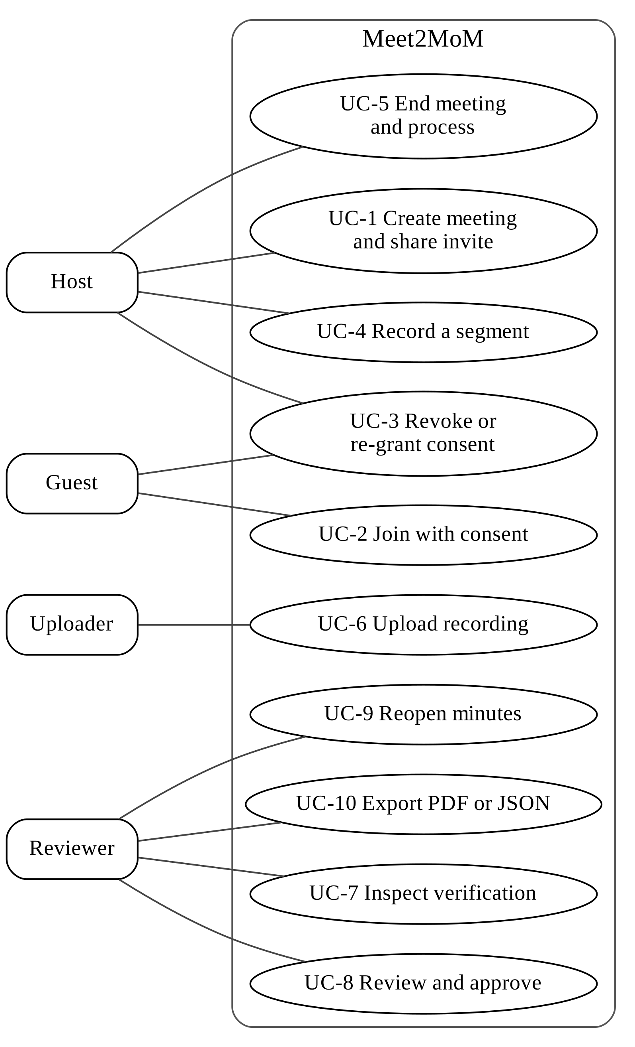
Figure 3.1: Use-case diagram of Meet2MoM.

3.5 System Architecture
Meet2MoM is a single-machine, client–server system (Figure 3.2) with the following parts:
- A React single-page application runs in the browser. It talks to the backend over REST and to LiveKit over WebRTC through the livekit-client library.
- A FastAPI backend serves two routers: /api for meetings, review and export, and /api/live for live meetings, consent and recording. It owns an SQLite database and a per-meeting file store.
- A server-side recorder joins LiveKit rooms as a hidden participant through the LiveKit Python real-time SDK.
- A job runner executes processing either inside the API process (the default inline mode) or in a separate worker process.
- ASR and diarization run in a subprocess, so that their heavy libraries do not stay loaded in the API. Indexing, topics, extraction and verification run in the job runner.
- Local models (Whisper, pyannote, MiniLM embeddings and mDeBERTa NLI) are loaded once per process. The only optional external service is the LLM provider.
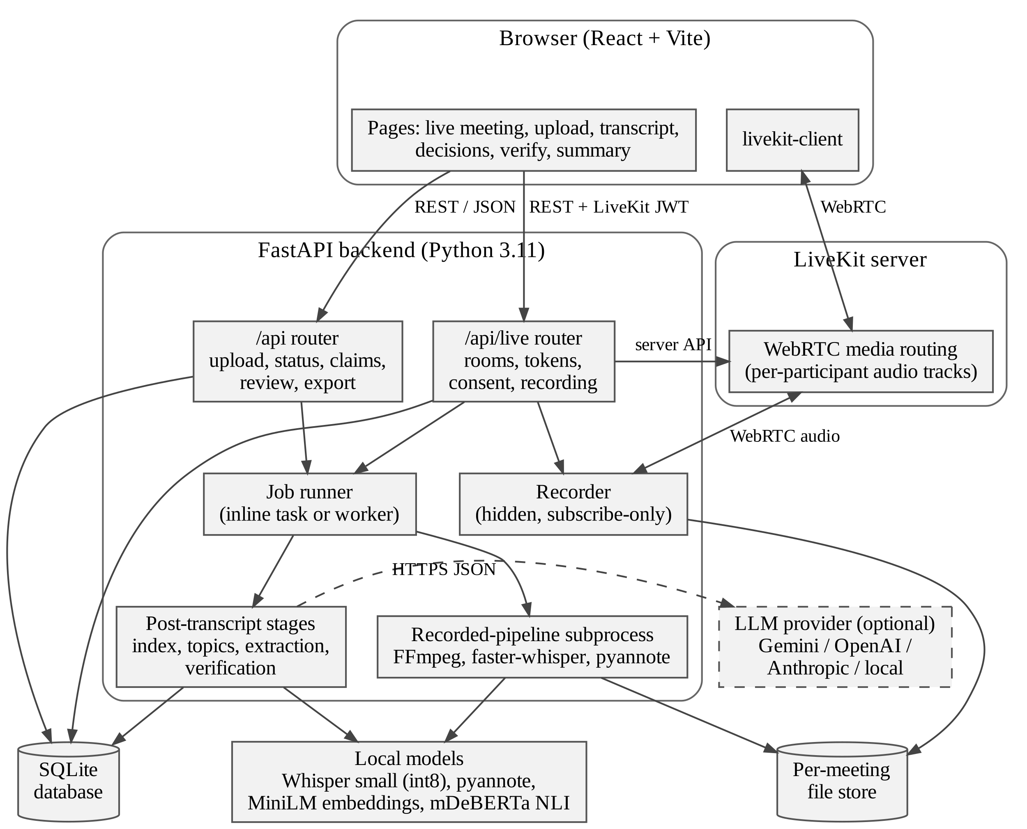
Figure 3.2: System architecture of Meet2MoM.

3.6 Component Responsibilities
Table 3.5: Main components and their source modules.
Component | Responsibility | Main source modules
Frontend workflow | Source selection and the five-step flow (source, transcript, decisions, verify, summary) | App.jsx, MeetingFlowContext.jsx
Live meeting page | LiveKit connection, consent controls, REC state, end and process | LiveMeeting.jsx
Review pages | Transcript, claim verification, review and approval, summary and export | Transcript.jsx, VerifyMeeting.jsx, Summary.jsx
API entry point | Application creation, CORS, start-up recovery, routers | app/api/main.py
Live router | Rooms, tokens, consent, recording, processing, audit | app/api/live_routes.py
Meeting router | Upload, status, transcript, extraction, verification, claims, review, approval, export, PDF | app/api/meeting_routes.py
LiveKit service | Token issue and verification, room management, consent metadata | livekit_service.py
Recorder | Consent-enforcing capture state machine and recording manager | recorder.py, recording_audio.py
Track transcription | Per-participant ASR and merge | track_transcription.py
Recorded pipeline | Audio processing, ASR, diarization, merge, report | run_recorded_pipeline.py, recorded_pipeline_adapter.py
Jobs | Stage orchestration, status, background worker | app/core/jobs.py, scripts/worker.py
Transcript index | Stable utterance rows | transcript_index.py
Extraction | Windows, LLM client, prompts, grounding, local extractors, claim writing | app/services/intelligence/, app/core/llm_client.py
Verification | Deterministic matching, retrieval, NLI, fusion, persistence | app/services/verification/
Persistence | Schema, migrations and queries | app/core/db.py, app/core/storage.py
Configuration | All settings in one place | app/core/config.py

3.7 Data Flow Diagrams
The context diagram (Figure 3.3) shows Meet2MoM as a single process exchanging data with participants, the reviewer, the LiveKit server and the optional LLM provider. The level-1 diagram (Figure 3.4) decomposes the system into eight processes and seven data stores.
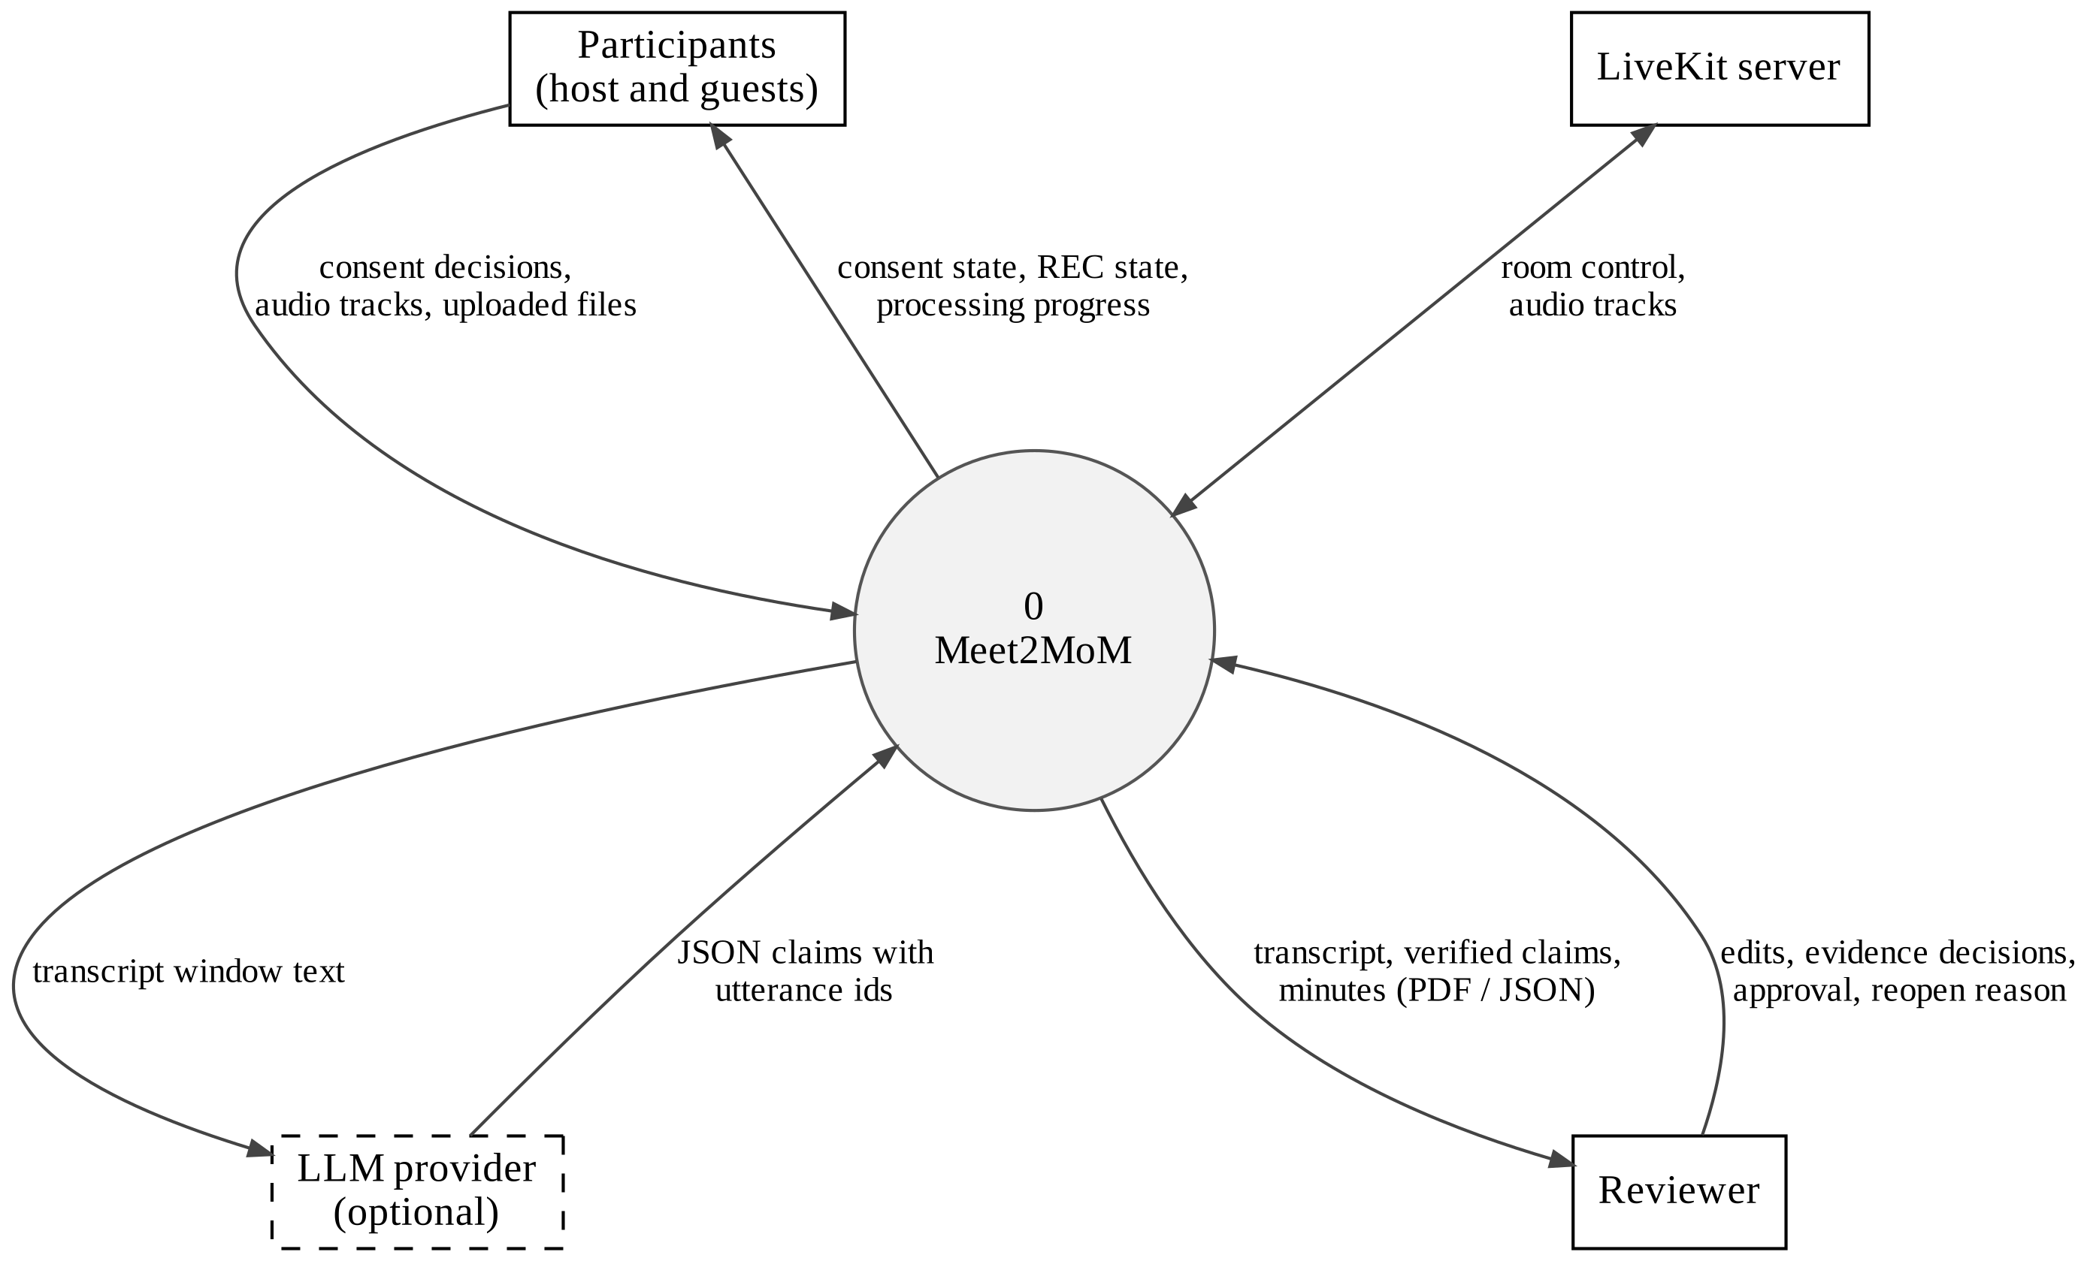
Figure 3.3: Context diagram (DFD level 0).
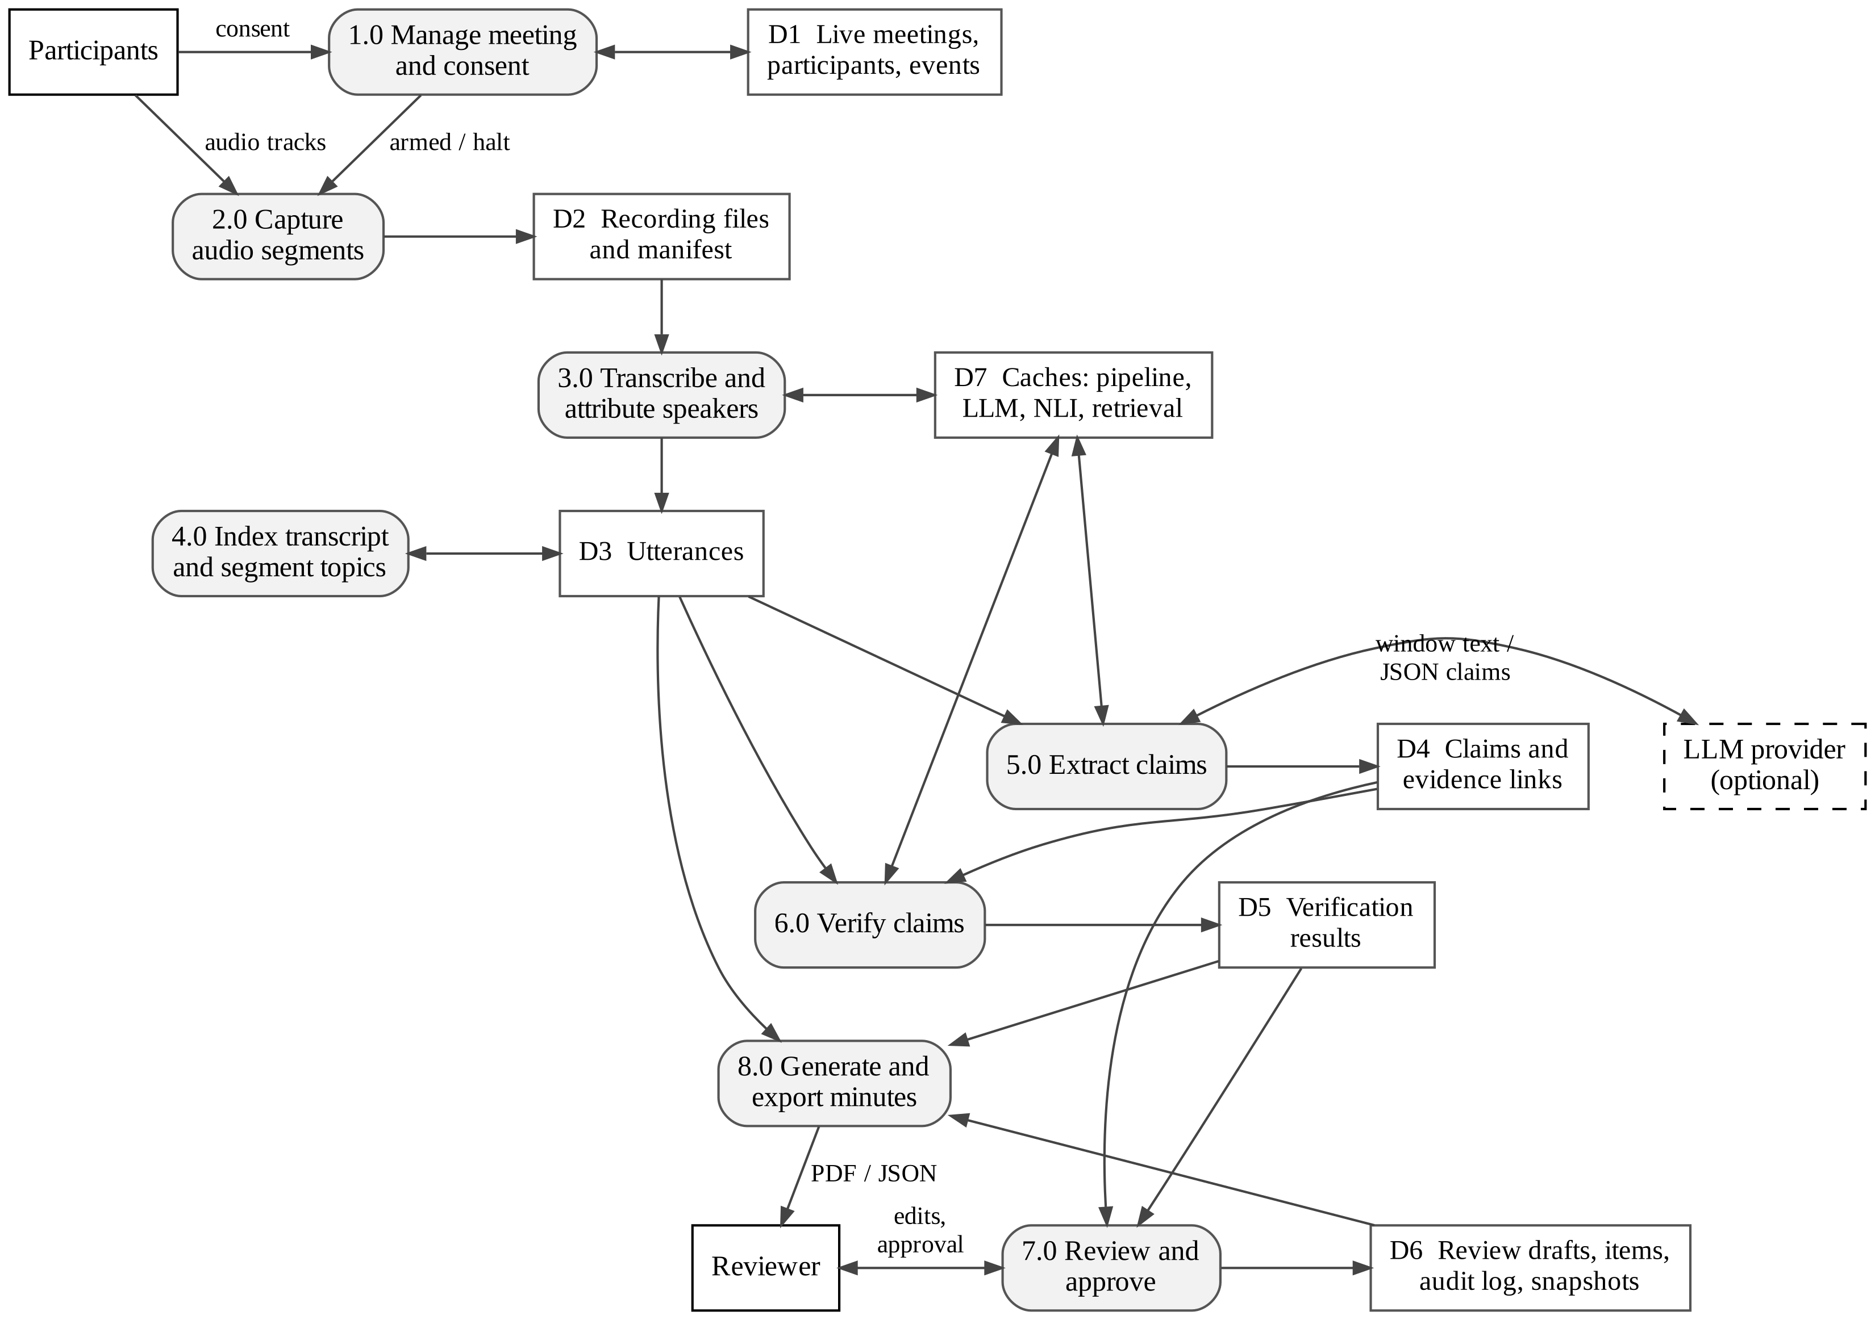
Figure 3.4: Level-1 data flow diagram.

3.8 Sequence Diagrams
Figures 3.5 to 3.8 show the four main interactions of the system: creating and joining a live meeting, consent-gated recording with revocation, processing a recorded meeting, and review, approval and export.
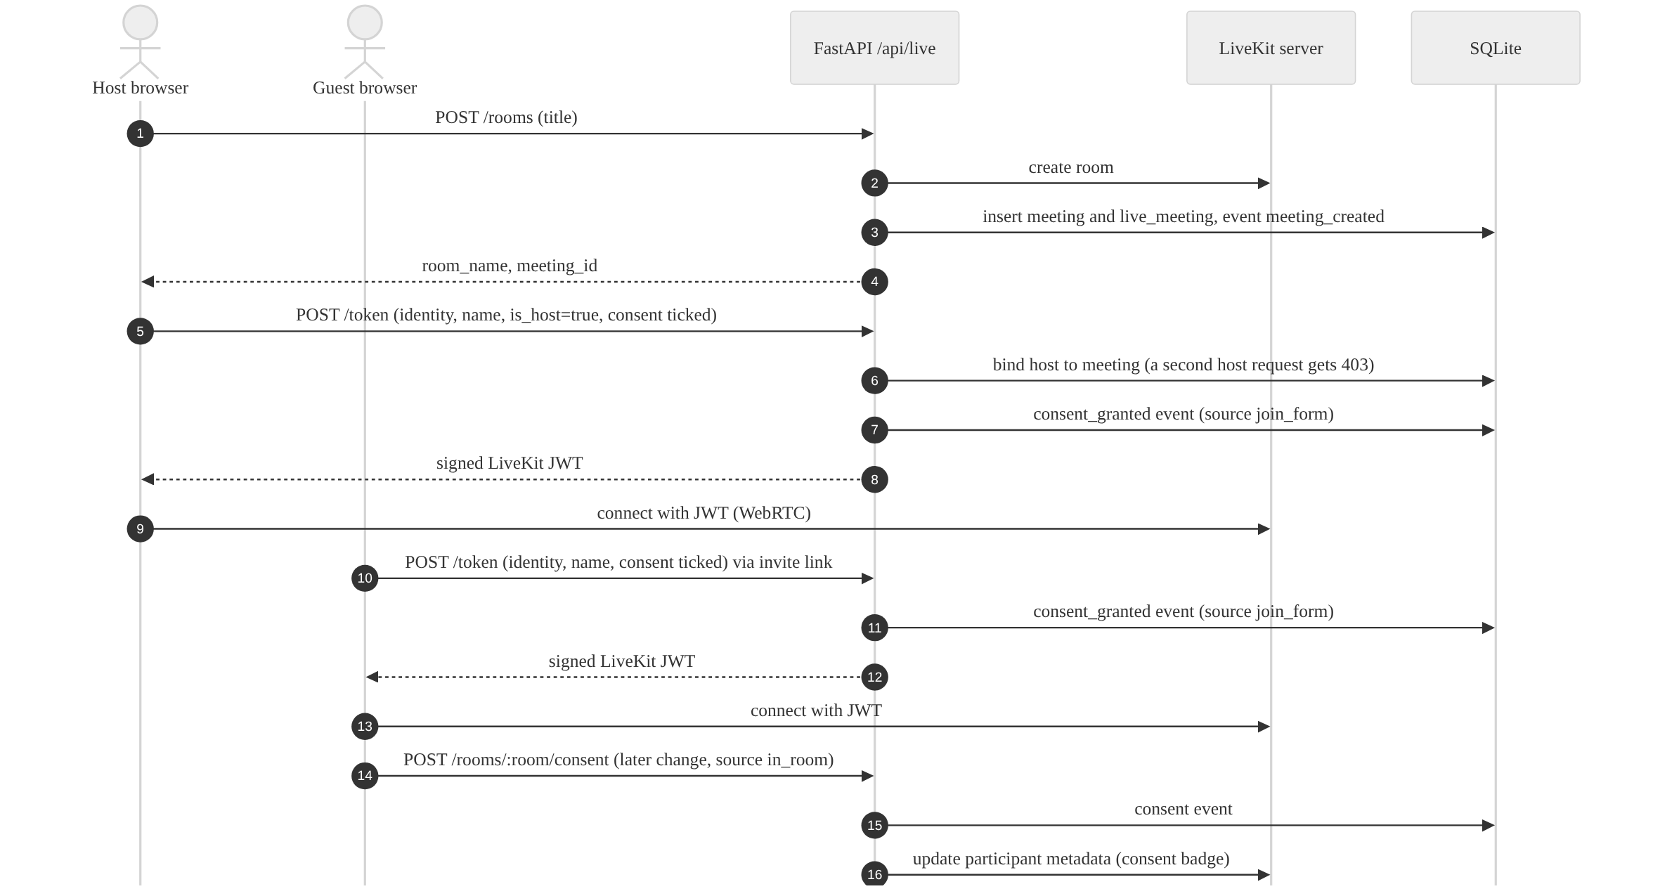
Figure 3.5: Sequence diagram: creating and joining a live meeting.
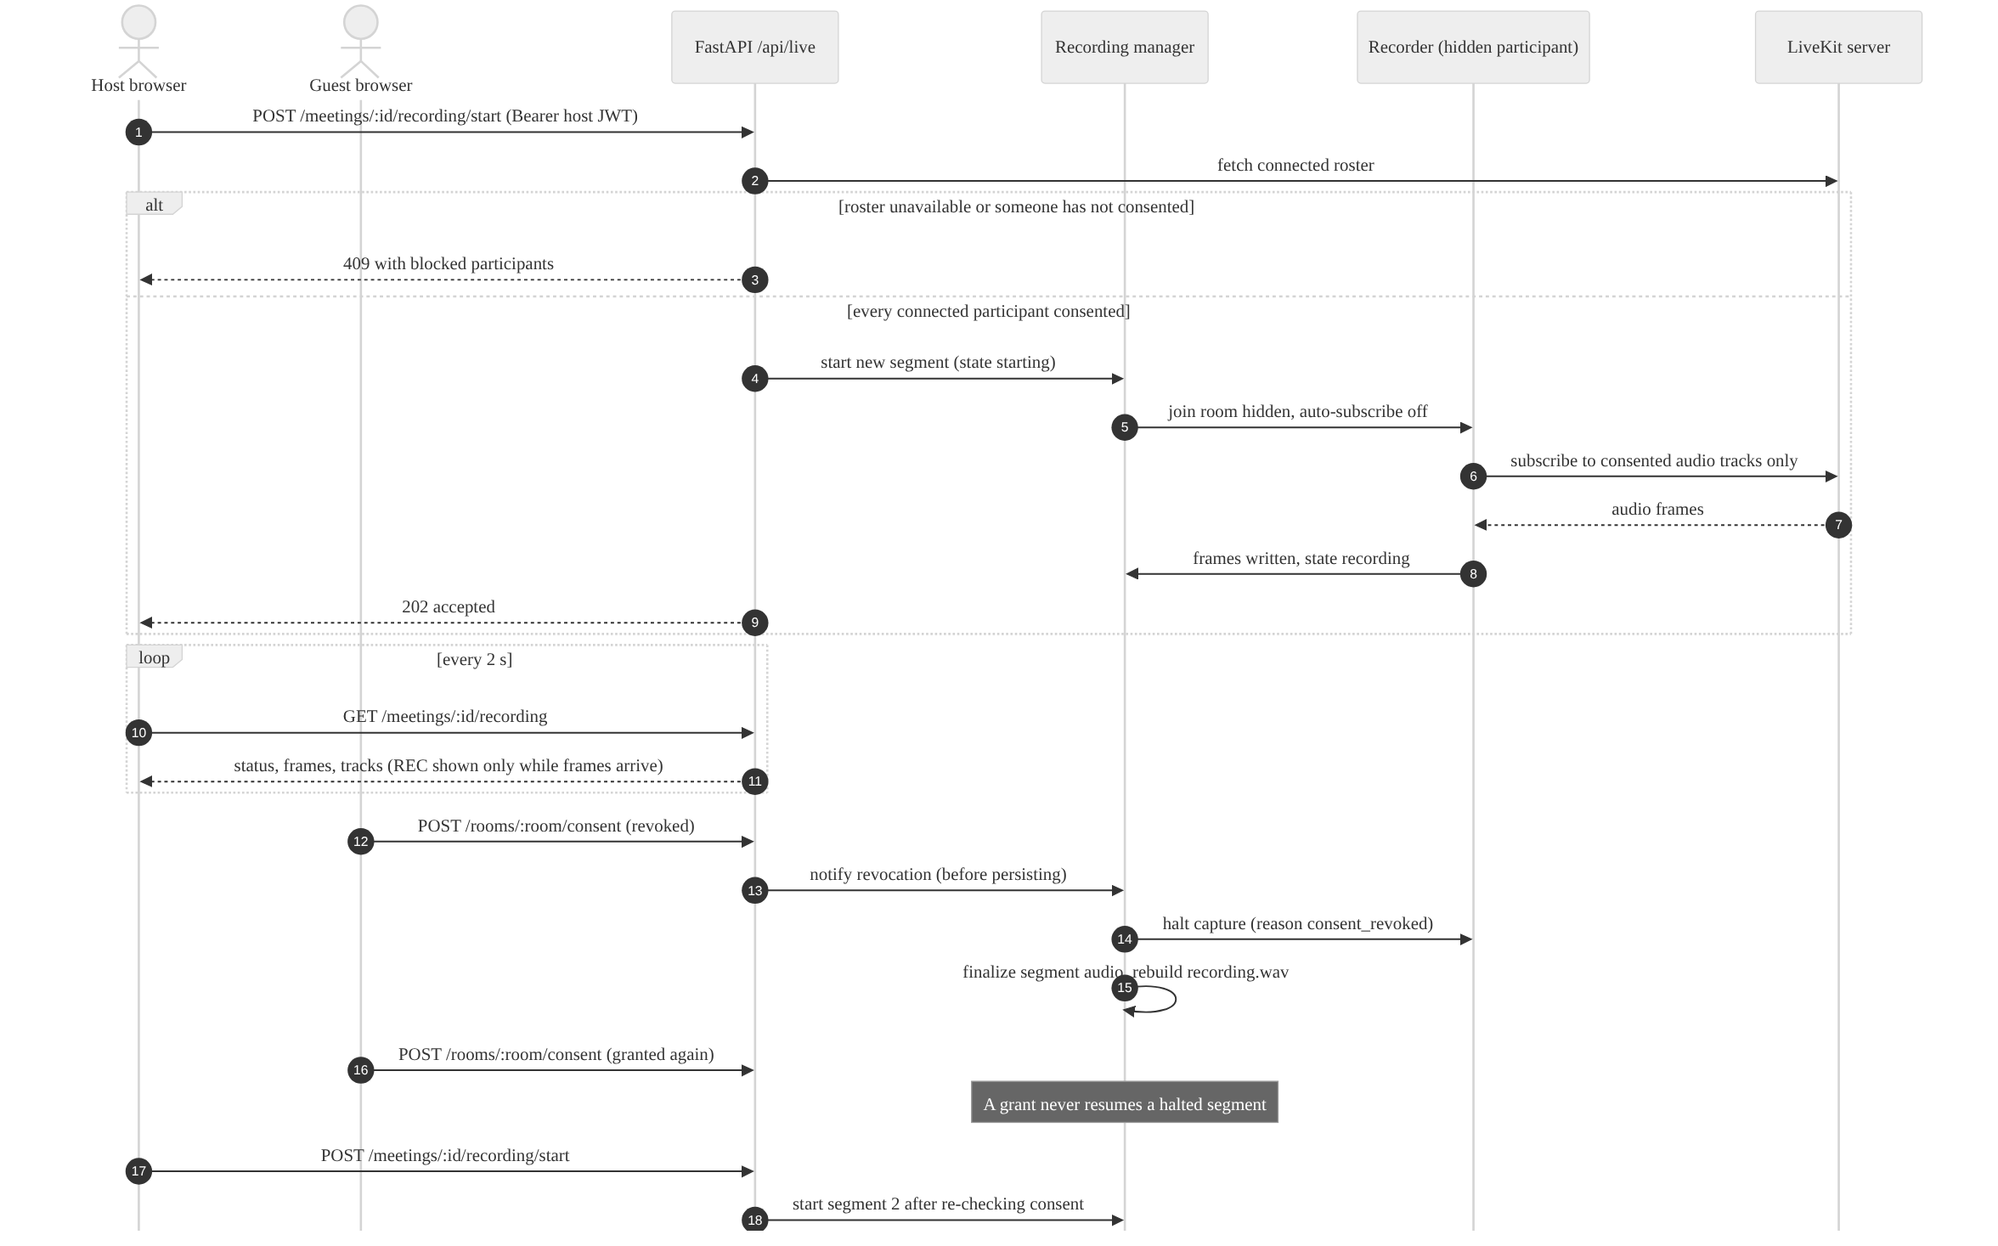
Figure 3.6: Sequence diagram: consent-gated recording and revocation.
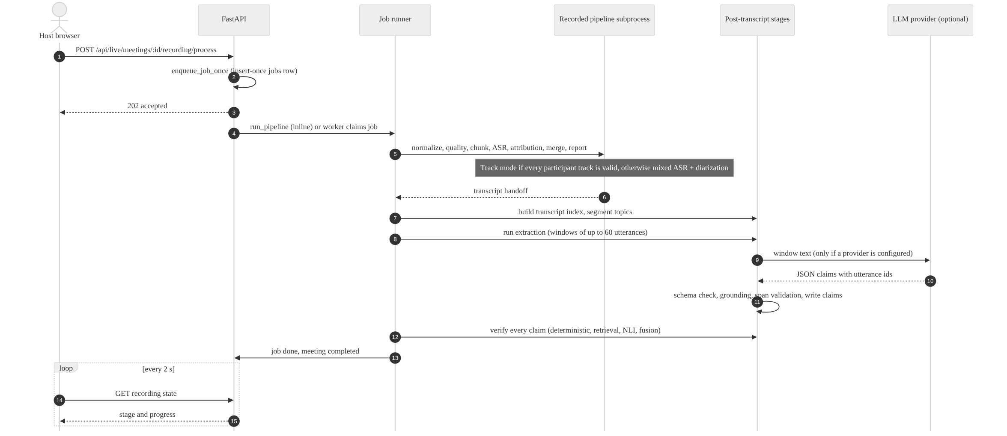
Figure 3.7: Sequence diagram: processing a recorded live meeting.
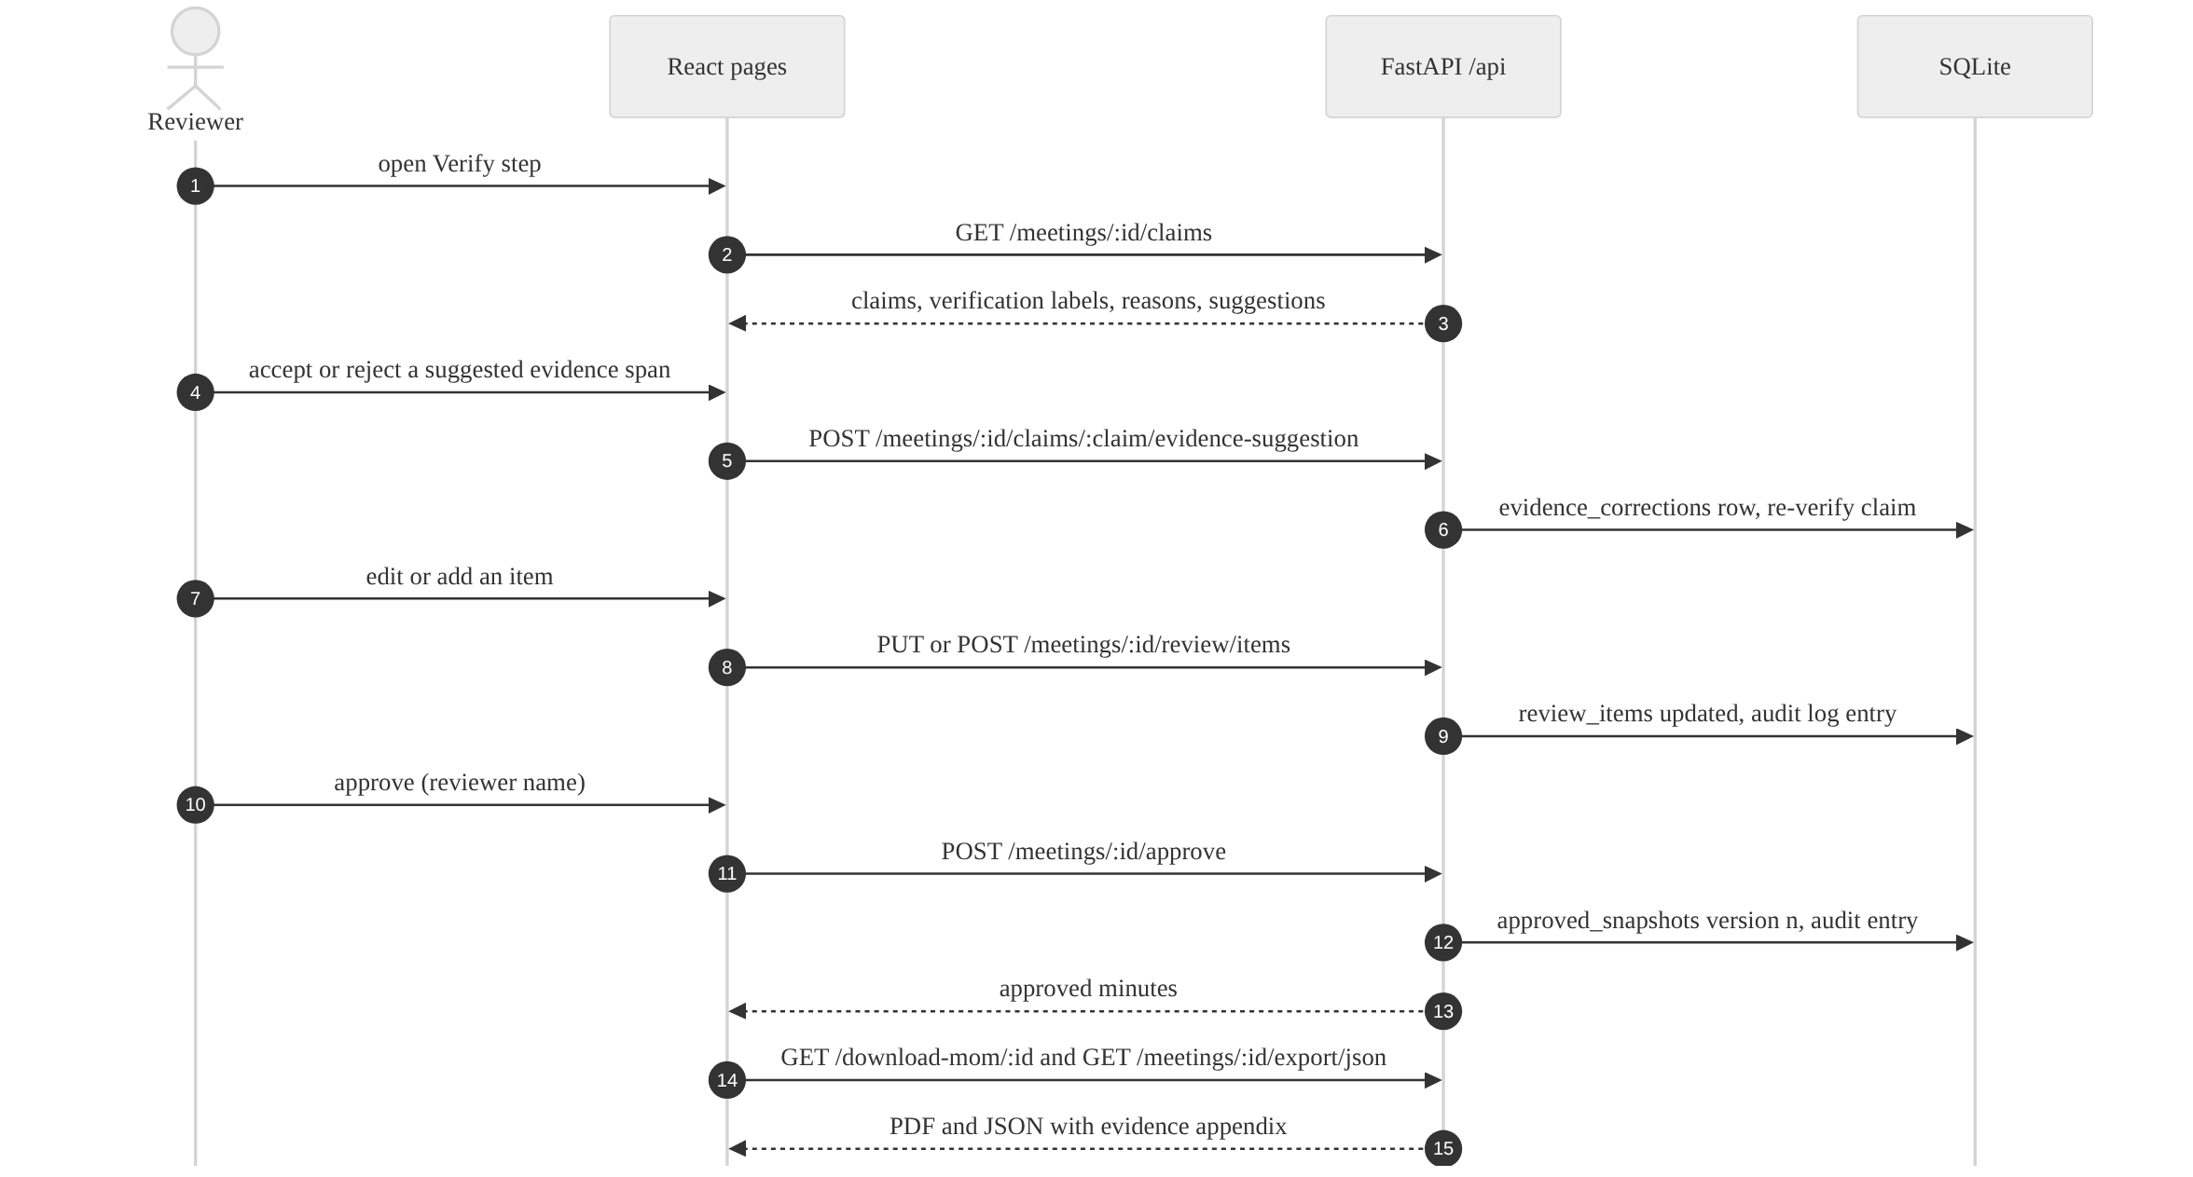
Figure 3.8: Sequence diagram: review, approval and export.

3.9 State Models
Three entities in the system follow explicit state machines: recording segments (Figure 3.9), processing jobs (Figure 3.10) and review drafts (Figure 3.11). A segment left in a non-terminal state by a crashed process is finalized at the next start-up with the stop reason "interrupted", and a halted segment never returns to the recording state.
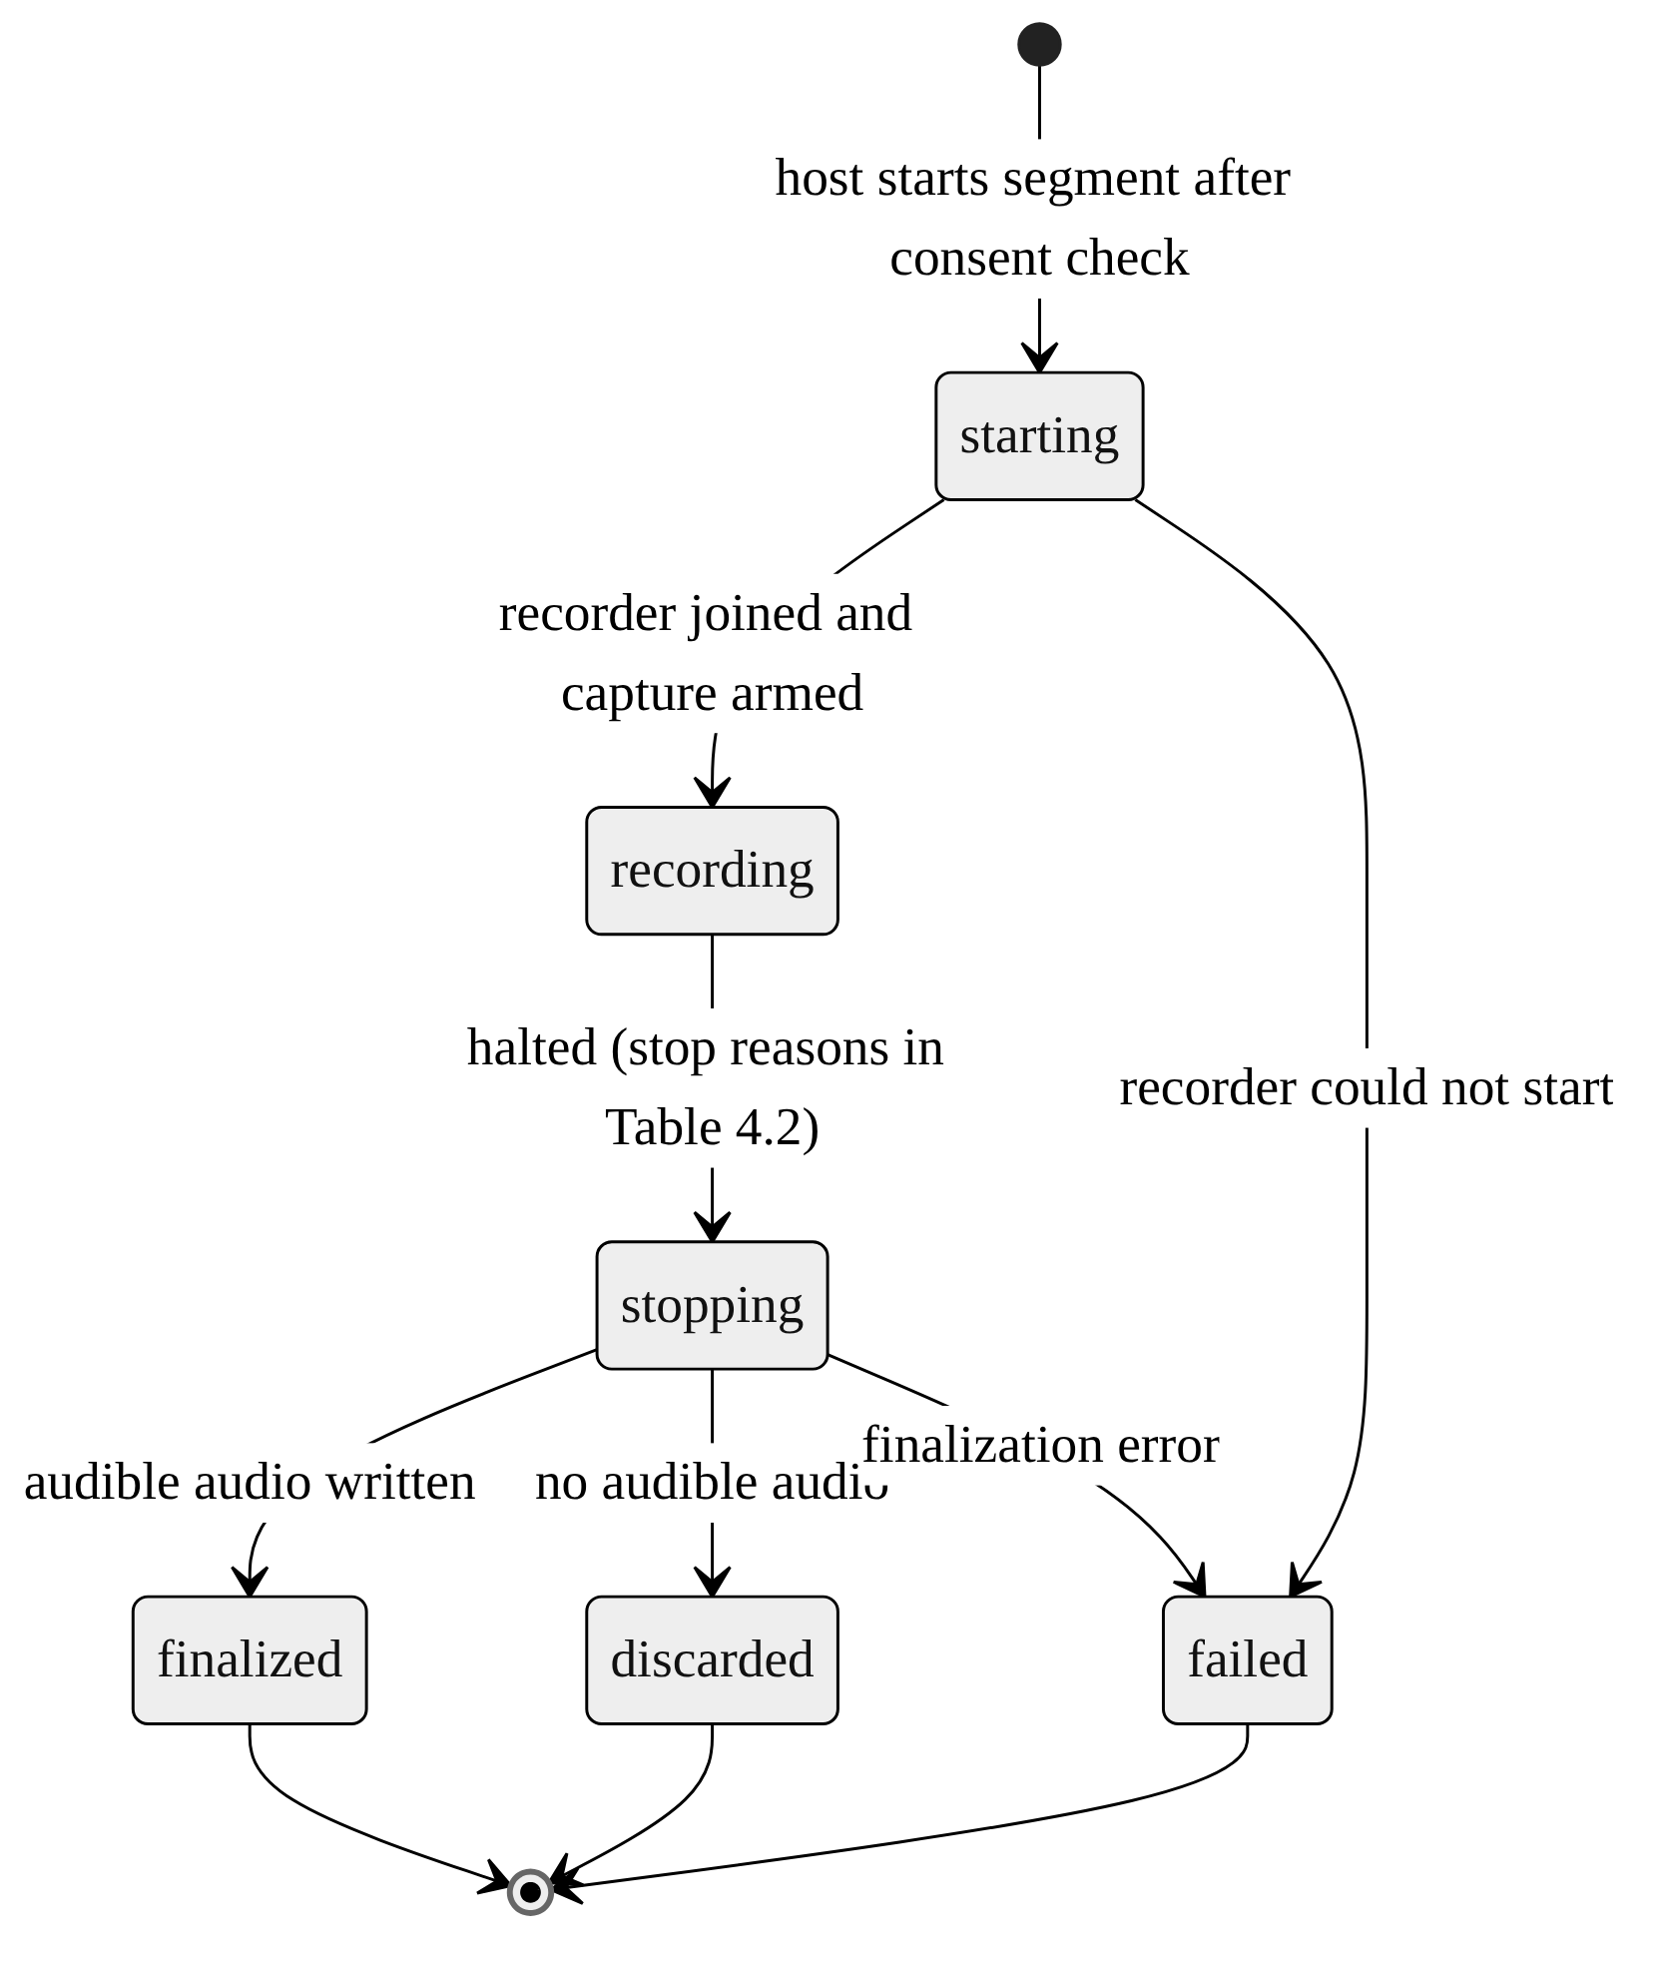
Figure 3.9: State diagram of a recording segment.
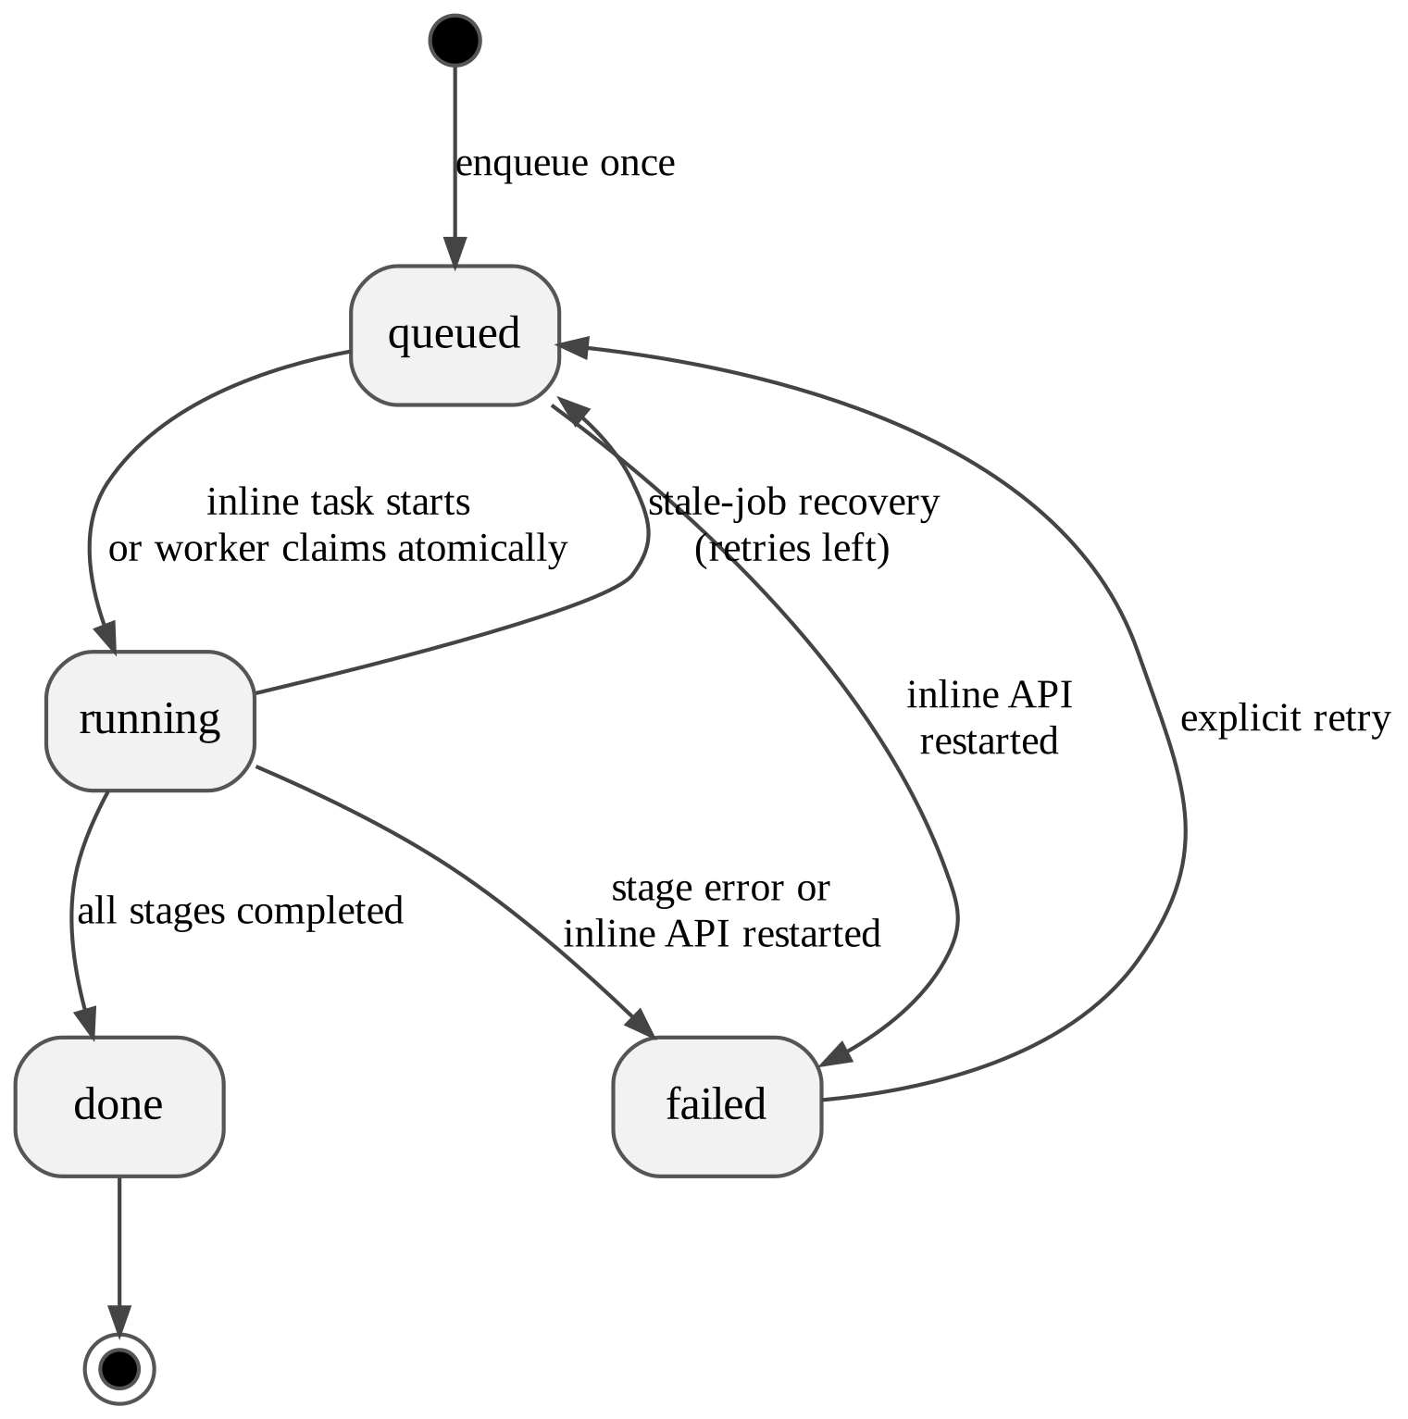
Figure 3.10: State diagram of a processing job.
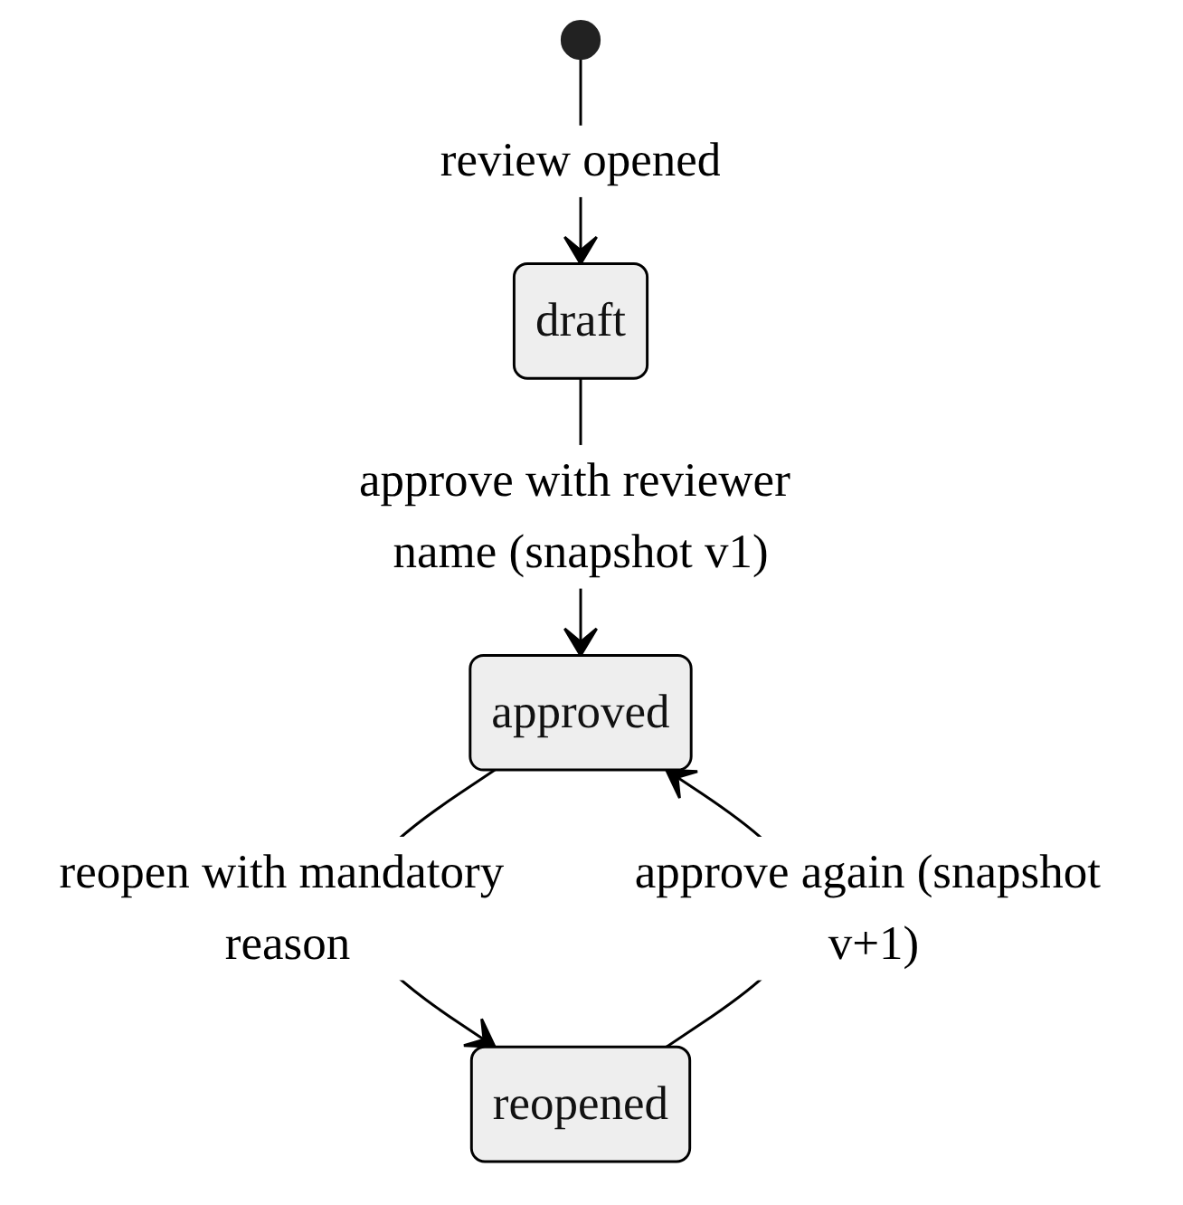
Figure 3.11: State diagram of a review draft.

3.10 Database Design
The database is SQLite. Foreign keys are enabled, and the schema is upgraded by numbered migrations tracked in the database's user-version field. The current schema version is 3:
- the base schema holds meetings, utterances, claims, evidence links, dropped claims and jobs;
- version 1 adds extraction and verification records;
- version 2 adds review drafts, review items, the audit log and approved snapshots; and
- version 3 adds live meetings, participants, events and recording segments.
Figure 3.12 shows the core entities, which hold the transcript, the claims and their verification. Figure 3.13 shows the entities for review and live meetings. Relationships drawn between tables are declared foreign keys, except three that are enforced by application code: the meeting of a job, the meeting of a live event and the original claim of a review item. Full column lists are given in Appendix D.
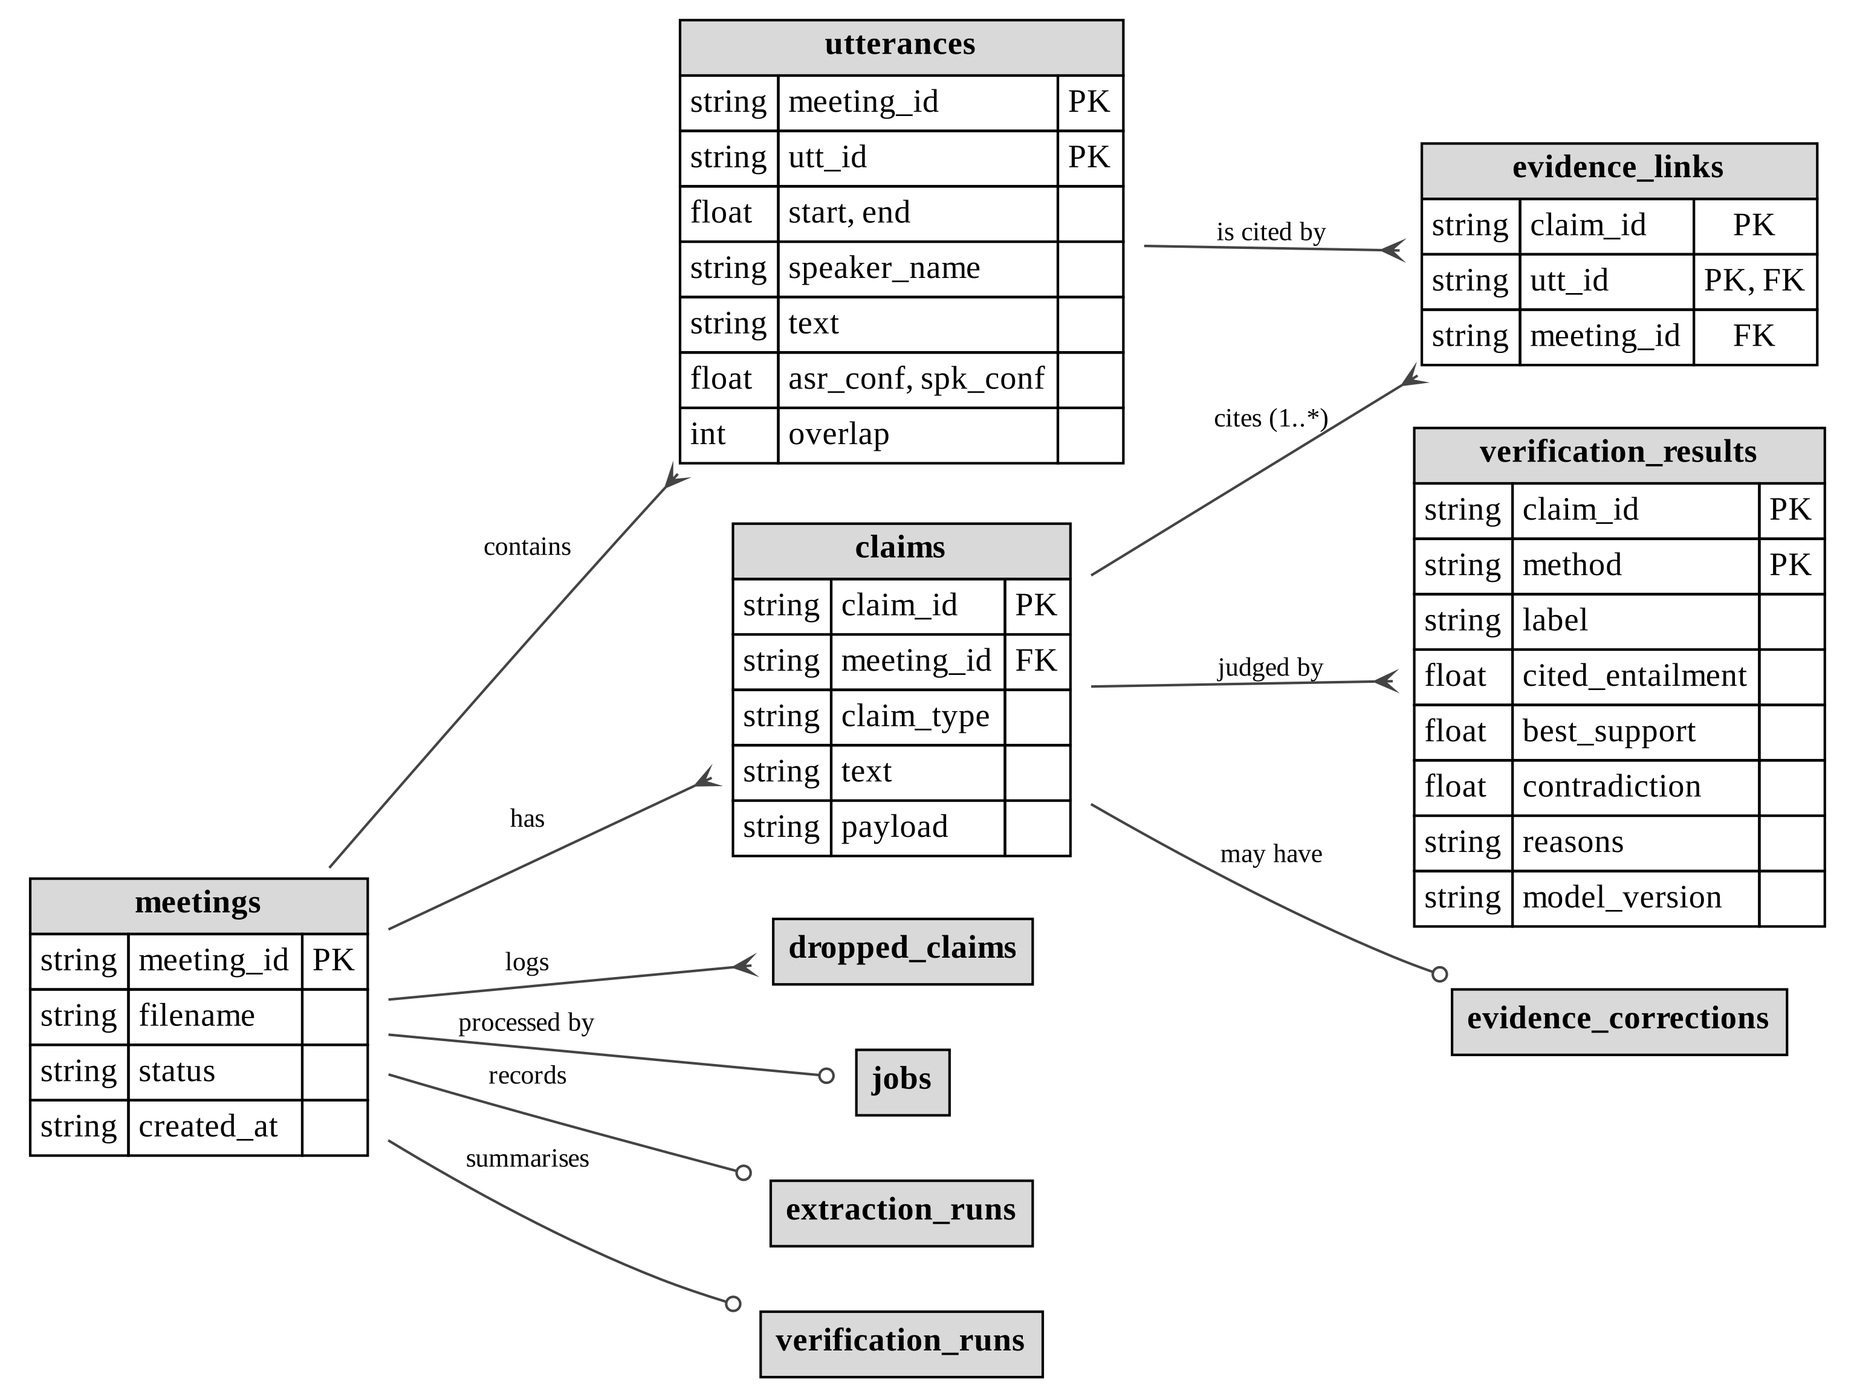
Figure 3.12: Entity–relationship diagram: transcript, claims and verification.
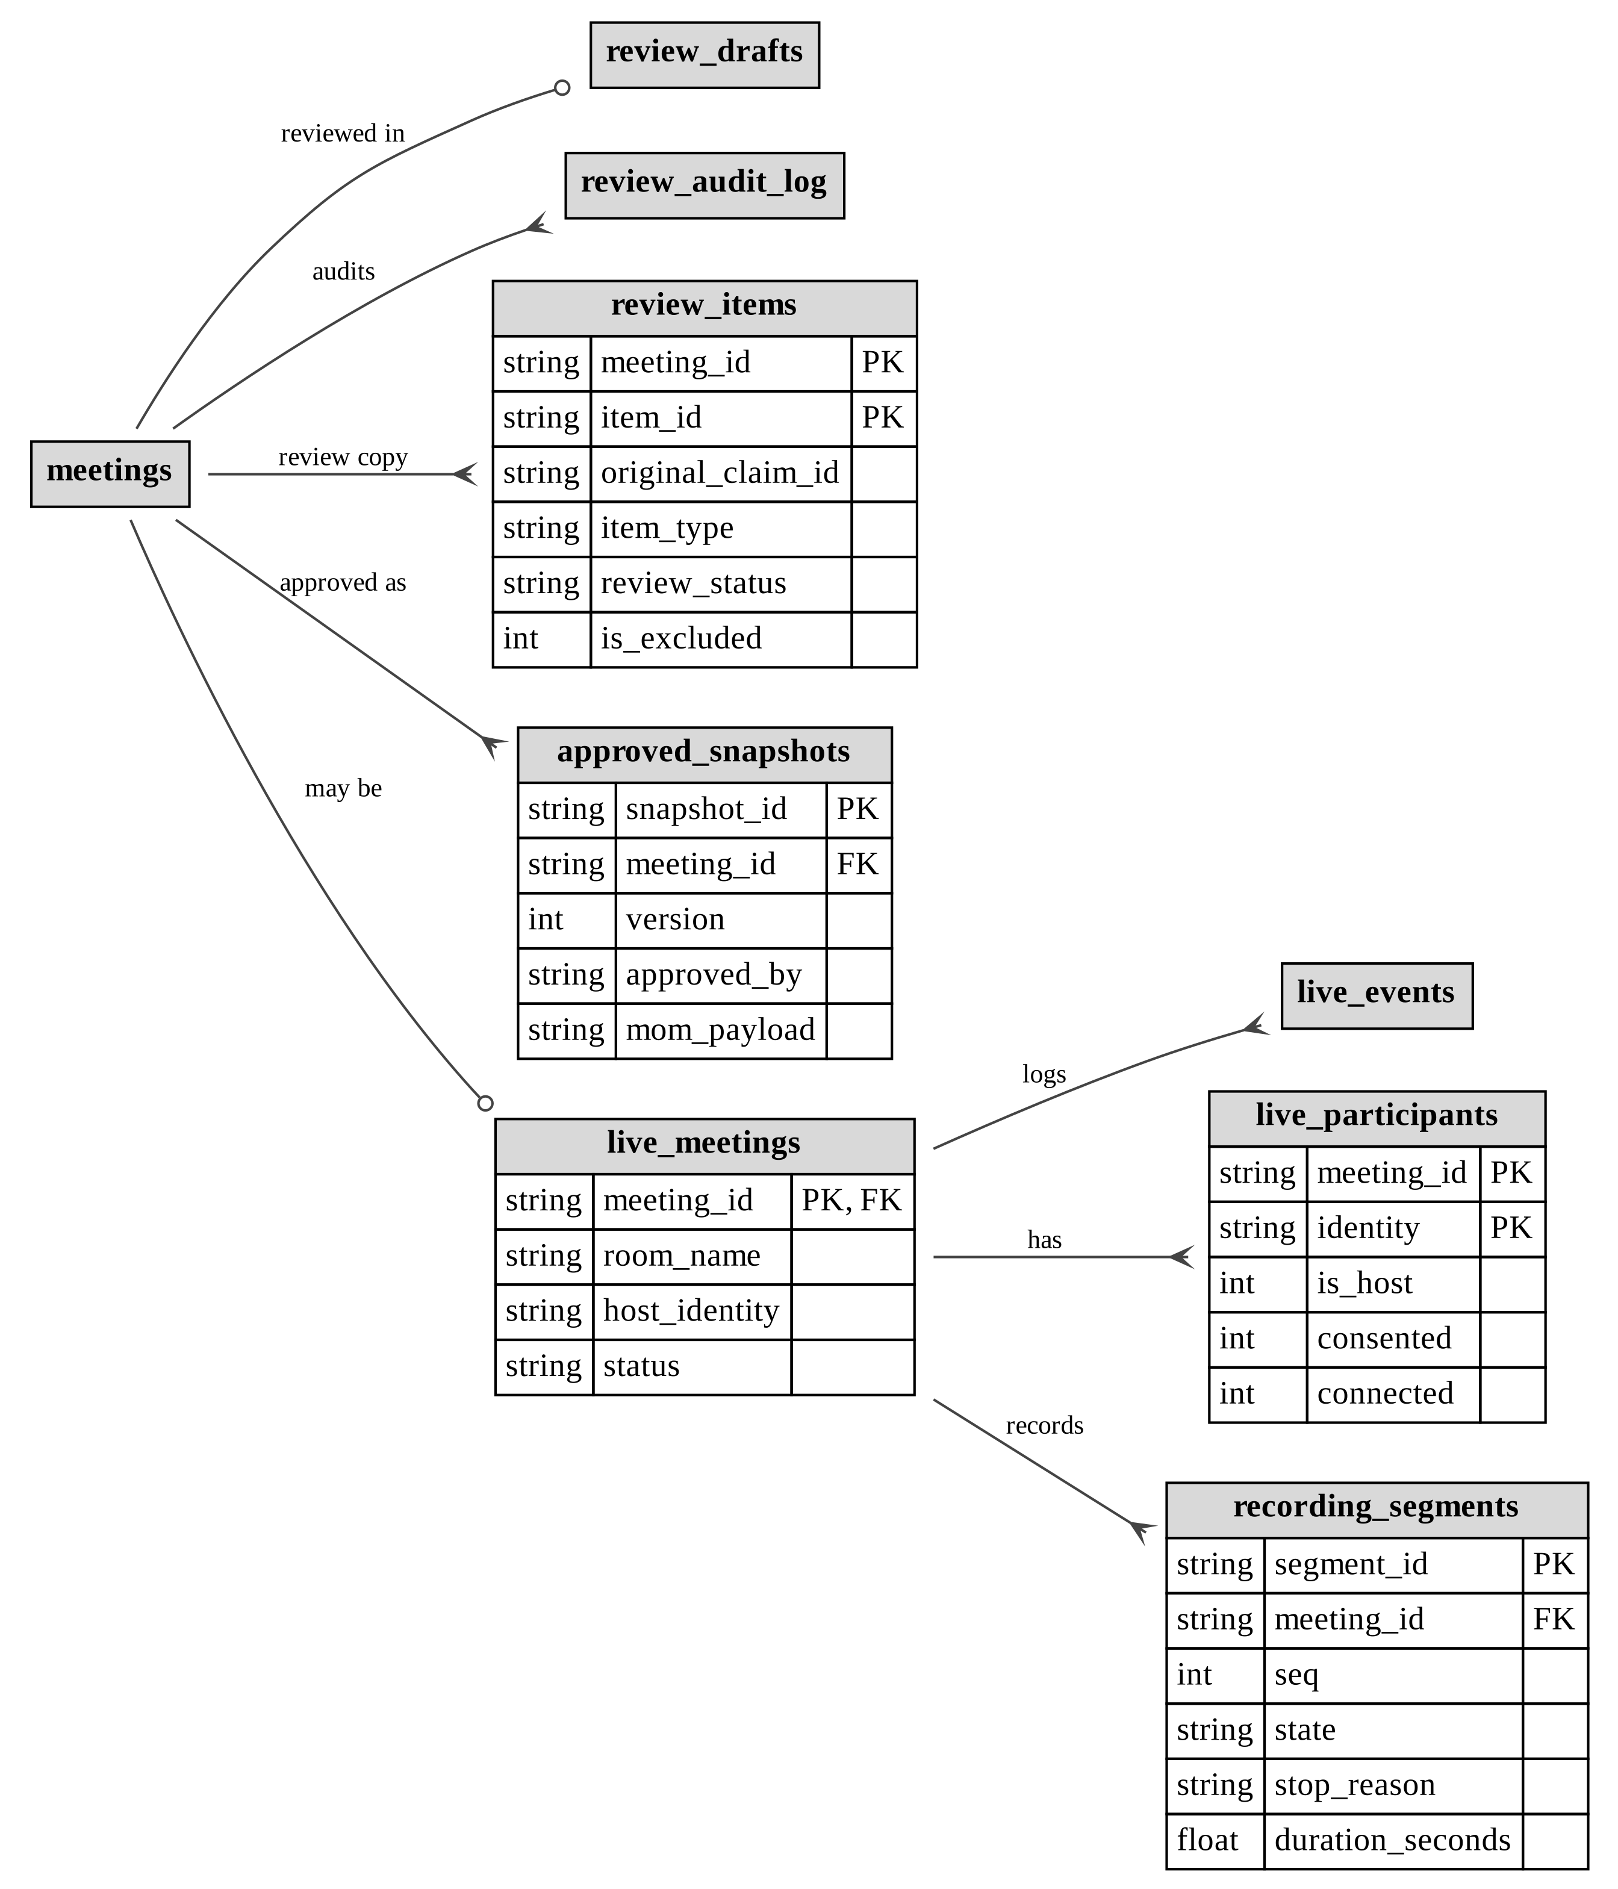
Figure 3.13: Entity–relationship diagram: review and live meetings.
Three integrity rules are enforced by the database itself:
- The evidence-links table has a composite foreign key to the utterances table, with deletion restricted. A claim therefore cannot cite an utterance that does not exist. This is the rule the project calls "no span, no claim".
- A partial unique index on recording segments, limited to the states starting, recording and stopping, allows at most one active segment per meeting.
- CHECK constraints restrict review states (draft, approved, reopened) and review-item statuses (original, edited, added, rejected and accepted from held).
Large or transient artefacts are kept as files in a folder per meeting rather than in the database: audio, chunks, transcripts, topics, extraction output, verification caches, and the minutes in JSON and PDF form.

3.11 Technology Stack and Rationale
Table 3.6 lists the technologies used, their versions and the reason each was chosen.
Table 3.6: Technology stack.
Layer | Technology (version) | Reason for choice
Frontend framework | React 19, Vite 8 | Component model for a multi-step workflow; fast development server [39], [40]
Real-time media (browser) | livekit-client 2.x | Official LiveKit browser SDK; one WebRTC track per participant [41]
Real-time media (server) | LiveKit server; livekit 1.1.21 and livekit-api 1.2.1 Python SDKs | Server-side subscription to individual tracks; JWT access tokens [16], [42]
Backend API | FastAPI 0.104.1, Uvicorn 0.24.0, Pydantic 2.12.5 | Typed request models, background tasks, OpenAPI documentation [43]
Database | SQLite | Zero administration; transactions, foreign keys and partial indexes [44]
Audio processing | FFmpeg | Format conversion, filtering and loudness normalisation [45]
ASR | faster-whisper 1.2.1 (Whisper small, int8) | Whisper accuracy at CPU-friendly speed [5], [6]
Diarization | pyannote.audio 4.0.7 (speaker-diarization-community-1) | Open, maintained diarization pipeline [12], [14]
Deep-learning runtime | PyTorch 2.11.0, Transformers 5.16.1 | Runs the NLI and diarization models [46], [47]
Embeddings | sentence-transformers 6.0.1 (paraphrase-multilingual-MiniLM-L12-v2) | Multilingual sentence embeddings for retrieval, topics and the dialogue model [36], [37]
Lexical retrieval | rank-bm25 0.2.2 | BM25 scoring for hybrid retrieval [38], [48]
NLI | mDeBERTa-v3-base-mnli-xnli | Multilingual entailment and contradiction scores [33]
Classical machine learning | scikit-learn 1.6.1 | TF-IDF topic titles, cosine similarity [49]
Fuzzy matching | rapidfuzz 3.14.6 | Bleed de-duplication and deadline grounding [50]
Dates | python-dateutil 2.9.0 | Resolving spoken deadlines to dates
PDF | ReportLab 4.4.10 | Programmatic, paginated A4 minutes with tables [51]
LLM (optional) | Gemini REST API through the Python standard library | No extra SDK dependency; provider-agnostic client [25]
Testing | pytest 9.0.2, Vitest 5, Testing Library, jsdom | Backend and frontend automated tests [52], [53]

3.12 Feasibility Study
Before implementation, the project was assessed from four points of view.
Technical feasibility. Every component needed — speech recognition, diarization, sentence embeddings, NLI, a WebRTC media server and a PDF generator — is available as mature open-source software that runs on a CPU. The main technical risks were processing speed on ordinary laptops and the reliability of diarization on short, overlapping speech. Both were addressed during development: quantised ASR runs faster than real time, the NLI verifier was optimised, and live meetings use per-participant tracks instead of diarization (Sections 4.7 and 5.8).
Economic feasibility. The system has no licence cost. All local models and libraries are open source, the LiveKit media server can be self-hosted, and the system runs on the team's existing laptops. The only optional running cost is an external LLM, which is billed per use; without it, the local extractors produce the minutes at no cost.
Operational feasibility. Participants join a live meeting from a web browser through an invite link, without installing software or creating an account. The organiser follows a guided five-step workflow, and the reviewer keeps the final say over the minutes, which matches how formal minutes are approved in practice.
Legal and ethical feasibility. Recording is gated by the explicit, server-enforced consent of every connected participant and stops immediately when anyone withdraws, in line with the consent principles discussed in Section 2.11. Meeting data stays on the local machine unless an external LLM is configured, and only transcript text — never audio — is sent to it.

3.13 Hardware and Software Requirements
Table 3.7 lists the hardware on which the system was developed and tested, and the configuration recommended for comfortable use. Table 3.8 lists the software requirements.
Table 3.7: Hardware requirements.
Component | Tested configuration | Recommended
Processor (host machine) | AMD Ryzen 3 3250U (2 cores, 4 threads); Intel Core i5-1155G7 (4 cores, 8 threads) | 4 or more cores
Memory (host machine) | About 18 GB | 16 GB or more
GPU | Not required | Not required
Storage | Local SSD | Space for the models, the Python environment and recordings
Participant devices | Laptops with a web browser and microphone | Any device with a modern WebRTC browser and a microphone
Network | Local network and internet connection | Stable connection between participants and the LiveKit server

Table 3.8: Software requirements.
Software | Version or detail | Purpose
Operating system | Windows 11 (tested) | Host machine
Python | 3.11 | Backend, pipeline and models
Node.js and npm | 22.13.1 and 10.9.2 (tested) | Frontend build and development server
FFmpeg | On the system path | Audio conversion, filtering and normalisation
LiveKit server | Self-hosted or hosted | WebRTC media routing for live meetings
Python packages | As listed in requirements.txt (Table 3.6) | FastAPI, faster-whisper, pyannote.audio, Transformers and others
Hugging Face access token | Account with the pyannote model conditions accepted | Download of the gated diarization model
Web browser | Chrome, Edge or Firefox | User interface and live meetings
LLM API key (optional) | Gemini, OpenAI, Anthropic or a local server | Optional LLM extraction

3.14 Development Phases and Gates
The project was developed in phases, each closed by an acceptance gate that had to be met before the next phase began (Section 1.5). Figure 3.14 shows the phases and the gate criterion of each.
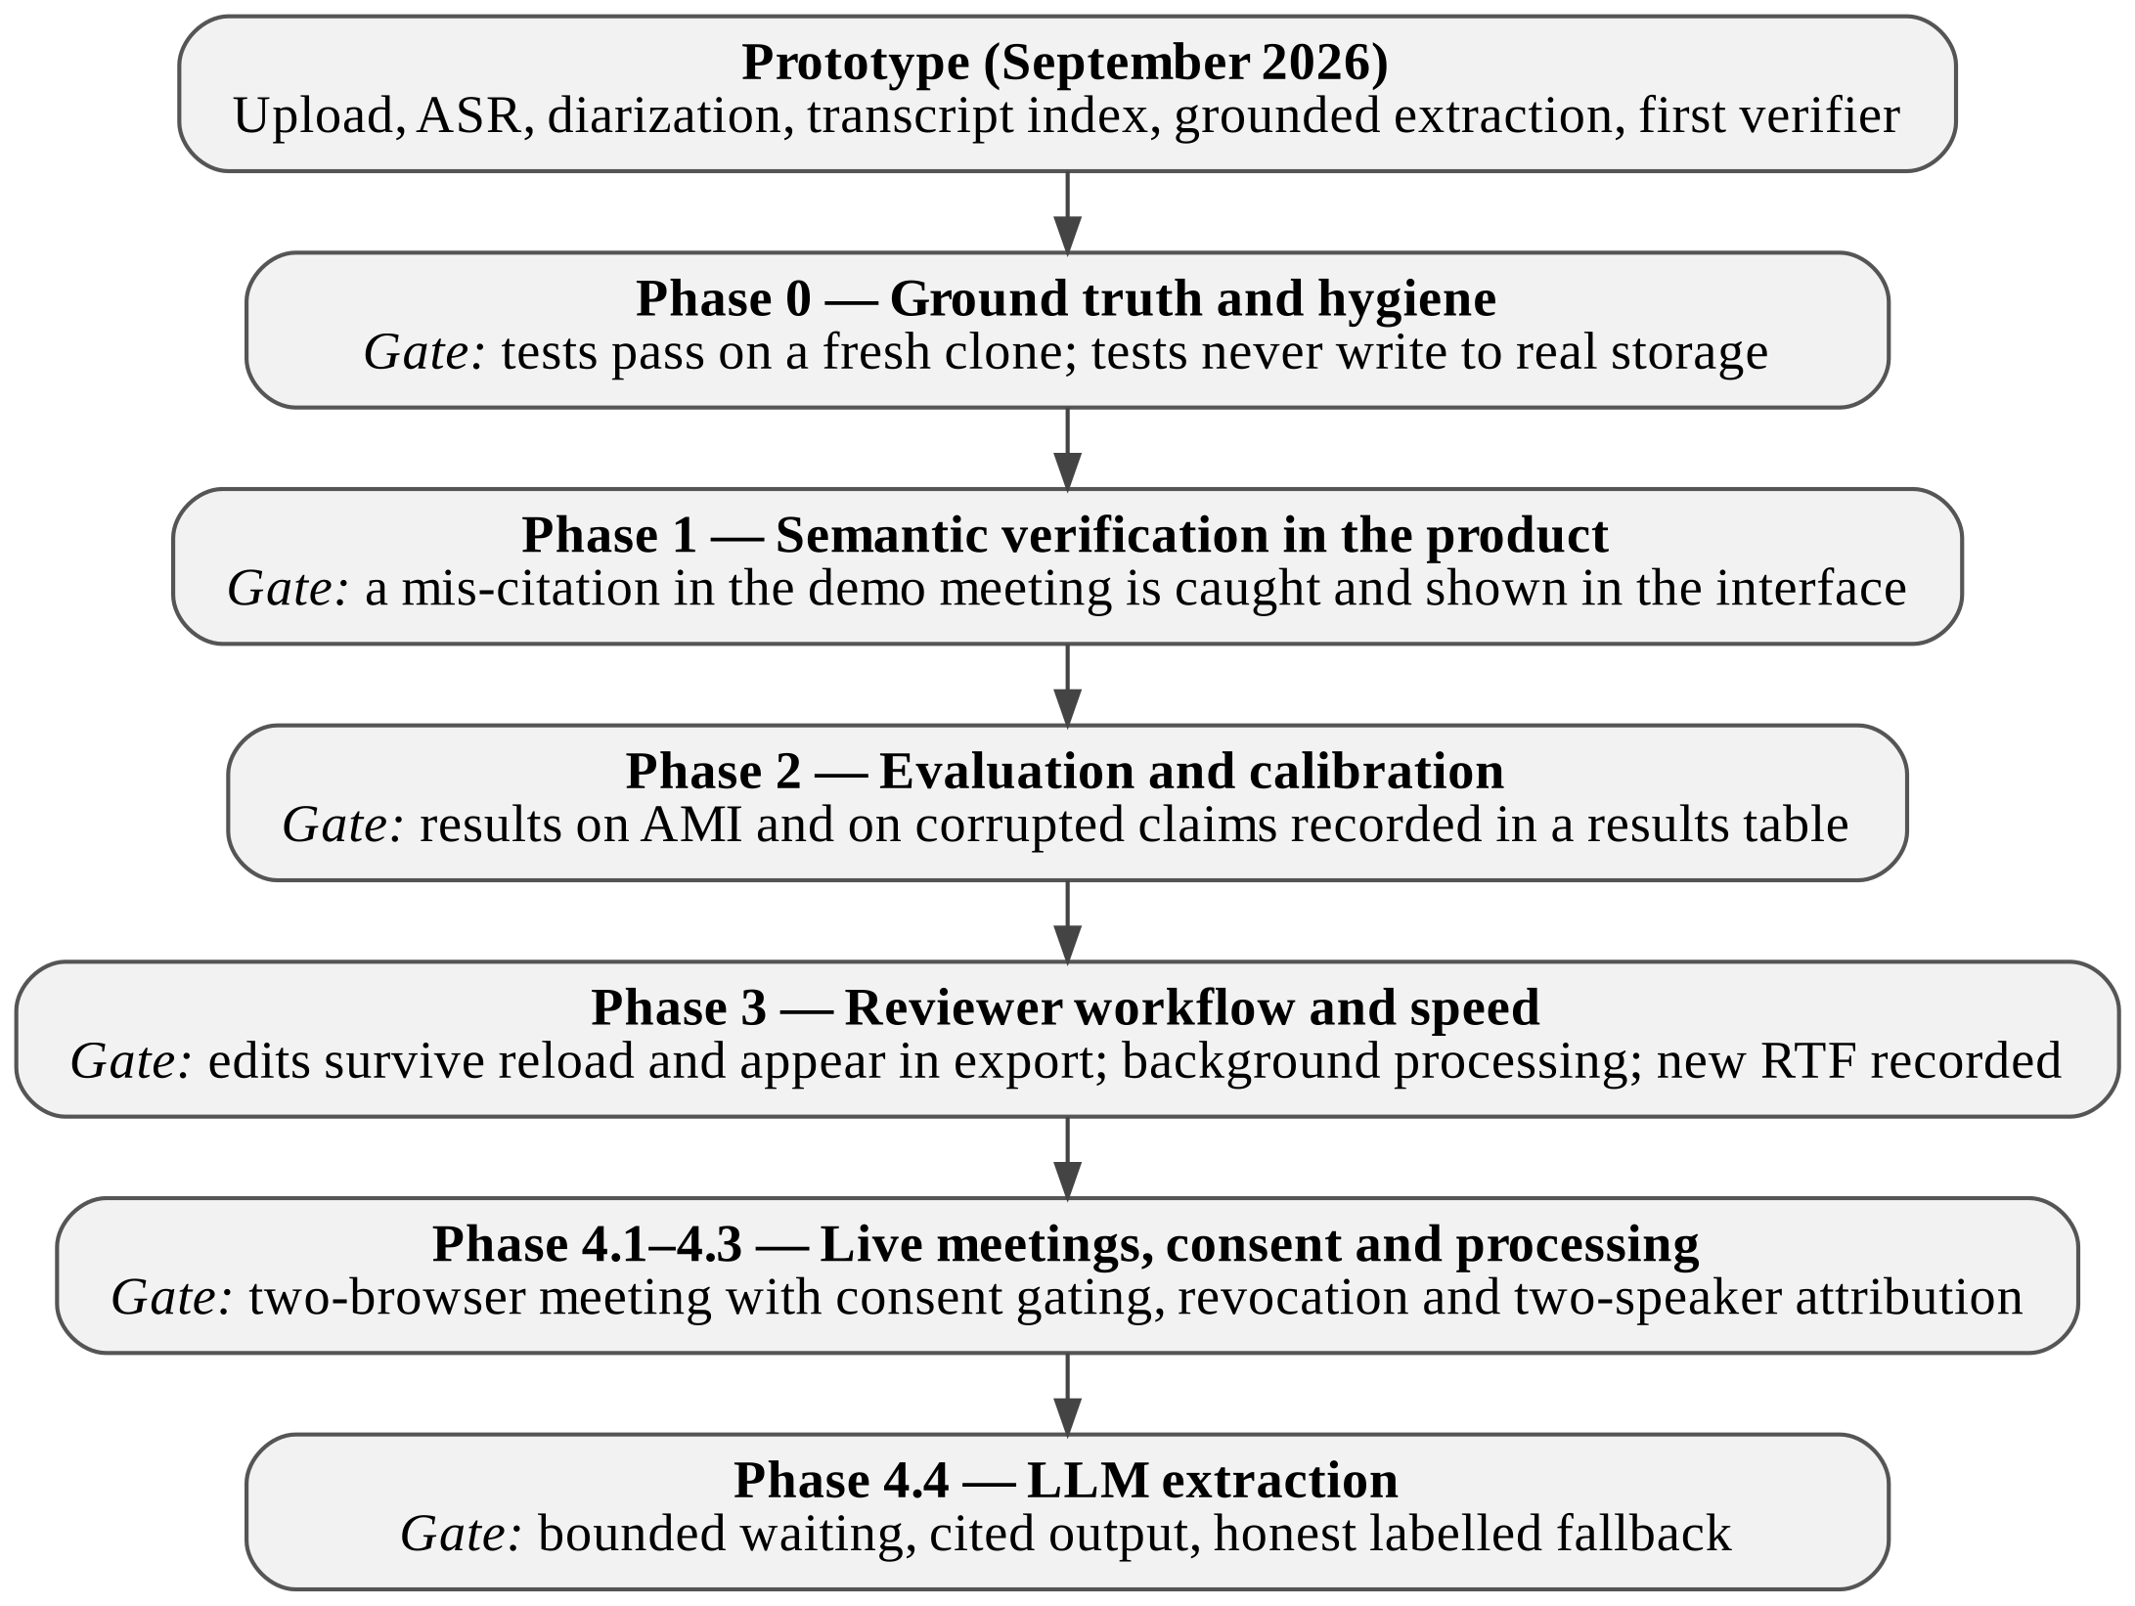
Figure 3.14: Development phases and their acceptance gates.

Chapter 4: Implementation
This chapter describes how the design in Chapter 3 is implemented. Code excerpts are short and simplified, and each names the module it comes from.

4.1 Repository Structure
Table 4.1: Top-level repository layout (generated folders such as storage, node_modules and the virtual environment are excluded).
Path | Contents
app/api/ | FastAPI application and the two routers (meeting routes and live routes)
app/core/ | Configuration, database, storage paths, job orchestration, LLM client, model registry, pipeline cache
app/schemas/ | Pydantic models for utterances, claims, jobs and verification
app/services/ | Ingestion, transcription, diarization, live meetings, transcript index, intelligence (extraction), verification, pipeline and reporting
scripts/ | Recorded-pipeline runner, background worker, ASR benchmark, report and clean-up utilities
evaluation/ | Evaluation harness, AMI loader, dialogue-model training, fusion calibration scripts, annotations
frontend/src/ | React pages, components, context, API client and Vitest tests
tests/ | Backend pytest suites, fixtures and fakes
docs/ | Phase reports and benchmark reports

The backend contains about 24,700 lines of Python under the app and scripts folders. The frontend contains about 12,500 lines under frontend/src, including styles and tests.

4.2 Frontend Architecture and Meeting Workflow
The frontend is a React single-page application built with Vite. A context provider (MeetingFlowContext) holds the current meeting and step. The application first asks for the meeting source and then shows a five-step flow (Figure 4.1). A link containing a room parameter opens live-meeting mode directly, so an invite link takes a guest straight to the join form. All HTTP calls go through a single API client module.
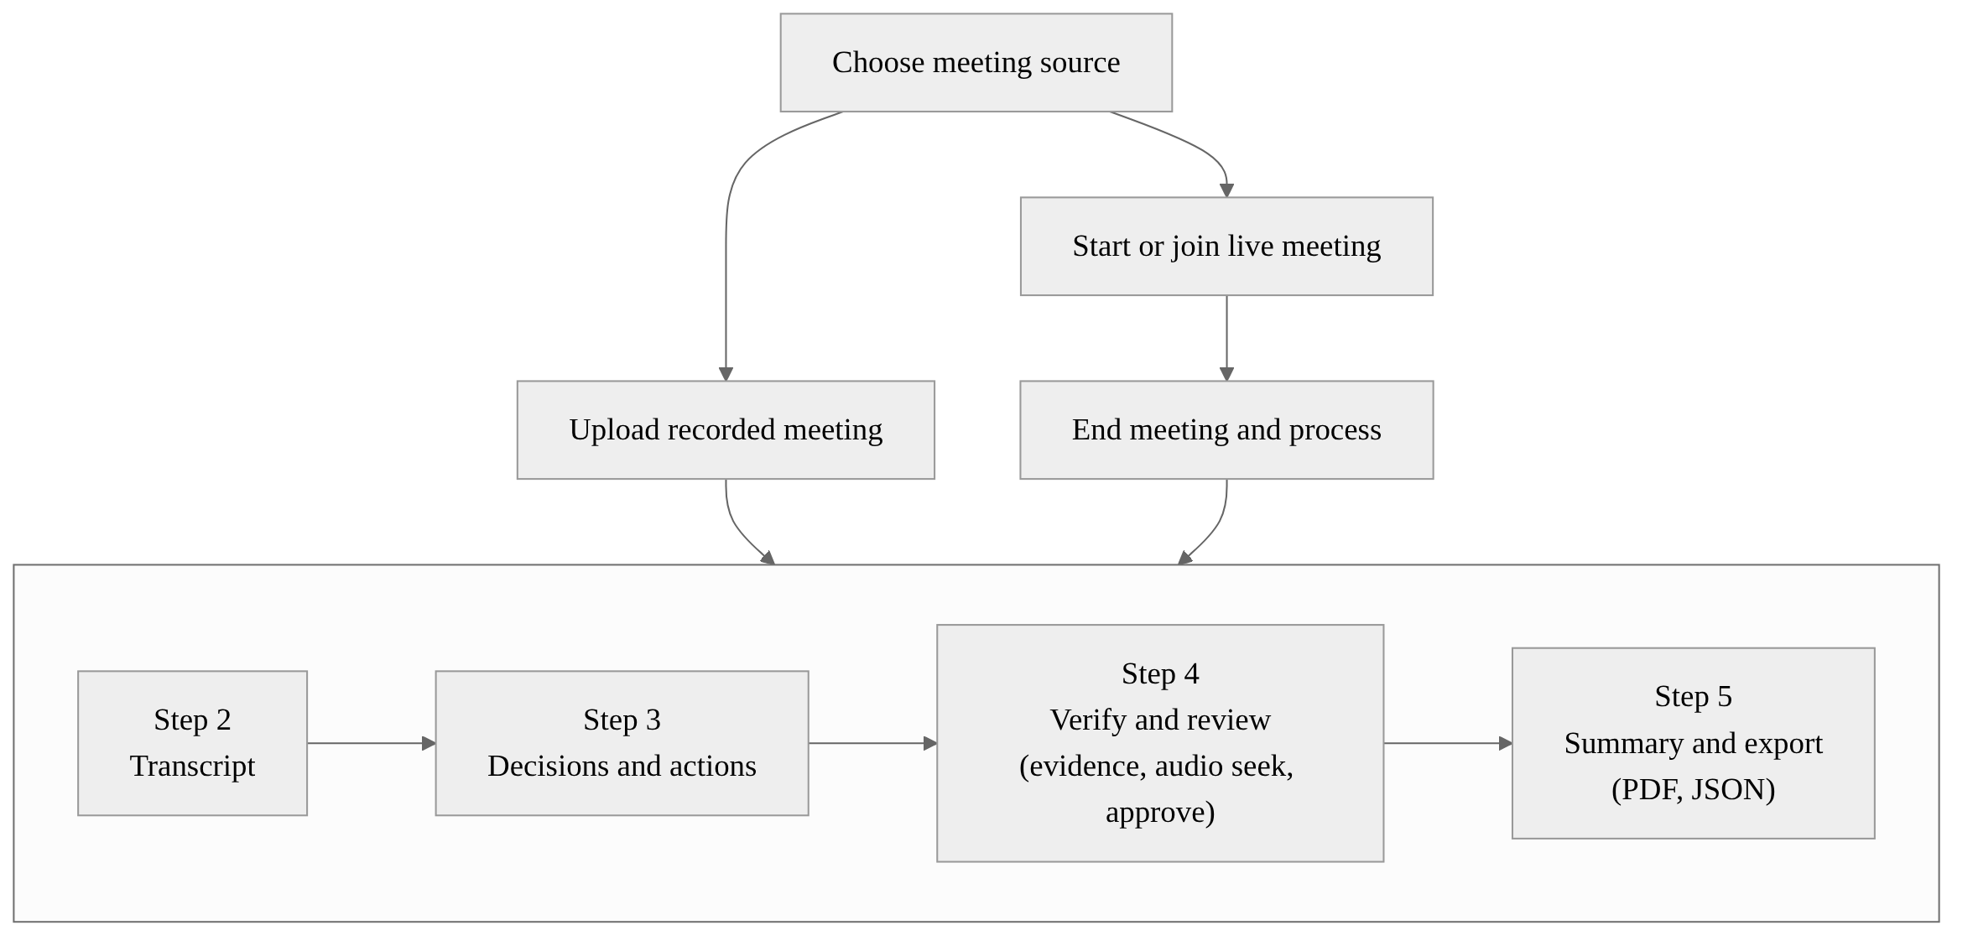
Figure 4.1: Frontend workflow.
The verification and review step (VerifyMeeting with the ClaimVerification component):
- shows each claim with its fused status, its reasons and its evidence;
- lets the reviewer accept or reject suggested evidence; and
- provides a sticky audio player: clicking an evidence timestamp seeks the meeting audio to that point. This also works from the keyboard (Enter or Space on a focusable element), and the player hides itself if no audio exists.
The summary step (Summary):
- shows the minutes;
- states whether a real LLM or a local extractor produced them, or why a fallback was used; and
- offers PDF and JSON export.

4.3 LiveKit Rooms, Tokens and Participants
LiveKit provides the WebRTC media server. Browsers connect with livekit-client, and the backend uses the LiveKit server API and real-time SDK [16], [41]. Access is controlled by JSON Web Tokens [54] signed with the LiveKit API secret; the LiveKit documentation requires tokens to be minted on a backend that holds the API keys [42].
The LiveKit service and the live router implement the following:
- Room creation (POST /api/live/rooms) sanitises the room name, creates the room on LiveKit and creates or reuses the meeting records.
- Token issue (POST /api/live/token) creates the live meeting if it does not exist; binds the host on the first host request and rejects a second host request with HTTP 403; registers the participant; records the consent ticked on the join form as a server-side event; and returns a signed token. Identities that start with the recorder prefix are reserved and refused.
- Token verification protects the live endpoints. The caller sends its token in the Authorization header, and the server verifies the HS256 signature, the issuer (its own API key) and that the token grants joining this particular room. Host-only actions additionally check that the caller is the bound host.
- Roster. The list of connected participants comes from LiveKit itself, excluding the recorder. Connection flags and join and leave events are kept in the live-participants and live-events tables.
The host is identified per meeting, and each participant's identity is stable for the browser tab in which they joined.

4.4 Recording Consent and Revocation
Consent is authoritative on the server; the browser only displays what the server reports. The rules, implemented in the live router and the recorder, are:
- A participant may change only their own consent. Any other change returns HTTP 403.
- Starting a segment requires the live roster from LiveKit, and every connected participant must have consented. If the roster cannot be fetched, recording is refused. If anyone has not consented, the response is HTTP 409 with the list of blocking participants, which the user interface shows by name.
- A revocation notifies the recording manager before it is persisted, so that capture halts at once. LiveKit participant metadata is then updated so that every browser shows the new consent badge.
- A grant is persisted but never resumes a halted segment. The host must explicitly start a new segment, which repeats the full consent check.
- Every grant, revocation, join, leave, start, halt, finalization, discard, meeting end and processing request is recorded in the live-events table, which forms the meeting's consent audit trail.
The consent check at the start of a segment is shown below.
# Simplified from start_recording() in app/api/live_routes.py
roster = await _fetch_roster(meeting["room_name"]) # from LiveKit, recorder excluded
if not roster:
raise HTTPException(409, "No participants are connected.")
blocked = [p for p in roster
if not db.is_participant_consented(meeting_id, p["identity"])]
if blocked:
raise HTTPException(409, {"blocked": blocked}) # UI names who must consent
manager.start_segment(meeting_id, ...) # new segment, state "starting"

4.5 Server-Side Audio Recording and Segments
The recorder joins the room through the LiveKit Python real-time SDK as a hidden, subscribe-only participant. Its token grants subscription but not publishing, it is marked hidden, and automatic subscription is turned off.
The recorder subscribes to audio tracks only after capture is armed, and only for consented participants. Each track is converted to 16 kHz mono and appended to a raw PCM file. All tracks in a segment share one clock that starts when capture is armed. The first frame of a track fixes its offset on that clock, and gaps such as mute periods or network stalls are padded with silence, so that concurrent speakers stay aligned.
Table 4.2: Conditions that halt a recording segment.
Stop reason | Meaning
host_stopped | The host stopped the recording
consent_revoked | A participant revoked consent
consent_missing | Not every participant had consented
unconsented_participant_joined | A participant without consent joined
unconsented_audio | Audio arrived from a participant without consent
no_participants | Everyone left the room
meeting_ended | The meeting ended
recorder_disconnected | The recorder lost its connection
recorder_error | The recorder failed
server_shutdown | The API server shut down
interrupted | The server restarted while recording; recovered at start-up

When a segment stops, it is finalized:
- each PCM track becomes a WAV file;
- a time-aligned mix of the segment is written;
- all finalized segments are concatenated, in order, into the meeting recording; and
- a recording manifest stores each track's identity, display name, track identifier and offset in the meeting recording.
A segment with no audible audio is marked discarded and its audio is deleted, while its metadata is kept for the audit trail. Raw PCM is written as it is captured, so a crash loses little audio, and at the next start-up any segment that a crashed process left open is finalized.
The database allows at most one active segment per meeting, through a partial unique index (Section 3.10). The user interface shows REC only while the server reports that frames are being written, by polling the recording state every two seconds. Because a recording lives in the API process that started it, the API runs as a single process, without auto-reload, while a meeting is being recorded.

4.6 Recorded-Meeting Pipeline (ASR and Diarization)
Processing is submitted by POST /api/live/meetings/{id}/recording/process for live meetings or POST /api/upload for uploads. It runs the recorded-pipeline script as a subprocess, so that the heavy ASR and diarization libraries do not stay loaded in the API. Table 4.3 lists the steps and their main settings.
Table 4.3: Recorded-pipeline steps and their main settings.
Step | Implementation | Key settings
Validation and media inspection | FFmpeg probing | Supported formats: mp4, mp3, wav, m4a, webm, mov, mkv, aac, flac
Audio enhancement | FFmpeg filter chain | High-pass 80 Hz, low-pass 7,600 Hz, FFT denoise, loudness normalisation (I = −16), 16 kHz mono
Audio quality | Volume statistics | Warnings stored with the meeting
Chunking | 300 s chunks | 8 s overlap to protect sentence boundaries
ASR | faster-whisper, Whisper small | CPU, int8, beam 5, VAD on, language auto-detected; a chunk with more than 20% low-confidence segments is retried with beam 8
Speaker attribution | Track mode (Section 4.7) or pyannote diarization | speaker-diarization-community-1; 1 to 10 speakers when the number is unknown
Merge and reliability | Speaker–transcript merger | Flags low ASR confidence, uncertain speaker and possible overlap
Report | Processing report | Counts of segments, speakers and review flags

A content-hash pipeline cache reuses normalised audio, transcription and diarization when the same recording is processed again. For track-mode meetings the cache key includes the track manifest and the track audio, so results from an earlier mixed-recording run are never replayed.

4.7 Participant-Track Transcription and Speaker Attribution
The first live-meeting implementation transcribed and diarized only the mixed recording. In a real two-person test meeting, pyannote grouped both voices into one cluster because only about 7.5 seconds of speech were available, and ASR on the mix misheard the guest's words "by Friday" as "Bye for now" (Section 5.5).
Participant-track transcription fixes this by treating each participant's own microphone track as the source of identity:
- Validate the manifest and every track. The path must resolve inside the recording folder, and the file must be a readable WAV with frames that fits inside the recording. A silent track is valid but skipped. If any track is invalid, the whole meeting uses the mixed-recording path, so that no participant's speech is lost.
- Transcribe each track with the same ASR and selective-retry logic, applying the track's offset exactly once.
- Merge the segments chronologically. Each segment carries the speaker identity, display name, track identifier and an attribution source marking it as coming from a LiveKit track.
- Handle overlap. Speech that two participants genuinely spoke at the same time is kept for both and flagged as possible cross-talk for review. When the same words appear on two microphones at once because of acoustic bleed, they are detected with fuzzy matching [50], and only the copy from the speaker's own, louder track is kept.
Uploaded recordings, and live meetings with unusable tracks, continue to use pyannote diarization of the mixed audio.

4.8 Transcript Index, Processing Jobs and Storage
Transcript index. The transcript index converts the merged transcript into utterance rows with stable identifiers u00000, u00001 and so on. Each row has start and end times, a speaker identity and display name, the text, language tags, ASR confidence, speaker confidence, no-speech probability, the source of the confidence value and an overlap flag. These rows are the only things that claims may cite.
Jobs. The job module runs twelve stages: uploaded, audio, quality, asr, diarization, merge, index, topics, extraction, verification, mom and done. Each stage writes its progress to the jobs table, which the user interface polls. Two job runners exist:
- Inline (the default): the API runs the job in a FastAPI background task. At start-up the API marks jobs left queued or running by a previous process as failed, with a clear message, so that they can be retried.
- Worker: a separate worker script polls the jobs table, claims jobs atomically with a conditional update and a unique claim token, writes a heartbeat every 10 seconds, and re-queues stale jobs up to three times. The worker refuses to start unless the worker mode is configured, because a worker running beside an inline API could otherwise process the same meeting twice.
Exactly-once submission. A job row is inserted with a conflict-ignoring insert, so repeated or concurrent "Process" clicks never start a second run. A failed job is re-queued only by an explicit retry.
Storage. Every meeting has its own folder with subfolders for the recording, audio, chunks, metadata, transcript, diarization, extraction output, verification and minutes. The database file is kept in the same storage root, which is excluded from version control.

4.9 Topic Segmentation
The topic segmenter groups utterances into blocks of three, embeds each block with the multilingual MiniLM model, and starts a new topic wherever the cosine similarity of adjacent blocks falls below 0.55 [22]. Titles are extractive:
- two to five words in title case, taken only from the topic's own utterances;
- chosen by TF-IDF with a tokenizer that preserves contractions, which fixed an earlier truncation of "Aren't" to "Aren"; and
- excluding speaker names and filler words.

4.10 Claim Extraction, LLM Configuration and Fallback
Figure 4.2 shows the path from transcript to verified claims.
Windows. The context builder splits the utterances into windows of at most 60 utterances with a 10-utterance overlap. Each line carries its utterance identifier, for example "[u00042] SPK_01 (12:03) Priya: …".
LLM client. The LLM client is provider-agnostic and built on the Python standard library. It supports Gemini (default model gemini-3.8-flash, taken from Google's published model list [55]), OpenAI, Anthropic, any OpenAI-compatible local server, and a stub provider used only in tests. The settings are listed in Table 4.4.
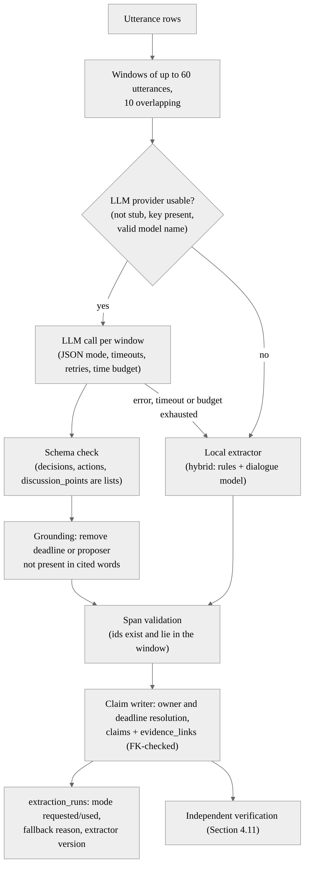
Figure 4.2: Extraction and fallback flow.
Table 4.4: LLM configuration (environment variables; values are never committed to the repository).
Setting | Default | Behaviour
LLM_PROVIDER | stub | The stub is a test fixture only and is reported as unavailable outside tests
LLM_MODEL | placeholder | Order: explicit argument, then LLM_MODEL, then the provider default (Gemini only); values with spaces, "=" or quotes are rejected without being echoed
Provider API keys | none | A generic key overrides provider keys; the Gemini key is sent in a request header, never in the URL
LLM_TIMEOUT_SECONDS | 180 | Per-request timeout
LLM_TIMEOUT_RETRIES | 1 | Extra attempts after a timeout; HTTP 429 and 5xx responses and network errors are retried up to three times, after pauses of 1, 2 and 4 seconds
LLM_EXTRACTION_BUDGET_SECONDS | 600 | Cap on all LLM calls for one meeting; request timeouts are shortened to the time left
EXTRACTOR | llm | llm (with fallback), hybrid, dialogue or rules
FALLBACK_EXTRACTOR | hybrid | Local extractor used when the LLM is unavailable or fails

With the defaults, one window can wait at most (1 + 1) × 180 s + 1 s = 361 s, and all LLM calls for a meeting together stop at 600 s. A reply that is not valid JSON gets one repair attempt. The client builds every error message itself and removes the configured API key from it before the message is logged or stored.
Prompt and schema. The extraction prompt states three requirements:
- every item must cite utterance identifiers copied from the window;
- owner, proposer and deadline may be given only when the cited utterances state them; and
- discussion points are short, cited summaries of substantive topics.
The response is checked against the expected schema before it is cached or trusted. A reply that parses as JSON but has the wrong shape counts as invalid output, not as "no claims". Valid responses are cached per window, model and prompt version.
Grounding. The LLM extractor removes details that the LLM added but its own citations do not contain. The claim itself is kept and must still pass verification, and the removals are counted in the extraction statistics.
# Simplified from _ground() in app/services/intelligence/llm_extractor.py
deadline = action.get("deadline_text")
if deadline and not _phrase_in(deadline, cited_text(action)): # substring or fuzzy >= 90
action["deadline_text"] = None # never trust an uncited date
proposer = decision.get("proposer")
if proposer and not re.search(rf"\b{re.escape(proposer)}\b",
cited_text(decision), re.I):
decision["proposer"] = None
Span validation and claim writing. The span validator drops any claim whose cited identifiers do not exist or lie outside its window, and records the reason in the dropped-claims table. The claim writer then resolves owners and deadlines and writes the claims and their evidence links:
- the owner resolver assigns a first-person commitment such as "I will…" to the speaker of the cited utterance; and
- the deadline resolver converts relative deadlines to dates with python-dateutil and keeps the spoken text.
The database foreign key guarantees that a claim can cite only real utterances.
Local extractors. When no usable LLM is configured, or when the LLM fails, one of three local extractors runs:
- Rules: pattern-based decision and action-item extractors that keep the decision state (proposed, accepted, conditional or rejected) rather than marking everything as accepted.
- Dialogue: a learned model that embeds each utterance together with its neighbours, with linear heads trained on the AMI train split to predict speech acts, decision and action evidence, and reply polarity. A decision counts as accepted only when a different speaker responds positively, and an action is firm only when someone else accepts it.
- Hybrid: the union of the rule-based and dialogue-model candidates. This is the default fallback.
Status reporting. Each run is recorded with the mode requested, the mode used, its status (completed, no claims, extractor unavailable or failed), the fallback reason and the extractor version, for example "llm:gemini:<model>:v2" or "rules-v2+dialogue-v1". The minutes, the PDF and the summary page say "Extracted by LLM: provider / model" only when the LLM really produced the claims; otherwise they name the local extractor and the reason. Discussion points from the LLM are shown under a separate heading, "Discussion Summary (LLM, cited, not verified)", and only for the run that produced them.

4.11 Evidence Grounding and Independent Verification
The claim-verification module judges every claim with three methods and stores one row per claim and method, including scores, reasons, model versions and latency.
- Deterministic matching checks the claim text against the cited utterances and their timestamps, together with audio-reliability signals.
- Semantic verification combines retrieval and NLI:
  - The retrieval index is a hybrid: a span's score is 0.65 × dense similarity (multilingual MiniLM) plus 0.35 × normalised BM25, and the top eight spans are returned.
  - The candidate builder combines the cited span with the independently retrieved spans.
  - The NLI scorer scores premise–hypothesis pairs with mDeBERTa-v3-base-mnli-xnli [33]. The premise is the candidate span plus one neighbouring utterance on each side, capped at 1,200 characters. The cited span is also scored strictly, without context, which catches a citation that looks supported only because a neighbour contains the claim. Secondary hypotheses about decision state, owner and deadline are scored on the strongest three candidates only, five background pairs estimate a noise floor, and contradiction is located at the utterances actually scored. Pair scores are cached per meeting.
- Fusion uses transparent rules. Each signal adds a reason with a severity of info, warning, review or reject, and the most severe reason decides the status. A claim is never marked verified without positive semantic support, and missing inputs count as unknown, never as perfect confidence. Only verified and verified-with-warning claims appear as confirmed items in the minutes; the others are listed under "Held for Review".
Table 4.5: Fusion thresholds used by the system.
Parameter | Value | Use
contradiction_reject | 0.80 | Contradiction on the cited span that rejects the claim
contradiction_review | 0.50 | Contradiction anywhere that needs a human look
cited_strict_min | 0.50 | Below this strict cited entailment, the citation is incomplete
owner_support_min, deadline_support_min | 0.50 | Below this, the owner or deadline is unsupported
low_asr_conf / low_spk_conf / high_no_speech_prob | 0.50 / 0.60 / 0.60 | Audio-reliability warnings

Typical reasons include cited_evidence_entails (information), not_entailed, citation_incomplete, possible_miscitation, contradicting_evidence_elsewhere, proposal_without_agreement, conditional_decision, deferred_decision, rejected_proposal, tentative_commitment and semantic_verifier_unavailable.
Evidence suggestions. When retrieval finds a span that supports a claim much better than its citation, the claim is flagged as a possible mis-citation and the span is offered to the reviewer as suggested evidence. Accepting or rejecting the suggestion records the decision in the evidence-corrections table and re-verifies the claim.
Model precision. Hugging Face pipelines are loaded in single precision (float32) unless a caller asks otherwise. With Transformers 5, the NLI checkpoint would otherwise load in half precision (float16), its stored format, which proved about 17 times slower on the project laptop while giving the same labels (Section 5.8).

4.12 Review, Approval and Export
Review drafts. When the review is first opened, the claims are copied into review items. The original AI claims are never modified; reviewer actions change only the review copy. Each item has one of five statuses — original, edited, added, rejected, or accepted from held (an item the reviewer accepted although the verifier held it) — and can also be excluded from the minutes. Every change is written to the review audit log with the field, the old value, the new value, the reason, the reviewer and the time.
Approval and reopening.
- Approval requires a reviewer name. It freezes the minutes into an approved snapshot with an incrementing version number, adds an audit entry and generates the approved PDF. Approving an already-approved draft returns the existing snapshot.
- Reopening requires a reason, records it and makes the draft editable again. A later approval creates the next version.
Exports.
- The PDF download returns a draft generated from the current minutes before approval, and is built from the latest snapshot after approval.
- The JSON export returns the approved minutes with an evidence appendix. It answers HTTP 409 until the minutes are approved, unless a preview is explicitly requested.
The PDF is generated with ReportLab [51]. Its sections are listed in Table 4.6.
Table 4.6: Sections of the generated PDF minutes.
Section | Content
Executive Summary | Deterministic overview, or the reviewer's summary after approval
Key Discussion Points | Topics with time ranges
Discussion Summary (LLM, cited, not verified) | Present only for a real LLM run with valid citations
Confirmed Decisions | Verified decisions with evidence references
Action Items | Owner, deadline, evidence
Held for Review (not confirmed) | Claims the verifier did not confirm, with reasons
Verification Snapshot | Counts by status, verifier versions and the extraction-source note
Follow-ups | Follow-up items
Evidence Appendix | Utterance identifier, speaker, timestamps, verbatim quote, evidence role and verification label for every cited utterance, in an A4 table with the header repeated on each page

4.13 Security, Error Handling, Logging and Performance
Table 4.7 summarises the security and robustness measures in the code, with remarks on their current extent.
Table 4.7: Security and robustness measures.
Area | Measure in the code | Remarks
Secrets | Configuration file loaded with python-dotenv and excluded from version control; the example file holds placeholders only | Keys never appear in the repository
Live endpoints | Server-issued LiveKit JWT checked for signature, issuer and room; host-only actions checked; participants change only their own consent; recorder identity reserved | Identity is per browser tab, not per user account
Meeting endpoints | Validation of meeting identifiers; CORS limited to local development origins | Designed for a trusted machine; authentication is future scope
LLM key | Sent in a header, never in the URL; redacted from error messages; malformed model names rejected without echoing | —
File paths | Track paths must resolve inside the meeting's recording folder | —
Errors | A stage failure marks the job failed with the stage name; extraction failures fall back with a stated reason; interrupted inline jobs are marked failed at start-up | —
Logging | Stage durations and LLM window counts and durations are logged, without keys or transcript text | —
Data retention | Per-meeting folders; caches stored with the meeting | A complete delete-meeting feature is future scope

The main performance measures are:
- models are loaded once per process through a model registry;
- ASR uses int8 CTranslate2 inference;
- ASR and diarization run in a subprocess;
- NLI pairs are sorted by length to reduce padding, scored in batches of eight and cached;
- NLI runs in float32 on the CPU;
- LLM calls are bounded by a time budget; and
- the pipeline cache avoids repeating ASR and diarization for an unchanged recording.
Section 5.8 reports the measurements.

4.14 Key Algorithms
This section summarises the three algorithms at the core of the system in pseudo-code. The pseudo-code is a simplified description of the behaviour implemented in Sections 4.4, 4.10 and 4.11; it omits error handling, caching and logging.
Algorithm 4.1: Consent-gated recording. A segment starts only after a complete consent check, and any of the stop conditions of Table 4.2 halts it permanently.
procedure START_SEGMENT(meeting, caller)
require caller is the bound host of meeting
roster <- connected participants from LiveKit, excluding the recorder
if roster is empty or unavailable then reject (HTTP 409)
blocked <- [p in roster where p has not consented]
if blocked is not empty then reject (HTTP 409, blocked)
segment <- new segment in state "starting" // at most one active segment
recorder joins room hidden, subscribe-only, auto-subscribe off
for each consented participant p: subscribe to p's audio track
segment.state <- "recording"

on event in {consent revoked, unconsented join, unconsented audio,
room empty, meeting ended, recorder lost, server shutdown, host stop}
HALT(segment, reason) // never resumes automatically

procedure HALT(segment, reason)
stop writing frames; segment.state <- "stopping"
if segment has audible audio then
write one WAV per track, a time-aligned mix, rebuild the meeting recording
segment.state <- "finalized"
else
delete the audio; segment.state <- "discarded"
record event (reason) in the audit trail
Algorithm 4.2: Evidence-grounded extraction with fallback. Claims are proposed per window, grounded in their citations and validated before they are stored.
procedure EXTRACT(meeting)
windows <- utterances in windows of 60, overlapping by 10
if LLM provider usable then mode <- "llm" else mode <- fallback extractor
claims <- []
for each window w:
if mode = "llm" and time budget remains then
reply <- LLM(w) // JSON mode, bounded timeout and retries
if reply invalid or call failed then mode <- fallback extractor, record reason
if mode = "llm" then
for each item in reply:
remove deadline or proposer not found in the cited words
claims.append(item)
else
claims.extend(LOCAL_EXTRACTOR(w)) // rules + dialogue model
for each claim c in claims:
if c cites an unknown utterance or one outside its window then
drop c and record the reason
else
resolve owner and deadline; store c with evidence links (FK-checked)
record mode requested, mode used, fallback reason and extractor version
Algorithm 4.3: Verification and fusion. Each claim is checked by deterministic matching, independent retrieval and NLI, and the most severe reason decides its status.
procedure VERIFY(claim, transcript)
reasons <- DETERMINISTIC_CHECK(claim) // text, timestamps, audio reliability
cited <- claim's cited utterances
e_cited <- NLI(premise = cited + one neighbour each side, hypothesis = claim)
e_strict <- NLI(premise = cited only, hypothesis = claim)
candidates <- top 8 spans by 0.65 x dense similarity + 0.35 x BM25
best <- candidate with the highest entailment
x <- strongest contradiction over cited span and candidates
if semantic models unavailable then add reason(review, "semantic_verifier_unavailable")
if x on cited span >= 0.80 then add reason(reject, "contradicted")
else if x anywhere >= 0.50 then add reason(review, "contradicting_evidence_elsewhere")
if e_strict < 0.50 then add reason(review, "citation_incomplete")
if best supports claim much better than cited then
add reason(review, "possible_miscitation"); suggest best to reviewer
if decision state is proposed, conditional or rejected then add reason(review, state)
if no positive semantic support then add reason(review, "not_entailed")
else add reason(info, "cited_evidence_entails")
status <- status of the most severe reason // verified, warning, review, reject
store status, scores, reasons and model versions

Chapter 5: Experiments, Testing and Results
This chapter reports how the system was tested and evaluated. It covers the test environment, the automated test suites, the manual acceptance tests of live meetings, speaker attribution, LLM extraction and fallback, the quantitative evaluation of extraction and verification on the AMI Meeting Corpus, and performance measurements. Every number reported was measured by the project team; where a figure is an estimate, it is stated as such.

5.1 Test Environment
Two laptops were used for the measurements in this chapter. Because their hardware differs, timings from one must not be compared directly with timings from the other.
Table 5.1: Hardware and software used for the measurements.
Item | Laptop A (test suites, live meetings, NLI benchmark) | Laptop B (ASR benchmark)
CPU | AMD Ryzen 3 3250U, 2 cores / 4 threads, 2.6 GHz | 11th Gen Intel Core i5-1155G7, 8 logical threads
Memory | About 18 GB | —
GPU | Not used | Not used
Operating system | Windows 11 Home | Windows 11
Python | 3.11.4 (project virtual environment) | —
Node.js / npm | 22.13.1 / 10.9.2 | —
Test tools | pytest 9.0.2, Vitest 5.0.5 | —

5.2 Automated Test Suites
Testing strategy. The backend is tested with pytest and the frontend with Vitest and Testing Library. The tests follow three rules:
- No external service is contacted. LLM provider calls are replaced at the HTTP layer by scripted fake responses, so no paid API is ever called by the test suites.
- No production data is touched. Every test uses a temporary database and temporary storage.
- Expensive components are faked where appropriate. LiveKit is replaced by fake rooms and sessions (the recording state machine has no LiveKit dependency, so it can be driven directly), ASR in the track-transcription tests uses a fake transcriber, and embedding and NLI models are replaced by deterministic fakes — except in eight tests marked slow, which run the real local models.
The backend suite was run from the repository root with the Hugging Face libraries in offline mode, which guarantees that no test downloaded a model; the tests that need real models loaded them from the local cache. The frontend suite was run with npx vitest run. The evaluation harness on the AMI corpus is run separately (Section 5.7).
Table 5.2: Automated test results.
Suite | Tests | Passed | Failed | Errors | Skipped | Time
Backend (pytest, 38 files) | 352 | 352 | 0 | 0 | 0 | 343.9 s
Frontend (Vitest, 3 files) | 55 | 55 | 0 | 0 | 0 | Under 2 minutes, including environment set-up

Table 5.3: Backend tests by functional area (per-file counts in Appendix C).
Area | Test files | Tests
Live meetings, consent, recording, track transcription | test_live_recording, test_live_routes, test_live_processing, test_track_transcription | 71
LLM client, extraction and grounding | test_llm_providers, test_llm_extractor, test_extraction_pipeline, test_extraction_scenarios, test_context_builder, test_context_builder_scale, test_span_validator, test_claim_writer, test_resolvers, test_dialogue_model | 117
Verification | test_fusion, test_nli_scorer, test_retrieval_index, test_candidate_builder, test_verification_persistence, test_verification_scenarios, test_semantic_real_models, test_claims_api | 82
Review, approval and export | test_review_workflow, test_golden_demo_01 | 15
Jobs and processing bounds | test_job_runner, test_async_jobs_api, test_worker, test_processing_bounds, test_meeting_isolation | 25
Data, storage and utilities | test_db, test_storage, test_schemas, test_transcript_index, test_config, test_console_encoding, test_model_registry, test_topic_title_polish, test_benchmark_asr | 42
Total | 38 files | 352

The frontend tests are in three files: live_meeting.test.jsx (15 tests), review_workflow.test.jsx (30 tests) and verification.test.jsx (10 tests).
Table 5.4 lists selected behaviours that the automated tests verify, together with the name of the test that checks each one.
Table 5.4: Selected behaviours verified by automated tests (all passed).
Behaviour | Expected result | Test
Recording refuses to start without complete consent | HTTP 409; nothing captured | test_recording_cannot_start_without_complete_consent
Revocation stops capture; re-grant does not resume | Segment halts; a new segment needs the host | test_revocation_stops_capture_and_regrant_does_not_resume
Unconsented join or audio | Capture halts; audio never written | test_unconsented_join_during_recording_stops_capture, test_audio_from_unconsented_identity_is_never_written
Participants change only their own consent | HTTP 403 for others | test_participants_can_only_change_their_own_consent
Crash and shutdown safety | Partial PCM finalized; interrupted segment recovered | test_partial_pcm_from_a_crash_is_finalized, test_interrupted_segment_is_recovered_on_startup, test_server_shutdown_finalizes_active_recording
Exactly-once processing | One job and one pipeline run | test_full_recording_lifecycle_processes_exactly_once, test_failed_processing_is_visible_and_retry_runs_once
Recording state never exposes secrets | No token or key in responses | test_recording_state_never_leaks_secrets
Two-speaker regression | Track mode attributes both participants | test_regression_mixed_diarization_collapses_two_participants_into_one_speaker, test_two_participant_tracks_are_attributed_with_names_and_global_times
Overlap and bleed | Simultaneous speech kept and flagged; bleed de-duplicated | test_simultaneous_speech_is_kept_for_both_participants_and_flagged, test_same_words_on_two_microphones_keep_only_the_speakers_own_track
Unsafe or corrupt tracks | Fall back to the mixed path | test_unsafe_track_paths_are_rejected, test_empty_and_corrupt_tracks_disable_track_mode
Mis-citation detection | Flagged, with a better span suggested | test_incorrect_citation_with_correct_evidence_elsewhere_is_flagged_and_suggested
Contradicted citation | Rejected | test_cited_evidence_that_contradicts_the_claim_is_rejected
Proposal, conditional and rejected states | Never final without review | test_proposal_conditional_and_rejected_states_are_never_final
Unavailable verifier | Explicit status; never "verified" | test_unavailable_semantic_verifier_is_explicit_and_never_verifies
Review lifecycle | Original claims preserved; approval locks a snapshot; reopening creates version 2; audit complete | test_approval_locks_draft_and_creates_immutable_snapshot, test_reopening_preserves_previous_snapshot_and_allows_version_2, test_audit_history_records_all_actions
Export rules and appendix | JSON blocked before approval; appendix in JSON and PDF | test_export_endpoints_respect_approval_lifecycle, test_evidence_appendix_in_json_and_pdf
End-to-end live meeting | Recording through processing, review, approval and export | test_live_recording_processes_through_review_approval_and_export
Golden demonstration meeting | Index, rule-based claims and verifier statuses unchanged | test_golden_demo_01 (5 tests)
Model precision | NLI pipeline requested in float32 | test_nli_verifier_model_is_float32
Worker safety | Worker refuses to run beside an inline API | test_worker_refuses_to_run_beside_an_inline_api
REC indicator (user interface) | REC shown only after the backend confirms capture | "shows REC only after the backend confirms audio capture"
Consent blocking (user interface) | Names participants without consent | "blocks recording and names participants who have not consented"

5.3 Growth of the Test Suite
The test suite grew with each phase of development, as Table 5.5 shows.
Table 5.5: Test counts at each milestone.
Milestone | Date | Backend tests passed | Frontend tests passed
Start of Phase 1 | 16 October 2026 | 110 | —
Phase 2 sign-off | 17 October 2026 | 189 | 10
Phase 3 sign-off | 18 October 2026 | 207 (8 slow tests run separately) | 39
First LLM-extraction milestone (Phase 4.4) | 19 October 2026 | 308 | 55
Final system | 20 October 2026 | 352 | 55

5.4 Live-Meeting Consent and Recording Acceptance
The live-meeting features were also tested manually with a host and a guest joining the same LiveKit room from two browsers, following an eleven-step procedure written during Phase 4.2. These tests confirmed consent gating, stopping on revocation, restarting only through an explicit new segment, two-speaker attribution, and transcript, verification and PDF generation.
Table 5.6 checks each scenario against the evidence stored by the system during those tests. Only metadata was read from the database — event types, stop reasons, counts, labels and timings — and meeting identifiers are shortened.
Table 5.6: Live-meeting acceptance scenarios.
Scenario | Expected behaviour | Stored evidence | Result
Consent required before recording | Start refused until all connected participants consent | Automated tests (Table 5.4); event logs show consent granted by every participant before each recording start | Pass
Revocation halts recording | Capture stops immediately | Meeting d75ebb78: segment 1 finalized with stop reason consent_revoked after 53.6 s, with 2 tracks | Pass
Re-grant does not resume | A new segment needs an explicit host start | Meeting d75ebb78: consent re-granted, followed by a new recording request and the start of segment 2 | Pass
Segment without audible audio | Discarded, never processed | Meeting d75ebb78 segment 2 (3.1 s) and meeting 5ea1d395 segment 1: state discarded | Pass
Per-participant attribution | Each speaker named from their own track | Meeting d75ebb78: 2 utterances, 2 speakers; meeting a67bec95: 7 utterances, 2 speakers, 2 tracks | Pass
Processing after recording | One job; transcript, claims and verification produced | Meeting d75ebb78: 1 action claim, fused label verified; meeting a67bec95: 4 claims (2 verified, 2 review) | Pass
REC shown only during capture | No REC before audio arrives | Manual observation; automated user-interface test (Table 5.4) | Pass
Review, approval and export of a live meeting | Locked snapshot; PDF and JSON with appendix | End-to-end automated test (Table 5.4) | Pass

5.5 Speaker Attribution and Transcription
Table 5.7 shows a two-participant test meeting processed twice from the same recording: first by diarizing the mixed recording, and then from the participants' own tracks. The quoted sentences are the scripted test sentences from the manual test procedure, not private meeting content.
Table 5.7: Two-participant meeting before and after track-based attribution (Whisper small).
Measure | Mixed recording with diarization | Per-participant tracks
Speakers found | 1 (SPEAKER_00) | 2 (host and guest, by display name)
Host utterance | 35.99–39.99 s, "…scheduled for Tuesday." | 35.92–39.92 s, "…scheduled for Tuesday."
Guest utterance | 39.99–53.95 s, "…marketing report. Bye for now. Thank you." (uncertain speaker) | 49.89–54.39 s, "…marketing report by Friday. Thank you."
Participants in the minutes | 1 | 2

Track-based attribution corrected two errors at once. Both speakers were identified by name, and the guest's words "by Friday", which were misheard as "Bye for now" on the mixed audio, were transcribed correctly from the guest's own track. One limitation was observed: on the guest's very short track, Whisper's per-track language detection reported Malayalam for English speech. Fixing the language for single-language meetings, which the configuration supports, avoids this.
ASR agreement. On the 4.14-minute demonstration recording, the output of the quantised faster-whisper configuration differed from the transcript produced earlier by the unquantised Whisper configuration by 8 word edits in 566 words, a difference of 1.41%, mostly British versus American spellings. Because the reference transcript was itself produced by a machine, this figure measures the agreement between two system outputs, not the word error rate against a human reference. It shows that quantisation did not materially change the transcript.

5.6 LLM Extraction, Fallback and Grounding
Mocked provider tests. The LLM integration is covered by 61 automated tests in which every provider HTTP call is replaced by a scripted response. They cover:
- provider and key selection, and the order in which the model is selected;
- rejection of malformed model names without echoing them;
- a full Gemini extraction followed by independent verification;
- the minutes, the PDF and the approved export reporting the real LLM and its cited summary;
- removal of uncited deadlines and proposers, and dropping of invented evidence;
- non-JSON output, wrong schemas and wrong field types;
- HTTP errors, rate-limit retries, timeouts, the retry cap and connection timeouts;
- the overall time budget, including running out between windows and the worst case under the default settings;
- blocked responses and stale discussion summaries; and
- redaction of the API key from provider error messages.
In every failure case the minutes fall back to the local extractor with an explicit reason, and never claim LLM extraction.
Live provider requests. To validate the integration against the real service and to measure its latency, requests were sent to the Gemini API. Only synthetic text was sent; no meeting data left the machine. The results are shown in Table 5.8.
Table 5.8: Requests to the Gemini API with synthetic prompts.
No. | Model | Request | Outcome | Time
1 | gemini-3.8-flash | 57-token synthetic prompt, JSON reply | Success, valid JSON (294 thinking tokens) | 67.3 s
2 | gemini-3.8-flash | Same, with thinking level set to low | Success, valid JSON (no thinking tokens) | 51.1 s
3 | gemini-3.8-flash | Repeat of request 1 | Success, valid JSON | 68.5 s
4 | gemini-3.6-flash | Same as request 1 | Success, valid JSON | 3.6 s
5 | gemini-3.8-flash | 60-utterance synthetic window through the system's LLM client and extraction prompt | Success; the decision cited the correct utterances, and the owner and deadline matched the synthetic text | 59.1 s
6 | gemini-3.6-flash | Same as request 5, single attempt | HTTP 503: model temporarily overloaded | 20.0 s

Request 5 confirms the complete extraction path end to end: the system's own client and prompt produced a correctly cited decision with a grounded owner and deadline. A separate check of the network (DNS resolution 0.03 s, TCP connection 0.02 s, model metadata request 0.6 s) showed that the latency of 50–70 s comes from the provider, not from the network. This finding directly informed the time bounds described in Section 4.10.
Fallback on real meetings. The real test meetings were processed by the local hybrid extractor. In one of them (meeting a67bec95), the LLM was enabled but the provider did not answer within the timeout then configured, so the system fell back to the hybrid extractor and stated the reason in the minutes. This demonstrated the honest-degradation behaviour of objective O7 on a real meeting, and it led to the revised timeout and time-budget settings (Section 5.8).
Representative verification output. Table 5.9 shows the stored verification of the four claims in meeting a67bec95. Only scores and reason codes are shown, without transcript text.
Table 5.9: Verification results for the four claims of meeting a67bec95.
Claim | Type | Cited entailment | Strongest contradiction | Fused status | Leading reason
d00000 | Decision | 0.997 | 0.004 | Verified | cited_evidence_entails
a00000 | Action | 0.964 | 0.423 | Verified | cited_evidence_entails
a00001 | Action | 0.996 | 0.977 (other utterances) | Review | contradicting_evidence_elsewhere
a00002 | Action | 0.696 | 0.774 (other utterances) | Review | contradicting_evidence_elsewhere

The two held actions illustrate the conservative design. A strong contradiction elsewhere in the meeting sends an otherwise supported item to a human reviewer instead of being resolved automatically.

5.7 Evaluation of Extraction and Verification
The local extractors and the verifier were evaluated quantitatively in Phase 2 on the AMI Meeting Corpus. The dialogue model was trained on the AMI train split only, and all results below are on held-out meetings. LLM extraction was not part of this evaluation.
Extraction. Table 5.10 compares the rule-based baseline with the hybrid extractor on 39 held-out AMI test meetings, under strict matching and under a tolerance of two utterances.
Table 5.10: Extraction on 39 held-out AMI test meetings (38,072 utterances).
Task (matching) | Model | Precision | Recall | F1
Decision (strict) | Rules baseline | 3.21% | 13.95% | 5.23%
Decision (strict) | Hybrid | 5.36% | 33.14% | 9.22%
Decision (within ±2 utterances) | Rules baseline | 5.97% | 23.84% | 9.55%
Decision (within ±2 utterances) | Hybrid | 8.79% | 50.58% | 14.98%
Action (strict) | Rules baseline | 1.05% | 1.41% | 1.20%
Action (strict) | Hybrid | 13.23% | 38.03% | 19.63%
Action (within ±2 utterances) | Rules baseline | 8.42% | 11.27% | 9.64%
Action (within ±2 utterances) | Hybrid | 21.16% | 53.52% | 30.33%

The hybrid extractor more than doubles the recall of the rule-based baseline and raises F1 on every task, but its precision remains low. AMI's gold annotations contain only about 4.4 decisions and 1.8 actions per meeting, and about 75% of the hybrid extractor's decision candidates are proposals, which the annotators did not count as decisions. The local extractor is therefore designed to over-generate candidates and rely on downstream verification and human review to filter them — the division of labour on which the whole system is built.
Verification. To measure whether the verifier catches errors, true claims from AMI meetings were deliberately corrupted in four ways: replacing the claim with one from another meeting, negating it, swapping its owner, and pointing its citation at the wrong utterance. Table 5.11 reports the results on six development and six held-out test meetings.
Table 5.11: Semantic verification on deliberately corrupted claims (6 development and 6 test AMI meetings).
Measure | Development | Test (held out)
Corruptions caught (all types) | 100% | 100%
Foreign claim / negated / owner swap / wrong citation | — | 18 of 18 / 18 of 18 / 5 of 5 / 18 of 18
True claims held for human review (false-hold rate) | 76.47% | 94.44%

The verifier caught every corrupted claim in the test set. It also held most true claims for review, so it is safe but conservative: it minimises the risk of publishing a wrong item at the cost of more reviewer effort. The thresholds behind Table 5.11 were selected on the development split, whereas the system as delivered uses the provisional thresholds of Table 4.5; adopting calibrated thresholds is the first recommendation of Chapter 6.

5.8 Performance Analysis and Optimisation
Speech recognition. Table 5.12 compares the ASR configurations on the 4.14-minute demonstration recording, measured on laptop B.
Table 5.12: ASR speed on the 4.14-minute demonstration recording (laptop B).
Configuration | ASR time | Real-time factor
Earlier unquantised Whisper configuration (baseline) | 427.29 s | 1.722
faster-whisper small int8, mean of two warm runs | 66.50 s | 0.268
faster-whisper small int8, best run | 64.84 s | 0.261
Full pipeline (ASR, diarization, topics, extraction, verification) | 503.51 s | —

Quantisation reduced the real-time factor from 1.72 to 0.27: speech recognition now runs about 3.7 times faster than real time instead of 1.7 times slower.
Bottleneck analysis of a live meeting. Meeting a67bec95 was a 68-second, two-participant live recording processed on laptop A, a low-power two-core machine. The job took 21 minutes 50 seconds from "Process" to completion. The stage timings, reconstructed from database timestamps, file modification times and stored verification timings, are shown in Table 5.13.
Table 5.13: Stage timings for meeting a67bec95 before optimisation (laptop A).
Stage | Duration | Cause
Recording pipeline (normalisation, per-track ASR) | 5 min 27 s, of which 3 min 40 s before the first output | Start-up of the transcription subprocess (loading PyTorch, Whisper and pyannote) on a busy two-core CPU
Transcript index and topics | 41 s | Normal
LLM extraction | 4 min 10 s | The provider answered more slowly than the 60 s timeout then configured, and repeated attempts were made before the fallback
Verification (NLI) | 11 min 35 s | The NLI model ran in float16 on a CPU without float16 hardware support: 58 pairs at about 10 s each

The analysis showed that more than half of the time was spent in verification. Because the NLI checkpoint is stored in half precision, Transformers 5 loaded it in float16, which this CPU executes very slowly. A micro-benchmark confirmed the cause (Table 5.14).
Table 5.14: NLI precision micro-benchmark on laptop A (16 synthetic premise–hypothesis pairs).
Precision | Time per pair | Largest score difference from float32 | Changed labels
float16 (library default for this checkpoint) | 8.77 s | 0.0044 | 0 of 16
float32 (adopted) | 0.51 s (17 times faster) | — | —

Two optimisations followed:
- the NLI verifier is now always loaded in float32, which gave identical labels and was 17 times faster; and
- LLM waiting is bounded, with one retry after a timeout, a 180-second request timeout and a 600-second budget for the whole meeting.
On the same laptop, the full backend test suite fell from 27 minutes 20 seconds (308 tests, before the change) to 5 minutes 44 seconds (352 tests, after it), mostly because of the tests that run the real NLI model. Applying the measured per-pair speed-up to the 58 pairs of meeting a67bec95 gives an estimated verification time of 30 to 40 seconds instead of 11 minutes 35 seconds.

5.9 Representative Outputs and Screenshots
Figures 5.1 to 5.8 show the main screens and outputs of the system, captured from a consented test meeting that contains no personal data.

[ Insert screenshot here ]
Join form showing the display-name field and the consent checkbox.
Figure 5.1: Live-meeting join form with the explicit recording-consent checkbox.

[ Insert screenshot here ]
Host view with the consent count, the banner "Recording is blocked until these participants consent", and "Not recording".
Figure 5.2: Host view showing the consent count and the recording-blocked banner.

[ Insert screenshot here ]
REC badge with elapsed time while the server is capturing; then the banner after a participant revokes consent.
Figure 5.3: REC indicator during capture and the banner shown after consent is revoked.

[ Insert screenshot here ]
Segments listed with stop reasons, duration and speakers, and the processing progress bar.
Figure 5.4: Meeting-ended screen with recorded segments and processing progress.

[ Insert screenshot here ]
Indexed transcript with utterance identifiers, display names and timestamps.
Figure 5.5: Transcript page with participant names and timestamps.

[ Insert screenshot here ]
Claims with status badges and reasons, a suggested-evidence card, and the audio player at an evidence timestamp.
Figure 5.6: Verification step with fused statuses, reasons, suggested evidence and audio seeking.

[ Insert screenshot here ]
Summary page with "Extracted by LLM: provider / model" or the local-extractor line, and the PDF and JSON buttons.
Figure 5.7: Summary step showing the extraction-source line and export options.

[ Insert screenshot here ]
First page of an approved PDF and the Evidence Appendix table.
Figure 5.8: First page and Evidence Appendix page of approved PDF minutes.

5.10 Discussion of Results
The results support the central claims of the project.
- Consent is enforced, not just displayed. Automated tests cover every halting condition, and the stored evidence of real two-browser meetings shows a segment stopped by revocation and a new segment started only by the host.
- Channel-based attribution is more reliable than diarization for live meetings. On the same recording, per-participant tracks recovered both speakers and corrected a transcription error that the mixed audio had introduced.
- The verifier is safe. It caught all deliberately corrupted claims on held-out meetings, and on a real meeting it held two actions with contradicting evidence for review instead of publishing them.
- Failures are visible. When the LLM provider was slow, the system fell back, labelled the minutes accordingly, and the time bounds were tightened.
- Processing is practical on a CPU. Quantised ASR runs faster than real time, and the largest bottleneck was removed with a 17-fold speed-up.
The results also show where the system is conservative or limited. The verifier holds many true claims for review, the local extractors have low precision on AMI, and the manual validation consisted of short two-person meetings. These points are discussed in Chapter 6.

Chapter 6: Conclusion and Recommendations

6.1 Conclusion
Meet2MoM set out to turn meetings into minutes that can be audited. Every recorded decision and action item had to be traceable to the transcript and checked independently of the component that proposed it, and recording had to happen only with every participant's consent.
- Chapter 2 showed that the individual techniques exist in the literature — speech recognition, diarization, decision detection and NLI-based consistency checking — but that generated summaries can be unfaithful, and that no surveyed system combines them into an auditable record.
- Chapter 3 turned this into requirements and a design in which proposing, verifying and approving are separate steps, and in which the database itself enforces that every claim cites real utterances.
- Chapter 4 described an implementation that runs entirely on one CPU-only laptop, with an optional external LLM.
- Chapter 5 showed, through 407 automated tests, manual two-browser meetings, an evaluation on the AMI Meeting Corpus and performance measurements, that the system behaves as designed.
The most significant result of the project is not a single model but a chain of safeguards that together make the minutes trustworthy:
- server-enforced consent with a complete audit trail;
- per-participant speaker attribution, which fixed a real two-speaker failure of diarization;
- citations enforced by database foreign keys;
- removal of LLM-stated details that the cited words do not contain;
- independent retrieval and NLI verification, with stated reasons for every status;
- explicit labelling of every fallback; and
- human approval with versioned, immutable snapshots.
Each safeguard is covered by automated tests, and real LiveKit meetings confirmed the consent and attribution behaviour. The project therefore meets its aim: it produces reviewer-approved Minutes of Meeting in which every recorded decision and action item is traceable to, and verified against, the meeting transcript.

6.2 Achievement of Objectives
Table 6.1 assesses each objective of Section 1.3 against the evidence in this report.
Table 6.1: Achievement of the objectives.
ID | Objective (short form) | Status | Evidence
O1 | Consent-enforced live capture | Achieved | Section 4.4; Tables 5.4 and 5.6
O2 | Transcript with speaker attribution | Achieved | Sections 4.6 and 4.7; Table 5.7
O3 | Cited decisions and action items | Achieved | Section 4.10; Tables 5.4 and 5.10
O4 | Independent verification and holding for review | Achieved | Section 4.11; Tables 5.9 and 5.11
O5 | Reviewer workflow with approval, reopening and audit | Achieved | Section 4.12; Table 5.4
O6 | PDF and JSON export with evidence appendix | Achieved | Section 4.12; Table 5.4
O7 | Configurable LLM provider with bounded time and honest fallback | Achieved | Section 4.10; Table 5.8; fallback on meeting a67bec95 (Section 5.6)
O8 | Practical processing time on a CPU | Achieved | ASR 3.7 times faster than real time; NLI bottleneck removed with a 17-fold speed-up (Section 5.8)
O9 | Quantitative evaluation on a public corpus and with corrupted claims | Achieved | Tables 5.10 and 5.11

6.3 Limitations
The following limitations of the delivered system were identified during testing:
- Conservative verification. With the provisional thresholds, reviewers will see many true items marked "review". The evaluation found a false-hold rate of 76% to 94%.
- Low precision of the local extractors on AMI. They are designed to over-generate and depend on verification and review to filter their output.
- Limited real-meeting evaluation of the LLM path. The LLM extraction path was validated with live provider requests on synthetic text and with mocked tests; the quantitative evaluation covers the local extractors only.
- Processing start-up time. The transcription subprocess spends two to four minutes loading its models on a low-power laptop before it produces output.
- No authentication or tenancy. The meeting endpoints are open to anyone who can reach the API, so the system is intended for use on a trusted machine.
- No complete deletion of a meeting and its caches, which contain transcript text.
- A single API process is required while a meeting is being recorded.
- No transcript imports from VTT or SRT files or from the Google Meet API.
- Language detection on very short tracks can be wrong; fixing the language avoids this for single-language meetings.
- Small-scale manual validation: short, two-person test meetings on one laptop.

6.4 Recommendations
Table 6.2 lists recommendations for strengthening the system, in priority order.
Table 6.2: Recommendations, in priority order.
No. | Recommendation | Reason
R1 | Store the calibrated thresholds from Phase 2 in versioned configuration that the system loads, and re-measure the catch and false-hold rates | Reduces reviewer effort while keeping the catch rate measurable
R2 | Evaluate LLM extraction on real meetings and on the AMI test set, alongside the local extractors | Quantifies the benefit of the LLM path
R3 | Measure end-to-end processing time stage by stage on a larger set of meetings, using the existing stage-duration log lines | Establishes processing time across meeting lengths and hardware
R4 | Keep a warm processing worker with the ASR models loaded, instead of starting a subprocess for each meeting | Removes the largest remaining fixed delay
R5 | Fix the language for single-language meetings by default, and keep automatic detection for multilingual ones | Avoids wrong language tags on short tracks
R6 | Add authentication before any deployment beyond a trusted machine | Security
R7 | Complete the configuration template with every variable the application reads | Prevents set-up errors

Chapter 7: Future Scope
The delivered system establishes a verified, consent-aware path from a meeting to approved minutes. The future work set out below extends that path to more meeting sources and prepares the system for use by real organisations. It is ordered by dependency and importance.
Table 7.1: Future work in priority order.
Priority | Work item | Depends on | Notes
1 | Transcript-file import: Zoom and Teams VTT exports, SRT, Google Meet document exports and plain "Speaker: text" | — | Imported transcripts enter the pipeline at the transcript index, skipping ASR and diarization; ASR confidence is recorded as unknown; a source field is added to meetings
2 | Google Meet API import | Item 1's normaliser; a Workspace edition with transcripts | OAuth with the read-only meeting-space scope; the same claims must result as for a file import of the same meeting
3 | Complete deletion of a meeting: database rows, audio, chunks, transcripts and all LLM, NLI and retrieval caches | — | Needed for consent withdrawal and data-protection requests under the DPDP Act [3]
4 | Authentication, organisations and roles (owner, reviewer, viewer), with an organisation identifier on every table and storage path | — | Prerequisite for any multi-user deployment
5 | Deployment: containers for the API, worker and frontend; PostgreSQL; continuous integration running both test suites; logs without transcript text | Items 3 and 4 | Makes the system installable by others
6 | Pilot testing with a few organisations, collecting reviewer corrections as labelled data | Items 3 to 5 | Target: three external meetings approved by non-team users
7 | Research: larger calibration sets, evaluation on code-switched Hindi–English and Marathi meetings, and evaluation of LLM extraction on AMI | — | Strengthens the quantitative claims
8 | Live transcription and a running draft of the minutes during the meeting | Item 5 | Lets participants see and correct the record before the meeting ends

Some directions were considered and deliberately deferred. Connectors and bots for Zoom and Microsoft Teams depend on platform review processes and paid plans, so they are worth building only if pilot users ask for them. Cross-meeting memory and integrations with task trackers and customer-relationship tools are already offered by commercial products and add little to the verification focus of this project.
The longer-term vision is a minutes service that organisations can trust as their official record: one in which every decision can be traced to the moment it was agreed, every uncertain item is reviewed by a person, and every recording respects the consent of the people in it.

References
[1] J. Maynez, S. Narayan, B. Bohnet, and R. McDonald, "On faithfulness and factuality in abstractive summarization," in Proc. 58th Annual Meeting of the Association for Computational Linguistics (ACL), 2020.
[2] Z. Ji et al., "Survey of hallucination in natural language generation," ACM Computing Surveys, vol. 55, no. 12, 2023.
[3] Government of India, "The Digital Personal Data Protection Act, 2023 (No. 22 of 2023)," 11 Aug. 2023. [Online]. Available: https://www.indiacode.nic.in/bitstream/123456789/22037/2/a2023-22.pdf
[4] J. Carletta et al., "The AMI meeting corpus: A pre-announcement," in Machine Learning for Multimodal Interaction (MLMI 2005), Lecture Notes in Computer Science, vol. 3869, Springer, 2006.
[5] A. Radford, J. W. Kim, T. Xu, G. Brockman, C. McLeavey, and I. Sutskever, "Robust speech recognition via large-scale weak supervision," in Proc. 40th International Conference on Machine Learning (ICML), PMLR vol. 202, 2023. arXiv:2212.04356.
[6] SYSTRAN, "faster-whisper," GitHub repository. [Online]. Available: https://github.com/SYSTRAN/faster-whisper
[7] OpenNMT, "CTranslate2," GitHub repository. [Online]. Available: https://github.com/OpenNMT/CTranslate2
[8] Silero Team, "Silero VAD," GitHub repository. [Online]. Available: https://github.com/snakers4/silero-vad
[9] M. Bain, J. Huh, T. Han, and A. Zisserman, "WhisperX: Time-accurate speech transcription of long-form audio," in Proc. Interspeech, 2023.
[10] X. Anguera, S. Bozonnet, N. Evans, C. Fredouille, G. Friedland, and O. Vinyals, "Speaker diarization: A review of recent research," IEEE Transactions on Audio, Speech, and Language Processing, vol. 20, no. 2, 2012.
[11] T. J. Park, N. Kanda, D. Dimitriadis, K. J. Han, S. Watanabe, and S. Narayanan, "A review of speaker diarization: Recent advances with deep learning," Computer Speech & Language, vol. 72, 2022.
[12] H. Bredin et al., "pyannote.audio: Neural building blocks for speaker diarization," in Proc. IEEE International Conference on Acoustics, Speech and Signal Processing (ICASSP), 2020.
[13] A. Plaquet and H. Bredin, "Powerset multi-class cross entropy loss for neural speaker diarization," in Proc. Interspeech, 2023.
[14] pyannote, "speaker-diarization-community-1," Hugging Face model card. [Online]. Available: https://huggingface.co/pyannote/speaker-diarization-community-1 (accessed 20 Oct. 2026).
[15] W3C, "WebRTC: Real-Time Communication in Browsers," W3C Recommendation. [Online]. Available: https://www.w3.org/TR/webrtc/
[16] LiveKit, "LiveKit Python SDKs (livekit, livekit-api)," GitHub repository. [Online]. Available: https://github.com/livekit/python-sdks
[17] A. Janin et al., "The ICSI meeting corpus," in Proc. IEEE International Conference on Acoustics, Speech and Signal Processing (ICASSP), 2003.
[18] M. Zhong et al., "QMSum: A new benchmark for query-based multi-domain meeting summarization," in Proc. NAACL-HLT, 2021.
[19] M. Purver, J. Dowding, J. Niekrasz, P. Ehlen, S. Noorbaloochi, and S. Peters, "Detecting and summarizing action items in multi-party dialogue," in Proc. 8th SIGdial Workshop on Discourse and Dialogue, Antwerp, 2007, pp. 18–25, doi: 10.18653/v1/2007.sigdial-1.4.
[20] P.-Y. Hsueh and J. D. Moore, "Automatic decision detection in meeting speech," in Machine Learning for Multimodal Interaction (MLMI 2007), Lecture Notes in Computer Science, Springer.
[21] R. Fernández, M. Frampton, P. Ehlen, M. Purver, and S. Peters, "Modelling and detecting decisions in multi-party dialogue," in Proc. 9th SIGdial Workshop on Discourse and Dialogue, 2008.
[22] M. A. Hearst, "TextTiling: Segmenting text into multi-paragraph subtopic passages," Computational Linguistics, vol. 23, no. 1, 1997.
[23] M. Galley, K. McKeown, E. Fosler-Lussier, and H. Jing, "Discourse segmentation of multi-party conversation," in Proc. 41st Annual Meeting of the Association for Computational Linguistics (ACL), 2003.
[24] Gemini Team, Google, "Gemini: A family of highly capable multimodal models," arXiv:2312.11805, 2023.
[25] Google, "Generating content (generateContent)," Gemini API reference. [Online]. Available: https://ai.google.dev/api/generate-content (accessed 20 Oct. 2026).
[26] Google, "Gemini thinking," Gemini API documentation. [Online]. Available: https://ai.google.dev/gemini-api/docs/thinking (accessed 20 Oct. 2026).
[27] P. Lewis et al., "Retrieval-augmented generation for knowledge-intensive NLP tasks," in Advances in Neural Information Processing Systems (NeurIPS), 2020.
[28] A. Williams, N. Nangia, and S. Bowman, "A broad-coverage challenge corpus for sentence understanding through inference," in Proc. NAACL-HLT, 2018.
[29] A. Conneau et al., "XNLI: Evaluating cross-lingual sentence representations," in Proc. Conference on Empirical Methods in Natural Language Processing (EMNLP), 2018.
[30] P. He, X. Liu, J. Gao, and W. Chen, "DeBERTa: Decoding-enhanced BERT with disentangled attention," in Proc. International Conference on Learning Representations (ICLR), 2021.
[31] P. He, J. Gao, and W. Chen, "DeBERTaV3: Improving DeBERTa using ELECTRA-style pre-training with gradient-disentangled embedding sharing," in Proc. International Conference on Learning Representations (ICLR), 2023.
[32] M. Laurer, W. van Atteveldt, A. Casas, and K. Welbers, "Less annotating, more classifying: Addressing the data scarcity issue of supervised machine learning with deep transfer learning and BERT-NLI," Political Analysis, vol. 32, no. 1, pp. 84–100, 2024.
[33] M. Laurer, "mDeBERTa-v3-base-mnli-xnli," Hugging Face model card. [Online]. Available: https://huggingface.co/MoritzLaurer/mDeBERTa-v3-base-mnli-xnli
[34] W. Kryściński, B. McCann, C. Xiong, and R. Socher, "Evaluating the factual consistency of abstractive text summarization," in Proc. Conference on Empirical Methods in Natural Language Processing (EMNLP), 2020.
[35] P. Laban, T. Schnabel, P. N. Bennett, and M. A. Hearst, "SummaC: Re-visiting NLI-based models for inconsistency detection in summarization," Transactions of the Association for Computational Linguistics, vol. 10, 2022.
[36] N. Reimers and I. Gurevych, "Sentence-BERT: Sentence embeddings using Siamese BERT-networks," in Proc. EMNLP-IJCNLP, 2019.
[37] N. Reimers and I. Gurevych, "Making monolingual sentence embeddings multilingual using knowledge distillation," in Proc. Conference on Empirical Methods in Natural Language Processing (EMNLP), 2020.
[38] S. Robertson and H. Zaragoza, "The probabilistic relevance framework: BM25 and beyond," Foundations and Trends in Information Retrieval, vol. 3, no. 4, 2009.
[39] Meta Open Source, "React," documentation. [Online]. Available: https://react.dev/
[40] Vite, "Vite," documentation. [Online]. Available: https://vite.dev/
[41] LiveKit, "LiveKit JavaScript client SDK (livekit-client)," GitHub repository. [Online]. Available: https://github.com/livekit/client-sdk-js
[42] LiveKit, "Authentication," LiveKit documentation. [Online]. Available: https://docs.livekit.io/home/get-started/authentication/ (accessed 20 Oct. 2026).
[43] S. Ramírez, "FastAPI," documentation. [Online]. Available: https://fastapi.tiangolo.com/
[44] SQLite, "SQLite foreign key support," "Partial indexes," and "Write-ahead logging," documentation. [Online]. Available: https://www.sqlite.org/foreignkeys.html, https://www.sqlite.org/partialindex.html, https://www.sqlite.org/wal.html
[45] FFmpeg, "FFmpeg filters documentation." [Online]. Available: https://ffmpeg.org/ffmpeg-filters.html
[46] A. Paszke et al., "PyTorch: An imperative style, high-performance deep learning library," in Advances in Neural Information Processing Systems (NeurIPS), 2019.
[47] T. Wolf et al., "Transformers: State-of-the-art natural language processing," in Proc. EMNLP 2020: System Demonstrations, 2020.
[48] D. Brown, "rank_bm25," GitHub repository. [Online]. Available: https://github.com/dorianbrown/rank_bm25
[49] F. Pedregosa et al., "Scikit-learn: Machine learning in Python," Journal of Machine Learning Research, vol. 12, pp. 2825–2830, 2011.
[50] M. Bachmann, "RapidFuzz," GitHub repository. [Online]. Available: https://github.com/rapidfuzz/RapidFuzz
[51] ReportLab, "ReportLab documentation." [Online]. Available: https://docs.reportlab.com/
[52] pytest, "pytest documentation." [Online]. Available: https://docs.pytest.org/
[53] Vitest, "Vitest documentation." [Online]. Available: https://vitest.dev/
[54] M. Jones, J. Bradley, and N. Sakimura, "JSON Web Token (JWT)," RFC 7519, Internet Engineering Task Force, 2015.
[55] Google, "Gemini models," Gemini API documentation. [Online]. Available: https://ai.google.dev/gemini-api/docs/models (accessed 19 Oct. 2026).

Appendices

Appendix A: API Endpoint Reference
Table A.1: Live-meeting endpoints (prefix /api/live).
Method | Path | Authorisation | Purpose
GET | /config | None | Whether LiveKit is configured; public WebSocket URL
POST | /rooms | None | Create or initialise a room and its meeting record
POST | /token | None | Issue a participant token; bind the host; record join-form consent
GET | /rooms/{room_name} | None | Room status and participants
POST | /rooms/{room_name}/end | Host token | End the meeting for everyone
POST | /rooms/{room_name}/consent | Own participant token | Grant or revoke the caller's own consent
GET | /meetings/{meeting_id}/recording | Participant token | Authoritative recording, consent and processing state
POST | /meetings/{meeting_id}/recording/start | Host token | Start a new segment after the consent check
POST | /meetings/{meeting_id}/recording/stop | Host token | Halt and finalize (idempotent)
POST | /meetings/{meeting_id}/recording/process | Host token | Queue processing once; a retry option re-queues a failed job
GET | /meetings/{meeting_id}/speakers | Participant token | Map utterances to participants
GET | /meetings/{meeting_id}/events | Host token | Consent, roster and recording audit trail

Table A.2: Meeting, review and export endpoints (prefix /api).
Method | Path | Purpose
POST | /upload, /meetings/upload | Upload a recording and start background processing
GET | /meetings | List meetings
GET | /meetings/{meeting_id}/status | Processing status
GET | /meetings/{meeting_id}/transcript | Transcript
POST | /process/{file_id}, /extract-audio/{file_id}, /transcribe/{file_id} | Individual processing steps
POST | /extract/{file_id} | Run claim extraction (reuses current results unless forced)
POST | /verify/{file_id} | Run verification
GET | /meetings/{meeting_id}/claims | Claims with verification results and suggestions
POST | /meetings/{meeting_id}/claims/{claim_id}/evidence-suggestion | Accept or reject suggested evidence
GET | /meetings/{meeting_id}/review | Review draft and items
PUT | /meetings/{meeting_id}/review/items/{item_id} | Edit or exclude an item
POST | /meetings/{meeting_id}/review/items | Add an item
POST | /meetings/{meeting_id}/approve | Approve and lock (reviewer name required)
POST | /meetings/{meeting_id}/reopen | Reopen with a reason
GET | /meetings/{meeting_id}/audit-log | Review audit log
GET | /meetings/{meeting_id}/export/json | Approved minutes as JSON (HTTP 409 before approval unless a preview is requested)
GET | /meetings/{meeting_id}/audio | Stream the meeting audio
POST | /generate-mom/{file_id} | Generate the minutes JSON
GET | /download-mom/{file_id} | Download the PDF minutes

Appendix B: Configuration Reference
Only variable names and defaults are listed. Secret values are kept in an uncommitted local configuration file and never appear in this report.
Table B.1: Environment variables read by the application.
Variable | Default | Purpose
LIVEKIT_URL, LIVEKIT_API_KEY, LIVEKIT_API_SECRET | Empty | LiveKit server connection (secret)
HF_TOKEN or HUGGINGFACE_TOKEN | None | Access to the gated pyannote model (secret)
LLM_PROVIDER, LLM_MODEL, LLM_BASE_URL | stub, placeholder, none | LLM selection (Table 4.4)
LLM_API_KEY, GEMINI_API_KEY, OPENAI_API_KEY, ANTHROPIC_API_KEY | None | Provider keys (secret)
LLM_TIMEOUT_SECONDS, LLM_TIMEOUT_RETRIES, LLM_EXTRACTION_BUDGET_SECONDS | 180, 1, 600 | LLM time bounds
EXTRACTOR, FALLBACK_EXTRACTOR | llm, hybrid | Extraction mode and fallback
TOPIC_TITLES | extractive | Topic title mode
JOB_RUNNER | inline | Inline or worker job runner
WORKER_POLL_INTERVAL_SECONDS, WORKER_STALE_TIMEOUT_SECONDS, WORKER_MAX_RETRIES | 1.0, 300.0, 3 | Worker behaviour
DIALOGUE_MODEL_PATH | Bundled model weights | Dialogue model weights
MEETING_ID | Generated | Pipeline meeting identifier
TESTING | Unset | Allows the stub provider outside pytest

The Whisper model (small), device (CPU), compute type (int8), beam sizes, chunk length and audio filter settings are constants in the configuration module.

Appendix C: Backend Test Inventory
Table C.1: Backend tests per file (all passed; times are per-file totals).
Test file | Tests | Time (s)
test_async_jobs_api.py | 5 | 0.5
test_benchmark_asr.py | 6 | 0.1
test_candidate_builder.py | 9 | 3.4
test_claim_writer.py | 5 | 1.7
test_claims_api.py | 10 | 18.6
test_config.py | 1 | 0.0
test_console_encoding.py | 3 | 0.6
test_context_builder.py | 4 | 0.3
test_context_builder_scale.py | 1 | 0.1
test_db.py | 8 | 2.0
test_dialogue_model.py | 10 | 1.6
test_extraction_pipeline.py | 4 | 3.6
test_extraction_scenarios.py | 13 | 5.3
test_fusion.py | 13 | 0.5
test_golden_demo_01.py | 5 | 1.3
test_job_runner.py | 7 | 3.2
test_live_processing.py | 14 | 20.3
test_live_recording.py | 30 | 11.0
test_live_routes.py | 5 | 0.2
test_llm_extractor.py | 7 | 0.0
test_llm_providers.py | 61 | 10.5
test_meeting_isolation.py | 1 | 1.4
test_model_registry.py | 2 | 0.0
test_nli_scorer.py | 19 | 22.5
test_processing_bounds.py | 6 | 0.3
test_resolvers.py | 6 | 0.0
test_retrieval_index.py | 7 | 0.6
test_review_workflow.py | 10 | 17.4
test_schemas.py | 4 | 0.0
test_semantic_real_models.py | 3 | 159.7
test_span_validator.py | 6 | 1.3
test_storage.py | 4 | 0.0
test_topic_title_polish.py | 7 | 0.0
test_track_transcription.py | 22 | 5.9
test_transcript_index.py | 7 | 0.6
test_verification_persistence.py | 7 | 2.6
test_verification_scenarios.py | 14 | 14.0
test_worker.py | 6 | 2.9
Total (38 files) | 352 | 343.9 (suite wall time)

Appendix D: Database Tables
Table D.1: Tables and columns (schema version 3; primary-key columns listed first).
Table | Columns
meetings | meeting_id (PK), filename, duration, created_at, status
utterances | meeting_id, utt_id (PK), start, end, speaker_id, speaker_name, text, lang_tags, script, asr_conf, spk_conf, no_speech_prob, conf_source, overlap, snr, topic_id
claims | claim_id (PK), meeting_id, claim_type, text, payload, created_at
evidence_links | claim_id, utt_id (PK), meeting_id; foreign key to utterances with deletion restricted
dropped_claims | drop_id (PK), meeting_id, window_id, claim_type, text, cited_evidence, reason, detail, created_at
jobs | meeting_id (PK), stage, progress, state, error, updated_at, heartbeat_at, retry_count, file_path, claim_token
extraction_runs | meeting_id (PK), mode_requested, mode_used, status, reason, fallback_reason, accepted, dropped, extractor_version, started_at, finished_at
verification_results | claim_id, method (PK), meeting_id, label, cited_utt_ids, cited_entailment, best_utt_ids, best_support, contradiction, contradiction_utt_ids, reasons, details, model_version, config_version, latency_ms, created_at
verification_runs | meeting_id (PK), status, reason, claims_total, seconds_total, semantic_seconds, model_version, config_version, created_at
evidence_corrections | claim_id (PK), meeting_id, action (accepted or rejected), original_utt_ids, proposed_utt_ids, created_at
review_drafts | meeting_id (PK), draft_status (draft, approved or reopened), meeting_title, summary, created_at, updated_at
review_items | meeting_id, item_id (PK), original_claim_id, item_type, text, state, owner, owner_type, deadline_text, deadline_resolved, evidence_ids, review_status, is_excluded, order_index, updated_at
review_audit_log | audit_id (PK), meeting_id, item_id, action, field_name, old_value, new_value, reason, reviewer_id, timestamp
approved_snapshots | snapshot_id (PK), meeting_id, version, approved_by, approved_at, mom_payload, reopened_at, reopened_by, reopen_reason
live_meetings | meeting_id (PK), room_name, room_sid, title, host_identity, status, created_at, ended_at
live_participants | meeting_id, identity (PK), name, is_host, consented, consent_updated_at, connected, first_seen_at, last_seen_at
live_events | event_id (PK), meeting_id, event_type, identity, segment_id, detail, created_at
recording_segments | segment_id (PK), meeting_id, seq, state, started_by, started_at, capture_started_at, stopped_at, stop_reason, participants, tracks, artifact_path, duration_seconds, error, updated_at

Appendix E: Development Timeline
Table E.1: Main development milestones.
Date | Milestone
3 September 2026 | Initial repository: meeting-intelligence pipeline, FastAPI backend and React dashboard
8 September 2026 | Improved decision extraction and minutes generation
11 September 2026 | Verification layer: transcript index, span-grounded extraction, retrieval and NLI scoring
17 October 2026 | Phases 0, 1 and 2: semantic verification in the product; evaluation scripts and report
18 October 2026 | Phase 3: review workflow, evidence-linked audio, evidence appendix, background worker, topic titles, ASR benchmark
18 October 2026 | Phase 4.1: LiveKit real-time meetings
19 October 2026 | Phase 4.2: server-side recording with enforced consent
19 October 2026 | Phase 4.3: processing integration and participant-track transcription
19–20 October 2026 | Phase 4.4: LLM extraction, model selection, time bounds, float32 NLI
20 October 2026 | Final integration of all features into the main branch

Appendix F: Feature Summary
Table F.1: Features of the delivered system.
Feature | Implemented | Automated tests | Manual testing
LiveKit meetings, tokens and host binding | Yes | Yes | Yes
Server-enforced consent and revocation | Yes | Yes | Yes
Server-side segmented recording | Yes | Yes | Yes
Per-participant transcription and attribution | Yes | Yes | Yes
Upload pipeline with diarization | Yes | Yes | Yes
Transcript index and topic segmentation | Yes | Yes | Yes
Local extraction (rules, dialogue model, hybrid) | Yes | Yes | Yes
LLM extraction with bounded time and fallback | Yes | Yes | Provider requests and fallback
Independent verification and fusion | Yes | Yes | Yes
Review, approval, reopening and audit | Yes | Yes | —
PDF and JSON export with evidence appendix | Yes | Yes | Yes
Background jobs and worker | Yes | Yes | —

Appendix G: Installation and Reproducibility Guide
- Clone the project repository (https://github.com/Asmee27/Meet2MoM) and check out the main branch.
- Install Python 3.11 and FFmpeg (on the system path). Create a virtual environment and run pip install -r requirements.txt.
- Install Node.js and run npm install in the frontend folder.
- Copy the example configuration file to .env and fill in the values locally: the Hugging Face token (after accepting the pyannote model conditions), the LiveKit URL, key and secret, and the LLM settings, one per line. Never commit this file.
- Run the backend tests with python -m pytest tests -q (352 tests are expected to pass). Run the frontend tests with npx vitest run in the frontend folder (55 tests are expected to pass).
- Start one API process with python -m uvicorn app.api.main:app --host 127.0.0.1 --port 8000, and start the frontend with npm run dev in the frontend folder.
- Open the application in a browser, choose a meeting source, and follow the five-step workflow.
- To repeat the ASR benchmark, run scripts/benchmark_asr.py on a recording and record the CPU model, because timings depend on hardware.
- To repeat the evaluation of Section 5.7, use the scripts in the evaluation folder with the AMI Meeting Corpus, which is downloaded separately.

