IOT PROJECT REPORT

EXPENSE MANAGER

**EXPENSE MANAGER**

**A Mini-Project Report**

**Under**

**Implementation of Technology**

***Submitted by***

**PRAYASHI BOHRA**

**DEEPAK DEWANI**

**REETIKA CHAUDHARY**

**SMIT DOSHI**

***in partial fulfillment for the award of the degree***

***of***

**BTECH**

**IN**

**COMPUTER ENGINEERING**

**at**

**NMIMS**

**MUKESH PATEL SCHOOL OF TECHNOLOGY MANAGEMENT AND ENGINEERING**

**APRIL 2015**

**CERTIFICATE**

This is to certify that the project entitled **EXPENSE MANAGER** is the bonafide work carried out by **Smit Doshi, Reetika Chaudhary, Deepak Dewani, Prayashi Bohra** B.Tech (Computer Engineering), MPSTME (NMIMS), Mumbai, during the fourth semester of the academic year 2014-2015, in fulfillment of the requirements for the award of the Degree of Bechelors of Technology as per the norms prescribed by NMIMS. The project work has been assessed and found to be satisfactory.

_______________________ ________________________

Examiner 1 Examiner 2

________________________

Dean

Dr. S.Y. Mhaiskar

**DECLARATION**

We, SMIT DOSHI, PRAYASHI BOHRA, DEEPAK DEWANI, REETIKA CHAUDHARY of B.Tech (Computer Engineering), semester- IV, understand that plagiarism is defined as anyone or combination of the following:

1. Un-credited verbatim copying of individual sentences, paragraphs or illustration (such as graphs, diagrams, etc.) from any source, published or unpublished, including the internet.

2. Un-credited improper paraphrasing of pages paragraphs (changing a few words phrases, or rearranging the original sentence order)

3. Credited verbatim copying of a major portion of a paper (or thesis chapter) without clear delineation of who did wrote what.

4. We have made sure that all the ideas, expressions, graphs, diagrams, etc., that are not a result of our work, are properly credited. Long phrases or sentences that had to be used verbatim from published literature have been clearly identified using quotation marks.

5. We affirm that no portion of my work can be considered as plagiarism and we take full responsibility if such a complaint occurs. We understand fully well that the guide of the seminar/ seminar report may not be in a position to check for the possibility of such incidences of plagiarism in this body of work.

Signature of the Students:

___________ ____________ ___________ ____________

Name: ___________ ____________ ___________ ____________

Roll No. ___________ ____________ ___________ ____________

Place: Mumbai

Date: April 2015

**ACKNOWLEDGEMENT**

This project consumed huge amount of work, research and dedication. Still, implementation would not have been possible if we did not have a support of many individuals. Therefore we would like to extend our sincere gratitude to all of them.

We are grateful to our professor Ms. Poonam Gupta for provision of expertise, and technical support in the implementation. Without their superior knowledge and experience, the Project would like in quality of outcomes, and thus their support has been essential. We would also like to thank our Dean Mr. S.Y. Mhaiskar and our HOD Mr. Dhirendra Mishra.

We would like to express our sincere thanks towards our project mates who devoted their time and knowledge in the implementation of this project.

Nevertheless, we express our gratitude toward our families and colleagues for their kind co-operation and encouragement which help us in completion of this proje**ct.**

Table of Content

Sr. No. Topic Page No.

List of Figures 6

Abstract 6

# 1. Introduction 7

## 1.1 Problem Specification 7

## 1.2 Solution Outline 7

## 1.3 Application/Usage 7

# 2. System Analysis 9

## 2.1 Existing System (If any) 9

## 2.2 Software Requirement 9

## 2.3 Hardware Requirement 9

# 3. Design and Methodology 10

## 3.1 Flowchart of App 10

## 3.2 Output (Screenshot of the app) 11

## 3.3 Limitation of App 15

# 4. Conclusion and Future Scope 15

# 5. References 16

**ABSTRACT**

As the name suggests, our app EXPENSE MANAGER is used to manage expense plans for each individual person keeping in mind their daily expense. It first asks for the total income then the amount and then accordingly it calculates the amount to spend. Later, on the next page, it asks the user to enter his/her expense category wise. There are many categories available like food, drink, fuel, merchandise others. It saves the data too.

**LIST OF FIGURES:**

1.) Figure 3.1.1 Flowchart of app

2.) Figure 3.2.1 Page 1 of app

3.) Figure 3.2.2 Page 2 of app

4.) Figure 3.2.3 Page 3 of app

5.) Figure 3.2.4 Page 4 of app

**INTRODUCTION**

EXPENSE MANAGER is a simple application for managing your entire daily expense.

The fastest and the easiest way to manage your expense for android. Considering the fact that we have now almost 1.25 billion people in our country and 900 million mobile subscriptions out of which 500 million people own a smartphone running some mobile OS like Android or IOS.

This app is designed to target every smartphone user who wish to monitor his or her expense the easy way. This application help us to track your expenses and helps in saving money also.

* 1. **PROBLEM SPECIFICATION**

Today everyone at each and every corner faces a lot of problem to maintain their budget and stick to it. They tend to surpass their budget even if they try to reduce the amount of money by writing their expenses in a notebook or diary. Then they have to calculate it by themselves probably by calculator or manually and most importantly maintain a record of it.

.

* 1. **SOLUTION OUTLINE**

The solution of the above problem is that one needs to be very careful while maintaining the record of their expenses.

So, hence we came up with an idea of making an android application which does everything right from maintaining record to calculating everything and adding stuff into it.

It also maintains every record according to the category. There are many categories available like food, drink, merchandise, hotel and others. One can save their data also.

* 1. **APPLICATION AND USAGE**

The Expense manager app is engineered in such a way so as to provide an individual a concise information about his daily expense displayed a category manner.

The outlay of the application is a simple interface so even a first time user can use it. The main screen would have an option to store the budget monthly and an option to enter expense category wise. Then as we go on adding our expenditure, it would show the balance and save it for future reference.

Application will allow setting budget as well as allow setting limit of the budget. Application will give the alert when category wise budget limit exceed. Application will allow adding new expenses. Application will also allow adding new category for expenses. It allows viewing data category wise.

**2.) SYSTEM ANALYSIS**

**2.1) EXISTING SYSTEM**

The google play store of the link www.play.google.com has different varieties of applications like

“SPENDING TRACKER” - calculates the expense, stick to a budget, save money and displays it.

“HAND POCKET” –track expense, incoming bills.

**2.2) SOFTWARE REQUIREMENTS**

The software required for the current application is

1. Minimum android version 2.2 (Froyo).
2. Preferred android version 5.0.2(Lollipop)
3. Jellybean

**2.3)** **HARDWARE REQUIREMENTS**

The hardware required for the current application is

1. Application storage space 5 MB.
2. RAM requirement 35 MB.
3. MUST provide at least one soft keyboard implementation .It requires a proper working touch keypad.
4. Sensitive touch screen with minimum of 240 pixel width and 320 pixel height.
5. Minimum kernel version- Linux kernel 2.6.32.

**3. DESIGN AND METHODOLOGY**

**3.1) FLOWCHART OF APPLICATION (Figure 3.1.1)**

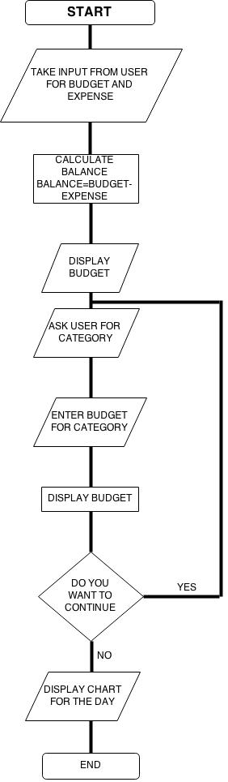

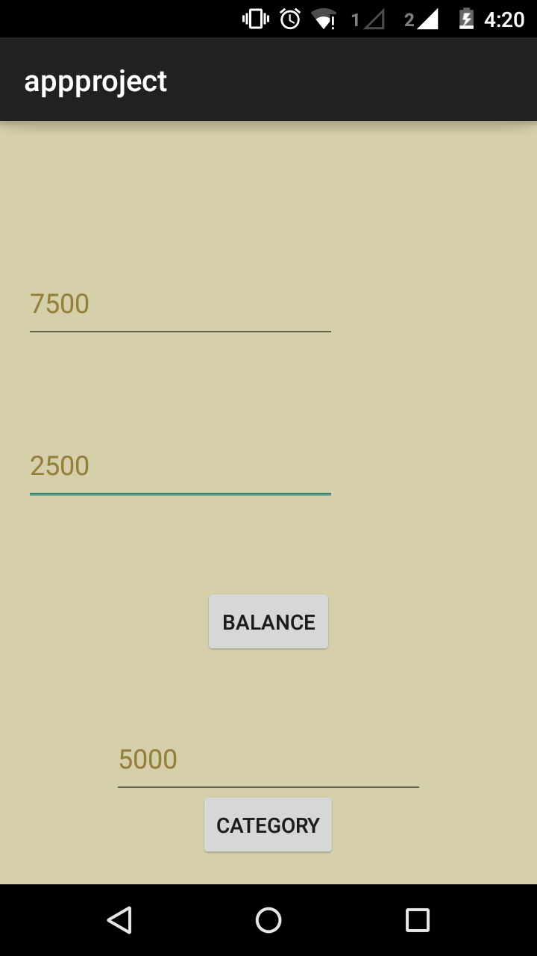**Figure 3.2.1**

**Figure 3.2.2**

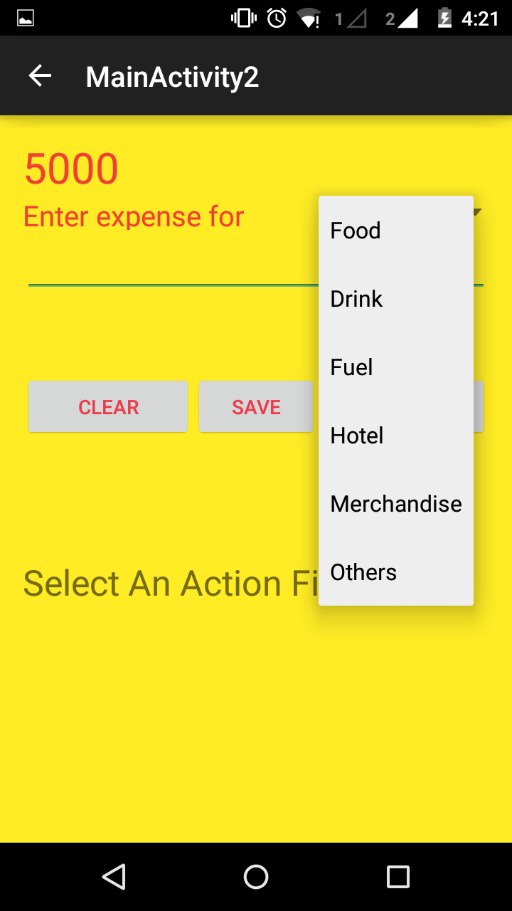

**Figure 3.2.3**

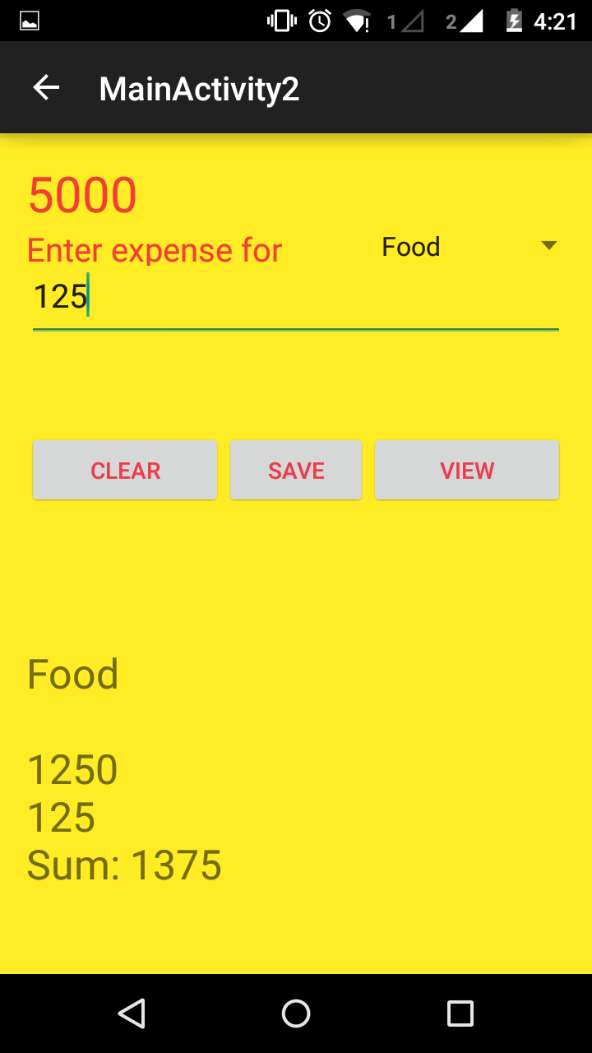

Figure 3.2.4

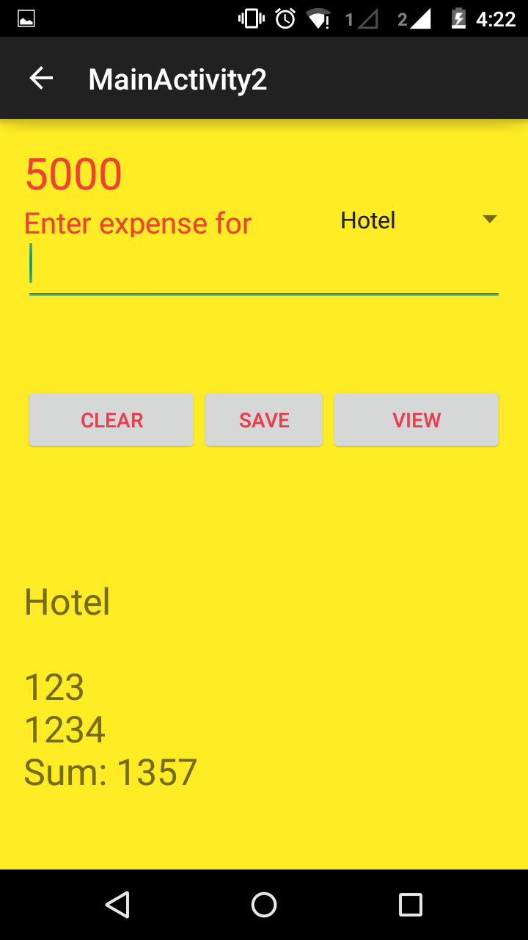

**3.3) LIMITATION OF THE APPLICATION**

1] Graphically lagging.

2] User interface not supported below 5” screen (use of dp instead of sp).

3] Data isn’t stored anywhere. It will retain data only for the current session

In the current version. (Will not be for long till we include a database).

4] We might like to implement the modules included in future scope.

**4. CONCLUSION**

Hence working on the above project proved to be very beneficial for us as we got to learn many new Android related technologies and also we learn how to use them in making applications which people can use in their daily life.

With the help of these technologies we have created the application called as expense manager which people can use to monitor their expenses regularly, weekly even monthly.

And also in the long run this application can be useful for people to keep a track of their expense related statistics.

**Future scope**

It can be used for maintaining records of your expenditure. It may have this special provision in which you save how much you want to save and it displays a message when the user exceeds his set budget. It may also have this module specially designed for college students in which they set their daily budget and also maintain a logbook in which they specify how much they owe other people.

**5.) REFERENCES**

1] Android developer 4.0 oxford publication.

2] https://developer.android.com/training/basics/firstapp

3] www.codelearn.org/android-tutorial