**FESTIPEDIA**

**A Mini-Project Report**

**Under**

**Project Workshop**

***Submitted by***

**Ganapathy S C Aiyer (B006)**

**Rishabh Bhandari (B012)**

**Ashish Bharti (B013)**

**Sahil Bhutani (B015)**

***Under The Guidance Of***

**Prof. Krishna Palod**

***In partial fulfillment for the award of the degree***

***Of***

**Bachelor of Technology**

**IN**

**Computer Science**

**At**

**NMIMS’ Mukesh Patel School of technology management and engineering, Mumbai**

**April 2014**

**CERTIFICATE**

This is to certify that the project entitled “FESTIPEDIA” is the bonafide work carried out by Ganapathy S C Aiyer, Rishabh Bhandari, Ashish Bharti, Sahil Bhutani of B.Tech (Computer Engineering), MPSTME (NMIMS), Mumbai, during the VI semester of the academic year 2013-14, in partial fulfillment of the requirements for the award of the Degree of Bachelors of Technology as per the norms prescribed by NMIMS. The mini-project work has been assessed and found to be satisfactory.

___________________

Prof. Krishna Palod

Internal Mentor

_______________________ ________________________

Examiner 1 Examiner 2

________________________

Dean

Dr. S. Y. Mhaiskar

**DECLARATION**

We,

Ganapathy S C Aiyer

Rishabh Bhandari

Ashish Bharti

Sahil Bhutani

Roll No. B006, B012, B013 and B015, B.Tech (Computer Engineering), VI semester understand that plagiarism is defined as anyone or combination of the following:

1. Un-credited verbatim copying of individual sentences, paragraphs or illustration (such as graphs, diagrams, etc.) from any source, published or unpublished, including the internet.
2. Un-credited improper paraphrasing of pages paragraphs (changing a few words phrases, or rearranging the original sentence order)
3. Credited verbatim copying of a major portion of a paper (or thesis chapter) without clear delineation of who did wrote what. (Source: IEEE, The institute, Dec. 2004)
4. I have made sure that all the ideas, expressions, graphs, diagrams, etc., that are not a result of my work, are properly credited. Long phrases or sentences that had to be used verbatim from published literature have been clearly identified using quotation marks.
5. I affirm that no portion of my work can be considered as plagiarism and I take full responsibility if such a complaint occurs. I understand fully well that the guide of the seminar/ project report may not be in a position to check for the possibility of such incidences of plagiarism in this body of work.

|  |  |  |  |
| --- | --- | --- | --- |
| Signature of the Student  Name: Ganapathy Aiyer  Roll No. B006  Place: Mumbai  Date: | Signature of the Student  Name: Rishabh Bhandari  Roll No. B012  Place: Mumbai  Date: | Signature of the Student  Name: Ashish Bharti  Roll No. B013  Place: Mumbai  Date: | Signature of the Student  Name: Sahil Bhutani  Roll No. B015  Place: Mumbai  Date: |

**ACKNOWLEDGEMENT**

We would like to express our gratitude and appreciation to all those who gave us the possibility to complete this report. A special thank s to our project mentor, Prof. KRISHNA PALOD, whose help, stimulating suggestions and encouragement helped us to coordinate our project especially in writing this report and for her full effort in guiding the team in achieving the goal as well as her encouragement to maintain our progress in track.

We would also like to acknowledge with much appreciation the crucial role of our project workshop teacher Prof. Supriya Agrawal for teaching us Basics of Android and for guiding us whenever we got struck somewhere.

Lastly, we would also like to extend our sincere thanks to the University and individuals who gave us the opportunity to do this project. This helped us to gain more knowledge about the subject. We thank almighty and our friends for their constant encouragement without which this project would not be possible.

**Table of contents**

**CHAPTER NO. TITLE PAGE NO.**

List of Figures i

Abstract ii

1. INTRODUCTION

1.1 Project Overview 1

1.2 Hardware Specification 1

1.3 Software Specification 1

2. INSTALLATION & SETUP 2-3

3. ANALYSIS & DESIGN

3.1 ANALYSIS 4-8  
 3.1.1 External Interface Requirements 4

3.1.2 Functional Requirements 4

3.1.3 Use Cases 5

3.1.4 Non-functional Requirements 5-6

3.1.5 Design Constraints 6

3.1.6 General Constraints 6

3.1.7 Sequence Diagram 7

3.1.8 Data Flow Diagram 7

3.1.9 State Chart Diagram 8

4. PROJECT IN DETAIL 9-18

4.1 Splash Screen 9

4.2 Main Page 10-11

4.3 Add Event 12-13

4.4 Search 14-15

4.5 Event List and Details 16-17

4.6 Drawer Layout 17-18

5. CONCLUSION & FUTURE SCOPE 19

REFERENCES 19

**List of Figures**

**CHAPTER NO. TITLE PAGE NO.**

**2. INSTALLATION & SETUP**

Fig 2.1 Permissions Request 3

Fig 2.2 Installing 4

Fig 2.3 App Installed 4

**3. ANALYSIS AND DESIGN**

Fig 3.1 Use Case Diagram 5

Fig 3.2 Sequence Diagram 7

Fig 3.3 Data Flow Diagram 7

Fig 3.4 State Chart Diagram 8

**4. PROJECT IN DETAIL**

Fig 4.1 Splash Screen 9

Fig 4.2 Main Page Screen 10-11

Fig 4.3 Add Event Screens 12-13

Fig 4.4 Search Screens 14-15

Fig 4.5 Event Details Screens 16-17

Fig 4.6 Drawer Layout Screen 18

**Abstract**

Our project is an android application called **FESTIPEDIA**. This application is specially designed for festival enthusiasts. FESTIPEDIA informs a user about all the college events and festivals which are being organized in the different parts of the country. The user can follow an easy and structured way of searching an event and can even add an upcoming event through the application. The purpose of the **FESTIPEDIA** app is to provide users with a simple and user-friendly interface through which the user can easily search/locate upcoming college festivals/events to visit or participate. The app will have information about the college festival, events, college name, city, organizers, and will even help you in reaching the event through its map support.

The application will be setup in a way that the admin will have all the rights to update, insert or delete an event. The application will be available free of cost for the users and would have wide cross platform support.

1. **INTRODUCTION**
   1. **Project Overview**

The FESTIPEDIA app will be a free app available to all kinds of users. Depending on the type of user, events can be browsed, added. We are providing different categories for events. This categorization will help the user to easily browse the events which are taking place.

The project aims to reduce the communication gap between the organizing colleges and interested people. The perspective user will have all the information about the events they are interested in within their reach. The organizers will have a better medium to connect to interested section of people.

This is a relatively new project. There are a few simple applications which provide information about the college festivals which are available on the android market but most of them are not updated or are not efficient. Our aim is to create a free and useful app for use of the common public. It will be available for everyone with Android 3.0 (Honeycomb) or higher; with all basic requirements fulfilled by every mobile phone (RAM, memory, etc.)

We will be providing update available to the users within one month improving the look and feel of the application and also some additional functionalities will be provided for improving user’s experience.

* 1. **Hardware Requirements**

RAM – Minimum 512 MB

STORAGE SPACE – Minimum 16.3 MB

NETWORK – Wi-Fi/GPRS/3G (atleast one of these)

* 1. **Software Requirements**

**Operating System**

ANDROID 4.0 or higher

1. **INSTALLATION AND SETUP**

The application will be uploaded in the playstore till then the user should have the apk to install the application.

1. The permissions are required to be accepted by the user to install the application. Following permission are required :

* Full Network Access – For loading the events from server and for loading the location.
* View Network Connections – To check the availability of the network.

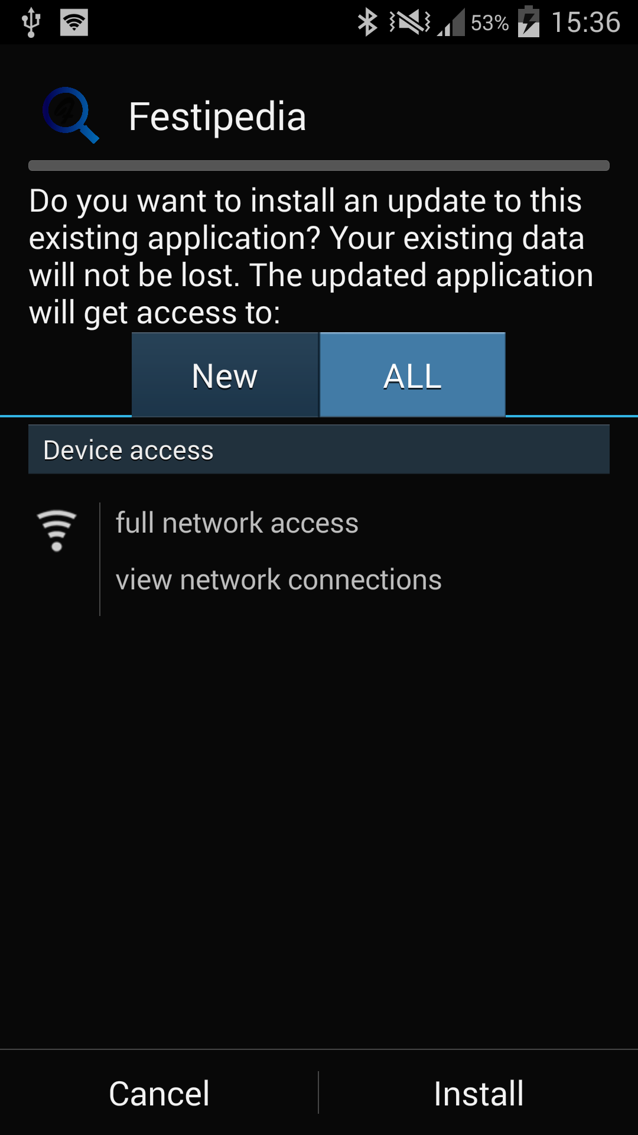

Figure 2.1 Permissions request

1. After verifying the permissions user is required to click on the ‘Install’ button which will start installing the application on the user’s device.

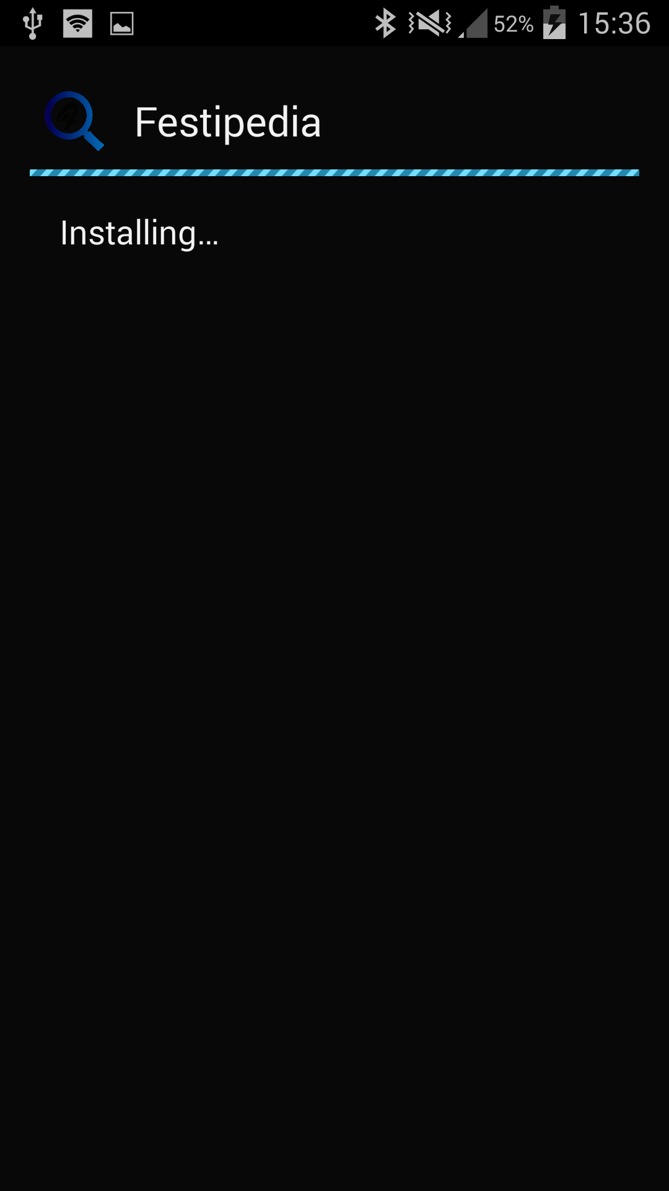

Figure 2.2 Installing

1. Once the application is installed the user has to click open button to view the application.

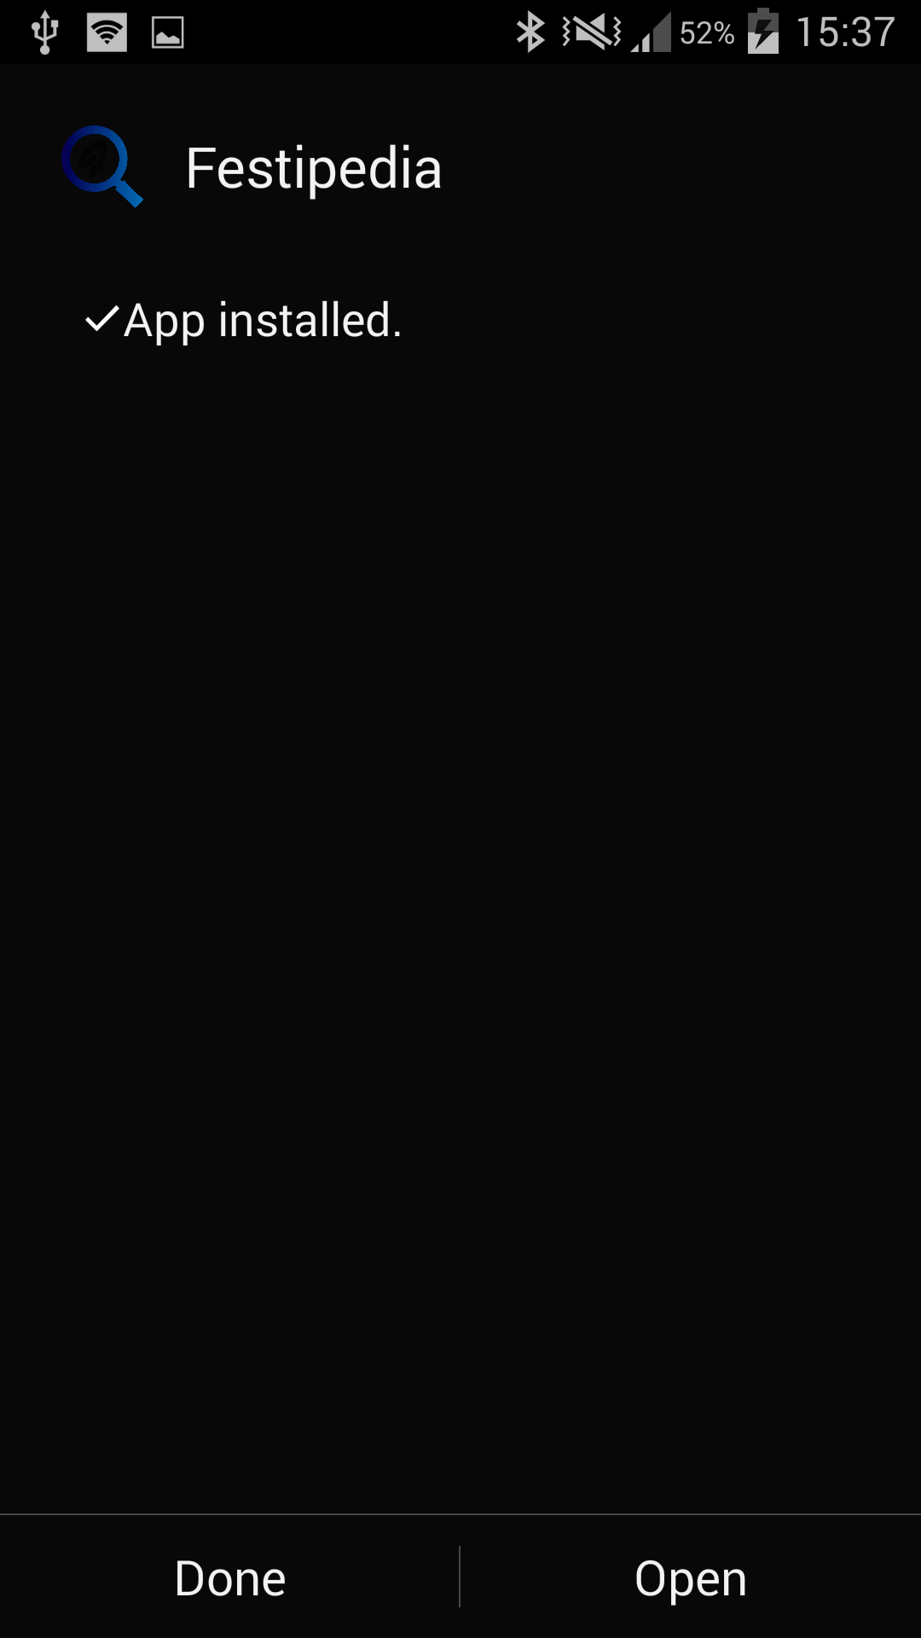

Figure 2.3 App Installed

1. **ANALYSIS & DESIGN**
   1. **ANALYSIS**

**3.1.1 External Interface Requirements**

**User Interfaces**

* User interface will be designed using XML.
* The interface will be as per the android guidelines.
* Different user interfaces are:
* Adding event
* Displaying list of events
* Displaying details of events
* Displaying Location in Google map

**Hardware Interfaces**

The application is intended to be a client-server, multi-user system. The application will run on an Android device or an Android emulator. No further hardware devices or interfaces will be required.

**Software Interfaces**

**Inputs**

The application will receive input from the users and appropriate query results from the database will be displayed to the user. The user interface will supply the searching/viewing details of a current event or submit request for addition of a new one.

**Operating System**

The software will run on the Android operating system, specifically version 3.0 (Honeycomb) and above.

**3.1.2 Functional Requirements**

Users can search festivals by categories like Cultural, Technical, Workshops, and Seminars etc. by college name, by festival name, by location then users will be provided with search results. User can then select any festival and view the details of that fest. Users can also add event not directly but through admin by submitting the details of the event to the admin for verification.

**3.1.3 Use Cases**

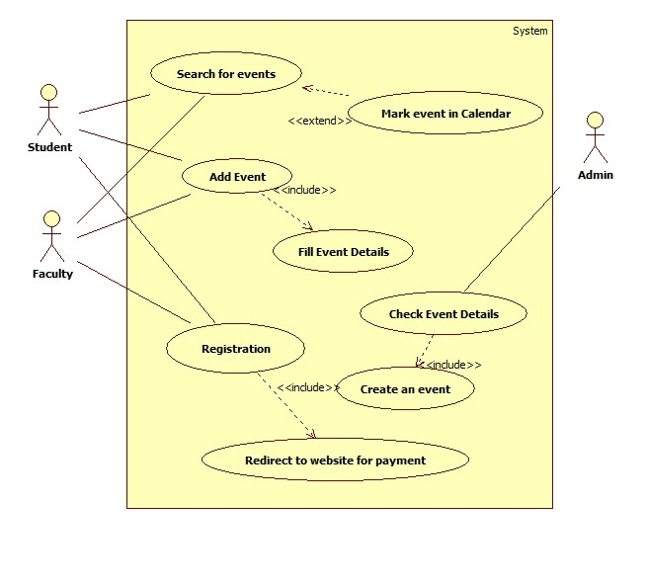

Fig 3.1 Use case Diagram

**3.1.4 Non-Functional Requirements**

**Performance:**

The software is expected to perform consistently all the time. No unexpected behaviour should occur. The event detail requested should be opened without delay.

**Reliability**

The software will meet all of the functional requirements without any unexpected behaviour. This application will provide authentic information to the users about the festival details. The information provided will be best and true as per the admins knowledge.

**Availability**

The software will be available at all times on the user’s Android device, as long as the device is in proper working order. The functionality of the software

will depend on availability of the server and internet connection on the device. It must be ensured that server is up and working. This application will be available to all kind of users. It is a free application.

**Security**

The data provided by the user during registration will be secure. Since this application does not handle any registration which includes payment. They will be handled by the college itself and hence there will be no issue of security because of application.

**Maintainability**

Maintenance of database and server will be done regularly to ensure that the information is not out dated. The software should be written clearly and concisely. The code will be well documented. Particular care will be taken to design the software modularly to ensure that maintenance is easy.

**Portability**

This software will be designed to run on any Android operating system version 2.0 or higher. Application can be easily made compatible to the higher versions of android as and when they are released.

**3.1.5 Design Constraints**

Time: The given for development is 3-4 months. While the basic functionality will be definitely ready in this time. Fine tuning it and adding functionality might be hampered.

**3.1.6 General Constraints**

* Internet connection is required to load the information from the server.
* In case of intra college events user can register only if he/she belongs to that particular college.
* User should request admin to add the events.
* Users will be allowed to register in an event only if the admin has been given rights to register participants for that event.

.

**3.1.6 Sequence Diagram**

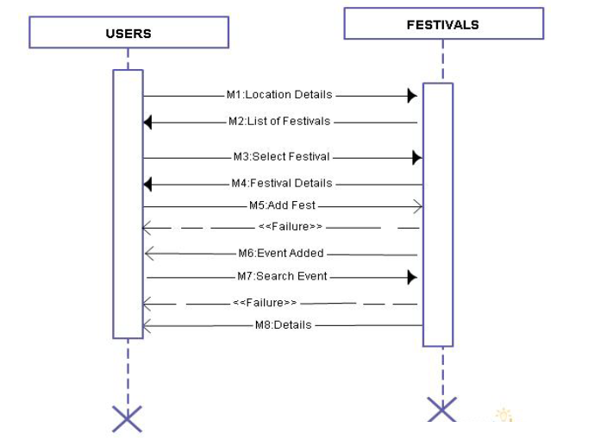

Fig. 3.2: Sequence Diagram

**3.1.7 Data Flow Diagram (DFD)**

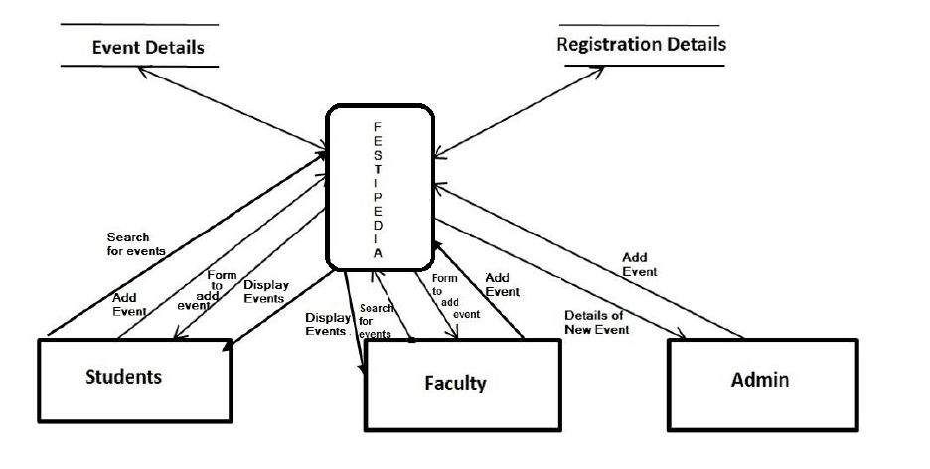

Fig 3.3: Data Flow Diagram

**3.1.8 State Chart Diagram:**

**STATES:**

• Event Added : When user adds a new event with its details.

• Getting Location: When the splash page is displayed and user provides the location.

• Warning Displayed: When internet connection is not available.

• Events Displayed: When user selects some category or an event is added then the related events are displayed.

**EVENTS:**

• No Internet Connection

• Change Location

• Category Selected

• Display Events

• Add Event

• Exit Pressed

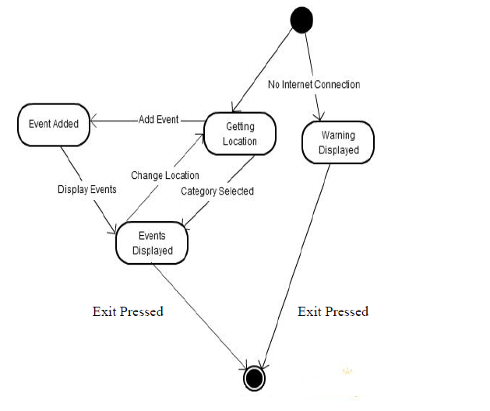

Figure 3.4 State Chart Diagram

1. **PROJECT IN DETAIL**

**WORKING OF OUR APPLICATION:**

Festipedia is a client server based application which has been implemented using PHP, JSON and MySql server. Whenever we open the application internet connection is required so that we can connect to the server which will load all the events and in turn its details. PHP is a server side program which is used to connect with the MySql database. JSON is used to pass the values from android to PHP and vice versa. If the internet connection is not available still the user will be allowed to view the layout of the application but won’t be able to use any of its functionalities.

Here we will describe the working of the project in detail with the help of screenshots.

* 1. **Splash Page**

Every time the user opens the application Splash appears. The Splash contains the logo of the application. This page is designed in such a way that every time the app is opened, background color of the splash page changes. The splash page automatically fades out after 4 seconds to reveal the main menu with different categories and locations.

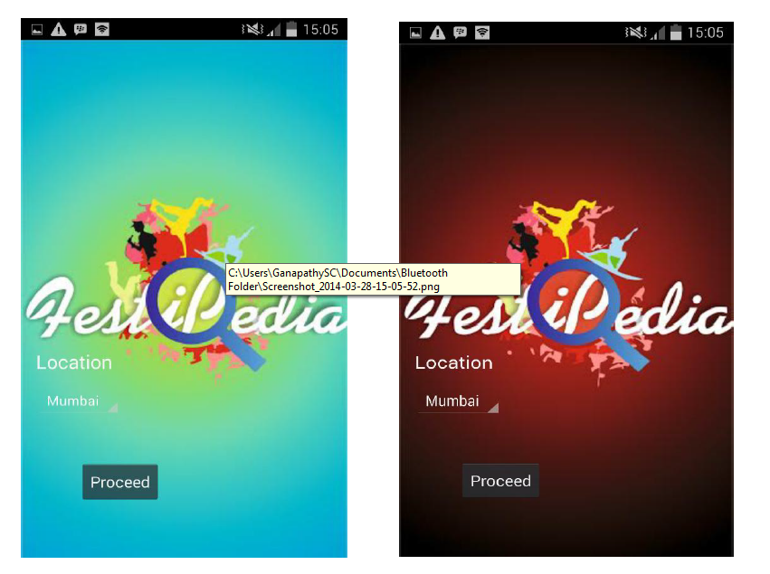

Figure 4.1 Splash Screen

* 1. **Main Page:**

This is the layout of the main page. The main page contains different categories of festivals, the location which the user want to search, the option to add an event and also to search an event. The main page buttons will not respond to an onclick event and the spinner won’t show any location if an internet connection is not available. If you click on the button a message will appear informing user that no internet connection is available otherwise user will be able to utilize all the functionalities.

Figure 4.2 Main Page Screens

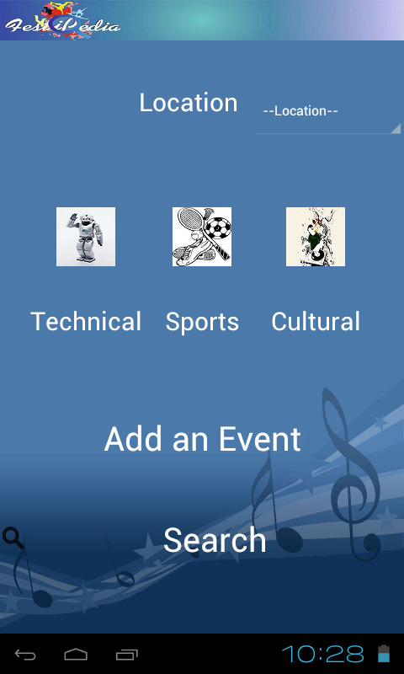 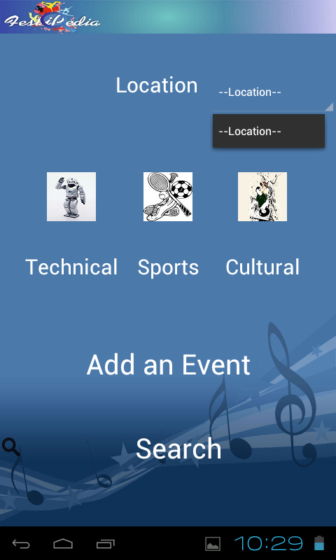

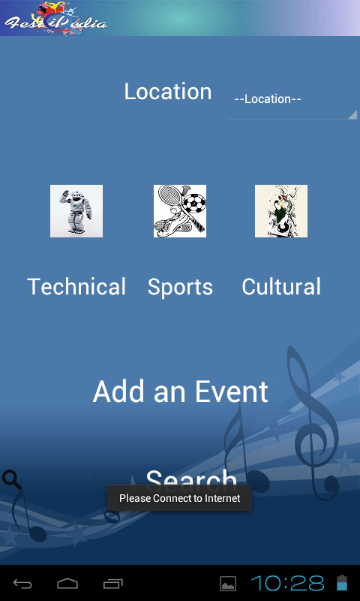 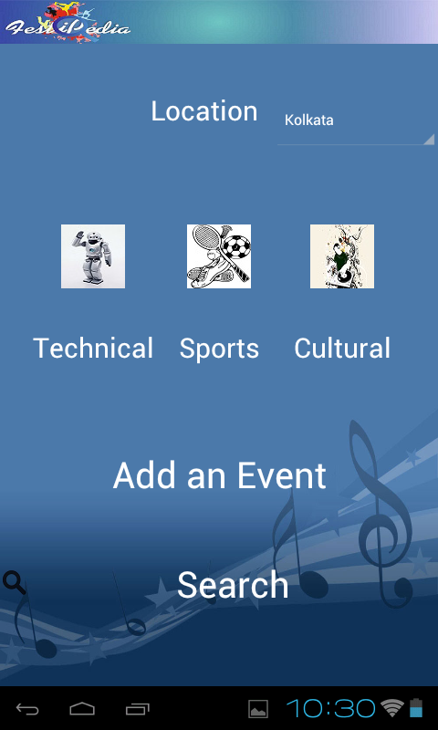

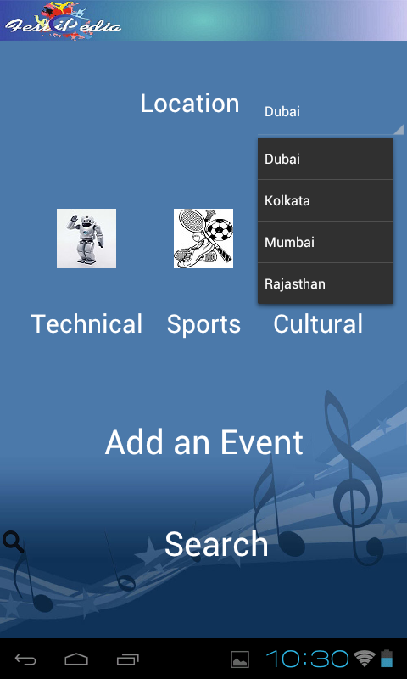 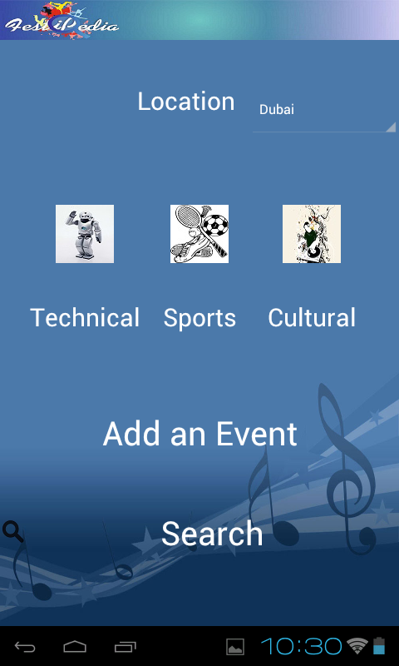

* 1. **Add Event:**

This page will allow the users to add events. The addition of events will be controlled by the admin. The various fields in the form are validated and the user is required to fill in authentic details. Following validation are implemented:

* All the fields are required
* All the text fields have been set with a maximum character limit
* URL fields are validated i.e. it should be of the format as displayed in the hint text
* The dates are validated using the calendar component

Once the user clicks the add event button an acknowledgement is displayed to the user.

The duty lies with admin to add the event to the database if the details are authentic. The events added by the admin will immediately reflect in the event list.

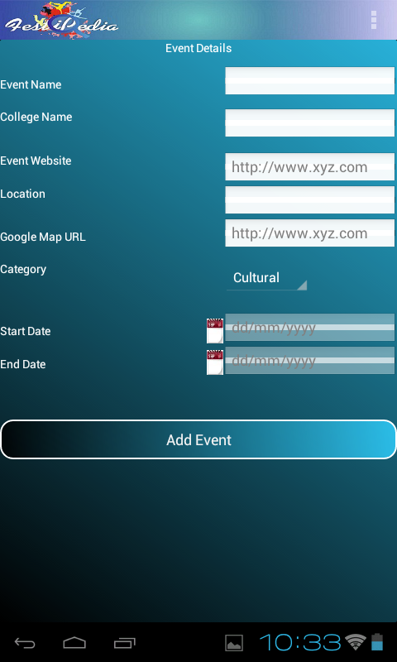 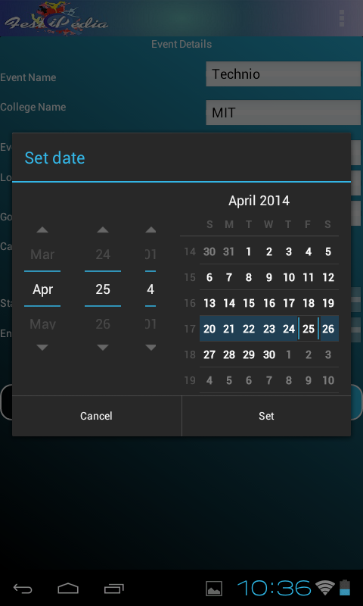

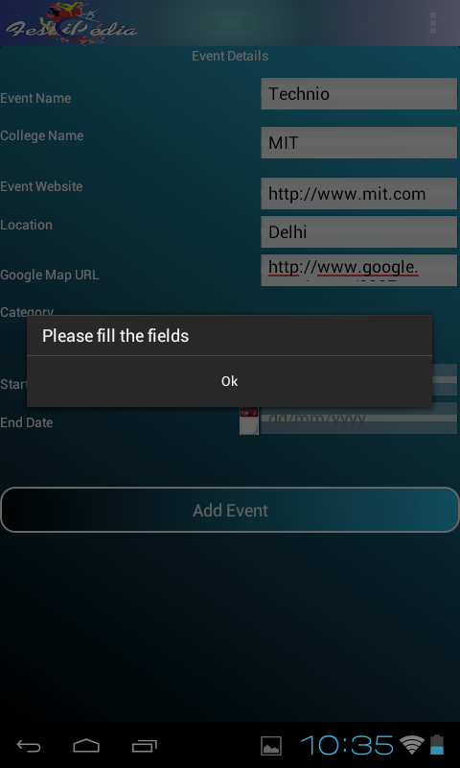 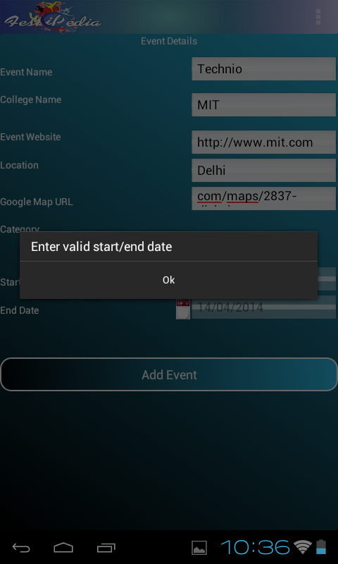

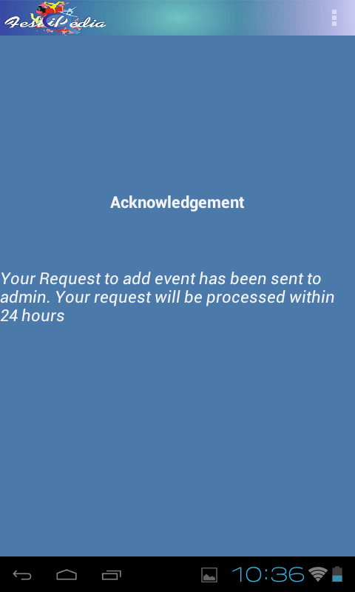Figure 4.3 Add Event Screens

* 1. **Search:**

User can search the events based on:

* Categories
* Location
* College Name
* Fest Name

Once the user selects type of search and types the search string, results will be displayed. Several features are included in this search like a partial search string can also fetch details.

If there is no matching results a message will be shown to the user.

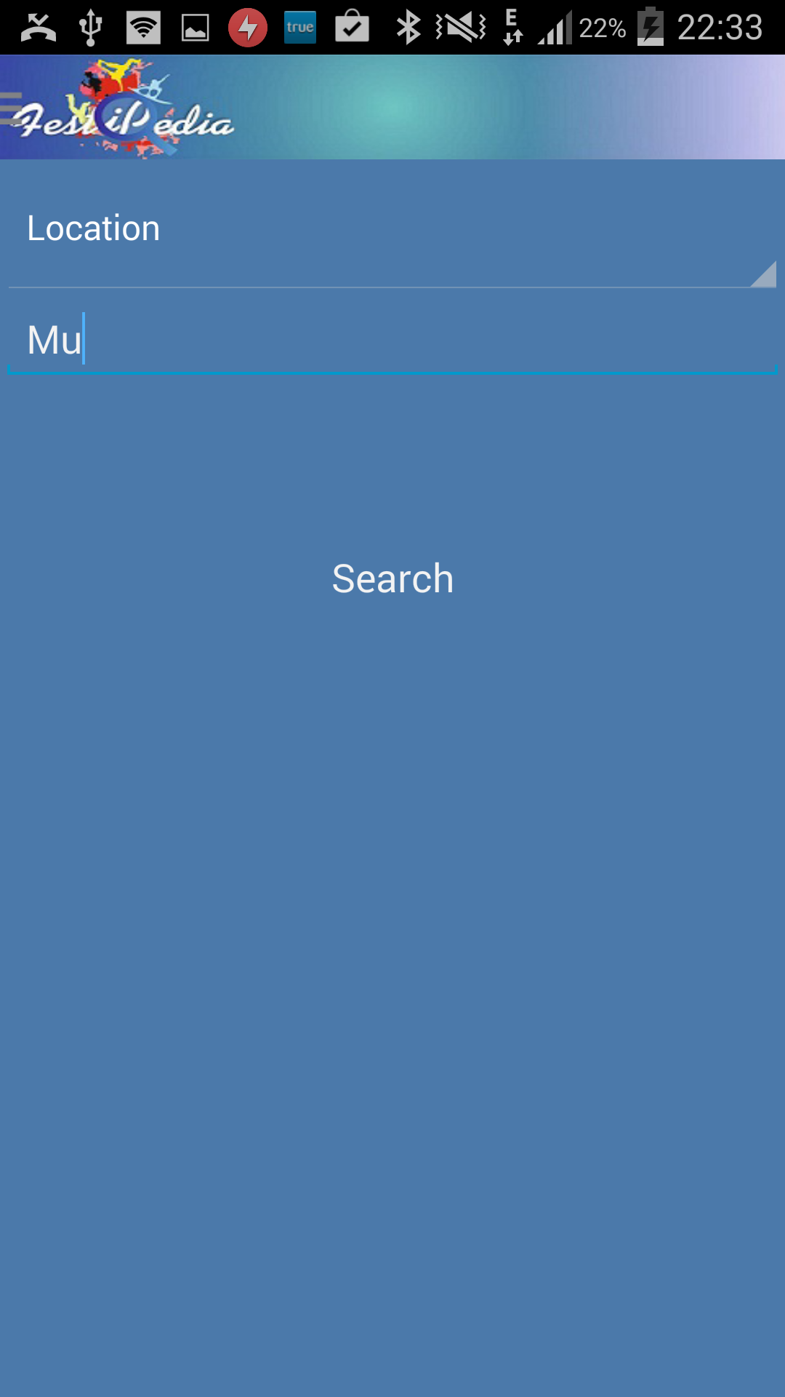 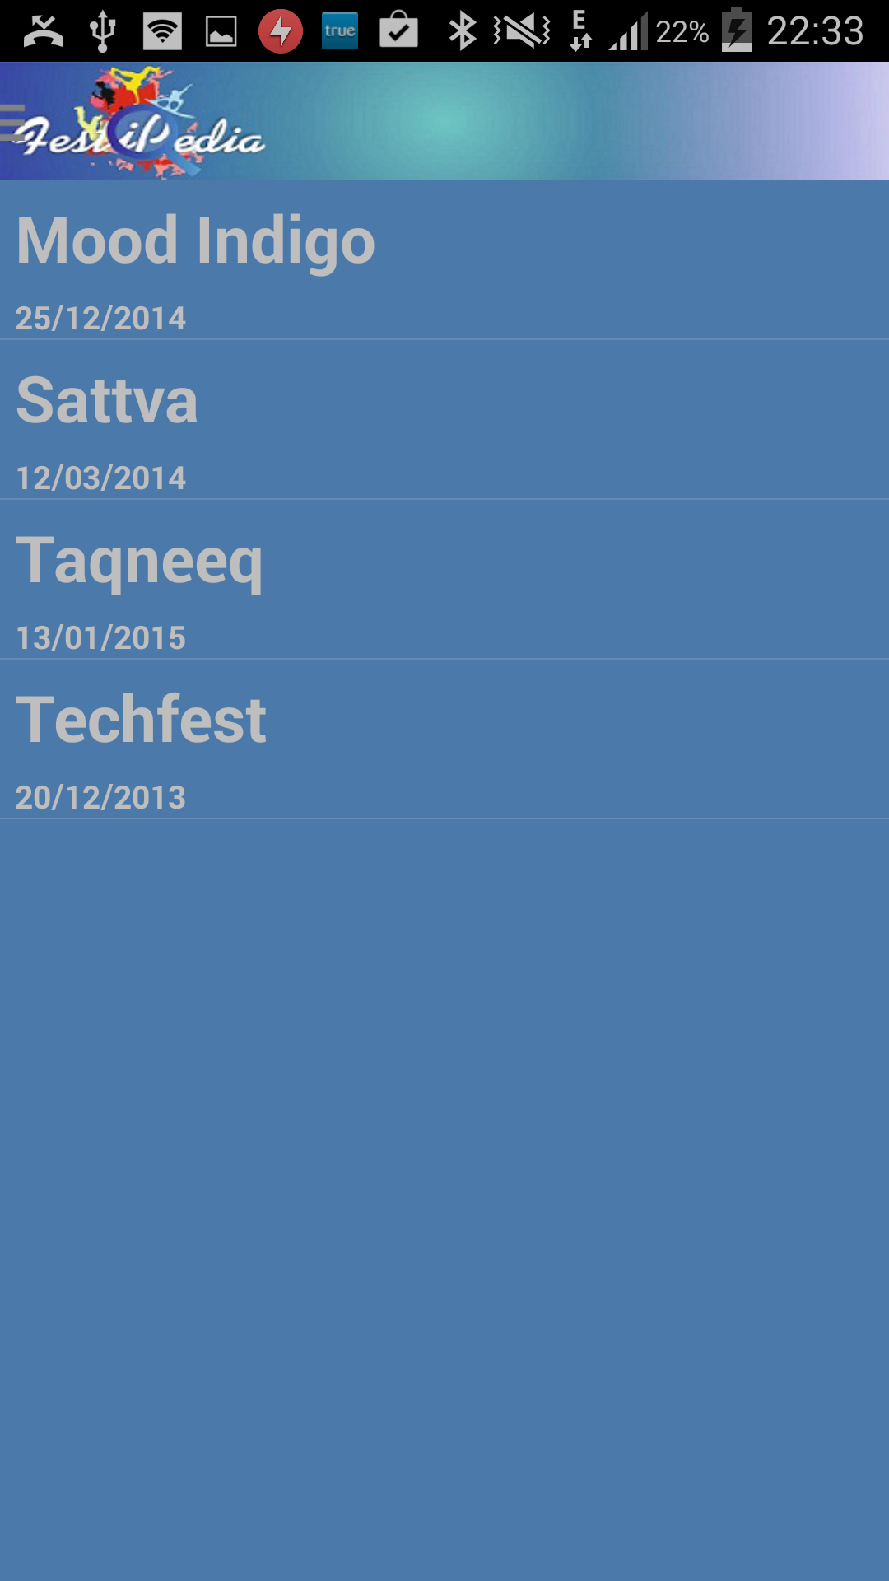

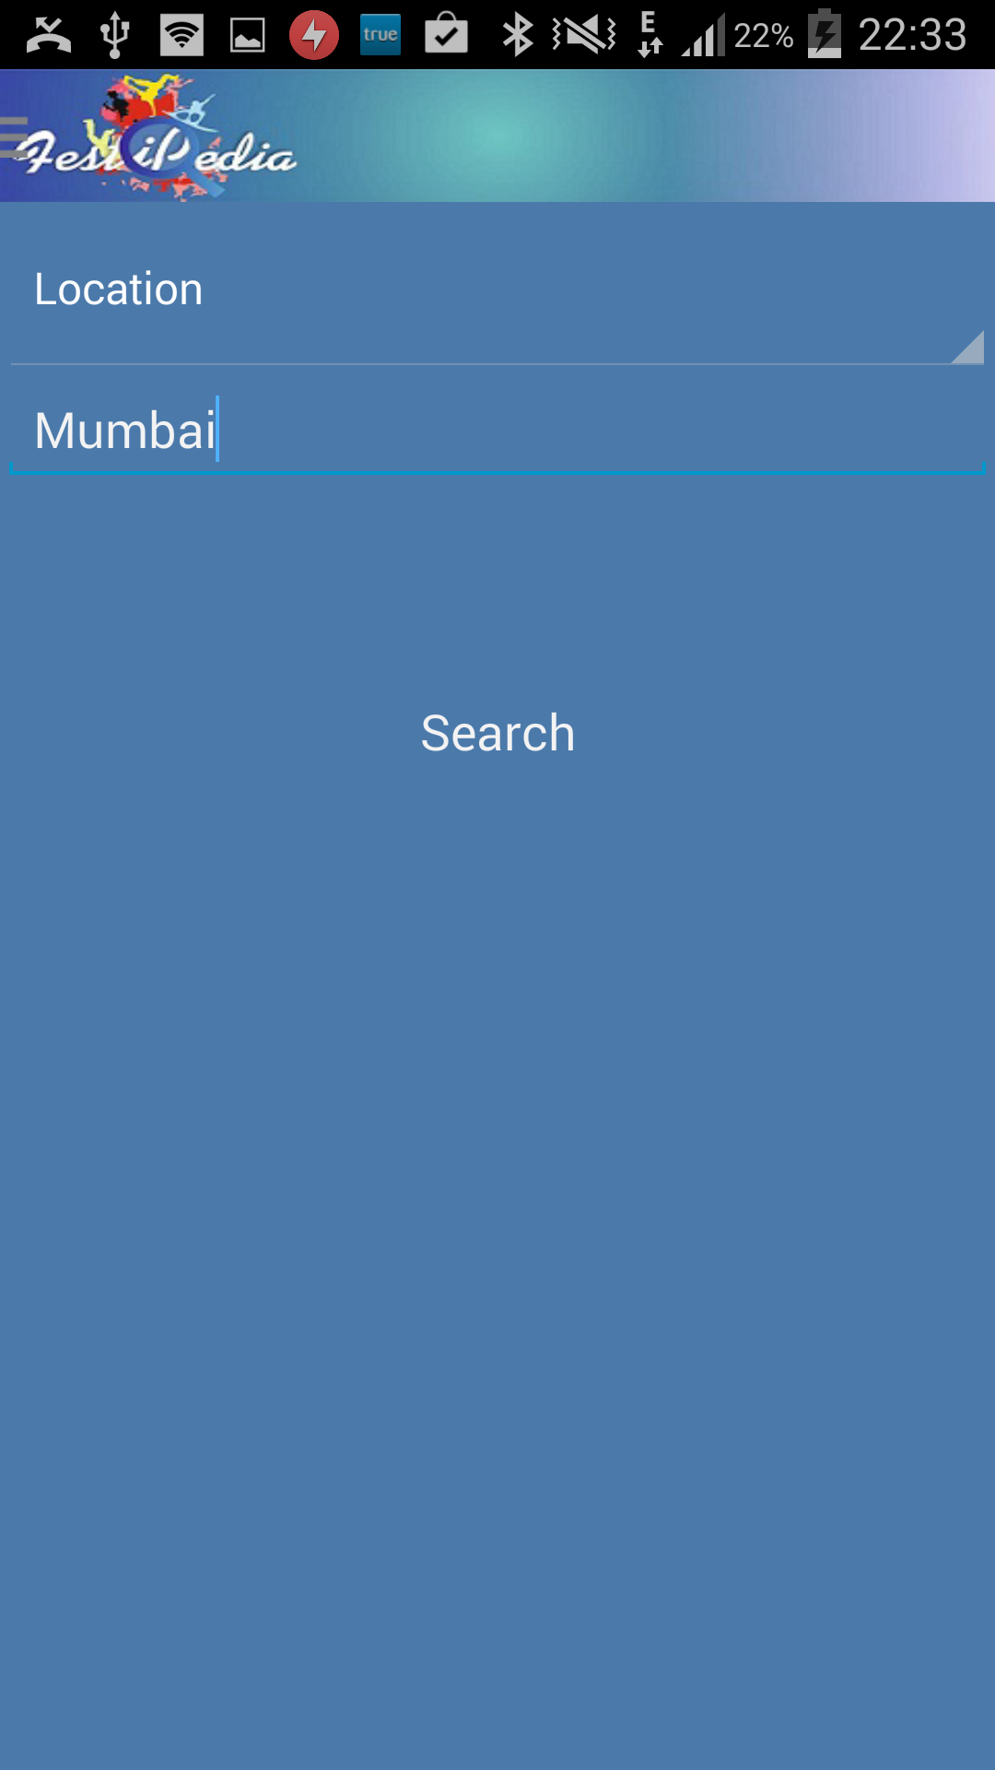 

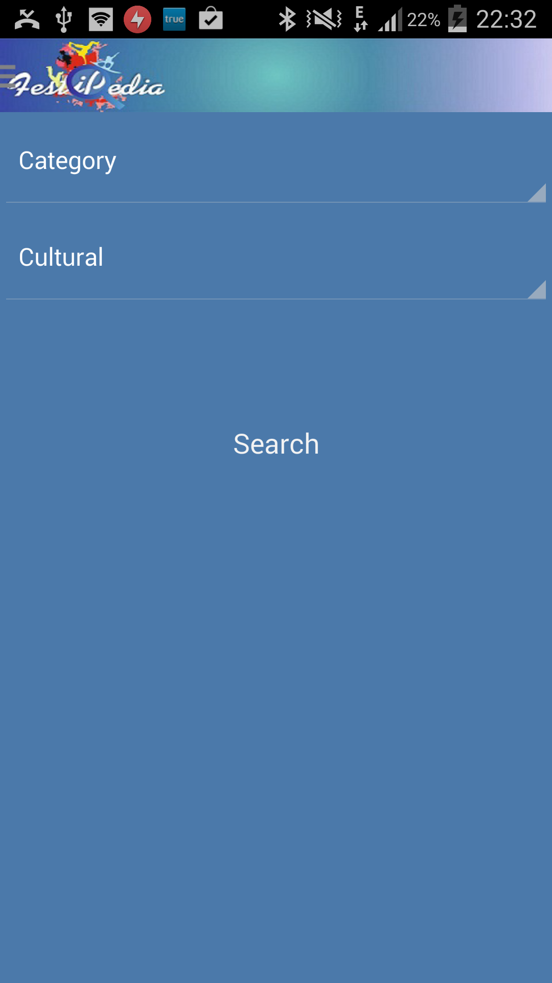 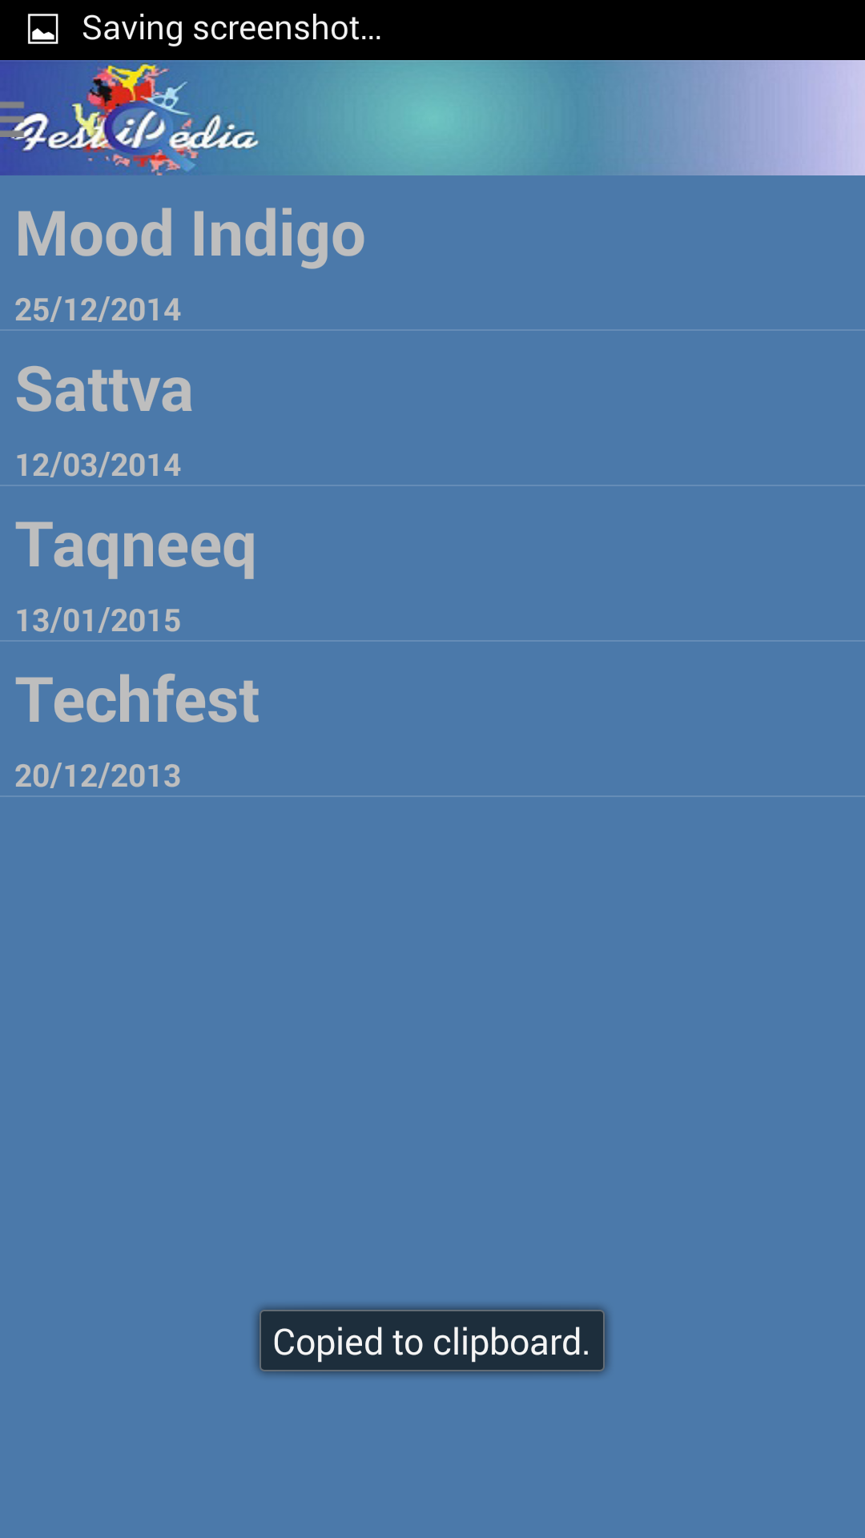

Figure 4.5 Search Screens

* 1. **Event list and details:**

Once the category and location is selected by the user all the events based on the above constraints are displayed. Event list contains event name as well as the start date of the event. If no events is present for the user selection a message will be displayed.

User can choose an event from the list which in turn displays the event details. Event details layout is divided into two tabs which can be accessed either by clicking or by swiping. The first tab contains event details and the second tab contains google map for the event location.

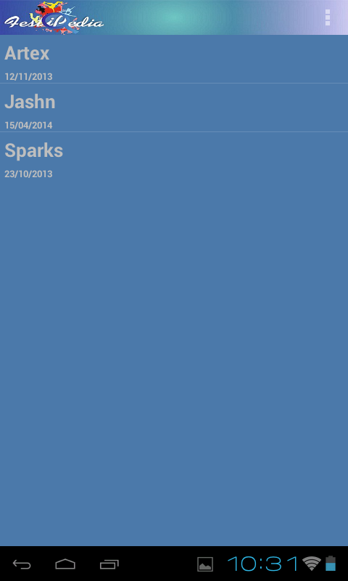 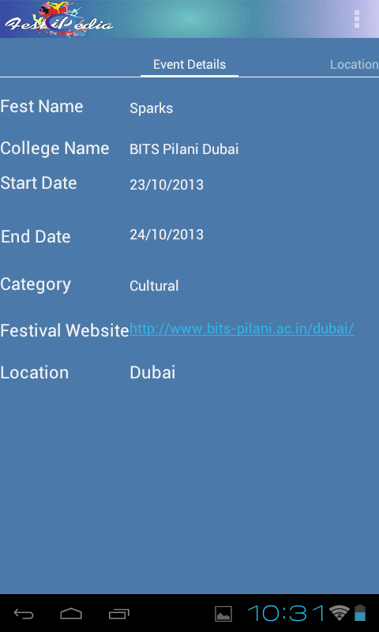

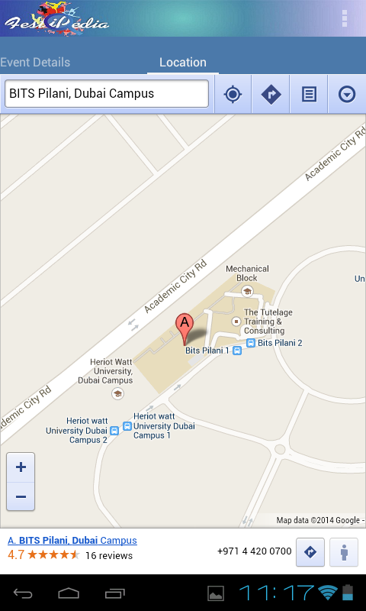 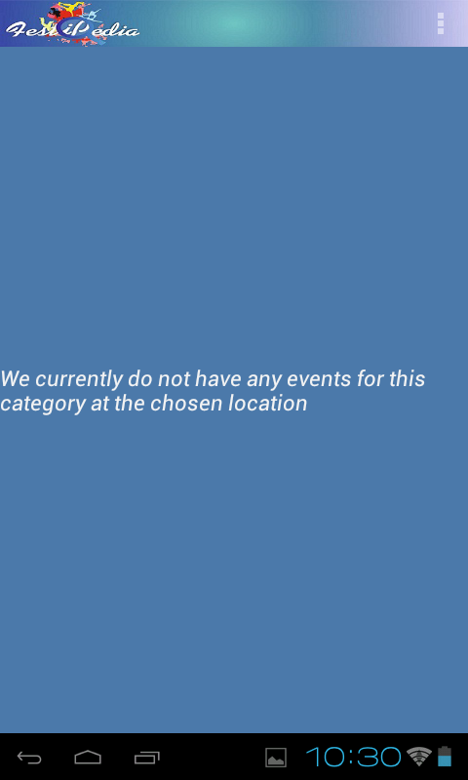

Figure 4.5 Event Details

* 1. **Drawer Layout:**

The drawer layout can be accessed from all the pages except main page. This drawer layout can either be accessed by clicking the icon on the top left corner or it can accessed by swiping from the left hand side of the screen. The drawer contains functionalities which are present in the main menu. This enables the user to access all the functionalities from any of the page.

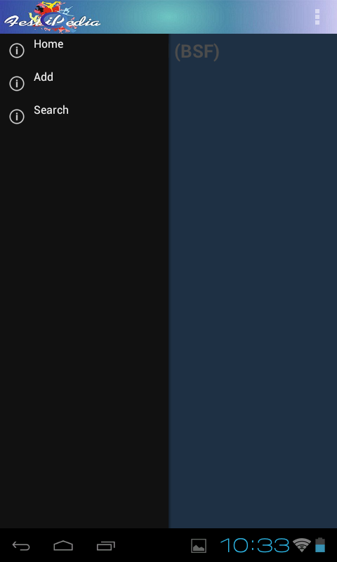

Figure 4.6 Drawer Layout Screen

1. **CONCLUSION & FUTURE SCOPE**
   1. **CONCLUSION**

Thus we have successfully developed an application that aims to inform the user about all the ongoing and upcoming college events throughout the globe.

The app gives a very user-friendly interface where a festival enthusiast can find the festival or event he is looking for in just a few clicks based on his requirements.

* 1. **FUTURE SCOPE**

This is not the final polished Application. There are a number of things that can be added to better the experience of using this App. Some of them are:

* The ability to add more categories to the application.
* The database and the PHP codes will be uploaded to a server so that the users around the globe will be able to access the database present in the server once the application has been downloaded from the play store.
* The ability to add user participation procedure to the application i.e. help the user register directly for an event through FESTIPEDIA.

Other amazing features as and when suggested will also be incorporated to the best of our abilities in the Application.

**REFERENCES**

* <http://stackoverflow.com/questions/21959527/r-cannot-be-resolved-to-a-variable-was-not-able-to-solve-with-the-solutions-giv>
* <http://stackoverflow.com/questions/22128001/not-able-to-connect-android-application-to-php-mysql-database-using-json-in-the>
* <http://stackoverflow.com/questions/22412988/how-to-save-and-load-state-of-an-application-during-change-of-screen-orientation>
* <http://stackoverflow.com/questions/22413824/customize-the-action-bar-of-android-app-with-an-image>
* <http://stackoverflow.com/questions/22419700/creating-a-splash-page-which-has-different-background-every-time-the-app-is-open>
* <http://stackoverflow.com/questions/22464101/jsonexception-string-cannot-be-converted-to-json-array-in-android>
* <http://stackoverflow.com/questions/22508364/not-able-to-set-simple-adapter-in-sherlockfragment-onpostexecute>
* <http://stackoverflow.com/questions/22736382/application-crashes-while-i-go-from-sherlock-activity-to-activity-using-intent>
* <http://stackoverflow.com/questions/22740606/android-application-running-perfectly-in-device-but-crashing-in-emulator>
* <http://stackoverflow.com/questions/22745306/hashmap-cannot-be-cast-to-java-lang-string>
* <http://stackoverflow.com/questions/22761814/android-fragment-no-view-found-for-id-0x7f040034>
* <http://stackoverflow.com/questions/22769488/blank-entries-are-getting-saved-in-database-android>
* <http://developer.android.com/index.html>
* <http://www.androidhive.info/2012/05/how-to-connect-android-with-php-mysql/>